Review

- Measure of Central Tendency: A single number that presents information about the “center” of a frequency distribution
- Mode: The most frequently occurring score in the distribution (most commonly used when distribution is asymmetrical)
Median: the score that divides a frequency distribution exactly in half. The same number of scores fall above and below the median ( most commonly used when distribution is not symmetrical)
- Mean: the sum of a set of scores in a distribution divided by the number of scores. The mean is also the average
- Variability: information about the spread of the scores in a distribution
- A theoretical distribution that is symmetrical with the mean, median and mode all falling at the exact middle of the distribution, sometimes called a “bell curve” or a standard normal curve or distribution
- Correlation: the relationship between two variables
- Correlation directions are often shown in scatter plot diagrams
- The Correlation Coefficient: the statistical measure of the relationship between two variables. The coefficient ranges from +1.00 to -1.00
- E.g. A positive correlation, would indicate that frequent yoga sessions were accompanied by high levels of energy and vice versa 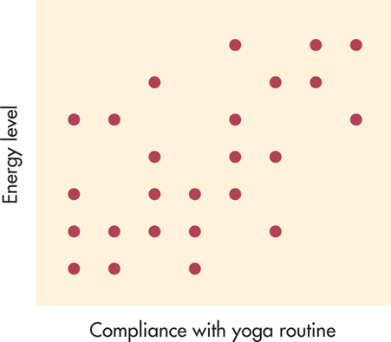
- E.g. a negative correlation, would indicate that the frequency of the mediation routine was always accompanied by less smoking 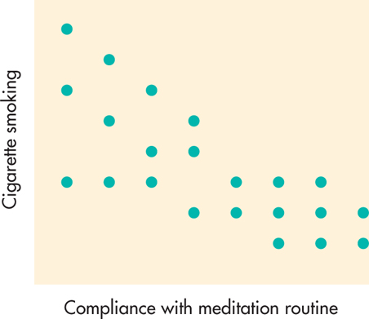

- A scatter plot with points that seem to fall randomly indicates no correlation between the variables
- Correlation does not show equal causation
- Descriptive statistics can tell us what might be leading to specific relationships
- Experiments and inferential stats allow us to determine cause and effect
- Descriptive stats are statistical procedures used to summarize, organize and simplify data

INFERENTIAL STATS

- Inferential stats consist of techniques that allow us to study samples and then make generalizations about the populations from which they were selected
- In psych inferential stats are used to determine the likelihood of a study’s outcome being due to chance or to real differences
- The ability to make inferential stats and the scope of inferences depend on the population (a complete set of something: people, nonhuman, animals, objects, events) and sample ( a subset of the population) of the subject under study
- In inferential stats we have a hypothesis and we’re making a judgment about whether or not its likely to be correct
- Inferential errors:
Type error 1: erroneously concluding that study results are significant e.g: data from a lie detector test indicating that suspect is lying when he is actually telling the truth

Type II error: Failing to find a significant effect that does in fact, exist. E.g. data from a lie detector test indicate that a suspect is telling the truth when he is actually lying

Inferential stats, generalizing from samples:

- Representative samples are better than biased samples
- Less variable observations are more reliable than those that are more variable.
- More cases are better than fewer
- Look for statistical significance. The difference between observations is probably not due to chance variation between samples
- Basically, although anecdotal evidence may be interesting and even compelling, inferences or generalizations based on a few unrepresentative cases are unreliable

Inferential stats, paying attention to methodology:

- In cross-sectional studies, different groups are studied at the same time.
- In longitudinal studies, the same group is studied over time
- Cross-sectional studies show the effects of time and environment on many different individuals.
- Longitudinal studies show these effects on the same people
- In complex studies, we do both cross sectional and longitudinal research at the same time
- Experiments and inferential stats allow us to determine cause and effect

Describing Data:

Three ways to summarize data:

What is the distribution of the data points; frequency distributions
What is the average of the data points; measures of central tendency
How much do the data points vary around the average; measures of variability

- Frequency distribution: organized tabulation of the number of scores in each category. Because it summarizes a mass of data points into a simple description: we need to impost order on the data
Types of variables affect how you summarize data in a frequency distribution
- Discrete variables have separate, indivisible categories. There are no values between categories. E.g. month of birth, number of students in class today. These are easy to put in a frequency table
- Continuous variables: infinite number of possible values. E.g. mass, time. These are hard to put into a frequency distribution until you choose a “range” for each frequency

Measurement scales:
- Nominal- categories with different names, but no distinction of quantity. Can’t be mathematically analyzed: can’t find an “average” score. E.g. room numbers, gender.

- Ordinal- categories, but in ordered sequence. Can’t assume equal intervals between categories. Can perform mathematical operations (e.g. “average” score) e.g. outcome of horse race (first, second, third): rating of teaching performance

- Interval and ratio scale - categories, with equal intervals between each category. E.g. mass, weight, age, money winnings from horse race

Nominal Measurement:
- Lowest form of measurement
- Numbers are used simply as labels to name categories
- Example: gender, coded with 2 arbitrary numbers
- It does not matter what the codes are, the numbers have no quantitative meaning (although codes like 0 and 1 are more sensible)
- Numbers from nominal measurements cannot be treated mathematically
Ordinal measurement:
- Uses numbers to designate ordering on an attribute
- Conveys some information about amount but does nor indicate distance between values
- Example: degree of pain 1: none 2: some 3: a lot
- In ordinal scales, distances are not equal and are not known
Interval measurement:
- Also uses numbers to designate ordering on an attribute and conveys information about amount
- Distance between values are assumed to be equal
- Averages can be computed
- Example: Ambien temperature (Fahrenheit)
Ratio measurement:
- Uses numbers to designate ordering conveys information about amount
- Distances are equal
- And there is a real rational zero
- Averages can be computed
- Example: medication dose (number of milligrams, number of pills)
How many people were entered in the marathon?
273 – type of variable?
How many females?
133 – type of variable?
What were winning times for the top 3 runners?
2:27, 2:34, 2: 36 – types of variable?
Placement of top three Canadian runners?
3rd, 7th, 18^{th –} type of variable?

Practice: getting to a frequency distribution
Step 1: code the variables
Step 2: Examine and then “clean” the data set
Step 3: Summarize the data in a frequency distribution

Step 1: Code the variables
- Nominal variables: a name is just a name so “code” the variables and the code doesn’t matter. E.g., 1 for female, 2 for male
- Ordinal variables: have a sequence, but no clear mathematical distinction other than other e.g. excellent, good, fair, poor might be coded as 4,3,2,1… but “excellent” isn’t twice as good as “fair”.... No direct mathematical relation between the encoded … no direct mathematical relation between the coded number
- Interval and Ratio variables: have a sequence with equal intervals e.g. age, grade. There is a mathematical relation between codes

Step 2: Data cleaning
- One aspect of data cleaning involves seeing whether the frequency distribution contains:
Outliers: values that lie outside the normal range of values, and that may or may not be legitimate
Wild ones: Impossible or invalid codes, like a code “3” for the variable gender when valid codes are 1 (female) and 2 (male)
When you should remove scores:
- When value is obviously “out of range”, usually due to entry error or an instrument error
- If you’re not absolutely sure of the value, just remove it
- Remove entries for entire case or remove just one score ?

Step 3: Start to summarize the data in a frequency distribution
- E.g. have you taken a stats course before?
- Code 1 for yes, 2 for no then count…then convert to %
- Nominal: categories with different names, but no distinction of quantity. Can’t be mathematically analyzed: can’t find an “average” score.
- E.g. gender, course take before
- Tabulate frequency of occurrence separately for men and women respondents
- Tabulation of frequency of occurrence … converted to a more understandable “proportion” of occurrence
- With nominal or ordinal data, it’s easy to put things in categories… (By definition, they are already in categories)
- But with interval data, we have to group the scores to make them understandable otherwise, we end up with a category for every possible score
- Example: with % test scores of 37, 40, 54, 7, 83, 89, 90 what’s the frequency distribution?
- Rule of thumb: choose between five and ten “groups”
1-20
21-40
41-60
61- 80
81-90
- For continuous variables, we have to use “groupings”
- Infinite number of possible scores, e.g. height, so we have to choose a range for each grouping

- Smooth curves are used for population graphs (where there are huge amounts of interval data)
- And we use statistical tests to determine whether out sample is a representative measure of the population
- The “normal” curve: one side of the curve is the mirror image of the other and we generally assume “normality” when we do calculations
- Often strictly true: many distributions have odd shapes
- Positive skew: Difficult exam…mostly low scores with a few high
- Negative skew: mostly high scores, with a few low
- Bi-modal: two “peaks”, often indicating two different distributions merged into one samples
E.g. heights measured in children age 5 and age 10, all in one sample

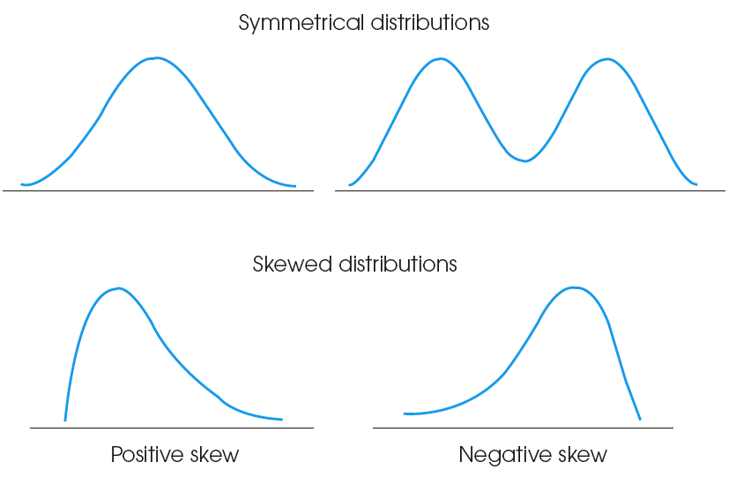
First step in analyzing research data :
- Before we can make inferences from a set of data, we have to summarize it and carefully describe it
- The nature of the data we collect (nominal, ordinal etc.)
- The validity of our recording of the data- are there coding errors
- The shape of the distribution of the data points
Each of these will affect the inferences (conclusions) we can draw from our research
3 related ways to describe data points
- What is the distribution of the data points
- What is the average of the data points
- How much do the data points vary around the average

Lecture 3: How to describe data
Mean:
Step 1: Code the variables (for nominal data)
Step 2: Clean the data
Step 3: Tabulate frequencies
Step 4: Calculate mean- total of all scores, divided by n (number of scores)
∑x/n
1021/49 = 20.8
- Mean can give a biased view of “the center” skewed distributions
Median:
- Measures an average as a midpoint of all scores
- Often what we mean when we talk about “top half” is above the median
- The median measures an “average” as the mid-point of all scores
- Put all the scores in order and choose the one that directly divides them in half
- This works perfectly when as an odd number. For even numbers, taken the midpoint between the two scores closest to the middle. E.g. 2,3,4,5. The median is between 3 and 4 therefore it is 3.5
Mode:
- The most common score in a distribution
- Most commonly used when distribution is asymmetrical and when data cant be computed using a numerical score e.g. for nominal data
- E.g. most popular restaurant

- We use the mean as a default because we can do other operations with it (e.g. measure variability) it uses every score to find the average- median and mode “throw out” some parts of data but, mean assumes a “normal” symmetrical distribution

Advantages of mean:
The balance point in the distribution: sum of deviations above the mean always exactly balances those below it
Does not ignore any information
The most stable index of central tendency
Many inferential stats are based on the mean
Disadvantages of mean:
Sensitive to outliers
Gives a distorted view of what is “typical” when data are skewed
Value of mean is often not an actual data value

- We use to median: extreme scores or very skewed distributions (where mean and median are very different), where there is missing data e.g. people who didn’t feel out their age and for ordinal scales, e.g. where the scale doesn’t allow you to use numerical calculations

Advantages of median:
Not influenced by outliers
Particularly goof index of what is “typical” when distribution is skewed
Easy to “compute”
Appropriate when data are ordinal level
Disadvantages of median:
Does not take actual data values into account- only an index of position
Value of median not necessarily an actual data value so it is more difficult to understand than mode

- We use mode: when there are nominal scales, when there are discrete variables and you want to identify a typical case e.g. a typical family has 2 children and 2 cars makes more sense than saying a typical family has 2.3 children and 1.7 cars. And when you want to clarify the shape of the distribution. Mode will tell the readers about particular peaks in the distribution of data

Advantages of mode:
Can be used with data measured on any measurement level (including nominal level)
Easy to compute
Reflects an actual value in the distribution, so it is easy to understand
Useful when there are more than 2 popular scores
Disadvantages of mode:
Ignores most information in distribution
Tends to be unstable (value varies a lot from one sample to the next
Some distributions may not have a mode

Variation:

- Central tendency: a single score that is most typical or representative of the group -–an average or a central score (shorthand way of describing a group)
- Variability: measure of how much scores in a distribution are spread our around the “central tendency”
Critical for understanding how two distributions of scores are the same (or different)
Measures how well a individual score represents the whole distribution of scores
- Every distribution has variability—no two people or things are exactly alike
- Variability describes whether scores are clustered close together or are spread out over a large distance.
- Usually, variability is defined in terms of distance. It tells how much distance to expect between one score and another
- Suppose you selected a sample of one person to represent an entire population. Because most adult males have heights that are within a few inches of the population average, there is a very good chance that you would select someone whose height is within six inches of population mean. On the other hand, the scores are much more spread out in the distribution of weights. In this case, you probably would not obtain someone whose weight was within six pounds of the population mean. Thus, variability provides info about how much error to expect if you are using a sample to represent a population.

Measuring Variability:

Range:
- Quick and easy measure of variability: take highest and lowest scores and compute distance
- E.g. range of ages in class: 19-24
- Strongly influenced by extreme scores

Interquartile Range:
- Range covered by the middle 50% of distribution
- Not so influenced by extreme scores
- Rarely used

Standard deviation and variance
- More complex, but better measure of variability because it uses every score to calculate the variation in the distribution
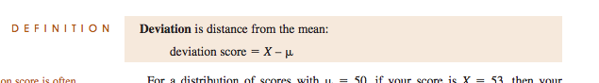
- More complex, than range but better measure of variability
- We need to know about variation if we want to compare two samples to see if they’re the same, both can have the same mean score but may have totally different patterns of distribution, and variability tells us about patterns in the data and about the spread of the scores around the general tendency
- Mean is μ
- Deviation: distance from the mean
- Each score (X) has a distance from the population mean (μ, the Greek letter pronounced “myu”)
- Deviation always adds to 0.
- We square them to get sum of squared deviations (sum of squares), then calculate the average of the deviations
- Calculate the average of deviations to get the variance and then take the square root of the variance to get the standard deviation.
- It’s standard because it gives us a measure of average distance from the mean
- We square the deviation to get rid of the “sign” then we calculate square root to get us back to normal

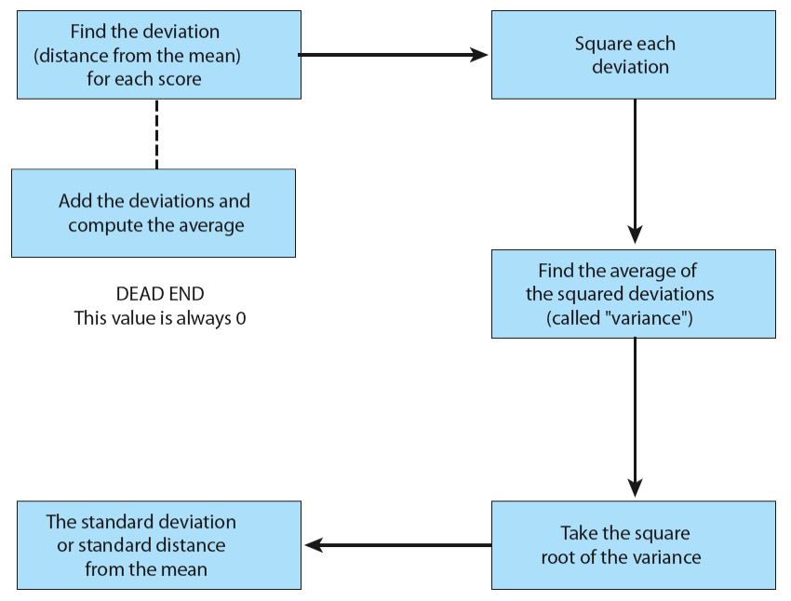

Developing the Standard Deviation

Step 1: Determine the deviation. Deviation is distance of an individual score from the mean

Step 2: if we calculate the mean of deviations…
Deviations sum to 0 because M is balance point of the distribution
The Mean Deviation will always equal 0;
Another method must be found to measure variability
Deviation score = X — μ
Step 3: Get rid of + and – in Deviations
Square each deviation score
Compute the mean Squared Deviation, known as the Variance
Variability is now measured in squared units
Variance is the average squared distance from the mean

Step 4: Goal: to compute a measure of the standard distance of the scores from the mean
Variance measures the average squared distance from the mean; not quite our goal
We compensate for having squared all the differences by taking the square root of the variance.

- Deviation has nothing to do with peculiar behavior… think of deviation is equal to dispersal

- The two formulas for SS give exactly the same result
Definitional Formula:
Find each deviation score (X–μ)
Square each deviation score, (X–μ)²
Sum up the squared deviations

Computational Formula
Square each score and sum the squared scores
Find the sum of scores, square it, divide by N
Subtract the second part from the first

A few extreme scores in a population make variability relatively large... but samples are not likely to choose these extreme values. Therefore: samples are “biased” and always underestimate the population variability.

Sample variance (s²)= SS/(n-1)
Population variance (σ²)= SS/(N)
Standard deviation for populations: √σ²
Standard deviation for samples: √s²

- We cant always measure a complete population (it’s expensive and sometimes impossible) so we have to take a sample and estimate the population characteristics
- If we sample every possible pair, we can estimate mean and standard deviation for the population

Variance and Inferential Statistics
- Goal of inferential statistics is to detect meaningful and significant patterns in research results
- Variability in the data influences how easy it is to see patterns
- High variability obscures patterns that would be visible in low variability samples
- Variability is sometime called “error variance” (but it has nothing to do with errors as mistakes)

Summary:
TO DESCRIBE A DATA SET WE NEED: CENTRAL TENDENCY (USUALLY THE MEAN ) AND VARIABILITY (MOST OFTEN STANDARD DEVIATION)
- Some measures are close to the mean, others far away – so these two measures tell us how variable the data set is around the central tendency. And they tell us how far away any individual score is from the average

How we use standard deviations:
  - About 70% of all scores are within one standard deviation of the mean
  - About 95% of all scores are within 2 standard deviations of the mean
  - We define “unusual” (significant) scores as being in the outside 5% of a distribution…
  - So the standard deviation of a score tells us how “significant” our findings are.

Standard Deviation Interpretation
- In a normal distribution, a fixed percentage of cases lie within certain distances from the mean

High Variability: A heterogeneous distribution
Low Variability: A homogenous distribution

Probability z-scores (standard scores)
- Exact location is described by z-score
- Sign tells whether score is located above or below the mean
- Number tells distance between score and mean in standard deviation units
- We “convert” to standard scores ( z scores) so we can make direct comparisons
- Important points about z scores
- The distribution remains exactly the same shape
- The mean is always 0
- The standard deviation is always 1
A z score is a relative value that allows us to directly compare two scores from different distributions
- The purpose of z-scores or standard scores is to identify and describe the exact location of each score in a distribution.
- Z-scores standardize an entire distribution
- Z score establishes its goal of describing the exact location of a score within its distribution by transforming each x value into a signed number.
- The z-score definition is adequate for transforming back and forth from X values to z-scores as long as the arithmetic is easy to do in your head. For more complicated values, it is best to have an equation to help structure the calculations. Fortunately, the relationship between X values and z scors is easily expressed in a formula. The formula for transforming scores into z scores is
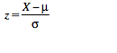
Probability:

- Informal probability
Hunches/guesses: the usual human approach
    - “There’s no way she’s ever going to go out with him”.
    - “The Leafs are going to win the Stanley Cup this year”.
- Formal probability
- Logical: randomly occurring events that can be defined precisely, e.g., chance of choosing the ace of spades from a deck of cards
- Historical/actuarial: randomly occurring events that can’t be defined precisely (logically), but can be estimated accurately after huge accumulations of data, e.g., population death rates, automobile accident rates
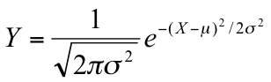 This formula is to know how likely or unlikely an observation is


