ECO 1102 – Macroeconomics

Lecture #1: Jan 12th & 14th

Ten Principles of economics
- People face tradeoffs
- The cost of something is what you give up to get it
- Rational people think at the margin
- People respond to incentives
- Trade can make everyone better off
- Markets are usually a good way to organize economic activity
- Governments can sometimes improve market outcomes
- A country’s standard of living depends on its ability to produce goods and services
- Prices rise when the government prints too much money
- Society faces a short-run tradeoff between inflation and unemployment

- When getting a job it is important to signal (ex. Dress nicely, done x amount of things, diploma)

The Economist as Scientist
- Economists play two roles:
1. Scientists: try to explain the world
2. Policy advisors: try to improve it
- In the first, economists employ the scientific method, the dispassionate development and testing of theories about how the world works.

The Economist as Policy Advisor

- As scientists, economists make positive statements, which attempt to describe the world as it is.
- As policy advisors, economists make normative statements, which attempt to prescribe how the world should be.
- Positive statements can be confirmed or refuted, normative statements cannot.
- The Govt of Canada, like other governments, relies on the advice of economists. Many government agencies and departments, including the Bank of Canada employ economists.
- Can’t care too much about equality

Positive vs. normative

- Which of these statements are “positive” and which are “normative”? How can you tell the difference?
- Prices rise when the government increases the quantity of money.
Positive – describes a relationship, could use data to confirm or refute
- The government should print less money.
Normative – this is a value judgment, cannot be confirmed or refuted
c. An increase in the price of burritos will cause an increase in consumer demand for video rentals. Positive – describes a relationship. Note that a statement need not be true to be positive

Why Economists Disagree

- Economists often give conflicting policy advice.
- They sometimes disagree about the validity of alternative positive theories about the world.
- They may have different values and, therefore, different normative views about what policy should try to accomplish.
- Yet, there are many propositions about which most economists agree.

Lecture #2: Chapter 4 Jan 19th

THE MARKET FORCES OF SUPPLY AND DEMAND

- Supply and demand are the two words that economists use most often.
- Supply and demand are the forces that make market economies work.
- They determine the quantity of each good produced and the price at which it is sold.
- If you want to know how any event or policy will affect the economy, you must think first about how it will affect supply and demand.

MARKETS AND COMPETITION
- The terms supply and demand refer to the behaviour of people as they interact with one another in competitive markets.
- Before discussing how buyers and sellers behave, let’s first consider more fully what we mean by a market and competition.

What Is a Market?
- Market: a group of buyers and sellers of a particular good or service
- Socialists only look at the supply. How much to produce.

What Is Competition?

- Competitive market: a market in which there are many buyers and many sellers so that each has a negligible impact on the market price

DEMAND

- We begin our study of markets by examining the behaviour of buyers.

The Demand Curve: The Relationship Between Price and Quantity Demanded

- Quantity demanded: the amount of a good that buyers are willing and able to purchase
- Law of demand: the claim that, other things equal, the quantity demanded of a good falls when the price of the good rises

The Demand Curve: The Relationship Between Price and Quantity Demanded

- Demand schedule: a table that shows the relationship between the price of a good and the quantity demanded
- Demand curve: a graph of the relationship between the price of a good and the quantity demanded

Market Demand versus Individual Demand

- Market demand: the sum of all the individual demands for a particular good or service

Shifts in the Demand Curve

**** EXAM Asks this diff b/w moving on curve and moving the whole curve. When you move price, you move ON the curve. If it’s icecream it’s the price of the icecream. Influence of the price – you move on the curve.

- Any change that rises the quantities that purchasers wish to purchase at a given price shifts the demand curve to the right and vice versa.

- Factors that shift the demand curve:

Income:
- Normal good: a good for which, other things equal, an increase in income leads to an increase in demand
- Inferior good: a good for which, other things equal, an increase in income leads to a decrease in demand

- Factors that shift the demand curve (continued):
  - Prices of related goods:

- Substitutes: two goods for which an increase in the price of one leads to an increase in the demand for the other

- Complements: two goods for which an increase in the price of one leads to a decrease in the demand for the other

- Factors that shift the demand curve (continued):
  - Tastes
  - Expectations
  - Number of buyers (add up more demands)

Think about all things you’re buying, you’ll use some savings, think that in future you’ll be richer so will buy more.

SUPPLY

- We now turn to the other side of the market and examine the behaviour of sellers.

The Supply Curve: The Relationship Between Price and Quantity Supplied

- Quantity supplied: the amount of a good that sellers are willing and able to sell
- Law of supply: the claim that, other things equal, the quantity supplied of a good rises when the price of the good rises
- Supply schedule: a table that shows the relationship between the price of a good and the quantity supplied
- Supply curve: a graph of the relationship between the price of a good and the quantity supplied

Market Supply versus Individual Supply

- Market supply: the sum of supplies of all sellers

Shifts in the Supply Curve
- Any change that rises the quantities that sellers wish to produce at a given price shifts the supply curve to the right and vice versa.
- Factors that shift the supply curve:
Input prices
- Technology
- Expectations
- Number of sellers (if higher, move right)
- Input prices higher – then move left

SUPPLY AND DEMAND TOGETHER

- Having analyzed supply and demand separately, we now combine them to see how they determine the price and quantity of a good sold in the market.

Equilibrium

- Equilibrium: a situation in which the price has reached the level where quantity supplied EQUALS quantity demanded
- Equilibrium price: the price that balances quantity supplied and quantity demanded
- Equilibrium quantity: the quantity supplied and the quantity demanded at the equilibrium price

- Surplus: quantity supplied is greater than quantity demanded

- If price higher, supply will produce more

- Shortage: quantity demanded is greater than quantity supplied
  - Qd higher than Qs
- Gov decides for you what the price will be, business doesn’t really decide.
  - Problem because
  - Q exchange on the market, b/w supplier and consumer
- Law of supply and demand: the claim that the price of any good adjusts to bring the quantity supplied and the quantity demanded for that good into balance

Three Steps to Analyzing Changes in Equilibrium

- Example: a change in market equilibrium due to a shift in demand
- Suppose that one summer the weather is very hot.
- How does this event affect the market for ice cream?
- To answer this question, let’s follow the three steps.

- Example: A change in market equilibrium due to a shift in supply
- Suppose that, during another summer, a hurricane destroys part of the sugar cane crop and drives up the price of sugar.
- How does this event affect the market for ice cream?
- Once again, to answer this question, we follow our three steps.

- Example: Shifts in both supply and demand
- Now suppose that the heat wave and the hurricane occur during the same summer.
- To analyze this combination of events, we again follow our three steps.

Lecture #4: Jan. 21st Chapter 5:

Measuring a Nation’s Inc

- Microeconomics: the study of how individuals and how firms make decisions and how they interact in markets

- Macroeconomics: the study of economy wide phenomena, including inflation, unemployment, and economic growth

- Gross domestic product (GDP): measures the total income of a nation; the most closely watched economic statistic because it is the best measure of a society’s economic well-being

THE ECONOMY’S INCOME AND EXPENDITURE

- For an economy as a whole, income must equal expenditure.

Circular Flow Diagram: Figure 5.1
- map of an economy
- markets for the factors of production
- If pay for goods here, you work
- Add 2 sides of equality it makes an equality
- Missing part is important for economy the taxes

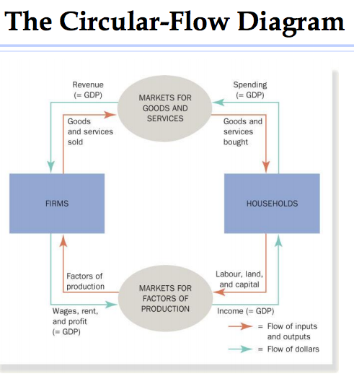

THE MEASUREMENT OF GROSS DOMESTIC PRODUCT
- GDP: the market value of all final goods and services produced within a country in a given period of time
  - Measure of econ well-being
  - UNDP – calc this measure in developing countries

“GDP Is the Market Value . . .”
- GDP adds together many different kinds of products into a single measure of the value of economic activity
- Prices we rely on

“ . . . Of All . . .”

- It includes all items produced in the economy and sold legally in markets.
  - Problem: Is everything we produce in economy active on transaction on the market? Recorded to government
  - Some things aren’t recorded, not taxed
  - Illegal activities. Selling what not supposed to sell.
- GDP also includes the market value of the housing services provided by the economy’s stock of housing.
  - Housing services, exception. When sell a house, owner most cases lives in the house. Sometimes pay rent – it’s a service and part of economic. Must be registered
  - Rent estimated by government
- There are some products, however, that GDP excludes because measuring them is so difficult.

“ . . . Final . . .”

- GDP includes only the value of final goods.
  - Period considered – if intermediate goods aren’t sold the producer can’t sell oranges to tropicana, inventory are registered as econ. Activity but as inventory investments, not registered.
  - Next period taken out of investments (-) so it will be zero
- The reason is that the value of intermediate goods is already included in the prices of the final goods.
- An important exception to this principle arises when an intermediate good is produced and is added to a firm’s inventory of goods to be used or sold at a later date.

“ . . . Goods and Services . . .”

- GDP includes both tangible goods (food, clothing, cars) and intangible services (haircuts, housecleaning, dentist visits).

“ . . . Produced . . .”
- GDP includes goods and services currently produced.
- used car, don’t want to double register

“ . . . Within a Country . . .”
- GDP measures the value of production
within the geographic confines of a
country.
- ex. Territory of CAN

“ . . . In a Given Period of Time”
- GDP measures the value of production that takes place within a specific interval of time.
  - Only once a year, often not enough
- Usually that interval is a year or a quarter.
- GDP measures the economy’s flow of income and expenditure during that interval.

THE COMPONENTS OF GDP

Y = C + I + G + NX

- Y : GDP
- C : Consumption
- I : Investment
- G : Government purchases
- NX: Net exports

Consumption:
- spending by households in goods and services, with the exception of purchases of new housing
Investment:
- spending in capital-equipment, inventories, and structures, including household spending on new housing
Government purchases:
- spending in goods and services by local, territorial, provincial, and federal governments
- macro splits in two: ppl believe more in markets – get economic activity right but time to time have to intervene.
- Founder of econ. Kaines idea of gov. purchases
Net exports:
- the value of a nation’s exports minus the value of its imports; also called the trade balance
- Exports - Imports

FYI: Other Measures of Income
• Gross national product
• Net national product
• National income
• Personal income
• Disposable personal income

***Q like this on Midterm***
In each of the following cases, determine how much GDP and each of its components is affected (if at all)

A) Debbie spends $200 to buy her husband dinner at the finest restaurant in Toronto.
Consumption and GDP rise by $200.

B. Sarah spends $1800 on a new laptop to use in her publishing business. The laptop was built in China. Investment rises by $1800, net exports fall by $1800, GDP is unchanged.(built in diff. territory)

C. Jane spends $1200 on a computer to use in her editing business. She got last year’s model on sale for a great price from a local manufacturer. Current GDP and investment do not change because the computer was built last year. ( Older things done years ago)

D. General Motors builds $500 million worth of cars, but consumers only buy $470 million of them. Consumption rises by $470 million, inventory investment rises by $30 million, and GDP rises by $500 million. ( consumption rises cuz this is all that was bought by consumers, registered as inventory investments, subtract 30mill form investment)

CASE STUDIES:

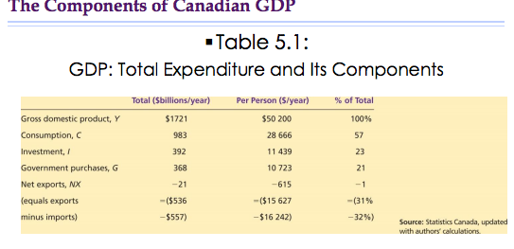
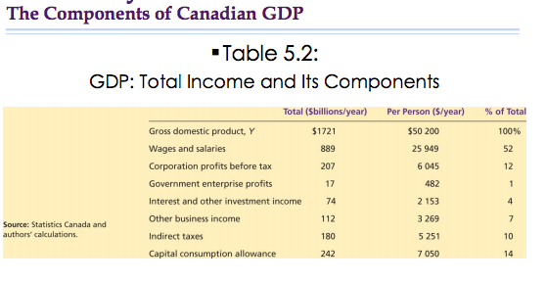
REAL VERSUS NOMINAL GDP
- If total spending rises from one year to the next, one of two things must be true:
1. The economy is producing a larger output of goods and services.
2. Goods and services are being sold at higher prices.
- When studying changes in the economy over time, economists want to separate these two effects.

A Numerical Example
♣Table 5.3 shows some data for an economy that produces only two goods: ♣Hot dogs ♣Hamburgers ♣The table shows the quantities of the two goods produced and their prices in the years 2010, 2011, and 2012.

The GDP Deflator
♣GDP deflator: a measure of the price level calculated as the ratio of nominal GDP to real GDP times 100
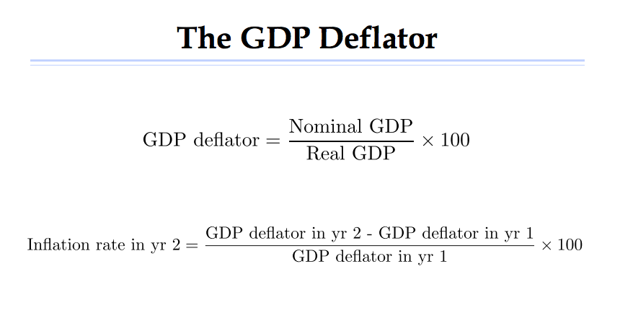

GDP AND ECONOMIC WELL-BEING
“GDP does not allow for the health of our children, the quality of their education, or the joy of their play. It does not include the beauty of our poetry or the strength of our marriages; the intelligence of our public debate or the integrity of our public officials. It measures neither our wit nor our courage; neither our wisdom nor our learning; neither our compassion nor our devotion to our country; it measures everything, in short, except that which makes life worthwhile. And it tells us everything about America except why we are proud that we are Americans.” Robert Kennedy (1968)

Lecture #6: Jan 28th

Chapter 6: Measuring The Cost Of Living

▪The consumer price index is used to monitor changes in the cost of living over time.
▪When the consumer price index rises, the typical family has to spend more dollars to maintain the same standard of living.

MEASURING THE COST OF LIVING

▪Economists use the term inflation to describe a situation in which the economy’s overall price level is rising.
▪The inflation rate is the percentage change in the price level from the previous period.

THE CONSUMER PRICE INDEX

♣The consumer price index (CPI): the overall measure of the cost of the goods and services bought by a typical consumer

How the Consumer Price Index Is Calculated

▪Every month, Statistics Canada computes and reports the CPI.
▪It uses data on the prices of more than 600 different goods and services.
▪To see how these statistics are constructed, a simple economy with two goods, hot dogs and hamburgers, is used.

How the Consumer Price Index Is Calculated

Five steps to compute the inflation rate:
1. Determine the basket.
2. Find the prices.
3. Compute the basket’s cost.
4. Choose a base year and compute the index.
5. Compute the inflation rate.
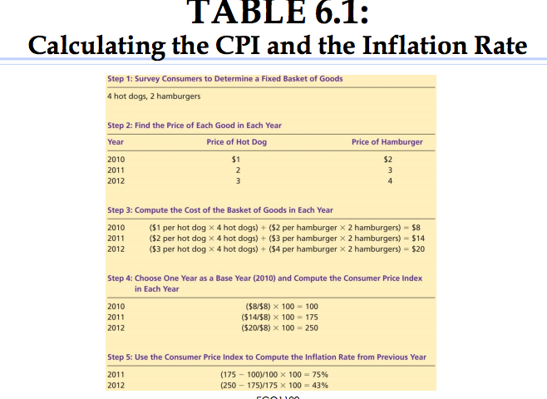

How the Consumer Price Index Is Calculated

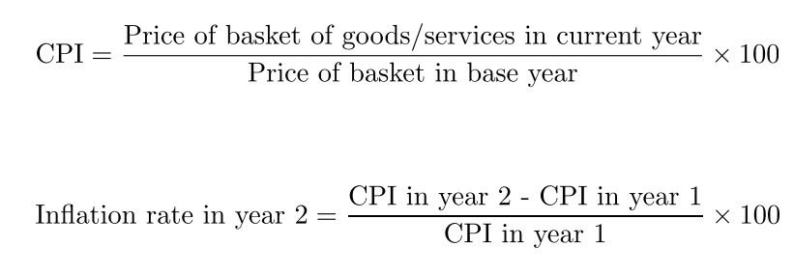

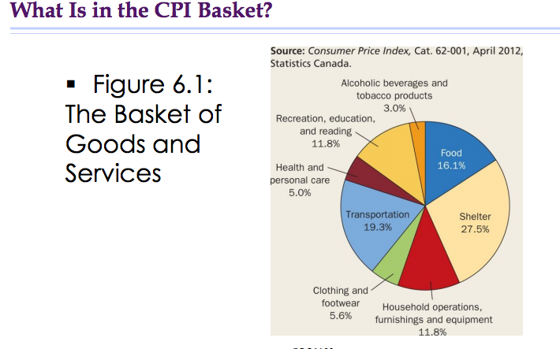

Problems in Measuring the Cost of Living

- Commodity substitution bias
- Introduction of new goods
- Unmeasured quality change
Taken together, these sources of bias cause the
CPI to overstate the cost of living by 0.6 percentage points a year according to the Bank of Canada.

The GDP Deflator versus the Consumer Price Index

♣ The GDP deflator reflects the current level of prices relative to the level of prices in the base year.
♣ Economists and policy makers monitor both the CPI and the GDP deflator to gauge how quickly prices are rising.
♣ Two differences:
♣ The GDP deflator reflects prices of goods and services produced domestically.
♣ The GDP deflator compares the price of currently produced goods and services with the price of the same goods and services produced during the base year.

Figure 6.2: Two measures of Inflation
- Yellow = GDP
- Blue = CPI
- Move together
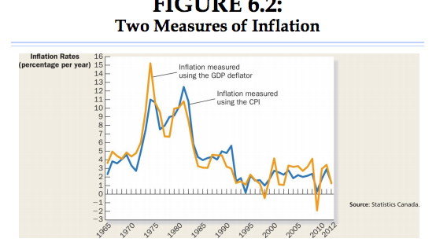

- Are the prices lower or higher in recession?’

CORRECTING ECONOMIC VARIABLES FOR THE EFFECTS OF INFLATION

- The purpose of measuring the overall level of prices in the economy is to permit comparison between dollar figures from different points in time.

Dollar Figures from Different Times

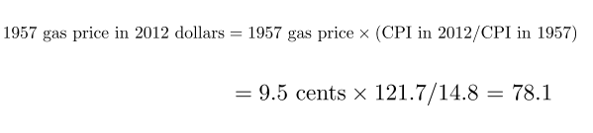

Indexation

- Indexation: the automatic correction of a dollar amount for the effects of inflation by law or contract
  - COLA: A COLA automatically raises the wage when the CPI raises.

Real and Nominal Interest Rates

- Interest rates involve comparing amounts of money at different points in time.
- To fully understand interest rates, knowing how to correct for the effects of inflation is important.

Real and Nominal Interest Rates

- ▪Suppose that you make a deposit of $1000 in a bank account that pays interest at a rate of 10 percent per year.
- After one year, that bank account now contains $1100 (= Principal of $1000 + Interest of $100).
- Are you actually wealthier after one year? Depends on how the prices move throughout the year. There is inflation.
  - Can make the price of product you bought before more expensive or cheaper. So the dollar in your account wont be worth the same as it was before.

Real and Nominal Interest Rates

- Nominal interest rate: the interest rate that is usually reported without a correction for the effects of inflation
- Real interest rate: the interest rate that is corrected for the effects of inflation

Real interest rate = Nominal interest rate – inflation

Case Study

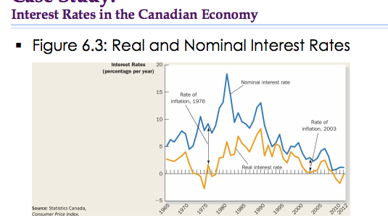

Chapter 7: Production and Growth

Calculation:

Y(1+r) r=0.05 (growth rate)
Y(1+r)(1+r) = Y(1+r)^2
Y(1+r)^20

- small variation of growth rate will be a huge part
- get amount it will take to double your initial amount

How do we explain the differences?

Productivity: its Role and Determinants

- Explaining the large variation in living standards around the world is, in one sense, very easy
- As we will see, the explanation

Why Productivity Is So Important?

- Productivity: The quantity of goods and services produced from each hour of a worker’s time

How Productivity Is Determined

- Physical capital per worker
- Human capital per worker
- Natural resources
- Technological knowledge

- Calculation: A.f(C/L)/H/N

- Physical capital: the stock of equipment and structures that are used to produce goods and services
  - Machines built, producing other goods

- Human capital: the knowledge and skills that workers acquire through education, training, and experience
  - Accumulate more and more machines that help us produce more.
  - Supposed to invest in order to get better

- Natural resources: the inputs into the production of goods and services that are produced by nature, such as land, rivers, and mineral deposits

- Technological knowledge: society’s understanding of the best ways to produce goods and services
  - Some kind of common knowledge we have as a society for being more productive

Economic Growth and Public Policy

▪ The importance of saving and investment
▪ Diminishing returns and the catch-up effect
▪ Investment from abroad
▪ Education
▪ Health and nutrition
▪ Property rights and political stability
▪ Free trade
▪ Research and development
▪ Population growth

The Importance of Saving and Investment

- You can consume or save it. (You should invest what you save because you will be accumulating more capital, in turn you will produce more in the future) It is a trade off.

- Because resources are scarce, devoting more resources to producing capital requires devoting fewer resources to producing goods and services for current consumption.

- Consequently, the accumulation of capital involves a tradeoff.

- When governments encourage saving and investment, they also encourage growth and in the long run this raises the standard of living.

Diminishing Returns and the Catch-up Effect

- Successful government policies that raise the saving rate mean that fewer resources are needed to make consumption goods and more resources are now available to make capital goods.

- Growth rate high in dvm and low in underdvm

- Idea is to accumulate the capital

- The capital stock increases, which raises productivity and thus leading to a higher rate of growth of GDP.

- However, the benefits from additional capital become smaller over time, so growth slows down. In the long run, the higher saving rate leads to a higher level of productivity and income but not too higher growth in these variables.

- This phenomena is known as diminishing returns.

- Diminishing returns: the benefit from an extra unit of an input declines as the quantity of the input increases

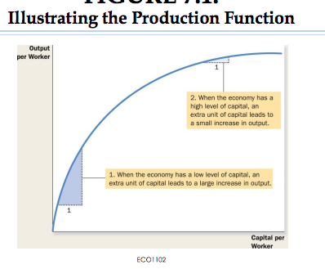
- When the economy has a low level of capital, an extra unit of capital leads to a large increase in output
- When the economy has a high level of capital, an extra unit of capital leads to a small increase in output.

Produce more, but at a different pace. You are still growing.

Diminishing Returns and the Catch-up Effect

- The diminishing returns to capital has another important implication:

- Other things equal, it is easier for a country to grow if it starts out relatively poor.

- Catch-up effect: Countries that start off poor tend to grow more rapidly than countries that start off rich.
Ex. South Korea

We need more elements in our explanation
- beginning of the 90s –

Investment from Abroad

Investment from foreigners is another way for a country to acquire new capital.

- Foreign direct investment: a capital investment that is owned and operated by a foreign entity

- Foreign indirect investment: an investment that is financed with foreign money operated by domestic residents
  - Foreign money going into company. Ex – buying shares in company in japan, but you aren’t big enough to operate or make decisions. You’re just investing.

- Foreign portfolio investment: an investment that is financed with foreign money but operated by domestic residents

- Investment from abroad does not have the same effect on all measures of economic activity.

- Foreign investment in Canada raises the income of Canadians (this is captured in GNP) by less than it raises production in Canada (this is captured by GDP).

- GDP increases because the investment increases Canada’s capital stock.

- GNP increases by less because the profits generated from the foreign investment return to the country of the investors.

- Investment from abroad can help a country grow.

- The World Bank tries to encourage the flow of capital to poor countries.

- Economic distress often leads to political turmoil, international tensions, and military conflict.

- The World Bank and the International Monetary Fund were created after World War II to promote economic prosperity around the world.

  - Fight against poverty,
  - Institution has changed over time
  - Linked to international financial system
  - After 2nd WW – change in int financial system – at the time economists had no choice but to base it all on the US dollar. To have $ that works at an international level, you must have an system you can trust.

Education

An individual and societal effect

- Investment in human capital (education) is at least as important as investment in physical capital for long-run economic success.
- It is well known that more education leads to higher wages and salaries.
- One way government policy can improve the standard of living is to provide good schools.

- Human capital is also important for economic growth because it conveys positive externalities.
- Externalities: the effect of one person’s actions on the well-being of a bystander
- For example, an educated person might generate a new idea that enters society’s pool of knowledge and therefore society can benefit from it.

- Education is a positive externality, so it has to be paid for

- Some poor countries face a brain drain.
- Brain drain: the immigration of many of the most highly educated workers to rich countries, where they can enjoy a higher standard of living

Health and Nutrition

- Other things equal, healthier workers are more productive.
- The causal link between health and wealth runs in both directions.
- Poor countries are poor in part because the populations are not healthy.
- Their populations are not healthy in part because they are poor.
- It is a vicious cycle.

- This fact opens the possibility of a virtuous cycle, however.
- Policies that lead to more rapid economic growth would naturally improve health outcomes.
- In turn, this would further promote economic growth.

Property Rights and Political Stability

- In a free-market economy, it is the invisible hand that brings supply and demand into balance in the many thousands of markets.

- For the price system to work, property rights must be respected.

- Property rights: the ability of people to exercise authority over the resources they own

- Institutions are the rules of the economic game – if what you produce isn’t yours, then you have no more incentive to produce it.

- Political instability is a threat to property rights.

- When revolutions are common, there is a doubt that property rights will be respected in the future.

- There is less incentive to save by nationals, and foreigners have less incentive to invest.

- Countries with an efficient court system, honest government officials, and a stable constitution will typically enjoy a higher standard of living.

Free Trade

- Most economists today will say that a poor country is better off pursuing outward-oriented (as opposed to inward-oriented) policies that integrate these countries into the world economy.

- Countries that eliminate trade restrictions often experienced the same kind of economic growth that would occur after a major technological advance.

- Trade volume is not only determined by government policy but also by geography.

- Trade has exploded in the world today

Research and Development

- One of the major reasons why living standards are so much higher today than they were a century ago is because state-of-the-art technological knowledge has progressed so much.
- Even if most R&D is conducted in the private sector, there is a public interest in promoting such efforts.
- Knowledge is a public good.
  - Ex. Class of 10 or 200 prof will still teach
- Governments have a vested interest in promoting R&D.

Over the years the Canadian government has:
- Funded research in CANDU nuclear reactors
- Offered research grants from the National Sciences and Engineering Research Council of Canada and the Social Sciences and Humanities Research Council of Canada.
- Offered tax breaks to firms that engage in R&D.
- Managed the patent system

Population Growth

- A large population means a larger total output of goods and services.
- However, it need not mean a higher standard of living for a typical citizen.
- Beyond these obvious effects of population size, population growth interacts with the other factors of production in ways that are more subtle and open to debate.

- Stretching natural resources
- A large population means a larger workforce. (if base only on natural resources)
- A large population means more consumers.
- Therefore, a large population need not mean a higher standard of living.

- Thomas Robert Malthus (1766 –1834) argued that an ever-increasing population would continually strain society’s ability to provide for itself.
- Mankind was doomed to forever live in poverty.
  - Growth rate higher than production at some point, so you go back to poverty and get poorer and poorer

- Diluting capital stock
- According to this theory, high population growth reduces GDP per worker because rapid growth in the number of workers forces the capital stock to be spread more thinly.
- A smaller quantity of capital per worker leads to lower productivity and lower GDP per worker.
  - At certain point was wrong because
  - Given fact able to share a little bit more, technology and knowledge, for moment we should not have problems here.

- Some analysts believe that reducing the rate of population growth would help poor countries raise their standards of living:
- By regulating the number of children (e.g., China)
- By policies that foster equal treatment of women
  - Families decide to have less children

- Promoting technological progress
- Some economists believe that population growth has been an engine of technological progress and economic prosperity.
- More people means more scientists, more inventors, and more engineers.

Chapter 8: Saving, Investment, and The Financial System

- Financial system: the group of institutions in the economy that help to match one person’s savings with another person’s investment
- This chapter examines how the financial system works.

Financial Institutions in The Canadian Economy

Financial institutions can be grouped into two categories:
- Financial markets
- Financial intermediaries

Financial Markets

- Financial markets: financial institutions through which savers can directly provide funds to borrowers
  - Exchange $ directly, its more simple

Financial Markets: The Bond Market

- Bond: a certificate of indebtedness that specifies the obligation of the borrower to the holder of the bond (I owe you paper)
  - Debt finance: the sale of a bond to raise money
- Pg 169 – small terms

Characteristics:
- the bond’s term
- the bond’s credit risk
  - Trust gov bond more than a private enterprise, they always have an alternative of payment. Authority of taxing citizens.
  - Private enterprise: risk may be higher ex. Apple in 5 yrs?

Financial Markets: The Stock Market

- Stock: represents ownership in a firm and is, therefore, a claim to its profits
  - Partly owner of enterprise, claim part of the profit
  - Might sell bond you promise to give back or sell part of you company
    - 1st step = initial public offering (I want to buy stock, ex. Fb price of a share)
    - 2nd step = Sell this at price you establish, ppl buy in first place can go in the market and sell stock at other price.
    - As people who acquire first place start to sell, the price starts to drop.

- Equity finance: the sale of a stock to raise money

- The prices at which shares trade on stock exchanges are determined by the supply and demand for the stock

- 2010 financial crisis – housing crisis, put mortgages together

  - bought and sold w/out knowing what’s inside of them

Stock index: is an average of a group of stock prices
(Image of how the market is doing)
- Dow Jones Industrial Average
- S&P/TSX Composite Index

- Because stock prices reflect expected profitability, stock indexes are watched closely as possible indicators of future economic conditions.

Financial Intermediaries

- Financial intermediaries: financial institutions through which savers can indirectly provide funds to borrowers

- Bank: The primary function of a bank is to take deposits from savers and use these deposits to make loans to people who want to borrow.

  - Yes taking money, so have to choose the good projects. Ppl who want to borrow, ppl who will pay back

- Mutual funds: an institution that sells shares to the public and uses the proceeds to buy a portfolio of stocks and bonds (access to them, must be rich. I know better markets than you and me, give me your money, and ill assure you a nice return rate)

  - Allow diversification
  - Access to the skills of professional money managers

Saving And Investment In The National Accounts
‘
- Accounting: refers to how various numbers are defined and added up

- The national income accounts include, in particular, GDP and many related statistics.

Some Important Identities

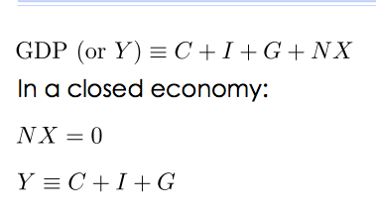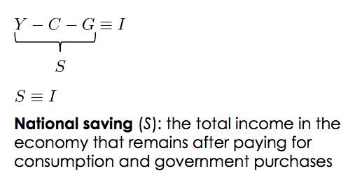

income-consumption-gov purchases = investment

- remember that this part of equality has a nice respresentato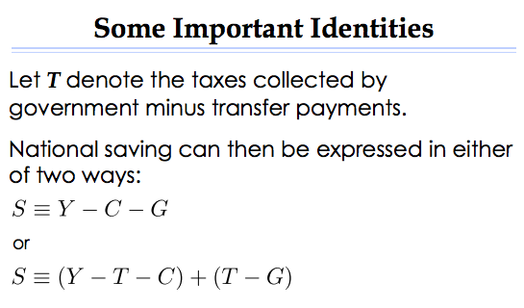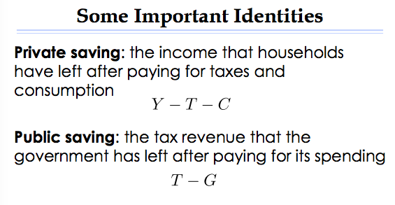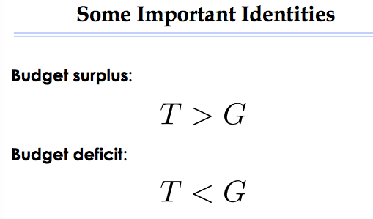

The Market For Loanable Funds

-Market for loanable funds: the market in which those who want to save supply funds and those who want to borrow to invest demand funds

Supply And Demand For Loanable Funds

- Saving is the source of supply for loanable funds.
- Investment is the source of demand for loanable funds.
- The interest rate is the price of a loan.

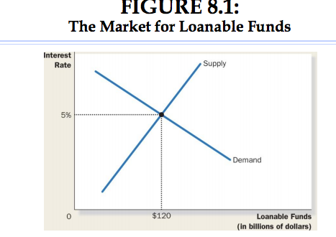

Policy I: Saving Incentives

- A higher saving rate could lead to a higher rate of growth of GDP.
- People respond to incentives:
- Consumption taxes like the GST
- RRSPs
- TFSA
- RESP
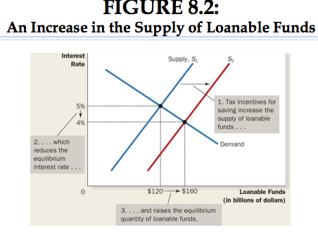

Policy2: Investment Incentives

- An investment tax credit gives a tax advantage to any firm building a new
factory or buying a new piece of equipment.
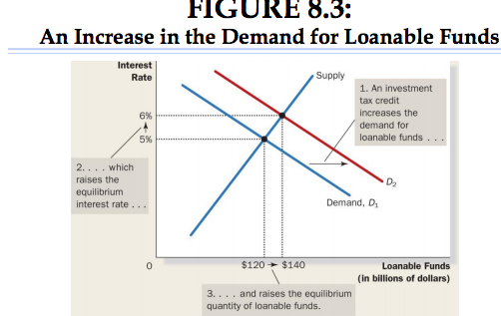

Policy 3: Government Budget Deficits and Surpluses

- Government debt: the sum of past budget deficits and surpluses
- Normal for gov. to have deficit once in a while, problem is having it period after period
  - Supply of money – eating up money
- Proposed to sell islands – many ppl were outraged
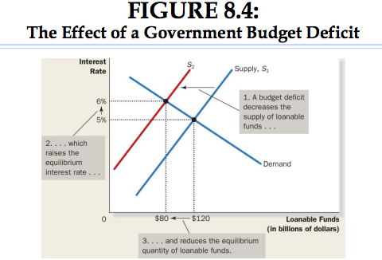
- Crowding out: a decrease in investment that results from government borrowing
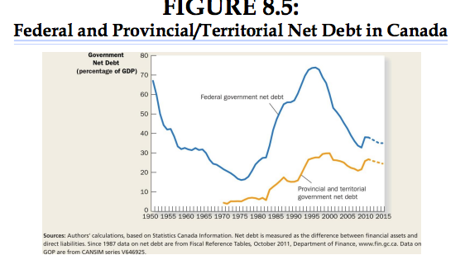

First Assignment:

- argument of 2 page essay
  - Convince that argument is right.
  - Do well on intro to get readers attention
  - Thesis center idea of argument
  - Body – ideas explaining main problem
  - MUST answer the question – don’t change & focus on that
  - Graphs? Good at writing then you don’t need graphs

Midterms:
- 75% mchoice – 25% short answers

Chapter 9 – Unemployment and Its Natural Rate

- The problem of unemployment is usually divided into two categories:
  - The long-run problem
  - The short-run problem
- Natural rate is the trend
- The economy’s natural rate of unemployment refers to the amount of unemployment the economy normally experiences
- Cyclical unemployment refers to the year

Identifying unemployment

- How is unemployment measured?
- What problems arise in interpreting the unemployment data?
- How long does the typical spell of unemployment lasts?
- Why will there always be unemployed people?

How is Unemployment Measured?

- Every month, Statistics Canada (SC) conducts the Labour Force Survey (LFS).
- Data are collected on:
  - Unemployment
  - Employment
  - Length of workweek
  - Duration of unemployment
- From the results of the survey, each adult (aged 15 and older) from the survey is either:
- employed (spent some time in the previous week working at a paid job)
- ▪unemployed (on temporary layoff or is looking for work)
- not in the labour force (none of the above, e.g., full-time student, a retiree, homemaker)

Figure 9.1 – breakdown of population in 2011
- are we supposed to be critical about this number? Big problem b/w unemployed and not in the labour force

- Once the surveyed individuals are categorized, then SC will compute various statistics.
- Labour force: the total number of workers, including both the employed and the unemployed
- LF= No. of employed + No. of unemployed

- Unemployment rate: the percentage of the labour force that is unemployed
- U= No. of unemployed/LF x 100
How this changes due to ppl who stop looking for a job. EXAM Q possibly

- Labour force participation rate: he percentage of the adult population that is in the labour force
- LFPR = LF/ Adult population x 100

Does the Unemployment Rate Measure What We Want It To?

- Movements into and out of the labour force are common and complicate the measurement of the amount of unemployment.
- Because people move into and out of the labour force often, statistics on unemployment can be difficult to interpret.
  - Unemployed people who are not trying hard to find a job.
  - People calling themselves unemployed in order to receive unemployment insurance.
  - People who are officially unemployed but are working “under the table.”

- Discouraged searchers: individuals who would like to work but have given up looking for a job

How Long Are the Unemployed without Work?

- In 2011, the average spell of unemployment lasted 18.8 weeks.
- From Table 9.2
  - One-third of those suffering through a spell of unemployment are unemployed for a month or less.
  - Three-fifths are unemployed for less than three months.
- Policy solutions directed toward fixing the unemployment problem should be directed at those suffering prolonged spells of unemployment

Why Are There Always Some People Unemployed?

- There are always workers without jobs, even when the overall economy is doing well.
- Natural unemployment rate: the rate of unemployment to which the economy tends to return in the long run
- The natural rate of unemployment in Canada is between 6 percent and 8 percent.

- Figure 9.4 shows that the observed unemployment rate fluctuates around the natural rate.
- Cyclical unemployment: the deviation of unemployment from its natural rate
- There are four ways to explain unemployment in the long-run:
  - Frictional unemployment: unemployment that results because it takes time for workers to search for jobs the best suit their tastes and skills
- Structural unemployment: unemployment that results because the number of jobs available in some labour markets is insufficient to provide a job for everyone who wants one
- This often occurs when wages are set above the level that brings supply and demand into equilibrium.
  - Wage laws
  - Unions
  - Efficiency wages

Job Search

- Job search: the process by which workers find appropriate jobs given their tastes and skills

Why Some Frictional Unemployment Is Inevitable

- Frictional unemployment is often the result of changes in the demand for labour by firms.
- Frictional unemployment is inevitable simply because the economy is always changing.
- The process where jobs are created in one industry but destroyed in another leads to higher productivity and higher living standards.
- The mismatch between available jobs and people seeking employment explains why one in every eight unemployed worker is without a job.

Public Policy and Job Search

- Government programs try to facilitate the job search in various ways:
  - Government-run employment agencies
  - Public training programs

- Employment Insurance (ER): a government program that partially protects workers’ incomes when they become unemployed

- EI may reduce the hardship of unemployment, but the design of the program influences workers’ behaviour in ways that will increase the unemployment rate.

- We respond to incentives, looking harder for a job

Minimum-Wage Laws

- Let’s now examine how structural unemployment results when the number of jobs is insufficient for the number of workers.
- Let’s first examine how minimum-wage laws effect unemployment.
- Although minimum-wage laws may not be the most important explanation for structural unemployment, it is nevertheless an important point.
- Ex. Switzerland - just got min wage. Voted against, reporters in Germany went to see restaurants & how affects economy

UNIONS AND COLLECTIVE BARGAINING

- Union: a worker association that bargains with employers over wages and working conditions
  - As of 2011, 30 percent of all employed workers in Canada belong to unions.

The Economics of Unions

- Collective bargaining: the process by which unions and firms agree on the terms of employment
- Strike: the organized withdrawal of labour from a firm by a union

Chapter 10: The Monetary System

- Bank of CAN Act
  - So independent
- To this end, the BoC has four main functions:
  - 1. Issue currency
  - 2. Banker to the commercial banks
  - 3. Banker to the Canadian government
  - 4. Control the money supply
- gov, abusing in dvm world

- Monetary Policy: the setting of the money supply by policy makers in the central bank
  - Bank of Canada has the power to increase or decrease the number of dollars in the economy.
    - important institution because changes in the money supply can profoundly affect the economy.

100 Percent-Reverse Banking
- assets and liabilities
- Reserves: deposits that banks have received but have not loaned out

Money Creation with Fractional-Reserve Banking
- Fractional-reserve banking: a banking system in which banks hold only a fraction of deposits as reserves
- Reserve ratio: the fraction of deposits that banks hold as reserves

Money Multiplier:
- Money multiplier: the amount of money the banking system generates with each dollar it receives
  - The money multiplier is the reciprocal of the reserve ratio.
    - 1/R
1st National Bank:
2nd National Bank
3rd National Bamk
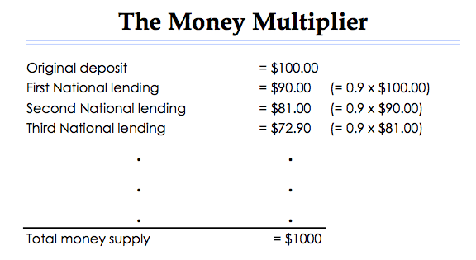

Bank Capital, Leverage, and Financial Crisis of 2007-09

- Bank capital: the resources the bank owners put into an institution from issuing equity (e.g., stock)
- Leverage: the use of borrowed money to supplement existing funds for purposes of investment
- Leverage ratio: the ratio of assets to bank capital
- Capital requirement: a government regulation specifying a minimum amount of bank capital
- Problem with liabilities

The Bank of CAN’s Tools of Monetary Control

3 main tools:

1. Open-market operations
2. Changes in reserve requirements
3. Changes in the overnight rate

- The BoC uses changes in the overnight rate to
control the money supply

Changing the Overnight Rate

- Bank rate: the interest rate charged by the Bank of Canada on loans to the commercial banks
- Overnight rate: the interest rate on very shortterm loans between commercial banks

The BoC’s Tools of Monetary Control:

Chapter 11:

Figure 11.1
- prices increasing, move money demand down
- monetary system, why so bad to play around for

Chapter 12: Open-Economy Macroeconomics: Basic Concepts

- ♣One of the ten principles of economics highlighted in Chapter 1 is that trade can make everyone better off.
- Closed economy: an economy that does not interact with other economies in the world
- Open economy: an economy that interacts freely with other economies around the world

International Flow of G and C

- ♣Exports: goods and services that are produced domestically and sold abroad
- Imports: goods and services that are produced abroad and sold domestically
- Net exports (or trade balance): the value of a nation’s exports minus the value of its imports
- Trade surplus: an excess of exports over imports
- Trade deficit: an excess of imports over exports
- Balanced trade: a situation in which exports equal imports

Flow of Financial Resources: Net Capital Outflow

- Net capital outflow: the purchase of foreign assets by domestic residents minus the purchase of domestic assets by foreigners
- Some of the variables that influence net capital outflow (NCO):
  - Real interest rates being paid on foreign assets
  - Real interest rates being paid on domestic assets
  - Perceived economic and political risks of holding assets abroad (if risk lower, than more of an incentive)
  - Government policies that affect foreign ownership of domestic assets

The Equality of Net Exports & Net Capital Outflow
- Net exports measure an imbalance between a country’s exports and its imports.
- Net capital outflow measures an imbalance between the amount of foreign assets bought by domestic residents and the amount of domestic assets bought by foreigners.

- That is, net capital outflow (NCO) always equals net exports (NX):
  - NCO = NX
- EX. Selling to Japan. Positive. Look @ currency as an asset
- If positive then equality already there
- EX. US country from other region want to buy on the harbor. How can you, its our nation? Problem is if import oil, at certain point you must give something back.

- When NX > 0, the country is selling more goods and services to foreigners than it is buying from them.
- What is it doing with the foreign currency it receives from the net sale of goods and services abroad?
- It must be using it to buy foreign assets.
- Capital is flowing out of the country (i.e., NCO > 0).
- When NX < 0, the country is buying more goods and services from foreigners than it is selling to them.
- How is it financing the net purchase of these goods and services in world markets?
- It must be selling assets abroad.
- Capital is flowing into the country (i.e., NCO < 0).

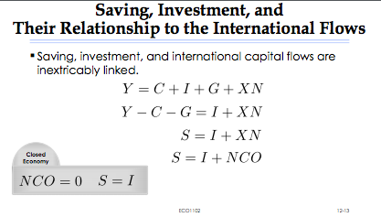
Int. Monetary fund try to say this NCO and push

Prices for International Transactions: Real & Nominal Exchange Rates

- 2 important int. prices

Nominal Exchange rates

What is my reference currency? (your countries currency)
- Nominal exchange rate: the rate at which a person can trade the currency of one country for the currency of another
- Appreciation: an increase in the value of a currency as measured by the amount of foreign currency it can buy
- Depreciation: a decrease in the value of a currency as measured by the amount of foreign currency it can buy (ex. Buying less euros)
  - Free market system behind it, as result of a market system. Some kind of Gov. imposes exchange rate

Import EX:
- 1 CAD = 0.5 Euro
- Paris: 1 coffee = 2 euro
- 1 coffee = 4 CAD
Export EX:
- Qc. 1 maple syrup = 8 CAD
- 1 maple syrup = 4 Euro
1 CAD = 1 Eruo
- 1 coffee = 2 CAD (if regularly 2 euros)
- CAN stronger, so CAN $ is depreciating
- Depreciation of exports is not good, lose $
1 CAD = 0.25 Euro
- Depreciating
- 1 coffee = 8 CAD (regularly 2 euros)
- 1 maple = 16 CAD (regularly 4 euros)

Real Exchange Rates
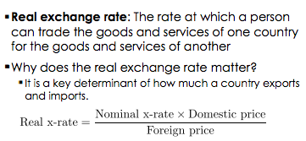
1
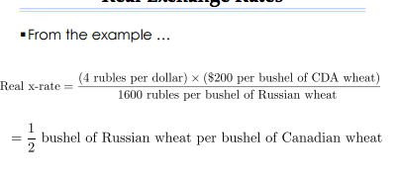
- Real x – rate = e x P / P*
- Purchasing-power parity (PPP): a theory of exchange rates whereby a unit of any given currency should be able to buy the same quantity of goods in all countries
- Small open economy: an economy that trades goods and services with other economies and, by itself, has a negligible effect on world prices and interest rates
- ♣ Perfect capital mobility: full access to world financial markets

Chapter 13 – 10 pages A Macroeconomic Theory of the Small Open Economy
- 2nd assignment ques: not the case considering in the textbook
  - loanable funds – equilibrium

Chapter 14 – Aggregate Demand And Aggregate Supply

- short term
- economic activity flucates from year to year
- Recession: a period of falling incomes and rising unemployment
- Depression: a severe recession
- The variables that we study in this chapter are largely those we have studied in other chapts
  - GDP – unemployment – interest rates – exchange rates – prices
- The model of aggregate demand and supply is often used by economists to analyze short-run fluctuations in the economy
- Know how to react/fight in a crisis
Three facts about economic fluctuations:

- Fact 1: economic fluctuations are irregular and unpredictable
  - Business cycles
- Fact 2: Most macroeconomic quantities (variables) fluctuate together
  - One is unemployment
- Fact 3: As output falls, unemployment rises

- Figure 14.1 - Look at Short-Run Economic Fluctuations

  - Investment always dropping

EXPLAINING SHORT-RUN FLUCTUATIONS
- describing patterns that economist

ASSUMPTIONS OF CLASSICAL ECONOMIES
- classical view – “money is a veil”
- What is important is the real variables and economic forces that determine them
Reality of short-run fluc.
- Need new model to understand

THE MODEL

- Model of aggregate demand and aggregate supply: most use to explain short run fluc. In economic activity around its long-run trend
- Aggregate-demand curve: curve that shows quality of goods and services that households, firms, and gov want to buy at each price level
- Aggregate- supply curve: shows quality of goods and services that firms choose to produce and sell at each price level
- Figure 14.2 –

WHY AGGREGATE D-CUURVE SLOPES DOWNWARD

- Y=C+I+G+NX
- Price level and consumption: The Wealth Effect
- Price level and investment: The Interest Rate Effect
- Price level and net exports: The Real Exchange Rate Effect
  - Real exchange rate = (e x P)/P*
  - If lower than it’s a depreciation
    - Exports will be higher, more rewarding so increases

WHY AGGREGATE- DCURVE MIGHT SHIFT
Changes in:
- Consumption
- Investment
- Government purchases
  - move D to right
  - equil. Output and prices would be higher
- Net exports

- financial system par of macroecon; crisis about housing market
  - prices fall

Short-Run aggregate-supply Curve

- Why Ag.-Supply Curve Slopes Upward in the Short-Run

- Sticky Wage Theory
- Sticky Price Theory
  - Lower than expected
- Misperceptions Theory
  - Relative prices,
  - Ex. Farmer selling wheat. All prices going down, includes price from job or labour market (i.e. wages). Nothing should happen, but you misperceive.
- All three theories suggest that output deviates from its natural rate when the price level deviates from the price level that people expected.
- 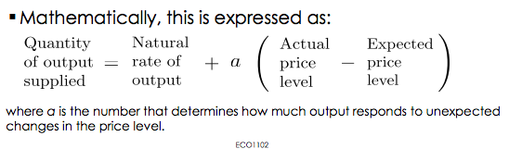
- ♣In the long run, wages and prices are flexible rather than sticky and people are not confused about relative prices.
- Quantity of output supplied = natural rate of output

Why Short-Run Aggregate-Supply Curve Might Shift
- ♣ We can think of the short-run aggregate-supply curve as similar to the long-run aggregate-supply curve but made upward sloping by the presence of sticky wages, sticky prices, and misperceptions. ♣ When thinking about what shifts the short-run aggregate supply curve, we have to consider all those variables that shift the long-run aggregate-supply curve plus a new variable—the expected price level—that influences the wages that are stuck, the prices that are stuck, and the perceptions about relative prices.

Effects of a Shift in Aggregate Demand
Four steps analyzing this impact:
- Does the event affect aggregate demand or aggregate supply?
- Determine the direction of the shift.
- Use the diagram of aggregate demand and aggregate supply to compare the initial and new equilibrium.
- . Keep track of the new short-run equilibrium, the new long-run equilibrium, and the transition between them.

Figure 14.9: Contraction in Aggregate Demand
- Short term – underneath and lower prices

The Effects of a Shift in Aggregate Demand

♣To sum up, there are three important lessons to remember here:
- 1. In the short run, shifts in aggregate demand cause fluctuations in the economy’s output of goods and services.
2. In the long run, shifts in aggregate demand affect the overall price level but do not affect the level of output.
3. Policy makers who influence aggregate demand can potentially mitigate that severity of economic fluctuations.

The Effects of a Shift in Aggregate Supply

- ♣ Suppose firms experience an increase in their costs of production.
- What is the macroeconomic impact of such a phenomenon?
- The same four steps are used for analyzing this impact:
  - Does the event affect aggregate demand or aggregate supply?
  - Determine the direction of the shift.
  - Use the diagram of aggregate demand and aggregate supply to compare the initial and new equilibrium.
  - Keep track of the new short-run equilibrium, the new long-run equilibrium, and the transition between them
- Ex. Oil in 70s
- Still short run decrease, unemployment
- Stagflation, unemployment and
- Sticky Wages Theory applied:
  - Prices cost labour too high, so
  - Prices higher, workers will demand more money, curve slides more to left
  - Self fulfilling, go from bad to worse because prices move with inflation
- ♣To sum up, there are two important lessons to remember here:
  - Shifts in aggregate supply can cause stagflation—a combination of recession (falling output) and inflation (rising prices).
  - Policy makers who can influence aggregate demand can potentially mitigate the adverse impact on output but only at the cost of exacerbating the problem of inflation.

Chapter 15:
The Influence of Monetary And Fiscal Policy On Aggregate Demand

- THE INFLUENCE OF MONETARY AND FISCAL POLICY ON AGGREGATE DEMAND

- In this chapter we examine in more detail how the government’s tools of monetary and fiscal policy influence the position of the aggregatedemand curve.
- We will also see how the tools of monetary and fiscal policy can shift the aggregate-demand curve and, in doing so, affect short-run economic fluctuations.

HOW MONETARY POLICY INFLUENCES AGGREGATE DEMAND

- ▪The aggregate-demand curve slopes downward for three reasons:
1. The Wealth Effect
2. The Interest Rate Effect
3. The Real Exchange Rate Effect

- The Interest Rate Effect is the most important reason for the downward slope of the aggregate-demand curve.

The Theory of Liquidity Preference

- ♣The theory of liquidity preference: Keynes’s theory that the interest rate adjusts to bring money supply and money demand into balance.
- ♣In the analysis that follows, the expected rate of inflation is held constant.

The Theory of Liquidity Preference: Money Supply

- The Bank of Canada alters the money supply using two methods:
  - Changing the bank rate
  - Open-market operations
    - Buying and selling federal government bonds
    - Foreign-exchange market operations
      - CAN buying US $
Figure 15.4 – equilibrium in the money market – opportunity cost is higher possible exam q?
- how we move on agg. Demand if move prices

Figure 15.5 IMPORTANT
- consume less today cuz cant consume more tomorrow
- about the investment (ie. Houses)
- prices higher, than higher. Aggregate b/w
- No q’s about open market and flexible exchange rate

Changes In Money Supply
- 15.6 Closed Economy
- decide to print money
  - new equilibria will be at low interest rate
  - If so slow, then what happens to aggregate demand curve?
  - Any given level of prices, the whole curve will move to the right
  - Agg. D shifting right – further affect on $ market. Consumers demand more $.
  - D for $ higher, when Agg D higher

- 15.7 Open Economy
  - int rate of small OE should be equal to int rate
  - int rate lower, small affect cuz money demanded. Will go back up but not entirely
  - $ will flow into country
  - exchange rate b/w US $ CAN – will rise because demand rises. D shifts to right. Will appreciate, and CAN dollar will depreciate
  - exports – more interesting ex. Coffee
Multiplier effect: the additional shifts in aggregate demand that result when expansionary fiscal policy increases income and thereby increases consumer spending
- 2 ideas – higher gov spending higher agg D
- Formula
Crowding-out effect on investment: the offset in aggregate demand that results when expansionary fiscal policy raises the interest rate and thereby reduces investment spending

-

