Ch 1
HRM functional: “Is a set of interrelated policies, practices, and programs whose goal is to attract, socialize, motivate, maintain, and retain an organization’s employees”
HRM goal based: “aims to improve the productive contribution of individuals while simultaneously attempting to attain other societal and individual employee objectives”
HRM integrated based: the policies, practices and systems that influence an employee’s behaviour attitudes and performance in the attainment of organizational goals.
HR’s key stakeholders: organization, employees, society

HR activities
Strategic HR: link HR function with the strategic objectives of the organization to improve performance. HR metrics include: effectiveness, planning, measurement, technology, retention
Equal Employment opportunity: compliance with the law, diversity, and employment equity.
Staffing: job analysis, recruiting, selection
Talent Management: orientation, training, HR development, career planning, performance management.
Total Rewards: wage/salary administration, incentives, benefits.
Health safety and security: health and wellness, safety, security.
Employee and Labour relations: employee rights and privacy, HR policies, union/management relations.

HR Professional
Lead managers in HR work, coach and train managers.
CHRP, Certified Human Resources Professional Designation.

Types of assets to manage
Physical: buildings etc
Financial: cash etc
Intangible: patents etc
Human : workers. ‘glue’ that holds other assets together.

Human Capital: not individuals. Is the talents and contributions they bring to organization.
Core competency: unique capability that creates high value and differentiates an organization from competition.

HR Management Challenges
Globalization of business: outsourcing, global competition
Economic forces
Technology booms: shift from manufacturing and agriculture to service and telecom.
Changing demographics: increase in diversity.
Labour changes: employee retention, esp. tough to replace skills. Increase in contingent (temp) workers
All cause Cost pressures
Which causesorganizational restructuring.

Companies outsource to reduce costs, be more competitive. Labour costs main reason.
Outsourcing- another company provides service
Offshoring- moving work to other company

Employability Skills
Fundamental Skills: communicate, manage information (basic)
Personal Management Skills: adapt, learn, responsible (grow)
Teamwork Skills: work with others (productivity)

HR Management Roles
Administrative: clerical admin, recordkeeping
Operation and employee advocate(for employees): manage most HR activities and serving as employee “champion”
Strategic (for organization): becoming a contributor to organizational results and he ‘keeper’ of ethics.

Change in HR Management
Strategic: 60%
Operation and employee advocate: 30%
Administrative: 10%
THIS USED TO BE THE OPPOSITE IN THE PAST

HRMS: Human resource management system. Integrated system provides info used by HR management, in conjunction with other managers in decision making.

HR Ethics:
CCHRA Code of Ethics. Canadian Council of Human Resources Association.
  - Competence
  - Legal requirements
  - Dignity in workplace
  - Balancing interests (between org, employees, etc.)
  - Confidentiality
  - Conflict of Interest
Misconducts:
Compensation-bias in performance appraisals, misrepresentation of hours and time worked
Employee relations-employees lying to supervisors, personal gifts from vendors.
Staffing and equal employment- sexual harassment, discrimination.

Ch 2
Strategic Human resource Management: process of linking HR with the strategic objectives of the organization to improve performance.

Strategies:
Cost leadership: low price, high quality. Lots of part time workers, lots of rules. (Toyota)
Differentiation Strategy: more appropriate in a dynamic environment characterized by rapid change and requires continually finding new products and new markets. (GM, Apple)
Focused Strategy: occurs when a firm concentrates its efforts on serving a distinctively defined market segment, which may include some combination of a portion of a product line, particular customer segment, limited geographic area or particular distribuition channel.

Miles and Snow Strategy Typology
Defenders: limited product lines that focus on improving the efficiency of their existing operations.
Prospectors: fairly broad product lines, focus on product innovation and new market opportunities.
Analyzers: operate in atleast 2 different product market areas. One stable and one is variable. Stable areas = efficiency. Variable areas = innovation, risk.
Reactor: lacs consistent strategy, structure or culture relationship. Changes based on current needs. Change costs based on new entrants to market.

HR Planning: process of analyzing and identifying the need for and availability of human resources so that the organization can meet its objectives.
Right people, right capabilities, right time, right place.
Involves
  - Forecasting demand
  - Forecasting supply
  - Addressing labour shortages and surpluses
Environmental scanning: process of studying the environment of the organization to pinpoint opportunities and threats.
Factors on HR Planning
Government influences
Economic conditions
Geographic and competive concerns
Workforce composition
Assessing the internal workforce
Jobs and skills audit

Forecasting methods:
Quantitative: numbers
Qualitative: judgemental

Forecasting periods:
Short range: immediate HR needs, 6 months to 1 year. Most common.
Intermediate range: 1 to five years
Long Range: beyond 5 years

Quantitative Forecasting
Trend analysis: study of organizations past employment needs. To predict future.
Ratio analysis: productivity would be determined by dividing average number of units produced per employee, then applied to sales forecast.
Scatter plot: compare relationship between two variables.
Regression analysis: statistical comparison of past relationships among a number of factors.
Simulation models: representation of real situations in abstract form.

Qualitative Forecasting:
Management forecasts: managers use their experiences to make projections and judgements about the needs of their operations.
Delphi Technique: ask experts, by filling out anonymous questionnaires about forecasted situations. The data is aggregated and shown to another group of experts for a second opinion. This process continues several rounds until there is agreement on a judgement.
Nominal group technique: participants brought together for a discussion session led by a moderator. Participants write down and read their opinions out loud. All them are written down by moderator. Asked for second and third opinions which are also written down by moderator.

Forecasting supply of HR
External supply: net migration, individuals entering/leaving the workforce etc
Internal supply: sourcing employees for internal movement within an organization.

Succession planning: process of identifying a longer term plan for the orderly replacement of key employees.
Markov Analysis: predicts needs based on probabilities and shows a forecast of supply.
Replacement Chart: projects potential personnel changes, identify possible backup candidates and keep track of attrition (resignations, retirements etc).

Current staffing level – projected outflows + projected inflows = internal supply of next year

Retention
Job design: job/person matching, time flexibility, work/life balancing
Characteristics of employer: culture and values, management, job security
Career opportunities: training/development and mentoring, carrer planning/advancement
Rewards: competitive pay and benefits, performance and compensation, recognition
Employee relationships: fair, non-discriminatory treatment. Supervisory/management support, co worker relations

Measurement and Assessment of Retention: employee surveys, attitude survey, engagement survey (measures how willing employees are to expend extra effort for employer), exit interview (reasons for leaving).

Retention evaluation and follow up: regular review of turnover data, tracking of intervention results and adjustment of intervention efforts (testing changes to work before applying them to entire company)

Managing Surpluses and Shortages of workers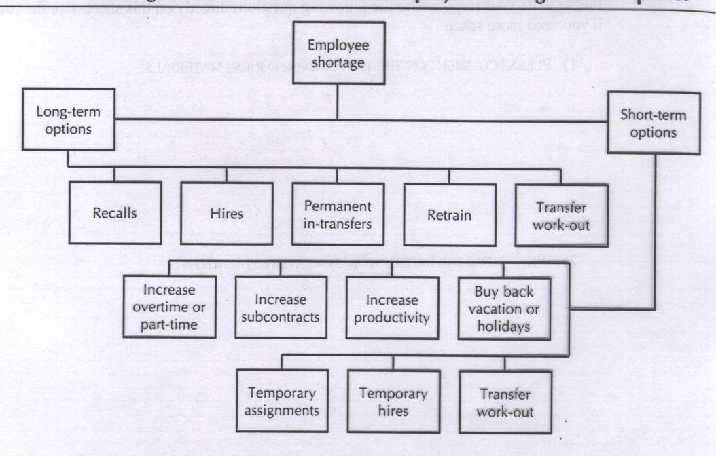
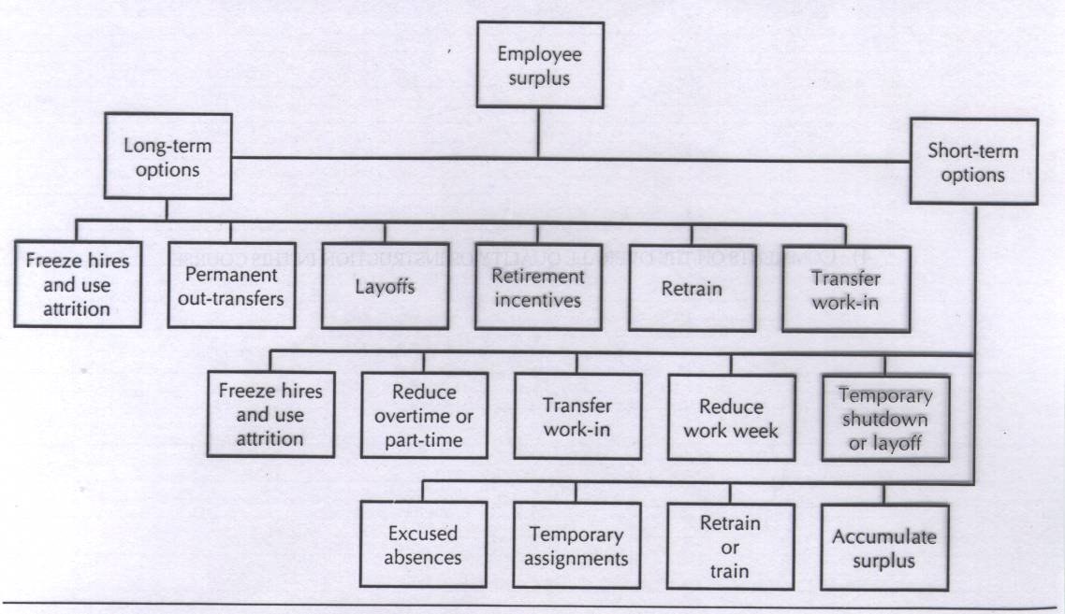
HR metrics: specific measures tied to HR performance indicators.

Return on investment: ROI = c / (a+b)
where a: operating costs of a new or enhanced system for the time period
b: one time cost of acquisition and implementation
c: value of gains from productivity improvements for the time period
Economic Value Added: net operating profit of a firm after the cost of capital is deducted.
Balanced Scorecard: measures strategic performance on four perspectives.
Financial, internal business process, customer, learning and growth

Measuring Absenteeism
Number of person-days lost through job absence during period x100
Divided by
(average number of employees) x (number of workdays)

Measuring turnover
Number of employee separations during the month x100
Divided by
Total number of employees at midmonth

Incidence rate: number of absences per 100 employees each day
Inactivity rate: percentage of lost time due to absenteeism
Severity rate: the average time lost per absent employee during a specific period of time.

Separation costs: time and money to prevent separations, exit interview time, unemployment expenses etc
Replacement costs: includes recruiting and advertising expenses.
Training cost: paid orientation time etc
Hidden costs: costs that affect productivity, decreased customer service etc.

Benchmarking: compares specific measure of performance against data on those measures in other organizations.

HR audit: formal research effort that evaluates the current state of HR management in an organization.

Ch3

Provincial and territorial human rights legislation: all provinces and territories have their own human rights laws and commissions prohibiting discrimination in employment.
Canadian human rights act: a federal law prohibiting discrimination in employment under various prohibited grounds.
Direct discrimination: an adverse distinction based on a prohibited ground.
Bona fide occupational requirement: a justifiable reason for discriminating against a member of a designated group.
Undue hardship: pertains to the significant difficulty or expense imposed on an employer in making an accommodation for individuals with disabilities.
Systematic (constructive) discrimination: occurs when a seemingly neutral policy or practice results in unintentional discrimination.
Duty to accommodate: an employer’s legal duty to take reasonable steps in policies or conditions of work to accommodate an employee’s individual needs.
Federal laws apply to federally regulated organizations. (10% of workforce)
Provincial laws apply to provincially regulated (90% of workforce)

Prohibited Grounds:
Race or colour, religion and creed, age, sex, sexual orientation, marital status, family status, disability, record of criminal conviction and pardoned conviction.
Harassment is a type of discrimination.
Quid Pro Quo: harassment in which employment outcomes are linked to the individual granting sexual favours.
Hostile Environment: harassment exists when an individual’s work performance or psychological well being is unreasonably affected by intimidating or offensive working conditions
Avoid sexual harassment:
Establishing a policy
Communicating the policy regularly
Training
Investigated and taking action on complaints.

Employment standards: designed to protect all workers of Canada from exploitation in unregulated labour markets.
Occupational health and safety: the right to know, participate and refuse dangerous work.
Labour relations legislation: for unions, no discrimination for people joining unions.

Designated group members: those most disadvantage in employment opportunities; women, aboriginals, visible minorities, disabled people.
Disparate impact: occurs when designated group members are substantially under represented.
Glass ceiling: prevent designated groups from advancing to executive level jobs
Glass walls/glass elevators: advancing women to senior management in positions that pay less compared to other jobs. Only advancing women in certain fields.
Reverse discrimination: when a person is denied an opportunity because of preferences given to designated group members who may be less qualified.
Pay equity: right to equal pay for work of equal value.
Wage gap between men and women is 71% of men’s salaries.

Ch 4
Work: effort directed toward accomplishing results
Job: grouping of tasks, duties, and responsibilities that constitute the total work assignment for employees.
Position: group of tasks, duties and responsibilities performed by an individual employee.

Workflow analysis: examining how work flows through the organization in order to improve operating efficiency.
Re-engineering: improving productivity by changing jobs themselves.
Job design: dividing up organizational work into jobs in order to utilize employee capabilities effectively.
Job descriptions: identifying tasks, duties and responsibilities in jobs and the capabilities needed for people to perform jobs well.

Workflow Analysis:
Begins with examination of quanitity and quality of the desired and actual outputs. Then the activities that lead to the outputs are evaluated. The inputs must then be assessed to determine if they make the outputs and activities more efficient.
Business Process Re-Engineering: measures for improving such activities as product development, customer service and service delivery.
Steps of BPR:
Rethink: examine current effects.
Redesign: analyze how jobs are ut together, the workflow and how results are achieved then redesign the process as necessary.
Retool: look at new tech as opportunities to improve.

Job Design can influence performance, job satisfaction, and physical and mental health.
Job enlargement: broadening the scope of a job by expanding the number of different tasks to be performed.
Job enrichment: increasing the depth of a job by adding responsibility for planning, organizing, controlling or evaluating the job.
Job rotation: process of shifting a person from job to job.

Characteristics of Jobs:
Skill variety: extent to which the work requires several different activities for successful completion
Task identity: extent to which the job includes a ‘whole’ identifiable unit of work that is carried out from start to finish and that results in a visible outcome.
Task significance: impact the job has on other people.
Autonomy: extent of individual freedom and discretion in the work and its scheduling.
Feedback: amount of information employees receive about how well or how poorly they have performed.

Factors affecting virtual team success: technology, training of team members, and virtual management.

Shift work: commonly used work schedule design.
Shift differential: extra pay for working nights.
Compressed workweek: working less than five days but more than 8 hours a day.
Flextime: scheduling arrangement in which employees work a set number of hours a day but vary starting and ending times.
Job sharing: two employees perform the work of one full time job.
Job analysis: systematic way of gathering and analyzing information about the content, context and human requirements of jobs.
Task: distinct, identifiable work acitivity composed of motions
Duty: larger work segment composed of several task that are performed by an individual.
Responsibilities: obligations to perform certain task and duties.
Competencies: individual capabilities that can be linked to enhanced performance by individuals or teams.

Psychometric practices: concerned with the deisgn, administration and interpretation of quantitative tests for the measurement of psychological variables such as intelligence, aptitude and personality traits.

Job analysis Process:
Planning: identifying objectives. Obtain top management support
Preparing and Introduction: identify jobs, review existing jobs, communicate process
Conduct job analysis: gather data, review it
Develop job descriptions and specifications: draft job descriptions. Review drafts with managers, finalize.
Maintain and update: update as organization changes. Periodically review all jobs.

Marginal job functions: duties that are part of a job but are incidental or ancillary to the purpose and nature of the job.

Job description: identification of the tasks, duties and responsibilities of a job.
Performance standards: indicators of what the job accomplishes and how performance is measured in key areas of the job description.
Job specifications: the knowledge, skills and abilities an individual needs to perform a job satisfactorily.

Job description Components:
Identification
General summary
Essential functions and duties
Job specifications
Disclaimer and approvals.

Job Analysis Methods:
Interviews
  - With SMEs
Observation
  - By trained job analysts
  - May include technology (e.g., video recording)
Self-monitoring
  - Incumbent records own activities – e.g., diary
  - Job analyst would develop tasks, infer KSAOs, etc. from the data

Position Analysis Questionnaire PAQ
- McCormick (1972)
- Developed because of criticism that JA relied on observation – not quantifiable
        - Detailed questionnaire (194 tasks)
  - Job context / working conditions
  - Mental processes / demands
  - Information input – where/how does worker get info?
  - Work output – actions/tools required to perform job?
  - Relationships with others
        - Determines extent to which each task is important for target job
  - Using a 5-point scale

Functional Job Analysis FJA
- Fine & Wiley (1971); Fine & Cronshaw (1999)
        - Focuses on task statements
        - Task statements include:
  - What? - What gets done (the action/behaviour)
  - To whom or what? - The object of the action
  - Why? - Purpose of the action - what is produced?
  - How? - What facilitates the action?

Competency JA
- Core Competencies
  - Apply to all jobs in the organization
  - Support organization’s mission
  - E.g., trust, communication, team orientation, adaptability
        - Functional Competencies
  - Apply to a group of similar jobs
  - E.g., customer service orientation
        - Job-Specific Competencies
  - Apply to all employees in the same job
  - E.g., ability to operate cash register

Critical Incident Technique
- Developed by Flanagan (1949; 1954)
  - Aviation Psychology Program of US Air Force during WWII
  - Problems – failures in bombing runs, aircraft crashes, pilot disorientation in flight
  - CIT developed to identify causes of problems and develop selection standards for aviation personnel
        - Identifies behaviours that are:
  - critical – for success or failure on the job
  - observable
  - 3 parts
    - Context
  - What is the background? In what situation did the incident occur?
    - Behaviour
  - Exactly what did the individual do that was effective or ineffective?
    - Consequences
  - What happened as a result of the behaviour?
  - Want to ensure that consequences are directly linked to the behavior

Ch 5
Recruitment: process of generating a pool of qualified applicants for organizational jobs.
Labour markets: external supply from which organizations attract employees.

Recruitment goals
  - Applicant pool of sufficient size
  - Qualified
  - Accurate perceptions of employer/applicant
Internal Influences
  - Staffing needs created by organizational strategy
  - Type and level of job openings
External Influences
  - Labour market
  - Legal environment
Labour force population: all individuals who are available for selection if possible recruitment strategies are used.
Applicant population: a subset of the labour force population that is available for selection using a particular recruiting approach.
Recruiting method: advertising medium chosen
Recruiting message: what is said about job and how it is said
Applicant qualifications required: eduction level and amount of experience etc
Administrative procedures: when recruiting is done, applicant follow-up and use of previous applicant files.
Low unemployment (tight labour market)
  - Broaden recruitment efforts
  - Target “passive” job seekers
  - Improve compensation, T&D, etc.
High unemployment
  - Narrow, targeted recruitment efforts
  - Goal
    - – target applicant population that likely has KSAOs for job
3 necessary conditions for recruitment to occur
  - Common communication medium
  - Job seeker must perceive a match between his or her personal characteristics and the job requirements
  - Job seeker must be motivated to apply

3 main functions of Realistic Job Preview
  - Self-selection
  - Vaccination
  - Increase commitment
Benefits of RJPs
  - Evidence suggests that RJPs achieve the 3 purposes to a certain degree (e.g., Phillips, 1998)
  - Perceptions of employer trustworthiness, honesty, and concern for employees
  - Facilitates P-O fit
  - Lower unrealistic expectations
Potential Disadvantages of RJPs
  - Negative info may discourage qualified applicants – particularly in competitive job market
  - Negative info may have stronger effect on best-qualified applicants

Flexible Staffing: use of workers who are not traditional workers.
Independent contractors: workers who perform specific services on a contract basis.

Recruiting considerations:
Training of recruiters on human rights
Targeted recruiting of diverse applicants
Compliance with human rights
Employment advertising content.

Internal Recruiting Processes:
Organizational databases
Job posting
Promotions and transfers

Employee focused recruiting:
Current employee referrals
Re-recruitment of former employees and applicants

External recruiting sources:
Campus recruiting
School recruiting
Labour unions
Competitive sources
Media sources

How to prepare effective job ad:
Attention
Interest
Desire
Action

What to include on effective recruiting ad:
Information on job and application process
Desired candidate qualifications
Information on the organization

Internet recruiting
Global internet recruiting
e-recruiting methods: internet job boards, professional/career websites, employer websites.

Advantages of internet recruiting:
Save money
Saves time
More responses

Disadvantages of internet recruiting:
More unqualified applicants
Some applicants have limited internet access
Privacy

Evaluating recruiting quantity and quality:
Quantity
Enough to fill vacancies?
Does recruiting provide enough qualified applicants?
Quality
Perform the jobs well after hire?
Failure rate?
Performance appraisal scores?

Time required to fill openings

Agencies: 25 days
Walkins: 7 days
Internet: 12 days

Recruiting expense/number of recruits hired = recruiting cost

Recruiting Metrics:
Yield ratios: comparisons of the number of applicants at one stage of the recruiting process with the number at the next stage.
Selection rate: percentage hired from a given group of candidates.
Acceptance rate: percent of applicants hired divided by total number of applicants
Success base rate: comparing number of past applicants who have become successful employees against the number of applicants tey competed against for the jobs.

Increasing recruiting effectiveness:
Resume mining: a software approached to getting the best resumes for a fit from a big database
Applicant tracking: follows from application to performance appraisal
Employer career websites: recruiting place on companys website where applicants can see what jobs are available and apply
Internal mobility: a system that tracks prospects in the company and matches them with jobs as they come open.

