Chapter 13: Personality
-personality: a person’s characteristic pattern of thinking, feeling, and acting
-two significant theories: Freud’s psychoanalytic theory proposed that childhood sexuality and unconscious motivations influence personality, and the humanistic approach focused on our inner capacities for growth and self-fulfillment

Psychodynamic theories
-psychodynamic theories: view human behaviour as a dynamic interaction between the conscious and unconscious mind, including associated motives and conflicts
-descended from Freud’s psychoanalysis

Freud’s psychoanalytic perspective: exploring the unconscious
-Freud turned to free association when studying unexplained nervous disorders, to try to figure out the unconscious
-free association: in psychoanalysis, a method of exploring the unconscious in which the person relaxes and says whatever comes to mind, no matter how trivial or embarrassing
-he believed that following a chain of thought leading into the patient’s unconscious, where painful unconscious memories, often from childhood, would be retrieved
-psychoanalysis: Freud’s theory of personality that attributes thoughts and actions to unconscious motives and conflicts; the techniques used in treating psychological disorders by seeking to expose and interpret unconscious tensions
-unconscious: according to Freud, reservoir of mostly unacceptable thoughts, wishes, feelings and memories. According to contemporary psychologists, info processing of which we are unaware
-of greater interest to Freud was the mass of unacceptable passions and thoughts that he believed we repress, or forcibly block from our consciousness because they would be too unsettling to acknowledge
-viewed jokes as the royal road to the unconscious

Personality structure
-he believed human personality arises from a conflict between impulse and restraint- between our aggressive, pleasure-seeking biological urges and our internalized social controls over these urges
-to understand the mind’s dynamics during this conflict, Freud proposed three interacting systems: the id, ego, and superego
-id: a reservoir of unconscious psychic energy that, according to Freud, strives to satisfy basic sexual and aggressive drives. The id operates on the pleasure principle, demanding immediate gratification
-ego: the largely conscious, “executive” part of personality that, according to Freud, mediates among the demands of the id, superego, and reality. The ego operates on the reality principle, satisfying the id’s desires in ways that will realistically bring pleasure rather than pain
-ego will look for long term pleasure… contains our partly conscious perceptions, thoughts, judgements, and memories
-around age 4-5 develop superego
-superego: the part of personality that, according to Freud, represents internalized ideals and provides standards for judgment (the conscience) and for future aspirations
-superego focuses on how we ought to behave
-because the superego’s demands often oppose the id’s, the ego struggles to reconcile the two

Personality development
-psychosexual stages: the childhood stages of development (oral, anal, phallic, latency, genital) during which, according to Freud, the id’s pleasure seeking energies focus on distinct erogenous zones
-during the phallic stage, boys seek genital stimulation, and they develop both the unconscious sexual desires for their mother and jealousy and hatred for their father- whom they consider a rival
-Oedipus complex: according to Freud, a boy’s sexual desires toward his mother and feelings of jealousy and hatred for the rival father
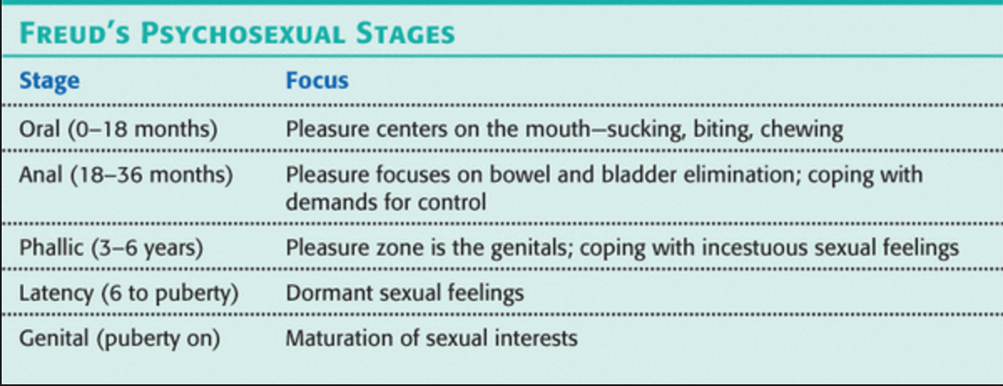
-identification process: the process by which, according to Freud, children incorporate their parent’s values into their developing superegos… if you can’t beat em join em
-fixation: according to Freud, a lingering focus of pleasure-seeking energies at an earlier psychosexual stage, in which conflicts were unresolved… could surface as maladaptive behaviour in the adult years

Defensive mechanisms
-defense mechanisms: in psychoanalytic theory, the ego’s protective methods of reducing anxiety by unconsciously distorting reality
-all defense mechanisms function indirectly and unconsciously
-repression: in psychoanalytic theory, the basic defense mechanism that banishes anxiety-arousing thoughts, feelings, and memories from unconsciousness
-repression underlies all the other defense mechanisms

The neo-Freudian and psychodynamic theorists
-neo-freudians (his young followers) broke off from Freud in two ways:
- they placed more emphasis on the conscious mind’s role in interpreting experience and in coping with the environment
- doubted that sex and aggression were all-consuming motivations
-collective unconscious: Carl Jung’s concept of a shared, inherited reservoir of memory traces from our species’ history… explains why spiritual concerns are deeply rooted

Assessing unconscious processes
-projective tests:a personality test, such as the Rorschach, that provides ambiguous stimuli designed to trigger projection of one’s inner dynamics
-Rorschach inkblot test: the most widely used projective test, a set of 10 inkblots, designed by Hermann Rorschach; seeks to identify people’s inner feelings by analyzing their interpretations of the blots

Evaluating Freud’s psychoanalytic perspective and modern views of the unconscious
Modern research contradicts many of Freud’s ideas
-our development is seen as more lifelong then fixed in childhood
-he overestimated parental influence and underestimated peer influence
-his theories have scientific shortcomings- his theory rests on few objective observations, and parts of it offer few testable hypotheses
-biggest problem: it offers after the fact explanations of any characteristic yet fails to predict such behaviours and traits

Modern research challenges the idea of repression
-repression may not be real, there is few true cases
-believe maybe high stress and associated stress hormones enhance memory

The modern unconscious mind
-defense mechanisms are motivated less by the seething impulses that Freud presumed than by our need to protect our self-image
-terror-management theory: a theory of death-related anxiety; explores people’s emotional and behavioural responses to reminders of their impending death

Humanistic theories
-humanistic theories: view personality with a focus on the potential for healthy personal growth
-Abraham Maslow and Carl Rogers offered a third force perspective that emphasized human potential

Abraham Maslow’s self-actualizing person
-proposed we are motivated by a hierarchy of needs
-developed his ideas by studying healthy, creative people rather than troubled clinical cases
-self-actualization: according to Maslow, one of the ultimate psychological needs that arises after basic physical and psychological needs are met and self-esteem is achieved; the motivation to fulfill one’s potential

Carl Rogers’ person-centered perspective
-believed that people are basically good and are endowed with self-actualizing tendencies, unless thwarted by an environment that inhibits growth
-believed that a growth promoting environment required three conditions:
- genuineness: open with their own feelings, drop their facades, and are transparent
- acceptance: they offer unconditional positive regard, in a close family or intimate friendship, we are free to be spontaneous without fearing the loss of others’ esteem
- empathy: share and mirror other’s feelings and reflect their meanings
-self-concept: all our thoughts and feelings about ourselves, in answer to the question, “who am i?”

Assessing the self
-one questionnaire inspired by Carl Rogers asked people to describe themselves both as they would ideally like to be and as they actually are
-when the ideal and the actual self are nearly alike, the self-concept is positive

Evaluating humanistic theories
-the individualism encouraged by humanistic psychology-trusting and acting on one’s feelings, being true to oneself, fulfilling oneself- can, the critics have said, lead to self-indulgence, selfishness, and an erosion of moral restraints
-humanistic psychology is naive, it fails to appreciate the reality of our human capacity for evil

Trait theories
-trait: a characteristic pattern of behaviour or a disposition to feel and act, as assessed by self-report inventories and peer reports
-the Briggs Type Indicator (MBTI) is a test often used by businesses to declare personality types

Exploring traits
Factor analysis
-factor analysis- the statistical procedure described in chapter 10 to identify clusters of test items that tap basic components of intelligence
-i.e. extraversion, introversion, emotional stability, and instability

Biology and personality
-our genes have much to say about the temperament and behavioral style that help define our personality

Assessing traits
-personality inventories: a questionnaire- T/F, agree/disagree- on which people respond to items designed to gauge a wide range of feelings and behaviours; used to assess selected personality traits
-Minnesota multiphasic personality inventory (MMPI): the most widely researched and clinically used of all personality tests. Originally developed to identify emotional disorders, this test is now used for many other screening purposes
-this test is empirically derived: a test developed by testing a pool of items and then selecting those that discriminate between groups

The big 5 factors
-conscientiousness, agreeableness, neuroticism, openness, and extraversion
-in adulthood, the big five traits are quite stable
-seems to be somewhat heritable

Evaluating trait theories

The person-situation controversy
-our behaviour is influenced by the interaction of our inner disposition with our environment
-thus people’s score on an extraversion test, do not neatly predict how sociable they will actually will be on any given occasion
-people’s average outgoingness, happiness, or carelessness is predictable

Social-cognitive theories
-social-cognitive perspective: views behaviour as influenced by the interaction between people’s traits (including their thinking) and their social context… individuals and their situations
-we learn many of our behaviours either through conditioning or by observing and imitating others
-what we think about our situations affects our behaviour

Reciprocal influences
-reciprocal determinism: the interacting influences of behaviour, internal cognition, and environment
-i.e. internal personal factors (thoughts and feelings about risky activities), environmental factors (rock-climbing friends), behaviour (learning to rock climb)
-three specific ways in which individuals and environments interact:
- different people choose different environments
- our personalities shape how we interpret and react to events
- our personalities help create situations to which we react

Personal control
-personal control: the extent to which we perceive control over our environment
-two basic ways to study the effect of personal control: correlate people’s feelings of control with their behaviours and achievements, or experiment by raising or lowering people’s sense of control and noting the effects

Internal versus external locus of control
-external locus of control: the perception that chance or outside forces beyond our personal control determine our fate
-internal locus of control: the perception that you control your own fate
-internals achieve more in school and work, act more independently, enjoy better health

Depleting and strengthening self-control
-self control: the ability to control impulses and delay short-term gratification for greater long term rewards
-self control requires attention and energy

Learned helplessness versus personal control
-people who feel helpless and oppressed often perceive control as external
-when repeatedly faced with traumatic events over which they have no control, people come to feel helpless
-learned helplessness: the hopelessness and passive resignation an animal or human learns when unable to avoid repeated aversive events
-under conditions of personal freedom and empowerment, people thrive
-but, when given too much freedom (as in western societies), we experience decreased life satisfaction, increased depression, and decisional paralysis

Optimism versus pessimism
-realistic positive expectations fuel motivation and success
-excessive optimism:
- concerned about failing an upcoming exam, students may study thoroughly and outperform their equally able but more confident peers
- success requires enough optimism to provide hope and enough pessimism to prevent complacency
- if overconfident of our ability to control an impulse such as the urge to smoke, we are more likely to expose ourselves to temptations- and fail
-blindness to one’s own incompetence
- the difficulty in recognizing one’s own incompetence helps explain why so many low scoring students are dumbfounded after doing badly on an exam
- our ignorance of what we don’t know helps us sustain our confidence in our own abilities

Assessing behaviour in situations
-the best means of predicting future behaviour is neither a personality test nor an interviewer’s intuition, rather it is the person’s past behaviour patterns in similar situations
-if you can’t check a person’s past behaviour, the next-best thing is to create an assessment situation that simulates the task so you can see how the person handles it

Evaluating social-cognitive theories
-critics charge that social-cognitive theories focus so much on the situation that they fail to appreciate the person’s inner traits
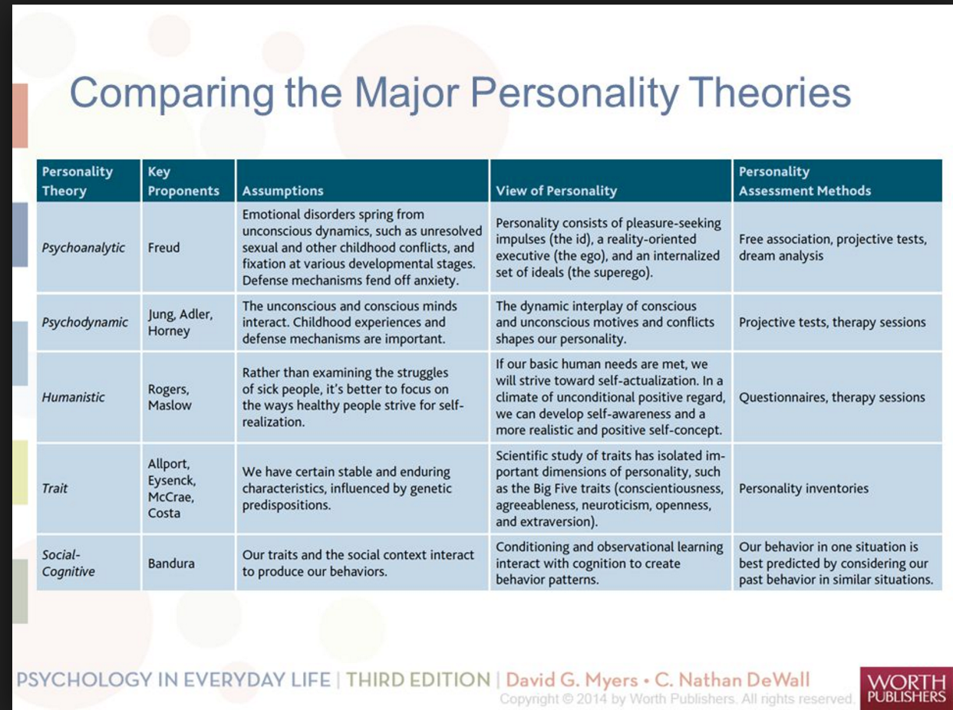

Exploring the self
-self: in contemporary psychology, assumed to be the center of personality, the organizer of our thoughts, feelings, and actions
-there are future selves you dream of- the rich self, and selves you fear- unemployed
-these possible selves motivate us by laying out specific goals and calling forth the energy to work toward them
-spotlight effect: overestimating others’ noticing and evaluating our appearance, performance, and blunders (as if we presume a spotlight shines on us)

The benefits of self-esteem
-self-esteem: one’s feelings of high or low self- worth
-those who are negative about themselves also tend to be oversensitive and judgmental
-accept yourself, and you’ll find it easier to accept others

Self-serving bias
-self-serving bias: a readiness to perceive oneself favourably
-people accept more responsibility for good deeds than for bad, and for successes than for failures
-most people see themselves as better than average
-threatened egotism, more than low self esteem, predisposes aggression
-narcissism: excessive self-love and self-absorption
-now adays, generation Me is more narcissistic
-defensive self esteem is fragile, it focuses on sustaining itself, which makes failures and criticism feel threatening
-secure self esteem is less fragile, because it is less contingent on external evaluations

