- Chapter 1: Organizational Behavior and Management

- What are Organizations?
  - Social inventions for accomplishing common goals through group effort
  - Social inventions: the coordinated presence of people
  - The field of organization behavior is about understanding people and managing them to work effectively

  - Goal Accomplishment: Organizational survival and adaptation to change are important goals
  - The field of organizational behavior is concerned with how organizations can survive and adapt to change

  - Group Effort: Interaction and coordination among people to accomplish goals
  - The field of organizational behavior is concerned with how to get people to practice effective teamwork.

What is Organizational Behavior?
  - The attitudes and behaviors of individuals and groups in organizations
  - How organizations can be structured more effectively
  - How events in the external environment affect organizations
    - Attitudes and Behaviors…associated with external environment
    - Outside world
    - Society
    - Economy

- Why Study Organizational Behavior?
  - Organizational behavior is interesting. It is about people and human nature
  - Organizational behavior is important to managers, employees, and consumers
  - Organizational behavior affects individuals attitudes and behavior as well as the competitiveness and effectiveness of organizations

- Goals of Organizational Behavior
  - Predicting organizational behavior and events
  - Explaining organizational behavior and events in organizations
  - Managing organizational behavior
- Trying to explain why individuals are behaving in a particular way…why are they doing what they’re doing, so we can garner a theory that will explain and predict the behaviors

Management
  - Management is the art of getting things accomplished in organizations through others
  - Prediction and explanation involves analysis while management is about action
    - Early Prescriptions Concerning Management
      - Attempts to prescribe “correct” way to manage an organization and achieve its goals:
        - Classical view + bureaucracy
        - Human relations view
      - The Classical View
        - The classical view advocates a high degree of specialization in labor, coordination and centralized decision making
        - Scientific Management: Frederick Taylor’s system for using research to determine the optimum degree of specialization and standardization of work tasks
      - Bureaucracy
        - Max Weber’s ideal type of organization that includes:
          - Strict chain of command (family??)
          - Selection and promotion criteria based on technical competence
          - Detailed rules, regulations, and procedures
          - High specialization
          - Centralization of power at the TOP of the organization
        - The Human Relations Movement/Critique of Bureaucracy:
          - Began with the famous Hawthorne Studies of the 1920s and 1930s conducted at the Hawthorn plant of Western Electric (once attention is given by management productivity will rise)

- Contemporary Management – The Contingency Approach
  - The general answer to many of the problems in organizations is: “it depends”
  - Dependencies are called contingencies
  - The contingency approach to management recognizes that there is no one best way to manage
  - An appropriate management style depends on the demands of the situation
- What do Managers do?
  - The field of organizational behavior is concerned with what managers actually do in organizations
  - Research on what managers do has focused on:
    - Managerial roles
    - Managerial activities
    - Managerial agendas
    - Managerial minds
    - International managers
  - Henry Mintzberg discovered a rather complex set of roles played by managers
    - Interpersonal roles
    - Informational roles
    - Decisional roles
      - Interpersonal Roles
        - Have to do with establishing and maintaining interpersonal relations. They include
          - Figurehead role
          - Leadership role
          - Liaison role
      - Informational Roles
        - Concerned with various ways managers receive and transmit information. They include:
          - Monitor role
          - Disseminator (spread/disperse) role
          - Spokesperson roles
      - Decisional Roles
        - Deal with decision-making. They include:
          - Entrepreneur role
          - Disturbance handler role
          - Resource allocation role
          - Negotiator role

- Managerial Activities
  - Fred Luthans, Richard Hodgetts, and Stuart Rosenkrantz found that managers engage in four basic types of activities:
    - Routine communication (formal sending and receiving information)
    - Traditional management (planning, decision making, controlling)
    - Networking (interaction with people outside of the organization
    - Human resource management (motivating, reinforcing, disciplining, punishing, managing conflict, staffing, T & D)

- 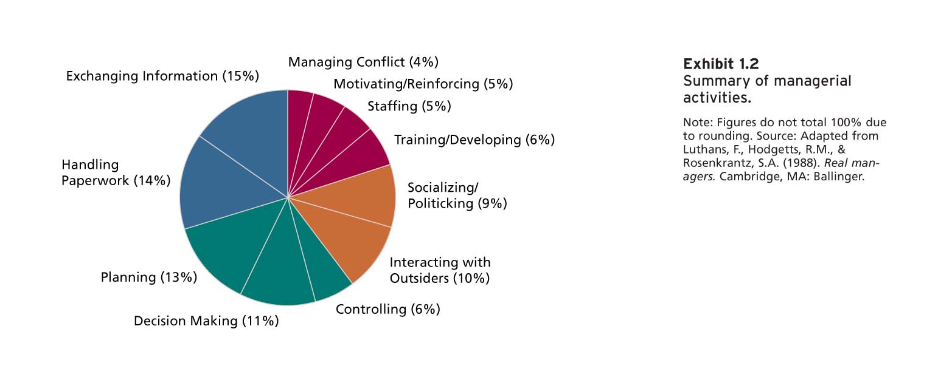

- In what areas would you keep the same? Decrease? Increase? What would you add?

- Managerial Activities and Success
  - Emphasis on these various activities is related to managerial success
  - Networking is related to moving up the ranks of the organization quickly
  - Human resource management is related to employee satisfaction, commitment, and unit effectiveness

Managerial Agendas
  - John Kotter studied the behavior patterns of successful general managers and identified the following categories of behavior:
    - Agenda setting
    - Networking
    - Agenda implementation
      - Agenda Setting
        - What they wanted to accomplish for the organization
        - Almost always informal and unwritten/concerned with people issues
      - Agenda Implementation
        - Managers used networks to implement agendas
        - They employed a wide range of influence tactics
        - A high degree of informal interaction and concern with people issues that were necessary for the managers to achieve their agendas
        - Managers often found themselves dependent on people over whom they wielded no power
      - Networking
        - Established a wide formal and informal network of key people inside and outside the organization
        - The network provides managers with information

and established cooperative relationships relevant to their agendas

- Managerial Minds
  - Herbert Simon and Daniel Isenberg explored how managers thing
  - Experienced managers use intuition to guide many of their actions:
    - To sense that a problem exists
    - To perform well-learned mental tasks rapidly
    - To synthesize isolated pieces of information and data
    - To double-check more formal or mechanical analyses
  - Good intuition is problem identification and problem solving based on a long history of systematic education/experience
  - Enables manager to locate problems within a network of previously acquired information

- International Managers
  - Cultural variations in values affect both managers’ and employees’ expectations about interpersonal interaction
  - Cannot lump together different international managers
  - National culture is one of the most important contingency variables in organizational behavior

Some Contemporary Management Concerns
  - Five issues with which organizations and managers are currently concerned
    - Diversity – Local and Global
    - Employee-Organization Relationships
    - A focus on Quality, Speed, and Flexibility
    - Talent Management
    - Corporate Social Responsibility (CSR)
      - Diversity – Local and Global
        - Global business has increased and so has the need to understand how workers and customers in other countries are diverse and culturally different
        - OB is concerned with issues that have to do with the management of a diverse workforce and how to benefit from the opportunities that a diverse workforce provides
      - Employee – Organization Relationships
        - Downsizing, restructuring, re-engineering, and outsourcing have had a profound effect on organizations
        - Major structural change in work arrangements (e.g., part-time, temporary, contract work)
        - Changes in the workplace have changed the nature of employee – organization relationships
        - The consequences of these changes:
          - Decreased trust
          - Lower morale and loyalty
          - Decline in job satisfaction and organizational commitment
          - Low levels of employee engagement
          - Increase in work-related illness and stress
            - - 53 billion $$$ addiction to prescription drugs (work-life balance)
          - Absenteeism is on the rise
      - A Focus on Quality, Speed, and Flexibility
        - Intense competition has given rise to the need for organizations to improve quality, speed, and flexibility.
        - This requires a high degree of employee involvement, commitment, and teamwork
        - Organizational behavior is concerned with these issues
      - Talent Management
        - Refers to an organizations processes for attracting, developing, retaining, and utilizing people with the required skills to meet current/future business needs
        - Two most important management challenges:
          - Recruitment of high-quality people across multiple territories
          - Improving the appeal of the company culture and work environment
        - OB can help companies improve recruitment/retention
        - Provides a means for organizations to be designed and managed in ways that optimize talent attraction, development, retention, and performance
      - Corporate Social Responsibility (CSR)
        - CSR refers to an organization taking responsibility for the impact of its decisions and actions on its stakeholders
        - It extends beyond the interests of shareholders to the interests and needs of employees and the community in which it operates
        - Many CSR issues have to do with OB ( work-family balance, work-life balance, employee well-being)

**Koziol means mountain goat

