Chapter 4- The Market Forces of Supply and Demand

The Market Forces of Supply and Demand
- Supply and Demand are the two words that economists use most often.
- Supply and Demand are the forces that make market economies work.
- They determine the quantity of each good and the price at which it is sold.
- If you want to know how any event or policy will affect supply and demand.

Shifts in the Demand Curve
- Any change that rises the quantities that purchasers wish to purchase at a given price shifts the demand curve to the right and vice versa.
- Factors that shift the demand curve:
  - Income:
    - Normal Good: a good for which, other things equal, an increase in income leads to an increase in demand
    - Inferior Good: a good for which, other things equal, an increase in income leads to a decrease in demand
  - Price of Related Goods:
    - Substitutes: Two goods for which an increase in the price of one leads to an increase in the demand for the other
    - Complements: Two goods for which an increase in the price of one leads to a decrease in the demand for the other
  - Tastes
  - Expectations
  - Number of Buyers

Supply

Supply Curve: The Relationship between Price and Quantity Supplied
- Quantity Supplied: the amount of a good that sellers are willing and able to sell
- Law of Supply: the claim that, other things equal, the quantity supplied of a good rises when the price of the good rises
- Supply Schedule: a table that shows the relationship between the price of a good and the quantity supplied
- Supply Curve: a graph of the relationship between the price of a good and the quantity supplied
- Market Supply: the sum of supplied of all sellers

Shifts in supply curves
- Any change that rises the quantities that sellers wish to produce at a given price shifts the supply curve to the right and vice versa
- Factors that shift the supply curve:
  - Input Prices
  - Technology
  - Expectations
  - Number of sellers

Supply and Demand Together

Equilibrium
- Equilibrium Price: the price that balances quantity supplied and quantity demanded
- Equilibrium quantity: the quantity supplied and the quantity demanded at the equilibrium price
- Surplus: quantity supplied is greater than quantity demanded
- Shortage: quantity demanded is greater than quantity supplied
- Law of supply and demand: the claim that the price of any good adjusts to bring the quantity supplied and the quantity demanded for that good into balance

Chapter 5- Measuring a nation income
- Microeconomics: the study of how individuals and how firms make decisions and how they interact in markets
- Macroeconomics: the study of economy wide phenomena, including inflation, unemployment, and economic growth
- Gross Domestic Product (GDP): measures the total income of a nation; the most closely watched economic statistic because it is the best measure of a society’s economic well-being

Economy’s income and Expenditure
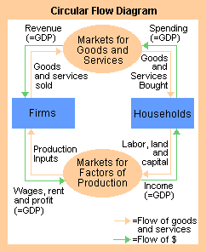
- For an economy as a whole, income must equal expenditure.

The Measurement of Gross Domestic Product
- GDP: the market value of all final goods and services produced within a country in a given period of time
- GDP adds together many different kinds of products into a single measure of the value of economic activity
- It includes all items produced in the economy’s stock of housing.
- There are some products, however, that GDP excludes because measuring them is so difficult
- GDP includes only the value of final goods
- The reason is that the value of intermediate goods is already included in the prices of the final goods.
- An important exception to this principle arises when an intermediate good is produced and is added to a firm’s inventory of goods to be used or sold at a later date
- GDP includes both tangible goods (food, clothing, cars) and intangible services (haircuts, housecleaning, dentist visits)
- GDP includes goods and services currently produced
- Also, measures the value of production within the geographic confines of a country
- GDP measures the value of production that takes place within a specific interval of time
  - Usually that interval is a year or a quarter
- GDP measures the economy’s flow of income and expenditure during that interval.

Components of GDP
Y = C + I + G +NX
- Y: GDP
- C: Consumption
  - Spending by households in G&S, with the exception of purchases of new housing
- I: Investment
  - Spending in capital-equipment, inventories, and structures, including household spending on new housing
- G: Government Purchases
  - Spending in goods and services by local, territorial, provincial, and federal governments
- NX: Net exports
  - The value of a nation’s exports minus the value of its imports; also called the trade balance

Other Measures of Income
- Gross national product
- Net national product
- National income
- Personal income
- Disposable personal income

Active Learning (EX)
- Debbie spends $200 to buy her husband dinner at the fines restaurant in Toronto
Consumption and GDP rise by $200
- Sarah spends$1800 on a new laptop to use in her publishing business. The laptop was built in China.
Investments rises by $1800, net exports fall by $1800, GDP is unchanged
- Jane spends $1200 on a computer to use in her editing business. She got last year’s model on sale for a great price from a local manufacturer.
Current GDP and investment do not change because the computer was built last year.
- General Motors build $500 million worth of cars, but consumers only buy $470 million of them.
Consumption rises by $470 million, inventory investment rises by $30 million, and GDP rises by $500 million.

Real versus Nominal GDP
- If total spending rise from one year to the next, one of two things must be true:
- The economy is producing a larger output of goods and services.
- Goods and services are being sold at higher prices.
- When studying changes in the economy over time, economists want to separate these two effects

GDP Deflator
- GDP deflator: a measure of the price level calculated as the ratio of nominal GDP to real GDP times 100
$GDP deflator=\frac{Nominal GDP}{Real GDP}$x100
$Inflation rate in yr 2=\frac{GDP deflator in yr 2-GDP deflator in yr 1}{GDP deflator in yr 1}$x100

Chapter 6-

Measure the Cost of Living
- Consumer price index is used to monitor changes in the cost of living over time
- When the consumer price index rises, the typical family has to spend more dollars to maintain the same standard of living.
- Economists use the term inflation to describe a situation in which the economy’s overall price level is rising.
- The inflation rate is the percentage change in the price level from the previous period.

Consumer Price Index
- Consumer Price Index (CPI): the overall measure of the cost of the goods and services brought by a typical consumer
- How the CPI is calculated:
  - Every month, statistics Canada computes and reports the CPI
  - it uses data on the prices of more than 600 different goods and services.
  - To see how these statistics are constructed, a simple economy with two goods, hot dogs and hamburgers, is used.
Five Steps to compute the inflation rate:
- Determine the basket
- Find the prices
- Compute the basket’s cost
- Choose a base year and compute the index
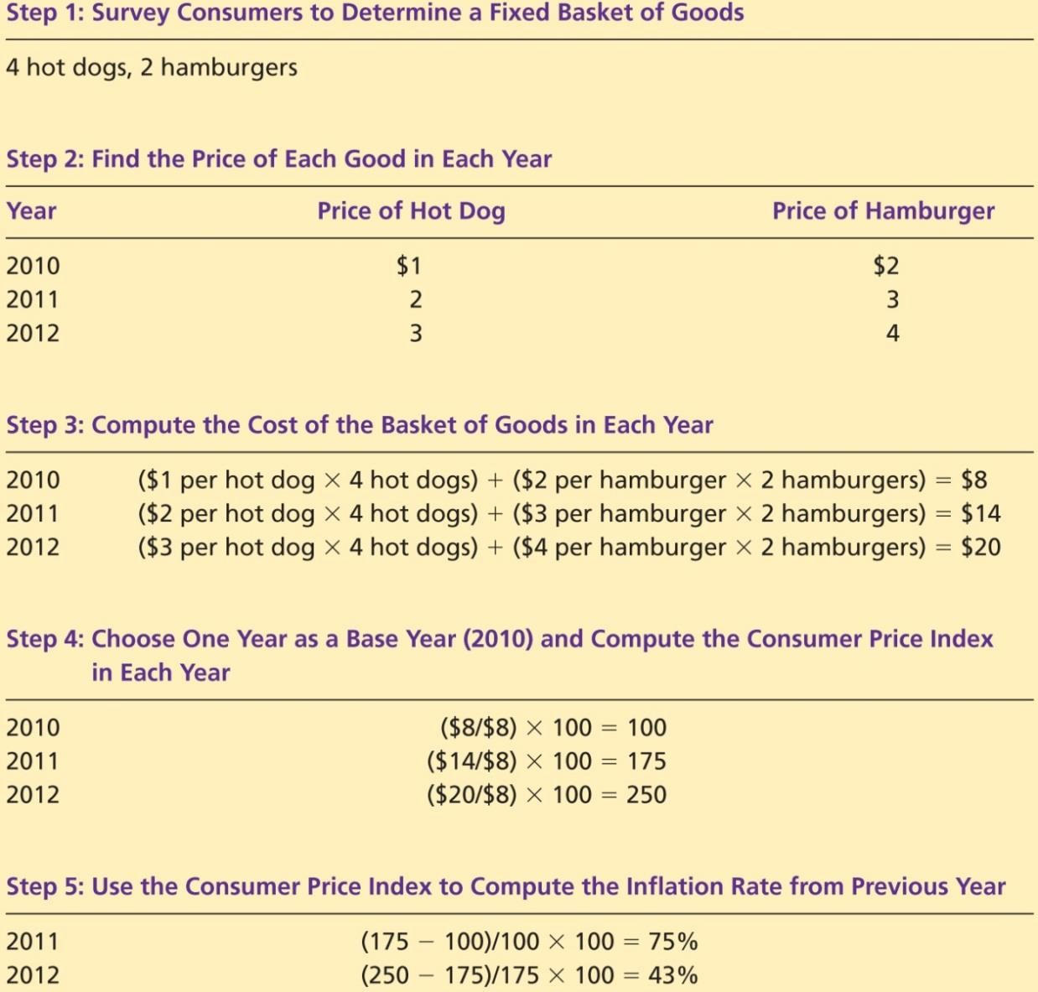
- Compute the inflation rate

CPI= $\frac{Price of\frac{Goods}{Services}in current year}{Price of basket in base year }x100$
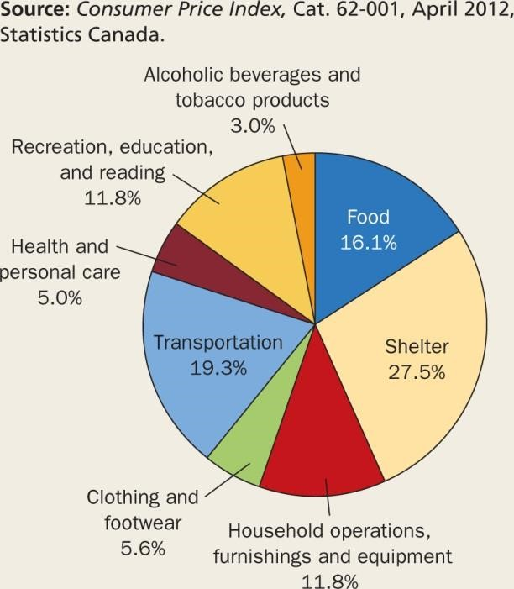
Inflation rate in year 2= $\frac{Price of g\&s in current year}{Price of basket in base year }x100$

CPI Basket

Problems in Measuring the Cost of Living
- Commodity substitution bias
- Introduction of new goods
- Unmeasured quality change

GDP deflator vs. the CPI
- The GDP deflator reflects the current level of price relative to the level of prices in the base year.
- Economists and policy makers monitor both the CPI and the GDP deflator to gauge how quickly prices are rising
- Two differences:
  - The GDP deflator reflects prices of goods and services produced domestically.
  - The GDP deflator compares the price of currently produced goods and services with the price of the same goods and services produced during the base year.
Correcting Economic Variables for the Effects of Inflation
- the purpose of measuring the overall level of prices in the economy is to permit comparison between dollar figures from different points in time
- Indexation: the automatic correction of a dollar amount for the effects of inflation by law or contract
- COLA: a COLA automatically raises the wage when the CPI raises

Real and Nominal Interest Rates
- Interest rates involve comparing amounts of money at different points in time
- To fully understand interest rates, knowing how to correct for the effects of inflation is important
- Nominal Interest Rates: the interest rate that is usually reported without a correction for the effects of inflation
- Real Interest Rate: the interest rate that is corrected for the effects of inflation
Real interest rate= Nominal interest rate - inflation rate

Chapter 7- Production and Growth

Economic Growth around the World
- Data on real GDP per person show that living standards vary widely from country to country
- Income per person in Canada is about:
  - 6 times higher than that of China
  - 12 times higher than that of India

Productivity: Its role and determinants
- Explaining the large variation in living standards around the world is, in one sense, very easy
- Productivity: the quantity of goods and services produced from each hour of a workers time
- Productivity is important because:
  - It is the key determinant of living standards
  - Growth in productivity is the key determinant of growth in living standards
  - For a country to enjoy a high standard of living, it must produce a large quantity of goods and services.

How productivity is Determined
- Physical Capital: the stock of equipment and structures that are used to produce goods and services
- Human Capital: the knowledge and skills that workers acquire through education, training, and experience
- Natural Resources: the inputs into the production of goods and services that are produced by nature, such as land, rivers, and mineral deposits
- Technological knowledge: society’s understanding of the best ways to produce and goods and services

Economic Growth and Public Policy

The importance of saving and investment
- Because resources are scarce, devoting more resources to producing capital requires devoting fewer resources to producing goods and services for current consumption
- Consequently, the accumulation of capital involves a tradeoff
- When governments encourage saving and investment, they also encourage growth and in the long run this raises the standard of living

Diminishing returns and the catch-up effect
- Successful government policies that raise the saving rate mean that fewer resources are needed to make consumption goods and more resources are now available to make capital goods.
- The capital stock increases, which raises productivity and thus leading to a higher rate of growth of GDP.

Investment from abroad
- However, the benefits from additional capital become smaller over time, so growth slows down. In the long run, the higher saving rate leads to a higher level of productivity and income but not too higher growth in these variables.
- This phenomena is known as diminishing returns.
- Diminishing returns: the benefit from an extra unit of an input declines as the quantity of the input increases
- Investment from abroad does not have the same effect on all measures of economic activity.
- Foreign investment in Canada raises the income of Canadians (this is captured in GNP) by less than it raises production in Canada (this is captured by GDP).
  - GDP increases because the investment increases Canada’s capital stock.
  - GNP increases by less because the profits generated from the foreign investment return to the country of the investors.
- Investment from abroad can help a country grow.
- The World Bank tries to encourage the flow of capital to poor countries.
- Economic distress often leads to political turmoil, international tensions, and military conflict.
- The World Bank and the International Monetary Fund were created after World War II to promote economic prosperity around the world

Education
- Investment in human capital (education) is at least as important as investment in physical capital for long-run economic success.
- It is well known that more education leads to higher wages and salaries.
- One way government policy can improve the standard of living is to provide good schools.
- Human capital is also important for economic growth because it conveys positive externalities.
- Externalities: the effect of one person’s actions on the well-being of a bystander
- For example, an educated person might generate a new idea that enters society’s pool of knowledge and therefore society can benefit from it.
- Some poor countries face a brain drain.
- Brain drain: the immigration of many of the most highly educated workers to rich countries, where they can enjoy a higher standard of living

Health and nutrition
- Other things equal, healthier workers are more productive.
- The causal link between health and wealth runs in both directions.
- Poor countries are poor in part because the populations are not healthy.
- Their populations are not healthy in part because they are poor.
- It is a vicious cycle.
- This fact opens the possibility of a virtuous cycle, however.
- Policies that lead to more rapid economic growth would naturally improve health outcomes.
- In turn, this would further promote economic growth.

Property rights and political stability
- Political instability is a threat to property rights.
- When revolutions are common, there is a doubt that property rights will be respected in the future.
- There is less incentive to save by nationals, and foreigners have less incentive to invest.
- Countries with an efficient court system, honest government officials, and a stable constitution will typically enjoy a higher standard of living.

Free trade
- Most economists today will say that a poor country is better off pursuing outward-oriented (as opposed to inward-oriented) policies that integrate these countries into the world economy.
- Countries that eliminate trade restrictions often experienced the same kind of economic growth that would occur after a major technological advance.
- Trade volume is not only determined by government policy but also by geography.

Research and development
- One of the major reasons why living standards are so much higher today than they were a century ago is because state-of-the-art technological knowledge has progressed so much.
- Even if most R&D is conducted in the private sector, there is a public interest in promoting such efforts.
- Knowledge is a public good.
- Governments have a vested interest in promoting R&D.
- Over the years the Canadian government has:
- Funded research in CANDU nuclear reactors
- Offered research grants from the National Sciences and Engineering Research Council of Canada and the Social Sciences and Humanities Research Council of Canada.
- Offered tax breaks to firms that engage in R&D.
- Managed the patent system

Population growth
- A large population means a larger total output of goods and services.
- However, it need not mean a higher standard of living for a typical citizen.
- Beyond these obvious effects of population size, population growth interacts with the other factors of production in ways that are more subtle and open to debate.
- Stretching natural resources
  - A large population means a larger workforce.
  - A large population means more consumers.
  - Therefore, a large population need not mean a higher standard of living.
- Diluting capital stock
  - According to this theory, high population growth reduces GDP per worker because rapid growth in the number of workers forces the capital stock to be spread more thinly.
  - A smaller quantity of capital per worker leads to lower productivity and lower GDP per worker.
- Some analysts believe that reducing the rate of population growth would help poor countries raise their standards of living:
  - By regulating the number of children (e.g., China)
  - By policies that foster equal treatment of women
- Promoting technological progress
- Some economists believe that population growth has been an engine of technological progress and economic prosperity.
- More people means more scientists, more inventors, and more engineers.

Chapter 8- Saving, Investment, and the Financial System
- Financial System: the group of institutions in the economy that help to match one person’s savings with another person’s investment

Financial Institutions in the Canadian Economy
- Financial institutions can be grouped into categories:
  - Financial Markets
  - Financial Intermediaries

Financial Markets
- Financial Markets: financial institutions through which savers can directly provide funds to borrowers

The Bond Market
- Bond: a certificate of indebtedness that specifies the obligation of the borrower to the holder of the bond
  - Debt finance: the sale of a bond to raise money
- Characteristics:
  - The bond’s term
  - The bond’s credit risk

The Stock Market
- Stock: represents ownership in a firm and is, therefore, a claim to its profits
- Equity finance: the sale of a stock to raise money
- The prices at which shares trade on stock exchanges are determined by the supply and demand for the stock.
- Stock index: is an average of a group of stock prices
  - Dow Jones Industrial Average
  - S&P/TSX Composite Index
- Because stock prices reflect expected profitability, stock indexes are watched closely as possible indicators of future economic conditions.

Financial Intermediaries
- Bank: the primary function of a bank is to take deposits from savers and use these deposits from savers and use these deposits to make loans to people who want to borrow
- Mutual funds: an institution that sells shares to the public and uses the proceeds to buy a portfolio of stocks and bonds
  - allow diversification
  - Access to the skills of professional money managers
- Accounting: refers to how various numbers are defined and added up
- The national income accounts include, in particular, GDP and many related statistics.

Important Identities
GDP (or Y)= C + I + G + NX
In a closed economy:
NX=0
Y= C + I + G
Y – C – G = I
S = I
- National Saving (S): the total income in the economy that remains after paying for consumption and government purchases
- Let T denote the taxes collected by government minus transfer payments
- National saving can then be expressed in either of two ways
S= Y – C – G
Or
S= ( Y – T – C ) + ( T – G)
- Private Saving: the income that households have left after paying for taxes and consumption
Y – T – C
- Public Saving: the tax revenue that the government has left after paying for its spending
T – G
Budget Surplus:
T > G
Budget Deficit:
T < G

The Meaning of Saving and Investment
- The terms saving and investment can sometimes be confusing.
- Although the accounting identity S = I shows that saving and investment are equal for the economy as a whole, this does not have to be true for every individual household or firm.

The Market for Loanable Funds
- Market for loanable funds: the market in which those who want to save supply funds and those who want to borrow to invest demand funds
- Saving is the source of supply for loanable funds.
- Investment is the source of demand for loanable funds
- The interest rate is the price of a loan
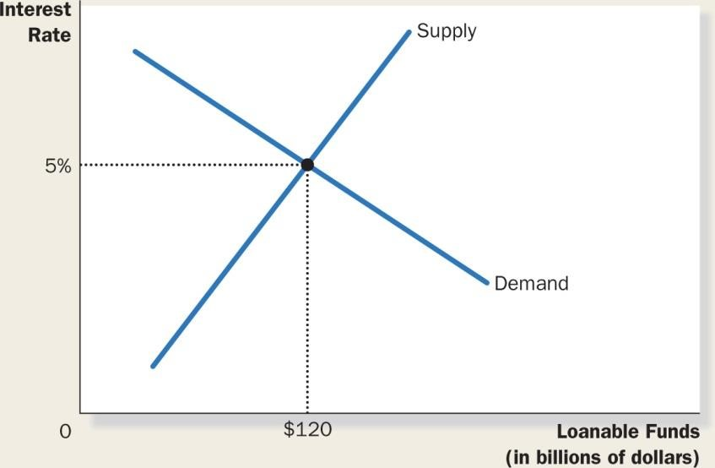

Policy I: Saving Investments
- A higher saving rate could lead to a higher rate of growth of GDP
- People respond to incentives:
  - Consumption taxes like GST
  - RRSPs
  - TFSA
  - RESP
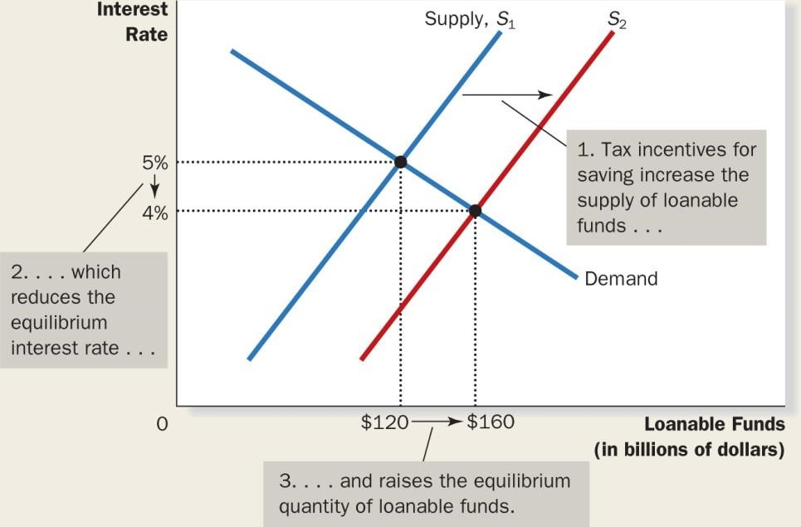

Policy II: Investment Incentives
- An investment tax credit gives a tax advantage to any firm building a new factory or buying a new piece of equipment
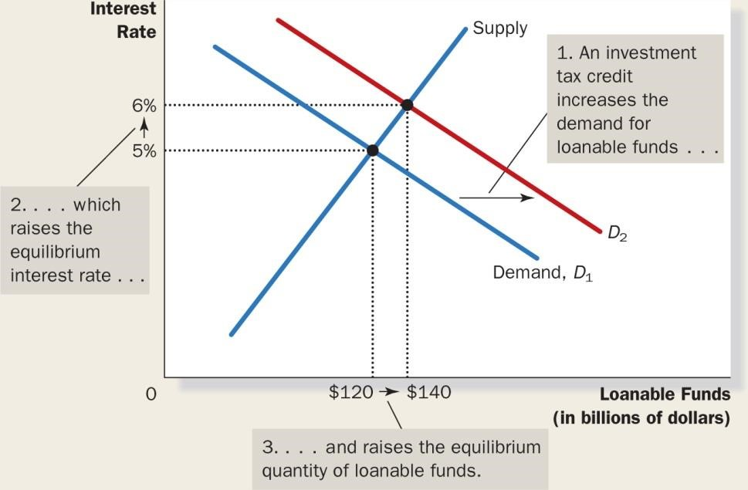

Policy 3: Government Budget Deficits and Surpluses
- Government Debt: the sum of past budget deficits and surpluses
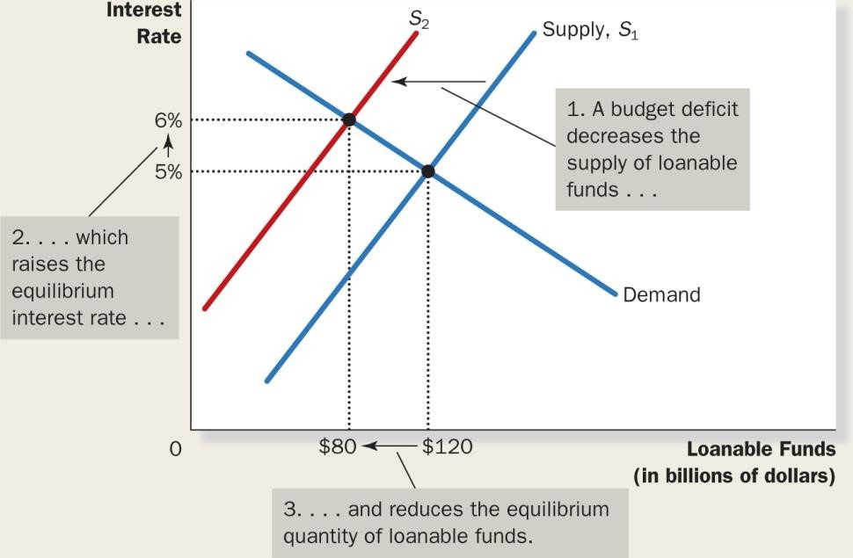
- Crowding out: a decrease in investment that results from government borrowing

Chapter 9- Unemployment and its Natural Rate

How is Unemployment Measured?
- Once the surveyed individuals are categorized, then SC will compute various statistics
- Labour Force: the total number of workers including both the employed and the unemployed
LF= No. of employed + No. of unemployed
- Unemployment rate: the percentage of the labour force that is unemployed
U= (No. of unemployed/ LF) x 100
- Labour Force participation rate: he percentage of the adult population that is in the labour force
LFPR= (LF/Adult Population) x 100

Does the Unemployment Rate Measure What we want it to?
- Movements into and out of th elabour force are common and complicate the measurement of the amount of unemployment.
- Because people move into and out of the labour force often, statistics on unemployment can be difficult to interpret
  - Unemployed people who are not trying hard to find a job
  - People calling themselves unemployed in order to receive unemployment insurance.
  - People who are officially unemployed but are working “under the table”
- Discouraged searchers: individuals who would like to work but have given up looking for a job.
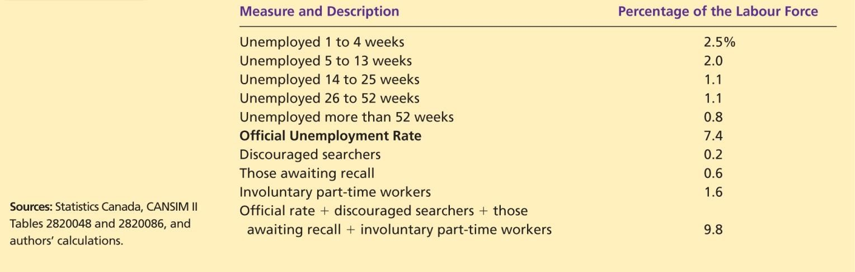

How Long are the Unemployed without Work?
- In 2011, the average spell of unemployment lasted 18.8 weeks
- From table 9.2
  - One-third of those suffering through a spell of unemployed for a month or less
  - Three-fifths are unemployed for less than three month
- Policy solutions directed toward fixing the unemployment problem should be directed at those suffering prolonged spells of unemployment

Why are there always some people unemployed?
- There are always workers without jobs, even when the overall economy is doing well.
- Natural unemployment rate: the rate of unemployment to which the economy tends to return in the long run
- the natural rate of unemployment in Canada is between 6 percent and 8 percent
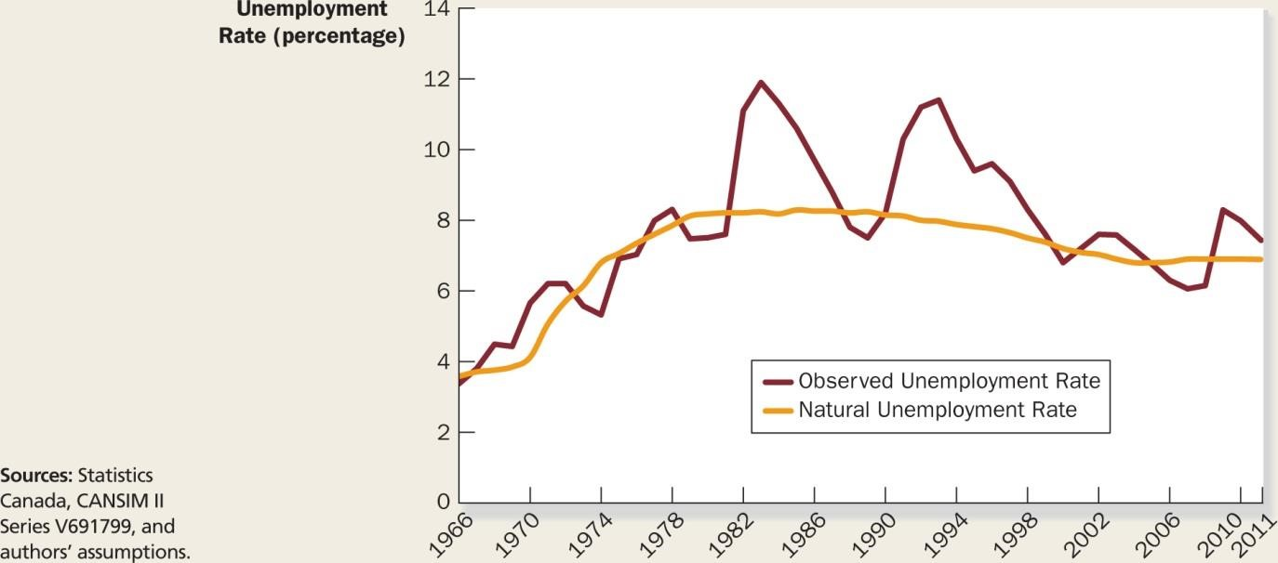
- figure above: shows that the observed unemployment rate fluctuates around the natural rate
- Cyclical unemployment: the deviation of unemployment from its natural rate.
- There are four ways to explain unemployment in the long-run:
  - Frictional unemployment: unemployment that results because it takes time for workers to search for the jobs the best suit their tastes and skills
  - Structural Unemployment: unemployment that results because the number of jobs available in some labour markets is insufficient to provide a job everyone who wants one
    - This often occurs when wages are set above the level that brings supply and demand into equilibrium
      - Wage laws
      - Union
      - Efficiency wages

Job Search
- Job Search: the process by which workers find appropriate jobs given their tastes and skills

Why some frictional unemployment is inevitable
- Frictional unemployment is often the result of changes in the demand for labour by firms
- Frictional unemployment is inevitable simply because the economy is always changing
- The process where jobs are created in one industry but destroyed in another leads to higher productivity and higher living standards
- The mismatch between available jobs and people seeking employment explains why one in every eight unemployed worker is without a job

Public Policy and Job Search
- Government programs try to facilitate the job search in various ways:
  - Government-run employment agencies
  - Public training programs

Employment Insurance
- Employment Insurance (ER): a government program that partially protects workers’ incomes when they become unemployed
- EI may reduce the hardship of unemployment, but the design of the program influences workers’ behaviour in ways that will increase the unemployment rate

Minimum Wage laws
- Minimum wage laws may not be the most important explanation for structural unemployment, it is nevertheless and important point
Unemployment from a Wage above the equilibrium level.
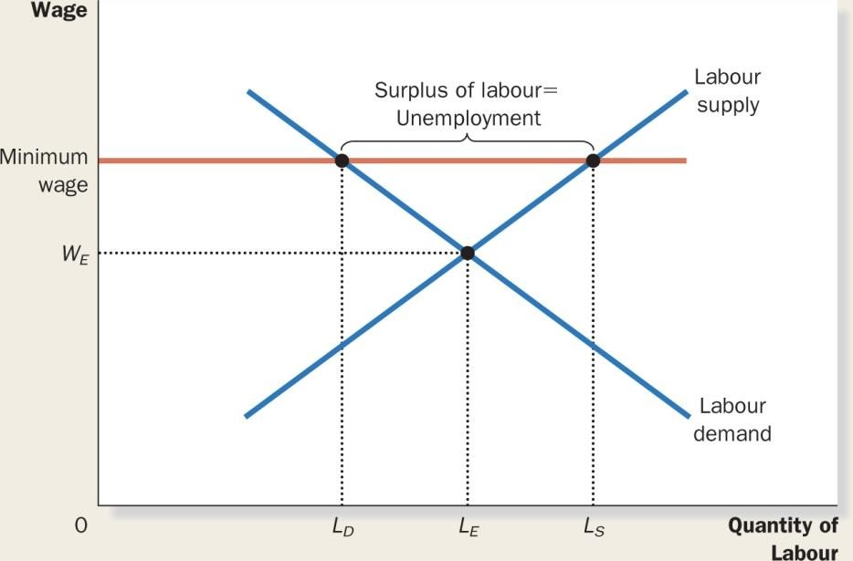

Unions and Collective Bargaining
- Union: a worker association that bargains with employers over wages and working conditions
  - as of 2011, 30 percent of all employed workers in Canada belong to unions
- Collective bargaining: the process by which unions and firms agree on the terms of employment
- Strike: the organized withdrawal of labour from a firm by a union
- When the union raises the wage above the equilibrium level, it raises the quantity of labour supplied and reduces the quantity of labour demanded, resulting in unemployment
- Workers who remain employed are better off
- Workers who lose their jobs are worse off
- It is believed that unions cause conflict between the insiders and the outsiders

Are Unions Good or Bad for the Economy?
- Critics of unions argue that they are merely a type of cartel
- Advocates of unions contend that unions are necessary antidote to the market power of the firms that hire workers
- Advocates also claim that unions are important for helping firms respond efficiently to the concerns of workers

The Theory of Efficiency Wages
- Efficiency wages: above-equilibrium wages paid by firms in order to increase worker productivity
- According to this theory, it may be profitable for the firm to keep wages high even if it causes a surplus of labout (or unemployment).
- Higher wages may increase the efficiency of workers
- Possible efficiency- wage theories:
  - Worker health
  - Worker turnover
  - Worker effort
  - Worker quality

Chapter 10- The Monetary System

Bank of Canada

The Bank of Canada Act
- Prior to the 1930s:
  - Bank notes were issued by the Department of Finance and the commercial banks
  - Canada was on the gold standard
- With the collapse of the gold standard as a result of the Great Depression, a need arose to control the quantity of fiat money in the economy.
- The end of the gold standard is 1970s, but it started to decline when the Great Depression hit Canada.
- The government enacted the Bank of Canada Act in 1934.
- The BoC was established in 1935 and nationalized in 1938.
- The BoC is managed by a board of directors. Including:
  - The governor, the senior deputy governor, and 12 directors, including the deputy minister of finance
  - The current governor of the BoC is Stephen Poloz
- In the practice, the BoC is independent of the government
- The BofC has four main functions:
- Issue Currency
- Banker to the commercial banks
- Banker to the Canadian government
- Control the money supply
- Money supply: the quantity of money available in the economy
- Monetary policy: the setting of the money supply by policy makers in the central bank

Monetary Policy
- The Bank of Canada has the power to increase or decrease the number of dollars in the economy.
- The Bank of Canada is an important institution because changes in the money supply can profoundly affect the economy.

Commercial Banks and the Money Supply
- Although the BoC alone is responsible for Canadian monetary policy, the central bank control the supply of money only through its influence on the entire banking system

The Simple Case of 100 Percent-Reserve Banking
- All deposits are held as reserves: 100 percent reserve banking
- Reserves: deposits that banks have received but have not loaned out

Money Creation with Fractional-Reserve Banking
- Fraction-reserve banking: a banking system in which banks hold only a fraction of deposits as reserves
- Reserve ratio: the fraction of deposits that banks hold as reserves
- They are multiplying money not wealth

Money Multiplier
- Money multiplier: the amount of money the banking system generates with each dollar it receives
- The money multiplier is the reciprocal of the reserve ratio
= 1/ reserve ratio

Bank Capital, Leverage, and the Financial Crisis of 2007-09
- Bank Capital: the resources the banks owners put into an institution from issuing equity (ex. Stock).
- Deposits are our money; debt is the (IOU papers), reserves is the interests of the deposits; and loans are the loans supplied to clients; securities (such as stocks).
- Leverage: the use of borrowed money to supplement existing fund for purposes of investment
- Leverage ratio: the ratio of assets to bank capital
- Capital requirement: a government regulation specifying a minimum amount of bank capital

The Bank of Canada’s Tools of Monetary Control
- Central banks have three main tools for monetary control:
  - Open-market operations
  - Changes in reserve requirements
  - Changes in the overnight rate
- The BoC uses changes in the overnight rate to control the money supply

Changing the Overnight Rate
- Bank rate: the interest rate charged by the Bank of Canada on loans to the commercial banks.
- Overnight rate: the interest rate on very short-term loans between commercial banks
- The BoC can alter the money supply by changing the bank rate
- This causes an equal change in the overnight rate
- A higher overnight rate discourages banks from borrowing reserves from the BoC; thus reducing reserves in the banking system
- The money supply contracts
- Changes to overnight rate posted eight times a year.

Open-Market Operations
- Open-market operations: the purchase or sale of Government of Canada bonds by the Bank of Canada
  - to increase the money supply, the Bo C buys bonds (or/ and Treasury bills) form the public
  - to reduce the money supply, the BoC sells bonds (or/and Treasury bills) to the public

- Quantitative easing: the purchase and sale by the central bank of nongovernment securities or government securities with long maturity terms
- Foreign exchange market operations: the purchase or sale of foreign money by the BoC
  - if the Bank of Canada buys $100M US dollars in the foreign exchange market for $150 M Canadian, the Canadian money supply increases immediately by $150M
  - If the Bank of Canada sells foreign currency from its foreign exchange reserves, it receives in exchange Canadian money supply is reduced.
- Sterilization: the process of offsetting foreign exchange market operations with open-market operations, so that the effect on the money supply is cancelled out.

Change Reserve Requirements
- Reserve Requirements: regulations on the minimum amount of reserves that banks must hold against deposits
  - An increase in reserve requirements means that banks must hold more reserves
  - It raises the reserve ratio
  - This lowers the money multiplier
  - The money supply decreases

Problems in Controlling the Money Supply
- The BoC does not control the amount of money households choose to hold as deposits in banks
- The BoC does not control the amount of money banks choose to lend

