Chapter #1 – Marketing: Creating and Capturing Customer Value

Marketing – The process by which companies create value for customers and build strong customer relationships in order to capture value from customers in return.

Needs – States of felt deprivation.

Wants – The form that human needs take as they are shaped by culture and individual personality.

Demands – Human wants that are backed by buying power.
Market Offerings – Some combination of products, services, information, or experiences offered to a market to satisfy a need or want.

Marketing Myopia – The mistake of paying more attention to the specific products a company offers than to the benefits and experiences produced by these products.

Exchange – The act of obtaining a desired object from someone by offering something in return.

Market – The set of all actual and potential buyers of a product or service.

Marketing Management – The art and science of choosing target markets and building profitable relationships with them. Questions to ask are what customers will we serve, how can we best serve these customers?

Market segment- refers to dividing the markets into segments of customers.

Target marketing- refers to which segments to go after

Demarketing- marketing to reduce demand temporarily or permanently; the aim is not to destroy demand but to reduce or shift it.

Value proposition- the set of benefits or values a company promises to deliver to customers to satisfy their needs.

Production Concept – The idea that customers will favor products that are available and highly affordable and that the organization should therefore focus on improving production and distribution efficiency.

Product Concept – The idea that customers will favor products that offer the most in quality, performance, and innovation features and that the organization should therefore devote its energy to making continuous product improvements.

Selling Concept - The idea that customers will not buy enough of the firm’s products unless it undertakes a large-scale selling and promotion effort.

Marketing Concept – A philosophy that holds that achieving organizational goals depends on knowing the needs and wants of target markets and delivering the desired satisfaction better than competitors do.

Societal Marketing Concept – The idea that a companies marketing decisions should consider consumers wants, the companies requirements, consumers long-run interests and societies long-run interest.

The marketing mix- is the set of tools (fours Ps) the firm uses to implement its marketing strategy. It includes product, price, promotion and place.

Integrated marketing program- is a comprehensive plan that communicates and delivers the intended value to chosen customers.

Customer Relationship Management (CRM) – The overall process of building and maintaining profitable customer relationships by delivering superior customer satisfaction and value.

Customer Perceived Value – The customers evaluation of the difference between all benefits and all costs of a marketing offer relative to those of competitors offers.

Customer Satisfaction – The extent to which products perceived performance matches buyer’s expectations.

Changing nature of customer relationships-
Relating with more carefully selected customers using selective relationship management to target fewer, more profitable customers.
Relating more deeply and interactively by incorporating more interactive two-way relationships through blogs, websites, online communities and social networks.

Customer Managed relationships – Marketing relationships in which customers, empowered by todays new digital technologies, interact with companies and with each other to shape their relationships with brands.

Consumer Generated Marketing – Brand exchanges created by consumers themselves – both invited and uninvited – through which consumers are playing an increasing role of shaping their own brand experience and those of other customers.

Partner Relationship Management – Working closely with partners in other company departments and outside the company to jointly bring more value to customers.
Supply chain: a channel that stretches from raw material to components to final products to final buyers
Supply management
Strategic partners
Strategic alliances

Customers Lifetime Value – The value of the entire stream of purchases that the customers would make over the lifetime of patronage.

Share of Customer – The portion of the customers purchasing that a company gets in its product categories.

Customer Equity – The total combined customer lifetime values of all of the company’s current and potential customers.

Building customer equity-
Building the right relationships with the right customers involves treating customers as assets that need to be managed and maximized.
Different types of customers require different relationship management strategies (build the right relationship with the right customers)

Projected loyalty
High
Profitability
Low
Long-term customers
Short-term customers
Good fit between company’s offerings and customer’s needs; high profit potential
Limited fit between company’s offerings and customer’s needs; low profit potential
Little fit between company’s offerings and customer’s needs; lowest profit potential
Good fit between company’s offerings and customer’s needs; highest profit potential
Strangers
Butterflies
True Friends
Barnacles

Chapter #2 – Company and Marketing Strategy: Partnering to Build Customer Relationships

Strategic Planning – The process of developing and maintaining a strategic fit between the organizations goals and capabilities and its changing marketing opportunities.

Mission Statement – A statement of the organizations purpose – what it wants to accomplish in the larger environment.

Market-oriented mission statement- defines the business in terms of satisfying basic customer needs.

Clear mission statement- acts as an “invisible hand” that guides people in the organization

Business objectives- builds profitable customer relationships, invest in research, and improve profits

Marketing objectives- Increase market share, create local partnerships and increase promotion

Business Portfolio – The collection of business and products that make up the company.

Portfolio Analysis – The process by which management evaluates the products and businesses that makes up the company.
The best business portfolio is the one that best fits the company’s strengths and weaknesses to opportunities in the environment.

Strategic business unit (SBU)- is a unit of the company that has a separate mission and objectives that can be planned separately from other company businesses
Company division, product line within a division, single product or brand

How to analyze the current business portfolio
- Identify key businesses (strategic business units, or SBUs) that make up the company
- Assess the attractiveness of its various SBUs
- Decide how much support each SBU deserves

The BCG growth-share Matrix

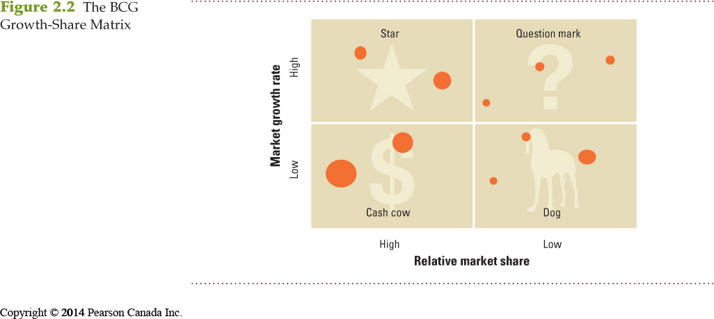

Growth Share-Matrix – A portfolio planning method that evaluates a company SBU’s in terms of its market growth rate and relative market share.
Problems with matrix approaches
- Difficulty in defining SBUs and measuring market share and growth
- Time consuming
- Expensive
- Focus on current businesses, not future planning

Product/Market Expansion Grid – A portfolio planning tool for identifying company growth opportunities though market penetration, market development, product development, or diversification.

Market Penetration - Company growth by increasing sales of current products to current market segments without changing the product.

Market Development – Company growth by identifying and developing new market segments for current company products.

Product Development – Company growth by offering modified or new products to current market segments.

Diversification – Company growth through starting up or acquiring businesses outside the company’s current products and markets.

Developing strategies for growth and downsizing product/market expansion grid strategies

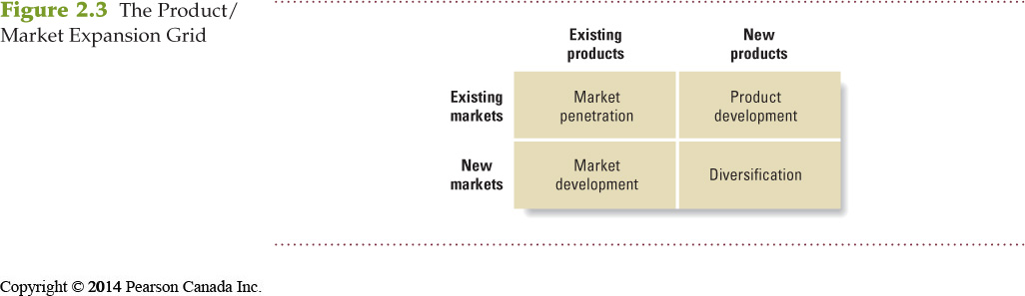

Downsizing- the reduction of the business portfolio by eliminating products or business units that are not profitable or that no longer fit the company’s overall strategy

Value Chain – The series of internal departments that carry out value-creating activities to design, produce, market, deliver, and support a firms products.
Partnering to build customer relationships (Wal-Mart)

Value delivery Network – The network made up of the company, its suppliers, its distributors, and, ultimately, its customers who partner with each other to improve the performance of the entire system.
Partnering to build customer relationships

Marketing Strategy – The marketing logic by which the company hopes to create customer value and achieve profitable customer relationships.

Market Segmentation – Dividing a market into distinct groups, of buyers who have different needs, characteristics, or behaviors, and who might require separate products or marketing programs.
Customer driven marketing strategy

Market Segment – A group of customers who respond in a similar way to a given set of marketing efforts.
Customer driven marketing strategy

Market Targeting – The process of evaluating each market segments ‘attractiveness’ and selecting one or more segments to enter.
Customer-centered marketing strategy

Positioning – Arranging for a product to occupy a clear, distinctive, and desirable place relative to competing products in the mind of the target consumers.
Customer-centered marketing strategy

Differentiation – Actually differentiating the market offering to create superior customer value.

Marketing Mix – The set of tactical marketing tools – product, price, placement, promotion – that the firm blends to produce the response it wants in the target market.
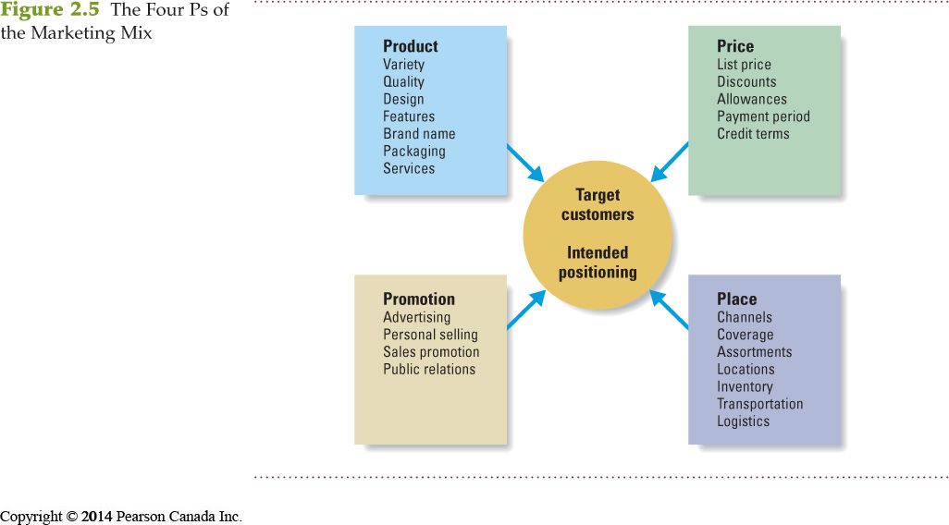
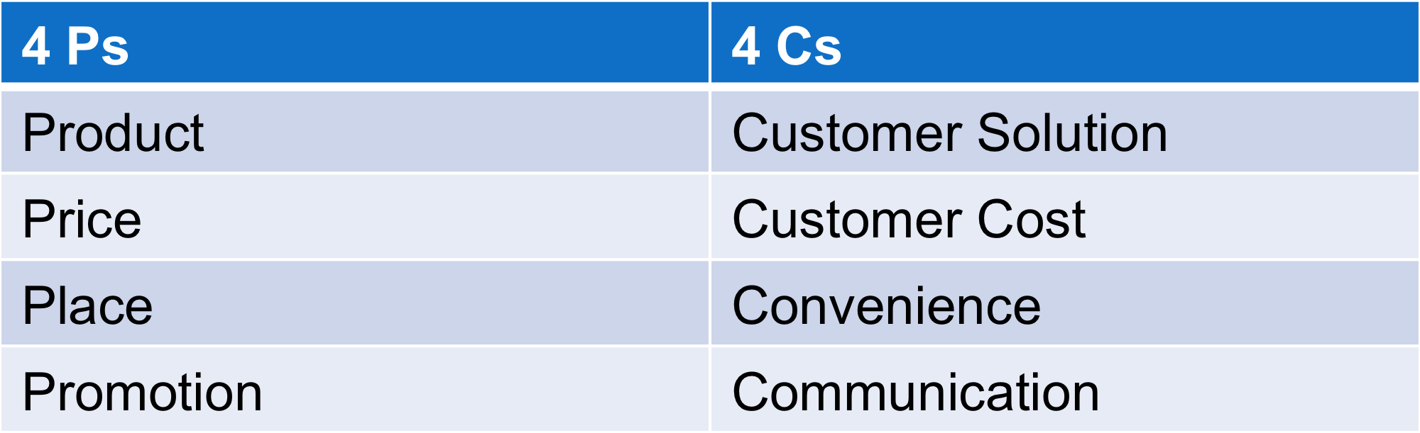

How to manage the marketing effort

Planning (develop strategic plans) develop marketing plansimplementation (carry out the plans)control (measure results)evaluate resultstake corrective action

SWOT Analysis – An overall evaluation of the company’s strengths, weaknesses, opportunities, and threats.

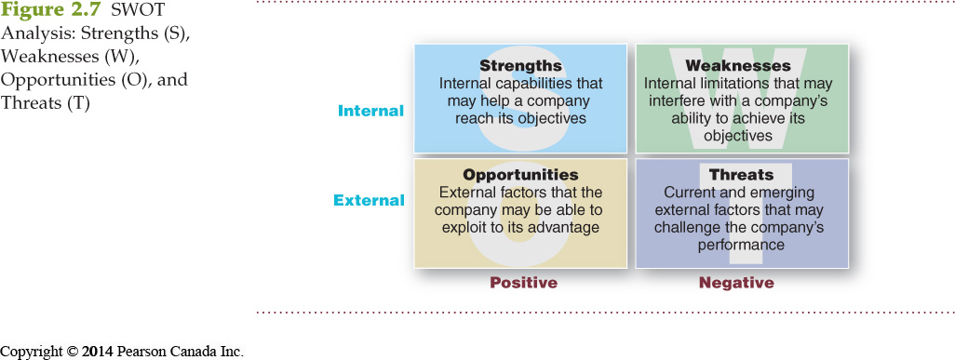

Marketing planning- executive summary, analysis of current situation, objectives, targets and positioning, marketing mix, budget, control

Marketing Implementation – Turning marketing strategies and plans into marketing actions to accomplish strategic marketing objectives.

Successful implementation depends on how well the company blends its people, organizational structure decision and reward system, and company culture into a cohesive action plan that supports its strategies

Marketing Control – Measuring and evaluating the results of marketing strategies and plans taking corrective action to ensure that the objectives are achieved.

Return on Marketing Investment (ROI) – The net return from a marketing investment divided by the total costs of the marketing investment.

Marketing ROI provides a measurement of the profits generated by investments in marketing activities

Designing a customer-driven marketing concept:
Chapter #3 – Analyzing the Market Environment
(Lecture 2)

Marketing Environment – The actors and forces outside marketing that affect marketing managements ability to build and maintain successful relationships with target customers.

Microenvironment – consists of the actors close to the company that affect its’s ability to serve its customers – the company, suppliers, marketing intermediaries, customers markets, competitors, and publics.
The company (top management, finance, R&D, purchasing, operations, accounting)
Suppliers (provide the resources to produce goods and services, treated as partners to provide customer value)
Marketing intermediaries (help the company to promote, sell, and distribute its products to final buyers) resellers, physical distribution firms, marketing service agencies, financial intermediaries
Competitors (firms must gain strategic advantage by positioning their offerings against competitors’ offerings)
Publics (any group that has an actual or potential interest in or impact on an organization’s ability to achieve its objectives) media financial government local general and internal publics.
Customer markets (consumer, business, reseller, government and international)

Macroenvironment – The larger societal forces that affect the microenvironment – demographic, economic, natural, technological, political, and cultural forces.

Demography – The study of human populations in terms of size, density, location, age, gender, race, occupation, and other statistics.

Why is demographic important? – Because it involves people and people make up markets

Baby Boomers – People born between 1946 and 1964. The 9.8 million Canadians born during the baby boom following the war and lasting until the mid-1960’s.

Generation X – The 7 million Canadians born between 1965 – 1976. High parental divorce rates, cautious economic outlook, less materialistic, family comes first.

Millennials (or Generation Y) – million children of the Canadian baby-boomers, born between 1977 – 2000. Confortable with technology, includes Tweens (age 8-12) teens (age 13-19), young adults (20s)

Generational marketing- important in segmenting people by lifestyle or life state rather than by age.

Demographic Environment – Economic factors that affect consumer purchasing power and spending patterns. More people are divorcing or separating, choosing not to marry, choosing to marry later, more working women, more stay at home dads.

Natural Environment – Natural resources that are needed as inputs by marketers or that are affected by marketing activities.
Trends (shortage of raw materials, increased pollution increased government intervention, environmentally sustainable strategies)

Technological environment- perhaps the most dramatic force now shaping our destiny. Technology has released such wonders as antibiotics, robotic surgery, miniaturized electronics, smartphones and Internet

Political environment- consists of laws, government agencies, and pressure groups that influence or limit various organizations and individuals in a given society.

Social environment- refers to social codes and rules of professional ethics beyond written laws and regulations, beyond doing simply the right thing (ex; toms)

Economic environment- consists of factors that affect consumer purchasing power and spending patterns (changes in income, offer the right combination of quality and service at a fair price)

Ernst Engel-Engel’s law
As income rises, the % spent on food declines, % spent on housing remains constant, % spent on savings increases

Cultural Environment – Institutions and other forces that affect a societies basic values, perceptions, preferences, and behaviors.

Core beliefs and values: persistent and are passed on from parents to children and are reinforced by schools, churches, businesses and government

Secondary beliefs and values: more open to change; include people’s views of themselves, others, organization, society, nature and the universe

Responding to the marketing environment
- Uncontrollable, react and adapt to forces in the environment
- Proactive, aggressive actions to affect forces in the environment
- Reactive, watching and reacting to forces in the

Chapter #5 – Managing Marketing Information and Gain Customer Insights
(Lecture 3)

Customer Insights – Fresh and deep understandings of customers needs and wants, difficult to obtain, not obvious, customer’s unsure of their behavior. The marketplace derived from marketing information that becomes the basis for creating customer value and relationships.

Marketing Information system (MIS) – People and procedures for assessing information needs, developing the needed information, and helping decision makers to us the information to generate and validate actionable customer and market insights.

MIS provides- information to the company’s marketing and other managers and to external partners such as suppliers, resellers and marketing service agencies

Characteristics of a good MIS- balancing the information users would like to have against what they need and what is feasible to offer. MIS offerings vs. user’s need.

Marketers obtain information from the following;
Internal data, marketing intelligence, marketing research

Internal Databases – Electronic collections of customer and market information obtained from data sources within the company’s network.
Information collected from different sources within the company and stored within the organization’s information system (accounting system, sales report, research study, operations/production)

Internal data is cheap, quick and easy; may not be in a usable form for the decision to be made. May be incomplete or inappropriate to a particular situation.
Marketing Intelligence – The systematic collection and analysis of publicly available information about consumers, competitors, and developments in the marketing environment.

Marketing Research – The systematic design, collection, analysis, and reporting of data relevant to a specific marketing situation facing an organization.

Steps to marketing research process

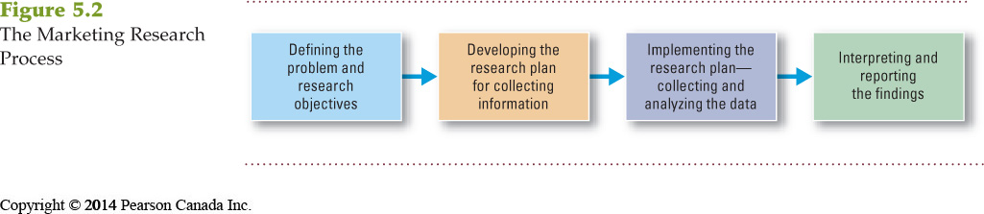

Defining the problem and research objectives -- defining the problem and the research objectives are often the hardest step in the research process. In the case of dove, the problem statement was how to women themselves define beauty.

Exploratory research: outlines sources of existing data, spells out the specific research approaches, contact methods, sampling plans, and instruments to gather data.

Developing the research plan
Secondary Data – information that already exists somewhere, having been collected.
Primary Data – Information collected for the specific purpose at hand.

Choosing the research method
- Survey research: interviewer interacts with respondents to obtain facts, opinions and attitudes
- Observation research: descriptive research that monitors respondents actions
- Experiments: measures causality, in which he researcher changes one or more variables and observes the effect of the changes on another variable

Research approach
Observational research – involves gathering primary data by observing relevant people, actions, and situations

Survey research: most widely used method and is best for descriptive information – knowledge, attitudes, preferences, and buying behavior (it is flexible, people may be unable or unwilling to answer, people may give misleading or pleasing answers, there may be privacy concerns)

Experimental research—best for gathering causal information, cause and effect relationships

Ethnographic research—involves sending trained observers to watch and interact with consumers in their natural environment.

Qualitative methods
Focus groups (6-10 people with a trained moderators), challenges because it is expensive, difficult to generalize from small group, consumers not always open and honest

Sampling plan
Sample is a segment of the population selected for marketing research to represent the population as whole.
Who is be surveyed, how many people should be surveyed, how should the people be chosen.

Probability sampling -- sample a subset of the population of interest, assumed to be a representative cross-section, every element in the population has a known non-zero chance of being selected.

Non-probability sampling—a subset of the population, chances of selection for the various elements in the population are known, usually based on convenience.

Different types of ways to do marketing research

- Online research – advantages (low cost, speed, higher response rates, good for hard to reach groups) disadvantage (restricted internet access, not sure who is answering)
- Questionnaires (most common, administered in person, by phone of online, flexible, research must be careful with wording and ordering of questions)
Close ended questions—include all possible answers, and subjects make choices among them
Open ended questions—allow respondents to answer in their own words

Implementing the research plan – collection information processing the info analyzing the info interpret findings

Interpreting and reporting the findings—draw conclusions make recommendationsreport to management

Customer Relationship Management (CRM) – consists of sophisticated software and analytical tools that integrate customer information from all sources, analyze it in depth, and apply the results to build stronger customer relationships

Information distribution: involves entering information into databases and making it available in a time-useable manner
- Intranet provides info to employees and other stakeholders
- Extranet provides information to key customers and suppliers

Chapter #6 – Consumer Markets and Consumer Buyer Behavior
(Lecture 4)

Consumer Buyer Behavior – The buying behavior of final consumers – individuals and households that buy goods and services for personal consumption.

Consumer Market – All of the individuals and households that buy or acquire goods or services for personal consumption.

Model of consumer behavior

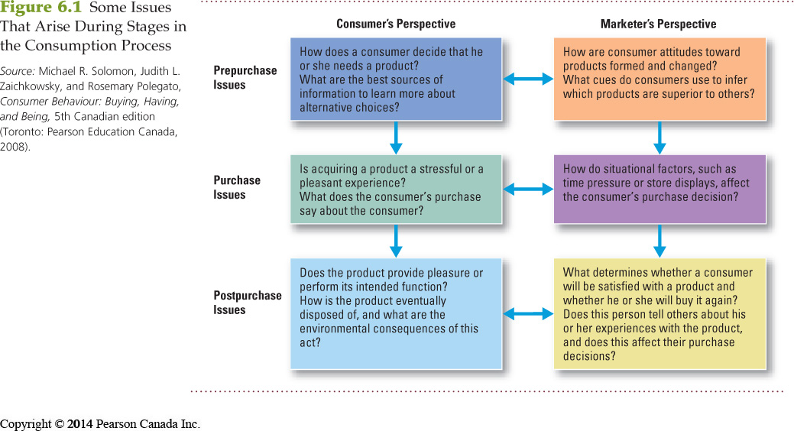

Culture—is the set of basic values perceptions, wants and behaviors learned from family and other important institutions

Subcultures – groups of people within a culture with shared value systems based on common life experiences and situations

Social Class – Relatively permanent and ordered divisions in a society whose members share similar values, interests, and behaviors.
Measured by a combination of occupation, income, education, wealth and other variables

Groups and social networks

- Membership groups: groups with direct influence and to which a person belongs
- Aspirational groups: groups an individual wishes to belong to
- Reference groups: groups that form a comparison or reference in forming attitude or behavior

Word of mouth influence and buzz marketing: opinion leaders are people within a reference group who exert social influence on others (influence leading adopters) note that marketers identify them to use as brand ambassadors

Online Social Networking – Online social communities – blogs, social networking’s websites, and even virtual worlds – where people socialize or exchange information and opinions.

Social factors—family is the most important consumer-buying organization in society, social roles and status are the groups family, clubs and organizations that a person belongs to that can define roles and social status.

Personal factors—age and life cycle stage, RBC has identified five life stages

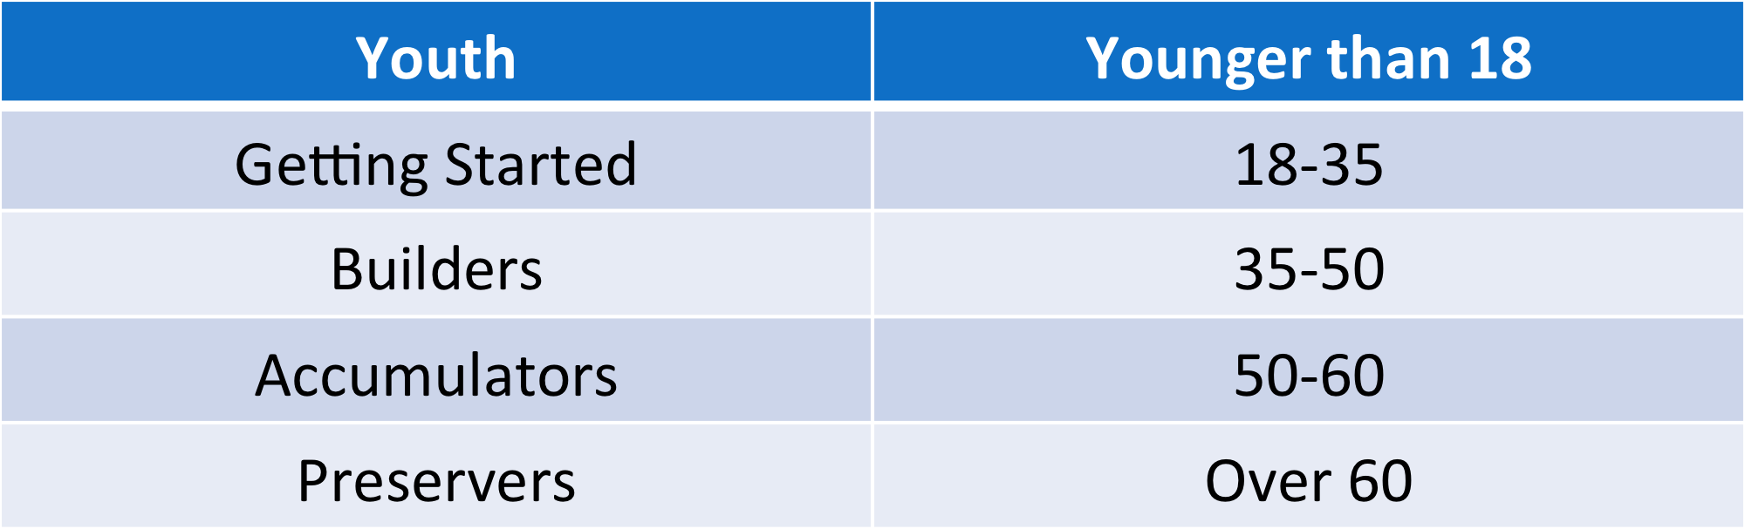

Occupation affects the goods and services bought by consumers

Economic situation includes trends in the following

Lifestyle is a person’s pattern of living as expressed in his or her psychographics

Personality refers to the unique psychological characteristics that lead to consistent and lasting response to the consumer’s environment (consumers are most likely to choose brands with personalities that match their own)

Psychological factor

Motive (drive) – A need that is sufficiently pressing to direct the person to seek satisfaction of the need.

Motivation research—refers to qualitative research designed to probe consumers’ hidden, subconscious motivations

Perception – The process by which people select, organize, and interpret information to form a meaningful picture of the world.
- Selective attention is the tendency for people to screen out most of the information to which they are exposed
- Selective distortion is the tendency for people to interpret information in a way that will support what they already believe
- Selective retention is the tendency to remember good points made about a brand they favor and forget good points about competing brands

Learning is the change in an individual’s behavior arising from experience and occurs through interplay of the following

Belief- descriptive thought that a person has about something based on the following (knowledge, opinion, faith)

Attitude – A persons relatively consistent favorable or unfavorable evaluations, feelings, and tendencies toward an object or idea.

Four types of buying behavior

1.Complex Buying Behavior – Consumer buying behavior in situations characterized by high consumer involvement in a purchase and significant perceived differences among brands.

2.Dissonance-reducing buying behavior – Consumer buying behavior in situations characterized by high involvement but few perceived differences among brands.

3.Habitual Buying Behavior – Consumer buying behavior in situations characterized by low consumer involvement and few significant brand differences.

Buyer decision process
Consumer decision-making process:

- Need recognition
- Information search
- Evaluation
- Purchase decision
- Post-purchase evaluation
Need Recognition – The first stage of the buyer decision process, in which the consumer recognizes a problem or need.

Source of information—personal source(family friends) commercial source(advertising internet) public source (mass media, consumer organization) experiential sources(handling, examining, using the product)

Evaluation of alternatives—how the consumer processes info to arrive at brand choice, from marketer perspective, it is important to highlight the features that are your product’s strength in the information stage. Those features also benefit the consumer this is where your product will stand out.

Purchase decision—act by the consumer to buy the most preferred brand, the decision can be affected by attitudes of others, unexpected situational factors

Post purchase decision—satisfaction or dissatisfaction that the consumer feels about the purchase. Consumer’s expectations and product perceived performance, the larger the gap, and the bigger the consumer’s dissatisfaction.

Cognitive dissonance: the discomfort caused by a post-purchase conflict
Customer satisfaction: key to building profitable relationships with consumers

Stages of adoption process; mental process an individual goes through from first learning about innovation to final regular use.
Awarenessinterestevaluationtrialadoption

Individual difference in innovativeness: people differ greatly int heir readiness to try new products, in each product area, there are consumption pioneers and early adopters

Influences of product characteristics
- Relative advantage (cd player vs. mp3)
- Compatibility (house phone vs. cell phone)
- Complexity (download music to put on mp3, is it hard?)
- Divisibility (were u able to try it before purchasing it )
- Communication (did you see ppl enjoy the product before buying it ?)

Chapter 8. Customer Driven Marketing Strategy

Market Segmentation: diving a market into smaller segments of buyers with different needs, characteristics, or behaviors that may require separate marketing strategies or mixes.

Market targeting: the process of evaluating each market segments attractiveness and selecting which ones to enter.

Differentiation: involves actually differentiating the market offering to create superior customer value

Positioning: consists of arranging for a market offering to occupy a clear, distinctive, and desirable place relative to competing products in the minds of target consumers.

4 Segments->
- Geographic segmentation: when you divide a market according to geographic units. (Nations, countries, provinces, regions, neighborhoods)
- Demographic segmentation: diving the market based on age, gender, family size, family life cycles, income, education, race, generation, religion, nationality.
Age and life-cycle stage segmentation: process of offering different products or using different marketing approaches for different age and life-cycle groups

Gender segmentation: devides the market groups based on gender

Income segmentation: devides the market into different income groups

- Psychographic segmentation: dividing the market based on social class, lifestyles or personality characteristics.
- Behavioral Segmentation: diving the market based on consumer knowledge, attitudes, uses and responses to a product.

Occasion segmentation: Divides the market into groups according to occasions when buyers get the idea to buy, actually make their purchase, or use the purchased item

Benefit segmentation: divides the market into groups according to the different benefits that consumers seek from the product

User status: segments that market into nonusers, exusers, potential users, first time users, and regular users of product

Usage rate: divides the market into light, medium, and heavy product users

Loyalty status: divides the market by consumer loyalty

Multiple segmentation: used to identify smaller, better-defined target groups

Geodemographic segmentation: example of multivariable segmentation that divides groups into consumer lifestyle patterns

Intermarket(cross market) segmentation: divides consumers into groups with similar needs and buying behaviours even though they are located in different contries

NOTE: in order to be useful, market segments must be measurable,accessible, substantial, differential and actionable
- Measurable: size, purchasing power, and profiles of segments can be measured
- Accessible: the market segments can be effectively reached and served
- Substantial: the market seems large or profitable enough to serve
- Diferentiable: the segments are conceptually distinguishable and responed differently to different marketing mix elements and programs
- Actionable: effective programs can be designed for attracting and serving the segments

Market Targeting Strategies

Target market: consists of a set of buyers who share common needs or characteristics that the company decides to serve

-Mass Marketing: strategy in which a form decides to ignore market segment differences and target the whole market with ONE offer

-Undifferentiated mass marketing: targets the whole market with one offer (focuses on common needs rather than on what is different)

-Differentiated (Segmented) marketing: strategy in which a firm decides to target several market segments and designs SEPERATE offers for each. (goal is to achieve higher sales and stronger position, more expensive than undifferentiated marketing)
-Concentrated (niche) marketing: practice of tailoring products and marketing programs to suit the tastes of specific individuals and local customer groups. (Limited company resources, knowledge of the market, more effective and efficient)

-Micromarketing: product and marketing programs to the needs and wants of -SPECIFIC individuals and local customer segments. (Include local and individual marketing

-Local marketing: involves tailoring brands and promotion to the needs and wants of local customer groups (cities, neighborhoods, stores)

-Individual marketing: involves tailoring products and marketing programs to the needs and preferences of individual customers (known as one-to-one marketing, mass customization, markets of one marketing)

Note: to choose a target market, it depends on company resources, product variability, product life-cycle stage, market variability, and competitor’s marketing strategies

Product position: is the way the product is defined by consumers on important attributes, the place the product occupies in consumer’s minds relative to competing products (perceptions, impressions, feelings)

Perceptual positioning maps: show consumers perceptions of their brands, versus competing products on important buying dimensions

Competitive advantage: advantage over competitors gained by offering great customer value, either through lower prices or by providing more benefits that justify higher prices
Product differentiation: on features, performances, or style and design
Service differentiation: speedy, convenient, careful delivery
Channel differentiation: design their channel’s coverage, expertise and performance
People differentiation: hiring and training people better
Image differentiation: strong, distinctive image conveying the product’s distinctive benefits and positioning

Choosing the right competitive advantage
- IMPORTANT: difference delivers a highly valued benefit to target buyers
- DISTINCTIVE: competitors do not offer the difference, or the company can offer it in a more distinctive way
- SUPERIOR: difference is superior to other ways that customers might obtain the same benefit
- COMMUNICABLE: difference is communicable and visible to buyers
- PREEMPTIVE: competitors cannot easily copy the difference
- AFFORDABLE: buyers can afford to pay for the difference
- PROFITABLE: company can introduce the difference profitable

Value proposition: is the full mix of benefits upon which a brand is positioned

Positioning statement: summarizes the company or brand position

Chapter 9. Products, Services & Brands: Building Customer Value

Products: anything that can be offered in a market for attention, acquisition, use, or consumption that might satisfy a need or want

Services: any activities or benefits that one party can offer to another that is essentially intangible and do not result in the ownership of anything

Experiences: represents what buying the product or service will do for the customer

Levels of product and services 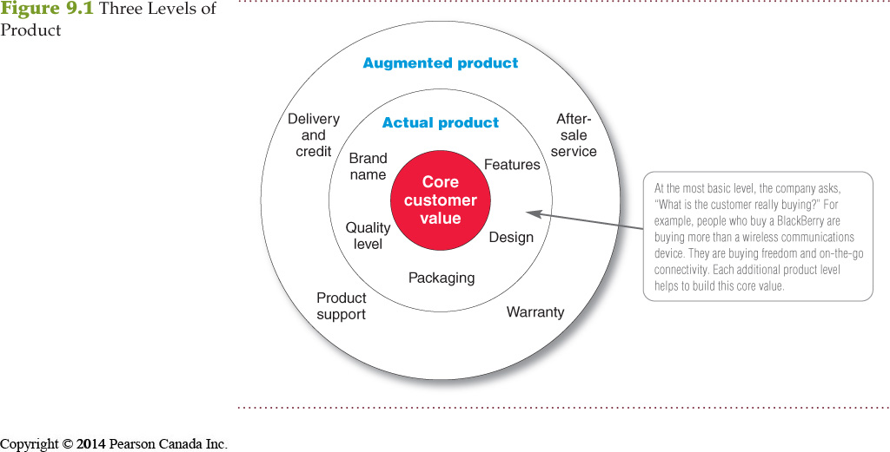

Convenience products are consumer products and services that the customer usually buys frequently, immediately, and with a minimum comparison and buying effort (candy, newspaper, fast food)

Shopping products are consumer products and services that the customer compares carefully on suitability, quality, price, and style (furniture, cars, appliances)

Specialty products are consumer products and services with unique characteristics or brand identification for which a significant group of buyers is willing to make a special purchase effort (medical services, designer, Rolex watches)

Unsought products are consumer products that the consumer does not know about or knows about but does not normally think of buying (life insurance, funeral services, blood donations)

Type of Consumer Product

Marketing Considerations | Convenience | Shopping | Specialty | Unsought
Customer buying behavior | Frequent: little planning, little comparison, or shopping effort; low customer involvement | Less, frequent purchase; much planning and shopping effort: comparison of brands on price, quality, and style | Strong brand preference and loyalty; special purchase effort; little comparison of brands; low price sensitivity | Little product awareness: knowledge( or If aware, little or even negative interest)
Price distribution | Low price  Widespread distribution convenient | Higher Price  Selective distribution in fewer outlets | High Price  Exclusive distribution in only one or a few outlets per market area | Varies
Promotion | Mass promotion by the producer | Advertising and personal selling by both the producer and resellers | More carefully targeted promotion by both the producer and resellers | Aggressive advertising and personal selling by the producer and resellers
Examples | Toothpaste, magazines and laundry detergent | Major appliances, televisions, furniture, and clothing | Luxury goods; such as Rolex watches or fine crystal | Life insurance and Canadian blood service donations

Industrial products are products purchased for further processing or for use in conducting a business.

Capital items are industrial products that aid in the buyer’s production or operations.

Materials and parts include raw materials and manufactured materials and parts usually sold directly to industrial users.

Supplies and services include operating supplies, repair and maintenance items, and business services.

Organization marketing consists of activities undertaken to create, maintain, or change attitudes and behavior of target consumers toward an organization.

Person marketing consists of activities undertaken to create, maintain, or change attitudes and behavior of target consumers toward particular people
Product Line Decisions: a group of products that are closely related because they function in a similar manner, are sold to the same customer groups, are marketed through the same types of outlets, or fall within given price ranges

Place marketing consists of activities undertaken to create, maintain, or change attitudes and behavior of target consumers toward particular places.

Social marketing is the use of commercial marketing concepts and tools in programs designed to influence individuals’ behavior to improve their well-being and that of society.

Steps to individual product and service decisions
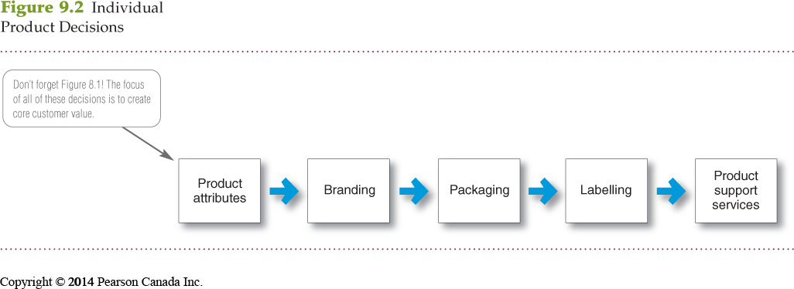

Product attributes are the benefits of the product or service:
Quality
- Quality level is the level of quality that supports the product’s positioning.
- Total quality management (TQM) is an approach in which all the company’s people are involved in constantly improving the quality of products, services, and business processes.
- Conformance quality is the product’s freedom from defects and consistency in delivering a targeted level of performance.
Features
- Product features are a competitive tool for differentiating a product from competitors’ products.
- Product features are assessed based on the value to the customer versus the cost to the company.
Style and design
- Style describes the appearance of the product.
- Design contributes to a product’s usefulness as well as to its looks.

Brand is the name, term, sign, or design—or a combination of these—that identifies the maker or seller of a product or service.

Brand equity is the differential effect that the brand name has on customer response to the product and its marketing.

Packaging involves designing and producing the container or wrapper for a product.

Labels identify the product or brand, describe attributes, and provide promotion.

Product line is a group of products that are closely related because they function in a similar manner, are sold to the same customer groups, are marketed through the same types of outlets, or fall within given price ranges.
Product line length is the number of items in the product line:
  - Line stretching
  - Line filling

Product Mix Decisions: consists of all the products and items that a particular seller offers for sale (width, length, depth, consistency)

Building strategy to build a strong brand

Brand represents the consumer’s perceptions and feelings about a product and its performance. It is the company’s promise to deliver a specific set of features, benefits, services, and experiences consistently to the buyers.

Brand Equity is the positive differential effect that knowing the brand name has on customer response to the product or service.
Young & Rubicam’s Brand Asset Evaluator measures brand strength along four consumer perception dimensions:
1. Differentiation (what makes the brand stand out),
2. Relevance (how consumers feel it meets their needs),
3. Knowledge (how much consumers know about the brand), and
4. Esteem (how highly consumers regard and respect the brand).

Brand name selection
Desirable qualities:
- Suggests benefits and qualities
- Easy to pronounce, recognize, and remember
- Distinctive
- Extendable
- Translatable for the global economy
- Capable of registration and legal protection

Brand sponsorship

National brands (manufacturer’s brands) are created by the manufacturer.

Store brands (private brands) are brands created and owned by a reseller of a product or service.

Licensing uses previously created names or symbols for a fee.

Co-branding is the practice of using the established brand names of two different companies on the same product.

Brand development strategies

Line extension involves extending an existing brand name to new forms, colours, sizes, ingredients, or flavours of an existing product category.

Brand extension involves extending an existing brand name to new product categories.

Multibrands are additional brands introduced in the same product category.

New brands are brands created when entering a new product category for which none of the current brand names are appropriate.

Types of service industries

1. Government
2. Private not-for-profit organizations
3. Business organizations

Nature and characteristics of a service

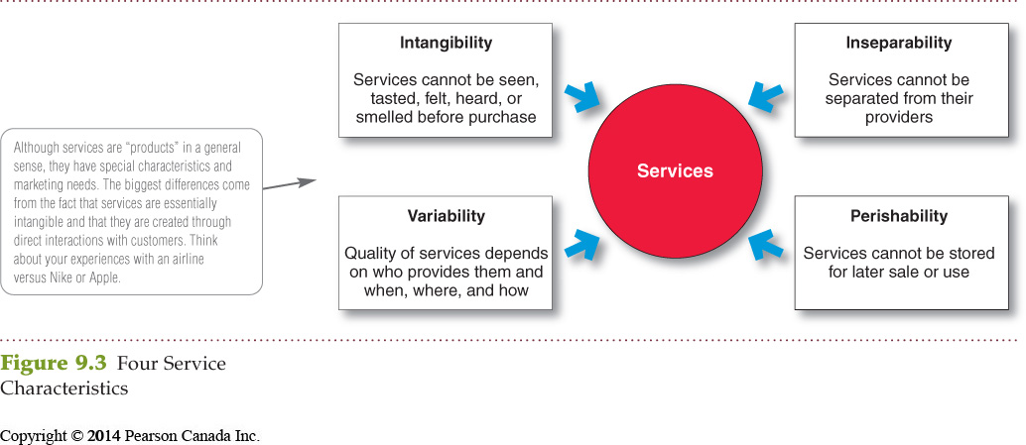
Marketing strategies for service firms

Service-profit chain links service firm profits with employee and customer satisfaction:
  - Internal service quality
  - Satisfied and productive service employees
  - Greater service value
  - Satisfied and loyal customers
  - Healthy service profits and growth

Internal marketing means that the service firm must orient and motivate its customer contact employees and supporting service people to work as a team to provide customer satisfaction. (Internal marketing must precede external marketing)

Interactive marketing means that service quality depends heavily on the quality of the buyer-seller interaction during the service encounter:
  - Service differentiation
  - Service quality
  - Service productivity

Managing service differentiation creates a competitive advantage from the offer, delivery, and image of the service:
  - Offer can include distinctive features.
  - Delivery can include more able and reliable customer contact people, environment, or process.
  - Image can include symbols and branding.

Managing service quality provides a competitive advantage by delivering consistently higher quality than its competitors.
- Service quality always varies depending on interactions between employees and customers.

Managing service productivity refers to the cost side of marketing strategies for service firms:
  - Employee recruiting, hiring, and training strategies
  - Service quantity and quality strategies

