Organizational Behavior Chapter 8 Notes

Characteristics of Explicit and Tacit Knowledge

- Learning is a relatively permanent change in a person’s knowledge or skill that comes from experience

- The more the employees learn, the more they bring to the table when it comes to work

- Decision making is the process of generating and choosing from a set of alternatives to solve a problem

- The more knowledge and skills employees possess, the more likely they are to make accurate and sound decisions

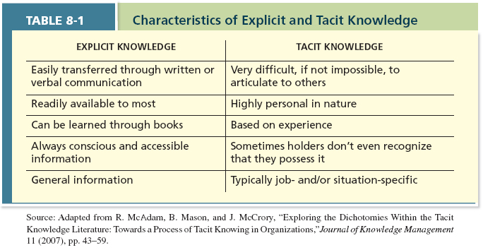

Methods of Learning

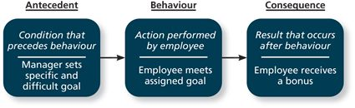

- Operant learning is when a goal is set by an employer for the employee to meet it and if he/she meets that goal, that employee is given a reward or bonus

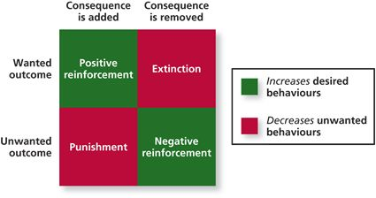

- Contingencies of reinforcement are four specific consequences that are used by organizations to modify employee behavior

- Positive reinforcement occurs when a positive outcome follows a desired behavior

- Perhaps the most common type of reinforcement and most associated with when an employee gets a reward

- For a positive reinforcement to be successful, an employee needs to see the direct link between his or her behavior and the desires outcome

- Negative reinforcement is occurs when an unwanted outcome is removed following a desire behavior

- Punishment occurs when an unwanted outcome follows and unwanted behavior

- The employee is given something he or she doesn’t like as a result of performing a behavior that the organization doesn’t like

- Extinction occurs when a consequence is removed following an unwanted behavior

- The use of extinction to reinforce behavior can be purposeful or accidental

- For example, maybe an employee gets attention from co-workers when he or she acts somewhat childishly at work and finding a way to remove the attention would be a purposeful act of extinction

- In general, positive enforcement and extinction should be the most common forms of reinforcement used by managers to create learning among their employees

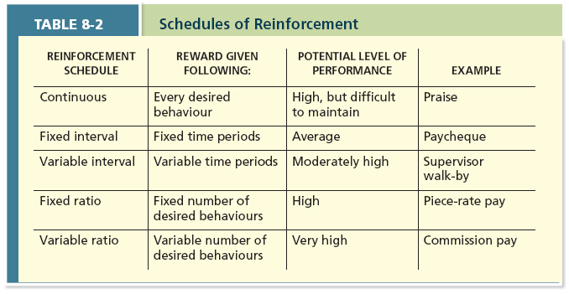

- Schedules of contingencies are the timing of when contingencies are applied or removed

- One of the simplest ones is continuous reinforcement it occurs when a specific consequence follows each and every occurrence of a desired behavior

- For most jobs, this type of reinforcement is impractical

- Studies show that continuous reinforcement may be the least long-lasting because as soon as the consequence stops, the desired behavior stops along with it

- The other four schedules differ in terms of their variability and basis of consequences

- A fixed-interval schedule is probably the single most common form and in this schedule, workers are rewarded after a certain amount of time

- A variable-interval schedule is designed to reinforce behavior at more random points in time

- For example, a supervisor walking around at different times of the day

- The fixed ratio schedule reinforces behaviors after a certain number of them have been exhibited

- For example, they way manufacturing plants pay their employees for the amount of goods that they have produced

- A variable ratio schedule is when employees are rewarded after a varying number of exhibited behaviors

- For example, sales people getting paid by commission

- The social learning theory argues that people in organizations have the ability to learn by observing others

- Many would argue that this is the way that employees gain knowledge in an organization

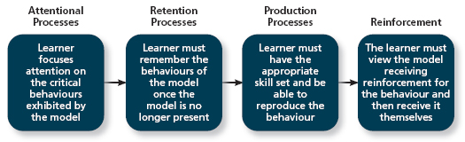

- Behavioral modeling is when employees observe the actions from others, learn from what they observe, and then repeat the observed behavior

- For behavioral modeling to occur successfully, a number of things must take place which are outlined in the figure above

- Learning orientation is the attitude that some people have in which building competence is deemed more important than showing competence

- Performance-prove orientation is when people focus on demonstrating their competence so that others think of them favorably

- Performance-avoid orientation when people focus on demonstrating their competence so that others will not think poorly of them

- In any case, performance-oriented people work on tasks in which they are good at which prevents them from failing in front of others

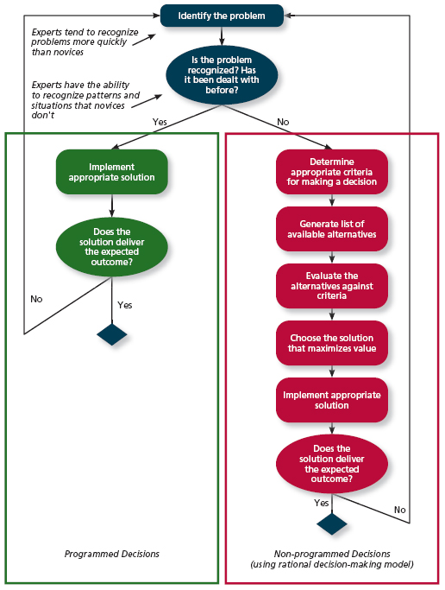

- Programmed decisions are decisions that have become somewhat automatic within a person because that person’s knowledge allows him or her to recognize and identify the situation and the course of action needed to be taken

- To experts, this type of decision making is often known as intuition or “gut-feeling”

- Intuitive decision making is probably most important when it comes to dealing with a crisis and a crisis situation is a change, whether sudden or evolving, that results in an urgent problem that must be dealt with immediately

- When a new and complex situation arises, it calls for a non-programmed decision on the part of the employee

- The rational decision-making model offers a step-by-step approach to making decisions that maximize outcomes by examining all available outcomes

- The first step in this process is to identify criteria that are important in making this decision, next is to generate a list of all available alternatives that may be potential solutions to the problem, the third step is to evaluate these alternatives against the criteria laid out in step one and lastly, select the alternative that results in the best outcome

Decision Making Problems

- There are four types of decision making problems, which include: limited information, faulty perceptions, faulty attributions and escalation of commitment

- Although most employees see themselves as rational decision makers, the reality is that they’re all subject to bounded rationality which states that decision makers simply do not have all available information and alternatives to make an optimal decision

- This limit results in two problems which are that first, people have to filter and simplify information in order to make sense of their complex environment and second, because people cannot possibly think of every single alternative when making a decision, they satisfice

- Satisficing occurs when people choose the first acceptable alternative that is considered and in addition come up with alternatives that are straightforward and are not that different from what they are already doing

- Perception is the process of selecting, storing, organizing and retrieving information about the environment and employees as decision makers are forced to rely on perception when making decisions

- Selective perception is the tendency for people to see the environment only as it affects them and as it is consistent with their expectations

- One false assumption that some people make is the belief that other people think, feel and act as they do and this is known as projection bias

- Another example of faulty perception is the social identity theory which holds that people identify themselves according to the groups to which they belong and perceive and judge others by their group memberships

- A stereotype occurs when assumptions are made about others in terms of their membership in a particular social group which causes some peoples’ decisions to be faulty through the use of inaccurate generalizations

- When confronted with tough decisions, we often use heuristics to make a decision of come up with a solution

- The availability bias is the tendency for people to base their judgments on information that is easier to recall

- The fundamental attribution error argues that people have a tendency to judge others’ behaviors as due to internal factors

- For example, you would conclude that Joe is unorganized, has low motivation skills, or some other negative internal attribute if he shows up late to work

- The self-serving bias occurs when we attribute our own failures to external factors and our successes to internal factors

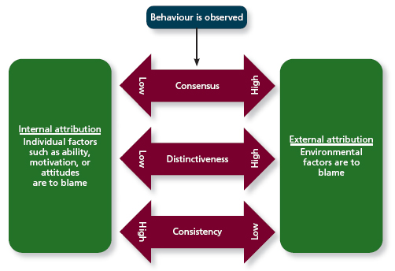

- Consensus is used by decision makers to attribute cause; whether individuals behave the same way under certain circumstances

- Distinctiveness is whether the person being judged acts in a similar fashion under different circumstances

- Consistency is whether this individual has acted this way before under similar circumstances

- The last type of decision making problem is the escalation of commitment which refers to the decision to continue to follow a failing course of action

Learning



