CHM 1321 Experiment #5
Preparation of Benzoic Acid using a Grignard Reagent
Daniela Gallardo, 8082335 Section D3
Indeewari Ranasinghe, irana083@uottawa.ca
Partner: Sidrah Zafar, 8163532
March 8, 2016
Introduction:

Procedure and observations:
- The initial step of the experiment was to prepare the glass ware by washing the round bottom flask as well as the condensing tube with water and acetone, respectively. They were placed in an oven for 15 minutes until dry
- they were assembled immediately after taken out of the oven, and the drying tube was filled with cotton, CaCl₂ (the drying agent) then cotton respectively, before the glass had enough time to cool down
- 0.8g of magnesium turnings and 2 small crystals of iodide were placed inside the round bottom flask. Meanwhile, 20mL of anhydrous ether was mixed with about 3.0mL of bromobenzene in a separate flask. A watch glass was placed on top to avoid water contamination
- This caused the solution in the round bottom flask to turn from a clear solution into a red/brown solution with the magnesium still visible
- Solution was stirred until the red colour started to fade, and the exothermic reaction caused slight boiling
- The other half of the solution was added to the flask, and after approximately 15 minutes, the solution had turned more opaque with no bubbling
- A hot water bath was used to continue the reflux of the boiling solution during the step above
Reaction with carbon dioxide
- Flask was removed from hot bath and the undissolved residue settled
- A dry 100mL beaker was filled with freshly obtained dry ice to 2/3 of the beaker. A Teflon rod was used to stir the solution. This caused the resulting solution to turn a yellow/white colour and of a sticky/ hard consistency as well as being lumpy.
- Solution was stirred for around 15 minutes
- 20g of ice, 20mL of water, 5ml of concentrated HCl and 15mL of ordinary ether were added, this caused a very exhilarated reaction with fizzing, and gas visibly rising out of the flask along with intense bubbling inside the flask. the resulting colour was a clear one, with a pleasant odour
- Mixture was transferred to a separatory funnel
- 15mL of ordinary diethyl ether was added to the flask to make sure all the remaining solution was fully transferred into the funnel. Funnel was shaken and two layers formed. A bright yellow organic layer and a clear aqueous layer.
- Aqueous phases was re-extracted with another 15mL of diethyl ether
- A TLC was taken of the organic layer, using bromobenzene as the reference. The eluant used was EtOAc: Hexanes 1:9
- The combined organic phases were extracted twice, each time with 20mL of aqueous 10% NaOH solution. The two layers had a yellow colour.
- Concentrated HCl was added to the aqueous extracts until the litmus paper showed a change in acidity (pink). Approximately 40 drops were added until the acidity changed
- Solution was cooled in an ice bath. White, cloudy precipitate started forming on surface
- Suction filtration was performed to collect resulting product which had a white, fluffly consistency once dried on a watch glass
- Melting point of product and a final TLC was taken of the collected substance
Table of reagents
Reagent | MW (g/mol) | Amount (g or ml) | Density (g/mL) | Moles (mmol)
Bromobenzene | 157.0079 | 3mL | 7.5 | 0.0285
Magnesium | 24.31 | 0.8g | -- | 0.0333
Iodine | 126.9 | Few crystals | -- | --
Carbon dioxide (dry ice) | 44.01 | 66.6g | 1.5 | 1.5133

Percent yield:
Weighed mass of filtrated product: 3.15 grams
MW | 157.01g/mol | 122.22g/mol
Amount | 3.0mL | 3.5g (theoretical yield)
Density | 1.5g/mL | --
Mmoles | 28.66 | 28.66mmoles

$$Percent Yield=\frac{Final Mass}{Original Mass} X 100$$
$$Percent Yield=\frac{3.15g}{3.5g} X 100=90$$
TLC 1: TLC 2:
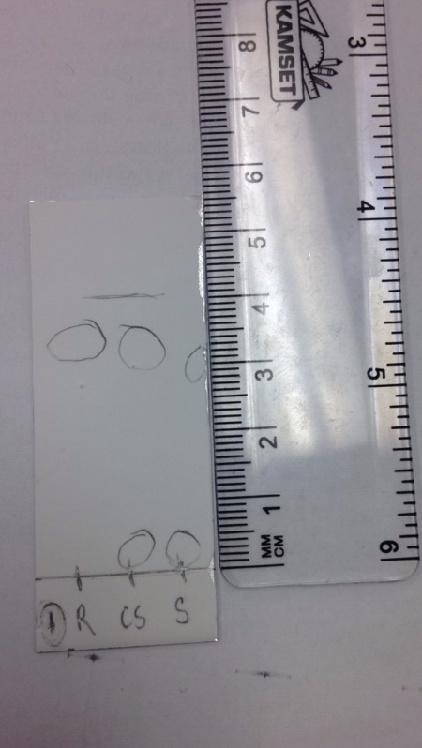
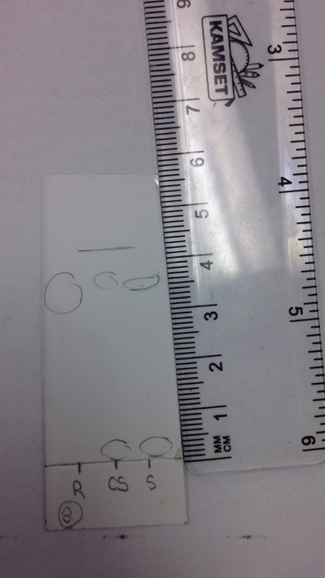
TLC (EtOAc: Hexanes 1:9 eluant used) | Rf values
1 | R: 3.25  CS: 0.1 (1) + 3.0(2)  S: 0.0 (1) + 2.7 (2)
2 | R: 3.2  CS: 0.0 (1) + 3.6 (2)  S: 0.0 (1) + 2.9 (2)

Flow chart demonstrating reaction:
Flow chart summary:
- To initiate the formation of the Grignard reagent, magnesium is added to bromobenzene, which forms the Grignard shown by the benzene ring attached to the bromide and magnesium. The iodide crystals help out in the activation of the reaction
- The next step is to react the Grignard with dry ice (solid carbon dioxide) which will cause the carbon present in the Grignard to serve as an extremely nucleophilic center which will interact with the electrophilic central carbon in the carbon dioxide
- Reaction yields a benzene ring attached to a carbon and the other attached elements
- With the addition of acid and water, as well as concentrated HCl, this causes a separation of 2 layers to initiate the purification process
- The organic layer, seen on the right side of the chart, shows the desired benzoic acid along with any unreacted bromobenzene as well as possible amounts of benzene resulting from a side reaction
- The aqueous phase, shown on the left side, consists of additional HOMgBr
- Because the emphasis is on the organic phase reaction mixture, it needs to purified a second time since there are other organic compounds present in the solution using the addition of sodium hydroxide
- This second purification results in another 2 layers, with the aqueous phase (shown on the left side) consisting of the OH pulling a hydrogen atom off the benzoic acid and the Na joining with the other ions along with the formed water
- The organic phase (shown on the right) will consist of bromobenzene and additional benzene by itself
- HCl is added to the aqueous phase which will result in the protonation of the nucleophilic oxygen and will reform the benzoic acid with the addition sodium chloride
Questions:
- Anhydrous ether is used in this reaction because it does not have any water in its composition. The presence of water is not wanted in this experiment because it will enter into an acid base reaction with the Grignard reagent, leaving no reagent left over to react with the carbon dioxide and yield a final result.
- A water bath is used to heat the reaction because ether is extremely flammable, and using a water bath to continue the boiling will act as a more stable heating environment and reduce the possibility of the ether catching flame
- Dry is essentially solid carbon dioxide, primarily used as a cooling agent which has lower temperatures than water ice reaching up to -78.5 degrees Celsius.
- It is important that the dry ice be freshly obtained because dry ice will quickly heat up, turning into water, which will cause an unwanted side product in this experiment with the Grignard reagent.
Discussion:
The purpose of this experiment was to obtain pure benzoic acid using the formation of a Grignard reagent. Before the reaction commenced, all the glassware was washed with water, then acetone following their placement in an oven to eliminate possible water contamination. The formation of the Grignard reagent itself occurred after the apparatus was assembled, and the magnesium turnings were mixed with the bromobenzene in the round bottom flask, aided with the presence of the two iodide crystals. The presence of water was something that was not wanted in this experiment, since its presence would cause an acid base reaction with the Grignard reagent and leave no more product to react with the carbon dioxide in the further steps.
The presence of I₂ is necessary because it forms a magnesium oxide layer on top of the solution and reacts with the surface of the magnesium to expose it for the Grignard reagent. After the formation of it, it will react with a fairly active electrophile such as solid carbon dioxide, also referred to as dry ice. This results in a carboxylic acid having one more carbon than the starting Grignard reagent, this is now a very poor electrophile. Simultaneously, water was added in this complex of water, HCl, dry ice, and more ether. This reaction with the Grignard separates it into 2 layers, commencing the purification process. After the re-exactration of the aqueous layer, the combined organic clear layers show the desired benzoic acid along with any unreacted bromobenzene as well as possible amounts of benzene resulting from a side reaction.
This composition of the organic layers is further confirmed through the first TLC, which is of the organic layer using bromobenzene as the reference. It is shown from the data that the Rf values of the reference and co-spot lane match up, therefore confirming the presence of the unreacted bromobenzene. The next step of the purification process requires that the collected organic layers be extracted twice more so the full isolation of benzoic acid can be performed. The organic layers were extracted with 10% NaOH, causing the NaOH to draw off a hydrogen and form water; it will also draw off an ion that will become part of the aqueous pahse with the other soidium ions as well as the water. This is acidified by the addition of HCl, which will reform the benzoic acid without the added sodium chloride, that is separated thorugh suction filtration. This resulting product is used to take a final TLC, using the bromobenzene as the reference. The final TLC showed matching Rf values, which is inconsistent since the left over bromobenzene should have been discarded before the addition of HCl. The expected TLC should have shown no matching Rf values, this inconsistency could be due to purification errors committed in the lab with imperfectly executed distillations leaving behind traces of unreacted bromobenzene and naked benzene from side reactions.
After the TLC of the product was taken, the filtered product mass was weighed and found to have a mass of 3.12grams, which results in a 90 percent yield, demonstrating that the collection of benzoic acid was successful with little water contamination. The remaining ten percent could have been missing since some water contamination was present. The melting point of the product was taken as well, although due to some time constraints, not enough product was able to be placed in the capillary and an accurate melting point was probably not found, although what the results showed is that it started melting around 89 degrees Celsius. The literature values of benzoic acid is approximately 122.41 degrees Celsius; melting point errors could have arisen from the small sample size which would’ve affected the range of temperatures making it smaller than the literature value. Furthermore, due to time constraints, the heating of the specimen could have been too fast, also affecting the final temperature. Additional reasons for temperature differences could have also been from the already present water contamination in the specimen from the beginning of the experiment.

Conclusion:
In summary, the formation of benzoic acid was possible through the use of a Grignard reagent, which yielded a 90 percent empirical yield. Possible errors could have arisen from water contamination as well as speeding up the reaction with the addition of the ether and not letting it go to completion due to time constraints. The two TLCs were somewhat consistent with the expected results from the extraction process, with the second TLC showing the presence of bromobenzene when it should not have, since it would have been discarded before the addition of HCl. This error could have arisen from an incomplete reaction, with left over bromobenzene. The filtered product had a white, fluffy consistency and a mass of 3.12 grams, along with a melting point of 88.9 degrees Celsius. Compared to the literature melting point value of benzoic acid, the inconsistency in values could have arisen from sample size, to contamination of the specimen.

Raw data:


