CONCORDIA UNIVERSITY - OCTBOBER 16th, 2016
ASSIGNMENT 1: WORD ASSIGNMENT
INTE 290

Contents
The Project description 2
Project Overview 2
OBJECTIVE 2
Description and Overall Idea surronding the project 2
What Fair repair and sales offers to its customers 4
TimeLine and Deliverables 5
Possible location of Fair Repair and sales store 6
possible location 1: 6825 Milan, Brossard 6
Possible location 2: 6100 Sherbrooke west, Montreal (downtown) 6
The Budget 7
The Potential Value 8
Bibliography 9

The Project description

Project Overview
Project Name | Fair Repair and Sales
Project Type | Computer Repair and Sales Store
CEO
CFO
Manager in Charge | Eric Webber
Lead Technician | William Tremblay
Chief of Sales | Sam Samuels

OBJECTIVE

To develop, build and manage a fair computer repair and sales store that I aimed at the consumer to provide them with the best possible service without getting totally ripped off as in the case of big box stores whose only focus is prime capital.

Description and Overall Idea surronding the project

In the last number of years, the number of electronic devices per person has skyrocketed to extreme numbers. Every person at any given time has one, if not multiple electronic devices on them at one time. In the last decade alone, the price of electronic devices has dropped exponentially, making them available to more and more consumers. With the increasing number of electronic devices, whether they be cell phones, personal computers, tablets, smart phones, or e-readers, opens a whole new market, electronic repair and customer service. Over the years, many electronic based computer repair shops have opened there doors allowing customers to have their personal electronic devices repaired, restored, modified to fit their needs or to buy a new device when it is time for an upgrade. However, since 90 percent of the population is clueless when it comes to electronics, these shops have taken it upon themselves to charge a fortune for these services. This is where my project comes in. I am here to propose opening up a computer repair and sales shop in which the customer is not totally ripped off.
In many cases, any given person has little knowledge on their own electronic devices. Take a standard personal desktop computer for instance. The average person knowns how to turn in on, use standard word processing programs, go online, check Facebook, check their emails and that’s pretty much it. However, as soon a problem arises, for example, a virus infects the system or the computer is running slowly, the average person in a state of instability, as they do not known how to fix the problem without external help, even though sometimes the problem is just a simple as running an anti-virus or anti-malware program. So, when this time of problem arises, the average person, takes there computer to a repair shop, or worse, buys a whole new system if the problem is severe, and at the shop, the person is taken advantage of because of their lack of knowledge on the subject.
Another example of how the opening of this store is essential, can be seen in the sales of personal computers. In many aspects, large corporation try to push products down the throats of consumers, telling consumers that they need the best on the market, loaded with features that they will probably never use, when all they needs a cheap, reliable and simple computing system. Consumers should not have to be pushed on the corporate umbrella when it comes to computing or any other personal electronic device for that matter. They should be the ones in control of the situation and not have to be held hostage.

In this day and age, due to the large and increasing number of electronic devices in the hands of the average consumer, this is a crucial option that must be considered. We should not stand by and let the average consumer be ruled my large corporations that are only interested in making a profit. We should fight back and put money and power back into the hand of the simple consumer, which is the thing that matters most.
Figure 1: Fair Repair and Sales Vs Other Companies

What Fair repair and sales offers to its customers
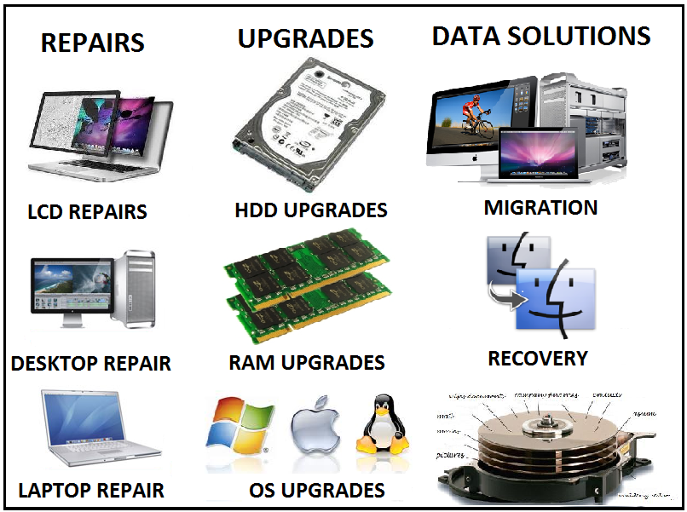

Figure 2: What Fair Repair and Sales Offers and More
Great professional work done at a low cost to the customer.
Fair Repair and Sales is the best option!

TimeLine and Deliverables

Task Number | Deliverable | Expected Time Frame | Approximation of Completion Date
1 | Proposal Approval | 2 weeks | End of October 2015
1.1 | Confirm Funding Request | 4 weeks | End of November
2 | Finding a Possible Location for Establishment | 6-8 weeks | End of January 2016
2.1 | Permit Registration and Approval | 4 weeks | End of February 2016
2.2 | Move into location | 2 weeks | Middle of March 2016
3 | Order necessary stock and materials | 8-12 weeks | Beginning of May 2016
3.1 | Shop preparation to prepare for sales and delivery of stock | 4-6 weeks | End of June 2016
3.2 | Shop upkeep, necessary organization and preparation due to influx of stock | 4-6 weeks | Beginning of August 2016
4 | Hiring of employees | 8-12 weeks | End of October 2016
4.1 | Advertising | On Going as of task 4 | End of October 2016
5 | Shop launch | 2-4 weeks | End of November 2016

*** Assuming now delays in the timeline, the fair electronic device sales and repair shop should be up and running before the winter holidays in order to receive the maximum number of customer influx. ***

Possible location of Fair Repair and sales store
- Two possible locations will be examined, the first on the south shore and the other in town. Both offer different benefits.

possible location 1: 6825 Milan, Brossard
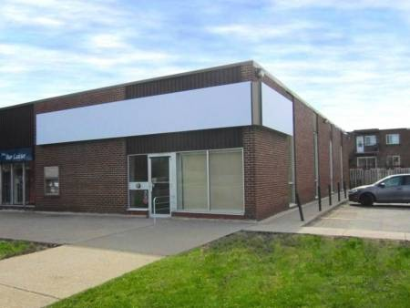
Commercial Space in Brossard (South Shore)
Cheap Rental for a large Space
Lots of Free Parking
Near other stores such as IGA and BMO
Located near the Autoroute 10. (Easy access)

Rental Cost: 10.00 $ per Square Foot per Year ------------ Rental Size: 3400 Square Feet

Possible location 2: 6100 Sherbrooke west, Montreal (downtown)
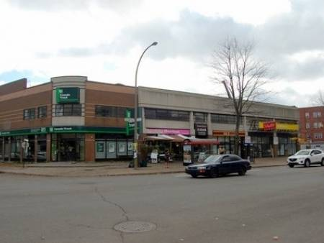
Commercial Space in Montreal
Higher Cost Rental
In the Big City
Street Parking in Not Convenient
Right Next to a bank, on a main street in Montreal

Rental Cost: 15.00 $ per Square Foot per Year ------------ Rental Size: 4500 Square Feet

The Budget
Bellow you will find the minimal budget/costs until opening of the store.
Task Number | Deliverable | Cost
1 | Proposal Approval | Maximal Cost of $10000
1.1 | Confirm Funding Request | Maximal Cost of $10000
2 | Finding a Possible Location for Establishment | Maximal Cost of $10000
2.1 | Permit Registration and Approval | 2500 $
2.2 | Move into location (First Year Rent) | 34000 $ to 67000 $
3 | Order necessary stock and materials | 50000 $
3.1 | Shop preparation to prepare for sales and delivery of stock | 20000 $
3.2 | Shop upkeep, necessary organization and preparation due to influx of stock | 15000 $
4 | Hiring of employees | 10000 $
4.1 | Advertising | 15000 $
5 | Shop launch | 15000 $
Total |  | Minimal Start-Up Cost of 171,500.00 $

Bellow you will find the minimal operating costs once the store has opened.
Expenses (Yearly) | Cost
Employee Salaries (Total) | 60000 $
Stock | 50000 $
Rent | 34000 $ to 67000 $
Permits | 5000 $
Maintenance | 15000 $
Renovations | 10000 $
Advertising | 10000 $
TOTAL | 184,000.00 $

The Potential Value

Every single person working with a computer or needing computer for whatever reason should have the option to be treated like a person and not just a dollar signs. Large Corporation only have one thing on their minds and that is money. As there are many average computer uses out there in the great city of Montreal, this is a perfect idea in order to ensure that every average computer user is sold the right system for their needs and if a problem may occur, there will always be place close to home or a short car ride away, to solve whatever problem they have for a proper cost. Taking advantage of the average consumer has gone on long enough and it is time to give the power back to the customer. Fair Repair and Sales, is the perfect idea and the best option for all.

Potential Return on Investment

Bibliography

1. Azoulay, Beatrice. Commerical Space for Rent - #6100f. 16 October 2016. <http://www.louer.com/6100f/>.
2. Computers, Bragg. Electronic Repair and Upgrade Services. 2016 October 2016. <http://www.braggcomputer.com/products/ELECTRONICS-Repair-%26-Upgrade-Services-%252d-FREE-Diagnostic-%26-Estimates.html>.
3. Herbu, Amanda. Commercial Space for Rent - #6825c. 16 October 2016. <http://www.louer.com/6825c/>.

Figure shows the benefits of selecting Fair Repair and Sales versus its competitors
This figure shows the possible operations that can be performed for a customer at Fair Repair and sales at a respectable cost when compared to its competitors. No unneeded work will be performed at Fair Repair and Sales
Commercial Space Brossard – Louer Search." - Google Search. Web. 16 Oct. 2016.
Commercial Space Montreal – Louer Search." - Google Search. Web. 16 Oct. 2016.

