ARENA NOTES

Half-width:
Runtime Confidence Intervals— Within a Replication (For Example, Steady State Systems)
Some sections included in the Entities, Processes, Queues, Resources, Transfers and User Defined Reports contain a column called "Half Width." This statistic is included to help you determine the statistical reliability of the results from your replications and for comparing results across different scenarios and experiments. Three results are possible in the "Half Width" category:
Insufficient: The formula used to calculate half width requires the samples to be normally distributed. That assumption may be violated if there is a small number (fewer than 320) of samples recorded in the category. If that is the case, Arena will return the message "Insufficient" for that variable’s half width, indicating there is insufficient data to accurately calculate the half width. Running the simulation for a longer period of time should correct this.
Correlated: The formula used to calculate half width requires the samples to be independently distributed. Data that is correlated (the value of one observation strongly influences the value of the next observation) results in an invalid confidence interval calculation. If data is determined to be correlated, the message "Correlated" is returned for that variable’s half width. Running the simulation for a longer period of time should correct this.
A value: If a value is returned in the Half Width category, this value may be interpreted by saying "in 95% of repeated trials, the sample mean would be reported as within the interval sample mean ± half width." The half width can be reduced by running the simulation for a longer period of time.
Arena uses a batching algorithm to calculate the half width. For details about the algorithm, see Simulation with Arena, 5th Edition (McGraw-Hill, 2009, W. D. Kelton, R. P. Sadowski, & N. B. Swets). If you specify a Repeat Interval for collecting periodic statistics during the replication, Arena uses a different method for calculating the half width, with the batch size equal to the specified Duration.
Related Topic: Runtime Confidence Interval Variables

Confidence Intervals— Across Replications (For Example, Terminating Systems)
The "Half Width" column of the Category Overview Report is included to help you determine the statistical reliability of the results from your replications and for comparing results across different scenarios and experiments. Three results are possible in the "Half Width" category:
Insufficient: If only one replication is executed, Arena will return the message "Insufficient" for that variable’s half width, indicating there is insufficient data to accurately calculate the half width. Running the simulation for more than one replication will produce a value.
NotCalc: If a periodic Dstat is included in the output statistics expression, Arena will return the message "NotCalc" for the half width value. Half widths are never calculated for output expressions containing periodic Dstats.
A value: If a value is returned in the Half Width category, this value may be interpreted by saying "in 95% of repeated trials, the sample mean would be reported as within the interval sample mean ± half width." The half width can be reduced by increasing the number of replications.

ORUNHALF
- Used to determine a specific halfwidth (if halfwidth is already given)
- “O” in ORUNHALF = output
- Used in DECIDE 2 in the new (second) model
- Must know this statement as it is not in the Expression Builder

NREP
- Number of current replications
- Cannot be changed by the user
NREP—Replication number. NREP returns the current replication number, an integer value. It may not be changed by the user. [Automation Syntax]
Note: Use the Expression Builder to easily look up replication variables when building or editing an expression.

MREP
- MaximuEx. 10000

*** Make sure “Statistics” and “System” boxes are CHEKED in Replication Parameters!!
*** During Quiz, will at most be asked to add a DECIDE or ASSIGN module.
*** To see ANSWER is CORRECT, make sure that HALF-WIDTH < number specified (plus/minus)

*** RECORD in first model, which will be used in the second model, usually comes after DECIDE
Example: DECIDE RECORD DISPOSE
Arena uses two variables to record the current and maximum number of replications.
MREP—Maximum replications. This integer variable is the Number of Replications value on the Run/Setup/Replication Parameters page. It is user-assignable. [Automation Syntax]

In-class example:

SCOM 492 – QUIZ 2 (FALL 2010)

Cars arrive every EXPO(18) minutes

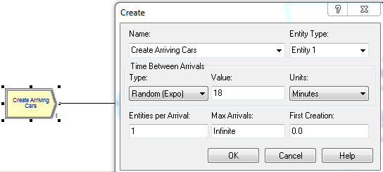

It takes EXPO(12) minutes to Wash

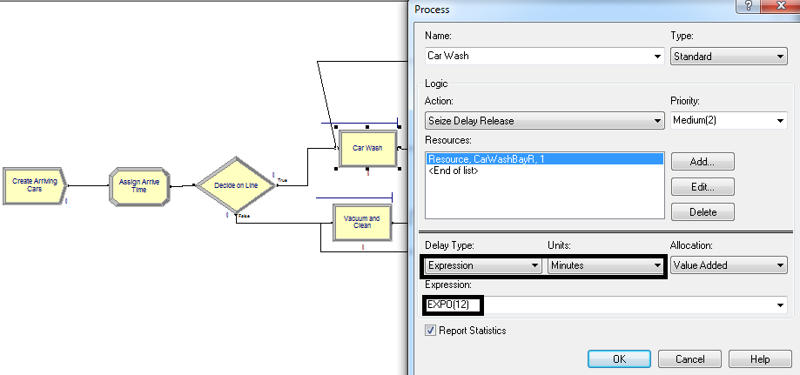

It takes EXPO(15) minutes to Vacuum Clean

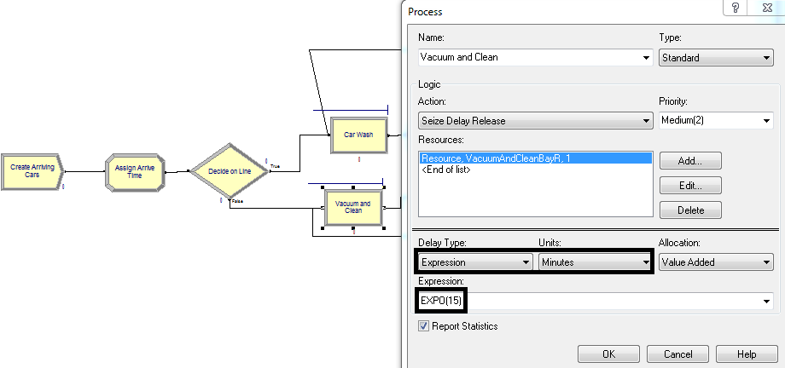

Question:
Determine the average time that a car spend in the washing, and the average time that a car spends in cleaning, as well as the time it spends in the system using a simulation model built using ARENA.

- Simulation model already has the following ASSIGN (myArriveTime, TNOW)

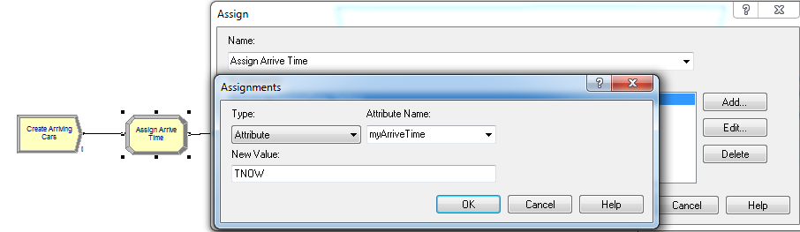

Add RECORD 1 to determine the “Average System Time”
- Average time for the PROCESSES (“Car Wash” and “Vacuum and Clean”) will be produced automatically
- The process below is the same as doing “TNOW-myArriveTime” with Type: Count
Name: What the Record will be called
Type: Time Interval Shortcut: to find out how long car stayed in the system
Attribute Name: myArriveTime (this was previously assigned in ASSIGN 1)
Tally Name: Name that will appear in the report

*** NEED TO HAVE A RECORD IN FIRST MODEL IN ORDER TO CALCULATE HALF-WIDTH IN SECOND MODEL ***

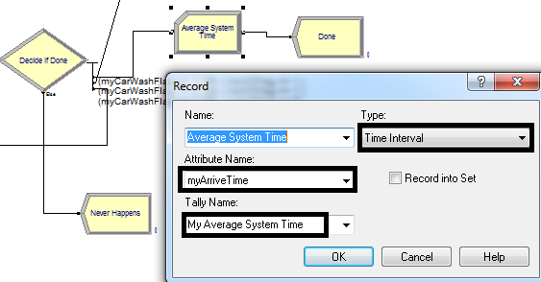

Run > Setup > Replication Parameters

Number of Replications: 1000 (want it to be a large number)
Time Units: Minutes (make sure it’s in minutes if that’s what it states!)
Base Time Units: Minutes (this produces the report in minutes)

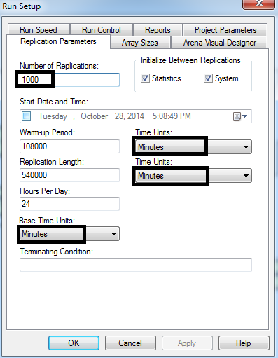

Run > Results

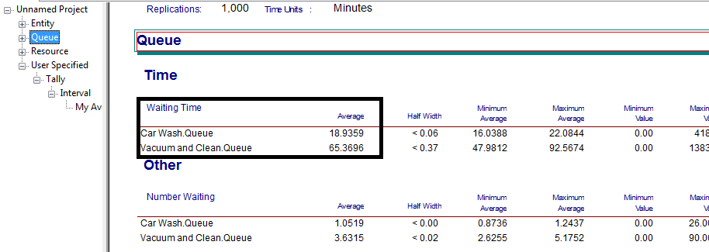

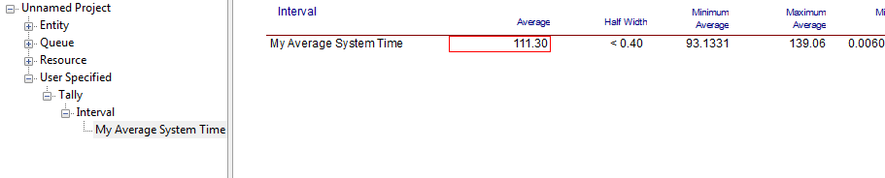

ANSWER

With 1000 replications, the average time that a car spends in washing is 18.9359 minutes.
The average time a car spends in cleaning is 65.3696 minutes.
The average time a car spends in the system is 111.30 minutes.

HALF-WIDTH

Always build the following:

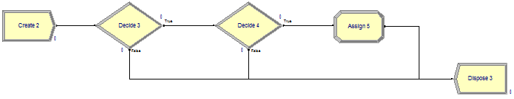
CREATE DECIDE 1 DECIDE 2 ASSIGN DISPOSE

Question:
Estimate the system time to within 2 minutes with 95% confidence.

Add CREATE
Type: Constant (always!)
Value: same as in Replication Length in Replication Parameters
Time Units: see units for Replication Length in Replication Parameters

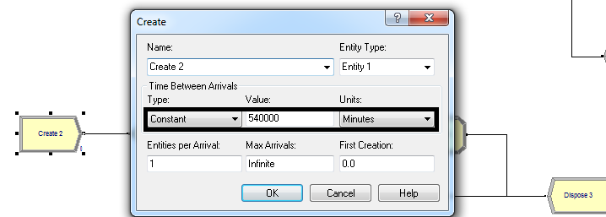

Add DECIDE 1
ALWAYS THE FOLLOWING:
Type: 2-way by Condition
If: Expression
Value: NREP>2 (ALWAYS>2)

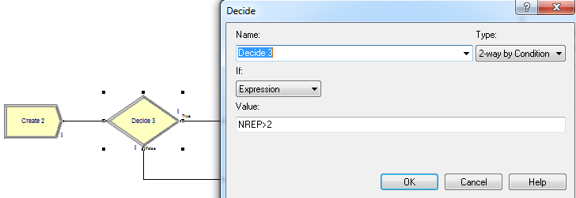

Go to Advanced Process on left side bar and double-click “Statistic”.
Delete existing row (should now say “Statistic 2”)
Right-click > Edit via Dialog...

Type: Output (always! Because we’re going to create ORUNHALF in DECIDE 2)
Expression: Right-click > Build Expression > Record > Tally > Average Value > Tally name assigned in RECORD 1 will appear)
Report Label: put any name you like that reflects the output – will appear in results (begin with “S_” because from Statistic)

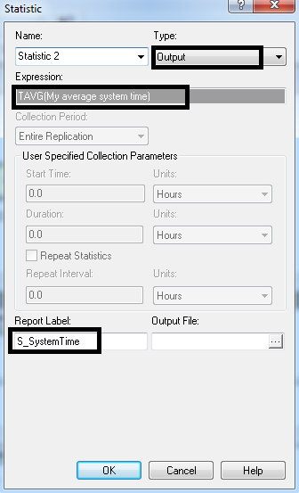

Add DECIDE 2
Type: 2-way by Condition
Put Expression of: “ORUNHALF(S_SystemTime)<2”
- Put <2 because system time is within +/- 2 minutes (always “<”)

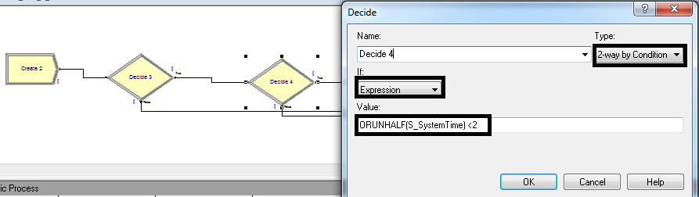

Add ASSIGN
ALWAYS THE FOLLOWING:
Type: Other
Other: MREP
New Value: NREP

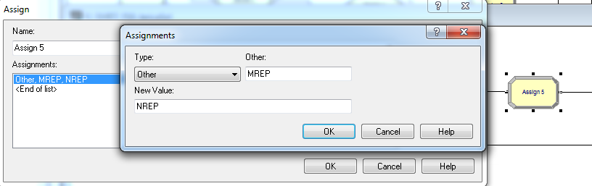

Add DISPOSE

Run > Results

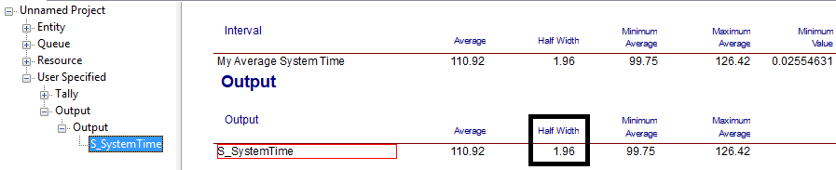

ANSWER
- The half-width is 1.96 minutes.

SCOM 492 – QUIZ 2 (FALL 2012)

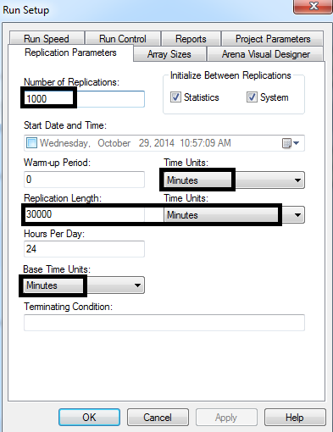

- In ASSIGN “Assign Adjustment”, you include “+1” to the value to indicate that inspection failed since the default is “0”.
- If don’t include “+1”, then YBox set is “0” and will be going in a circle.
- It is possible that after the set has gone through the first adjustment, that it fails again (after going through DECIDE). If set fails again, in the system, it will indicate that it has failed 2 times.
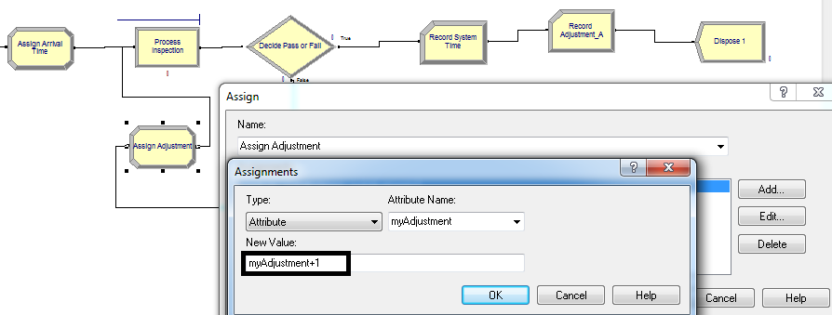
- How many jobs failed the inspection even after adjustments?
- Here, in RECORD you put “>=2” because you want to know how many jobs failed the inspection even after adjustments.
- Since in Assign Adjustment (see above) you indicate a fail with “+1”, to find the number of jobs who failed even after that you should indicate greater than “1”.
  - Can put “>=2” or “>1”

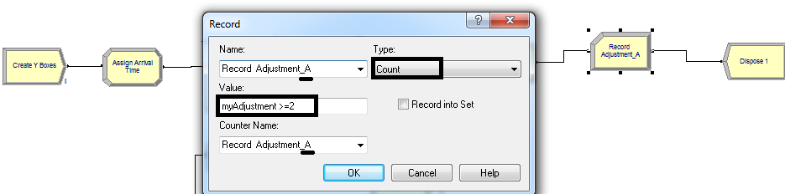

Run > Results

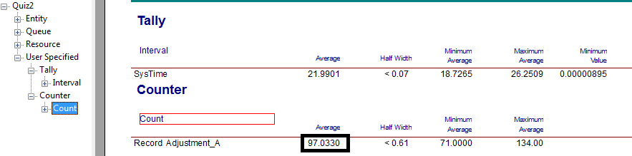

ANSWER
97.0330 jobs failed the inspection even after adjustments.

- Compute the average system time for YBox. Measure this quantity such that you are 95% confident to within 1 minute.

HALF-WIDTH

Add CREATE

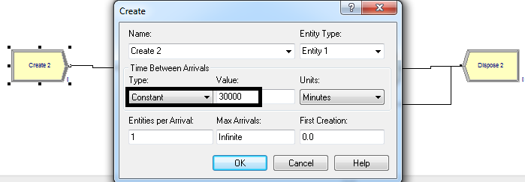

Add DECIDE 1
Type: 2-way by Condition
If: Expression
Value: NREP>2

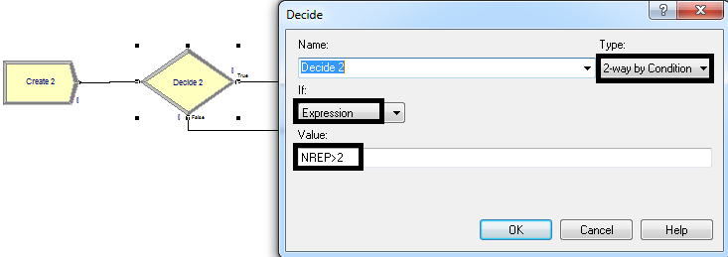

Go to Advanced Process on left side bar and double-click “Statistic”.
Delete existing row
Right-click > Edit via Dialog...

Type: Output (always! Because we’re going to create ORUNHALF in DECIDE 2)
Expression: Right-click > Build Expression > Record > Tally > Average Value > Tally name assigned in RECORD 1 will appear)
Report Label: put any name you like that reflects the output – will appear in results (begin with “S_” because from Statistic)
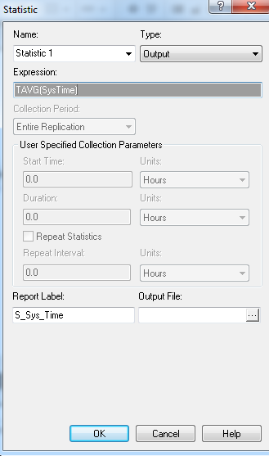

Add DECIDE 2
Type: 2-way by Condition
Put Expression of: “ORUNHALF(S_Sys_Time)<1”
- Put always “less than <” because question says 95% confident to within 1 minute and you have already accounted the “greater than >” in DECIDE 1.

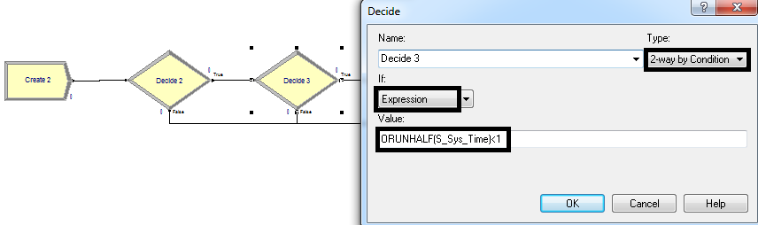
Add ASSIGN
Type: Other
Other: MREP
New Value: NREP

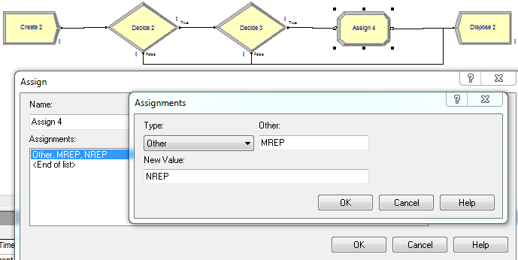

Add DISPOSE

Run > Results
Model ran for 14 replications and then stopped.

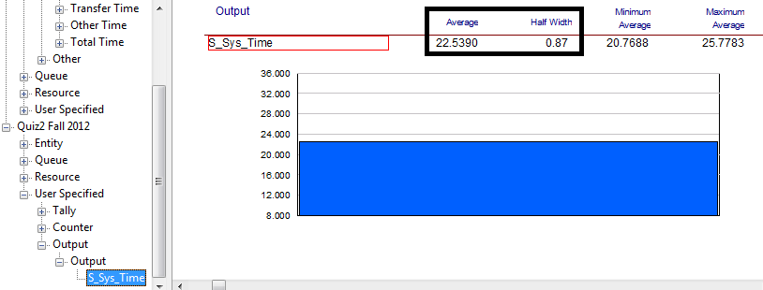

ANSWER
The average system time for YBox is 22.5390 minutes.
The Half-width is 0.87 minutes.
SCOM 492 – QUIZ 2 (FALL 2011)

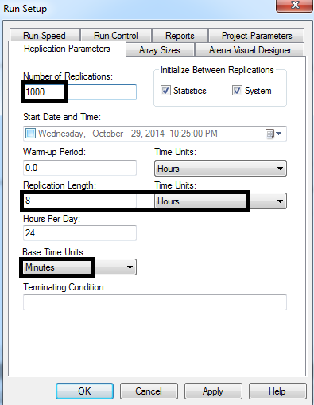

ASSIGN 1 and ASSIGN 2
Make the following changes:
Type: Attribute
Attribute Name: ArrivalTime
New Value: TNOW
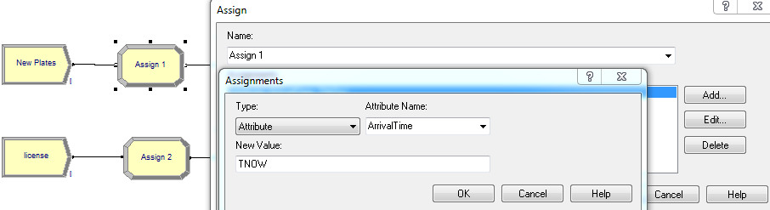

- How many customers are served during the first hour?

Add DECIDE1
Type: 2-way by Condition
If: Expression
Value: TNOW < 60 (want to know how many customers were served within the first hour – Base Units: minutes, that’s why 60, and not 1)
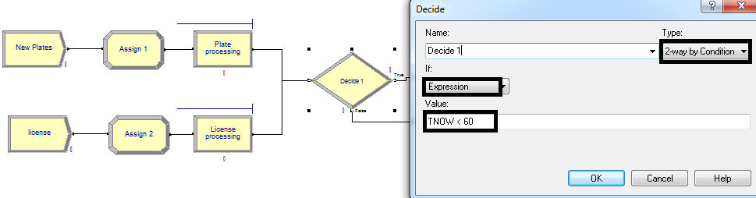

Add RECORD 1 (to record the number of customers served during the first hour)

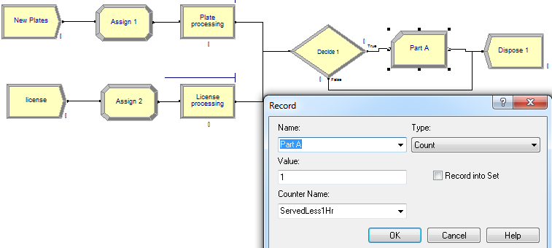

Run > Result
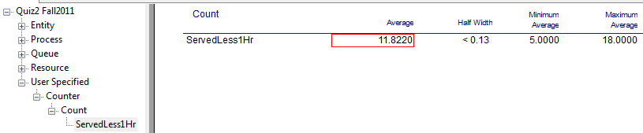

ANSWER
11.8220 customers were served during the first hour.
- Compute the average system waiting time (waiting time in queue + service time), within plus or minus 0.03 hour with 95% confidence, for customers who stayed more than 0.5 hour. How many replications are required?

- To calculate average system waiting time, need to create a RECORD 2 of System Time.

Add DECIDE 2
Type: 2-way by Condition
If: Expression
Value: (TNOW – ArrivalTime) > 30 (want to know how many customers stayed more than 0.5 hour or 30 minutes in the system)

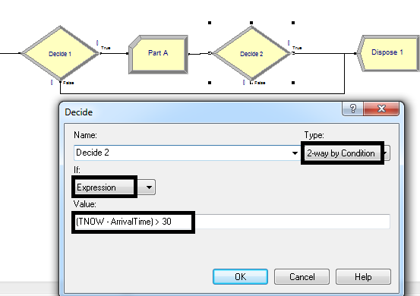

Add RECORD 2
This is the same as doing “TNOW-ArrivalTime”
Always put a RECORD! This will be used for HALF-WIDTH

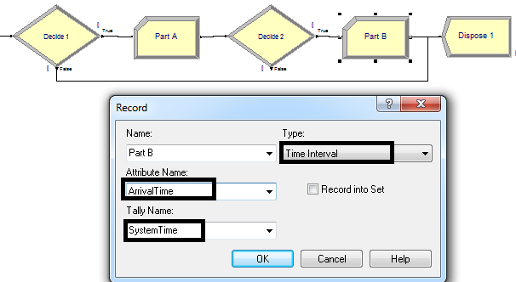

HALF-WIDTH

Add CREATE

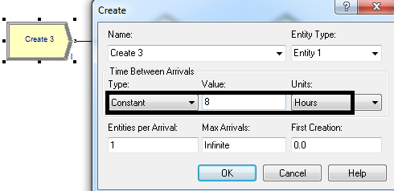

Add DECIDE 1

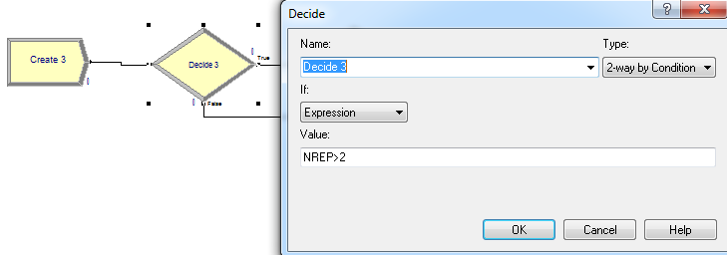

Go to Advanced Process on left side bar and double-click “Statistic”.
Delete existing row
Right-click > Edit via Dialog...

Type: Output (always! Because we’re going to create ORUNHALF in DECIDE 2)
Expression: Right-click > Build Expression > Record > Tally > Average Value > Tally name assigned in RECORD 2 will appear)
Report Label: put any name you like that reflects the output – will appear in results (begin with “S_” because from Statistic)
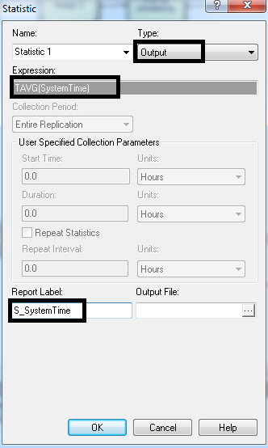

Add DECIDE 2
Type: 2-way by Condition
If: Expression
Value: ORUNHALF(S_SystemTime)<1.8
- 0.03hr * 60 = 1.8 minutes

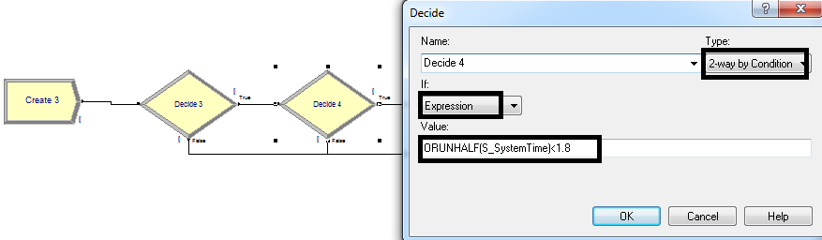
Add ASSIGN

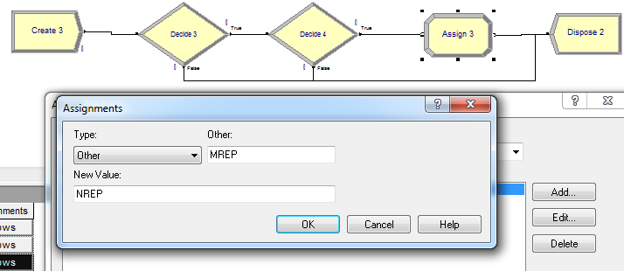

Add DISPOSE

Run > Result

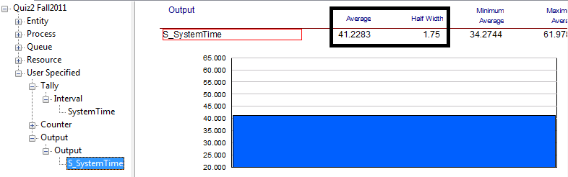

ANSWER
The average system wait time for customers who stayed more than 0.5 hour is 41.2283 minutes.
The half-width is 1.75 minutes.
48 replications were required.

***ANOTHER WAY TO MODEL a) and b)

- RECORD 2 and RECORD 3
  - Type: Count
  - Value: TNOW<1 (to calculate how many customers were served during first hour)

- DECIDE 3
  - Type: 2-way by Condition
  - If: Expression
  - Value: (TNOW-Atime) >0.5

- RECORD 1
  - Type: Time Interval
  - Attribute Name: ArrivalTime
  - Tally Name: SystemTime

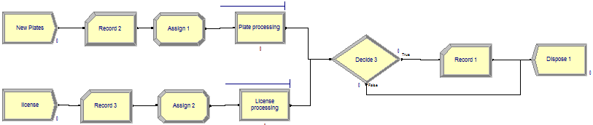

SCOM 492 – QUIZ 2 (SUMMER 2011)

10 hour shift each day = 10 Replications
Base Time Units: Minutes

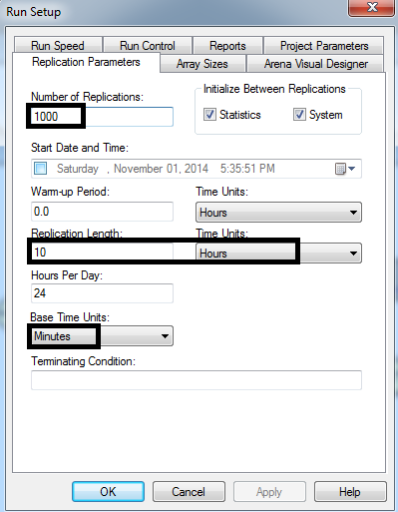

Jobs arrive in batches of 10 items each.

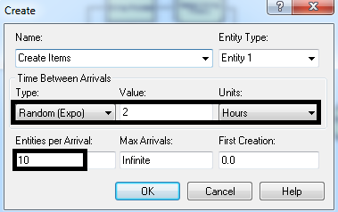

Machine shop contains 3 milling machine and 1 drill press.

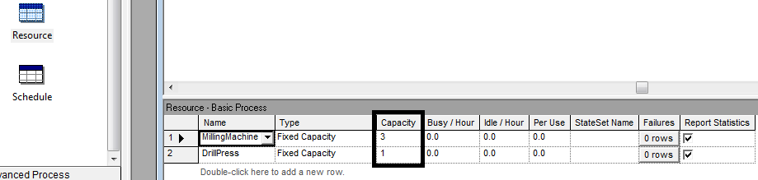

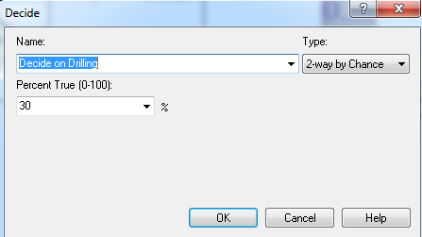

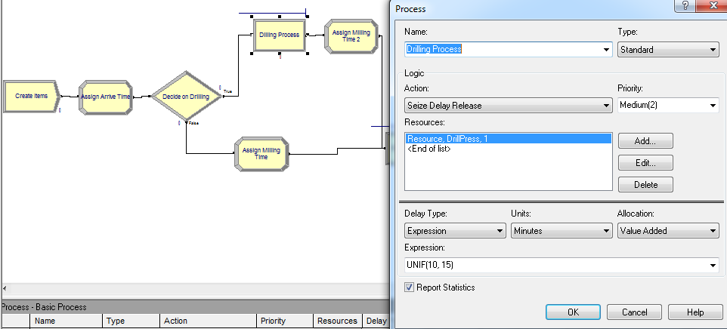
Milling time for items that require drilling before being processed on the milling machine (“Assign Milling Time 2” comes after “Drilling Process”)

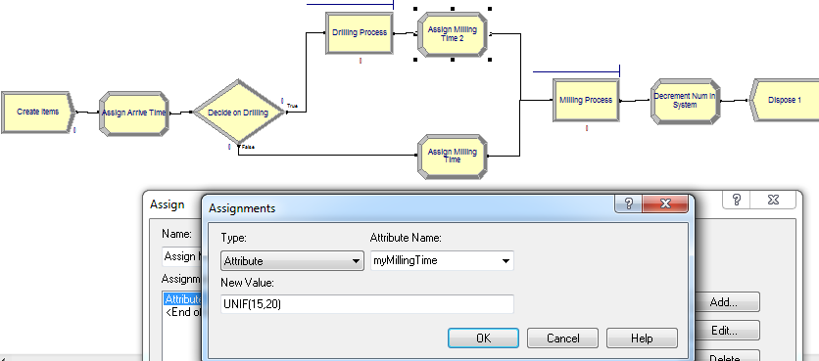

Milling time for items that DO NOT require drilling before being processed on the milling machine (“Assign Milling Time 2” branches off the bottom - false – of DECIDE)

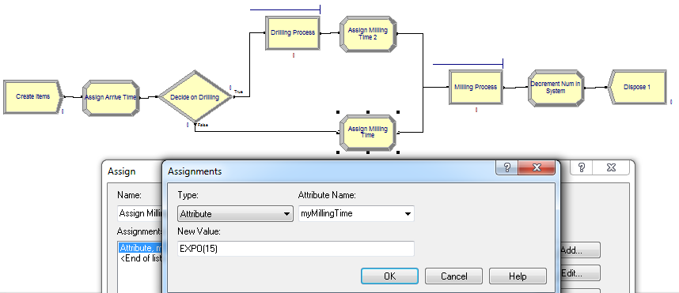

DELETE the following rows because it has no relevance to the problem.

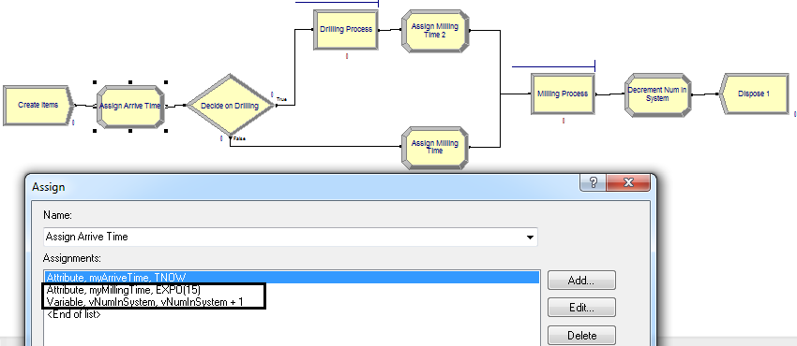

DELETE Assign module “Decrement Num in System” because it is related to a row from the above and has no relevance to the problem.

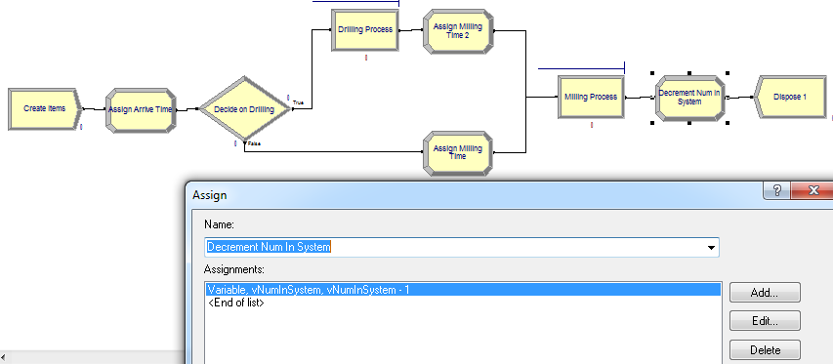

Question:
The manager is interested in evaluating the average time spent by a job that requires processing on two machines.

- Since all jobs will go through the Milling Machine, and may or may not go through the Drill Press, we will focus on the jobs that will go through the Milling Machine and Drill Press.
This is highlighted in “Assign Milling Time 2”.

Add another ATTRIBUTE in ASSIGN

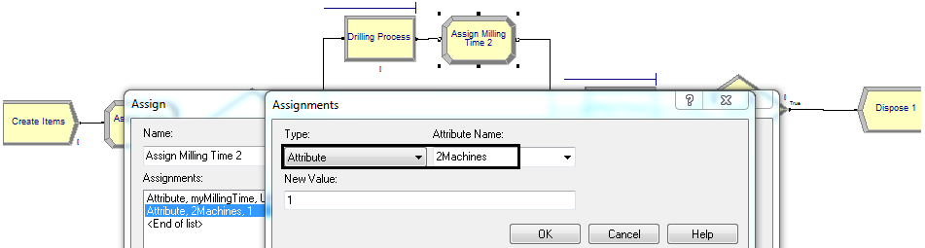

Add DECIDE 2
Decide to incorporate a job that requires processing on two machines

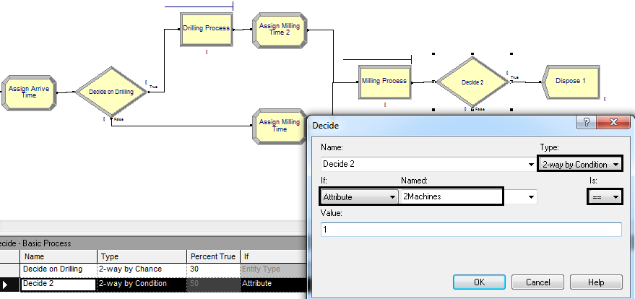
Add RECORD
Type: Time Interval (same as doing “TNOW – myArriveTime”)
Attribute Name: same as name in ASSIGN 1)
Tally Name: SystemTime
***Make sure bottom branch of DECIDE 2 (false) is connected to DISPOSE

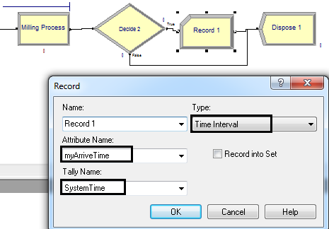

Question:
Estimate the average time to within plus or minus two minutes with 95% confidence.

HALF-WIDTH

Add CREATE

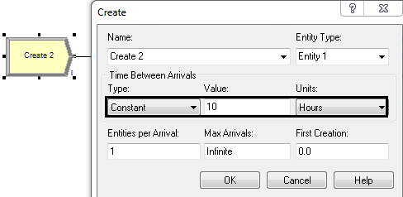

Add DECIDE 1
Type: 2-way by Condition
If: Expression
Value: NREP>2

Go to Advanced Process on left side bar and double-click “Statistic”.
Delete existing row
Right-click > Edit via Dialog...

Type: Output (always! Because we’re going to create ORUNHALF in DECIDE 2)
Expression: Right-click > Build Expression > Record > Tally > Average Value > Tally name assigned in RECORD 1 will appear)
Report Label: put any name you like that reflects the output – will appear in results (begin with “S_” because from Statistic)
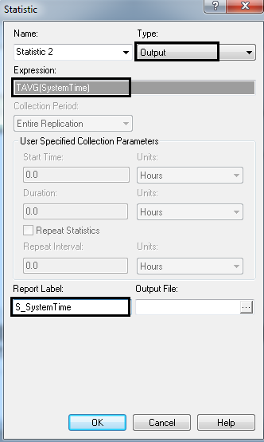

Add DECIDE 2
Type: 2-way by Condition
Put Expression of: “ORUNHALF(S_System_Time)<2”
- Put always “less than <” because question says 95% confident to within 2 minute and you have already accounted the “greater than >” in DECIDE 1.

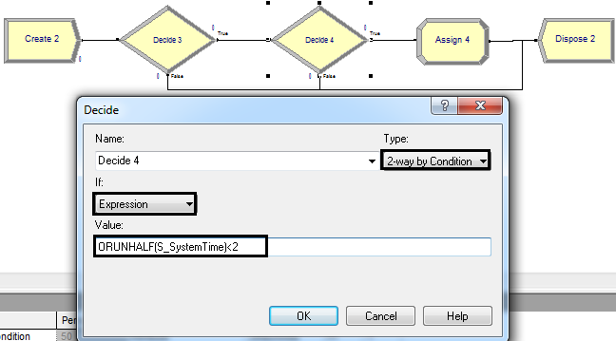

Add ASSIGN
Type: Other
Other: MREP
New Value: NREP

Add DISPOSE

Run > Results

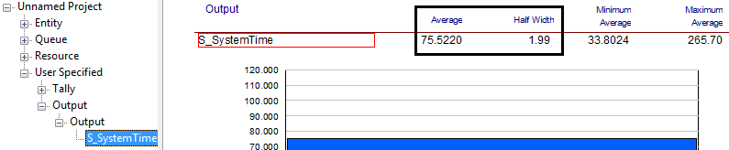

ANSWER
The average time is 75.5220 minutes
The half-width is 1.99 minutes. (Since 1.99 < 2, then we have confidence that the answer is correct)
There were 692 replications.

SCOM 492 – QUIZ 2 (WINTER 2014)

Flight has maximum capacity of 150 passengers

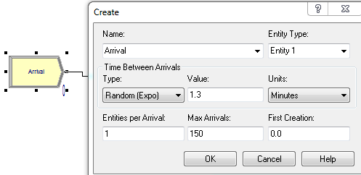

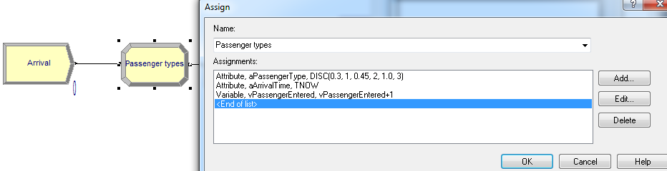

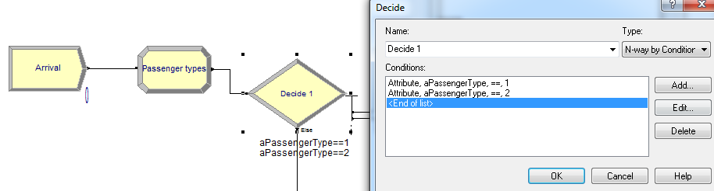

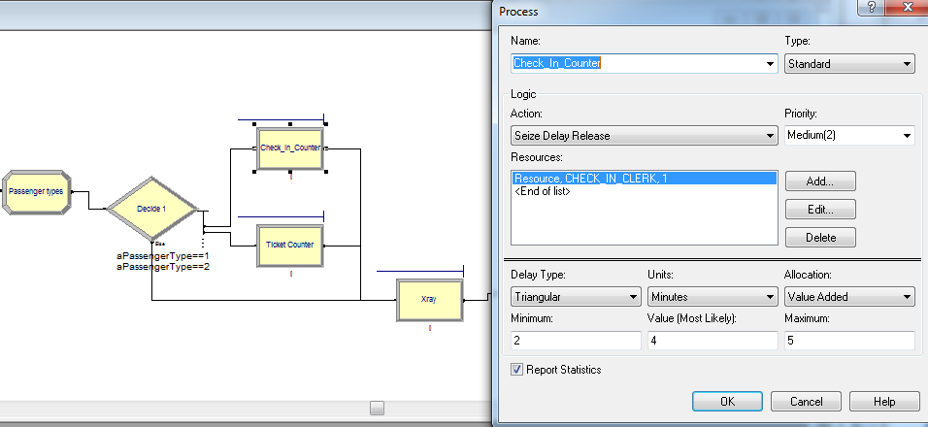

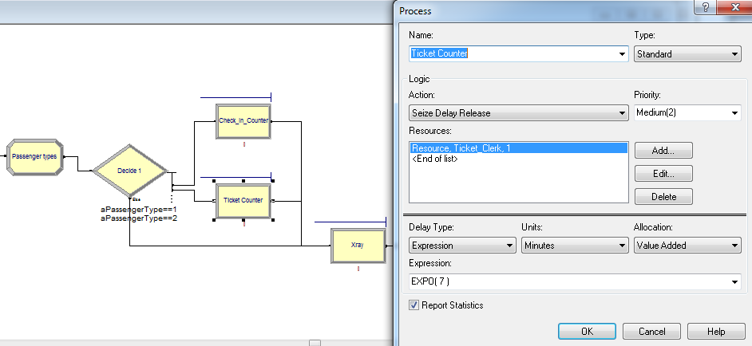

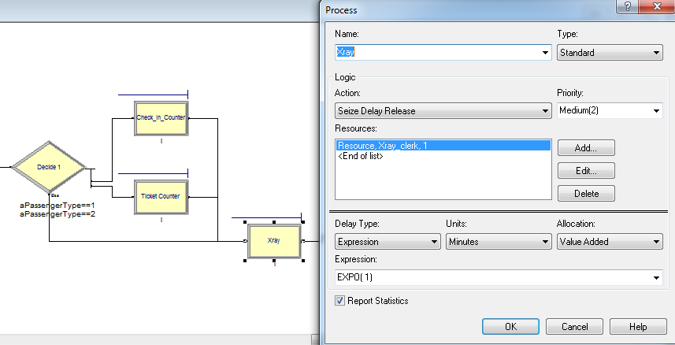

Attribute: aPassengerType == 3
- Takes into account all 3 counters

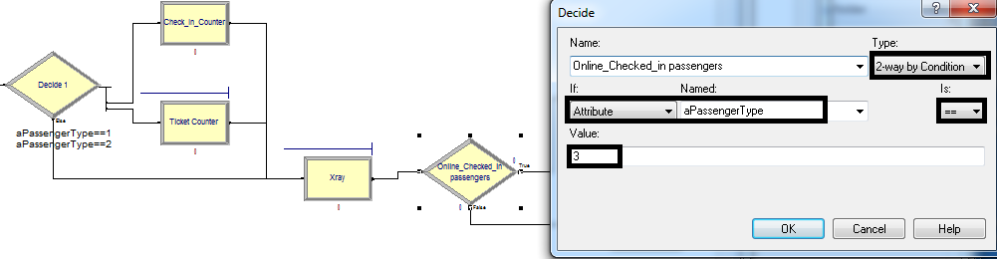

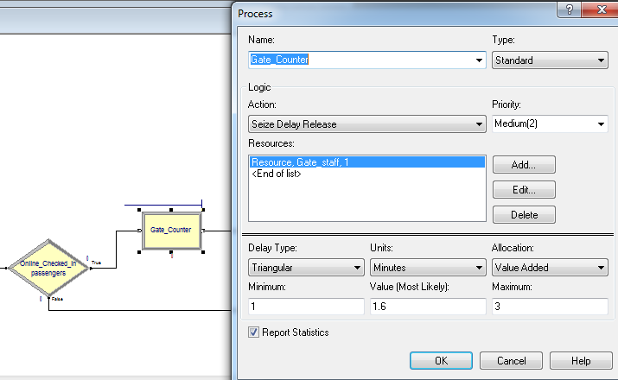

- Compute the average system time for “online-checked-in” passengers.

Add RECORD 1
Add after Process “Gate_Counter” (branch off TRUE) to take into account “online-checked-in” passengers.

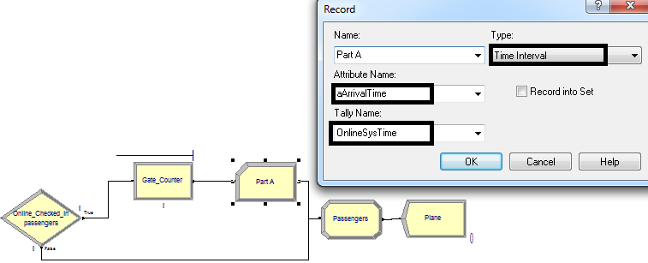
Run > Results

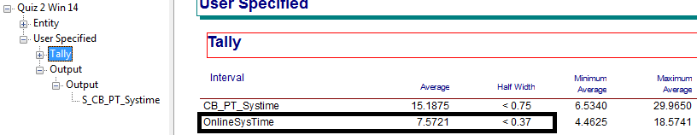

ANSWER
The average system time for “online-checked-in” passengers is 7.5721 minutes
Halfwidth is < 0.37 minutes

- Compute the average system time for CB and PT passengers within plus or minus 0.75 minutes with 95% confidence.

Add RECORD 2
Add after DECIDE (branch off FALSE) to take into account “CB and PT” passengers.

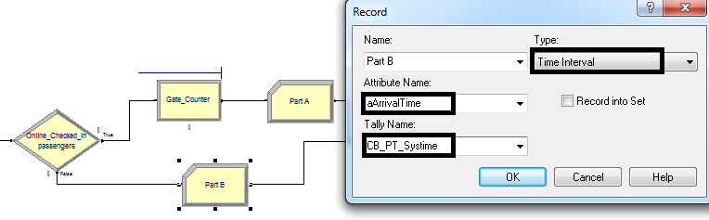

Final Model

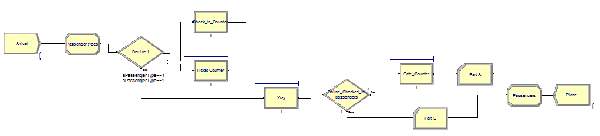
Run > Setup > Replication Parameters

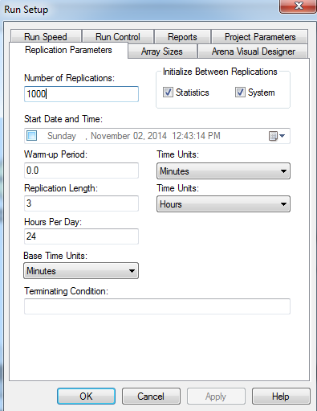

HALF-WIDTH

Add CREATE
Do not include Max Arrivals (“maximum capacity of 150 passengers”) in CREATE for HALF-
WIDTH

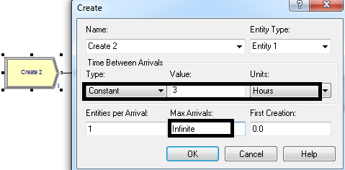

Add DECIDE 1
Type: 2-way by Condition
If: Expression
Value: NREP>2

Go to Advanced Process on left side bar and double-click “Statistic”.
Delete existing row
Right-click > Edit via Dialog...

Type: Output (always! Because we’re going to create ORUNHALF in DECIDE 2)
Expression: Right-click > Build Expression > Record > Tally > Average Value > Tally name assigned in RECORD 2 will appear)
Report Label: put any name you like that reflects the output – will appear in results (begin with “S_” because from Statistic)
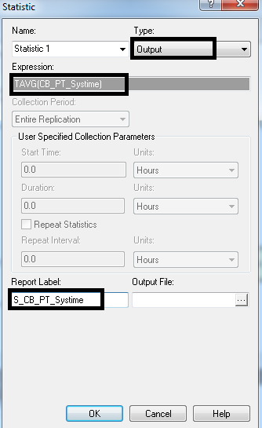

Add DECIDE 2
Type: 2-way by Condition
Put Expression of: “ORUNHALF(S_CB_PT_Systime)<0.75”
- Put always “less than <” because question says 95% confident to within 0.75 minute and you have already accounted the “greater than >” in DECIDE 1.

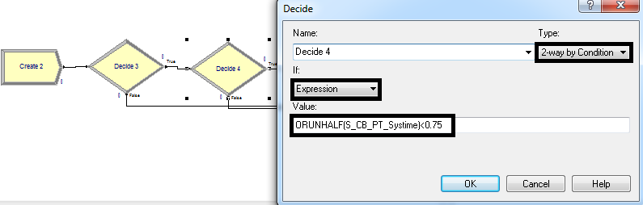

Add ASSIGN
Type: Other
Other: MREP
New Value: NREP

Add DISPOSE

Run > Results

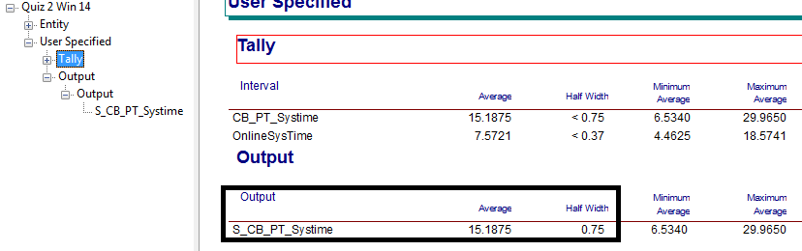

ANSWER
The average system time for CB and PT passengers is 15.1875 minutes
Halfwidth is 0.75 minutes

