Lab BCH2333

Section: A3

LAB 4: LIPIDS AND MEMBRANES

TA: Jiayin Sun

Lab Performed: March 7th, 2016

Team 9

By: Kade Bloskie
7829852
Partner: Taite Dibdin
7651445

Introduction:
The main goal of this experiment was the separation of peroxisomes and microsomes from a rat liver. The main technique used to perform this task is by using a centrifuge. To start this experiment, the rat liver was crushed and mixed with a cold homogenization buffer. This mixture was then placed in the centrifuge, to be separated. This mechanism essentially works by separating different substances based on their weight, and not by mean of polarity. This apparatus will spin a set of different test tubes at very high speeds, and is called a centrifuge as it uses the fictitious centrifugal force for the separation. By spinning at very high speeds, the heavier pieces of matter will be thrown more to the bottom of the test tube, as it will be the farthest point from the centre. Since the momentum of the heavier pieces of the rat liver are more than that of the smaller molecules diluted in the liver juice, they will be thrown towards the bottom of the test tube, and will be stuck there until they are removed. This stick substance on the bottom is called the pellet, and is discarded after the centrifuge is done. This process had to be done twice, since the first pellet produced only managed to separate the unwanted product (chunks that did not become soluble in the solvent). The second run through the apparatus is what gave rise to the separation of the microsomes and the peroxisomes. The microsomes are what remained within the solvent, whereas the peroxisomes are what was in the pellet.

Results and Discussion:
R1) Figure 1: TLC performed in two dimensions of the microsomal lipids. The first dimension of the TLC was done in the solvent Chloroform-Methanol-Ammonia (65:35:5 v/v). The plate was then dried and rotated in order to perform the second dimension of the TLC. This TLC was done in the solvent Chloroform-Acetone-Methanol-Acetic Acid-Hydrogen Gas (10:4:2:2:1 v/v).
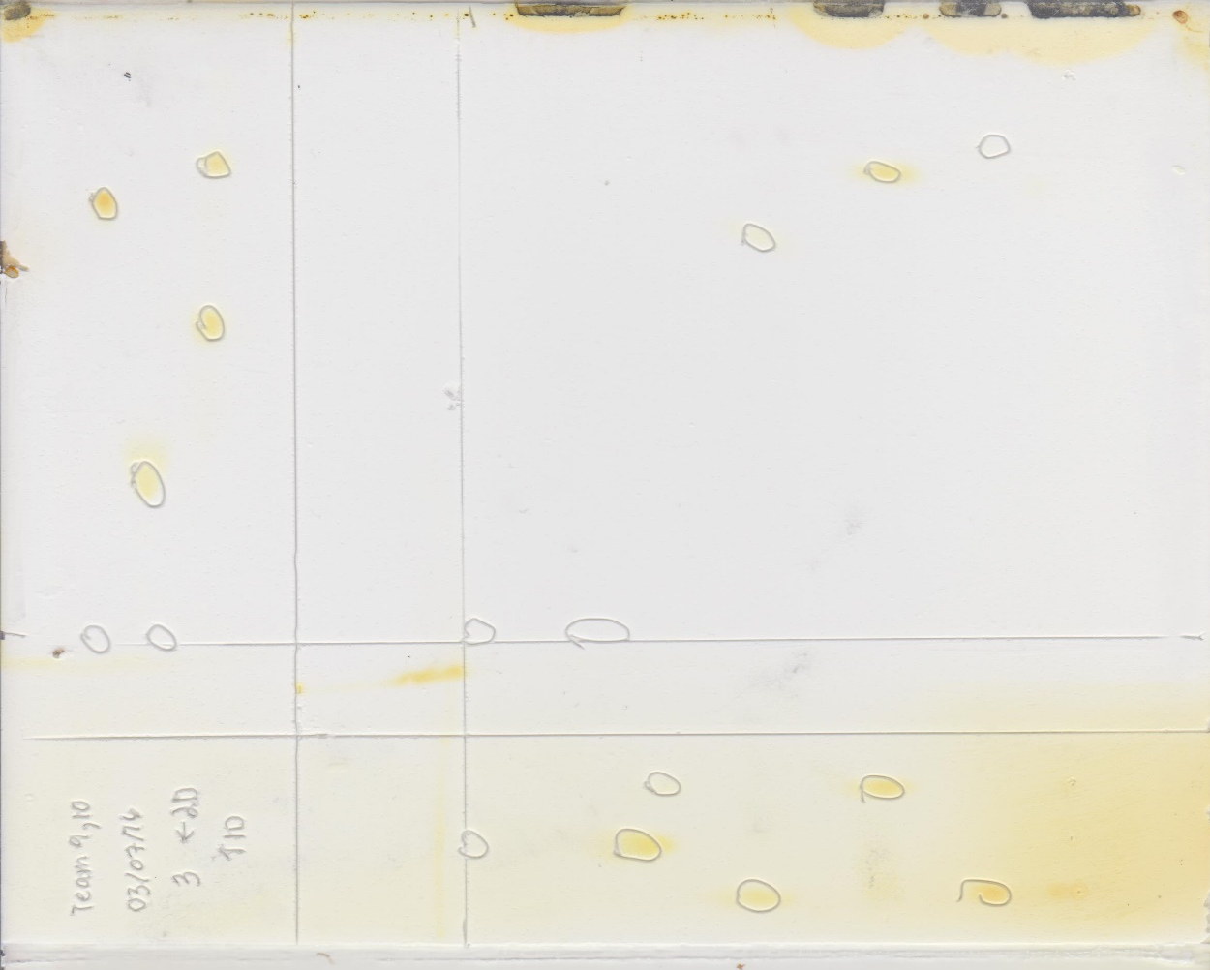
CH
FA
PE
PC
PI
PI
PC
PE
FA
CL
CH
PI
PC
PE
CL
CH
FA
Abbreviations for the TLC:
- Phosphatidylinostiol (PI)
- Phosphatidylethanolamine (PE)
- Cardiolipin (CL)
- Cholesterol (CH)
- Fatty Acid (FA)
- Phosphatidylcholine (PC)

Rf Calculations:
Table 1: Rf values observed on the two dimensional TLC plate for the lipid standards. The first dimension of the TLC was done in the solvent Chloroform-Methanol-Ammonia (65:35:5 v/v). The plate was then dried and rotated in order to perform the second dimension of the TLC. This TLC was done in the solvent Chloroform-Acetone-Methanol-Acetic Acid-Hydrogen Gas (10:4:2:2:1 v/v).
Standard | 1st Dimension Rf value | 2nd Dimension Rf value
Phosphatidylcholine (PC) | 0.40 | 0.26
Fatty Acid (FA) | 0.65 | 0.96
Cholesterol (CH) | 0.96 | 0.96
Cardiolipin (CL) | 0.70 | 0.68
Phosphatidylethanolamine (PE) | 0.56 | 0.46
Phosphatidylinositol (PI) | 0.32 | 0.24

The Rf values were obtained by calculating the total distance the standard travelled, divided by the total distance that the solvent traveled.
Rf sample calculations:
D_{M} = 4cm D_{S} = 10cm
Rf = (Distance travelled by molecule) / (Total distance travelled by solvent)
Rf = D_{M}/D_{S}
Rf = 4cm/10cm
Rf = 0.4
Therefore, the Rf for PC in the first dimension is 0.4
Analysis:
The Rf values from the first dimension are larger than the values from the second dimension, with the exception of the Fatty acid, which seems to be opposite. This can be explained due to the fact that the solvent used for the first dimension TLC is more polar than that of the solvent used for the second dimension. The TLC works by having a polar silica gel on the backbone of the plate, which attracts the more polar molecule. When a solvent is added, the molecule will begin to slightly follow the solvent up the plate. This is useful for comparing the polarities, as a more polar molecule will have more interactions with the silica gel in the presence of a non-polar solvent, and therefore move less up the plate. This however will change when the solvent is more polar, since the molecule will have a more interactions than a non-polar solvent, and it will therefore travel farther up the plate. With this being said, the reason that the fatty acid is different is because it will be protonated in the second dimension. For the first solvent, the fatty acid remains deprotonated, and will therefore have more interactions with the silica gel, giving a lower Rf. For the second solvent however, the stronger acid will protonate the fatty acid, and therefore cause it to lose its charge and become less polar, causing it to travel farther up the TLC plate.

R2)
Ranked by increasing order of polarity for the 1st dimension
- Cholesterol (Least polar)
- Cardiolipin
- Fatty Acid
- Phosphatidylethanolamine
- Phosphatidylcholine
- Phosphatidylinositol (most polar)

Ranked by increasing order of polarity for the 2nd dimension
- Fatty Acid (Least polar)
- Cholesterol
- Cardiolipin
- Phosphatidylethanolamine
- Phosphatidylcholine
- Phosphatidylinositol (most polar)

Table 2: shows the ranking order of the standards by showing their Rf values obtained through a two dimension TLC analysis. This table shows how these molecules rank against each other when it comes to polarity, where 1 is the most polar, and 6 is the least polar.
Standard | Structure | Rank in 1st Dimension | Rank in 2nd dimension
Fatty acid | 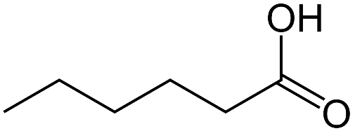 | 4 | 6
Cholesterol | 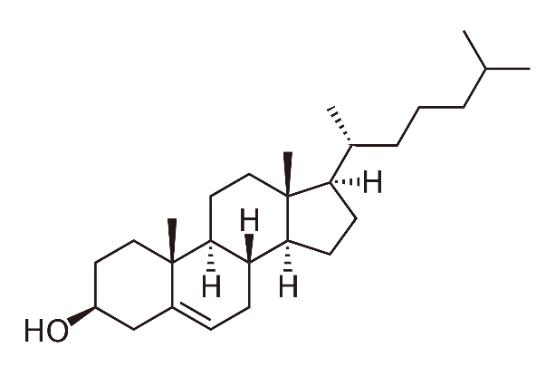 | 6 | 5
Cardiolipin | 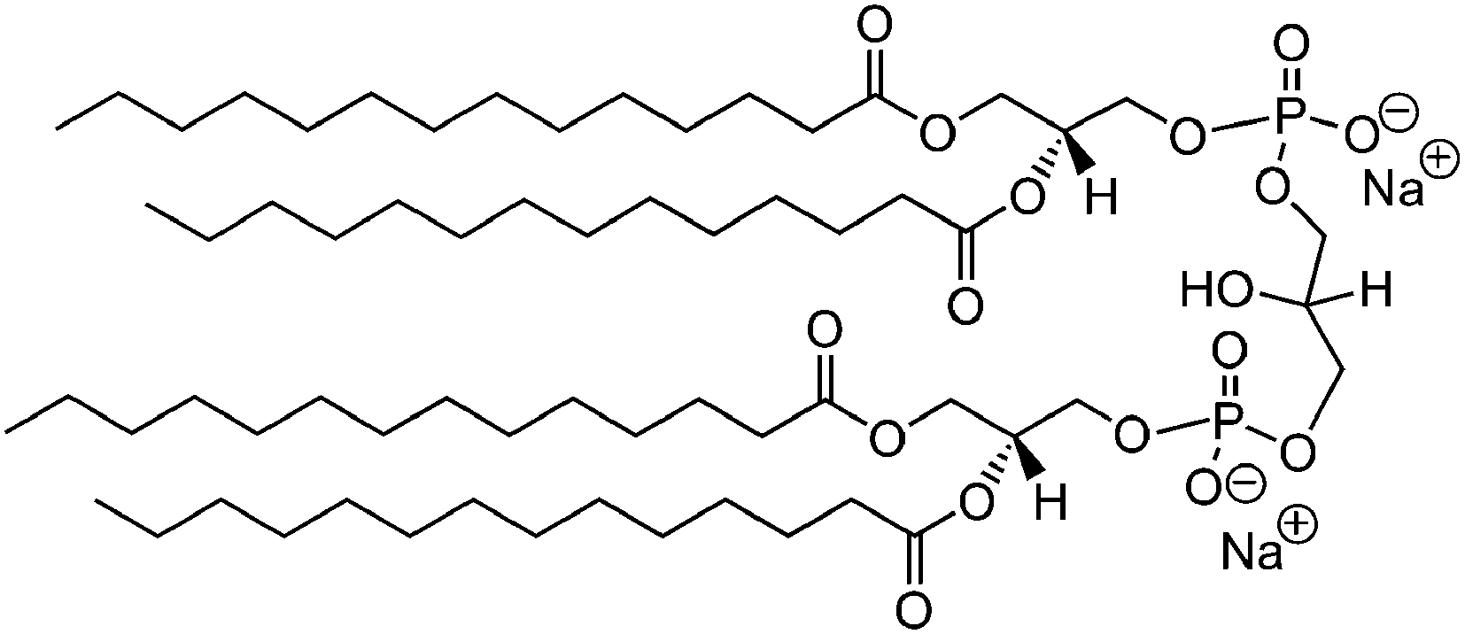 | 5 | 4
Phosphatidyl-ethanolamine | 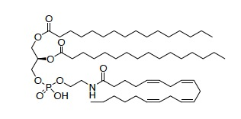 | 3 | 3
Phosphatidyl-choline | 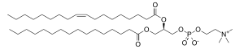 | 2 | 2
Phosphatidyl-inostiol | 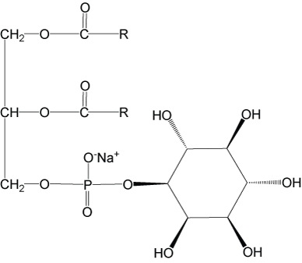 | 1 | 1

Note: The Blue box shows the polar groups on each of the molecules.
The PI is more polar than the PE. This is apparent in the structures, due to the fact that the PI has a carbon ring with 5 hydroxyl groups, whereas PE only has a couple of ester groups, an amide group and a protonated phosphate group. With these structures, it is clear to see that the hydroxyl groups would be much more polar.
The CL is more polar that the CH. When looking at the structures, CL has two deprotonated oxygens on the phosphate groups (which are very polar) along with a few ester groups, and the CH only has one hydroxyl group. These groups would add a much higher polarity, then that of for the CH.
Finally, the PC is much more polar then the FA. The PC has a deprotonated oxygen, along with a couple of ester groups, whereas the FA only has the one Carboxyl group. Even with the Fatty acid deprotonated, the carboxylate is still not enough to make the whole molecule more polar then that of the PC.
R3)
Table 3: Absorbance’s recorded from the lipid assays
Sample | Dilution Fracton | Phosphate (pH 11, 0.2M) | Water (mL) | Membrane Suspension (μL) | Brilliant Blue 125 g/L (μL) | A₅₅₉
Control | 0 | 1.0 | 0.95 | 0 | 50 | 0.954
1/250 | 0.004 | 1.0 | 0.942 | 8 | 50 | 0.919
1/125 | 0.008 | 1.0 | 0.934 | 16 | 50 | 0.881
1/50 | 0.020 | 1.0 | 0.910 | 40 | 50 | 0.503
1/25 | 0.040 | 1.0 | 0.870 | 80 | 50 | 0.406

Y = -9.125 + 0.9545

Figure 2: shows the dilution fraction vs. the absorbance of the lipid assays taken at wavelength of 559 nm. This data was obtained by use of a spectrophotometer and was taken for all of the lipid assay test tubes that were prepared.

Table 3: Absorbance’s recorded for the protein assays
Sample | Dilution | Phosphate (pH 11, 0.2M) | Water (mL) | Membrane Suspension (μL) | A₂₈₀
Blank | 0 | 1.0 | 1 | 0 | 0.005
1/100 | 0.01 | 1.0 | 0.98 | 0.02 | 0.145
1/20 | 0.05 | 1.0 | 0.90 | 0.10 | 0.612
1/5 | 0.25 | 1.0 | 0.50 | 0.50 | 2.265

Y = 12.007x + 0.0139
Figure 2: shows the dilution fraction vs. the absorbance of the protein assays taken at wavelength of 280 nm. This data was obtained by use of a spectrophotometer and was taken for all of the protein assay test tubes that were prepared. Each of these data points were obtained while suspended in a cuvette.
R4)
In order to calculate protein concentration, we much use the equation of the line obtained in Figure 2. To find the absorbance for the pure sample, we use the point (1,Y) to find this expected absorbance.
ε = 2.0 L/g*cm l = 1.0 cm A = ? C = ?
y = 12.007x + 0.0139
y = 12.007(1) + 0.0139
A = 12.0209
C = A / (ε*l)
C = (12.0209) / ((2.0 L/g*cm)*(1.0 cm))
C = 6.01 g/L
Therefore, The Theoretical absorbance of a pure protein is 12.0209 and the concentration of the membrane preparation was 6.01 g/L.
R5)
C_{M} = 1.0 μg/mL A_{M} = 0.013 A_{D} = 0.919 C_{D} = ?
C_{D}/A_{D} = C_{M}/A_{M}
C_{D} = ((1.0 μg/mL)*(0.013))/(0.919)
C_{D} = 0.0142 μg/mL
Therefore, the concentration at the 1/250 dilution is 0.0142 μg/mL.
From this, we can now use the Beer-Lambert law in order to find the concentration of the fraction containing the mitochondria, where F_{D} or F_{M} is the dilution factor for that fraction.
C_{D} = 0.0142 μg/mL F_{D} = 0.008 F_{M} = 1 C_{M} = ?
C_{M}/F_{M} = C_{D}/F_{D}
C_{M} = ((0.0142 μg/mL)*(1.0))/(0.004)
C_{M} = 3.56 μg/mL
Therefore, the concentration of the mitochondria enriched fraction is 3.56 μg/mL.
R6)
V_{S} = 0.01L M_{L} = 2.0g C_{P} = 6.01 g/L
A = (V_{S})*(C_{P})
A = (0.01L)*(6.01 g/L)
A = 60.1 mg
Y = (Exp)/(Thr)
Y = (60.1 mg)/(2.0g)
Y = 30.05 mg/g
Therefore, the total theoretical amount of mitochondrial protein is 60.1 mg and the yield of mitochondrial protein /gram of liver tissue is 30.05 mg/g.

