CMN 1148 Review
Chapter 1: The Communication Process: Learning from Models

Communication – the process of simultaneously giving and receiving information, verbal and nonverbal

How models help us understand communication
- provides jargon
- explains processes of how and why we communicate
- identity relationships during parts communication
- pinpoint reasons for communication breakdowns

7 MODELS OF COMMUNICATION:

Aristotle’s Model of Communication
- linear Model

Communicator Speech persuade an audience

- in order to persuade to the audience the speech must appeal to the audience
- 3 types of Appeal
- Ethos: appeals based on source creditability of the speaker
  - Trustworthiness (ranked #1)
  - Expertise
  - Sociability
  - Composure
  - dynamism
- Logos: Appeals based on logic
- Pathos: Appeals based on emotion
  - emotional appeals based on fear, compassion, pride, guilt, generosity, patriotism, loyalty or other... use more than or seem unethical

Laswell’s Effects Model (1948)
- linear model .... often used by politicians ... developed during radio comm.
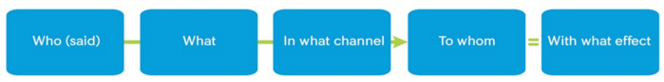
From Aristotle
- who: communicator
- What: Speech
- To whom: audience
new
- Channel: the medium used to transmit a message
- Effects: the intended or unintended impacts of a message
  - Generally an emotional reaction
Shannon-Weaver Mathematical Model (1949)
- 1st model linear, 2nd model interactive

- 1st model only the source and Destination were human
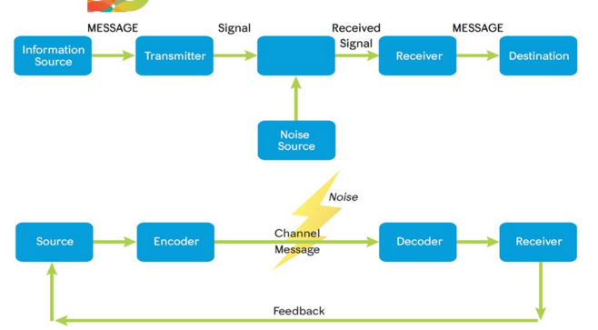
new (even from Aristolean)
- noise: interference that occurs in the transmitting or receiving of signals
  - external or internal noise, psychological or physiological
- Feedback: Response to a message or activity
  - The audience is no longer passive

Schramm Model (1965)
- interactive model

- signal: overlapping/ shared fields of experience
- focus on encoding and decoding of messages
  - how we create, interpret and assign meaning to words and actions
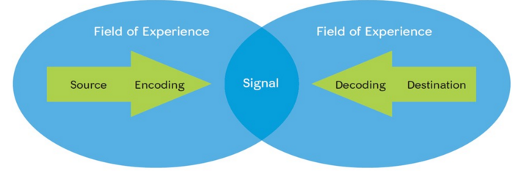
New
- field of experience: the totality of all we are at the moment of communication
Dance Model (1967) ..... the spiral one
- I believe it is an interactive model
- communication is never-ending process with no fixed beginning or ending
- experience will always be part of our past with the ability influence future interactions

Barnlund’s Transactional Model (1970)
- Transactional Theory: communication as a dynamic process, involving continuous changes in communicators and environments (both sender and receiver)
  - Paralanguage: speech that are not recognized as language
  - Sees communication as a dynamic and fluid process
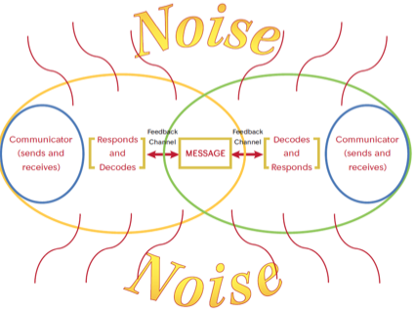

- Incorporates the importance of context of communication
- Includes verbal and non verbal communication

Ferguson’s Critical Communication Model (2006) –CCM
- Outcomes of communication acts
  - Short term
  - Long term
- Cost of Achieving Outcomes to;
  - Individuals
  - Groups
  - Society
- Based for judging costs
  - Motives of the communicator (intent)
  - Means employed (legitimacy of strategies and power bases)
  - Ethical quality of the outcomes)
New,
- ethical and power dimensions

CHAPTER 2 – PERCEIVING SELF IN RELATION TO OTHERS

Self –concept: is a relatively stable and organized collection of thoughts and feelings about the self, which lead to attitudes and drive behaviour
- ie: thoughts and feelings about the self that influence attitudes and drives behaviour
- forms at 6-7 months, once we engage in self-evaluation

Self-Esteem: how we perceive out overall sense of worth or value
Self-Efficacy: Our perceived ability to accomplish something or to make a difference
** when our different selves conflict with one another, our self-esteem
and self-efficacy suffer

Faces of Self-Conception (4):

- Self-Image: Our views of ourselves

- Life Scripts: storylines that we create to guide us through life
- Self-Fulfilling Prophecy: a prediction or belief that leads to its own fulfillment

- Inner script/voice is important for
  - Helping is know how to think and behave in unfamiliar environments
  - Develop storylines, positive or negative
  - Ideas from first hand or second-hand experience
  - Identifying on physic level with settings and places
- Validating Life scripts
  - Social Comparison Theory: we look to others for a standard of comparison
  - Reference Group: a group whose opinions we value in which we hold or aspire to membership
    - Demographic and psychographic
  - Assimilation effect: heightened self-esteem following a favourable social comparison
  - Contrast effect: feelings of inadequacy and lower self-esteem following an unfavourable social comparison
  - Positive feedback in one area can make up for negative feedback in another (poor athlete, excellent social skills and academics)
- Revision Our Life Scripts
  - Recognize out scripts have become outdated
    - Sometimes don’t realize until a tragic moment in our lives

- Looking Glass Self: How we think others see us
a.k.a reflected appraisal: how we think others see us

- Significant Others: peoples who opinions matter to us
  - ex; family, partner , peers, coaches, teachers, caregivers, colleagues
- Self-fulfilling prophecy also applies. The expectation of a significant other can affect your performance on that task
  - The power of significant others to influence our self-concept

- The Ideal Self: The person we would like to be

- the media is the most readily available source as a standard for comparison
- myth of perfection: it is both possible and desirable to achieve perfection
- event thought and belief -> consequence
  - if we can control our thoughts we can control our emotions. Putting a positive spin onto things brings out positive emotions
  - Ellis’ Rational-Emotive Model
- children consume 6.5 hours of media each day. Greatest comparison to the media between the 4-8th grade
- 1900s-mid 1980s women’s body sizes in advertisements decreased 50%
- Exposure to unrealistic media images often result in a three-step process:
- underestimate the weight of the media personalities and overestimate our own weight
- these unfavourable comparisons lead to body image disturbance or dissatisfaction
- Body image disturbance leads to lower self-esteem and sometimes obsessive dieting and eating disorders

- REAL SELF: The person we actually are
- People with high self-esteem are better able to access and feel comfortable displaying the “real self” as they’re willing to stand up for themselves when necessary

Challenges in measuring self-concept across cultures
- Self-Enhancement: the tendency to pay more attention to information that supports a positive view of the self
- Self-criticism: the tendency to pay more attention to information that supports a negative view of the self
- Self-serving Bias: The tendency to credit our successes to internal or personal factors and our failures to external or situational factors
- Face Work: Politeness strategies aimed at making other people feel better about themselves

CHAPTER 3 – PERCEPTION

Perception: Perception is the process of sensing, interpreting, and reacting to the physical world
- 5 vehicles of perception; touch, taste, hearing, smelling and sight
- we learn through experience
- Perception is; learned, backwards looking, culture bound, racially biased, selective, self-serving, value driven, spontaneous and unconscious, relative, context bound, mood dependent, completion seeking

Perception is culture bound and racially bias

Breadth of their perceptual fields: The amount of information we take in our visual or other perceptual systems

Optical Communities: A social group that shares a similar view of the world

Own-race Bias: The idea that accuracy increases when we identify specific members of our own race

Out-group: a group of which one is not a member

Perception is selective and self-serving

Selective Perception: the process by which we see and retain certain kinds of information while ignoring or discarding other kinds of information

Load-induced Blindness: inability to see as a result of information overload in the visual field

Perception is spontaneous, largely unconscious and value driven

Warranting Theory: theory that says we are more likely to believe information that someone cannot manipulate

Impression Formation Theory: how we put together different pieces of information to form an impression of a person

Tar effect: A tendency to dislike the person who criticizes someone else rather than disliking the person who is criticized

When encountering unfamiliar information
- leveling sharpening assimilating

Perception is relative and Context Bound

Standpoint theory tells us that we can never escape our place in the economic, social, and political order

Perception is mood dependent

Mood Contagion: The idea that we can “catch: the mood of someone else much like we catch a cold

Perception is Completion-seeking

Stereotypes: popularly held beliefs about a type of person or group of persons that do not take individual differences into account.
- the completion-seeking nature of perception manifests itself in the practice of stereotyping

Self-Categorization Theory: the idea that we see ourselves as both individuals and group members, whereas we see others as either individuals or group members based on other factors

Perspective Taking: Looking at a situation from the other person’s point of view

Counter-Stereotyping: Effort to eliminate stereotypes by focusing on similarities

Active Perceivers: individuals who choose the amount and type of information they receive

Passive Receivers: individuals who rely on others to select information for them

In-Group: A group of which one is a member

----------

Perception Checking: A process for confirming what we think we have seen, heard, or experienced
- 1. Notice behaviour
- 2. Two interpretations of behaviour
- 3. Ask for clarification

Low-Context Cultures: Cultures that rely heavily on words rather than context
- Canada

High-Context Cultures: Cultures that place great importance on context and rely to a lesser degree on words
- Japan and Mexico

Communication Predicament of Aging (CPA) Model: Predicts the relationship among aging cues, stereotyping and communication behaviour

Common problems in perceiving others;
Primacy effect: we pay more attention and remember what we see first
- ** note our first impressions are often wrong

perception is spontaneous and unconscious
- cues to decide on a persons characteristics connect characteristics to personality personality to anticipate behaviour

Aboriginals do not see time as linear but circular. Where community and family may be in the inner circle and get first priority while dr appointments maybe in the outer circle, being addressed last.

We respond more to the negative than to the positive

2 million bits a second

CHAPTER 4- UNDERSTANDING, NAVIGATING AND MANAGING OUR IDENTITIES

Identity: Characteristics that let other people recognize us
- Identity Markers; (4) Physical, Social, Academic and emotional
- This is the opposite of self-concept. Self-concept ask “Who am I?”. Identity asks “Who are you?”
- Identity may contain elements not in our self-concept and vice versa... for example babies do not have a self-concept but they have an identity

Multiple Identities: Multiple identies related to roles
- can have multiple selves; example, athlete, boyfriend, student, uncle, brother..
- also have a collective dimension

Collective Identity: The characteristics of our personal identity that we share with members of a larger group
- gender identities, ethnical & racial identities, religious identities, linguistic & cultural identities and regional & national identities
- National Identities: Geert Hofstede cultural dimensions (4)
  - Power Distance: how we believe those in power should look and act powerful
  - Uncertainty avoidance: How much we accept and needs rules, regulations and clear delineation of responsibilities
  - Individualism-collectivism: Extent to which people value and reward individualism versus groups
  - Achievement-nurturance: the extent to which people value stereotypically masculine traits versus stereotypical feminine traits

Experimenting With identities: Experimenting with the identity markers
- online identities: (50% of internet users have once assumed a fake identity)
  - sometimes online identities reflect our ideal selves and or historical selves
  - we can internalize our online identities offline. Can be good or bad

Validating our Identities:
- Self Verification Theory: Theory that says we want others to see is as we see ourselves
  - Rokeach: Creditable threats to our belief system can destroy self-identity
  - Type A beliefs – beliefs related to Physical Reality... 100% consensus
    - Ex my name is Roy, I am in a university
  - Type B beliefs – ego beliefs that require 0 consensus
    - Ex attractive, intelligent
  - Type C beliefs – authority beliefs.. authority beliefs
    - Ex supporter of the Green Party
  - Type D beliefs derived from authority figures
    - I am a supporter of Donald Trump haha
  - Type E beliefs – beliefs about arbitrary and inconsequential matters of taste
    - Ex i like my steak rare or I prefer Nike products
- Happens when a person’s innermost beliefs about the world and his/her place in it are threatened
  - Credible threats to Type A beliefs can destroy self-identity.
  - Credible threats to Type B beliefs can destroy self-concept.
  - Credible threats to Type C beliefs can destroy authority systems—and by extension, societies

Self-monitoring: the extent to which we regulate our behaviour sin order to look good to others
- High self-monitors: People who are very aware of the opinions of others
  - make good managers
- Low Self-Monitors: do not worry about others opinions
  - Good research and project members

Impression Management: The way we create impressions of ourselves in the eyes of others.... in other words, the way we self-monitor
- Strategies;
  - Self-promotion: Emphasize their strengths (competencies, abilities, or accomplishments) to make a positive impression on others
  - Ingratiation: show extreme concern with being liked by others
    - Compliments and flattery
  - Intimidation: try to achieve their goals by provoking fear in others
  - Exemplification: Attempt to gain respect by displaying sincerity, devotion, and responsibility
    - Can backfire, seen as a try-hard or hypocrites
  - Supplication: Attempt to get sympathy and attention by presenting oneself as in need of help
- Online environment.. Computer-mediated Communication (CMC)
  - Synchronous: Same time different place (texting)
  - Asynchronous: Different time different place (e-mail)

Women online are more likely to lie about the weight online but more honest in Disclosing their status as single, divorced or separated
Men are more likely to lie about their height online
Families also tend to be engaged in family secretes, also hidden on online identities

