Stats2 midterm prep

Chapter 10

Chapter 11

Chapter 12

Type 1 vs Type 2 error

Type 1: is called gullibility. Its when for example someone says when you know the mean to be 10, and then someone says no the mean is actually 20 and you believe it

Type 2: when you thought the mean was 10, but then later find out that the mean was actually 30, you were BLIND to it (error of blindness)

When do you use Z score vs T score?
- When sample size is SMALLER then 30, we use T SCORE
- When sample size is 30 OR ABOVE, WE use z score

What is X bar & P hat?
- they are essentially the MEAN of the THING we are interested in proving

Types of questions

Test the claim/hypothesis

One sample claims
Test that there are MORE than we thought (right tailed one sided)
Test that there are LESS than we thought (left tailed one sided)
Test that there is a CHANGE (two tailed test)
With two tailed test, we get HO= and H1 cannot equal

Two sample claims
Test that the females is GREATER than males (one sided, p1-p2>0)
Test that females is LESS than males (one sided, p1-p2<0)
Test that there is a CHANGE in females from 2011 to 2013 (two tailed p1-p2 does NOT equal 0)

Assumptions:
- When a sample is more than 30, we assume its normally distributed, which is valid with parametric T test
- Sometimes when the sample is large, when parametric testing is legit there are no assumptions require

TYPE1

- Simple, straight forward with no tricks
- When they give you a significance level, of lets say 0.05. this is relevant to finding Zcritcal value
- If the claim is saying MORE THAN, we use the Z score associated with the opposite side (0.95)
- Gives us 1.6445
- Compare that to Zcalc
- When the ZCrit is low, reject the HOE

Type 2
- Test to see if your claim if it actually being LOWER is true using a 5% significance level
- Because we are seeing for LOWER, we just use 0.05 instead of the other side (95%)

Type 3
- instead of giving us the standard deviation, they give us the SE. the SE is not the entire right side, the Se only replaces the SD, calulcations carry on as usual

Type 4
- there are NO proportions given; all values given are QUANTATIVE.
- Suppose your stocks have an increase in 25%, this is not some proportion or mean it’s a value

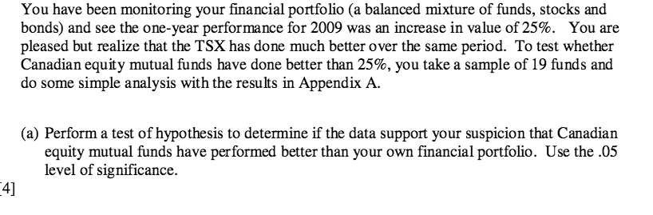

- in this question we want to use a T score, instead of a Z score because the SAMPLE IS LESS THAN 30 (19 in this case)
- to be able to reject or accept a claim, we are going to compare the H1 to H0, by comparing the T test, to the Tcritical value
- when the T test >Tcritical, we can REJECT THE NULL, which usually means that there IS sufficient evidence to support our claim (usually)
- Now, this is two part.
- The T test value is using our equation of
- 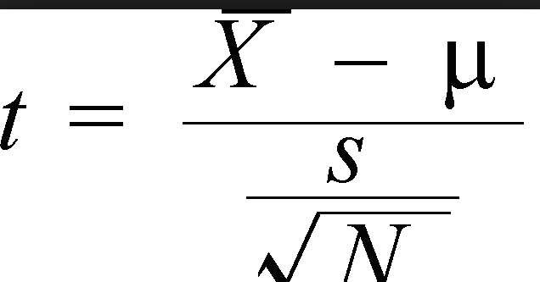 & we are comparing that value to the T critical value.
- using alpha of 0.05, and a DF of n-1 (sample number minus 1) we can look at a T chart to find the T value, this is called the T critical value.
- Remember this saying: When the P is low, reject the HOE
- Here, it’s if the H0 is low, and HO is associated with T critical value, so if the T value is low, reject the HO, so reject the null hypothesis

- So H0 = 25 is our null claim
- H1 >25 is our ALT claim
- Now test
- T score is the equation Xbar – Mew / Sd / (sqrt(n)
- = 4.1484 (not that the SD, and MEAN are both given to us but for some reason not written in the question)
- Using our DF of 18 and alpha of 0.05, the T critical value is 1.7341. Now
- Since 4.1 > 1.73, the HO is low so we reject the Null (the claim that they are equal and that my original claim is wrong) therefore there is evidence to support the claim that they are outperforming 25%

b) Calculate the 95% 1 sided confidence interval (usually asked AFTER some hypothesis question)
- Usually, you use the Zcrit that we found in parta)
- simple and no tricks to this one, Zcrit is 1.6445

Type 2: Calculate the 95% confidence interval (does not say 1 sided)
- This is the first part of the question they ask
- here, we use 1.96 as the Zcrit
- but if the sample is less than 30 (T stat question)
- we use 2.06 (the T score associated with, 1-c /2) = 0.025

calculate the average return using 95% confidence interval
- NOTE: CALCULATE THE 95% CONFIDENCE INTERVAL IS DIFFERENT THAN WHEN THEY SAY “WHAT IS SOMETHING USING A 95% confidence level)
- when they say to calculate the 95% confidence interval, they want you to use the normal equation, where Zcrit = 1.6445.
- when we say “USING A 95% confidence LEVEL” you use Z crit as, 1-c / 2
- so for a 95% confidence level, it would be 1.96

in this case, we use the confidence interval which is given. Whenever a confidence interval is given, we must remember the other equation, which looks like..

Phat plus minus Zcrit x SE (Se is sometimes pq/n, or it’s the more complicated version)

- whenever they say “using a certain confidence interval” (in this case 95%) we must remember the equation of, 1-c / 2 = alpha
- so here, 1-95%/ 2 = 0.025

finding the using a margin of error
- always use Z values even if the question before was T score based
- 95% confidence interval is Zcrit=1.96
- note, usually say “margin of error of 1%” which is qualitative, 0.01 but sometimes they say “that the average return margin error is 1% which makes it 1 not 0.01 because that question was related to stocks being up 25% which was also quantative”

Here we are simply isolating for that variable, by working backwords
Margin of error is basically the total of Zcrit x SE
Example
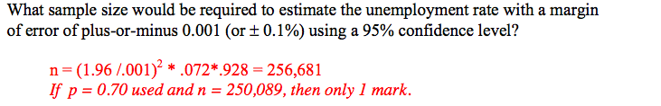
(Background info; this is a standard Z score question, where SE = Sqrt(pq/n)
notice that it says confidence level? That means 1-c /2 = 0.025. the question asks for more than, so the other side is 0.975, which gives a Zcrit of 1.96. P is = 0.072
SO
Margin of error = Zcrit x SE
0.001= 1.96 x (0.072 x (1-0.072) / (n)
isolating for n, we get what is in red
anytime we do confidence interval, the only weird thing that changes is SE, there are many forms of SE which we will look at later and when to use each one )

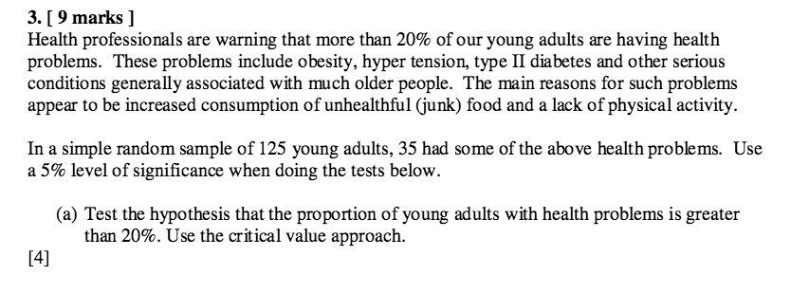

Here we are using Z score because the sample is above 30
We know the mean is 0.2, but what is Phat? In this case its given as, 35/125. We know this because that talks about having health problems, which is our ALT hypothesis.

- Use the Z calc (Phat-mean) / SD and compare that to Zcrit
- Note that usually in these Z score questions the SD is not given but don’t forget that SD = SQRT(pq/n) where we use the 0.2 P not Phat
- Note: when comparing them Zcalc, there are some rules to consider
- 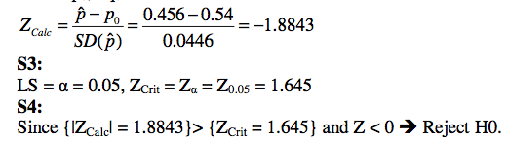(differ example)
- Because Zcalc is less than 0, we can use absoloute value to make it + which then makes it bigger than Zcrit
- We can only do this when Phat<P
- If Phat was >P we would NOT reject the null (I don’t fully understand this)
- To make life simple, when we get a negative Zcalc, check to see if Phat is less than P, we are gonna have to absolute value the Zcalc when comparing it and also state that Z<0REJECT HO in ur answer
- Zcrit is found using the level of significance they give you
- What does the level of significance mean?
- So here, 5% means that the left side is 5% and the right side is 95%
- When the claim is GREATER, we use the right side (95%) but when the claim is LESS than, we use the 5% given
- What do we do with them?
- We find the Z value associated with that area
- In other words, when we have an area of 5%, or 95%, what is the Zvalue?
- If it was a 2 tail test, we divide that area by 2
- So, 0.05 /2 or 0.95/2
- HINT: whenever they say 5% significance level instead of 0.05, ur prob gonna use Z score critical value
- We must assume that the pooled variances are equal

- We use the standard deviation from the 0.2, not 0.28
- We use Phat P later in the question

b) find the P value (otherwise known as NON PARAMETRIC TESTING)
- the P value is the Percentile using the Z score (not the critical value)

- to do this, we know the Z score is 2.23 (using 0.28-0.2 / SD)
- this gives us two areas, 98.734 & 0.0125.
we use the right side because our question is asking for GREATER
so the P value is 0.0125, which is LESS than our level of sig, 0.05 so we reject it as well
- in other words, whenever they ask for the P value, you use your Z score (not your Zscritical value)
- find the one sided areas that the z score gives us
- if claim is asking for GREATER THAN (example, the claim that our stocks have INCREASED) than we use right side, if less than then decreased
- in other words, when H1>mean, right side
Finding the P value from T statistic,
- you isolate DF, and then find the number closest to your value then estimate

Now calculate the 95% confidence interval for our appropriate
- when using Z scores, the confidence interval is simple:
- Phat Plus/Minus Zcritical x sqrt(pq/n)
- In this case, we use the P of Phat, and not the P of the mean

Testing if a new drug is effective given before and after data
EITHER ITS GONNA BE PAIRED OR INDEPENDENT
WHEN PAIRED:
- The data for each of the patients is called “paired” because each piece of datas before and after measures the SAME patient
- Suppose we were looking at different companies, it would be independent
- Our claim H1 would be that the new drug is actually effective.
- This means that H1>0 & that H0 = 0 (no effect of the drug)
- But what numbers do we use for the T test?
- We use the DIFFERENCE in means, as the X bar, we use the difference in SD as the main SD
- We use the difference in means because the difference is associated with the drug being effective or not, so that acts as our X bar
- Carry on the question as usual, using our equation ,
- (XBAR – 0)/(SD/√n)
- in this question, when looking for your information, there are many boxes to gather information from “2 sample t test.. paired t test and CI.. mann-witney..” etc gather your information from “Paired T test and CI”
- when the data is paired, the name of the tests done on them are called the 1) Paired T test or the Paired Wilcoxon tests.
- In these types of questions, they also give you 3 box plots (by saying refer to appendix B or A)
- The only relevant boxplot is the one labeled “differences”
- Paired T test used when there is a normal distribution present
- Paired Wilcoxon test is used when there are OUTLIERS in the boxplot titled “differences” because it means we cannot assume the data came from normal distributed.

Parametric vs non parametric testing
- when the data is skewed (shown by the middle line or outliers) then this means that the data is NOT normally distributed; when it is not normally distributed, we use NON parametric testing
- when the data is NOT skewed, it is normally distributed; when it is normally distributed, we use parametric testing

When independent
- The differences boxplot is not relevant because we are not comparing the same thing at different times, to measure a difference between those, we are simply measuring the difference between 2 independent things, like 2 companies

We are given two populations (males and females lets say)
We want to test a claim about the relationship between these two
In this case, lets say we want to test wether there is enough evidence to support the claim that, the average male BMI is greater than the average female by more than 3BMIS

Type1 – SD is given for both
- we do the same as before, we compare HO to H1 but with a difference
- H0: P1-p2 = 0 (that the difference in the populations are the same)
- H1: p1-p2 > 0 (the difference in males vs females is greater for males. Sometimes they can ask, show that males are greater then females by 3 in which case the 0 becoems a 3. )
- Given this, when we do our T score, we are going to use xBar (the difference in the populations) and the MEAN we use is 0 (unless another number is stated)
- Mistake I’ve made: do not simply average out the standard deviation for both because you can get it wrong like that. Find the POOLED VARIANCe, which if we recall, variance is SD^2 so, average out the variance, then SD that by square rooting it
- 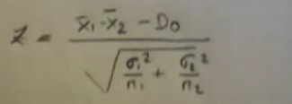 this is the equation we use for the Z score (H1) if both Sd’s are given

Type 2
When SD is NOT given, instead of doing PQ/N for both and then plugging in, we will get wrong answer. Instead, find the POOLED sd using total N & added P
Once we have this, we can continue to the equation same way, but instrad of putting SD on top of n1, we simply do the sqrt(SD pooled x 1/n1 + 1/n2)

When doing pooled, we must assume that each population is normally distributed
When this is NOT satisfied, we use the MANN-Whitney U test

Margin of error question
N = Zcrit^2 x Pq / ME^2 (when it’s a simple Z score question where SE is sqrt(pq/n)

P test (Using T)
- the Tcalc answer gives us the T score we are gonna search for on our T table
- once we find the T score close to that, we look all the way up to see the area
- if it is 2 sided, we multiply P by 2
- sometimes if Tcalc was lower than the smallest Tnumber shown we can subtract differences in different T score to arrive at an estimate area

Hypothesis testing
- when it asks for the MEAN “claim” we use T test (don’t forget to check)

Is the parametric test valid in this case?
- When the sample Is above 30, it does not have to be normally distributed even if it has outliers
- if it is above 30, the data must NOT be skewed, if it is skewed then Parametric testing is not valid
- when the data is BELOW 30, (t test) there must be no outliers, if there are outliers then it is not normally distributed and therefore, would not work

whenever we are pooling, use Tcrit even if sample is above 30

Paired vs indepdnent data
- when the data is independent, we treat it as POOLED, using our pooled equation
- paired, do as normal
- 

