Learning Objectives
- Define a marketing strategy
- Describe the elements of a marketing plan
- Analyze a marketing situation using a SWOT analysis
- Explain how a firm chooses what consumer group(s) to pursue with its marketing efforts
- Outline the implementation of the marketing mix as a means to increase customer value
- Describe how firms grow their businesses

What is a marketing strategy?
- Marketing strategy identifies:
  - A firm's target market(s)
  - A related marketing mix - the four P's and the bases upon which the firm plans to build a sustainable competitive advantage

Developing customer value & sustainable competitive advantage
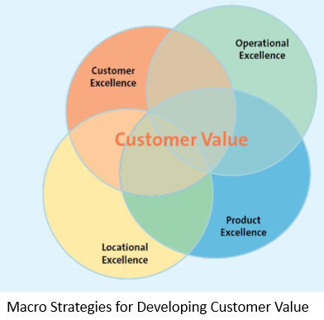
Customer excellence
- Retain loyal customers
- Provide excellent customer service

Operational excellence

Product excellence
- High perceived value + effective branding and positioning

Location Excellence
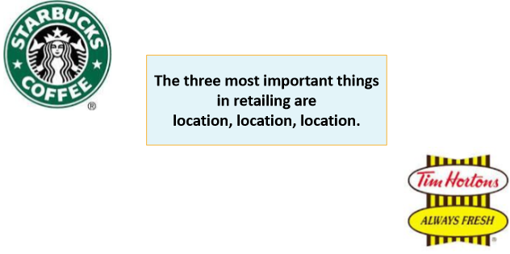

Developing a Marketing Plan
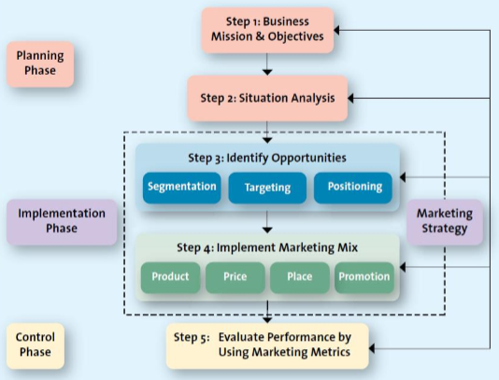

Step 1: Define the Business Mission & Objectives
- Defining the mission:
  - The mission statement is a broad description of a firm's objectives and the scope of activities
  - 

- 

- 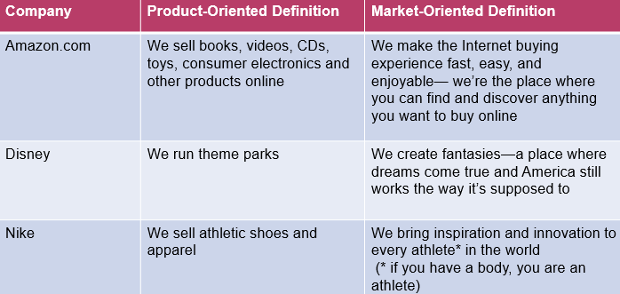

Step 2:Conduct a situation analysis (using SWOT)
- 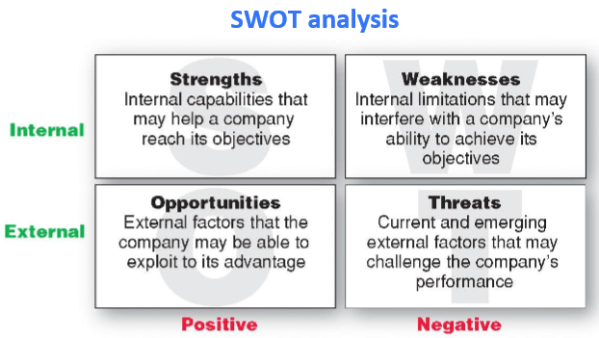

- 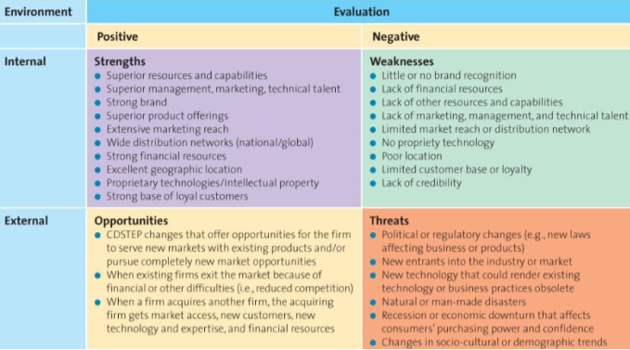

Step 3: Identify and Evaluate Opportunities by using STP
- 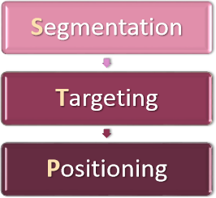
- Example: Hertz
  - 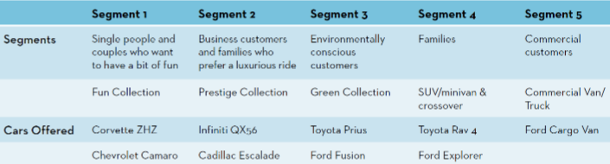

Step 4: Implement Marketing Mix and allocate resources
- 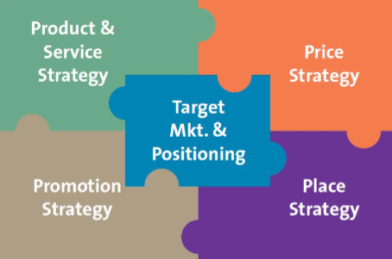

Step 5: evaluate performance by using marketing metrics
- 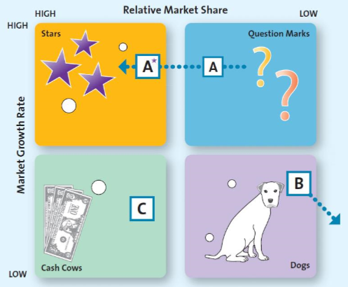

Growth Strategies
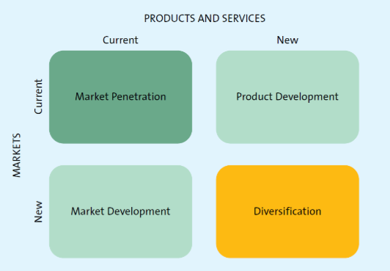
- Diversification
  - Related diversification
    - Companies have a strategic fit with the new venture
    - They capitalize on the strengths or competitive advantage they've already established
  - Unrelated diversification
    - Nothing to do with leveraging current business strengths or weaknesses

Test Your Knowledge


