Ch2
LO 2.1 Scientific management
Management = getting the right things done through other people
Classical approaches to management include: Scientific management (Fredrick Taylor), Administrative principles (Henri Fayol), Bureaucratic organization (Max Weber)
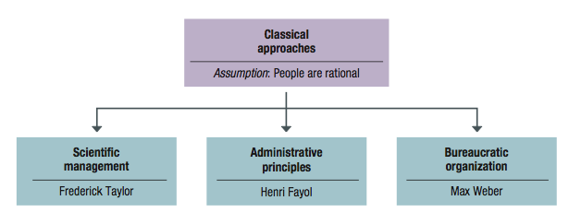

Scientific management-Taylor: The systematic study of the relationships between people and tasks to redesign the work for higher efficiency.
Taylor sought to reduce the time a worker spent on each task by optimizing the way the task was done.
- Principles to increase efficiency:
- For every job develop a science that includes: Rules of motion, Standardized work implements, Proper working conditions
- Carefully select workers with the right abilities to perform the job
- Train workers to do the job and give them proper incentives to cooperate with the job science
- Support workers by carefully planning their work
Study & Codify –> Select & Train –> Reward
- Problems of Scientific Management:
- Managers often implemented only the increased output side of Taylor’s plan. (They did not allow workers to share in increased output; Specialized jobs became very boring, dull; Workers ended up distrusting Scientific Management)
- Workers could purposely “under-perform”
- Management responded with increased use of machines.

Scientific Management – Frank and Lillian Gilbreth
Frank and Lillian Gilbreth refined Taylor’s methods. - Made many improvements to time and motion studies.
- Time and motion studies:
- Break down each action into components.
- Find better ways to perform it.
- Reorganize each action to be more efficient.
Gilbreths also studied fatigue problems, lighting, heating and other worker issues.
The Gilbreths vs. Taylor
Gilbreths’ studies were more focused on how a task was done, and how to best eliminate unneeded, fatiguing steps in any process
Gilbreths’ form of scientific management had a more developed view of the worker and his/her interests vs. Taylor’s predominant view of the worker as driven solely by pay
Gilbreths used photography as a means to study human motion in completing tasks (micro motion films)
- Practical lessons from scientific management
  - Make results-based compensation a performance incentive
  - Carefully design jobs with efficient work methods
  - Carefully select workers with the abilities to do these jobs
  - Train workers to perform jobs to the best of their abilities
  - Train supervisors to support workers so they can perform jobs to the best of their abilities

Administrative Management – Henri Fayol
Fayol: all administrative activities could be divided into 6 groups:
- Technical operations (production/manufacturing)
- Commercial operations (purchases, sales)
- Financial operations (finding & controlling capital)
- Security operations (protecting property & persons)
- Accounting operations (stock-taking, costing)
- Administrative Operations or managerial activities: foresight, organizing, commanding, coordinating, controlling
Fayol developed a set of 14 principles of management:
- Division of Labour: allows for job specialization. Fayol noted firms can have too much specialization leading to poor quality and worker involvement.
- Authority and Responsibility: Fayol included both formal and informal authority resulting from special expertise.
- Unity of Command: Employees should have only one boss.
- Line of Authority: a clear chain from top to bottom of the firm.
- Centralization: decisions are primarily made from the top.
- Unity of Direction: One plan of action to guide the organization.
- Equity: Treat all employees fairly in justice and respect.
- Order: Each employee is put where they have the most value.
- Initiative: Encourage innovation.
- Discipline: obedient, applied, respectful employees needed.
- Remuneration: All should receive fair payment for their work; employees are valuable and not simply an expense.
- Stability of Tenure: Long-term employment is important.
- General interest over individual interest: The organization takes precedence over the individual.
- Esprit de corps: Share enthusiasm or devotion to the organization.

Bureaucratic organization (Max Weber)
Bureaucracy: An ideal, intentionally rational, and very efficient form of organization. Based on principles of logic, order, and legitimate authority.
- 5 Principles of Bureaucracy:
- A manager’s formal authority derives from his/her position.
- People should occupy positions because of performance, not social connections
- The authority, responsibility of each position relative to every other position should be made clear.
- Positions should be arranged hierarchically.
- Managers must create a well defined system of rules standard operating procedures, and norms.

LO 2.2
Behavioural Management- human resource approaches include:
- Follett’s notion of organizations as communities
- Hawthorne studies
- Maslow’s theory of human needs
- McGregor’s Theory X and Theory Y
- Argyris’s theory of adult personality
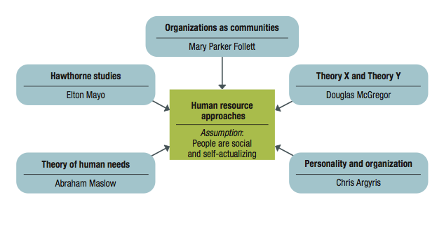

Mary Parker Follett:
- Suggested workers help in analyzing their jobs for improvements.
- The worker knows the best way to improve the job.
- If workers have the knowledge of the task, then they should control the task.

The Hawthorne Studies - Elton Mayo: Occurred at the Hawthorne Plant of the Western Electric Company in Cicero, Illinois. Initially examined the physical and environmental influences of the workplace (brightness of lights, humidity) and later examined the psychological aspects (breaks, group pressure, working hours, managerial leadership)
Four General Conclusions for Hawthorne:
  - The aptitudes of individuals are imperfect predictors of job performance
  - The informal organization affects productivity
  - Work-group norms affect productivity
  - The workplace is a social system

Maslow’s theory of human needs (a physiological or psychological deficiency a person feels compelled to satisfy.)
Need levels: PhysiologicalSafety-SocialEsteemSelf-actualization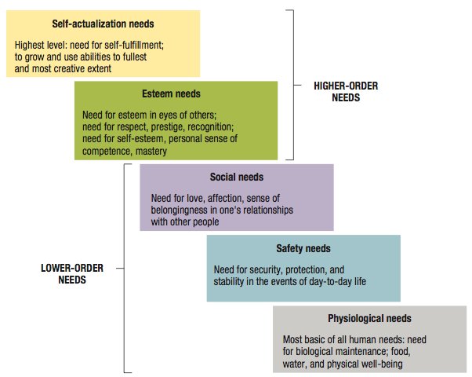

Maslow's theory is based on two underlying principles:
- Deficit principle: A satisfied need is not a motivator of behaviour.
- Progression principle: A need becomes a motivator once the preceding lower-level need is satisfied.
Both principles cease to operate at self-actualization level.

Douglas McGregor's Theory X and Theory Y:
Two different sets of worker assumptions:
- Theory X: Assumes the average worker is lazy, dislikes work and will do as little as possible.
Managers must closely supervise and control through reward and punishment.
- Theory Y: Assumes workers are not lazy, want to do a good job and the job itself will determine if the worker likes the work.
Managers should allow the worker great latitude, and create an organization to stimulate the worker.

Argyris's Theory of Adult Personality: Managers who treat people positively and as responsible adults will achieve the highest productivity.

LO 2.3 Modern Management Foundations for continuing developments
- Quantitative analysis and tools: management science and operations research , are increasingly supported by computer technology and software programs
  - Systems view of organizations: organizations were described as open systems that interact with their environments in the continual process of transforming inputs from suppliers into outputs for customer
  - Contingency thinking: tries to match management practices with situational demands.
  - Commitment to quality:
  - Learning organizations
  - Evidence-based management

