ECO1102
Octavian Strîmbu
Saving and interest rates (eco1102)
Mathilde Jovanovic-Pelletier 8128741

There are two components that are paramount in economic growth in the long-run in the financial system-the savers and borrowers. Many commentators, including high officials of the bank of Canada, have blamed the spending habits of the Canadian public from 1981 to 2005 for high interest rates. These commentators and high officials of the bank of Canada are in fact correct. Figure 1.0 illustrates that there is a factor somewhere in the Canadian economy that is detracting savers from saving at a somewhat constant rhythm from 1981 to 2005.
The causality of this household saving rate downfall can be due to a plethora of economic components. With regards to interest rates, the decline in household saving rates can be attributed to either higher interest rates or lower interest rates. The mechanisms of supply and demand of the financial market are demonstrated in the Market for Loanable Funds diagram (figure 2.0). Simply put, this diagram presents how savers and borrowers affect interest rates and loanable funds, and vice-versa. The savers represent the supply curve considering they are supplying the funds to the borrowers. The borrowers represent the demand curve because they are in demand for funds from the savers; both curves are codependent and co-reliant.
Fundamentally, household savers are stimulated when interest rates are high, as this means a higher return on capital in the future. On the other hand, when interest rates are low, savers are less inclined to save and more inclined to consume and spend; this is the tradeoff. This brings us to the point of interest rates and public spending. As the interest rates go down so does the household saving rate (supply curve shifts to the left, lowering capital for investors). If households are not putting their money in banks to save and grow interest on, they now have this money to use. This justifies the savers’ greater and substantial spending habits. When the interest rates are favorable to savers, the percentage of savers increases (supply curve shifts to the right). This increase in the supply in the market for loanable funds makes the interest rates consequently go down (makes the quantity of loanable funds demanded go up) which in turn makes the supply for loanable funds go down once again. This creates a characteristic of a back-and-forth in the supply curve. This is illustrated in figure 1.0 when the household saving rate fluctuates between certain years, for example between 1987-1989 and 2003-2004. When interest rates decrease due to an increase in supply for loanable funds, this is beneficial to the borrowers.
The constant decline in household saving rates is somewhat problematic as higher saving rates generates a higher rate of growth of gross domestic product. This negative slope can evidently be halted by increasing interest rates. This will incite savers to save once again. However, low interest rates on their own are not a negative, as they encourage borrowing and investing which stimulates the economy.

Appendix

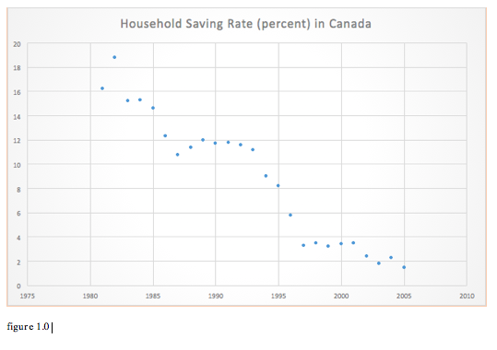

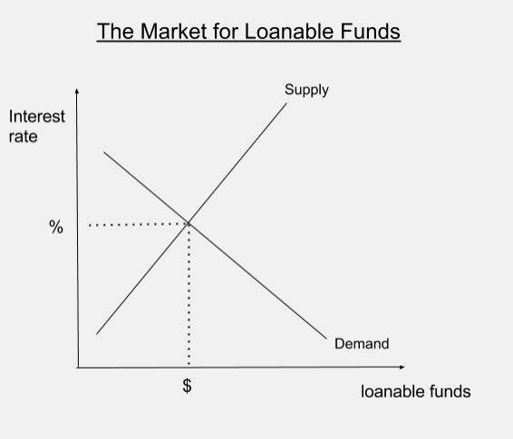
figure 2.0

