KEY TOPICS – SESSION 2

I. Why Plan

II. Planning Variables
- Objectives: goals – what you want to accomplish
- Strategies: how you will accomplish it and utilizing which resources to do so
- Tactics: specify the actions required to execute the strategy

III. Strategic Planning
- The process of developing & maintaining a strategic fit between the organization’s goals & capabilities & its changing marketing opportunities

A. Mission Statement
- A mission statement asks: What is our business? Who is the customer? What do consumers value? What should our business be?
- 5 criteria for a good mission statement: Market oriented, Realistic, Specific, Motivational, Consistent with the market environment

- Setting Objectives
- can be expressed quantitative or qualitative terms
- guide the development of strategic plans for the corporation, & subsequently the functional plans for each SBU

- Designing the Business Portfolio
- Business portfolio: The collection of businesses & products that make up the company
- Analyzing the portfolio

- Downsizing to trim SBUs & product lines

- Business Development Strategies - Growth Strategies
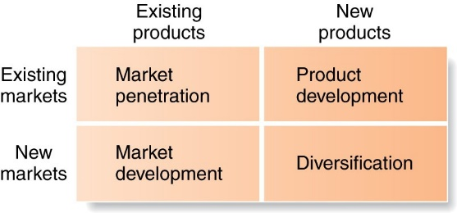

- Concept of Related Diversification

IV. Marketing Management Process (Fig 2.4)
Analysis:
- Analyzing marketing opportunities
Planning
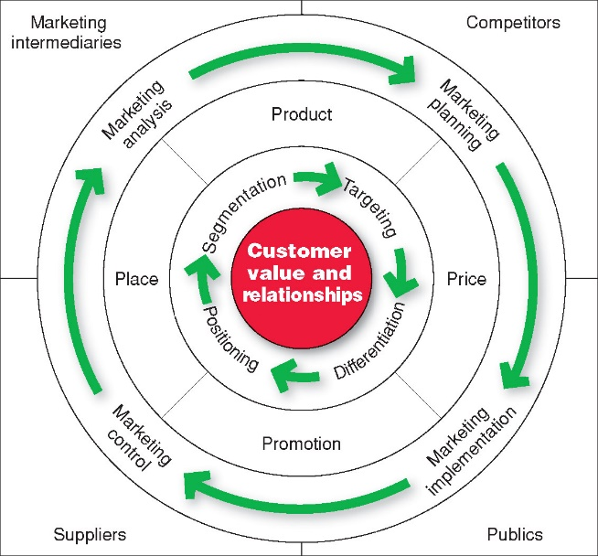
Implementation
Marketing Control

V. Customer-Centered Marketing Strategy
- Identifying Consumers’ Needs

- Segmenting the Market – grouping together consumers with similar needs, preferences or responses to marketing programs – each identified group is then called a market segment

- Market Targeting
- analyze each segment’s potential re. size, demand, estimated market share accessibility, actionability, etc.
- are the segment’s needs being served already, if so, by whom and how well
- internal & external factors that can affect our ability to do business in each segment

D. SWOT Analysis & Environmental Scanning Fig 2.7
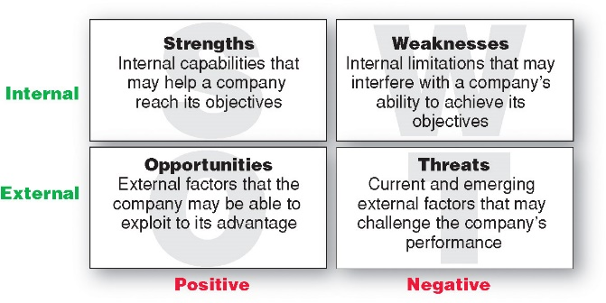
- See chart at end for sample of items commonly found in each area of a SWOT analysis

- Marketing Environment consists of 2 broad categories of influences:
The Microenvironment - forces that are close to the company that affect its ability to serve its customers
The Macroenvironment – larger societal forces that affect the whole environment

- The Microenvironment – Fig 3.1
  - The Company:
    - Management, finance, research & development, purchasing, manufacturing, accounting, & human resources
    - Each has their own objectives, but must work in harmony to achieve the company’s broader goals
  - Suppliers:
    - Supply availability, pricing, quality are key issues
    - Effective partnership/relationship management with suppliers is essential for a strong value delivery network
  - Marketing Intermediaries:
    - Help to promote, sell & distribute goods to final buyers
    - Includes resellers, physical distribution firms, marketing services agencies & financial intermediaries
    - Partners in the overall value delivery system
  - Customers:
    - Consumer, business, reseller, government, institutional, and international markets
  - Competitors:
    - Monitor competitors’ offerings to create strategic advantage
  - Publics:
    - Any group that has an actual or potential interest in or impact on an organization
    - Seven publics include: Financial, Media, Government, Citizen-action, Local, General, & Internal

- The Macroenvironment – Fig 3.2
  - Demographic Environment:
    - Aging population
    - The three largest age groups are: the Baby Boomers (1 in 3 Canadians belong to it), Generation X, & Millennials or Generation Y (includes Tweens - ages 8–12, Teens 13–19, & Young adults 20’s).
    - Urban population – geographically skewed
    - Fewer kids – more single parent households – working mothers
    - More educated
    - Increasing diversity

What’s Ahead
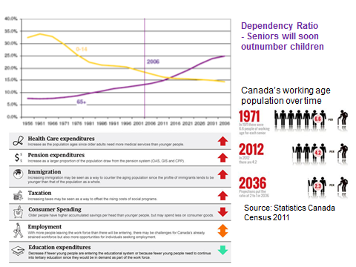
Immigrants by Country of Origin – Canadian Census 2011

  - Economic Environment
    - Factors affecting consumer buying power & spending patterns
    - Type of economy will influence resources & purchasing
    - Changes in Income
    - The distribution of income has created a two-tiered market
    - $27,131: Average consumer debt excluding mortgages – up 3.47% over 2012
    - Value marketing - offers financially cautious buyers greater value—the right combination of quality & service at a fair price
    - In recessionary times, consumers are more likely to cut back on non-necessities first.
    - In recessions, consumers normally cut back on spending and focus on paying off debt, as the US has done. Contrary to normal patterns, Canadians actually spent recklessly, amassing record high debt levels. Current debt to disposable income ratio is 163%. Implications: With the possibility of a double dip recession or if the Bank of Canada raises interest rates, consumers may be hard pressed to make their payments.
  - Natural Environment:
    - Focus on reduction of dependence on non-renewable resources
    - Increased government intervention
    - Focus on environmental sustainability strategies
  - Technological Environment
    - Rapidly changing – can create new opportunities or result in obsolescence
    - Ability to collect consumer information – privacy issues
  - Political & Social Environment
    - Competition Act, provincial laws, industry regulations, etc
    - Increased emphasis on ethics (socially responsible & cause marketing)
  - Cultural Environment:
    - Core values & secondary values (more open to change)
      - E.g. emphasis on value & frugality
    - Can include people’s views of…Themselves…Others (Cocooning)… Organizations…Society… Nature…Universe

E. Target Marketing, Positioning & the Marketing Mix
  - Market Targeting
    - Evaluating the attractiveness of each market segment
    - Deciding which segment(s) to enter
    - Most profitably serve
  - Positioning:
    - For each target market, we develop a positioning, set quantifiable marketing objectives, and then design a full marketing mix (4 Ps) to execute the positioning & achieve objectives.
    - Goal of positioning: to establish a unique image & sustainable competitive advantage for our product offering in the minds of consumers relative to how they view competitors’ offerings
    - Each positioning requires a full marketing mix be developed to communicate it & meet the needs & preferences of the target market it is intended for
    - Differentiating your product from competitors is key
  - Establish Marketing Objectives
    - Must be quantifiable - e.g. sales, market share, profits, etc.

  - Marketing Mix – 4Ps – Fig 2.5

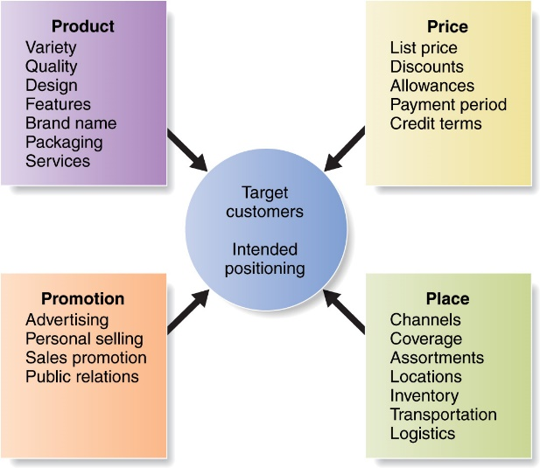

Examples of Strategy Decision Areas and Items for Each of the 4Ps

Product Distribution/ Place Promotion Price
Physical good Objectives Objectives Objectives

Service Channel type Promotion blend Flexibility
Features Market exposure Salespeople Level over product

Accessories Kinds of middlemen - kind, number, life cycle
Installation Kinds and locations selection, training, Geographic terms

Instructions of stores motivation Discounts

Warranty Who handles transporting Advertising Allowances
Product lines and storing -targets, kinds of ads,

Packaging Service levels media type, copy
Branding Recruiting middlemen thrust, prepared by

Managing channels whom
Sales promotion
Publicity

VI. The Marketing Plan (Table 2.2)

VII. Implementing & Controlling
- Control: measure performance & evaluate it versus objectives/goals. Examples of common control measures: unit or dollar sales, market share, ROI, distribution re: number of resellers carrying the product, promotion objectives, etc.
- If actual performance exceeds or falls short of planned performance, take corrective action.

VIII. SWOT (Strengths, Weaknesses, Opportunities & Threats)

Internal Factors External Factors
Strengths or Weaknesses Opportunities or Threats
(Can be controlled by the firm) (Cannot be controlled by the firm)
________________________ __________________________
Mission, vision, business philosophy Industry: Product category review (mkt. size,
growth rate, seasonality,....)
Corporate financial resources Competitive environment, competitor review
Ownership & leadership Economic environment
Technological resources Political environment
Staff expertise Cultural Environment
R&D capabilities Natural environment
Corporate culture Technological environment
Commitment to quality Physical environment
Organizational structure Global environment
Analysis of current marketing program Customer/consumer review
(Target Market[s], Mktg. Mix[es]) Other market analysis factors from the text

Note: This only represents a sample of some of the aspects that can be contained in each area of a SWOT.

Identification and Prioritization of SWOT data – what is the:
- Significance of each of the weaknesses & threats
- Feasibility of correcting for them & resources required
- Significance of each of the strengths & opportunities
- Resources required to capitalize on them
- Immediacy of each of the threats & opportunities

