KEY TOPICS SESSION 1

Core Marketing Concepts –Text Fig. 1.1, 1.2, & 1.5

- Marketing - An organizational function & a set of processes for creating, communicating, & delivering value to customers & for managing customer relationships in ways that benefit the organization and its stakeholders

- Marketing Process – Fig 1.1

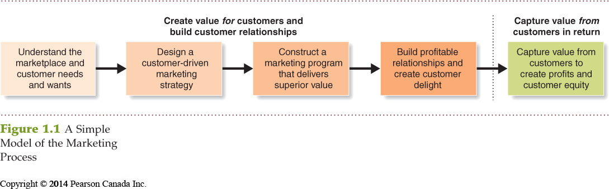

- Needs - State of felt deprivation
- Wants - The form of needs as shaped by culture & the individual
- Demands - Wants which are backed by buying power

- Marketing offer—some combination of products, services, information, or experiences offered to a market to satisfy a need or want.
- Customer Perceived Value - The customers’ evaluation of the difference between benefits and costs
- Customer Satisfaction - Product’s perceived performance relative to customers’ expectations
- Exchange process - the act of obtaining a desired object from someone by offering something in return
- Market - Set of actual and potential buyers of a product, service, idea, experience, etc

- Understanding the marketplace – Fig 1.2 – The modern marketing system.
  - The suppliers, company & marketing intermediaries work together to form a value chain to deliver value to the end user. All parties in the chain seek to be profitable, otherwise the exchange process will breakdown. Companies also seek to build relationships with their partners in the value chain.

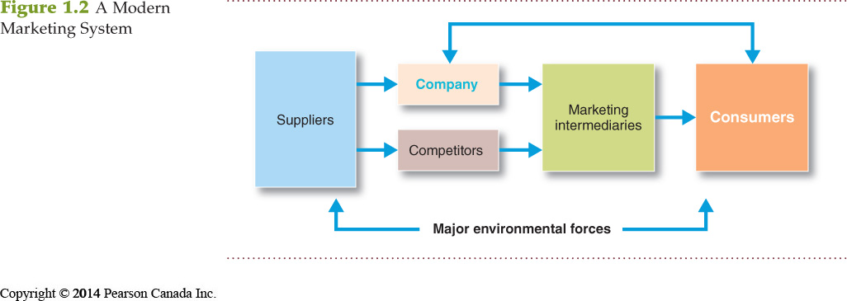

- CRM – Customer relationship management - is the overall process of building and maintaining profitable customer relationships by delivering superior customer value and satisfaction. It deals with all aspects of acquiring, keeping and growing chosen customers.

- Designing a Customer-Driven Marketing Strategy –
  - What customers will we serve?
    - Market segmentation
    - Select segments that can be served profitably – target markets
  - How can we serve these customers best?
    - Define a value proposition (the set of benefits & values it promises to deliver to satisfy needs)
- Overview - marketing mix, 4 Ps (product, price, promotion & place), channels of distribution, marketing environment

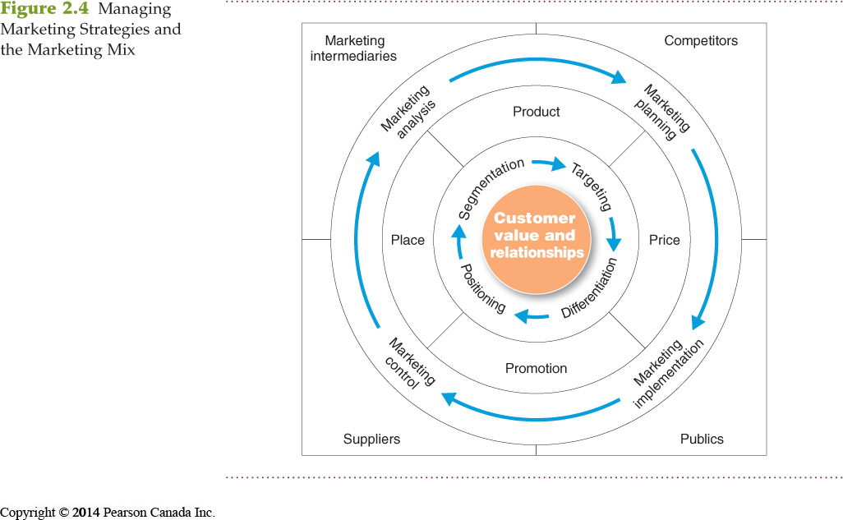

Expanded Model of the Marketing Process
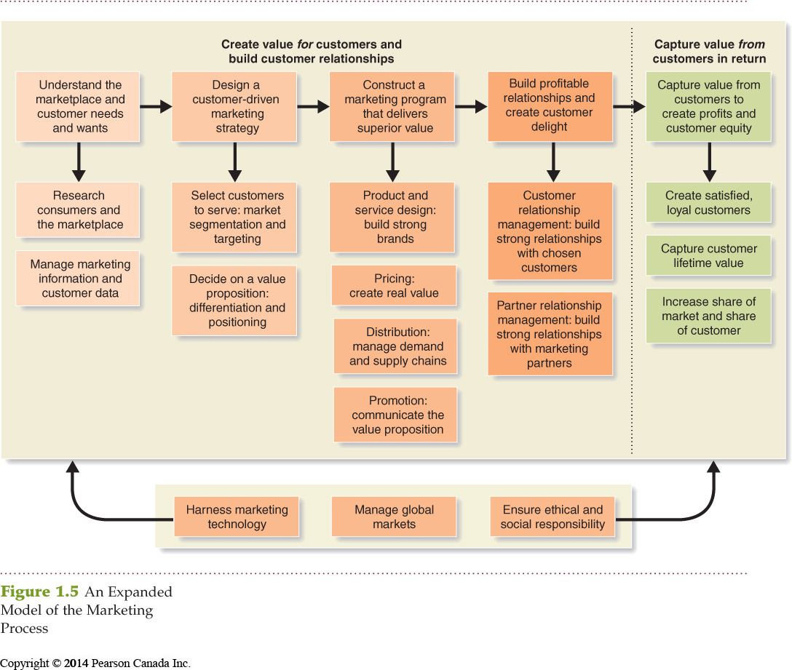

Marketing Management Orientations

Production concept:
Consumers will favour available/affordable products
Focus on improving production/distribution efficiency
Still useful when demand exceeds supply or product costs are too high

Product concept:
Consumers favour products with the best:
Quality, Performance & Features
Focus on continuous product improvements
Can lead to marketing myopia

Selling concept
The idea that consumers will not buy enough of the firm’s products unless it undertakes a large scale selling and promotion effort
Risky as it focuses on the immediate sales transaction not on building relationships
Assumes dissatisfied customers will buy again

Marketing concept
The idea that achieving organizational goals depends on knowing the needs and wants of the target markets and delivering the desired satisfactions better than competitors do

Societal marketing concept
The idea that a company should make good marketing decisions by considering consumers’ wants, the company’s requirements, consumers’ long-term interests, and society’s long-run interests

Note: Students should integrate their class notes & key topics with detailed notes on the text for a complete set. CRM (customer relationship management) will be continued next session.

Major Developments in Marketing
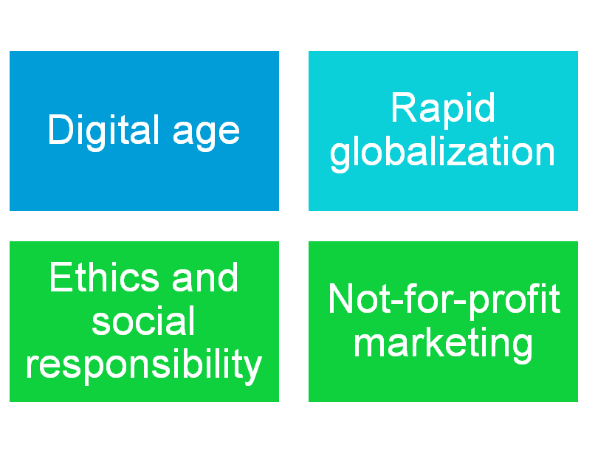
Uncertain Economic Environment

Market Share
The percentage or portion of the total sales in the market that a company has or hopes to capture. Most often expressed as a percentage of unit sales (see example below), but can also be expressed as dollar market share using dollar sales to calculate the percentage.
E.g. Our Product: City Lights Running Shoes for Kids
Year 1 sales - 20,000 Pairs
Total Sales in Kids' Running Shoes Market sales for the same year are 200,000 Pairs

City Lights' Market Share = City Lights’ Sales in Pairs (during a specific time period) X 100
Total Sales (in Pairs) in the Kids’ Running Shoe Market
(during the same time period)

= 20,000 X 100
200,000

= 0.1 X 100

= 10% market share

Preparation assignment for Session 2:

- Visit the Canadian site of Rollerblade at http://www.rollerblade.com/canada/en/ & familiarize yourself with the company. We will be using it to work an application for the concepts in class 2
- There is also an international site at http://www.rollerblade.com/?dealer=00
- Also visit http://www.tecnicagroup.com/ owners of Rollerblade
- Read Assigned chapters
- Complete Individual cards
- Don’t forget to print the Key Topics for Session 2 & bring to class

Hint for Projects
The full presentation from the Sweets & Snacks Expo trade conference on marketing confectionary products is available at:
http://youtu.be/JSQLeOkhvGo

