Questions from Last Lecture
- •Are geologists licensed like doctors? Yes There is a provincial license and only licensed geoscientists can certified geoscience work.
- •What units are m/a? (Meters per year; a=year)
- •Explain the Unit Runoff concept?
- •What is the base level in a graded stream?
Unit Runoff / Discharge (difference between what goes in and what goes out)
What is the average discharge of the Ottawa River at the Carillon Dam (~Montreal)?
– Flow = 1940 m^3 sec^-1
– Drainage Area = 146,300 km 2
What is the annual average UNIT discharge of the Ottawa River?
– Unit Discharge = Flow/Drainage Area
– Unit Discharge = flow m^3 a^-1 / Drainage Area (m2)
– Unit Discharge = 0.42 m a^-1
Think of unit runoff like precipitation (m/a)

Base Flow and Channel Formation
- All rivers eventually drain into the ocean
- The ultimate base level would be sea level

How would you form Grand Canyon using the base flow concept?
- The Colorado plateau gets lifted up by other tectonic activity
- It’s now way above base level
- Erosion than erodes it down to base level
- Need sedimentary basin, need to be uplifted, then you have down cutting that’s occurred over time

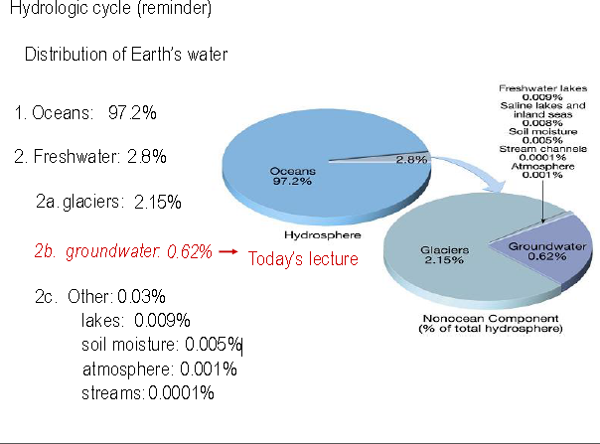
- Ground water is small quantity of the total but it’s extremely important

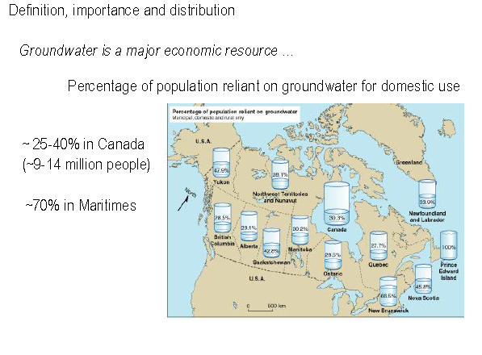
- 9-14 million people rely on groundwater

Groundwater
- The water that lies beneath the ground surface = moves slowly
- Hydrosphere's fresh water:
  - Glaciers (~77%)
  - Groundwater (~22%)
- ~ 15% of total precipitation infiltrates ground and ends up as groundwater
- Groundwater is slow moving, but not static:
  - recharges (rain)
  - discharges (feeds rivers)
Misconception: groundwater is found in underground lakes and rivers (true but quite rare)
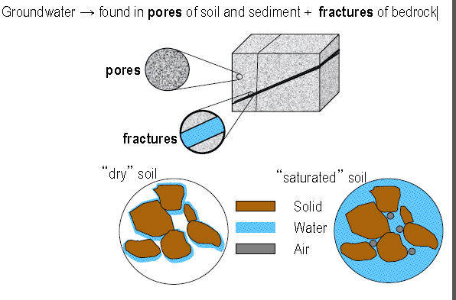
- There are spaces in between dry soil particles
- Both pores and fractures can hold water
Porosity
- Fraction of voids or pore spaces compared to the total volume of rock
- The more uniform the grain size (the larger the grain size)=high porosity
- Not uniform (large mixed with small grains)=low porocity
- Determines how much groundwater can be stored.
  - • Φ = f(grain roundness, sorting, and cementation) → texture

Measurement of Porosity
- •Volume of sand column = 1000mL
- •Column contains sand plus porosity
  - –In dry sand the porosity is filled with air
- •Replace all the air with water
- •Porosity = volume water / total volume

Permeability or Conductivity:
- Capacity of a rock or sediment to transmit a fluid. Function of pore SIZES and INTERCONNECTIVITY.
How much water can you get from a material? “Yield” of Water
Sand Experiment
- Porosity =35%
- Water Yield =very low
  - Would have to pump hard to get water oi
Gravel Experiment
- Porosity = 48%
- Water yield =96%
  - Connectivity is high
  - Why did we not get all of it back?
    - Some of water molecules are participating in surface tension
Porosity and permeability
- Which one will produce best water?
  - Shale
    - High concentrations of sulfur and other organic materials
  - Quartz sandstone
  - Granite
  - Fractured crystalline rock
- 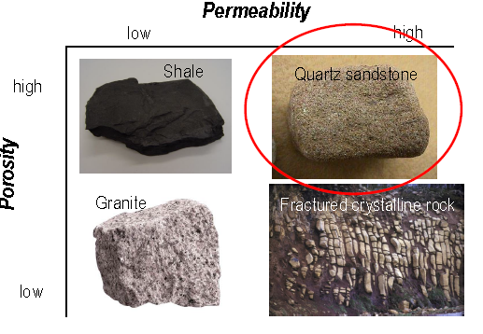
- 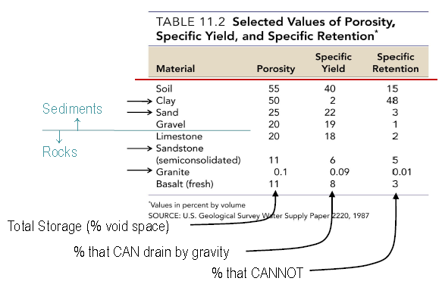
Distribution of groundwater
1. Unsaturated zone
- •voids filled by water and air; infiltration and percolation
- •water is under suction (negative pressure) due to capillary forces
- •water cannot be pumped by wells

2. Water table:
- upper limit of zone of saturation; surface of the water level in the ground

3. Zone of saturation
- •zone where all of the voids in soil, sediment and rock are completely filled with water
- •water is under + pressure and can be extracted by wells
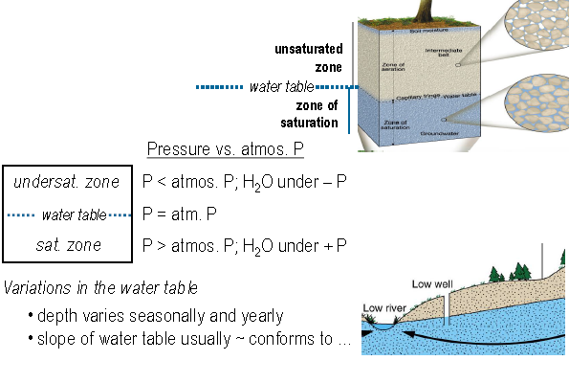
- Water table can fluctuate by few centimeters per year

What factors control infiltration?
1. Precipitation (qty / time)
2. Slope
- If we got flat system, there is lots of time for water to infiltrate
3. Geologic Material
4. Vegetation
- Taken water that can reach the well and evaporate it off
Where is groundwater stored?
- Aquifer: permeable rock strata or sediment that stores and transmits groundwater. (e.g.: sand, gravel)
- Acquitard: semi-permeable rock layer (… retards water)
- Aquiclude: impermeable rock layer (… excludes water)
  - Both are confining layers (barriers to flow ex. shale)
  - Prevents water form going up and prevents it from entering
  - So the water has been there since long time ago and you are drawing water from it
  - Doesn’t get recharged
  - Not sustainable
  - Unconfined = sustainable
- 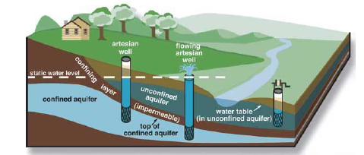

Aquifers
• Unconfined aquifer: aquifer uncapped by a confining layer; groundwater is not under pressure; top of aquifer (water table) moves freely up and down.
• Confined aquifer (syn.: artesian aquifer): aquifer sandwiched in between two confining layers (usually inclined to allow recharge); groundwater is under pressure and level of ‘projected’ water table (pressure or potentiometric surface) is above the top of the aquifer.
Well: a hole (usually lined) drilled into the ground to penetrate an aquifer (goal : extract water).
Non-flowing artesian well: when the water table (pressure surface) of a confined aquifer rests BELOW the ground level
Flowing artesian well: when the water table (pressure surface) of a confined aquifer rests ABOVE the ground level
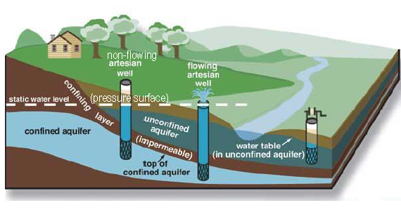
- Artesian well is flowing cause of more pressure

General pattern of movement
Recharge (high) → discharge (low)
Balance between:
- potential energy (high to low elevations)
- pressure (weight of water above)
Velocity in order of cm/day
- Faster near surface
- But still very slow
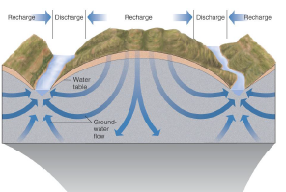

Henry Darcy (French engineer) – equation to calculate fluid velocity through a porous media (circa 1850).
- Darcy’s Law – states that if permeability remains uniform, the velocity of groundwater will increase as the slope of the water table (hydraulic gradient) increases.
- 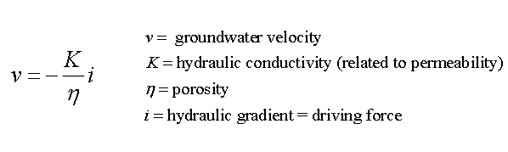
- If we want to calculate velocity in aquifers of sand or gravel these are the things we need to know
- 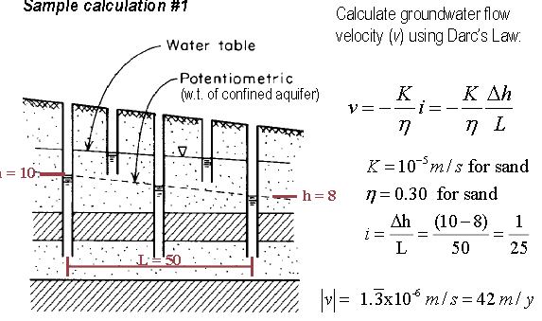
- H=10m at one well and 8m at another well
- Distance between wells is 50m
Two basic types of interactions:
Exchange of water between groundwater and streams depends on the positions of the water table (w.t.) with respect to the stream bed

- gaining streams:
  - gain water from the inflow of groundwater through the streambed
- losing streams:
  - lose water to the groundwater system by outflow through the streambed
- 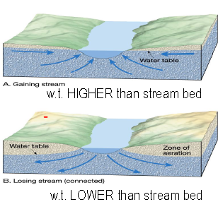
Sample calculation 2
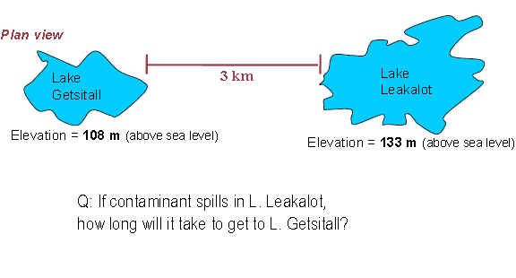
- Getsitall – ground water flows into it
- Leakalot – ground water leaks out cause it’s higher at elevation
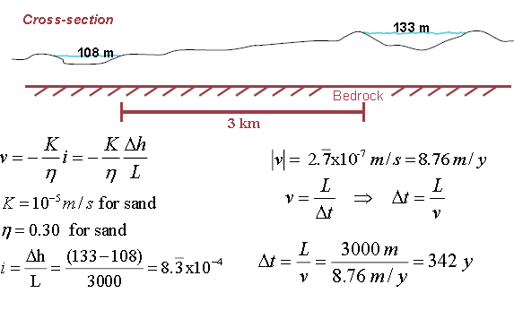
Ground water contamination
Other sources and types of contamination include:
  - Highway road salt
    - Number 1 contaminant in our area
  - Fertilizers
  - Pesticides
  - Chemical and industrial materials
  - Bacteria and viruses
Problems associated with groundwater withdrawal
Sewage contamination: sewage often becomes purified as it passes through tens of meters of an aquifer composed of sand or permeable sandstone.
- In extremely permeable aquifers, such as coarse gravel or fractured bedrock, groundwater may travel long distances without being cleaned.
- 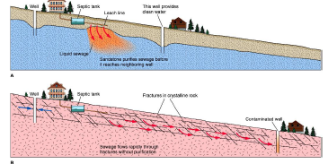
- To ensure a continuous supply of water, a well must penetrate below the w.t.
- Excessive pumping of wells can cause:
  - • drawdown (lowering) of the w.t.
  - • cone of depression in the w.t.
  - 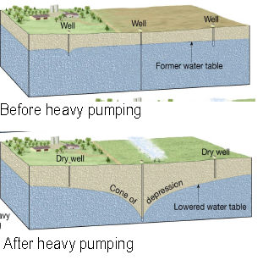
Other problems
- Treating groundwater as a non-renewable resource –
  - in many places the water available to recharge the aquifer falls significantly short of the amount being withdrawn
  - Hydrologic mass balance is out of Balance!
  - Can lead to subsidense
  - Subsidence: ground sinks when water is pumped from wells faster than natural recharge processes can replace it.
- Saltwater contamination: excessive groundwater withdrawal causes saltwater to be drawn into wells
  - 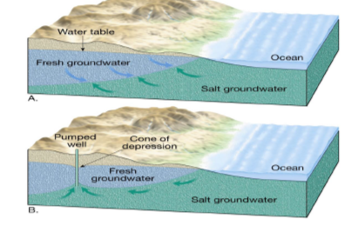
Features associated with groundwater
- Geysers: intermittent surface emission of hot water
  - Water erupts with great force, often rising 30-60 m into the air
  - Occur when complex network of fractures in hot igneous rock
  - Groundwater heats, expands, changes to steam, and erupts
- 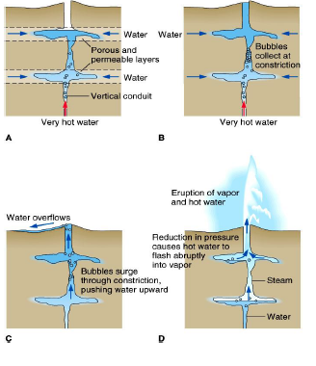
- Erosional features
  - Caves: large underground cavity
  - Karst topography: feature created when ground or surface water dissolves rock; typically forms in limestone bedrock
  - 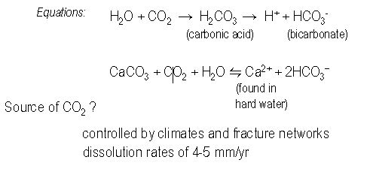
- Depositional features
  - Groundwater is often mildly acidic → dissolves rock (particularly limestone – CaCO3)
  - 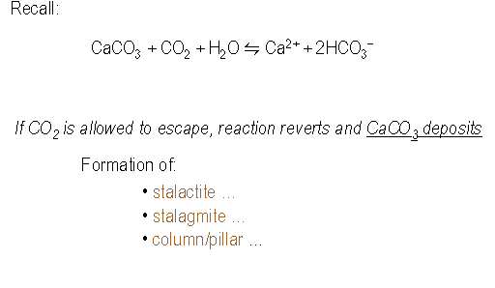
- 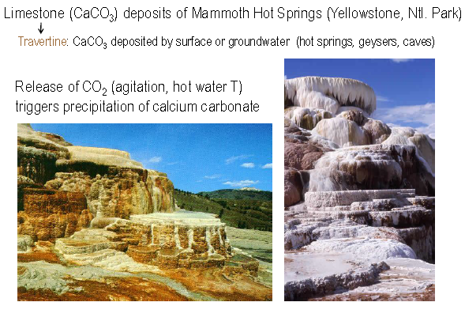
Summary
- GROUNDWATER is widely distributed and a key source of potable water for many people.
- Groundwater is in the porosity of the rock or soil
- Groundwater movement controlled by gradient and hydraulic conductivity of the porous media (Darcy’s Law).
- Groundwater can dissolve carbonate rocks leading to sink holes and other geologic features.
- Excess usage of groundwater is depleting the resource in many areas or contaminating it with chemical / biological wastes.

