- Standardized Financial Statements
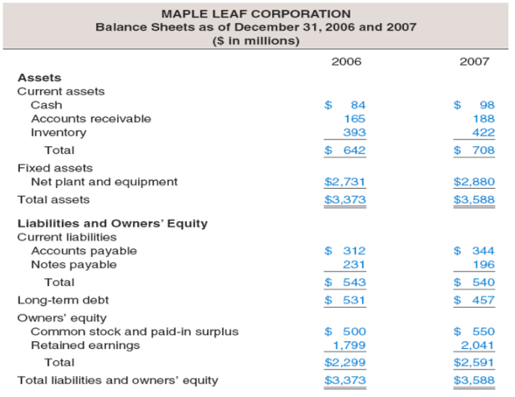
- Know how to standardize financial statements for comparison purposes (e.g., compare the financial statements of previous years to the current years):
- Almost impossible to directly compare the financial statements for two companies because of the difference in size.
- Financial Statements are:
- Balance Sheets:
- Standardized Balance Sheets are called Common-Size Balance Sheets:
- Compute all accounts as a percent of total assets.
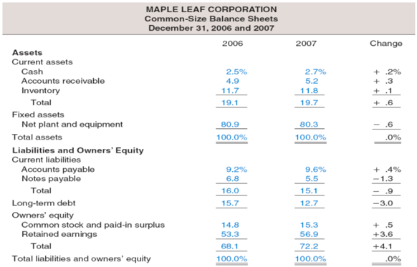
- Common-Size Balance Sheets make it easier to compare financial information, particularly as the company grows.
- Common-Size Balance Sheets are also useful for comparing companies of different sizes, particularly within the same industry:
- In the Maple Leaf example, we took the cash and divided by the total assets (84$/3373$), and we did the same thing for the accounts receivable (people who owe you money), the inventory, the net plant and equipment, etc.
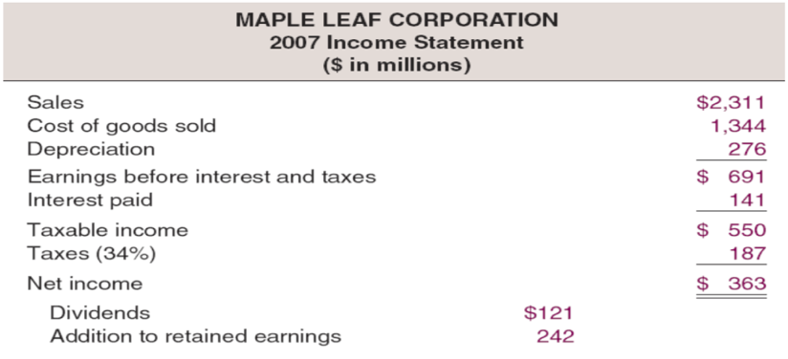
- Income Statements:
- In the Maple Leaf example, we subtracted the top number from each of the bottom ones until we got to 363$. Then we gave 121$ to our dividends and kept the rest in the retained earnings account.
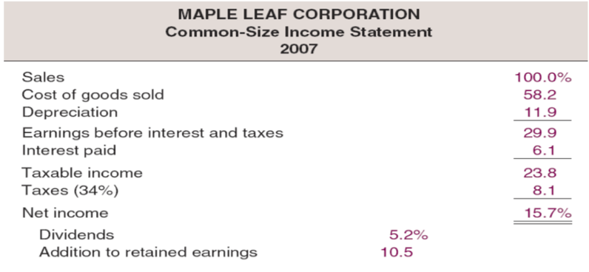
- Standardized Income Statements are called Common-Size Income Statements:
- Compute all line items as a percent of sales:
- Divide everything by the sales.
- The way you read it is (for example) cost of good sold is 58.2% of sales.
- Common-Size Income Statements make it easier to compare financial information, particularly as the company grows.
- Common-Size Income Statements are also useful for comparing companies of different sizes, particularly within the same industry.

- Ratio Analysis
- Know how to compute and interpret important financial ratios.
- Why compute Financial Ratios:
- To avoid the problems involved in comparing companies of different sizes.
- Financial ratios also allow for better comparison through time (e.g., last years figures with this year’s figures) or between companies.
- Financial ratios are used both internally (i.e. to make internal decisions) and externally (i.e. by government, investors, etc.).
Sample Balance | Sheet
Current Assets | Fixed Assets
Sample Income Statement

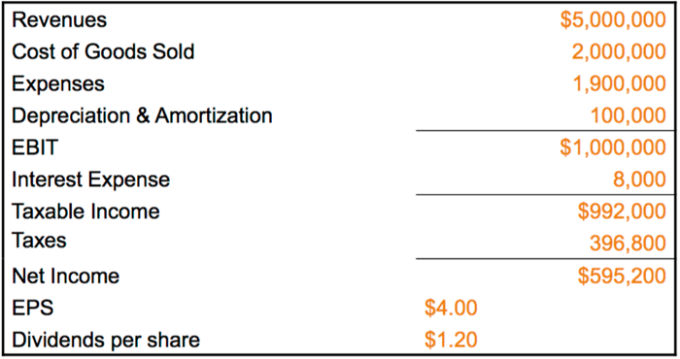

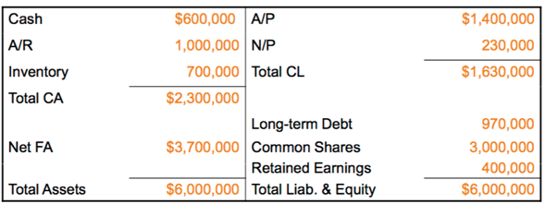

- Categories of Financial Ratios
- Short-term (< 1 year) solvency or liquidity ratios:
- Determine whether the company has enough money to survive during the short-term period.
- Compute Short-Term Solvency or Liquidity Ratios:
- Current Ratio = CA/CL = 2,300,000/1,630,000 = 1.41 times:
- For every 1$ that you owe other people, you have 1.41$ in current assets.
- Companies like a 2:1.
- Quick Ratio = (CA – Inventory)/CL = (2,300,000 – 700,000)/1,630,000 = 0.98 times:
- For every 1$worth of current liabilities, you have 98 cents available in liquid cash available (no good; companies like 1:1).
- How quick we can convert our current ratio into cash.
- Cash Ratio = Cash/CL = 600,000/1,630,000 = 0.368 times:
- How much cash do you have to pay your current liabilities.
- For every 1$ worth of current liabilities that you owe people, you only have 0.368$ available (no good).
- Long-term (> 1 year) solvency or financial leverage ratios:
- In order for a company to survive for a longer period they need to borrow money. This is used to determine how much they borrowed.
- Total Debt Ratio = (TA – TE)/TA = (6,000,000 – 3,400,000)/6,000,000 = 0.433 times or 43.3%:
- The firm finances are slightly over 43% of its assets with debt:
- 43% of your total assets depend on debt.
- (Debt/Equity) = TD/TE = (6,000,000 – 3,400,000)/3,400,000 = 0.765 times or 76.5%:
- If you compare debt and equity, if equity represents 1$, debt is 76.5 cents.
- Computing Coverage Ratios:
- Times Interest Earned (TIE) = EBIT/Interest = 1,000,000/8,000 = 125 times:
- Based on your current sales and current EBIT, you can pay an interest of 8000$ 125 times before you run into trouble.
- Cash Coverage/Interest = (EBIT + Depreciation & Amortization)/Interest = (1,000,000 + 100,000)/8,000 = 137.5 times:
- If you have to pay someone 8000$ worth of interest, you have enough cash to pay this 8000$ (based on your current sales) 138 times before you run out of cash.
- Asset management or turnover ratios:
- Determines if we are using our assets efficiently, if we are collecting money from our customers efficiently, etc.
- Inventory Turnover = Cost of Goods Sold/Inventory = 2,000,000/700,000 = 2.86 times:
- The inventory was purchased and sold close to 3 times:
- The higher the IT, the better (you’re selling more).
- Days’ Sales in Inventory = 365/Inventory Turnover = 365/2.86 = 128 days:
- When you buy inventory, how long does it stay in the company before it is sold?
- Every time you buy inventory, it stays in the warehouse for about 128 days (before it runs out completely):
- The short the number of days, the better (you’re buying and selling quicker).
- Receivables Turnover = Sales/Accounts Receivable = 5,000,000/1,000,000 = 5.0 times:
- Recall accounts receivables are people who owe you money (debtors).
- Customers have been buying and paying back 5 times:
- The higher the times, the more you are completing sales and receiving money.
- Days’ Sales in Receivables (Collection Period) = 365/Receivables Turnover = 365/5.0 = 73 days:
- When you sell your goods on credit, your customers pay you in 73 days:
- The earlier the better.
- Total Asset Turnover (TAT) = Sales/Total Assets = 5,000,000/6,000,000 = 0.833 times:
- Measure of the total asset use efficiency:
- In this case total asset is only efficient 83% of the time.
- Not unusual for TAT < 1, especially if a firm has a large amount of fixed assets.
- Profitability ratios:
- Determine if we are getting a reasonable rate of return (profit) from our sales (assets).
- Computing Profitability Ratios:
- Profit Margin = Net Income/Sales = 595, 200/5,000,000 = 0.1190 times or 11.90%:
- 11.9% of sales = profit.
- Return on Assets (ROA) = Net Income/Total Assets = 595,200/6,000,000 = 0.0992 times or 9,92%:
- Net income as a % of the total asset is 9.92%.
- Return on Equity (ROE) = Net Income/Total Equity = 595,200/3,400,000 = 0.1751 times or 17.51%:
- Share holders are getting 17.51% return based on the net income.
- Market value ratios:
- Determine what the market value per share.
- Computing Market Value Measures:
- Market Price (12/31/08) = 96.00$ per share
- # of Shares Outstanding = 148,800
- EPS = Net Income/Shares Outstanding = 595,200$/148,800 = 4.00$/share.
- PE Ratio = Price per Share/Earnings per Share = 96.00$/4.00$ = 24 times:
- The company based on its EPS is making 24 times its earnings.

- Using Financial Statement Information
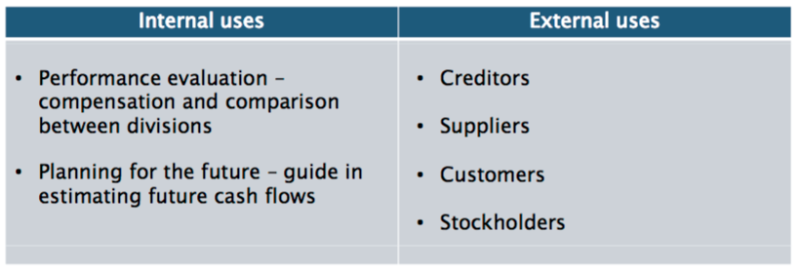
- Benchmarking (Restrictions):
- Ratios are not very helpful by themselves:
- They need to be compared to something (e.g., compare it to last year to make it useful; compare with another time period).
- Time-Trend Analysis:
- Used to see how the firm’s performance is changing over time.
- Internal and external uses.
- Peer Group Analysis:
- Compare to similar companies (competitors) or within industries.

- Problems with Financial Statement Analysis
- There is no underlying theory, so there is no way to know which ratios are most relevant.
- Benchmarking is difficult for diversified firms (selling many various items).
- Globalization and international competition makes comparison more difficult because of differences in accounting regulations.
- Varying accounting procedures:
- Example: FIFO vs. LIFO:
- FIFO = First-In-First-Out:
- Dairy industry, fruit industry (fresh sells first).
- LIFO = Last-In-First-Out:
- Mining (Pile of tiles sell the one on the top of the pile first top of the pile is the last one you make).
- Different fiscal years:
- Some are Jan-Dec, others Apr-March, etc.
- Extraordinary events:
- Strikes, shutdowns, make it hard to compare year-to-year.

- Key Equations
- Short-Term Solvency Ratios or Liquidity Ratios:
- Current Ratio = $\frac{Current Assets}{Current Liabilities}$
- Quick Ratio = $\frac{Current Assets-Inventory}{Current Liabilities}$
- Cash Ratio = $\frac{Cash}{Current Liabilities}$
- Long-Term Solvency Ratios or Financial Leverage Ratios:
- Total Debt Ratio = $\frac{Total Assets-Total Equity}{Total Assets}$
- Debt-Equity Ratio = $\frac{Total Debt}{Total Equity}$
- Equity Multiplier = $\frac{Total Assets}{Total Equity}$
- Times Interest Earned Ratio = $\frac{EBIT}{Interest}$
- Cash Coverage Ratio = $\frac{EBIT+Depreciation}{Interest}$
- Asset Utilization Ratios or Turnover Ratios:
- Inventory Turnover = $\frac{Cost of Goods Sold (COGS)}{Inventory}$
- Day’s Sales in Inventory = $\frac{365 days}{Inventory Turnover}$
- Receivables Turnover = $\frac{Sales}{Accounts Receivable}$
- Day’s Sales in Receivables = $\frac{365 days}{Receivables Turnover}$
- Total Asset Turnover = $\frac{Sales}{Total Assets}$
- Profitability Ratios:
- Profit Margin = $\frac{Net Income}{Sales}$
- Other forms of Profit Margin:
- Gross Profit Margin = $\frac{Sales-COGS}{Sales}$
- Operating Profit Margin = $\frac{EBIT}{Sales}$
- Return on Assets (ROA) = $\frac{Net Income}{Total Assets}$
- Return on Equity (ROE) = $\frac{Net Income}{Total Equity}$
- Market Value Ratios:
- Earnings per Share (EPS) = $\frac{Net Income}{Shares Outstanding}$
- Price-Earnings (PE) Ratio = $\frac{Price per Share}{Earnings per Share}$
- Market-to-Book Ratio = $\frac{Market Value per Share}{Book value per share}$
- Du Pont Identity:
- ROE = $Profit Margin × Total Asset Turnover × Equity Multiplier$
- ROE = $\frac{Net Income }{Sales}×\frac{Sales}{Assets}×\frac{Assets}{Total Equity}$
- Dividend Payout and Earnings Retention:
- Dividend Payout Ratio = $\frac{Cash Dividends}{Net Income}$
- Retention Ratio = $\frac{Addition to Retained Earnings}{Net Income}$
- Internal Growth Rate:
- Internal Growth Rate = $\frac{ROA × b}{1-ROA × b}:$
- Where b = $Plowback \left(retention\right)Ratio=\frac{Addition to Retained Earnings}{Net Income}=1-Divident Payout Ratio$
- The internal growth rate is the maximum growth rate that can be achieved with no external financing of any kind.
- Sustainable Growth Rate:
- Sustainable Growth Rate = $\frac{ROE × b}{1-ROE × b}$:
- The sustainable growth rate is the maximum growth rate that can be achieved with no external equity financing while maintaining a constant debt-equity ratio.

- Summary and Conclusion of Third Lecture
- This chapter has discussed aspects of financial statement analysis, including:
- Standardized Financial Statements:
- We explained that differences in firm size make it difficult to compare financial statements, and we discussed how to form common-size statements to make comparisons easier.
- Ratio Analysis:
- Evaluating ratios of accounting numbers is another way of comparing financial statement information.
- We therefore defined and discussed a number of the most commonly reported and used financial ratios.
- The Du Pont Identity:
- We discussed the famous Du Pont identity as a way of analyzing financial performance.
- We have see how the Du Pont equation lets us break down ROE into its basic three components:
- Profit margin.
- Total asset turnover.
- Financial leverage.
- Internal and Sustainable Growth:
- We defined the internal and sustainable growth rate, and we examined the connection between profitability, financial policy, and growth.
- Using Financial Statements:
- We described how to establish benchmarks for comparison purposes and discussed some of the potential problems that can arise.

