- The 6 Major Functions of a Financial Manager
- Working capital management.
- Cash Management (prepare budgets; cash in, cash out).
- Credit (or accounts receivables) management (people that owe the company money; interest change).
- Inventory management (control what you buy, how much you buy, when you buy, etc.).
- Investment decisions (also referred to as capital budgeting)
- Buy a new asset that will last more than 1 year (or machine).
- Replace an old asset or contract (or machine) with a new asset or contract (or machine).
- Financing decisions.
- Long-term loan (from a bank).
- Issue long-term debt (or bond) where you make promissory notes of the amount you plan on paying them.
- Issue preferred stock (preferred share holders cannot vote, must be paid dividends first before the common share holders).
- Issue common stock.
- Use retained earnings (earnings retained in the business after distribution of earnings or profits to shareholders).
- Distribution of earnings (or Profits) and retained earning management.
- Distributing earnings (or profits) is called dividends (“when you pay profits to the share holders”).
- The balance of the earnings (or profits) is called retained earnings (“earnings retained in the business”).
- The retained earnings must be managed.
- Financial statement analysis, planning and control.
- Understand financial statements (namely the balance sheet and the income statement).
- Understand balance sheets:
- Financial position of a company.
- What the company owe others (share holders).
- Understand income statements:
- Did the company make money (profit)?
- Did the company lose money (loss)?
- Understand the relationship between balance sheets and income statements (interconnected; circularity in the model):
- Any profits made in the income statements must be transferred to the balance sheets in an account called retained earnings.
- From the retained earnings, the profits are distributed to share holders (dividends).
- The balance is retained in the retained earnings account.
- Calculate and understand ratio analysis using information from balance sheets and income statements:
- A way of understanding how we are performing.
- Social responsibility.
- Day care for employees.
- Pollution control.
- Health benefits
- Gym for employees.

- Goal for Financial Management
- What should be the goal of a corporation?
- Maximize profit.
- Minimize costs.
- Maximize market share.
- Maximize the current value of the company’s stock.

- Financial Intermediaries and Markets: An Overview
- There are three external ways by which available funds can be transmitted to firms requiring funds:
- One way is through a financial intermediary (bank), which is an institution that accumulates and then distributes savings to those needing funds.
- Another way is through financial markets (stock market) – organized forums where the suppliers and demanders of funds can meet and make transactions:
- For the suppliers and demanders to meet in a forum, there needs to be a middle man (financial intermediary).
- A third way in which funds can be transferred from a saver to an investor is through a direct (or private) placement arrangement. This direct placement is very unstructured, so we will focus on financial intermediaries and financial markets.

- Financial Intermediaries
- Financial intermediaries, or financial institutions, channel the savings of various parties into loans or investments.
- The process by which savings are accumulated by financial institutions and then loaned out or invested is generally referred to as financial intermediation.
- Financial intermediaries can be divided into two groups – private sector financial intermediaries and public financial intermediaries
- Key private sector financial intermediaries:
- Chartered banks.
- The Quebec savings.
- Caisses populaires and credit unions.
- Finance companies.
- Trust companies.
- Life insurance companies.
- Investment companies.
- Pension funds.
- Venture capital companies.
- Key public sector financial intermediaries:
- Canada and Quebec Pension Plans.
- Federally Guaranteed Loan Plans.
- The Federal Business Development Bank.
- The Export Development Corporation.
- Regional Development Programs.
- Provincial Development Corporations.

- Key Participants in Financial Transactions
- The key suppliers (savers) and demanders (borrowers) of funds are:
- Individuals
- Businesses
- Governments
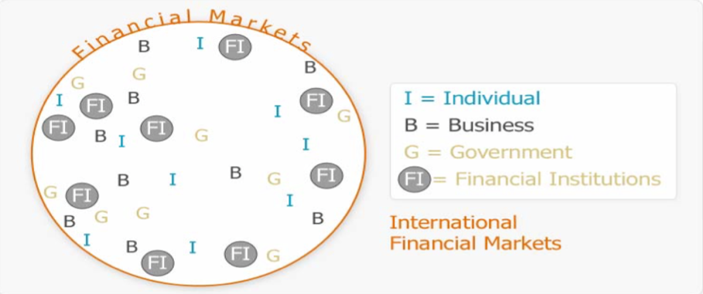

- Outside circle = the International Financial Market

- Financial Markets
- Financial markets permit the demanders and suppliers of short-term and long-term loans and investments to transact business directly.
- The two key financial markets are:
- The MONEY MARKETS:
- Transactions in short-term (anything less than 1 year) debt instruments or marketable securities take place in the Money Market (e.g., savings account in bank).
- The CAPITAL MARKETS:
- Long-term (anything more than 1 year) securities (share and bonds) are traded in the Capital Market (e.g., long-term bank loans).
- The OPTIONS MARKETS
- Not talking about this in this course.
- Deals in short-term with common shares (long-term shares found in capital market).

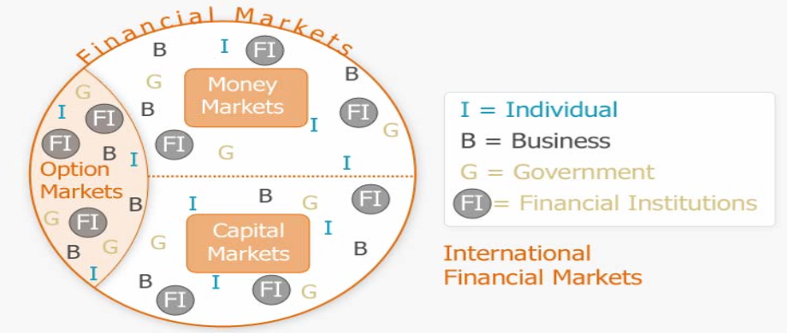

- Primary Markets:
- The markets in which new securities are originally (first) sold to investors.
- Two types of primary market transactions:
- Pubic offerings of debt and equality (stock).
- Private placements of debt and equity.
- Secondary Markets:
- The markets in which previously issued securities are traded among investors:
- Securities are bought and sold after the original sale was done in the Primary market.
- Two kinds of secondary markets:
- Auction markets (has a physical location (i.e. Wall Street), match those who wish to sell with those who wish to buy).
- Dealer markets (aka over-the-counter (OTC) markets; not a physical location).

- Forms of Business Organization
- Sole proprietorship
- Advantages:
- Easiest to start.
- Least regulated (few rules).
- Single owner keeps all the profits.
- Taxed once as personal income.
- Disadvantages:
- Unlimited liability (any debt is the responsibility of the sole owner).
- Limited to life of owner (owner dies, so does proprietorship).
- Equity capital limited to owner’s personal wealth.
- Difficult to sell ownership interest (sole proprietorship).
- Partnership
- Advantages:
- Two or more owners.
- More capital available.
- Relatively easy to start.
- Income taxed once as personal income.
- Disadvantages:
- Unlimited liability:
- General partnership (General Partner: Partner who is responsible for any debt created by the partnership beyond the personal wealth of the partnership).
- Limited partnership (Limited Partner: Partner who has a limited liability in the partnership agreement depending on the amount in question).
- Partnership dissolves when one partner dies or wishes to sell.
- Difficult to transfer ownership.
- Corporation
- Advantages:
- Limited liability (100$ share = 100$; you can only loose that much).
- Unlimited life.
- Separation of ownership and management.
- Transfer of ownership is easy.
- Easier to raise capital.
- Disadvantages:
- Separation of ownership and management (agency problem).
- Double taxation (income is taxed at the corporate level and then dividends are taxed at the personal level).

- Summary and Conclusions from First Lecture
- A working knowledge of finance is important even if you are not planning a career in finance.
- Usually, financial topics are grouped into four main areas:
- Corporate finance
- Investments
- Financial institutions
- International finance
- Business finance includes three main areas of concern:
- Capital budgeting:
What long-term investments should the firm make?
- Capital structure:
Where will the firm get the long-term financing to pay for its investments? In other words, what mixture of debt and equity should we use to fund our operations?
- Working capital management:
How should the firm manage its everyday financial activities?
- The corporate form of organization is superior to other forms when it comes to raising money and transferring ownership interests, but it has the significant disadvantage of double taxation.
- The goal of financial management in a for-profit business is to make decisions that increase the value of the stock, or, more generally, increase the market value of the equity.
- Conflicts between stockholders and management may arise in a large corporation:
- These conflicts agency problems and discussed how they might be controlled and reduced.
- Financial markets function as both primary and secondary markets for debt and equity securities, and secondary markets can be organized as either dealer or auction markets:
- In Canada the shares of established companies are traded on the Toronto Stock Exchange (TSX), while the shares of emerging companies are traded on the TSX Venture Exchange.

