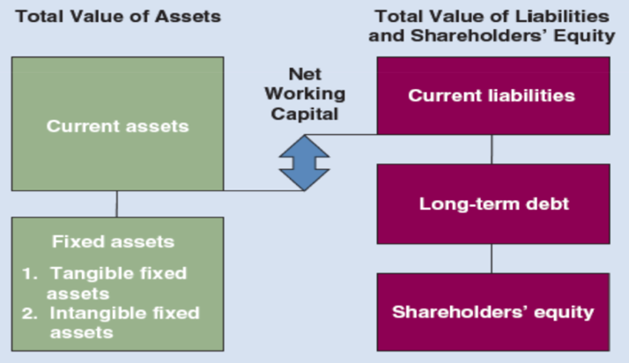
- Balance Sheet (What is your financial position?)
- Assets (A):
- Left-Hand Side (LHS; “Debit Side”) of the Balance Sheet.
- Consist of:
- Current Assets (Short-Term Assets):
- CA examples:
- Cash
- Accounts Receivable (also called Debtors; People who owe you money)
- Inventory (things you buy for resale).
- Fixed Assets (Long-Term Assets; anything more than a year):
- FA examples:
- Land
- Plant and Equipment
- Automobiles.
- Total Assets:
- $TA=Total CA+Total FA$
- Liabilities (L):
- Right-Hand Side (RHS; “Credit Side”) of the Balance Sheet.
- Consist of:
- Current Liabilities (Short-Term Liabilities):
- CL examples:
  - Accounts Payable (also called Creditors; People you owe money i.e. your suppliers).
  - Notes Payable (Short-Term Bank Loans, Line of Credit, anything less than a year).
- Fixed Liabilities (Long-Term Liabilities):
- LTL examples:
- Long-Term Bank Loan (More than a year)
- Long-Term Debt (or Bonds Payable).
- Total Liabilities:
- $TL=Total CL+Total FL$
- Equity (E) or Shareholders’ Equity (Or Owners’ Equity):
- Right-Hand Side (RHS) of the Balance Sheet.
- Consists of:
- Common Stock (CS) or Common Shares.
- Retained Earnings (RE):
-Earnings in the business after profit has been given out to shareholders.
- Common Equity:
- $CE=CS+RE$
- The Balance Sheet Equation:
- $Assets=Liabilities+Equity$or $TA=TL+CE$
- (LHS = RHS)
- The Balance Sheet balances because:
- $Total Assets=Total Liabilities+Equity$:
- Since $A=CA+FA$
- Since $L=CL+LTL$
- Since $CE=CS+RE$
- We know $TA=TL+CE$
- Therefore, $CA+FA=CL+LTL+CS+RE$

- Working Capital
- Working Capital consists of:
- Currents Assets (CA); Left Hand Side
- Cash.
- Account receivable (customers).
- Inventory.
- Current Liabilities (CL); Right Hand Side
- Accounts payable (suppliers/creditors).
- Note payable (bank account or short-term loan with the bank).
- Net Working Capital (NWC) is:
- $NWC=Current Assets \left(CA\right)- Current Liabilities (CL)$:
- NWC is always expressed in dollar (or any currency).
- +NWC more money in than more money out in the day-to-day transactions.
- –NWC means you are spending more than you are bringing in.

- Working Capitol Ratio (aka Current Ratio)
- Working Capital Ratio (or current ratio) is equal to:
- $Currents Assets \left(CA\right)÷Current Liabilities (CL)$
- Current Ratio is always expressed as a multiplier (i.e. number of times):
- Example: Current Ratio = 1.50 times.

- Income Statement

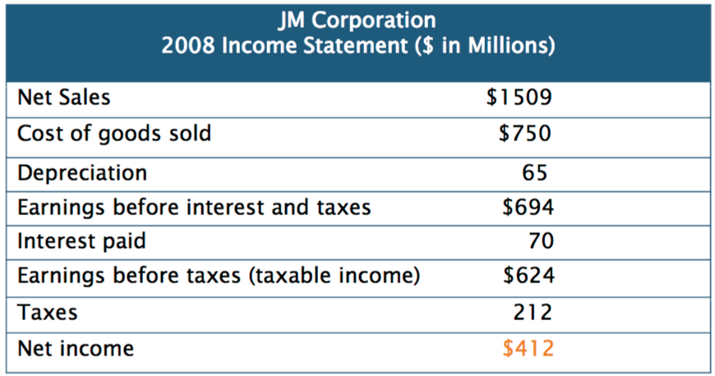

(REVENUE)

(WEAR & TARE of Equipment)

(Any loan or long-term debt)

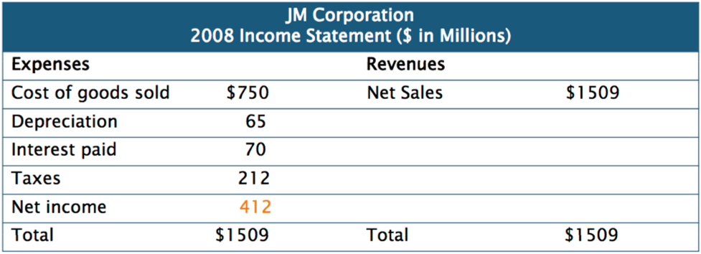

- $Net income=Revenues-Expenses$
- Net income = 1509 – [750 – 65 – 70 – 212] = 412
- Earnings before interest and taxes (EBIT):
- Net Sales – Cost of Goods Sold – Depreciation = EBIT
- Earnings before taxes (EBT):
- EBIT – Interest Paid = EBT
- What is an Income Statement?
- Expenses (E):
- Left-Hand Side (LHS) of Income Statement.
- Revenues (R):
- Right-Hand Side (RHS) of Income Statement.
- Profit:
- $Profit=Revenues \left(R\right)-Expenses \left(E\right)$
- i.e. when R > E.
- Loss:
- $Loss=Revenues \left(R\right)-Expenses (E)$
- i.e. when R < E.

- Cash Flow Statement

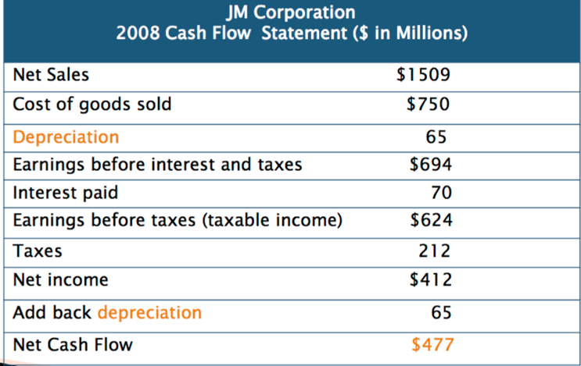

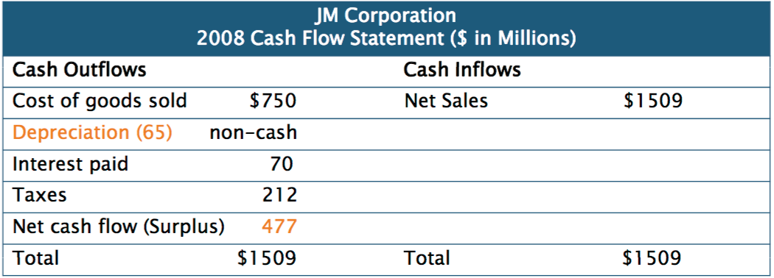

- $Net Cash Flow=Cash Inflows-Cash Outflows=Net Income+Add Back Depreciation$
- Net Cash Flow = 1509 – [750 – 70 – 212] = 477 (Surplus)
- What is a Cash Flow Statement?
- Cash Outflows (CO):
- Left-Hand Side (LHS) of Cash Flow Statement.
- Cash Inflows (CI):
- Right-Hand Side of Cash Flow Statement.
- Surplus:
- $Surplus=Cash Inflows \left(CI\right)-Cash Outflows (CO)$
- i.e. CI > CO
- Deficit:
- $Deficit=Cash Inflow \left(CI\right)- Cash Outflows$
- i.e. CI < CO

- The Relationship Between Balance Sheet and Income Statement
- At the end of the fiscal (financial; when the company balances its books):
- Profits and losses are transferred to Retained Earnings (RE).
- Income Statement is CLOSED.
- Balance Sheets are balanced and the balances carried forward to the next fiscal year:
- The process of closing the Income Statement and transferring the profit (or loss) to the Balance Sheet is referred to as the “circularity of the model”.
- Sample (Income statement for period ending December 31 2008):
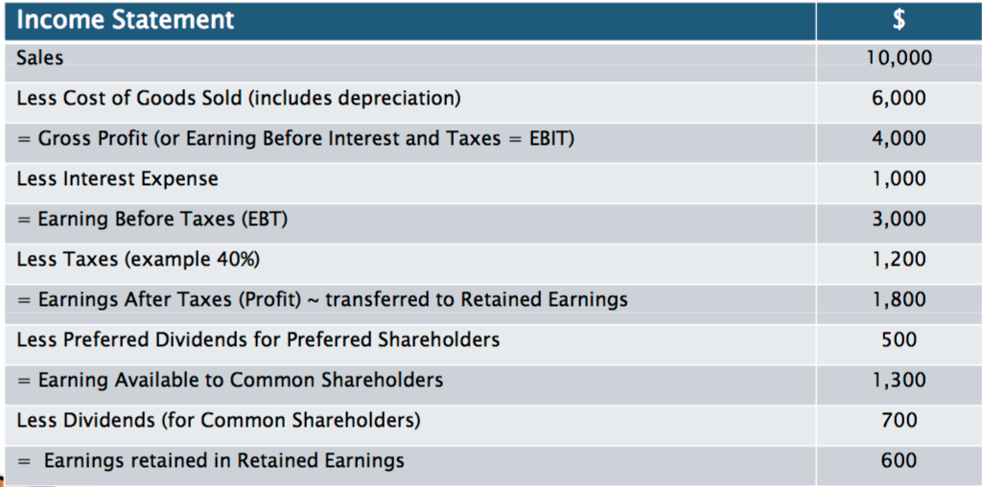

(Includes CCA)

- Depreciation:
- Depreciation is the allocation (distribution) of Fixed Assets (e.g., to record the wear and tear of equipment).
- Depreciation is tax-deductible (i.e. paid before taxes).
- Depreciation expense is calculated using Generally Accepted Accounting Standards (GAAS):
- It is calculated using various accounting methods.
- Capital Cost Allowance (“Depreciation of Canada”):
- Capital Cost Allowance (CCA) is the depreciation expense allowed under the Income Tax Act or as permitted by Revenue Canada.
- CCA is calculated using a specific CCA rate against a specific class of assets under a specific CCA class as outlines by Revenue Canada.
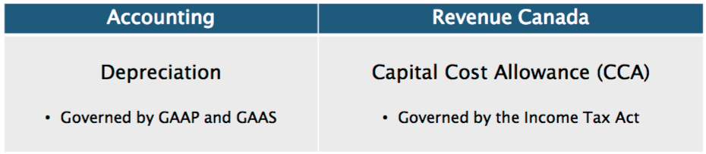

- Interest Expense:
- Payments made for borrowed funds (when using other people money; bank loans, bonds, etc.), if the company has short-term loans, long-term loans, and long-term debt or bonds.
- Interest expenses are tax-deductible (i.e. deducted before calculating taxes).
- Dividend Payments:
- Profits distributed to Preferred and Common Shareholders:
- When profits are distributed to Preferred Shareholders, it is called Preferred Dividends.
- When profits are distributed to Common Shareholders, it is called Common Dividends (or Dividends).
- Dividends are NOT tax-deductible (i.e. They are paid after taxes are calculated).

- Key Equations
- The balance sheet identity:
- $Assets=Liabilities+Shareholders^{'}Equity$
- The income statement equation:
- $Income=Revenues-Expenses$
- The cash flow identity:
- $Cash flow from assets=Cash flow to creditors \left(bondholders\right)+ Cash flow to stockholders (owners)$
where
- $Cash flow from assets=Operating cash flow \left(OCF\right)- Net capital spending-Change in net working capital (NWC)$:
- $Operating cash flow=Earnings before interest and taxes \left(EBIT\right)+ Depreciation-Taxes$
- $Net capital spending=Ending net fixed assets-Beginning net fixed assets+Depreciation$
- $Change in NWC=Ending NWC-Beginning NWC$
- $Cash flow to creditors=Interest-Net new borrowing$
- $Cash flow to stockholders=Dividends paid-Net new equity raised$

- Summary and Conclusions from Second Lecture
- The book values on an accounting balance sheet can be very different from market values:
- The goal of financial management is to maximize the market value of the stock, not its book value.
- Net income as it is computed on the income statement is not cash flow:
- A primary reason is that depreciation (a noncash expense) is deducted when net income is computed.
- There is a cash flow identity, much like the balance sheet identity:
- It says that cash flow from assets equals cash flow to creditors and stockholders.
- The calculation of cash flow from financial statements isn’t difficult:
- Care must be taken in handling noncash expenses, such as depreciation, and in not confusing operating costs with financing costs.
- It is important not to confuse book values with market values and accounting income with cash flow.
- Marginal and average tax rates can be different, and it is the marginal tax rate that is relevant for most financial decisions:
- Investment income such as interest, dividends, and capital gains are taxed differently in the hands of individuals and corporations.

