Experiment 1: Thin Layer Chromatography

Rakshika Ramendra, 8229945

Partner: Olivia Urquhart, 6848520

TA: Jeremy Dawkins

Due: 19/1/2016

Introduction

Chromatography is when separation of mixtures occurs between two solvents with different solubility. A thin layer chromatography is a type of adsorption chromatography, a coating of silica gel on a glass plate.

Reagent Table:

Part 1

Compound | Mol.Wt (g/mol) | Amount | Density (g/mol)
Ethyl Acetate | 88.11 | 10 mL
Hexane | 86.18 | 10 mL | 0.659
Dichloromethane |  | 2 mL
Benzophenone |  | 2 mL
Biphenyl |  | 2 mL

Part 2

Compound | Mol.Wt (g/mol) | Amount | Density
Ethyl Acetate |  | 10 mL
Hexane |  | 10 mL
Dichloromethane |  | 2 mL
Benzophenone |  | 2 mL
Biphenyl |  | 2 mL

Part 3

Compound | Mol.Wt (g/mol) | Amount | Density
YY |  | 2 mL
Hexane |  |  | 0.660
Bromonitrobenzene
O-Bromonitrobenzene
P-Bromonitrobenzene
M-Bromonitrobenzene

Discussion

Increasing the polarity of the solvent system affect the results of a thin layer chromatography because a polar solvent such as ethyl acetate will increase the Rf values of all of the compounds dotted on the plate. A non-polar solvent such as hexane will decrease the Rf values of all of the compounds dotted on the plate.

Benzyl alcohol Benzaldehyde Benzyl acetate
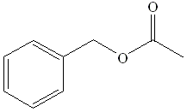
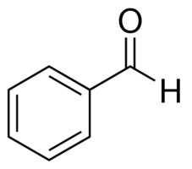
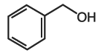

Benzyl alcohol would be most polar because it has one dipole for polarity and has none that would cancel it out. The hydroxyl group attached to the ring also means that the molecule is available for hydrogen bonding and that makes the molecule more polar than the benzaldehyde. Benzyl acetate is least polar because it has three dipoles that cancel each other out.

Aniline N,N-dimethylaniline Naphthalene
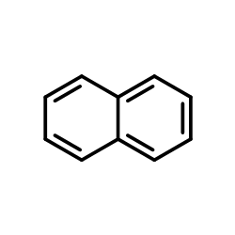
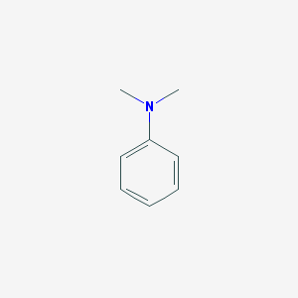
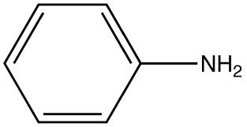

Aniline would be most polar and would therefore have the lowest Rf value because it has two dipoles that only slightly cancel each other out. The aniline also has a nitrogen that is available for hydrogen bonding and that makes the molecule slightly more polar. N,N-dimethylaniline would be second most polar because it has dipoles but because there are three, they all cancel each other out. Naphthalene is least polar because it has no dipoles.

Benzophenone Biphenyl Benzoic acid
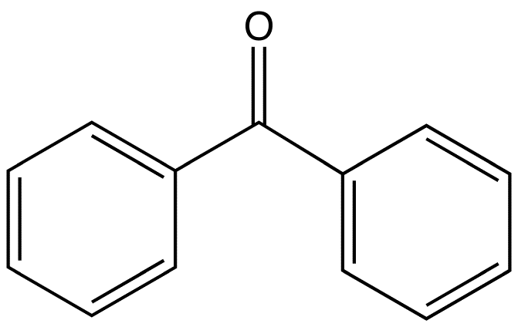
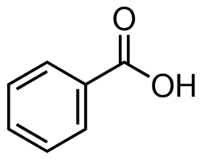

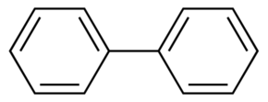

Benzophenone would be the most polar and therefore have the lowest Rf value because it has only one dipole for polarity and has none that would cancel it out. Benzoic acid would be the second most polar because it had two dipoles, but they are pulling in slightly opposite directions so they are beginning to cancel one another out. Biphenyl is least polar because it has no dipoles.

Conclusion

Raw Data


