Bio1140

Lecture 1 Readings

Chapter 2.1 F6
The plasma membrane is made up of a phospholipid bilayer, due to water being insoluble with lipids, it must pass through protein channels.

Chapter 2.1 F7

Chapter 2.2 Prokaryotic Cells (not needed)
Have capsule and cell wall, providing rigidity and structure to the cell.
Wall may be coated with polysaccharides called a glycocalyx.
When the glycocalyx is diffuse and loose it is referred to as a slime layer. When it is gelatinous and closely packed to the wall it’s a capsule, providing protection and possibly helping the cell attach to things.
Prokaryotic cells lack internal organelles, since most cell function takes place in the cytoplasm or on the membrance. There are however a few invaginations which may occur in organisms like photosynthetic bacteria which allow photosynthesis to take place.

Chapter 2.3B Eukaryotic nucleus contains more DNA than Prokaryotic nucleoid
The nuclear envelope has lamins lines to help inforce the structure. (protein filament)
Nuclear pore has an octagonal symmetrical nuclear pore complex. Ions and small molecules can move passively through the nuclear membrane, bigger molecules move through pores. .
The nuclear pore complex is made of nucleoporins (type of protein)
Proteins that are to be passed through the nuclear pore are indicated using a special amino acid sequence called the nuclear localization signal. With this, a protein in the cytoplasm (cytosol) recognizes it and moves it toward the n.pore complex.
Nucleoplasm inside nucleus. Also contains one or more nucleoli, which is made of small fibers and granules. Within the nucleoli there are rRNA genes creating ribosomal subunits. Ribosomes then are either free in the cytosol or attached to membranes.

Chapter 3.1
7 Characteristics of life
1 | Display order | - Cell is the smallest fundamental unit  - Cells are arranged in an orderly way
2 | Harnessing/utilizing energy | - Takes in external energy  - Uses energy in an orderly way
3 | Reproduce | - Make more of their kind
4 | Respond to stimuli | - Adjusting behavior, function structure as a result of environment
5 | Exhibit homeostasis | - Regulatory adjustments made to keep constant conditions
6 | Grow and develop | - Increase size/ cells
7 | Evolve | - Populations of organisms ability to change over time

These characters are emergent, where simple interactions between them (atoms, then up to cells, etc) create new properties found in higher levels.
ex. Proteins, molecules and membranes by themselves don’t have the ability to utilize energy, but when put together they do.

3.2 The Chemical origins of life
Amino acids are the building blocks of life.
3.2A Synthesizing biologically important molecules
Hypothesis 1: Oparin-Haldane (Reducing Atmosphere)
The primordial atmosphere was a reducing atmosphere, with high concentration of H2, NH3 and methane. There were many electrons and protons which would make organic molecules.
Supported with the Miller- Urey experiment.
- Recreated reducing atmosphere, results yielded organic molecules such as urea, glutamic acid, etc. (major bio molecules)
Hypothesis 2: Deep Sea Vents
Sea vents release nutrient rich water as well as reduced molecules of NH3, and H2S.
Hypothesis 3: Panspermia
Meteorites such as the Murchison meteorite could have impacted the earth, leaving molecules behind.

3.2D Life requires the synthesis of polymers
Polymers (nucleic acid, protein) are synthesizes by simpler, monomers (amino acids and nucleotides). To synthesize polymers from monomers, dehydration synthesis reactions occur.
To make nucleic acid and protein, there must be enzymes used to catalyze the reactions. However were not around to make the first strands of dna or protein, which begs the question of how those first molecules were made.
Clay is the leading answer, as its solidity meant that atoms were packed close together, as well as its composition since it is composed of very thin layers of clay separated by a thin layer of water. Clay is also charged with potential energy stored for polymerization reactions.
Clay also catalyzed production of lipid vesicles, with some clay particles being trapped within the lipid, catalyzing formations of other biomolecules.

3.3 The macromolecules of life
Attributes of a cell
- Membrane defined compartment
- System to store genetic info, used to create new proteins
- Energy transforming pathways, bringing in energy to sustain life

3.3A Lipid spheres lead to cell development
Forming the membrane defined cell compartment
A Protobiont (an abiotically produced organic molecule with a membrane) can form spontaneously if conditions are like that of primordial earth.
An early protobiont is thought to be a liposome, since it is a lipid vesicle with a lipid bilayer (like a cell membrane) that is semipermeable.

3.3B RNA can carry info and catalyze reactions
DNA is copied into RNA which synthesizes protein (central dogma)
Ribozymes (suck as ribosomes) catalyze precursor RNA molecules as well as creating itself.
Properties such as being single stranded allow it to fold into specific shapes.

Purple Pages: F6-7
The SI system of measurement

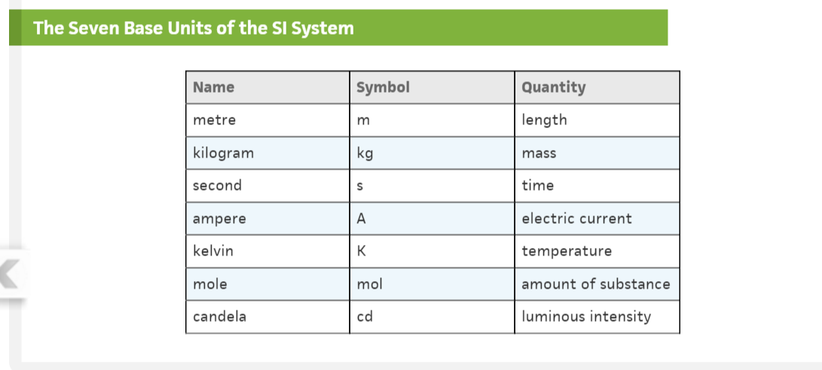
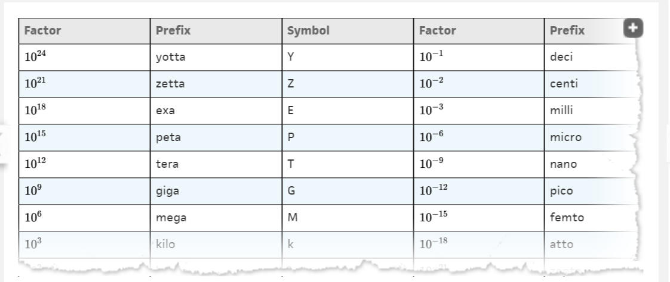

Lecture 2

2.3D The Endomembrane system divides the cytoplasm into functional and structural compartments
The membranes of a system are either physically connected or indirectly connected using membrane bound sacs, vesicles.
Components of the membrane bound system include:
Endoplasmic Reticulum
- Network of membrane channels called cisternae, surrounding the ER lumen.

- Rough ER has ribosomes on the surface, making proteins that then attach and enter the ER lumen. Once in the lumen, the proteins fold into their final form.
- Proteins then pinch off into vesicles and travel through the cytosol into another organelle.
- Proteins may also travel to the Golgi complex which package them and sort for delivery.
- Similar to outer membrane of nucleus.

- Smooth ER has no ribosomes attached.
- Synthesizes lipids (becomes membrane) , breaks down toxins, drugs, poison
- Rough and smooth are connected. Cells that make protein (ie pancreas) have more rough than smooth and vice versa. (liver cells)
Golgi Complex
- Made of cisternae (flattened membrane sacs) that are separated (stacked) on top pf each other. (3-8)
- Cells that secrete a lot of protein have a high number of cisternae.
- Vesicles from the ER enter enter through the cis face (facing nucleus), release their contents within the cisternae (cisternal) where the proteins are modified, then exit through the trans face. (where vesicles are sorted and bud off)
- Secretory vesicles (vesicles that transport the protein to the plasma membrane) attach to the plasma membrane then release their content to exit the cell.

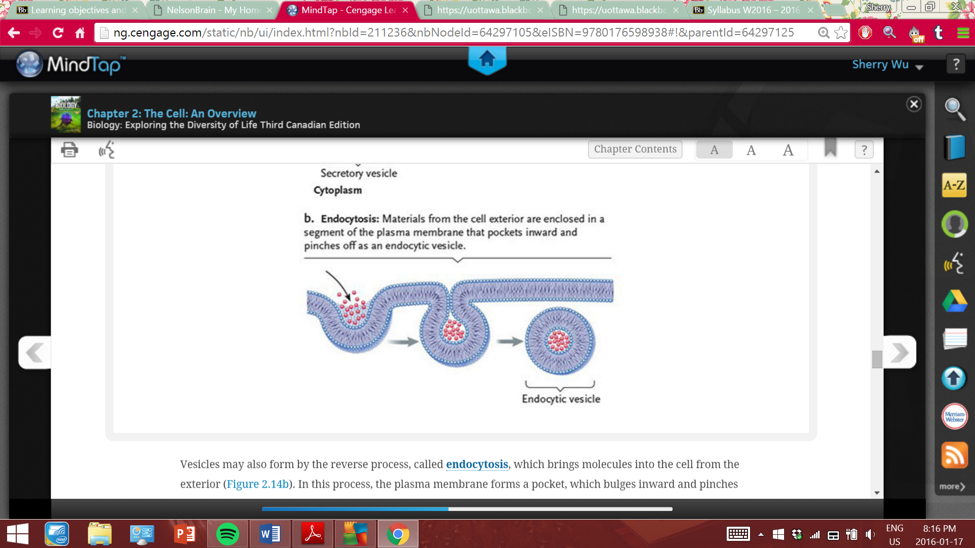
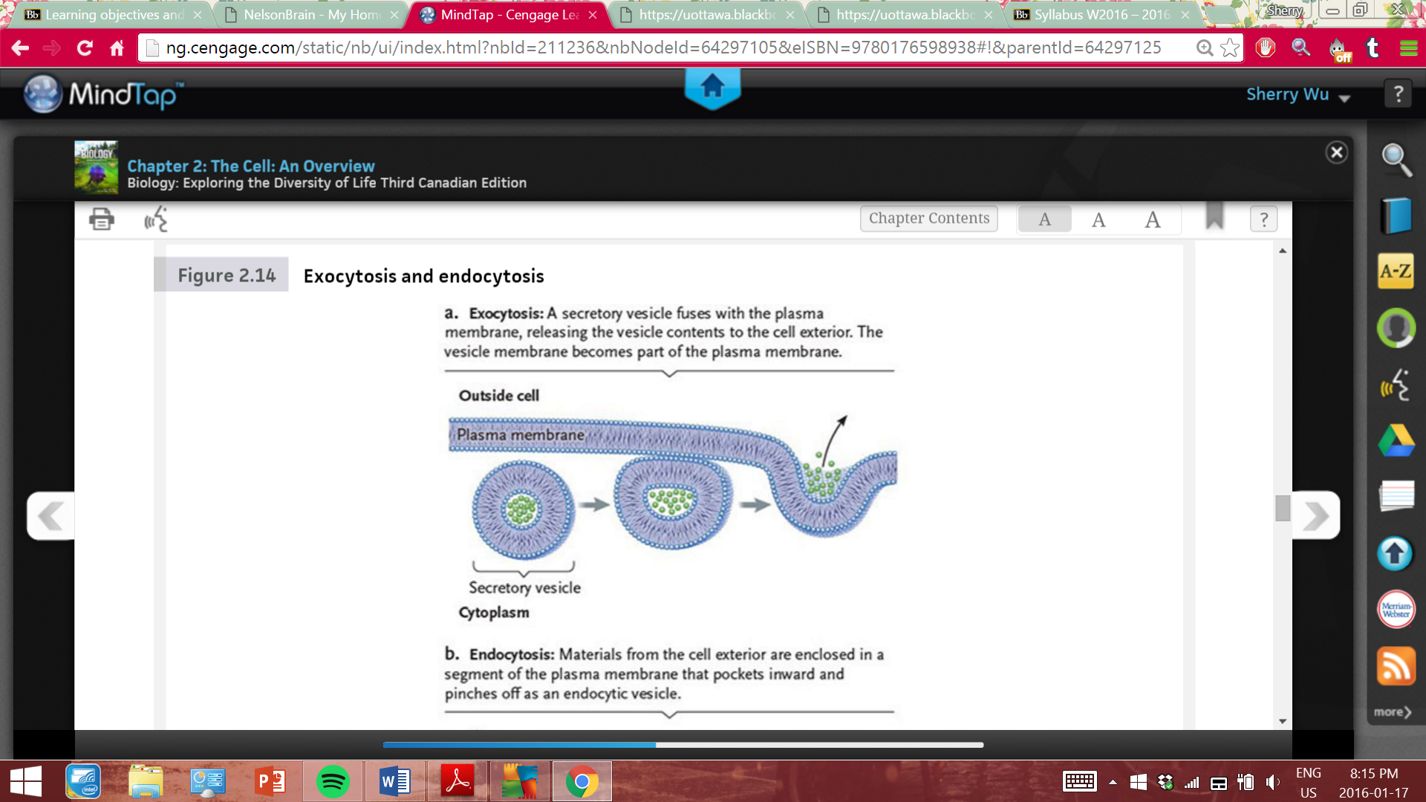

Lysosomes
- in animals but not plants
- Contains enzymes do break down and recycle proteins, lipids, nucleic acids and sugars.
- Formed when rough ER forms hydrolytic enzymes, modified by the ER lumen, which then get packaged by the Golgi apparatus. (pH is 5, lower than cytosol)
- Engists food that is entering the cell, and digests improperly functioning organelles (autophagy)
- Autophagy: membrane surrounds defect forming a vesicle which attaches to lysosomes.
- Also break down large vesicles as a result of phagocytosis.
Summary of endomembrane system
- Golgi complex is the key distributer,

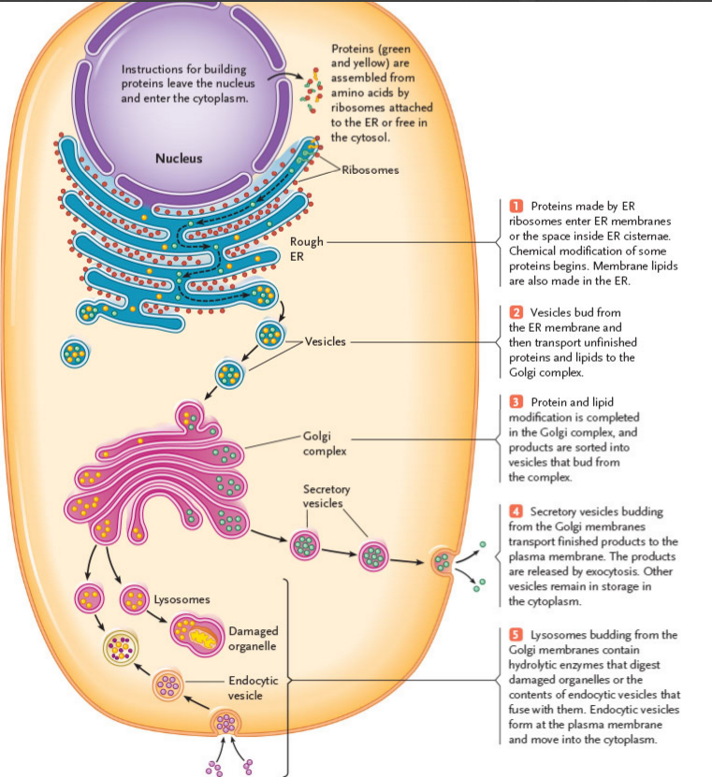

Mitochondria (2.3e)
- Cellular Respiration: process by which complex, energy rich molecules (sugars, fats) get broken down by the mitochondria to create water and co2.
- These ATP generating reactions occur in the cristae and matrix of the mitochondria
- The matric also contains DNA and ribosomes. (suggests ancient bacterial origins)
Cytoskeleton (2.3f)
- Cytoskeleton is an interconnected system of protein fibres and tubes throughout the cytoplasm.
- Reinforces plasma membrane and DIRECTS MOVEMENT (of cell and organelles)
- Includes: microtubules, intermediate filaments and microfilaments. (in descending order according to size)
- Microtubules:
- made of 13 protein filaments which consist of tubulin dimers (made of one alpha tubulin and one beta tubulin, arranged head to tale to create polarity)
- dynamic structures, changing in lengths (why animal cells change shape) due to adding and removing dimers
- Microtubules formed at centrosome (cell center) from centrioles, radiating outward along with intermediate filaments. (MT anchors ER, golgi, lysosomes, secretory vesicles and some mitochondrian)
- Dyneins and kinesins (motor proteins) walk along microtubules, pushing/pulling the MT’s and creating cell movement.
- Intermediate filaments
- only found in MC organisms.
- tissue specific
- Microfilaments
- made of asymmetrical actin units, creates polarity.
- involved in cytoplasmic streaming
Flagella and Cilia
- Arise from centrioles (triple microtubules instead of double), aka basal body.

2.4 specialized structures within plant cells
Plastids:
Chloroplasts:
- site of photosynthesis
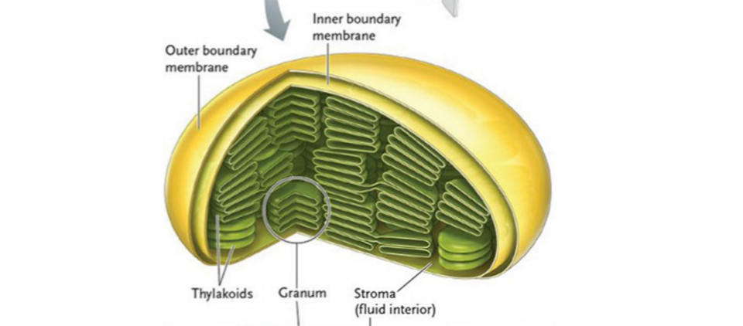
Amyloplasts: store starch
Chromoplasts: contain red yellow pigment (chromophores)

All plastids contains DNA genomes, and thins needed for gene expression. (bacterial ancestry)
Central Vacuole
- 90% of the plants volume is the vacuole, supporting the cells
- A tonoplast surrounds the vacuole, containing transport preoteins and give rigidity to the cell.
- Store salts, sugar, enzymes etc.
Cell Wall
- Made of cellulose fibers, with small channels (plasmodesmata) allowing communications between plant cells. (ions can flow through)

The animal cell surface

Cell Junctions and Adhesion
Anchoring junctions
- Spots/belts that weld adjacent cells together
- A type of anchoring junctions, desmosomes are made with intermediate filaments that anchor the junction in the underlying cytoplasm.
- Adherens junctions use microfilaments to anchor the cytoskeletal component.
- * anchoring junctions are found in tissues subject to tearing, (heart, skin, muscle etc)
Tight Junctions
- Tighter connections between cellular membranes.
- Seal spaces between cells, ie found in cells that line stomach, intestine etc. (don’t allow ions to move between cell layers)
*think that you need it to be tight, other wise H+ ions would attack the stomach.
- Formed by fusing protein on the outer surfaces of adjacent cells, forming a stichwork of protein.
Gap Junctions
- Allow direct channels for ion and small molecule movement from cell to cell.
- Allows for cytoplasmic connections
*like a plasmodesmata
*heart muscle

The Extracellular Matrix
- Animal cells are embedded in an ECM, made by the secretion of cells.
- Made of glycoproteins (usually collagen)
- Consistency of matric is dependent on proteoglycans (glycoprotein with protein attached to it)

Evolutionarily, in terms of rRNA and phospholipids and membranes.

UNICeLLULAR EUKARYOTES: PROTISTS
Prokaryotes:
Small, unicellular organisms. KISS
Adaptable, genomes in plasmids.
Eukaryotes: Why does DNA now need to be bigger? Cell is bigger, tasks are more complex. Therefore we need more proteins and DNA to give instructions for that protein.
Internal network of membranes, allowing the formation of organelles. With a transport system to move between the compartments.
***nothing floats freely in cells. Everything is connected to an intricante network of the cytoskeleton

Typical bacteria:
Flagellum: made of microtubules
No nuclear compartment, tons of ribosomes
No organelles
Several outer layers. : Glycocalyx (outer, protection, attachment), cell wall, plasma membrane
Typical Plant Cell:
Central vacuole changes shape with osmotic contractions, it’s a fluid filled sack which lacks rigidity
Tonoplast(?) makes sure plant cell maintains rigidity

