Yi Yang 214545081
ECON3210 Assignment 2: Chapter 3
Questions 1, 3, 5, 6, 7
Computer exercises: C3.3, C3.4, C3.7

1.
- According to the question, hsperc is the top percent of the class. For example, hsperc=5 means top five percent of the class. That is to say, the better high school grades are, the smaller hsperc is. When the coefficient is negative, the smaller hsperc is, the smaller negative effects on colgpa will be.
- When hsperc = 20 and sat = 1050, college GPA=1.392-0.0135*20+0.00148*1050=2.676
- Holding hsperc constant, when ΔSAT=140, Δcolgpa=0.00148*140=0.2072
- Holding hsperc constant, when Δcolgpa=0.50, ΔSAT=Δcolgpa/0.00148=338
3.
- In the given model, it doesn’t make sense to hold sleep, work, and leisure fixed, while changing study. For each student, any activity is put into one of the four categories. Therefore, when holding sleep, work, and leisure fixed, study will also be fixed because study= 168- sleep-work-leisure.
- MLR.3 requires no perfect collinearity among regressors. In the question, x1+x2+x3+x4=168. We can’t change the value of one variable when holding other three constant.
- We can drop one of these four variables and then the equation will satisfy MLR.3.
5.
- Heteroskedasticity: unbiased
- Omitting an important variable: biased
- A sample correlation coefficient of .95 between two independent variables both included in the model: unbiased
6. Because corr(avgtrain, avgabil) is negative and β2 is positive, the bias which is corr(avgtrain, avgabil) times β2 is negative. Therefore, the bias is downward.
7.
- According to the statement, corr(x1,x2)>0 and β2>0. The bias is positive and quite big. β1 and β1 will be very different.
- According to the statement, corr(x1,x2)≈0. β1 and β1 will be similar.
- According to the statement, corr(x1,x2)>0 and β2≈0. R1^2 is big. se(β1) will be smaller than se(β1).
- According to the statement, corr(x1,x2)≈0 and β2>0. R1^2 is zero. σ² of se(β1) is smaller than σ² of se(β1). se(β1) will be smaller than se(β1).

C3.3

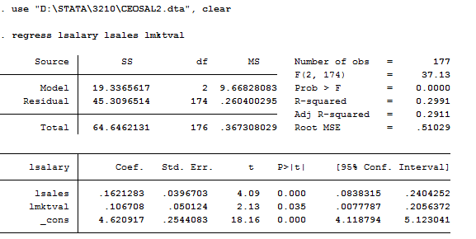
SRF:

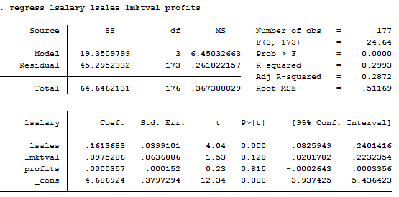
SRF:
We cannot add profits in logarithmic form because profits have negative values. I would not say that these firm performance variables explain most of the variation in CEO salaries. The R-squared is approximately 0.3, which is too low.

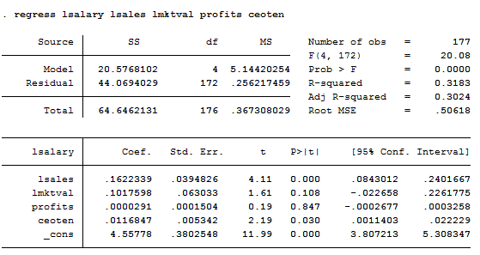
Holding other factors constant, the estimated percentage return for another year of CEO tenure is 1.17%.

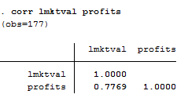
The sample correlation coefficient between the variables log(mktval) and profits is 0.7769.

C3.4

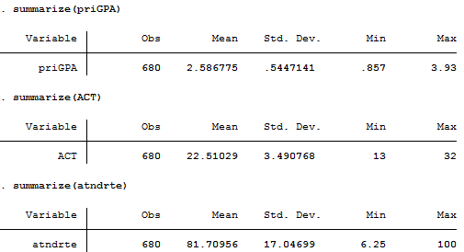
For atndrte: Max=100 min=6.25 ave=81.71
For priGPA: Max=3.93 min= 0.857 ave=2.59
For ACT; Max=32 min=13 ave=22.51

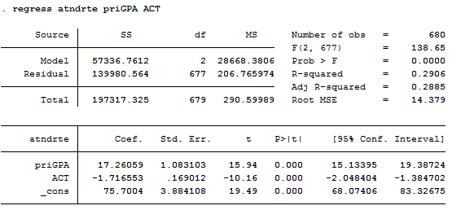
SRF:
The interpret 75.70 is the atndate for a student with 0 priGPA and 0 ACT. I think it is useful for determining the standard of atndate.
- One point increase in priGPA increase atndate by 17.26 percent. This makes sense because increasing priGPA increases atndate. However, one point increase on the ACT exam decrease attendance by -1.72 point. This does not make sense.
- When priGPA is 3.65 and ACT is 20, atndrte is predicted to be:
104.30 = 75.7 + 17.26 ∗ (3.65) − 1.72 ∗ (20)
It is impossible for a student to attend more than 100% of the class.
- For student A: 93.09 = 75.7 + 17.26 ∗ (3.1) − 1.72 ∗ (21).
For student B: 67.23 = 75.7 + 17.26 ∗ (2.1) − 1.72 ∗ (26)
Difference between A and B: 93.09-67.23=25.86 percent.

C3.7

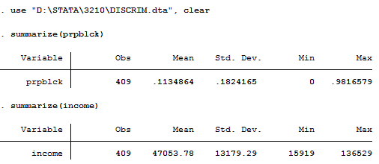
The sample mean and standard deviation of prpblck are 0.11 and 0.18.
The sample mean and standard deviation of income are 47053.78 and 13179.29.
The units of measurement of prpblck and income may be 1 and dollar, respectively.

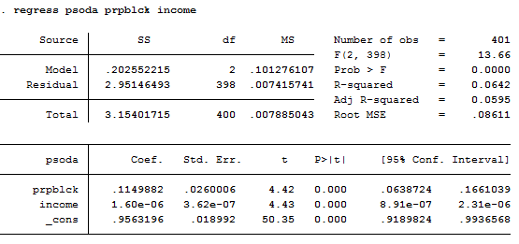
SRF:
When prpblck increases by 1, the price of a medium soda increases by 0.11 dollars. Holding other factors constant, the difference of psoda between 100% white community and 100% black is 0.11 dollars. It is not an economically large effect.

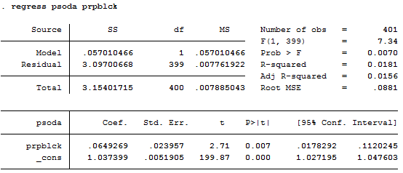
The discrimination effect is smaller when controlling for income.
d)
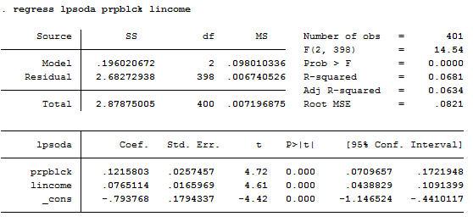
SRF:
If prpblck increases by .20 (20 percentage points), the estimated percentage change in psoda is 2.4 percent.
e)
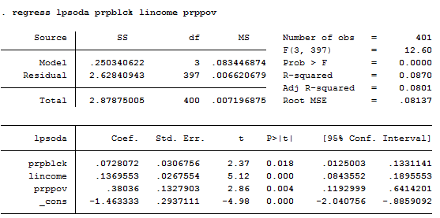
The coefficient on prpblck goes from 0.12 to 0.073.

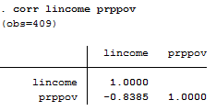
The correlation between log(income) and prppov is -0.84. It is expected to be a negative value.
- Because of the high correlation between log(income) and prppov, it will be difficult to identify the independent effect of each variable. However, there will be no effect for these two variables to be in the same regression.

