Trevor Bush
Principles of Marketing

Chapter #1 – Marketing: Creating and Capturing Customer Value
(Lecture 1)

Marketing – The process by which companies create value for customers and build strong customer relationships in order to capture value from customers in return.

Needs – States of felt deprivation.

Wants – The form that human needs take as they are shaped by culture and individual personality.

Demands – Human wants that are backed by buying power.

Market Offerings – Some combination of products, services, information, or experiences offered to a market to satisfy a need or want.

Marketing Myopia – The mistake of paying more attention to the specific products a company offers than to the benefits and experiences produced by these products.

Exchange – The act of obtaining a desired object from someone by offering something in return.

Market – The set of all actual and potential buyers of a product or service.

Marketing Management – The art and science of choosing target markets and building profitable relationships with them.

Production Concept – The idea that customers will favour products that are available and highly affordable and that the organization should therefore focus on improving production and distribution efficiency.

Product Concept – The idea that customers will favour products that offer the most in quality, performance, and innovation features and that the organization should therefore devote its energy to making continuous product improvements.

Selling Concept - The idea that customers will not buy enough of the firm’s products unless it undertakes a large-scale selling and promotion effort.

Marketing Concept – A philosophy that holds that achieving organizational goals depends on knowing the needs and wants of target markets and delivering the desired satisfaction better than competitors do.

Societal Marketing Concept – The idea that a companies marketing decisions should consider consumers wants, the companies requirements, consumers long-run interests and societies long-run interest.

Customer Relationship Management – The overall process of building and maintaining profitable customer relationships by delivering superior customer satisfaction and value.

Customer Perceived Value – The customers evaluation of the difference between all benefits and all costs of a marketing offer relative to those of competitors offers.

Customer Satisfaction – The extent to which products perceived performance matches buyer’s expectations.

Customer Managed relationships – Marketing relationships in which customers, empowered by todays new digital technologies, interact with companies and with each other to shape their relationships with brands.

Consumer Generated Marketing – Brand exchanges created by consumers themselves – both invited and uninvited – through which consumers are playing an increasing role of shaping their own brand experience and those of other customers.

Partner Relationship Management – Working closely with partners in other company departments and outside the company to jointly bring more value to customers.

Customers Lifetime Value – The value of the entire stream of purchases that the customers would make over the lifetime of patronage.

Share of Customer – The portion of the customers purchasing that a company gets in its product categories.

Customer Equity – The total combined customer lifetime values of all of the company’s current and potential customers.

Chapter #2 – Company and Marketing Strategy: Partnering to Build Customer Relationships
(Lecture 2)

Strategic Planning – The process of developing and maintaining a strategic fit between the organizations goals and capabilities and its changing marketing opportunities.

Mission Statement – A statement of the organizations purpose – what it wants to accomplish in the larger environment.

Business Portfolio – The collection of business and products that make up the company.

Portfolio Analysis – The process by which management evaluates the products and businesses that makes up the company.

Growth Share-Matrix – A portfolio planning method that evaluates a company SBU’s in terms of its market growth rate and relative market share.

Product/Market Expansion Grid – A portfolio planning tool for identifying company growth opportunities though market penetration, market development, product development, or diversification.

Market Penetration - Company growth by increasing sales of current products to current market segments without changing the product.

Market Development – Company growth by identifying and developing new market segments for current company products.

Product Development – Company growth by offering modified or new products to current market segments.

Diversification – Company growth through starting up or acquiring businesses outside the company’s current products and markets.

Value Chain – The series of internal departments that carry out value-creating activities to design, produce, market, deliver, and support a firms products.

Value delivery Network – The network made up of the company, its suppliers, its distributors, and, ultimately, its customers who partner with each other to improve the performance of the entire system.

Marketing Strategy – The marketing logic by which the company hopes to create customer value and achieve profitable customer relationships.

Market Segmentation – Dividing a market into distinct groups, of buyers who have different needs, characteristics, or behaviors, and who might require separate products or marketing programs.

Market Segment – A group of customers who respond in a similar way to a given set of marketing efforts.

Market Targeting – The process of evaluating each market segments ‘attractiveness’ and selecting one or more segments to entre.

Positioning – Arranging for a product to occupy a clear, distinctive, and desirable place relative to competing products in the mind of the target consumers.

Differentiation – Actually differentiating the market offering to create superior customer value.

Marketing Mix – The set of tactical marketing tools – product, price, placement, promotion – that the firm blends to produce the response it wants in the target market.

SWOT Analysis – An overall evaluation of the company’s strengths, weaknesses, opportunities, and threats.

Marketing Implementation – Turing marketing strategies and plans into marketing actions to accomplish strategic marketing objectives.

Marketing Control – Measuring and evaluating the results of marketing strategies and plans taking corrective action to ensure that the objectives are achieved.

Return on Marketing Investment (ROI) – The net return from a marketing investment divided by the total costs of the marketing investment.

Designing a customer-driven marketing concept:

Chapter #3 – Analyzing the Market Environment
(Lecture 2)

Marketing Environment – The actors and forces outside marketing that affect marketing managements ability to build and maintain successful relationships with target customers.

Microenvironment –…ability to serve its customers – the company, suppliers, marketing intermediaries, customers markets, competitors, and publics.

Macroenvironment – The larger societal forces that affect the microenvironment – demographic, economic, natural, technological, political, and cultural forces.

Marketing Intermediaries – Firms that help the company promote, sell, and distribute its products to final buyers.

Demography – The study of human populations in terms of size, density, location, age, gender, race, occupation, and other statistics.

Baby Boomers – The 9.8 million Canadians born during the baby boom following the war and lasting until the mid-1960’s.

Generation X – The 7 million Canadians born between 1967 – 1976 in the birth-dearth following the baby boom.

Millennials (or Generation Y) – The 10.4 million children of the Canadian baby-boomers, born between 1977 – 2000.

Economic Environment – Economic factors that affect consumer purchasing power and spending patterns.

Natural Environment – Natural resources that are needed as inputs by marketers or that are affected by marketing activities.

Environmental Sustainability – Developing strategies and practices that create a world economy that the planet can support independently.

Cultural Environment – Institutions and other forces that affect a societies basic values, perceptions, preferences, and behaviors.

Steps in strategic planning:

- Define the company mission
- Setting company objectives and goals
- Designing the business portfolio
- Planning marketing and other functional strategies

BCG Growth-share matrix:

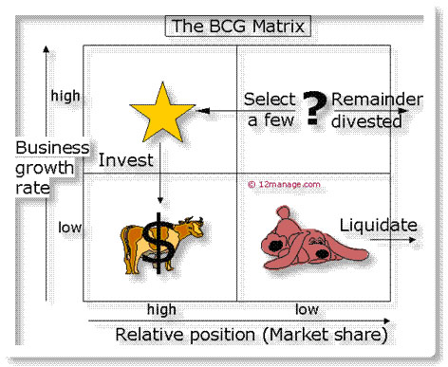

Build Stars
Hold Questions marks
Harvest Cash Cows
Divest Dogs

Product/market expansion grid:

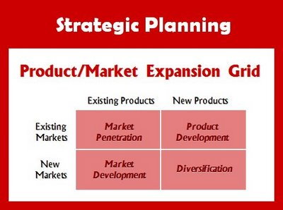

Chapter #5 – Managing Marketing Information and Gain Customer Insights
(Lecture 3)

Customer Insights – Fresh understandings of customers and the marketplace derived from marketing information that becomes the basis for creating customer value and relationships.

Marketing Information system (MIS) – People and procedures for assessing information needs, developing the needed information, and helping decision makers to us the information to generate and validate actionable customer and market insights.

Internal Databases – Electronic collections of customer and market information obtained from data sources within the company’s network.

Competitive Marketing Intelligence – The systematic collection and analysis of publicly available information about consumers, competitors, and developments in the marketing environment.

Marketing Research – The systematic design, collection, analysis, and reporting of data relevant to a specific marketing situation facing an organization.

Secondary Data – information that already exists somewhere, having been collected.

Primary Data – Information collected for the specific purpose at hand.

Customer Relationship Management (CRM) – Managing detailed information about individual customers and carefully managing customer touchpoints to maximize customer loyalty.

Chapter #6 – Consumer Markets and Consumer Buyer Behavior
(Lecture 4)

Consumer Buyer Behavior – The buying behavior of final consumers – individuals and households that buy goods and services for personal consumption.

Consumer Market – All of the individuals and households that buy or acquire goods or services for personal consumption.

Social Class – Relatively permanent and ordered divisions in a society whose members share similar values, interests, and behaviors.

Opinion Leader – A person within a reference group who, because of special skill, knowledge, personality, or other characteristics, exerts social influence on others.

Online Social Networking – Online social communities – blogs, social networking’s websites, and even virtual worlds – where people socialize or exchange information and opinions.

Motive (drive) – A need that is sufficiently pressing to direct the person to seek satisfaction of the need.

Perception – The process by which people select, organize, and interpret information to form a meaningful picture of the world.

Attitude – A persons relatively consistent favorable or unfavorable evaluations, feelings, and tendencies toward an object or idea.

Complex Buying Behavior – Consumer buying behavior in situations characterized by high consumer involvement in a purchase and significant perceived differences among brands.

Dissonance-reducing buying behavior – Consumer buying behavior in situations characterized by high involvement but few perceived differences among brands.

Habitual Buying Behavior – Consumer buying behavior in situations characterized by low consumer involvement and few significant brand differences.

Need Recognition – The first stage of the buyer decision process, in which the consumer recognizes a problem or need.

Stimulus Brain factors (thoughts) Reaction

External Factors – Culture and social
Internal Factors – Personal and psychological

Compliance tactic: reason

- Excuse me, I have five pages. May I use the Xerox machine?
60% compliance
- Excuse me, I have five pages. May I use the Xerox machine because I’m in a rush?
94% compliance
- Excuse me, I have five pages. May I use the Xerox machine because I have to make some copies?
93% compliance

Compliance tactic: scarcity
Compliance tactic: consistency
Compliance tactic: authority
Compliance tactic: social proof

Maslow’s hierarchy of needs:

- Self-actualization
- Self-esteem
- Social
- Safety
- Physiological

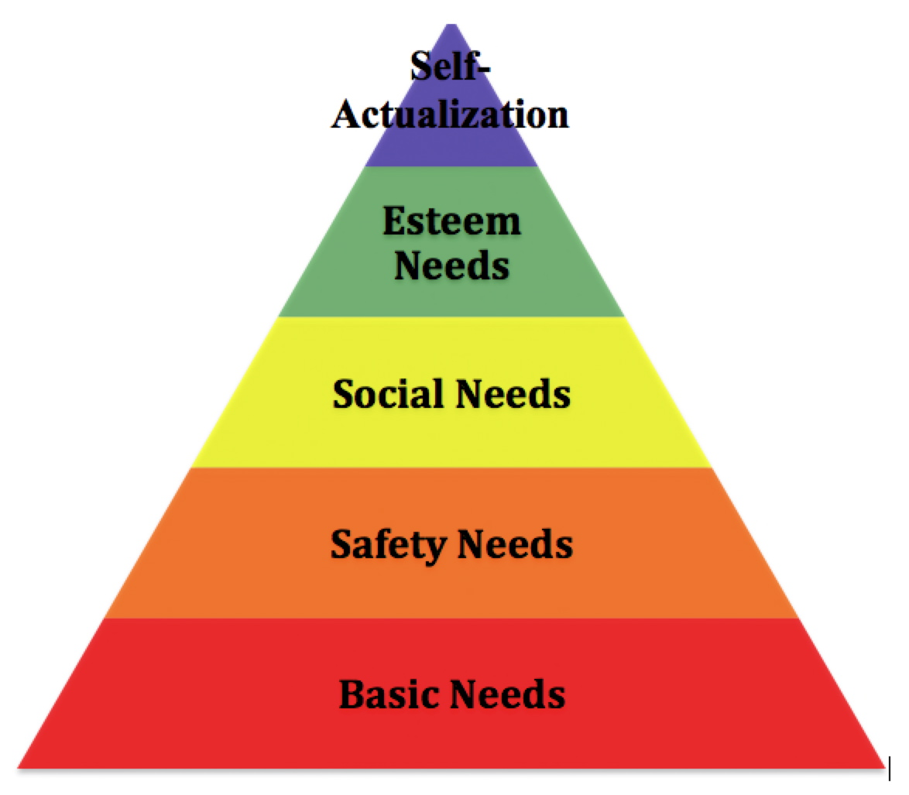

Selective attention – screen out most of the information exposed.

Selective distortion – interpret information in a way they already believe.

Selective retention – remember good point of a brand they like, forget good points of brand they don’t.
“Perception is constructed reality”

Consumer decision-making process:

- Need recognition
- Information search
- Evaluation
- Purchase decision
- Post-purchase evaluation

Chapter #10 – New Product Development and Product Life-Cycle Strategies
(Lecture 5)

New Product Development – The development of original products, product improvements, product modifications, and brands through the firms own developmental efforts.

Idea Generation – The systematic search for new product ideas.

Crowdsourcing – Inviting broad communities of people – customers, employees, independent scientists and researchers, and even the public at large – into the new product innovation process.

Idea Screening – Screening new product ideas to spot good ideas and drop poor ones as soon as possible.

Product concept – A detailed version of the new product idea stated in meaningful consumer terms.

Concept Testing – Testing new product concepts with groups of target consumers to find out if the concepts have strong consumer appeal.

Marketing Strategic Development – Designing an initial marketing strategy for a new product based on the product concept.

Business Analysis – A review of the sales, costs, and profit projections for a new product to find out whether these factors satisfy the company’s objectives.

Product Development – Developing the product concept into a physical product to ensure that the product idea can be turned into a workable market offering.

Test marketing – The stage of new product development in which the product and its proposed marketing program are tested in realistic market settings.

Commercialization – Introducing a new product into the market.

Customer-centered new-product development – New product development that focuses on finding new ways to solve customer problems and create more customer-satisfying experiences.

Team-based new-product development – An approach to developing new products in which various company departments work closely together, overlapping the steps in the product developmental process to save time and increase effectiveness.

Product Life cycle – The course of a products sales and profits over its lifetime. It involves five distinct stages; product development, introduction, growth, maturity, and decline.

Style – A basic and distinctive mode of expression.

Fashion – A currently accepted or popular style in a given field.

Fad – A temporary period of unusually high sales driven by consumer enthusiasm and immediate product or brand popularity.

Introduction Stage – The PLC stage in which a new product is first distributed and made available for purchase.

Growth Stage – The PLC stage in which a products sales start climbing quickly.

Maturity Stage – The PLC stage in which a products sales growth slows or levels off.

Decline Stage – The PLC stage in which a products sales decline.

The NPD (New product development) Process –

- Idea generation
- Idea Screening
- Concept Development & Testing
- Marketing Strategy development
- Business Analysis
- Product Development
- Test Marketing
- Commercialization

Why new products fail?

- Overestimation of market size
- Poor design
- Incorrect positioning
- Wrong timing
- Priced too high
- Ineffective promotion
- Management Influence
- High development costs
- Competition

Customer adoption:

- Innovators 2.5%
- Early Adopters 13.5%
- Early Majority 34%
- Late Majority 34%
- Laggers 16%

Differences in adoption: The chasm model

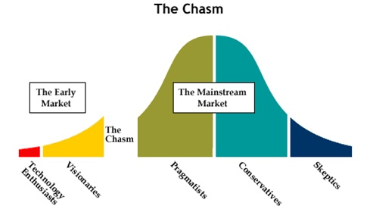

Buyer decision process for new products:

- Awareness
- Interest
- Evaluation
- Trial
- Adoption

Product Life Cycle:

- Development
- Introduction
- Growth
- Maturity
- Decline

Pioneer Advantages –

- Get to chose best target market
- Product becomes prototype against which all others judged
- Lock up necessary resources/ distribution
- Experience curve effects
Second mover advantages –

- Learn from pioneer actions
- Benefit from pioneer marketing efforts
- Customer preference can evolve faster than pioneer
- Different customer segments have different preferences

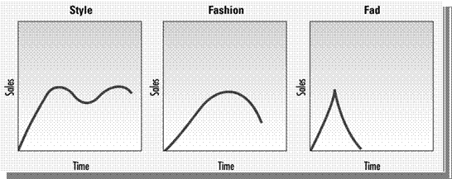

Chapter #8 – Segmentation, Targeting, and Positioning
(Lecture 7)

Market Segmentation – Dividing a market into smaller segments of buyers with distinct needs, characteristics, or behaviors. They may require separate marketing mixes.

Market Targeting (targeting) – The process of evaluating each market segments attractiveness and selecting one or more segments to entre.

Differentiation – Differentiating the market offering to create superior customer value.

