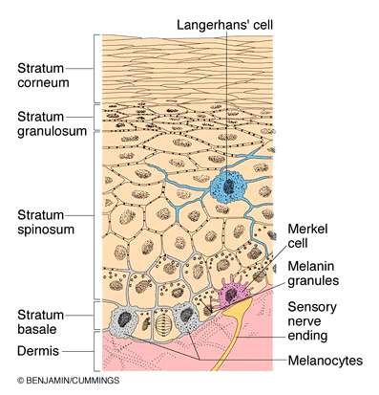
2. INTEGUMENTARY SYSTEM!
There are two distinct regions of the skin
- Epidermis: epithelial layer, thick keritanized stratified squamous epithelium.
- Dermis: connective tissue, vascularized
There are 4 types of EPIDERMAL cells.
- Keratinocytes: majority of epidermal cells, produce keratin (fibrous protein), tightly connected by desmosomes, by the time they reach the skin surface they are dead
- Melanocytes: produce melanin, deepest layer of epidermis, provide pigment, protection from sun, protect nucleus from UV damage. Sun exposure increases melanin production
- Dendritic cells: Langerhan’s cells (star shaped) migrate to epidermis from bone marrow, macrophages activate immune system
- Tactile cells: Merkel cells, at the epidermis/dermis boundary, have disc like sensory nerve ending, TOUCH RECEPTORS
Four major layers in epidermal THIN skin
- Stratum Corneum: outermost, dead cells, flattened out filled with keratin, connected by tight junctions and desmosomes, hold up to a lot of wear and tear and keratin waterproofs the body, 2-4 weeks for complete replacement
- Stratum Granulosum: 5 layers of flattened cells, granules of keratin formed here
- Stratum Spinosum: layers of keratinocytes connected by desmosomes, cells round up into little balls, DENDRITIC CELLS
- Stratum Basale: one row of active mitotic stem cells, MELANOCYTES
THICK SKIN
- Has Stratum Lucidum
  - Clear layer, 2-3 rows of clear flat dead keratinocytes
  - Corneum, lucidum, granulosum, spinosum, basale, dermis
  - On soles of feet and palms, no colour
Dermis
- has all the normal CT cells (fibroblasts, macrophages, mast cells, WBCs
- semi-fluid matrix with a lot of collagen, elastin and reticular fibers
- supplied with nerve fibers, blood and lymphatic vessels
- 2 layers, papillary and reticular
  - Papillary forms projections into epidermis, interwoven mat of areolar CT fibers interspersed with blood vessels
    - Dermal papillae contain capillaries or nerve endings for touch and pain, peglike structures indent epidermis
    - In thick skin, dermal papillae overlie dermal ridges on palms of hands, feet to give us friction ridges
      - Friction ridges responsible for fingerprints
  - Reticular layer- network of collagen and elastic fibers, strength and flexibility, attaches dermis to epidermis
    - Dense irregular CT
    - Source of lines of cleavage/tension lines
    - Collagen fibers give strength and resiliency and maintain skin hydration, elastic fibers provide stretch recoil
- Striae/stretch marks: when dermis tears because it has been stretched too far
- Blisters: fluid pocket separating dermis and epidermis
- Flexure lines: on joints, dermal folds, on palm and digits
Hypodermis
- It is superficial fascia, adipose tissue, areolar CT and blood vessels, subcutaneous tissue
- Anchors skin to underling structures, shock absorber, insulation, stores fat, has the ability to slide
Pigments contributing to skin colour
- Melanin
  - Only pigment made IN THE SKIN
  - Skin colour dependent on type, relative amount and keratinocyte retention of the pigment
- Carotene
  - Yellow orange pigment found in carrots, stratum corneum and hypodermis
- Hemoglobin
  - From capillary circulation and gives skin a pinkish hue
  - Cyanosis: poor circulation, the hemoglobin is poorly oxygenated
Accessory structures of the skin
Hairs and Hair follicles
- Functions of hair: sense insects on skin, guard head from heat loss, sun, physical trauma, shield eyes, filter particles from inhaled air, hard keratin (more durable and doesn’t flake)
Hair shaft
- Shape determines whether hair is straight or curly
- Medulla: innermost layer, large cells partially separated by air spaces, absent in fine hairs
- Cortex: flattened keratinocytes, pigment is here
- Cuticle: single layer of overlapping scaly cells most heavily keritanized, provides strength
- Split ends: when cuticle tears away

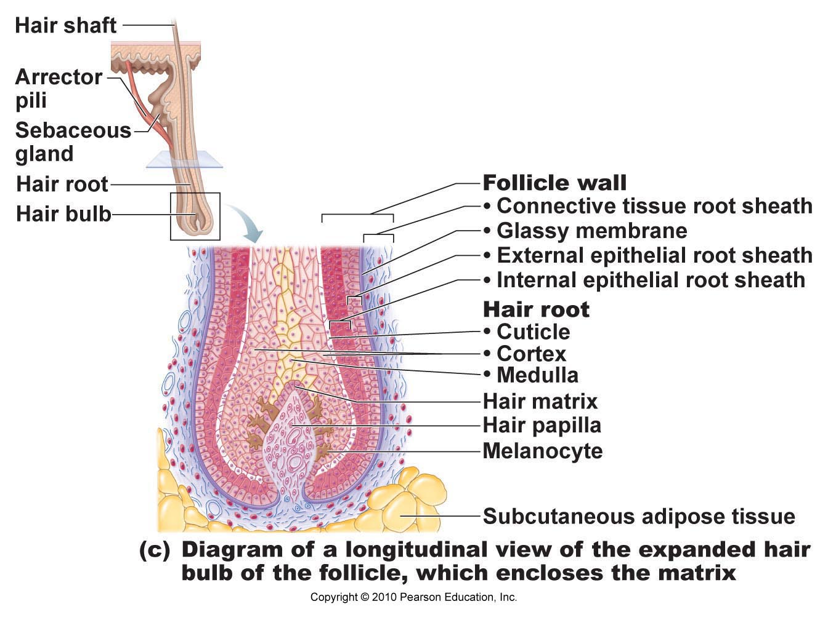
Hair Structure
- Shaft: hard keratin, part that projects from the skin, has 3 layers (medulla, cortex, cuticle)
- Root: part embedded in skin, contained within the hair follicle
- Bulb: expanded deep end of follicle, has papilla and root hair plexus
- Follicle: outer CT rooth sheath and inner epithelial root sheath, hair matrix
- Arrector pili muscle: 1 per follicle, contract to pull hair up and dimple the skin
- Sebaceous gland: HOLOCRINE gland that secretes sebum
- Vellus hair: short, fine, light coloured on children,
- Terminal hair: what we know as scalp hair
- Hirsutism: abnormal growth of hair on face and body, especially on women
- Average rate of hair growth: around 2.5 mm per week
- Eyebrow hair has a shorter active phase than head hair

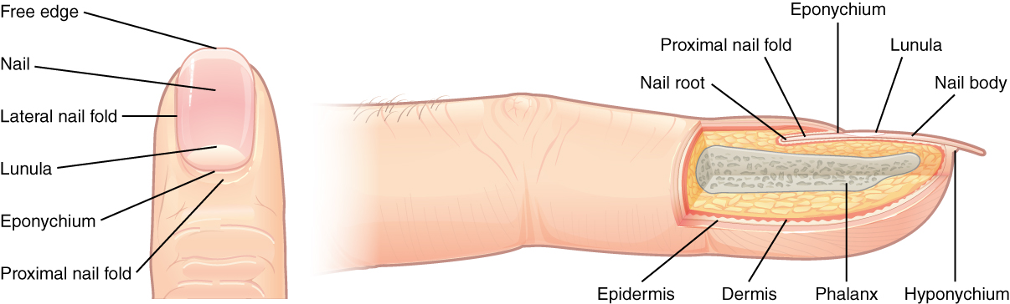
Nails
- Scale lie modification of epidermis, protective and useful tool
- Lunula: the half moon kind of shape, is white because thick nail matrix underneath it blocks the pink color of dermal blood supply, the lunula is a thick layer of epithelium
- Nail body: densely packed keratinocytes
  - Forms at nail root and has matrix of multiplying cells that enables nail to always grow
  - Lateral nail fold overlaps nail on sides, and anchors
- Nail cuticle: where nail fold meets proximal end of nail body (eponychium)
- Nail bed: rich in blood vessels, appears pink except for lunula
- Yellow tinged nails: fungal infection or serious respiratory or thyroid gland disorder
- Thickened ails: fungal infection
- Spoon nail: iron deficiency
- Beau’s lines: (horizontal, malnutrition (sporadic stoppage of matrix growth
- Clubbing: pulmonary or cardiovascular disease, common in cystic fibrosis
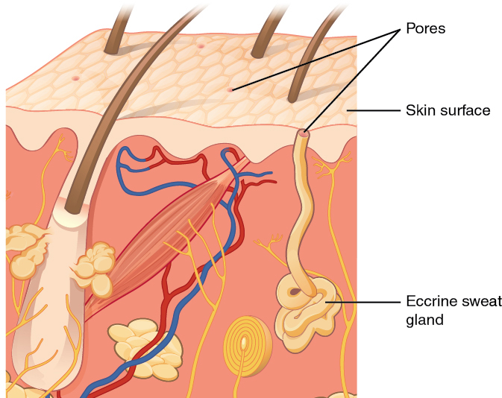
Sweat Glands
- Distributed over skin surface except nipples and parts of external genitalia
- Merocrine: most numerous,, palms, soles, forehead
  - Simple coiled tubular glands with pore at the surface
- Apocrine: axillary and anogenital areas, larger, lie deeper in the dermis or hypodermis, ducts empty into hair follicles
  - Same as sweat but more fatty substances and some proteins – odourless until decomposed by skin bacteria that leads to BO
  - Reduce friction between hair follicles and skin
  - Modified sweat glands:
    - Ceruminous: secrete wax (cerumen) in external ear canal
    - Mammary: secrete milik
Major functions of skin
PROTECTION
- Chemical barriers: secretions, melanin, low pH, some natural bactericidal substances, antibiotics
- Physical barriers: barrier to trauma and bacterial invasion, also waterproofing
- Biological: Langerhan’s cells of epidermis and macrophages in dermis
Body temp, sweating vasoconstriction
Metabolic, blood reservoir, cutaneous sensation, exretion
Burns
- First degree: only epidermis
- Second degree: epidermis and upper dermis
- Third degree: entire thickness of skin
- Rule of nines: assesses percentage of skin damaged by burns

