Lecture 4: The Civil Segment Society
- Civil Society: Key Terms
- Community -Reciprocity-exchange –Trust and collaboration -Social arrangements -Social capital -Civic engagement

- Civil Society (Social Segment)
- The community, volunteer sector, civic sector, civil society

- What is ‘civil society’?
-Also referred to as the ‘third segment’
-nonprofit –voluntary –“community” –not for profit –independent

-The totality of voluntary civic and social organizations and institutions

- “Community”
- “locality and common interests”
- Shared characteristics, values, interests, goals that provokes a sense of belonging: Closeness, Warmth, Protection , Engagement
- Can be occupational (physicians, accountants)
- Can occur within organizations: Professors, Auditors, Finance “community”, Accountants, HR “community, Senior management “community”
- Can be based on: Skills, gender, age, ethnicity or some combination of these

- Civil Society (Social Segment) – Who is Included?
- The community, but also:
- United Way, Foundations (Maytree, Atkinson), Sun Youth, Imagine Canada (formerly the Canadian Centre for Philanthropy), Kids Help Phone, Caledon Institute, Planned Parenthood

- What characterizes the segment?
- Activities mainly instituted through forms of reciprocal relationships or solidarity.
- Based on “good neighbourliness” and social trust
- Its value system is reciprocity-based: Engagement, Trust, Cooperation, Commitment, Obligation, Collaboration

- Civil Society (Social Segment)
- Overall characteristics: Relative to the economic and political segment:
- Smaller, more cooperative, less hierarchical orgs.
- Large (#) of women relative to men
- Less emphasis on private accumulation & minimizing cost, more emphasis on public goods and maximizing participation
- Activities are more labour intensive

- The Contemporary civil society segment:
- Now features: Involved communities, NGOs/Interest groups/Associations that are “issue-oriented”, Knowledge groups/Institutes/Think Tanks –civic entrepreneurs linking community and economic development

- The Dynamics of the Civil Society Segment
- The dynamics of this sector are somewhat different from the other 2 sectors:
- In the economic segment, emerging issues are translated into opportunities for profit –the sorting mechanisms are supply and demand in the context of competition.
- In the political segment, the government must learn from the values and views of its citizens following which the sorting mechanisms is redistributed and coercion.
- In the social segment, the art of associating, rooted in civil society provides the 3rd sorting mechanisms and kicks in generally when the other 2 fail.
- The 3rd sector is a set of social arrangements that are continually evolving into active networks of non-market and non-state arrangements.

- Social Capital – Some Perspectives
- Social capital is generally defined as the relationships, networks and norms that facilitate collective action
- Social capital directs attention to the relationships that shape the realization of human capital’s potential for the individual and collectively.
- Social capital is defined as norms, networks, and other related forms of social connection.
- The central idea of social capital is that networks and the associated norms of reciprocity have value.

- Social Capital vs. Human Capital
- Social capital is not human capital. The differences can be expressed as follows:

 | Human Capital | Social Capital
FOCUS | Individual Agent | Relationships
MEASURES | Duration of schooling, Qualifications | Attitudes, Values, Memberships, Participation
OUTCOME | Direct: Income, productivity  Indirect: health, civic activity | Social cohesion, economic achievement, more social capital

- Some Simple Forms of Social Capital
- Highly formal forms: Parent-teacher association, a national organization of any sort, a labour union (where each is formally organized with a chairperson, a president and membership duties)
- Highly informal forms: a group of people of gathering at a bar every Thursday night

- Densely interlaced or comparatively invisible:
- A group of steelworkers who work together every day at the factory, go bowling together on Saturday, and the same Church every Sunday is the nodding acquaintance you have with the person you occasionally see waiting in line at the supermarket.

- Five Roles of Civil Society
- Monitoring through which policy is kept “honest”
- Advocacy through which policy options can be supported or not supported.
- Innovator through which different ways of doing things are developed and demonstrated.
- Service provides through which a particular need is fulfilled
- Capacity builder through which support is provided to other civil society organizations.

- The Civil Society Segment – Likely Contributions:
- Alternative service delivery models based on inter-sectoral partnerships
- Employment generation and recognition
- Valuing and conceptualizing the importance of “community”
Civil Society: An important but complex segment with complex issues
- Segment fragmentation
- Funding
- Attracting and retaining volunteers and strong non-profit band members

- Segment Fragmentation
- > 161,000 incorporated non-profit organizations plus thousands of unincorporated com. groups:
- Dif. Issues , different missions, highly diversified and incongruent , varying management capacity and ability
- Challenges due to fragmentation –for the smaller organizations:
- Being heard by government and industry, getting on the government on business agenda, partnering with government and business.

- Funding
- A finite amount of money to be shared amongst the fragmented 3rd segment
- Changes in government policy intended to foster improved stewardship has had a negative impact on the 3rd segment
- Project-based funding model:
- Overheard costs not funded, but more reporting requirements
- Funding targeted on specific issues that causes mission drift

- Attracting and Retaining Volunteers
- Age demographics:
- By 2011 the potential exists for every person aged 55-64 there will be only one person aged 15-24
- More people available to do volunteer and charitable work, but also more demand for 3rd segment services
- Changing volunteer paradigms: employee volunteerism, virtual volunteerism, episodic volunteerism, VolunTourism, Cross-national volunteering

- Reflection: Might “civil society” and/or “Community” be in decline?
- Putnam (2000):
- People disengaged from “civic life”: fewer voters, political activity, newspaper readership, participation in local associations the result: a decline in social capital, community relations and social cohesion – a weakening of the “social glue” in society.
- The Cause(s):
- Changes in family structure, Suburban sprawl, Time Pressures, Electronic entertainment, technology

- Bourdieu: 4 types of Personal Capital
- Each person in society will possess differing amounts of:
- Social capital (who you know)
- Economic capital (what you know)
- Cultural capital (legitimate knowledge: what you know)
- Symbolic capital (your status in the eyes of others)

Lecture 5: Stakeholders

- Who are stakeholders?
- Any group or individual who is affected or can affect the achievement of an organization’s objective
- Pluralism
- A condition in which there is diffusion of power among society’s many groups and organizations – a wide decentralization and diversity of power concentration.
- Pluralistic Society:
Diffusion of Power
Strengths | Weaknesses
- Prevents concentration of power  - Maximizes freedom  - Disperses individual allegiances  - Creates diversified loyalties  - Provides safeguards | - Pursuits self-interest  - Proliferates organizations with similar goals  - Forces conflicts  - Promotes inefficiency

- Stakeholders – Individuals and groups with a multitude of interests, expectations and demands as to what business should provide to society

- Shareholder Viewpoint
- A business exists to make money – greatest efficiency is achieved through profit maximization
- > profits, > takes paid to government for use in dealing with social issues
- Property rights theory (corporation owned by shareholders)
- Stakeholder Viewpoint
- Business has a responsibility to do more than maximize profits
- Business has caused several problems so it has a responsibility to fix them
- Social institution theory (society provides the very existence of business through legal frameworks)

- Stakeholders: A Complex Landscape
- Who are the organization’s legitimate stakeholders?
- Who are the organization’s key stakeholder and how do you determine which ones are key?
- What is the correct balance between profit generation and stakeholder interests?

- Stakeholders: Some Realities
- Stakeholders’ interests will not always be clear
- Some stakeholders will win, others will lose
- Stakeholders watch how the organization treats others stakeholders
- Stakeholder management will cost money, but might be cheaper than not managing stakeholders.
- Stakeholders and stakeholder groups are not static
- Stakeholder contributions are essential

- Key Questions in Stakeholder Management:
- Who are stakeholders?
- What are stakeholders’ stakes?
- What opportunities and challenges do stakeholders represent?
- What economic, legal, ethical and philanthropic responsibilities does a firm have?
- What strategies or actions should firms take to manage stakeholders’ opportunities and challenges?

- Who are our stakeholders?
- Management must identify generic stakeholder groups and specific sub groups
- What are out stakeholders’ stakes?
- The nature/legitimacy of a group’s stakes
- The power of a group’s stakes
- The specific groups within generic groups
- What opportunities and challenges do stakeholders represent?
- Productive working relationships with stakeholders
- Challenges and action on how the firm handles stakeholders
- What strategies or actions to take?
- Deal directly or indirectly with stakeholders?
- Take the offence or the defence in dealing with stakeholders?
- Accommodate, negotiate, manipulate, or resists stakeholder overtures?
- Employ a combination of the above or singular strategies

- A Key Stakeholder
- One who can exist and sustain a negative or positive affect on the organization
- Those stakeholders having interest and high power to influence would be perceived as key

- Who are Business Stakeholdrs?
- Primary and Secondary Stakeholders?
- Primary stakeholders are those that have a direct interest in the organization and its success
- Secondary stakeholders are those that have a public or special interest in the organization
- Core, Strategic, and Environmental Stakeholders?
- Core stakeholders are essential to the firm’s survival
- Strategic stakeholders are directly affected by threats and opportunities the organization faces
- Environmental stakeholders are all others in the organization’s environment

- The Business Stakeholders
- Legitimacy, Power, Urgency
- Legitimacy is the perceived validity of the stakeholder’s claim to a stake
- Power is the ability of a stakeholder to produce an effect
- Urgency is the degree a stakeholders’ claim demands immediate attention

- Identifying Stakeholders
- Power, legitimacy and urgency –any party possessing at least one of these attributes is a stakeholder
- Latent stakeholder possesses only 1 attribute
- Expectant stakeholder possesses 2 attributes
- Definitive stakeholder would possess all 3 attributes

- Stakeholder Capacity
- An approach to identifying stakeholders in terms of their capacity to influence the organization and level of risk tolerance

- The Stakeholder Capacity Method
- Develop an initial stakeholder list
- Rate each stakeholder on a scale of low, medium, high in terms of their capacity to affect the organization (positively or negatively)
- Assign a numerical value to Low, Medium, and High (such as, for example, 1,2, and 3)
- Compute the overall score for each stakeholder
- Associate each stakeholders’s score with a pre-determined stakeholder relevance interval
- Determine how each stakeholder will be managed: partner, dialogue or passively observe.

Lecture 6: Globalization and Multiculturalism

- Globalization: What is it?
- Globalization: the merging of previously domestic spaces and issues into one multifaceted and interconnected transnational global village

- Globalization
- A term used to describe the growing interdependence of people around the world with regard to social influence, economies, and cultural exchanges
- Refers to the increasing economic integration and interdependence or countries
- A global movement to increase flow of goods, services, people, real capital, and money across national borders in order to create a more integrated and interdependent world economy.

- Types of Globalization
- Globalization: a process of decreasing constraints on the interactions among the nations and peoples of the world
- Economic globalization: the integration of fragmented markets into a global economy
- Political globalization: the process by which world power relationships change, and there is a loss of sovereignty by the state
- Social or cultural globalization: the emergence of a worldwide cultural system

- Globalization: Key Drivers
- Market
- Cost
- Government
- Technology

- Markey Drivers
- New markets
- Strategic alliances
- Demand for products
- Cost Drivers
- Source of inexpensive labour
- Cheaper raw material
- New sources of capital
- Competition Drivers
- Trade liberalization
- Industry deregulation
- Privatization
- Participation in globalization institutions
- Technology Drivers
- Advances in information and communities technologies facilitate: Coordination of business activities from anywhere, Cross border banking
- Homogenization of many enabling technologies

- Globalization: Emerging Themes
- Interconnectedness
- Interdependence
- Integration
- Complexity
- Competition
- Risk
- Ethical Dilemmas
- Civil society
- Social Responsibility
- Culture
- Laws

- Globalization can create “new” ideas issues for Business
- Damage to environment
- Support for oppressive regimes & Arms trade
- Criticism of marketing practices (e.g. tobacco, pharmaceutical, baby formula, etc.) and manufacturing plant safety practices
- Treatment of employees (e.g. sweatshops and labour abuses)
- Treatment of indigenous peoples
- Genetic modification of plants and animals
- Corruption, bribery, and questionable payments

- Globalization: Good or Bad?
- Arguments FOR globalization:
- Increases economic growth rate, prosperity and opportunity for all participants
- Private operations and open markets provide better goods and services to society
- Increases civil liberties and reduces inequalities
- Leads to lower prices, higher employment in developing countries and better standards of living
- Facilitates the transfer of technology, capital, intellectual property and skilled labour
- A cleaner world environment
- Rising standard of living in developing countries
- Limits on international behaviour

- Arguments AGAINST globalization:
- Increases the wealth of giant corporations and leaves developing countries poorer
- Harms the environment
- Neuters government’s ability to govern and results in conspiracies between corporations
- Increases unemployment in undeveloped countries
- Reduces standards (manufacturing, health, quality, and environmental)
- Periodic financial crises are caused, disrupting the economies of many countries
- Intellectual property is not respected
- Homogenizes cultures
- Fuels income inequality between nations
- Increases the gap between haves and have-nots
- Causes problems that cannot be resolved by single nations

- Globalization’s Impact on Government
- Perceptions of loss of ability to govern
- Changes in industrial policy and the instruments available
- Changes in the tax base and fiscal policies
- Greater transparency in the activities of government
- Increased number of stakeholders

- Globalization’s Impact on Civil Society
- More available and accessible information
- Larger receptive audience
- Greater capacity to raise public awareness
- New sources of resources
- Greater network capacity

MULTICULTURALISM
- What is culture?
- The interactive aggregate of common characteristics that influence a group’s response to its environment (Hofstede)
- A learned, shared, compelling, interrelated set of symbols whose meaning provides a set or orientation for members of a society (Terpstra and David)
- The collection of values, beliefs, behaviours, customs and attitudes that distinguish a society.
Cultural values: enduring beliefs that specific modes of conduct or states of existence are socially preferable to their opposites (Rokeach) embedded in a system that is seen as a relatively permanent perceptual framework that influences an individual’s behaviour (England).

- Culture is:
- A complex interaction of values, attitudes, and behaviours in continually changing patterns
- Value: something explicitly or implicitly desirable to an individual or group reflecting general beliefs that specify preferences or define right or wrong.
- Attitude: an expression of values disposing a person to act or react in a certain way toward something
- Behavior: Any form of human action

- Cultural Dimensions
- Who am I?
- How do I see the world?
- How do I relate to other people?
- What do I do?
- How do I use time and space?

- Multiple Dimension Models of National Culture
- Hofstede
- Power distance -how a society deals with the fact that people are unequal in a social and status sense
- Uncertainty avoidance -how society copes with uncertainty and deals with risk
- Individualism –Collectivism-the relative closeness of the relationship between one person and others
- Masculinity-femininity -the sexuality of roles in society and the degree to which society allows overlap between the roles of men and women

- Hofstede: USA vs. Japan
USA | Japan
- Low power distance: prefer that power is shared equally  - Low uncertainty avoidance: deviating from the norm is acceptable  - High individualism: an individualist society with emphasis on the individual  - A masculine society: aggressive, competition, gender-based roles | - High power distance: accept unequal sharing of power  - High uncertainty avoidance: deviating from the norm is unacceptable  - Low individualism: a collectivist society with emphasis on groups  - A masculine society: aggressive, competitive, gender-based roles

- Hofstede: USA vs. Singapore
USA | Singapore
- Low power distance: prefer that power is shared equally  - Low uncertainty avoidance: deviating from the norm is acceptable  - High individualism: an individualist society with emphasis on the individual  - A masculine society: aggressive, competitive, gender-based roles | - High power distance: accept unequal sharing of power  - Low uncertainty avoidance: deviating from the norm is acceptable  - Low individualism: a collectivist society with emphasis on groups  - A feminine society: nurturing, human relationships more important than acquisition of material goods

- Characteristics of culture
- Culture:
- Is learned
- Forms the basis for interpretation
- Anchors identity
- Involves diversity
- Is a fact of life in the global village
- Exerts a powerful influence
- Is essential to understand

Lecture 7: The Ethics of Business
- Common Themes Emerging from Definitions of Business Ethics:
- Right and wrong
- Moral standards
- Value judgments

- Value judgements
- Subjective evaluations of what is considered important, based on how managers intuitively feel about the goodness or rightness of various goals

- Moral Standards
- The means by which individuals judge their actions and the actions of others based upon accepted behaviour in society

- Influences on Ethical Behaviour
- Individual morals, National and ethnic cultures, Government legislation and regulation, The legal system, Religion, Colleagues or peers, Education, Media, Corporate mission, vision, and value statements, Union contracts, Competitive behaviour, Activist or advocacy groups, Business or industry organizations, Professional associations

- Two key branches of ethics:
- Descriptive ethics involves describing, characterizing and studying morality
- “What is”
- Normative ethics involves supplying and justifying moral systems
- “What should be”

- Making Ethical Judgements
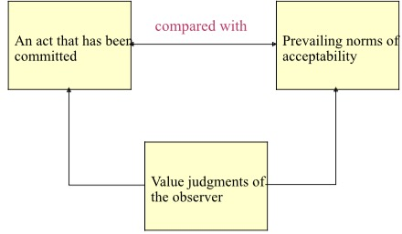

- Making Ethical Judgements: Deciding what is Ethical
- Ethical dilemmas:
- Situations where a decision must be made between two equally valid but mutually exclusive courses of action
- What approaches exist to help make defensible ethical decisions:
- Otto Bremer: Four Questions
- Josephson: Bell, Book, Candle
- Nash
- Pagano
- Integrated Ethical Decision Model

- Otto Bremer: 4 Ethics Questions
- What is (descriptive ethics)?
- What is actually going on in an ethical sense (what is the real situation)
- What ought to be (normative ethics)?
- What managers should doo
- How do we get from What Is to What Ought to Be?
- How is the gap closed? May actually not be able to fully close the gap!
- What is our Motivation?
- What is the motive for being ethical?

- Josephson’s “Bell, Book, Candle” Approach
- Three tests:
- “Listen for the bells warning you of an ethical decision (the ‘bell’);
- Check to see if there are any laws, regulations or rules which restrict your choices (the ‘book’); and
- How will your decision look in the light – could a reasonable, fair-minded person conclude you acted improperly? (The candle).”

- Nash: Some Plainly Worded Questions
- Have you defined the problem accurately?
- How would you define the problem if you stood on the other side of the fence?
- How did this situation occur in the first place?
- To whom and to what do you give your loyalty to as a person and as a member of the corporation?
- What is your intention in making this decision?
- How does this intention compare with the probable results?
- Whom could your decision or action injure?
- Can you discuss the problem with that affected parties before you make your decision?
- Are you confident that your position will be as valid over a long period of time as it seems now?
- Could you disclose without qualm your decision or action to your boss, your CEO, the Board of Directors, your family, society as a whole?
- What is the symbolic potential of your action if understood? If misunderstood?
- Under what conditions would you allow expectations would you allow exceptions to your stand?

- The Pagano Model
- Is it legal?
- The benefit cost test (the greatest good for the greatest number)
- The categorical imperative (Do you want this action to be a universal standard?)
- The light of day test (What If your actions appeared on TV?)
- Do unto others (Do you want the same to happen to you?)
- The ventilation test (Get a second opinion from someone with no investment in the outcome)

- An Integrated Ethical Decision Model
- What exactly is the decision?
- Is the decision a matter of ethics?
- *Does the decision involve doing what is right, just and fair? Does the decision cause the decision-maker to reflect on personal morals, values, duties, goals, norms and beliefs. If YES, then this decision is a matter of ethics
- Precisely articulate the decision(s) to be made.
- Decisions and “decision outcomes”: Decision X, Decision Y, Decision Z
- Who are the key stakeholders impacted by this decision?
- Do you believe the decision is right, just and fair for the majority of key stakeholders?

Deontological Test:  Is the decision consistent with my ideals for behaviour, the behaviour others have a right to expect of me, and my sense of duty? | Teleological Test:  Does the decision produce the best outcome for the greatest number, or the worse outcome for the fewest number?

- Importance of Business Ethics:
- Business ethics helps business understand how to deal with:
- The uneasiness of many public stakeholders with the growing power and influence of business in society
- Providing significant contributions to society
- Mitigate business malpractices with the potential to inflict harm on individuals, communities, and the environment
- Increasingly complex demands to be ethical
- Formalizing business ethics, given that few business people receive formal ethics training our education
- Ethical violations that continue to occur in business, across countries
- How to assess the benefits and problems associated with different ways of managing ethics in organizations
- Issues that transcend the traditional framework

- Ethical Perspectives and Challenges:
- Ethical decisions make good business sense but can be complicated by:
- Globalization –managers from diverse cultures and backgrounds doing business in different geographic locations governed by different laws and customs.
- Accountabilities –In 2008 Greece’s GDP was about the same as Wal-Mart’s revenues (US$ 4 billion): but the stakeholders affected by Wal-Mart decisions have comparatively little influence on the company compared to shareholders
- Technology –internet technology for sales, research, distributions, promotion: what type of information is being collected and for what purpose?

Lecture 8: Business’s Influence on Government
- Business-Government Relations
- The prevailing view that business and government rarely agree and that each is of the view the other “doesn’t get it”
- Business-Government Relations: Understanding one another
- Does business understand government?
- Does government understand business?
- Recall: unique characteristics of government:
Multiplicity of goals, difficulty in measuring performance, need to address difficult problems, multiple accountabilities, public visibility, many stakeholders, complexity

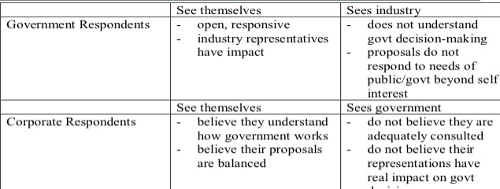

How can this difference be explained?
Some models:
- Jane Jacobs
- W.T. Stanbury

- Business-Government Relations: Paradigms
- Jane Jacobs
- The “guardian value syndrome”: vs. the “commercial value syndrome”
- Government as the “guardian”
-Collectivist -Public Interest -Risk averse
- Business as the “commercial”
- Individualist -Private Interest

Jane Jacob’s Two “Syndromes”
The “Guardian (Gov’t) | The “Commercial” (Industry)
- Authority and rules  - Stunning of trade and coercion  - Power as given  - Public interest  - Tradition  - Protectors  - Willing to take vengeance  - Risk averse | - Voluntary agreements  - Collaboration and exchange  - Power as contested  - Private interest  - Innovation  - Investors  - Work ethic  - Risk-takers

- W.T. Stanbury
- Factors affecting government:
- Size of government’s majority
- Regional distribution of seats in the legislature
- Actions of other governments
- Prevailing extent of government intervention instruments
- Behaviour of the media
- Legal and constitutional allocation of powers between different levels of government
- Action of opposition parties
- Public opinions, attitudes and perceptions
Stanbury’s framework:
- Two worlds –Business and Government
- Consistent with Jacobs
- Different variables/Processes/Factors
- Policy evolves along different trajectories
- FYI look at exogenous &endogenous factors
- They clash in the “Policy Arena”
- Business “lobbying” Government
- Government “regulating” business
- Portrait of business facing off against government, strategizing within environmental constraints to shape outcomes according to their preferences and priorities
- Each sector always attempting to protect and further its own interests –confrontational model

- Business-Government Relations” The Result?
- Business is different from government
- Business and government are influenced by different factors
- Public policy results from a series of processes and influences
- Expecting each segment to fully understand the other is perhaps ambitious (but reasonable to expect each segment to BETTER understand each other)

- Business-Government Relations:
- Notwithstanding business-government “differences” today senior managers of major corporations generally believe the worse possible strategy is to take positions that would be perceived by the public as unresponsive to social interests
- Social interests, of course, are represented by government
- Senior executives spend considerable time in four external areas:
- Meetings with elected officials
- Dialoguing with regulatory personnel
- Maintaining relations with the corporations various constituents (stakeholders)

- Functions of a Government Relations Department
- Legislative monitoring and analysis
- Regulatory agency liaison and response
- International legislative monitoring and analysis
- Domestic and international market development assistance
- Trade association liaison
- Political analysis and response
- Government information services
- Relations with think tanks and public interest groups

- Business dealing with government –fundamental errors:
- Dealing only with the politicians
- Approaching the government at the wrong time
- Providing tome-like reports to politicians
- Wading in on an issue too late
- Assuming influence is directly proportional to company size
- Using an unprepared, disorganized, and uncoordinated approach
- Reacting to government on an issue-by-issue basis

- Lobbying: What exactly is lobbying?
- “An activity, directed at decision makers, carried out on behalf of special interests to influence public policy outcomes?”
- “A communicational with public officials to influence their decisions in a manner harmonious with the interests of the individual or group communicating”

- The “Ask”
-Procurement ($13 billion per year on goods and services)
- Freebies (grants & contributions)
- Policy (most common and most complicated)
- The “Ask” policy
- Policy concerns the “rules” that frame and influence the business environment
- Joe Jordon: 4 types of rules
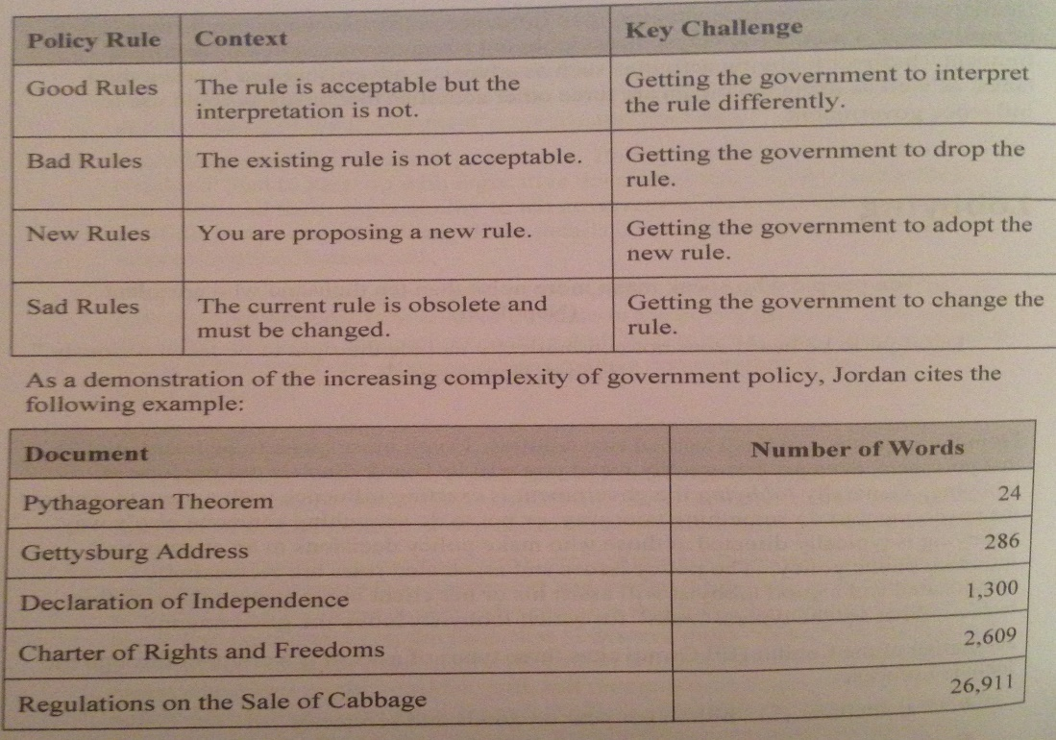
- The Lobbying Act
- On December 12, 2006 the Federal Accountability Act received Royal Assent
- Among the changes that this act makes to Federal statutes are several relating to the Lobbyists Registration Act (LRA), which is currently in force
- Lobbying Defined in the Act
- The Act now states that lobbying will consist of: “any oral or written communication made to a public office holder”

- Types of Lobbyists
- Consultant lobbyists: consultants who are paid to lobby on behalf of clients
- They may be:
- Consultants in public relations or in marketing
- Lawyers, notaries, engineers or accountants whose functions include lobbying
- In-house lobbyists (corporations) and in-house lobbyists (organizations): These are salaried employees of either corporations or organizations who lobby on behalf of their employer

- Business dealing with government –lobbying
- There are approx. 7,483 registered lobbyists in Canada of which 5, 322 are active

- Types of Issues: Strategic vs. Operational Issues
Strategic | Operational
-Involve public resolution or broad policy directions  -Resolution from the top  -Must incorporate public opinion  -Legislative involvement  -Typically | - More technical  - May be resolved without public stand  - Bottom up decisions  - Regulatory or bureaucratic decisions  - Typically reactive

What do lobbyists do?
- Be informed of emerging legislation that could affect their clients or organization
- Be knowledgeable of the position of key players of the issue
- Be credible with good contacts
- Understand the issue from several perspectives
- Understand the public policy process
- Prepare the client to lobby – not lobby for the client

- Business dealing with government – Direct vs. Indirect
Direct | Indirect
- Formal and informal meetings  - Submission of briefs and policy papers  - Appearances before parliamentary committees  - Telephone calls  - Written mail  - E-mail, petitions, alliance and coalition building  - Organization of protests | - Advocacy advertising  - Funding think tanks

- Advocacy Advertising: A Special Type of Lobbying Effort
-Advocacy advertising – any kind of paid public communication or message, from an identified source and in a conventional medium of public advertising, which represents information or a point of view bearing on a publicly recognized controversial issue.
- Designed to sell ideas, not products or services
- Aimed directly at policy makers or at some segment of public opinion
- Ultimate objective is to influence public opinion and public policy on an item that is of importance to the advertiser
- Five KEY targets:
- KEY stakeholders
- Politicians and public servant advisors
- Media influences
- Influential intellectual leaders
- Politically aware persons with influence

- Think-Tanks – An Indirect Lobbying technique
- An organization or group of experts researching and advising on issues of society, science, technology, industry or business: Academic, Contract, Advocacy, Approx. 46 Canadian Think-Tanks
- Importance is increasing:
- Policy issues are increasingly complex and require a full knowledge contribution from all stakeholders
- Present networking opportunities for business and government

- The lobbying strategy
- Frame the issue (strategic, operational, both?)
- Position the issue in the sector (important only to your firm or other firms in your sector?)
- Whom to lobby? (politicians, bureaucrats, or both?)
- Which lobbying approach? (direct, indirect?)
- How long? (Timing is key –how long will your lobbying effort last?)
- Resources? (people, organizations/collaborators, money)
- Contingency plan (what is plan B in the event of a sudden change in policy direction, Minister, Bureaucrats?)

- Business’s influence on civil society
- Funding
- Encouraging employee participation
- Knowledge transfer
- Network opportunities

Lecture 9: Government’s Influence

- Government’s Influence on Business
- Regulation
- Market failure
- Social
- Political
- Non-regulatory forms of influence
- Industrial policy

- Regulation
- The imposition of constraints, backed by the authority of government, that are intended to modify economic behaviour in the private sector significantly (Economic Council of Canada)
- According to the Cabinet Directive on Streamlining Regulation, 2007, p.1, in regulating the federal government seeks to:
- Protect and advance the public interest
- Promote a fair and competitive market economy
- Make decisions based on hard evidence and the best available knowledge
- Create regulation that is accessible, understandable and responsive
- Advance the efficiency and effectiveness of regulation
- Require timeliness, policy coherence, and minimal duplication

- Market Failure: Responding to Natural Monopoly Conditions
- Monopoly – a market controlled by one supplier
- Considered natural when the economies associated with large scale production make it inefficient for more than one firm to operate
- If unregulated production can be restricted and prices increase
Market Failure: Use of natural Resources
- A common resource needs to be used sensibly
- Where many producers draw from a common pool – the fisheries for example –no single producer will have an economic incentive to conserve
Market Failure: Externalities
- Spillover effects –costs imposed on other people e.g. pollution
- In the absence of regulations compelling the polluter to minimize spillover effects, they would have little incentive to do this on their own
Market Failure: Inadequate Information
- Insufficient information with which to make informed decisions in the marketplace
- Free availability of product safety information –companies have little incentive to do this on their own
Market Failure: Public Goods
- Public Goods: goods that generate social benefit that everyone can enjoy and that no one can be deprived of
- Examples: clean air, national defense
- Government provides these services to all Canadians (funded through tax dollars)
Market Failure: Moral Hazard
- A party insulated from risk may behave differently than if exposed to the full risk
- In the context of economic regulation…

- Social Regulation
- Focuses on firm’s impacts on people as employees, consumers, and citizens
- Addressing business practices in all industries
- Examples – employment equity, regulations, occupation health and safety regulation
Regulation for Political Reasons
- For votes but also:
- To appear as a leader in a matter of public policy (Kyoto)
- In response to pressure from interest groups
- In response to pressure from the media
Non-regulatory forms of government influence on business: government ownership
- Crown corporations typically provide a service or product that the private sector would be unwilling or unable to provide
- Export Develop Corporation
- Canada post
- Canadian wheat board
Other Corporate Interests | Description | Number in 2013
Mixed Enterprises | Corporate entities with shared ownership split between the Government of Canada and private sector | 0
Joint Enterprises | Corporate entities with shared ownership split between the Government of Canada and another level of government | 2
International Organizations | Corporate entities created pursuant to international agreements in which the Government of Canada either owns shares or has the right to appoint members to the governing body | 15
Shared Governance Corporations | Corporate entities without share capital in which the Government of Canada has the right to appoint members to the governing body and includes airport and port authorities | 75+
Corporations under the terms of the Bankruptcy and Insolvency Act | These corporations are partially owned by the Government of Canada following receipt by a bankruptcy trustee | 45

Non-Regulatory Forms of government influence on business: government subsidies
- Either the direct transfer of cash to a recipient or the indirect transfer of benefits
- Either increase the supply of a product or the demand for the product or service –the resulting market prices affect competition
- $19 billion in subsidies to business in 2004

Non-Regulatory forms of government influence on business: tax policy
- Encourage investment in some activities, but not others
- Deductibility of business operating expenses
- Capital cost allowance policy
- Tax credit policy
Non-Regulatory forms of government influence on business: government procurement
- Government is a major purchaser of goods of services
- $13 billion annually
- Changes in procurement policy can significantly affect business
Non-Regulatory forms of government influence on business: International trade
- Negotiation of international tariff laws
- Non-tariff barrier elimination
- Strong proponent for Canadian business abroad

- Industrial Strategy
- Any attempt by government to apply a coherent and consistent set of policies that are designed to improve the performance of the economy:
- Framework policies
- Concentration-based strategies
- Intervention

- Government’s influence on civil society
- direct funding
- Tax policy
- Contracts
- Knowledge transfer
- Alternative service delivery mechanisms

Lecture 10: Civil Society’s Influence

- Civil’s Society’s Three Main Objectives
- To inspire
- To inform
- To persuade

- Drivers of the Importance of Civil Society
- Increasingly culturally diverse Canadian population introducing new demands that fall outside the purview of government or business (to improve)
- Information Communications Technology enables civil society to being instantaneous attention to its causes and issues (to inspire, to inform)
- Complexity of civil society issues (to improve, to inform)

- Changes in the relationships between and the not-for-profit segment
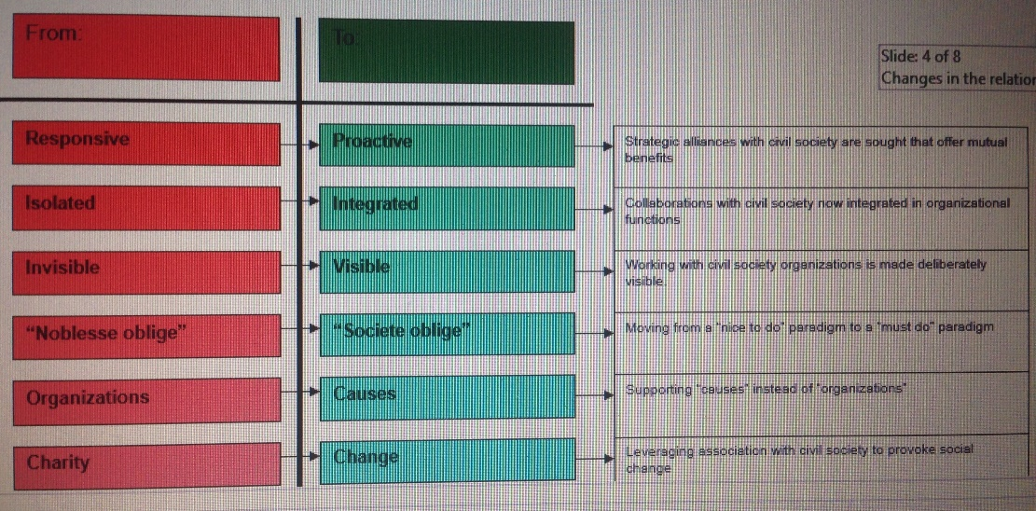

- Civil Society’s Supportive Influence
- Neutral broker between government and business
- Supplier of knowledge and skills (knowledge transfer)
- Source of workers
- Intimate knowledge of community (closer to stakeholders)
- Citizen engagement venue
- Social capital provider
- Building image and buffering media
- Alternative service delivery methods and new models of community engagement
- Cause-related marketing venue
- Awareness building
- Public policy test environment
- Distributor of information
- Point of entry for citizens to engage in policy debates

