The Direct Comparison Approach
- Do time adjustments first THEN all other adjustments based on the new time adjusted figure
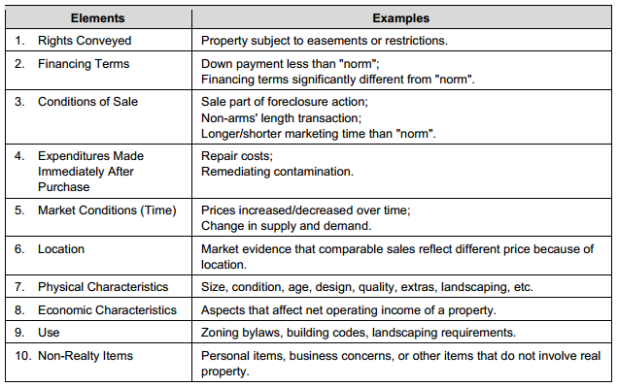
*** Order matters for 1 -5 *** Order does not matter for 6-10

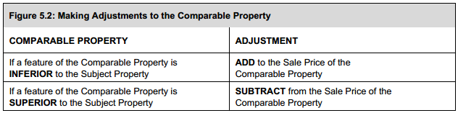

- Adjustments are made to make the comparables equal to the subject (subject is the benchmark property)
- Object is to narrow the range of the comparable prices
- After all the adjustments to the comparables, they should indicate a reasonable range of value for the subject

Reconciliation
- Summarize in a sentence or two your adjustments for each comparable. Why and how.
- Finally, write a reconciliation indicating which comparable(s) best indicates an estimated value for the subject (DO NOT ESTIMATE)

FINAL Reconciliation
- Once both approaches are complete write a full reconciliation indicating why the Cost or Direct Comparison Approach, best indicates a value for the subject
- If they two approaches are too far apart in value then both approaches are suspect. They must support each other

