Student Name: __________ _Stephen Beange___ _____ ________

Student Number: _________ 8303819_ __________________ ___

Partner’s Name: ______ lbn Umar Elijak 8221925 _______

Demonstrator's Name: _____ Joel M. Kolle__ ___________________

Lab Day: Friday Feburary 12th 2:30-5:30

Lab Week: 1

Laboratory Report Form

Experiment 3: Extraction

Procedure: As stated in “CHM Organic Chemistry Laboratory” lab manual.

Table of reagents:
Compound | Mol. Wt (g/mol) | Amount
Benzophenone | 182.2 | 0.57 g
Benzoic acid | 106.54 | 0.57 g
dichloromethane | 84.93 | 10 mL
2 M NaOH | 39.99 | 10 mL
HCl | 36.46

Observation, Results and Discussion:

Part A:
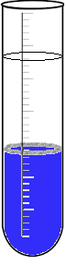
-After shaking 2 mL of ether, 2 mL of distilled water and 1 drop of a 0.006 M methylene blue solution in a test tube, there was a clear colourless layer on top and a blue layer on the bottom (as shown in diagram to the right). Ether is less-dense and immiscible in water, therefore it rose to the top and created the organic layer, where the water sank to the bottom. The methylene blue solution was only present in the bottom layer. This means that 0.006 M methylene blue solution dye is aqueous.

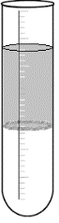
-After shaking 2 mL of ether, 2 mL of distilled water and 1 drop of a 0.006 M methyl red solution in a test tube, there was a clear colourless layer on the bottom and a cloudy layer on top (as shown in diagram to the right). Ether is less-dense and immiscible in water, therefore it rose to the top, and water sank to the bottom; creating the top organic layer and the bottom aqueous layer. The 0.006 M methyl red solution was only present in the top layer, which means that the dye is organic.

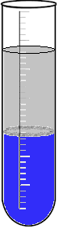
-When mixing the solutions of methylene blue, and methyl red there was a clear distinction of the bottom and the top layer present in the test tube. The bottom layer was the blue colour of the 0.006 M methylene blue and the top layer was the cloudy white colour of the 0.006 M methyl red (as shown in diagram to the right). This means that the extraction between ether and water would be a good way to separate the mixture, because each solution completely separates between the organic (top) and aqueous phases (bottom).

Salting out effect
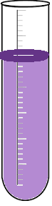
-After shaking the first test tube (5mL of distilled water, 1 drop of 0.003 M aqueous crystal violet and 0.5 mL of 1-butanol) and letting the contents settle, the solution stayed purple throughout, with a slight amount of darker-purple at the top.
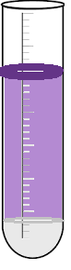
- After shaking the second test tube with the added NaCl (5mL of distilled water, 1 drop of 0.003 M aqueous crystal violet and 0.5 mL of 1-butanol) the solution had a small cloudy-white layer on the bottom, a purple layer in the middle, then a small, dark purple layer on the top. Over time the clear layer slowly became bigger, where the purple layer became smaller. The dark purple layer at the top became larger as-well.

Adding the NaCl to the second test tube caused a salting out effect. This effect increased the ionic strength of the water and “pushed” the organic compound out of the aqueous layer. The presence of Cl in the NaCl causes the organic layer to be denser than the aqueous layer, therefore the aqueous layer went to the top of the solution and the bottom became the organic layer. You can see this happening with the separation of purple (5mL of distilled water, 1 drop if 0.003 M aqueous crystal violet) on top and the cloudy-white solution on the bottom.

Part B:
-We obtained 0.57 g of unknown #1
-After every 5 seconds of shaking we stopped and opened the stopcock to release the pressure. We stopped shaking when there was no more pressure being released (40 seconds in total).
-After the layers separated, the top layer was a slightly cloudy solution (organic phase) and the bottom layer was a clear colourless solution (aqueous phase), with a clear distinction between the two phases.
-Our area did not have a 125 mL Erlenmeyer flask so we used a bigger 250 mL flask for the organic phase.
-82 drops of HCl was added to the aqueous phase after the two extractions with 2 M NaOH. This created a cloudy white precipitate.

The resultant weight of the powder (after drying the solid product by suction filtration) was 0.03g. Our percent yield of the experiment was (0.03g/0.57g)x100= 5.26 %. This means that from our 0.57 g sample we extract 5.26%, and got 0.03g of Benzophenone.

We added dichloromethane to the 0.03 g of benzophenone (unknown) until completely dissolved. We then put the unknown on TLC slides along with the organic layer, aqueous layer, Benzophenone and biphenyl.

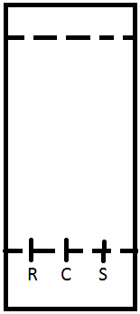
Solvent System: (C- Co-spot) Solvent System: (C- Co-spot)
2:8 mixture of ethyl acetate 2:8 mixture of ethyl acetate
(EtOAc) and hexanes (EtOAc) and hexanes

Unknown: Unknown:
(R-Reference) (R-Reference)
R_{f} = 0.689 R_{f} = 0.614

Organic Layer: Aqueous Layer:
(S-Sample) (S-Sample)
R_{f} = 0.689 R_{f} = 0.591

R_{f} = Distance from start to middle of dot
Distance from start to end of solution on TLC slide

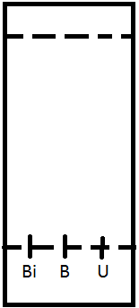
Solvent System:
2:8 mixture of ethyl acetate
(EtOAc) and hexanes

Biphenyl (Bi):
R_{f} = 0.88

Benzophenone (B):
R_{f} = 0.627
Unknown (U):
R_{f} = 0.627

The results from the first two TLC slides show us that the unknown is close to the same polarity as both the organic layer and the aqueous layer, but closer to the organic layer. The last TLC with Bipheyl, Benzophenone and the unknown tells us what our unknown is. The polarity is the same as the Benzophenone, this shows us that the unknown we were given was the mixture of benzophenone and benzoic acid.

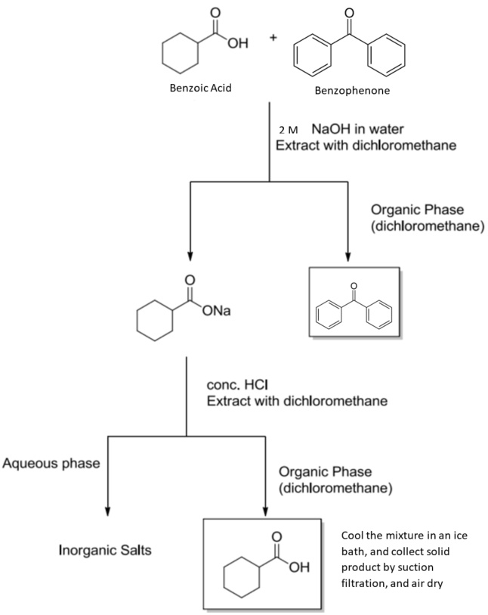
Pour the organic phase back into the separatory funnel and extract twice more with 2 M NaOH. Combine the basic aqueous phases. (not drawn because it all becomes this, just added in later.)

Errors:
For each of our separations, some of the organic phase could have been added to our aqueous phase flask. Some of our aqueous phase spilled, which could have led to a greater change in percent yield. Adding too much HCl to our aqueous phase could have caused NaCl to precipitate out, again changing our percent yield.

Questions:
- It would be hard to perform an extraction using ethanol and water because ethanol is miscible in water. This means that the ethanol and water would mix together and there would be no clear separation between the two solutions.

- Adding NaCl to a mixture of methylene blue, water and ether would decrease the amount of dye in the aqueous layer. The salting out effect would increase the ionic strength of the water, and would “push” the organic compound (methylene blue) into the organic layer.

- K_{D} = [A]_{solvent 1}
[A]_{solvent 2}
= [2.0g/100mL] _{water}
[20.0g/100mL] _{Ether}
= 0.1

K_{D} = W_{eight 1}/ V_{olume 1}
W_{eight 2}/ V_{olume 2}
= 1.8g / 100 mL water
Y g / 100 mL ether
0.1 = 1.8g / 100 mL water
Y g / 100 mL ether
Y = 1.8/0.1
Y = 18 g
18 grams of compound Y would be extracted with the ether

- From question 3) K_{D}= 0.1
K_{D} = W_{eight 1}/ V_{olume 1}
W_{eight 2}/ V_{olume 2}
0.1 = 1.8g / 100 mL water
Y g / 50 mL ether
Y = 1.8
2(0.1)
Y = 9 g
9 grams of Compound Y would be extracted after the first extraction.

K_{D} = [A]_{solvent 1}
[A]_{solvent 2}
= [2.0g/100mL] _{water}
[9 g/ 50mL] _{Ether}
= 1/9

1/9 = 1.8g / 100 mL water
Y g / 50 mL ether
Y = 1.8x9
2
Y = 8.1 g

The second extraction would extract 8.1 g of compound Y.

- To determine which layer is the aqueous phase, the student could add a few drops of water to the mixture. The phase that the water mixes with is the aqueous phase.

- To separate the mixture, either benzyl amine, or naphthalene would have to be water soluble. We can accomplish this by doing a reactive separation. Adding an acid (like H₂SO₄) to the mixture will produce a charged species that is soluble in the aqueous phase. The charged materials will be soluble in water, whereas the neutral (naphthalene) compound will remain in the organic solvent. Charged organic materials can then be recovered from water by adding a base to regenerate the neutral organic form.



