Last class review:
- Seismometer
- Determining distance to epicenter
- Determining location of earthquake
- Richter scale
- Controls on P-and S-wave velocity
- Evidence for seismic discontinuities (Lehmann, Gutenberg, Moho)
- Composition of mantle
- Composition of core
The Earth’s Interior & Plate Tectonics
How is energy transmitted from inside the Earth?
- Slow transmission
  - Conduction (through solid by molecular vibrations)
- Fast transmission
  - Convection (energy transmitted by density driven fluid motion set up by temperature gradient)
The mantle transmits S-waves (it’s a solid)-last lecture review
Mantle is actively convecting (it’s also a fluid)
- Substances that share both solid like and fluid like properties, such as the mantle and glaciers, are said to be viscoelastic (visco->all fluids have viscosity (resistance to flow); elastic->solids have the ability to rebound elastically when deformed)
What proof exists that mantle flows like a fluid?
- Raised beaches (old beach higher than younger beach)
- Vertical motion of Earth’s surface
  - Post glacial rebound proves the mantle flow like a fluid. From the rate of rebound, the viscosity of the mantle can be calculated.
How do we know that the mantle convects? Could heat not escape simply by conduction (a fluid that flows does not necessarily need to thermally convect)
- The mantle must be thermally convecting because it has a very high Rayleigh number
  - Studies of thermal convection in the lab have established a parameter, the Rayleigh number (Ra), that indicated whether or not convection will occur in a fluid that is being heated from below
  - Convection occurs when Ra >2000
  - Ra=(variables that promote convection)/(variables that hinder convection)
  - 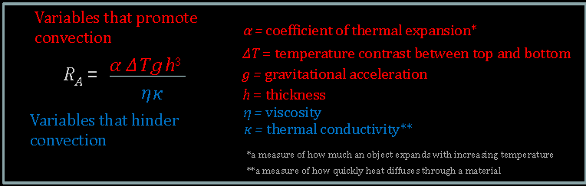
  - When approximate values of these variables are plugged in for the mantle, Ra comes out somewhere close to 1 million (the mantle must therefore be convecting)
  - Despite its high viscosity (which hinders flow and thus convection), the mantle must convect because:
    - It is very thick (large h…harder for heat to diffuse away…helps maintain that requisite density imbalance)
    - It is very poor at conducting hear (low k…helps maintain that requisite density imbalance)
    - The temperature contrast between its bottom and top is substantial (helps maintain the requisite density imbalance)
- What do convection cells look like? Does mantle convection drive plate tectonics?
  - Some problems with a thermal convection driven model of plate tectonics
    - Plate vary in size, so regular sized convection cells not possible
    - Convection cells in mantle should be stable long term features, but spreading ridges move rapidly over Earth’s surface (in places at rates approaching the spreading rates themselves), indicating they are superficial features
    - Some plates surrounded by ridges; no subduction zones that could correspond to down welling limb of convection cell
    - Spreading ridges can be subducted
  - Solution
    - Plate tectonics (and mantle convection) is likely driven in part by the plates themselves
      - Gravity acting on the hot, elevated spreading ridge pushes the lithospheric plate outward (ridge push), whereas gravity acting on the cold, dense, dewatering, subducting lithospheric plate pulls the rest of the plate downward into the mantle (slab pull) like a tablecloth sliding off the table. These processes must generate convection in the mantle (although the mantle would convect irrespective given the high Rayleigh number)
      - 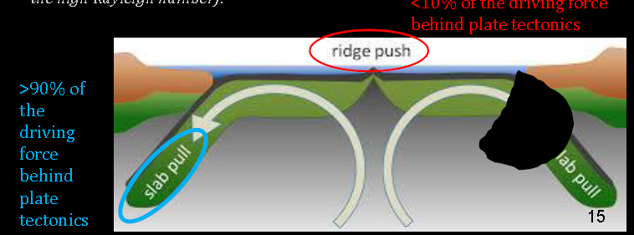
      - Seismic data suggest the slabs travel deep down into the mantle possibly even reaching the core-mantle boundary (CMB)
      - 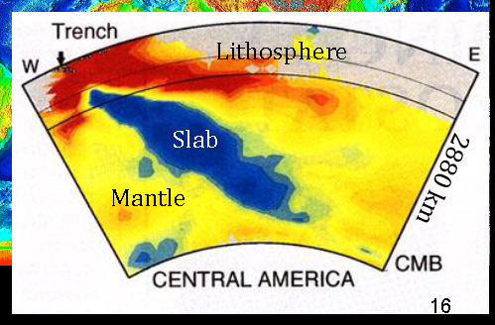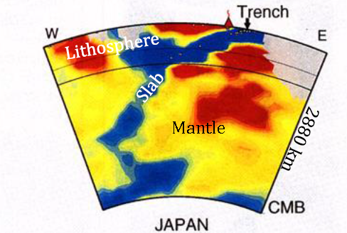
      - Earthquakes only occur in within the crust or upper mantle (i.e. the lithosphere—brittle failure (faulting) possible), not in the mantle beneath (no faulting or brittle failure – deforms like a viscous fluid)
        - Benioff zone: Planar zone of seismicity associated with down-going slab at subduction zone.
        - 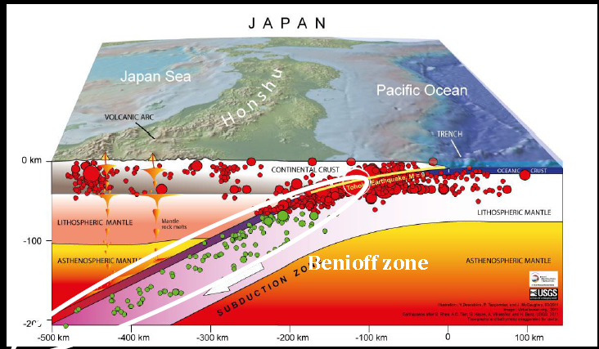
        - 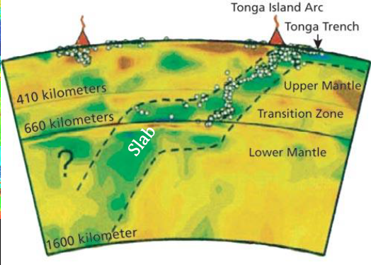
      - Is there any evidence of mantle convection independent of plate tectonics?
        - Hotspots in intraplate locations are manifestations of mantle convection independent of plate tectonics (the hotspot stays stationary, the lithosphere moves overtop)

Grand Tour
Three types of boundaries
- Divergent
- Transform
- Convergent
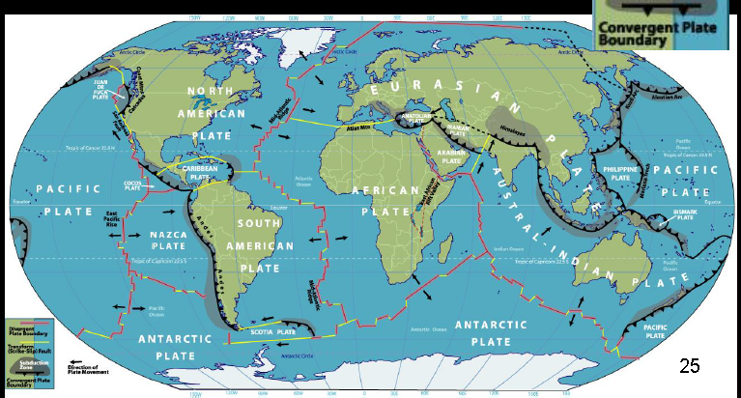
Divergent Boundaries
- Extension (e.g. normal faults); crucial thinning; rifting of continental crust; eventually mafic volcanism (oceanic crust generated along spreading ridge)
Transform Boundaries
- Plate slide horizontally past one another (strike-slip motion); no thinning or extension of crust; lithosphere not created or destroyed; limited to no volcanism
Convergent Boundaries
- Oceanic-oceanic
  - Older plate subducts under younger one; brings water with it (in sediments and hydrous materials), which acts as a flux (flux melting) that lowers the melting point of the slab, sediments and overlying mantle, mafic to intermediate magmas are produced, generating a volcanic island arc
  - Water, flux melting and subduction zone magmas
    - Water acts as a flux to depress the melting point of mantle (in addition to the subducting sediments and slab) by hundreds of degrees. Water is therefore the key to understanding magma production and volcanism in subduction zones. It tends to instigate partial melting of the mantle and sediments (and in some cases, the cold (and thus hard to melt) slab itself), leading to a mixed bog of magmas that can vary in composition from mafic and intermediate (volcanic island arcs and continental arcs) to felsic (continental arcs)
- Oceanic-continental
  - Oceanic lithosphere subducts under continental lithosphere; brings water with it (in sediment and hydrous minerals), which acts as a flux (flux melting) that lowers the melting point of the slab, sediments and overlying mantle; mafic to felsic magmas produced (the felsic magmas likely reflect crustal contamination), generating a continental arc (a chain of volcanic mountains along the edge of the continent)
  - 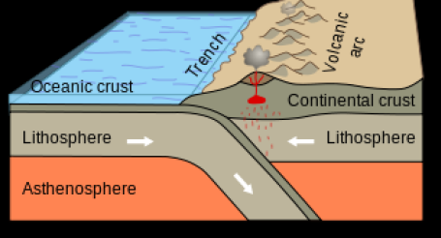
- Continental-continental
  - Neither plate subducts completely (too buoyant); no volatiles being delivered to depth --> no volcanism. Significant crustal thickening occurs (intense folding and thrust faulting). Shallow earthquake activity only (no subduction, no Benioff zone)
  - 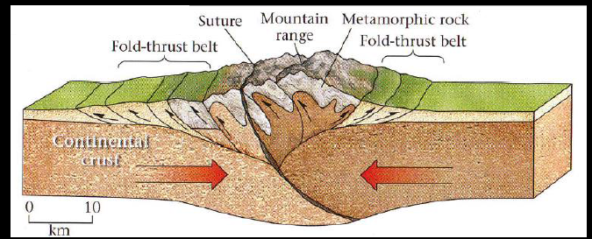
Hotspots
Seamounts
- Older, extinct volcanoes generated at spreading ridges or hotspots
- Flat topped seamounts are termed guyots
  - Likely formed by levelling of volcanoes that once reached the sea surface, but that have since subsided (thermal subsidence)
Hotspots commonly have big heads, narrow tails
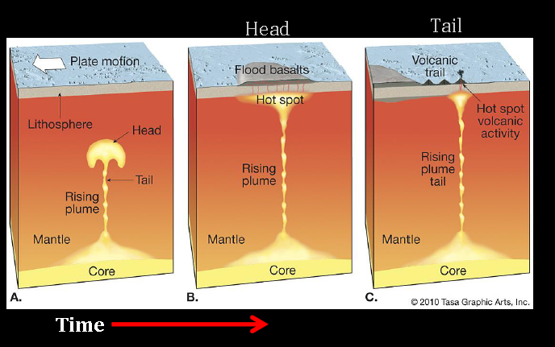

\

Pacific and Atlantic Margins
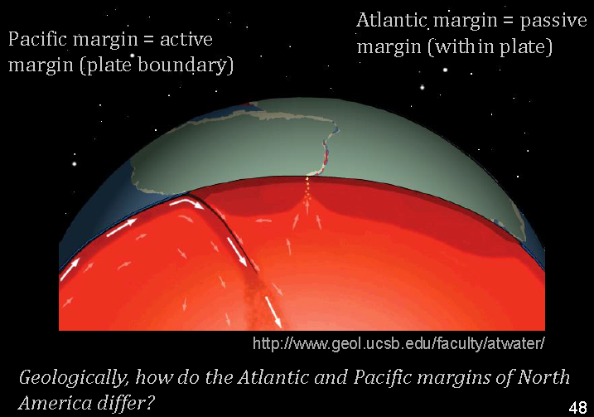
- Pacific margin
  - Active margin (convergent plate boundary)
  - Subduction
  - Lots of earthquakes
  - Volcanoes
- Atlantic margin
  - Passive margin (within plate – not a plate boundary)
  - Oceanic lithosphere stuck onto continental lithosphere
  - Aseismic zone
  - No volcanoes

