Lab #1
Thin Layer Chromatography
NAME
Lab Partner: NAME
January 12, 2016

Introduction:
In order to examine the components of an unknown sample, a technique known as thin layer chromatography (TLC) is often used. TLC is often performed by spotting (placing small amounts) the unknown sample (S) and the reference solution (R) into separate lanes on a TLC plate covered by a thin layer of silica gel – which is highly polar. When the TLC plate is developed in a solvent system, the components of R and S begin to travel up the TLC plate due to capillary action. Due to differences in the polarity of different components in R and S, the more polar components tend to adhere to the silica on the TLC plate, while non polar components tend to travel further up the TLC plate along with the solvent system. For this reason, non-polar components in R and S have a greater Rf value – which is a ratio of how far the component travelled up the TLC plate in comparison with the solvent system. By comparing Rf values of components in R and S, one may be able to determine the identity of the unknown sample.

Procedure:
As described in the lab manual (CHM 1321 Organic Chemistry Laboratory, Dr. Rashmi
Venkateswaran, 2016, Exp. 1, p. 16-18)
Modifications:
Omit bromobenzene from step 2 in part C.

Observations:

Part A: Identifying the components of an unknown mixture using TLC
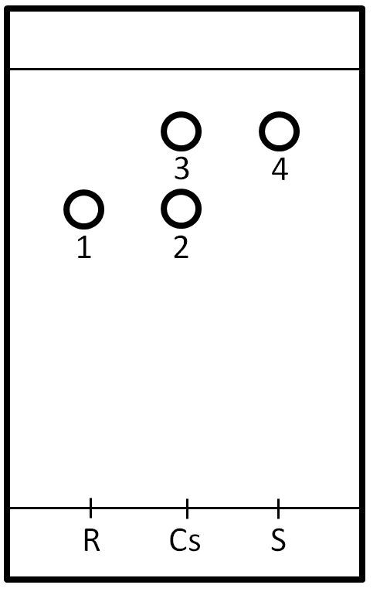
Solvent system:
Ethyl acetate: hexane 2:8
R: Benzophenone
Cs: Co spot
S: Sample 94
Rf values:
1 and 2: 0.70
3 and 4: 0.84
Diagram 1: TLC – A1

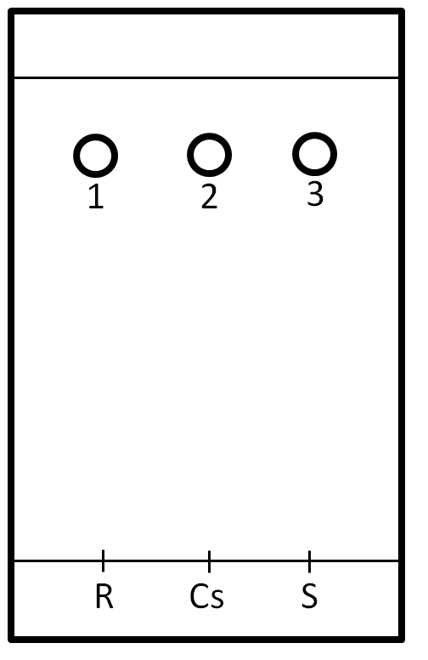
Solvent system:
Ethyl acetate: hexane 2:8
R: Biphenyl
Cs: Co spot
S: Sample 94
Rf values:
1, 2 and 3: 0.92

Diagram 2: TLC – A2

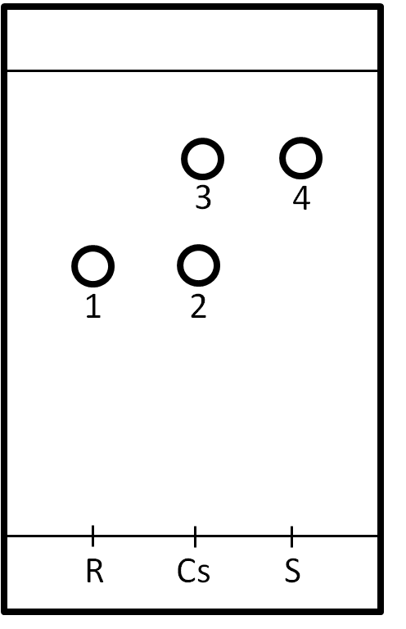
Part B: Effect of solvent on TLC.
Solvent system:
Hexane
R: Benzophenone
Cs: Co spot
S: Sample 94
Rf values:
1: 0.41
2: 0.40
3 and 4: 0.69
Diagram 3: TLC – B1

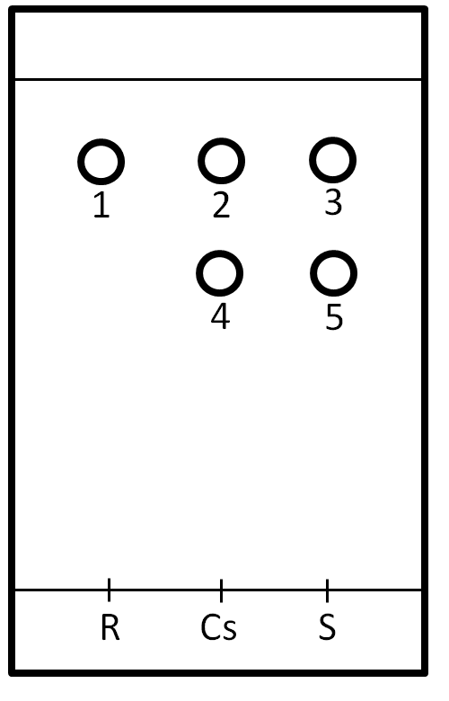
Solvent system:
Hexane

R: Biphenyl
Cs: Co spot
S: Sample 94
Rf values:
1, 2 and 3: 0.84
4 and 5: 0.62

Diagram 4: TLC – B2

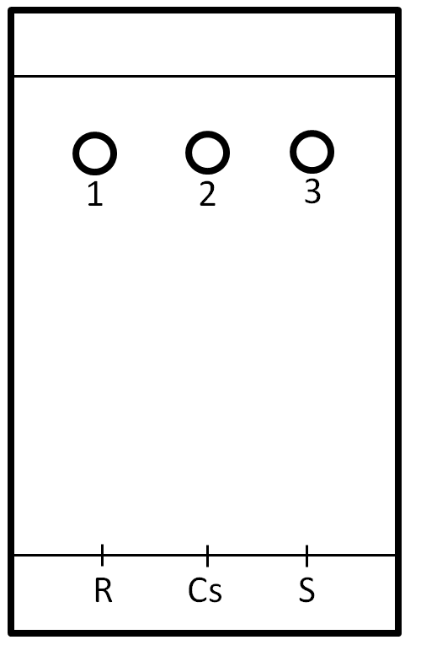
Rf values:
1, 2 and 3: 0.86
R: Benzophenone
Cs: Co spot
S: Sample 94
Solvent system:
EtOAc

Diagram 5: TLC – B3

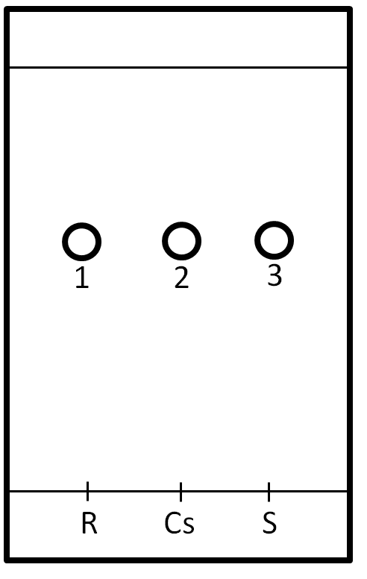
Solvent system:
EtOAc
Diagram 6: TLC – B4

Rf values:
1, 2 and 3: 0.57

R: Biphenyl
Cs: Co spot
S: Sample 94

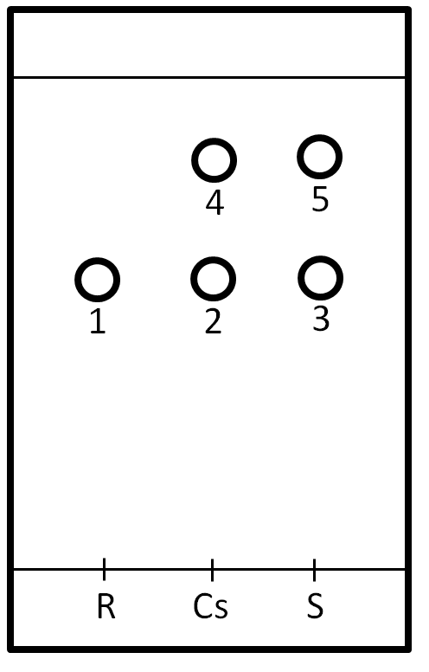
Part C: Ratio of compounds
Solvent system:
Hexane: EtOAc 9:1
R: o- Bromonitrobenzene
Cs: Co spot
S: Sample XX
Rf values:
1, 2 and 3: 0.38
4 and 5: 0.56

Diagram 7: TLC – C1

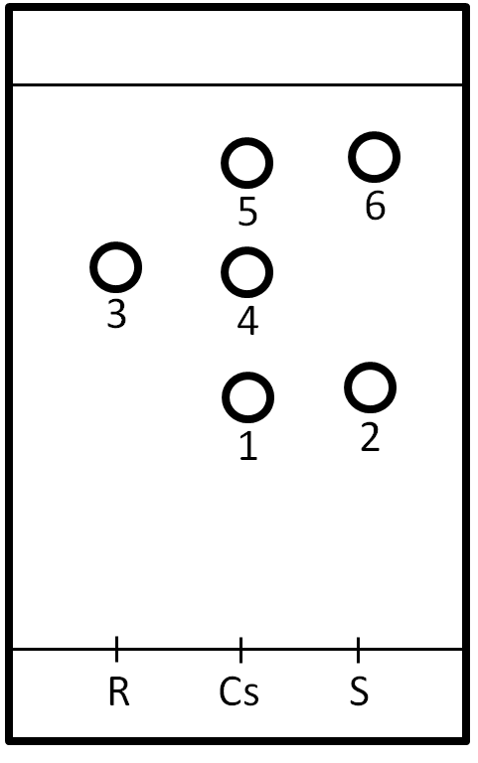
Solvent system:
Hexane: EtOAc 9:1

Rf values:
1: 0.33
2: 0.39
3: 0.57
4: 0.49
5: 0.67
6: 0.73

R: m- Bromonitrobenzene
Cs: Co spot
S: Sample XX

Diagram 8: TLC – C2

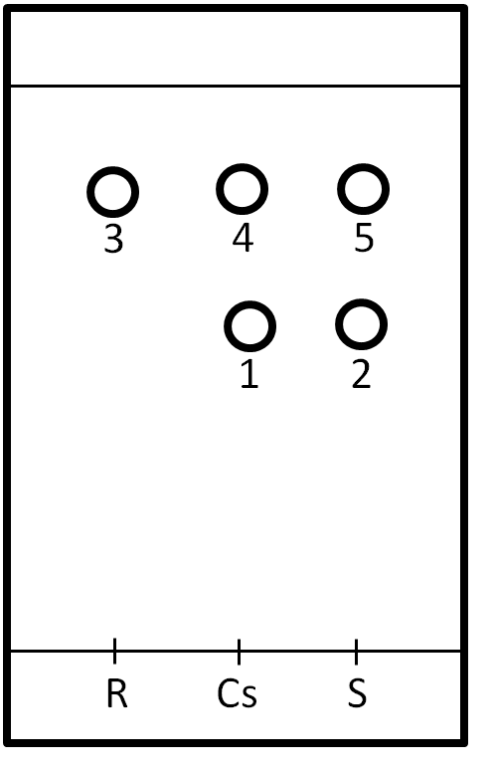
Solvent system:
Hexane: EtOAc 9:1
Diagram 9: TLC – C3

Rf values:
1 and 2: 0.43
3 and 5: 0.65
4: 0.63

R: p- Bromonitrobenzene
Cs: Co spot
S: Sample XX

Calculations for part C:

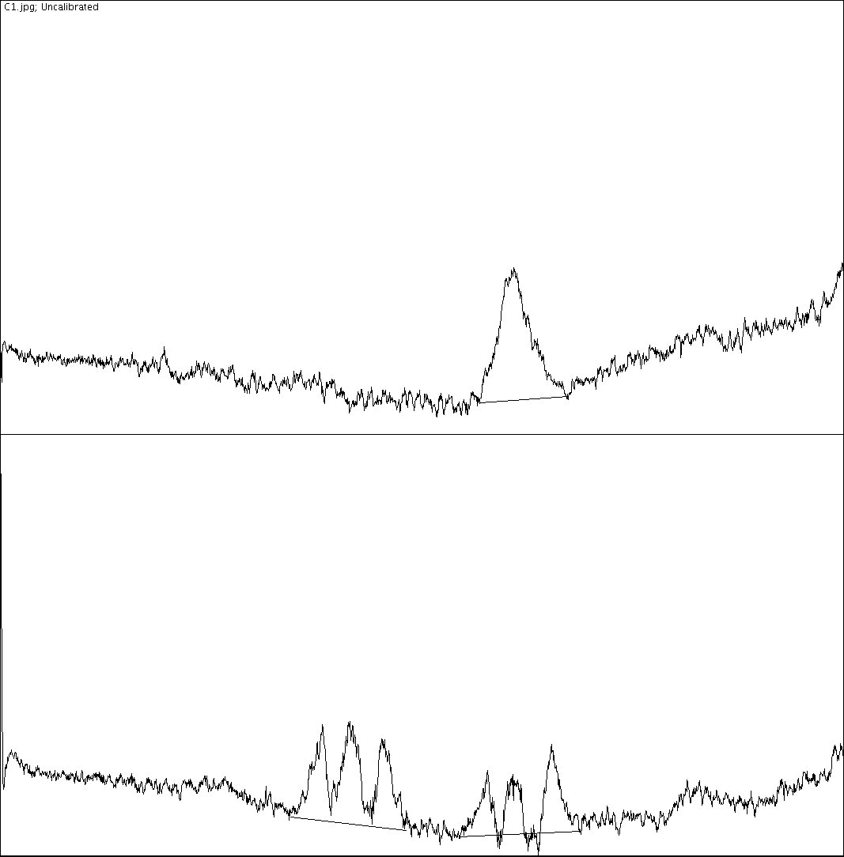

Figure 2: Comparing sample XX to m-bromonitrobenzene

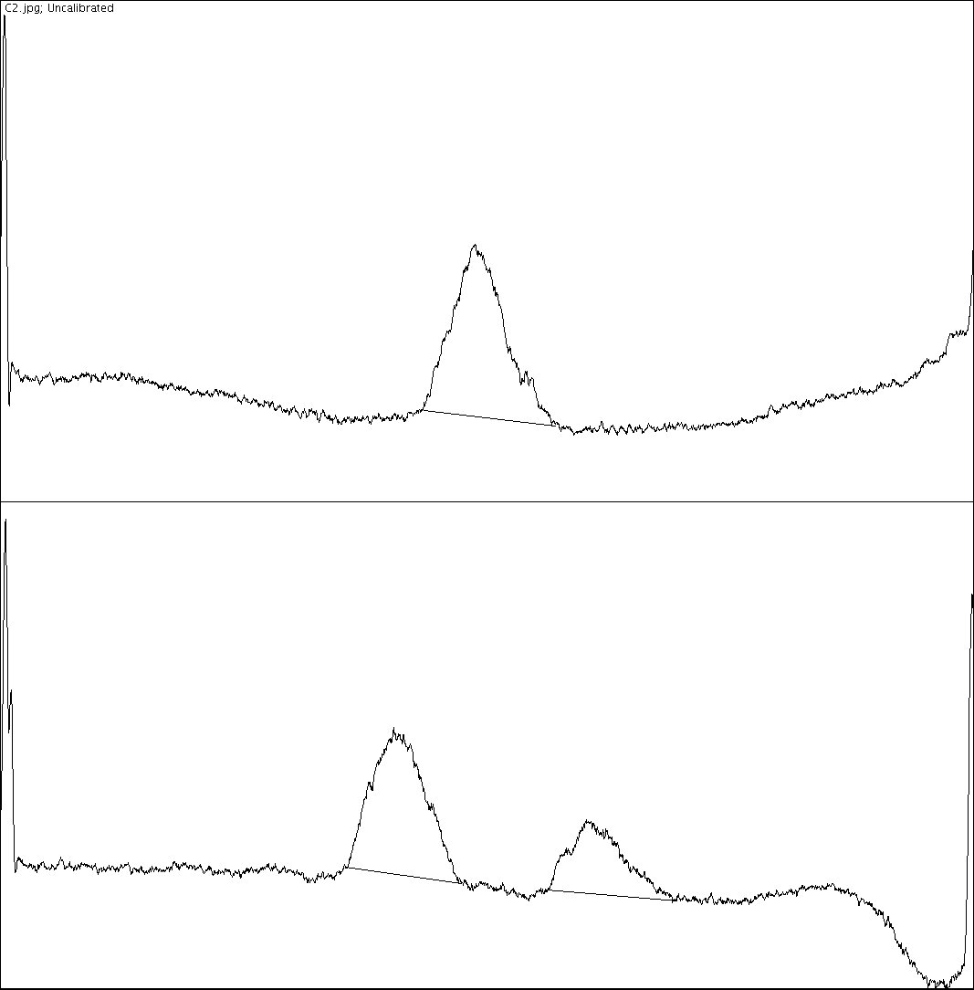
Figure 2: Comparing sample XX to m-bromonitrobenzene

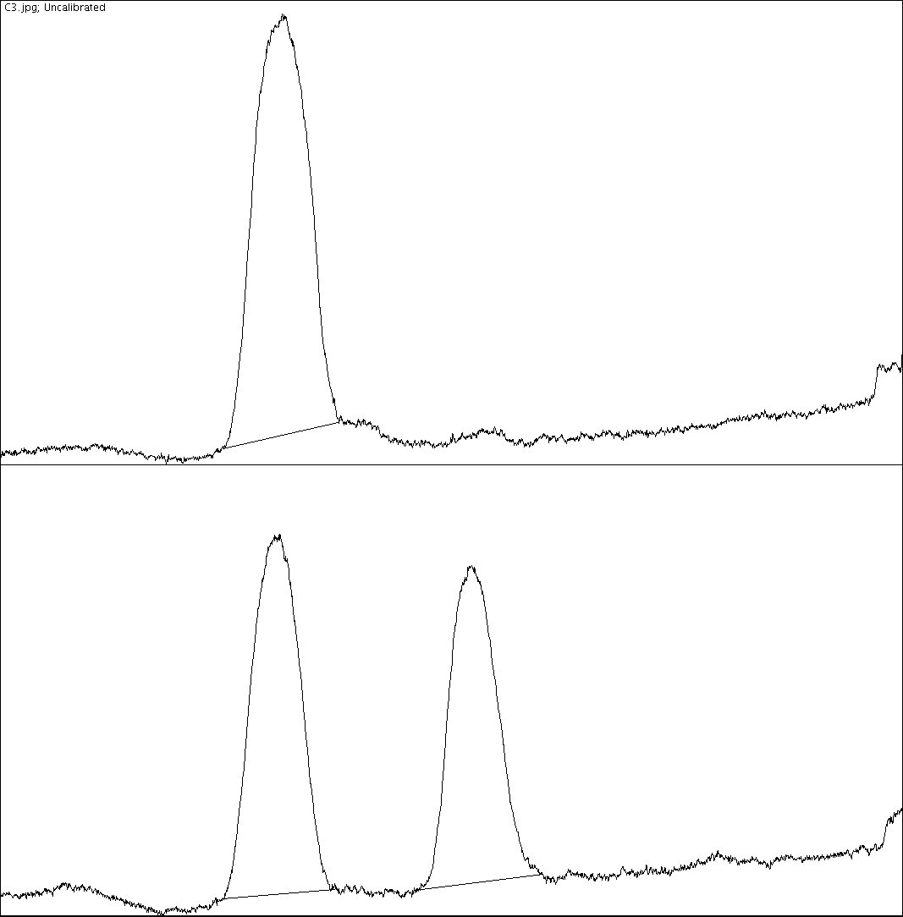
Figure 3: Comparing sample XX to p-bromonitrobenzene

 | Area of peak 1 | Area of peak 2 | Area of peak 3
o- bromonitrobenzene | 7916.439 | 8121.794 | 5019.924
m- bromonitrobenzene | 12160.309 | 10737.167 | 5369.823
p- bromonitrobenzene | 37007.673 | 27965.459 | 24098.016

Determining peak % of o- bromonitrobenzene:

% peak 2 = peak 2/(peak 2 + peak 3) x 100%
= 8122/(8122 + 5020) x 100%
= 62 %

% peak 3 = peak 3/(peak 2 + peak 3) x 100%
= 5020/(8122 + 5020) x 100%
= 38 %

Determining peak % of m- bromonitrobenzene:

% peak 2 = peak 2/(peak 2 + peak 3) x 100%
= 10737/(10737 + 5370) x 100%
= 66.7 %

% peak 3 = peak 3/(peak 2 + peak 3) x 100%
= 5370/(10737 + 5370) x 100%
= 33.3 %

Determining peak % of p- bromonitrobenzene:

% peak 2 = peak 2/(peak 2 + peak 3) x 100%
= 27965/(27965 + 24098) x 100%
= 53.7 %

% peak 3 = peak 3/(peak 2 + peak 3) x 100%
= 24098/(27965 + 24098) x 100%
= 46.29 %

Average % composition of ortho- bromonitrobenzene = (46.29% +38%)/2 = 42.145%
Average % composition of para- bromonitrobenzene = (53.7% + 62 %)/2 = 57.85%
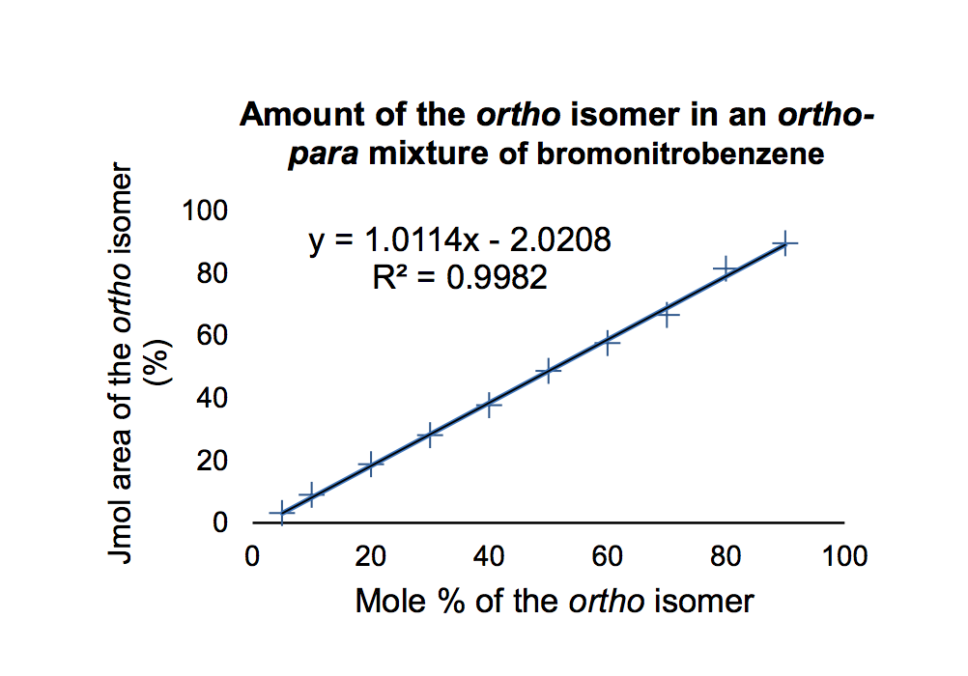

Y = 1.0114x – 2.0208
42.145 = 1.0114x – 2.0208
x= 44.2 Jmol % of ortho- bromonitrobenzene

Jmol % of para- bromonitrobenzene = 100 – 44.2 = 55.8 %

Discussion:
- Non-polar components of a solution are not as attracted to the polar silica gel and therefore travel further along with the solvent system and have a greater Rf value
- Polar solvent systems travel up the TLC plate more quickly and might not be very effective at separating the components of a solution
- Inaccuracies in determining the Rf values might be due to inaccuracies of determining the center of the circle.
  - A large dot/circle is due to spotting an excessive amount of solution
Part A:
Benzophenone is more polar than biphenyl, therefore it did not travel up the TlC plate as biphenyl. As a result, benzophenone has a small Rf value (0.70) than that of biphenyl (0.92). Using ethyl acetate and hexane in a 2:8 ratio as the solvent system was ideal since it included the right polarity and non polarity gradient. As a result, components of R and S were separated well in A1. The Rf values in A2 of biphenyl and sample 94 are the same (0.92). This proves that the identity of sample 94 is biphenyl.

In part B:
It is quite evident that the polarity of the solvent system had a great impact on the results of the TLC. In TLC plates were hexane was used, the components of R and S were separated well. This is evident through the differences of the Rf values. The use of EtAOc as a solvent system, however, was not very effective since the components of R and S were not separated at all. As a result, the Rf of the dots are equal among the solutions. This happens because the polarity of EtAOc is too high and therefore “drags” the components along with it, rather than separating them. Hexane on the other hand, is non-polar and therefore travelled up the TLC plate at a slower rate and was able to separate the components of the solution.
Since biphenyl is less polar than benzophenone, biphenyl is expected to have a higher Rf value in a similar solvent system. This, however, is not the case in B3 and B4. As a result, it is hypothesised that a mix up occurred between these two TLC plates

In part C:
Through comparison of Rf values (equal Rf values), it is clear that sample XX is a combination of o- Bromonitrobenzene and p- Bromonitrobenzene. Moreover, further analysis of the TLC plates using Jimage determined the exact composition of sample XX

Questions:
- How does increasing the polarity of the solvent system affect the results of a TLC?

As the polarity of the solvent system increases, the components in the solutions move faster. The solvent system will reach the solvent front in a shorter period. If the polarity of the solvent system is higher than ideal, the separation is not very effective. Therefore, the Rf values tend to be greater and very close in value between the components.

- In the following sets of compounds, which would have the smallest RF on silica gel?
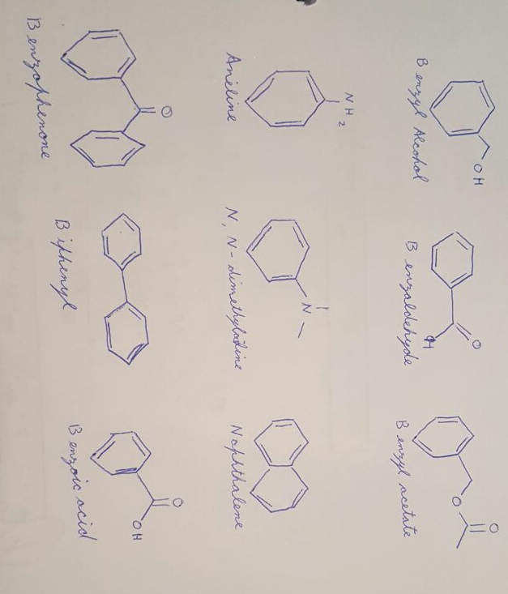
Draw line structures of each compound

- Benzyl alcohol, benzaldehyde, benzyl acetate

Benzyl alcohol will have the smallest Rf value since it is the most polar. Its polarity is caused by the hydroxyl group

- Aniline, N,N-dimethylaniline, naphthalene

Aniline, being the most polar due to its amine group, will have the smallest Rf value

- Benzophenone, Biphenyl, Benzoic acid

Benzoic acid, being the most polar due to the carboxylic group, will have the smallest Rf value

Conclusion:
Therefore, in part A, the identity of sample 94 is biphenyl. In part B, it was clear that less polar solvent systems are more effective at separating components of a solution than polar solvent system. In part C, it was determined that sample XX has a molar composition of 44.2% ortho- bromonitrobenzene and 55.8% para- bromonitrobenzene.

Raw data:


