Lab 09 Submission Template
Name: Salman Saghir
Student Number: 040842418

Task 2: (3 marks)
Task2-RouterScrn.jpg

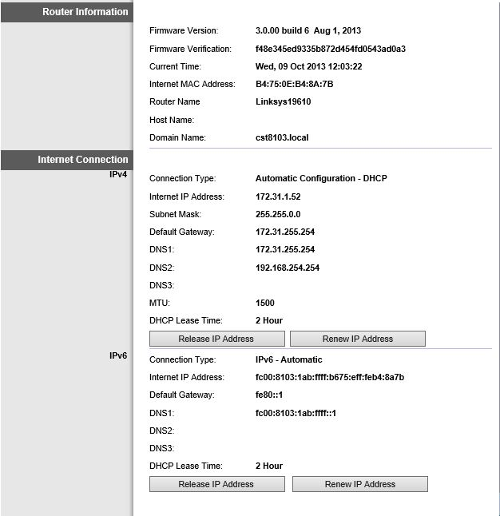
Task2-LocalNetScrn.jpg
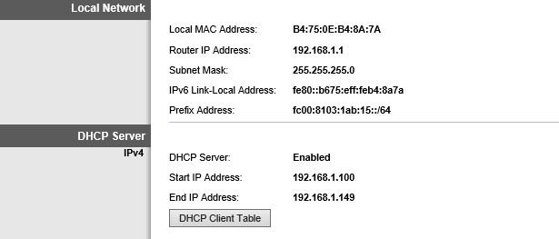
Task2ConfigScrn.
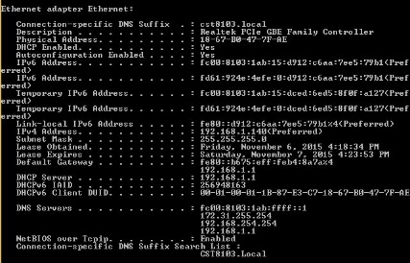

Task 3:
Task3RouterPageScrn.jpg
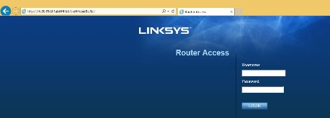

Task 4: Questions (9 Marks)
- We learned that there are 3 ways in which a device can get an IPv6 address. Which method was used by your PC to get its IPv6 address? (1 Mark)
SLAAC only
SLAAC and DHCPv6

DHCPv6 only

- What type(s) of IPv6 address(es) does your laptop have ( look only at the IP address lines not DHCP,DNS etc) (2 marks with (right – wrong))
Link-Local
Global Unicast
Multicast
Unique Local
- What type of addresses is your PC using for its DNS servers (IPV6 only)? (1 mark)
Ipv6 and ipv4

- IPv6 does not use ARP. (1 mark)
In task 3 step 2 you pinged your router's Internet address. Locate any packets that performed the IPv6 equivalent to ARP. Note: You may find some that originated from the router asking for your PCs MAC. Take a screen capture of those packets and upload it (as a jpg only). Details must be shown for the first of the two packets
Sample (not the correct frames but shows detail required)
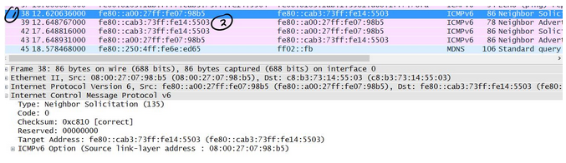
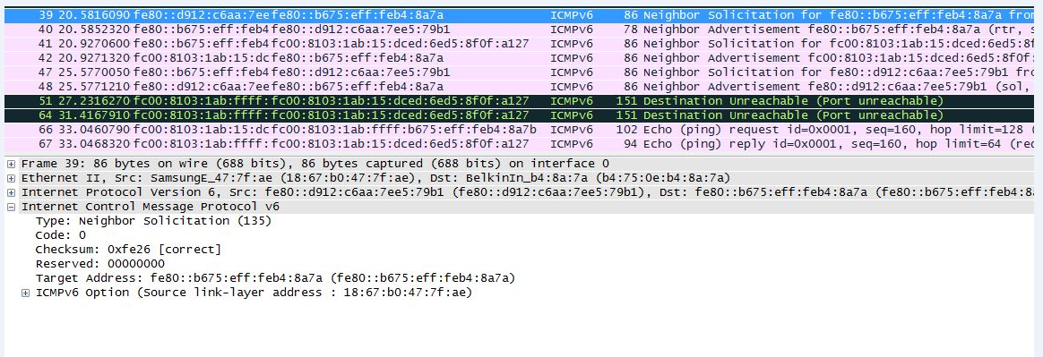
- In Task 3 step 3 you pinged your router's DNS server. This server is a Cisco router. Cisco routers use a default IPv6 Hop limit of 64 (TTL). Examine the ICMPv6 Echo reply. How many routers did this reply pass through before reaching your PC? (1 mark)
94

- In IPv4 tracert uses ICMP and TTLs to find intermediate routers. Examine your capture from Task 3 step 4 and explain how IPv6 does tracert. Include a screen capture proving your explanation, using highlighting to show what you mean (2 Marks)

Paste screen capture here
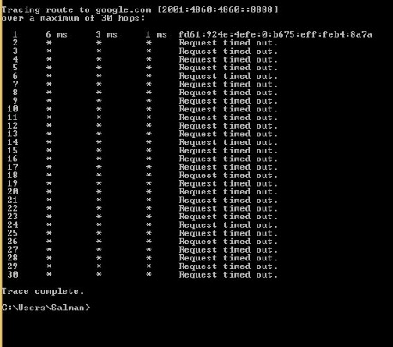

Write your explanation
Click here to enter text.

Click here to enter text.
5. In Task 3 Step 5 you opened a web page on your Router's DNS server. Locate the packet containing the HTTP GET request for this page. Upload the a screen capture of this packet (in jpg format only) (1 mark)
Sample (not the correct packet)


