ADM 1340 C Financial Accounting Exam Review
Chapters 8,9,10,11,12,13
7-10 Friday December 12th-Sports Complex Room One

Chapter 8-Reporting and Analyzing Receivables

Types of Receivables: amounts due to a business from it’s customer or other entities expected to be collected in cash.
Frequently classified as:
-AR: amounts owed by customer due to the sale of goods and services
-Notes receivables: formal credit instrument (written promise to pay)
-Other Receivables: Interest receivables, loans and advances to employees, recoverable sales taxes, income tax receivables

Accounts Receivables: recorded when service is provided on account or at point of sale. Receivable is reduced when cash is collected, sales discount is taken or the merchandise is returned by the customer.
Non-bank Credit card Receivables: Bank credit card and debit card transactions recorded as cash. Non bank company credit cards recorded as A/R (collections usually outsource and sent to a credit card company for re-imbursement)

A/R- Subsidiary ledger-Group of accounts that share a common characteristic (i.e they are all receivable accounts). S.L for A/R provides the details that support the total balance for A/R in the general ledger.-->Single A/R accounts in the general ledger is the control account.

Interest Revenue-If a customer does not pay in full within a specific period of time (usually 30 days), an interest charge may be added to the balance due. Seller receives interest revenue and increases A/R balance owed by the customer.

Recording Estimated Uncollectible Accounts-Some A/Rs become uncollectible. Losses from these uncollectible accounts are debited to an account called bad debt expense This is recognized in the same period that the related sales revenue is generated.
Allowances Method-This method estimates the uncollected accounts at the end of each period. The amount estimated is shown in the allowance for doubtful accountscontra asset account that is shown below the A/R.
-Allowance is an estimate-it does not show specific customer accounts.
Estimating the Allowance: Most companies use the percentage of receivables basis to determine the allowance.
- Estimate what percentage of receivables are likely to be uncollectible.
- Apply this percentage to total receivables, OR
- Apply the percentage to receivable classified according to the length of time they have been outstanding (Called aging the A/R)
Once the appropriate estimate for uncollectible accounts is determined, an adjusting entry can be recorded. The amount of the adjusting entry is the difference between the required balance and the ecisting balance in the allowance account.
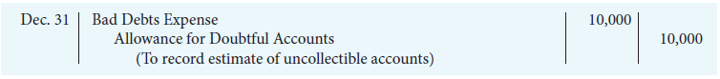
The balance for allowance for doubtful accounts is deducted from accounts receivable in current assets section.
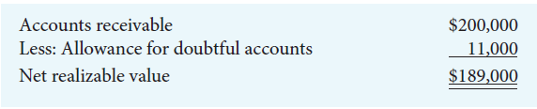
Recording the Write-Off of an Uncollectible Account
VP of finance authorized a write-off of 2,500$ owed by T.Ebett:
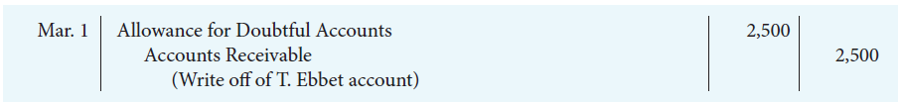
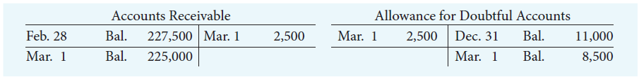
Recovery of an Uncollectible Account Record in Two separate entries:
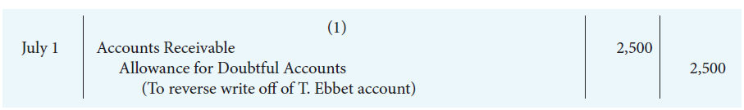
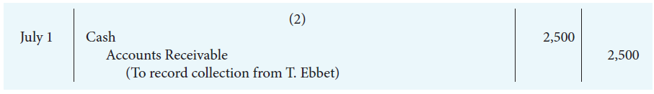

Summary of Allowance Method
1.Recording estimated uncollectible accounts:
any increase to the allowances is recorded as bad debt expenses
2.Recording the write-off of an uncollectible account
Actual accounts are written off when they are determined to be uncollectible
Write off reduces the allowance
3.Recording the recovery of an uncollectible account
If a written off account is collected later, write off is reversed and the collection is recorded.
Notes Receivable-Stronger legal claim to asset then A/R; written as promise (promissory note) to repay. A credit instrument that normally: (1)requires the payment of interest. (2)extends the time period greater than 30 days.
Often accepted from: customers who need to extend payment of an A/R. These customers are high-risk.

Formula for Calculated Interest: Basic formula for calculating interest on an interest bearing note:
Time in terms of one year
Annual interest Rate
Interest
Face Value of Note
Interest rate specified on the note is an annual rate of interest

Derecognizing Notes Receivables
Honored: Paid in full @ maturity date, collection recorded
Dishonored: Not paid @ maturity date; note no longer negotiable. Balance transferred to A/R, an eventual collection expected. Balance transferred to allowance for doubtful note if collection not expected
Statement Presentation:
Statement of Financial Position: Record reported in current assets section, - -Following cash and short-term investments
-Only required to disclose net realizable value, but helpful to disclose gross revenue and the allowance for doubtful accounts
Income Statement: Bad debt expense is reported as an operating expense.
-Interest revenue is non-operating.
Managing Receivables
-Determine to whom to extend credit
-Establish a payment period
-Monitor collections
-Prepare and update an A/R aging schedule
-Evaluate the liquidity of receivablesliquidity is measured by how quickly certain assets can be converted into cash (receivables turnover, average collection period)

Chapter 9: Reporting and Analyzing Long-lived Assets

Property, Plant and Equipment: Long lived resources that are controlled by a company. They have physical structure and are used in operation. They are not intended for sale to customers as they provide benefits over years.
Determining the Cost of PPE-Record at cost which includes:
-Purchase price, non-refunded taxes/duties
-Less discounts/rebates
-Expenditures necessary to bring asset to it’s intended location and make sure its ready for use.
Types of Expenditures
Operating Expenditure:
-Benefit only the current period, immediately charged as an expense.
Capital Expenditures:
-Capitalized as an asset, benefit future periods, increases a company’s investment in productive activity
Land
Cost of land includes: Purchase price, closing costs such as title and legal fees, additional costs to prepare land for it’s intended use (less any proceeds from salvage). Land has an unlimited life, therefore it is not depreciated
Land Improvements: The costs of structural additions made to land are considered improvements. These decline in service potential over time (recorded separately from land, depreciated over useful life. It is not one-time costs).
Buildings: All expenditures related to the purchase or construction of a building. When building purchased costs are:
-Purchase price, closing costs (legal fees), building permits, costs required to make building ready for it’s intended use
When building is constructed it’s costs are:
-Contract price, Architecture fees, building permits, excavation costs, and interest costs during construction.
Buy vs. Leasing:
Advantages of leasing: Reduce risk of obsolescence, 100% financing, income tax, “Off balance sheet” financing.
Lessor: Owner of asset for lease. Leasee: Part leasing asset
Operating Lease: Treated as rental by leasee, periodic payment (rent expense)
Financial Lease: Treated as purchase (asset and corresponding liability), periodic payment (decrease liability and charge interest expense)

Depreciation Methods
- Straight Line Method-Used by majority of Canadian Publicly traded companies.
- Diminishing Balance
- Units of Production
Management choose the method that best reflects the pattern of use of the economic benefits from that asset

EXAMPLE: Delivery Van was bought January 1st, 2015
Cost: $33,000
Estimated Residual Value: $3000
Estimated life: 5 years
Estimated Useful life in KMs: 100,000

Straight Line Method-Depreciation is constant for each year.
2 Equations: a. Cost – Residual Value =Depreciable Amount
b. Depreciable Amount/Useful life (in years)= Depreciation Expense
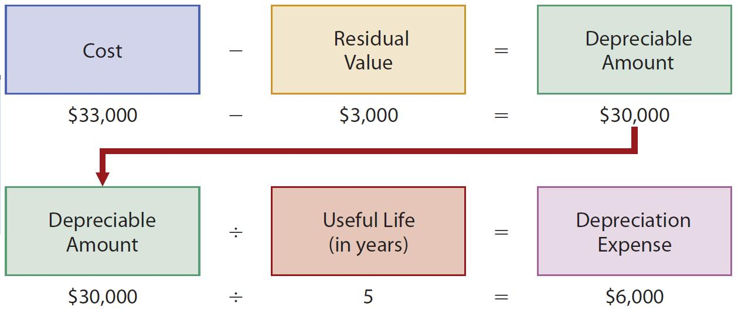
Diminishing Balance Method
Produces a decrease annual depreciation expense over useful life.
Depreciation is calculated based on the asset’s carrying amount, which diminishes each year as accumulated depreciation increases
Annual depreciation expense is calculated by multiplying carrying amount by depreciation rate
Residual Values is not included in calculated
Can be applied using different rates.
Depreciation rate=Straight line rate x multiplier
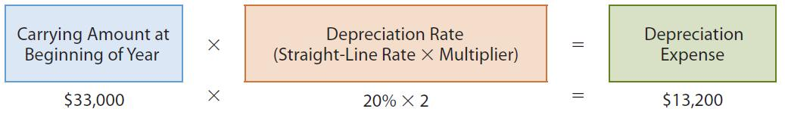

Units of Production Method
Useful life is expressed in terms of total units of production or activity expected from asset:
such as units and/or machine worked hours
Method useful for factory machinery, vehicles and airplanes
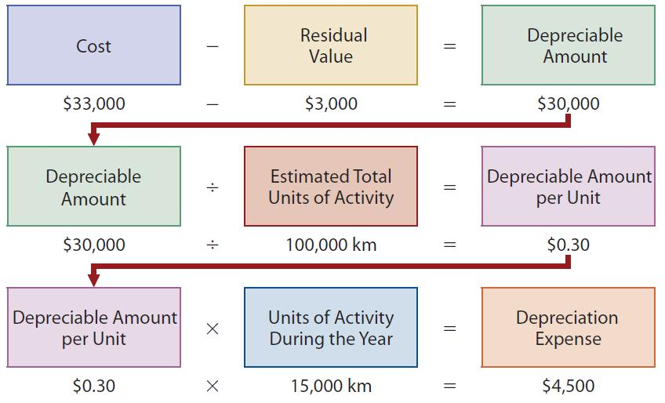

Other Depreciation Issues
Significant Components: May be appreciated separately
Income Tax
Impairments: This loss occurs when carrying amount of assets proceeds it’s recoverable amount

Revisions (Revising Periodic Depreciation) Needed If:
-Capital expenditures during useful life, impairment losses, change in estimated useful life or residual vale, change in patter in which the asset’s economic benefits are consumed
Accounting for a change in estimate: Change made in current and future years, but not in prior periods (prospectively)
Derecognition of Property, Plant and Equipment
- Update depreciation: depreciation for the fraction of the year to the date or disposal must be recorded
- Calculate Carrying Amount: Cost-Accumulated Depreciation
- Calculate Gain or Loss: Proceeds – carrying amount= Gain/Loss
- Record Disposal: Remove cost of asset and accumulated deprecation. Record proceeds (if any) and gain or loss on disposition

Cash xx
Acc. Dep xx
Asset xx
Gain on disposition xx
OR Loss on disposition xx
gain makes shareholders richer

Intangible Assets and Goodwill
These do not have physical substance. These could be considered rights, privileges, and/or competitive advantage (ex: intellectual property in a production process)
They must be identifiable-can be separated from company and sold; or based on contractual or legal rights.
Accounting for Intangible Assets: Accounting for I.As parallels accounting for tangible assetsrecording at cost including all costs to make asset ready for use. If IA has finite life, its cost must be systematically allocated over it’s useful life (amortization). IA that have an infinite life are not amortized.

Amortization for Intangibles
Amortize over shorter of: -estimated useful life or legal life
-Test for impairment
Intangibles with Finite Lives
-Patents: exclusive rights to produce for 20 years
-R+D costs: Research costs are expensed, development costs are capitalized only if associated with an identifiable , feasible product.
-Copyright: Protection for the life of the creator + 50 years
Intangibles with Indefinite Lives: Trademarks and Trade names, Franchises, Licenses
Goodwill: Asset representing future economic benefits arising from the purchase of a business. Excess of cost over fair market value of net assets required (A-L). Represents extra value relating to a business when it is purchased. Only identified with business as a whole. It is not amortized, but subject to an annual test for impairment.
Presentation Of a Long Lived Asset
Statement of Financial Position: Reported as PPT, Intangible assets, goodwill.
-Disclose cost and accumulated depreciation of each major class of assets.
-Disclose department/amortization methods and useful lives or rates.
Income Statement: Depreciation expenses, gains and losses on disposal and impairment losses are included in the operating section.
Statement of Cash Flows: Cash flows from purchase and sale of long lived-assets are reported in the investing section

Profit margin Revisited: together, profit margin and asset turnover explain the returns on assets ratio: profit margin x asset turnover = Return on Assets

Chapter 10: Reporting and Analyzing Liabilities

Liabilities: Obligations resulting from past transactions, classified as current and non current
Liabilities must be settles in the future by transfer of assets or services

Current Liabilities- expected to be paid:
-From existing current assets or through creation of other current liabilities.
-Within one year of the date on the Statement of Financial Position.
Debts that do not meet both criteria are classified as non-current (or long term) liabilities.
Typical Current Liabilities: Banks indebtness, accounts payable and accrued liabilities, unearned revenues, notes and loans payable, sales taxes and property taxes.
Operating Line of Credit: Pre-arranged between a company and a lender to allow the company to borrow up to an agreed upon amount: to help manage temporary cash shortfalls.
Interest is charged using a floating (or variable) interest rate. Security (collateral) may be required by bankwhen used results in bank indebtness.
Sales Taxes: Federal goods and Services Tax (GST), Provincial Sales Tax (PST or QST), Combined into one harmonized sales tax (HST in some provinces.
Sales Tax Payable: May or may not be included in sales price, must be remitted periodically to respective governmentswhen paid, debit sales tax payable account and credit cash.

Property Taxes
Business that own property pays property tax for each calendar year to municipal or provincial governments. Property taxes are calculated at a specified rate for every 100$ of the assessed value of the property.
Property tax payable: Upon receipt of the property tax bill (assume in March), an expense is recorded for the months that have passed (assume January and February)
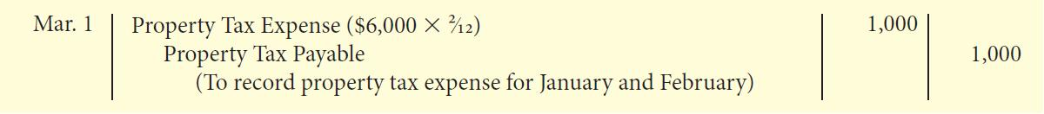
When paid (assume in May), expense is recorded for additional months that have passed and prepaid is set up for remaining months.
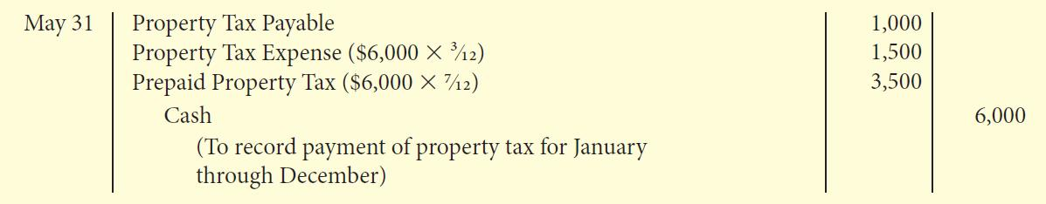

Prepaid is cleared to expense at the end of the year.
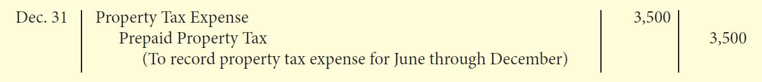
Payroll
3 types of reliabilities related to employee salaries and wages:
- Salaries and wages owed to employees (gross pay)
- Payroll deductions required to be withheld from gross paygross pay (less) payroll deductions is known as net pay or take home pay.
- Employer Payroll Obligations
Employee Payroll Deductions
Mandatory payroll deductions: Canada Pension Plan (CPP), Employment insurance (EI), Federal and Provincial Income Taxes
Voluntary Payroll Deductions: Benefits such as health and pensions, union, charitable contributions.
Employer Obligations
Employers share costs of CPP and EI, worker’s compensation, employee’s benfits (compensation packages/absences, employer sponsored health plans)

Short Term Notes Payables: This is considered a promise to pay a specified amount either at a future date or on demand. It is often used instead of A/P. It can provide written documentation, if needed, for legal remedies. It normally has interest attached and is issued for varying periodsdue within one year of Financial Statement date, they are classified as current liabilities.

Current Maturities of Non-Current Debt: Portion of long-term debt that is due within the current year or operating cycle should be classified as a current liabilities.
Uncertain Liabilities: Events with uncertain outcomes: who is owed, when is it owed. Provisions are uncertain as to timing or amount.
Contingent Liabilities are possible obligations that are dependent upon some future events.
Noncurrent Liabilities: Obligations to be paid after one year or longer. Also known as financial liabilities (type of financial instrument): contractual obligation to pay cash in the future. These include long-term notes, bonds and leases. May be secured or unsecured (example of secured: mortgage).
Installment Notes Payable: Normally repayable in a series of periodic payments called installments. Installment payments usually take one of two forms:
-Fixed principal payments plus interest (fixed or floating)
-Blended principles and interest payments

Installment Payment Schedule-Fixed Principle Payments
Loan is repayable in equal periodic amounts plus interst
Example: Assume Belanger Ltee. Borrows 120,000 for five years @ 7%.
-terms: monthly installment payments of 2000 (120,000/60 months)
Monthly Interest expense is calculated by multiplying outstanding balance by interst rate.
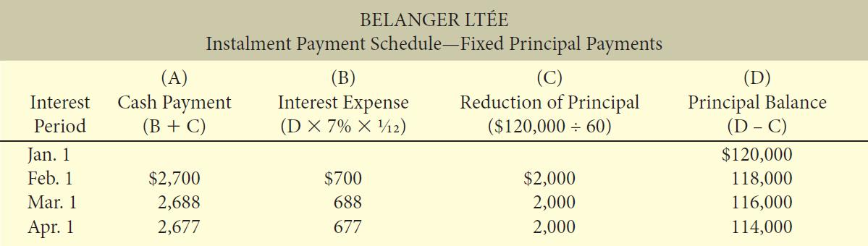

Installment Payment Schedule-Blended Payment
Loan is repayable in equal periodic amounts including interest.
Ex: Belanger repays $120000, 7% five year load in equal monthly installments of 2,376. Monthly interest expense is still calculated by multiplying outstanding principle balance by the interest rate.
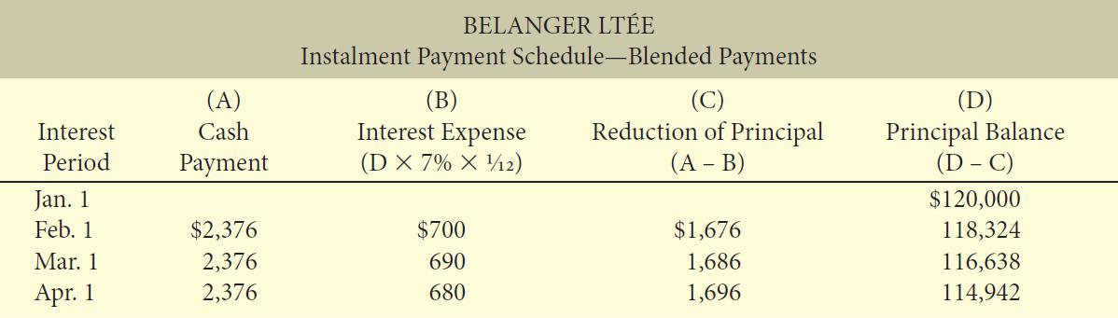

Statement Presentation
Current Liabilities: reported as the first category of liabilities. It can be listed separately and is normally listed in order of liquidity.
Non-current liabilities: Reported separately in the Statement of Financial Position. It is measured and reported at amortized cost
Analysis of Debt-Obligations
Liquidity: measure of short term ability to pay maturing obligations and meet cash needs: current ratio, inventory turnover ration, receivables turnover ratio
Solvency: measures ability to meet long term obligations: debts to total assets, times interest earned
Operating Leases:

