Chapter 15- Lecture- Stress

Lecture Notes
Common Themes across Therapy
Different types of therapy
- Psychoanalytic: Understanding
- Behaviors: Doing
- Cognitive- behavior: Thinking
- Humanistic: Feeling

Emotional Diffusing
- Reduce/eliminate fear
Interpersonal Learning
- Patients learn how to react with others by playing it out with the therapist
Insight
- Patients achieve a greater self- knowledge
Step-by-Step Process
- Therapy is a gradual affair
Therapy is socially acceptable
- Preferred means to treatment for emotional problems

Stress
- The stress response
- Psychosomatic disorder
- Traumatic stress
- A pattern of physiological, behavioral, emotional, emotional and cognitive response to real or imagined stimuli that are perceived as blocking a goal or endangered our well-being
Stressors: catastrophes, life changes, hassle
Intervening Factor: appraisal perceived control personality social support coping
Stress reaction: physiological stress position

Stress Components: Stressors-> Intervening Factors -> Stress Reaction

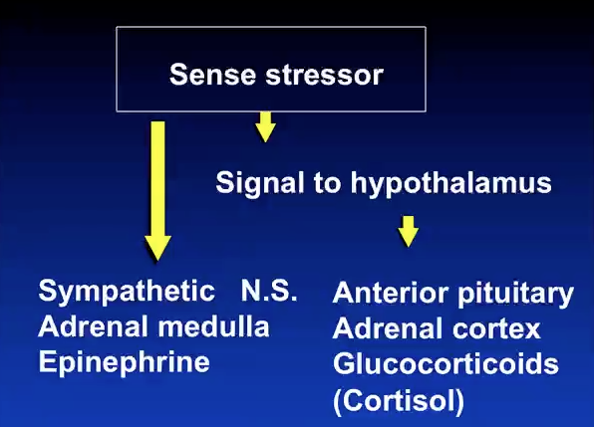
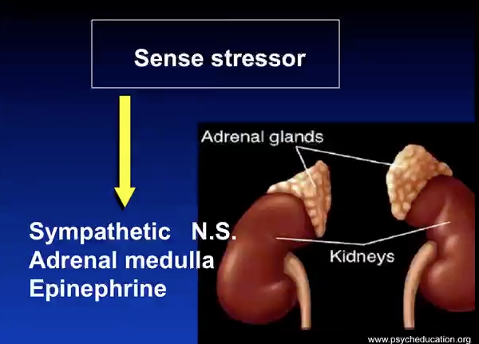
Gastric Ulcers
- Painful lesions of stomach lining
- Over 500k new cases per year
- Linked to living in stressful environments
- But, not due to stress alone
- Importance of control (stress, depression, other disorders); If Iperceie that I have control then I am less likely to suffer from these problems

Control
Weiss (1977) Experiment 1
Done with rats who are jumping over hurtles
- Group 1: No shock
- Group 2: Avoidable shock
- Group 3: Unavoidable shock
  - NOTE: Groups 2 and 3 are “yoked… they receive exactly the same number of shocks
- Those who had unavoidable shocks had a huge amount of ulcers that were long?? Longer then the rats who did not have to be shocked because they had control
Experiment 2
- Group 1: No shock
- Group 2: Signalled shock… proceeded by warning, no escape possible
- Group 3: Unsignalled shock
- Unsignalled shock had the worst ulcers again because they have 0 control, the signaled shock group ulcers were not that bad

Conclusion: Prediction and control are huge factors in stress and allow us to come to terms with what is about to happen even if we cannot stop this

Anxiety Disorders
- Anxiety: negative emotion experiences as an uncomfortable level of apprehension/fear; marked by physiological arousal, doubt concerning the source of threat and self-doubt about one’s capacity to cope with it.
- General Symptoms:
  - Subjective distress
  - Physiological activation
  - Avoidance/escape behavior
  - Interference/restriction in daily routine, occupational or social functioning
- Anxiety disorders
  - Panic attack; panic disorder
  - Phobic disorder
  - Obsessive compulsive disorder
  - Post traumatic stress disorder
- Post traumatic stress
  - Results from specific traumatic event
    - Sever anxiety, arousal, distress
    - Trauma relived in “falshbacks”
    - Emotional, but numb to the world
    - Avoid exposure to related stimuli
    - May experience “survivor guilt”
  - Often seen following:
    - Torture
    - Rape
    - Horrible accident
    - War
  - Onset immediate or months later
  - Multiple exposure to events more problematic then single highly traumatic event
  - Importance of coping style and social support
  - Individual may try to “self-medicate” with drugs or alcohol
  - Increased risk for other disorders ex: depression
  - Treatment:
    - Remove from traumatic situation
    - Educate survivors and family
    - Medication (Zoloft)
    - Exposure therapy common
    - Training in coping

Dealing with Stress
- Recognize symptoms
- Change what you can… learn to live with the rest
- Relax and exercise
- Talk… family, friends and professionals
- Do not self-medicate
- Take the time to smile

Textbook Notes
The Nature of Stress
- Stress viewed as in three different ways (stimulus, response, and organism-environment interaction)
  - Stimulus (stressors) – situations that place demands on organisms that tax or exceed their resources
  - Stress – a pattern of cognitive appraisals, physiological responses, and behavioural tendencies that occurs in response to a perceived imbalance between situational demands and the resources needed to cope with them
- Stressors
  - Stressors range in severity
    - Microstressors – daily hassles and everyday annoyances we encounter
    - Catastrophic events – natural disasters, acts of war, etc.
  - Life event scales – questionnaires that measure the number of positive and negative life events that have occurred over a specific period of time
- The Stress Response
  - Four aspects of appraisal process are of particular significance:
    - Primary – appraisal of demands of situation
    - Secondary – appraisal of resources available to cope with it
    - Judgments of what consequences of situation could be
    - Appraisal of personal meaning (what the outcome might imply about us)
- Chronic Stress and the GAS
  - General adaptation syndrome (GAS) – a physiological response pattern to strong and prolonged stressors
    - Consists of three phases:
      - Alarm reaction – a rapid increase in physiological arousal
        - Occurs due to sudden activation of sympathetic nervous system and release of hormones
      - Resistance – body’s resources continue to be mobilized so that the person can function despite the presence of a stressor
        - Length of stage depends on severity of stress, individual’s health, available support, and other factors
        - Adrenal glands release epinephrine, norepinephrine, and cortisol to maintain arousal
      - Exhaustion – body’s resources are dangerously depleted
        - Occurs when stressor is intense and persists for too long

Stress and Health
- Stress and Psychological Well-Being
  - Studies of results of catastrophic events has found average increase of 17% in rates of psychological disorders
  - Rape trauma syndrome – a pattern of cognitive, emotional, and behavioural responses that occurs in response to being raped
  - Neuroticism – a personality trait that involves the tendency to experience high levels of negative affect and to behave in self-defeating ways
    - People high in neuroticism have heightened tendency to experience negative emotions and to involved in stressful situations through maladaptive behaviours
- Stress and Illness
  - Stress can combine with other physical and psychological factors to influence the entire spectrum of physical illness
  - Stress can trigger illness by causing a breakdown in immune system functioning
  - Stressors can release sufficient stress hormones to induce structural changes in the hippocampus that last for a month or longer

Vulnerability and Protective Factors
- Vulnerability factors – increase people’s susceptibility to stressful events (includes lack of a support network, poor coping skills, tendencies to become anxious, etc.)
- Protective factors – environmental or personal resources that help people cope more effectively (includes social support, coping skills, and personality factors such as optimism)
- Social Support
  - One of the most important environmental resources that people can have
  - Enhances immune system functioning
  - Discussing traumatic incidences can enhance immune system functioning
- Cognitive Protective Factors: The Importance of Beliefs
  - Hardiness – a stress-resistant personality pattern that involves the factors of commitment, control, and challenge
    - Hardy people are committed to work, families, and believe what they are doing is important
    - View themselves as having control over outcomes (strongest stress buffer)
    - Appraise demands of situations as challenges or opportunities, rather than threats
  - Coping self-efficacy – beliefs relating to our ability to deal effectively with a stressful stimulus or situation
  - Optimistic people are at lowered risk for anxiety and depression when confronted with stress
- Physiological Reactivity
  - Physiological toughness – relations between two classes of hormones secreted by the adrenal glands in the face of stress
    - Catecholamines (which includes epinephrine and norepinephrine) and corticosteroids (cortisol) mobilize the body’s fight-or-flight response
    - Cortisol’s arousal affects last much longer, seem more damaging than those produced by catecholamines
      - Reduces immune system functioning and helps create fatty deposits in arteries that lead to disease
      - Catecholamines increase immune system functioning
  - Physiological toughness includes:
    - A low resting level of cortisol, low levels of cortisol secretion in response to stressors, and a quick return to baseline level of cortisol after stress is over
    - A low resting level of catecholamines, but a quick and strong catecholamine response when the stressor occurs, followed by a quick decline in catecholamine secretion and arousal when the stressor is over
  - Fact that physical exercise entail catecholamine-produced arousal may help account for exercise’s health-enhancing effects

Coping with Stress
- Coping strategies when faced with a stressor can be divided into three classes:
  - Problem focused coping – attempt to confront and deal directly with demands of the situation, or change the situation so that it is no longer stressful (Examples: studying for a test, going directly to another person to work out a misunderstanding, etc.)
  - Emotion focused coping – attempt to manage the emotional responses that result from it (Examples: appraising the situation in a manner that minimizes the emotional impact, avoidance or acceptance of the stressful situation)
  - Seeking social support – turning to others for assistance and emotional support in times of stress
- Problem focused coping and seeking social support often demonstrate favorable adjustment in stressors, while emotion focused coping often predict depression and poor adjustment
- In hostage studies, problem focused coping and seeking social support fare better than those with no strategy, but emotion focused coping was found to help individuals adapt most to uncontrollable conditions of captivity
- People with high stress who are too emotionally restrained to express negative feelings have a higher likelihood of developing cancer
- Men are more likely to use problem focused coping, while women often seek social support and use emotion focused coping

Pain and Pain Management
- Biological Mechanisms of Pain
  - Gate control theory – the experience of pain results from the opening and closing of “gating mechanisms” in the nervous system
    - Sensations from two types of sensory fibres enter the spinal cord, and activate neurons that travel up toward the brain regions responsible for our perception of pain
    - Thin fibres carry sharp pain impulses, thick fibres carry dull pain information
    - Experience of pain depends on ratio of thin-to-thick fibre transmission
    - Thin fibre activity opens spinal cord “gates”, while thick fibre activity closes them
      - rubbing a bruise or scratching an itch stimulate thick fibres, and produce relief
      - acupuncture may stimulate mostly thick fibres, causing pain relief
  - Endorphins – natural opiate-like substances that are involved in pain reduction
    - Inhibit release of neurotransmitters involved in synaptic transmission of pain impulses
    - Individuals often differ in pain experiences despite identical pain stimulation
      - Linked in variations in number of receptors for endorphins and ability to release endorphins
    - Stress-induced analgesia – a reduction in, or absence of, perceived pain that occurs under stressful situations
- Cultural and Psychological Influences on Pain
  - Interpretation of pain impulses sent to brain depends in part on experiences and beliefs, and both are influenced by our culture
  - Women report pain more frequently than men
  - Differences in pain experience also occur within culture
    - Soldiers often require less pain medication than civilians for war-related wounds, since soldiers see the injury as a ticket home to their families, while civilians see the wound as a life disruption
  - Placebos – substances that have no medicinal value but are thought by the patient to be helpful
  - People in control of their own medication often feel less intense pain and will give themselves less medication than those with prescriptions
- Psychological Techniques for Controlling Pain and Suffering
  - Cognitive strategies
    - Dissociation – involves dissociating, or distracting, oneself from the painful sensory input
    - Associative – involves focusing attention on the physical sensations and study them in a detached and unemotional fashion, without labeling them as painful or difficult to tolerate
  - Surgical patients with informational interventions show better courses of recovery and require less pain medication than those treated in a traditional fashion

Health Promotion and Illness Prevention
- Health psychology – the study of psychology and behavioural factors in the prevention and treatment of illness and in the maintenance of health
- Health related behaviours fall into two main categories:
  - Health enhancing behaviours – serve to maintain or increase health
  - Health compromising behaviours – promote development of illness
- How People Change: The Transtheoretical Model
  - Transtheoretical model – identifies six major stages in process of how people change
    - Precontemplation (problem unrecognized or unacknowledged), Contemplation (recognition of problem, contemplating change), Preparation (preparing to try and change), Action (implementing change strategies), Maintenance (behaviour change is being mastered), Termination (permanent change, no maintenance efforts required)
    - People do not go through stages in smooth sequence
      - Often go back and forth, and failure is likely if previous stages not mastered
- Increasing Behaviours That Enhance Health
  - Aerobic exercise – sustained activity that elevates heart rate and increases the body’s need for oxygen
  - Yo-yo dieting – severe intermittent dieting that results in large weight fluctuations
    - Results in accumulation of abdominal fat, increased risk of dying from cardiovascular disease

Combating Substance Abuse
- Motivational interviewing – a treatment approach that avoids confrontation and leads clients to their own realization of a problem and to increased motivation to change
- Multimodal treatments – substance abuse interventions that combine a number of treatments
  - Often combines a biological measure (nicotine patch) with psychological measures
    - Aversion therapy – undesired behaviour is associated with an aversive stimulus, such as nausea, to create a negative emotional response to the substance
- Relapses – a return to the undesirable behaviour pattern
  - Often occurs after a lapse (one time “slip”) in a high-risk situation (stressful event, social pressure)
  - Lapse followed by abstinence violation effect (a person blames himself and concludes that he is incapable of resisting high risk situations)
Harm reduction – a prevention strategy that is designed not to eliminate a problem behaviour, but to reduce harmful consequences

