Power point 1
- Multimedia: An application that can be used to present text, sound, video, images, and animation
- We communicate through the 5 senses
  - Sight
  - Smell
  - Sound
  - Touch
  - Taste
- Interactivity: User has control over the application
- Hyperlinking: Index allows for jumping around sections
- Development systems: Systems used by a multimedia developer to create applications (Photoshop)
- User Systems: systems used to play back/ view/ user the multimedia application (the end picture)
- France was the earliest drawing/paintings found by humans
- First photo was in 1826
- 1st movie 1880-1890
- 1st sound film “The Jazz Singer”
- 1st black and white + color movie was “The Wizard of Oz”
- 1st name of the internet was “Arphanet”
- Berners Lee started the WORLD WIDE WEB “www”
- 1st internet browser was “Mosaic”
- 1st band to give a concert on the internet “Rolling Stones”
- 1st animated movie “Toy Story”
- 1st application to change music in 1999 “Napster”
- 1st affordable camera for the public was in 1996
- Crap
  - Contrast
  - Repetition
  - Alignment
  - Proximity
- THIS IS SERIF, with lines
- This is SAN SERIF, NO LINES!
- Kerning adjust the spaced between pairs of letters
  - AW (further)
  - HN (closer)
- Tracking adjust the distance between ALL letters
- Leading = spacing between lines. i.e. double spaced etc…
- Color
  - Digits are: 0,1,2,3,4,5,6,7,8,9,A,B,C,D,E,F
  - #RRGGBB
  - #FF0000 = RED
  - 0 = black, higher = white
  - #FFFFFF = white
  - #000000 = black
  - #888888 = grey
  - RG= yellow, RB= purple
  - GB = teal, RGB = white, 0 = black
Power Point 2
- Computer only understand/speak Binary
- Binary are a number language
- Words, sound, image, movies, are represented by Binary
- There are infinite amount of numbers
  - 1 bit = 1,0
    - could represent anything
    - i.e. Black and white, or yes and no, or true and false etc…
  - 2 bit = 00, 01, 10, 11
  - 3 bit = 000, 100, 010, 001, 110, 101, 011, 111
- To calculate amount of different character by the bit is:
  - 2^{n}
  - N = number of bit
  - i.e. 8 bit = 2⁸ = 256
- Computer determine binary through voltage
  - High volt = 1, low volt = 0
- Sampling images is breaking an image apart
  - Sampling 4 = 
  - Sampling 64=

- Quantizing images is colours represented in bits
  - 1 bit (2 colors) = 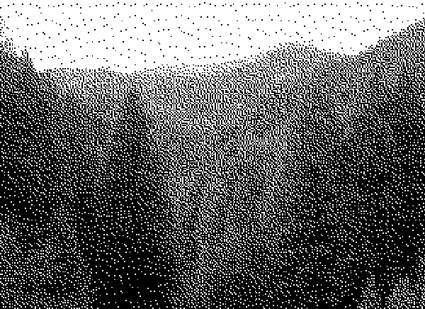 (black and white)
  - 4 bit (16 colors) = 
- More bit, more colors.
- The more samples that are taken the higher the resolution
- DPI – Dots Per Inch
  - samples on scanners/printers use DPI to measure
- PPI – Pixels Per Inch
  - Samples on a monitor/computer use PPI to measure
- Example:
  - 8 by 10 inch image scanned at 100 dpi
  - 8 *100 + 10 * 100
  - =800,000 SAMPLES/PIXELS
- Pixels have their own numerical value that represents a color in images.
- Always print 300 dpi
  - 3000 pixels by 1500 pixels, perfect print size?
  - 3000/300 = 10 inches
  - 1500/300 = 5
  - = 10 by 5 photos are perfect print size, any bigger and pixels we’ll be seen.
- 72 ppi displays the actual size in real life and on the screen.
- File size is determined by pixels
  - More pixels the greater the file size
  - Less pixels the smaller
  - DPI/PPI DOES NOT CANGE FILE SIZE!
- Printers use CMY for primary colours
  - Cyan (teal)
  - Magenta (purple)
  - Yellow
- On monitors RGB

Power Point 3
- Bitmap = a pixel image
  - Distorts when made larger.
  - Usually photo’s
- Vectors = non pixel image
  - Doesn’t distort when made larger.
  - Non photo, illustrator.
- To compress an image you change the bit
  - Less amount of colors will compress the image
  - It will look different, but not noticeably different
  - Depending on the amount of change there was to the image
- Lossless compression
  - When you don’t lose any information
- Lossy compressions
  - Losing some original information
- .bmp, no compression
- Human eye notice change in color more than brightness
- .gif
  - Only holds 256 colours
  - is lossless
    - If it’s less than 256 colours
  - have transparent images
  - dithering = 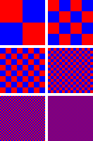
    - mixing two colors like ^^ is dithering
  - Interlacing: when downloading a picture online, it shows you the whole image, but it’s really pixilated, and continues to increase the pixels until it reaches the full image.
    - Look at image above, same process from top left to bottom right.
- JPG
  - Good for photo’s, screenshots, etc…
  - Best for blends of colors
  - Bad for sharp contrasts between colors
  - Ex. JPG  GIF 
  - Is a lossy compressions
  - I.e. loses some original imformation
  - No transparency
  - No animation
  - No interlacing
  - No dithering
- PNG
  - Has a LOSSELESS compressions
  - Two versions:
    - PNG-8
    - PNG24
  - PNG-8 is very similar to GIF
    - Has 8bit i.e. 256 colors
    - Allows 1 transparent colour
  - PNG-24
    - Allows 24 bit color
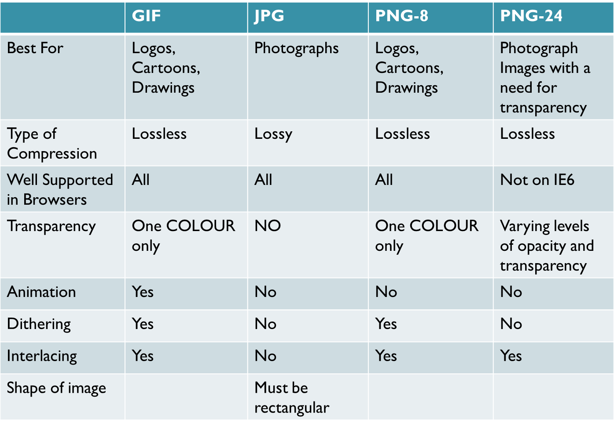

Power point 4

- Messages on the internet are packets
- Packet: a small group of bytes consisting of a header (tells where it is going: destination and where it came from: source) and the body. (Often 64 bytes for header and 512 bytes for body)
- Ip addresses have to have 4 sets of numbers that are between 0-255
  - 123.41.251.231 Valid
  - 255.270.2.3 NOT VALID
- www. Is NOTT part of the domain name. is www.google.ca a domain name. NO!
- One ip address can map to multiple domain names, vise versa
- Www.csd.uwo.ca
  - Csd is the sub domain
  - Uwo is the secondary domain
  - .ca is the main domain
- Need atleast 3 letters in the domain ex.
  - www.CSD.UWO.ca
  - Www.cs.uwo.ca would not work because of cs
- Cases sensitivity doesn’t matter
  - www.CsD.uWo.ca same as www.csd.uwo.ca
- No (shift + symbols) can be in a domain ex.
  - www.csd_uwo.ca does not work because of the _
  - Also no spacese
- tim berner lee (google) invented tags in code
Power point 5
- Webserver: the computer that is the server of the website
- Web browser: software/program that displays the webpages
Power point 6
- Search engines, how do they work?
  - 1st, they are a library of the internet.
  - 2nd, they then take the key words and match them to the best/most appropriate page
  - Like going to a library looking for a book.
- Web crawler/spider is the internet constantly looking at all words of a webpage
- Then it finds words that match your keywords
- Then it displays them by the best match/ highest ranked pages.
- They do this by:
  - Scenario 1:
    - Pages B, C, and D all have a link to Page A. (Thus page A must be very useful because everyone is pointing at it).
    - Then pages B, C and D are each giving their 0.25 rank to A, so A gets a ranking of 0.75
  - Scenario 2:
    - Page B links to A and C (0.25 divided between 2 pages)
    - Page C just links to A (all of 0.25 goes to A)
    - Page D links to A, B and C (0.25 divide between 3 pages)
    - The Weight of A is now:
    - 0.25/2 (Bs ranking ) + 0.25 (Cs ranking) + 0.25/3 (Ds ranking)
    - 0.125 +0.25 + 0.083 = 0.458
- Key words should be in title, body text, etc...
- Bad placements are in domain name, file names etc…
- Links are key to search engines. The more links to your site for the keyword searched the higher rank your website would be.
- Links should be easy for spider crawlers
  - Its hard for them to crawl through JavaScript, image maps, etc…
- Popularity is always important, if your site is really popular the higher the rank.
- History of searching the net
  - First ARCHIE was invented by students in McGill in 1990
    - Just archives and you would need to search through everything
  - Then came GOPHER
    - Written in 1991 by students in Minnesota
  - Then World Wide Web 1991
    - Developed by Tim Berner Lee
    - He had a criteria.
    - Data was hard to access
  - Then YAHOO
    - 1994
    - Starts as a search engine and web directory
  - Then GOOGLE
    - Started in 1998
Power Point 7
- Cel Animation
  - Animation drawn by HAND
  - The first full length cel animation was SNOW WHITE and the seven dwarfs.
  - In 1937
- Path based animation
  - Flash.
  - Tweening
- 2d animation
  - Keyframe, new beginning frame
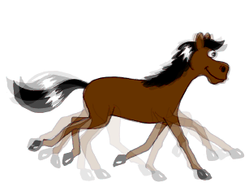
  - Tweening: smoothly moving animations
  - Onion skinning: allows you to see multiple frames at once
- 3D Animaiton
  - Modeling
  - Rendering
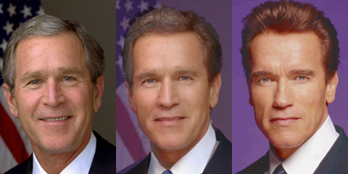
  - Animating
- Morphing
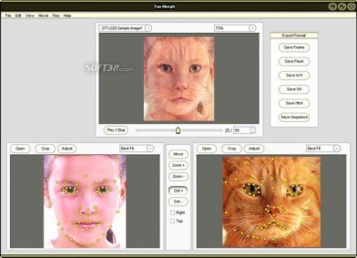
  - Process of belnding together two images into a series of images.
- Warping
  - Distorts a single image
- Flash
  - Launched in 1996
  - First created by Macromedia
  - Adobe bought in 2005
- History of animation
- Early cave drawings showed animals with 8 legs trying to show movement
- 1868 flip book patented
- 1898 stop motion animation introduced
- 1937 first full length animation snow shite
- 1960 first tv animation
- 1982 startek had some computer generated effects
- 1995 toystory first full length computer animated movie
Power Point 8
- FPS (Frames per second)
  - Movies 24-30 fps
  - Computer displayed video 12-15 fps
- Regular Analog TV began in the U.S.A in 1939 using the NTSC (National System Committee) standard
- Experiments on HD TV began in the late 40’s and 50’s but never appeared on a station until 1996
- TV used an electron beam to activated dots that were on the screen
  - The beam would scan horizontally but only the odd numbers
  - It would then head back up and then scan the even numbers
    - Each line skipped/ it passes is called a FIELD
    - This process is called interlaced display
- The frame size of NTSC standard DV frame is 720 pixels by 480 pixels
- High Definition for NTSC:
  - 1440 X 1080
  - 1280 X 720
- Digital camera’s compress your video automatically but only a little
  - They can be transferred straight to ur computer
- Firewire
  - A high speed data transfer technology
  - Made by apple in the late 80’s
  - Have firewire 400, and 800
  - 400 mbps and 800 mbps
- USB
  - USB 1.1 = 12mbps
  - USB 2.0 = 480 mbps
- 1967 sony made first portable camcorder black and white
- 1971 first cassets
- 1982 video and sound recorder
- 1995 first digital video camera
- Now don’t use tapes as much as mini dvd, hard drives, sticks, etc…
Power Point 9
- A codec is a piece of code that compresses video or audio as it is created (exported from the editing software) and then when displaying it to the user decompresses the video or audio (also stands for coder/decoder)
- Compression strategies
  - Pick a codec with a higher compression
  - Lower the picture quailtiy of the video
  - Lower the color depth
  - Compress audio
  - Spatial
    - Compress each frame individually
    - Uses the same techniques as JPG compression
    - Codecs that do spatial compression are: Animation, PlanarRGB
  - Temporal
    - Just save info on selected frames (called keyframes)
    - All other frames just save the differences from the previous keyframe
    - Good when the difference between current frame and keyframe is small
    - Codecs using temporal compression are: Sorenson Video, H.264
- Video formats
  - Avi
  - Mov
  - Flv
  - Mkv
- Digital media player
  - A piece of software which plays multimedia files (video or audio)
- Three main ways to get a video
  - Download
    - Stays on computer
  - Progressive download
    - Stays on computer
  - Streaming
    - Doesn’t stay
- Unicast
  - each user gets his/her own stream of video, the server has to send out A LOT of data if several users are watching at once
- Multicast
  - send the same stream to a bunch of users but then they lose the ability to pause, rewind, etc.
Power point 10
- The Nyquist Limit
  - This rule says you MUST take at least 2 samples for every cycle of the wave. If you take less than two sample, you will get a completely different sound wave
- Sound compression strategies
  - Reduce the number of samples (sample rate)
    - 44khz to 22khz
  - Reduce the bit depth (sample size)
    - 16 bit to 8 bit
  - Reduce the channels
    - Mono is one channel stereo is two
  - Compress using the appropriate codec
- Loseless compressions
  - .wav
  - .aiff
  - .cdda
- Lossy compressions
  - .wma
  - .mp4
- MIDI are used for: ( doesn’t handle voices/ noise well)
  - Which instrument is supposed to be represented
  - The not being palyed
  - How hard the note was pressed

