1)
This product is catered to:
- Lactose free demands
- Gluten free demands
- Soy free demands
- Vegan demands
This product is portraying the global health trends that has begun, it is portraying a very natural product for those that are radical vegans. This is implicated in the Average Household Food Expenditure chart we looked at in the first week of classes; where we saw fruits, vegetables, nuts, dairy products and eggs expenditure becoming closer to meat expenditure, which shows us that we are heading toward a more health conscious mindset in our eating habits.

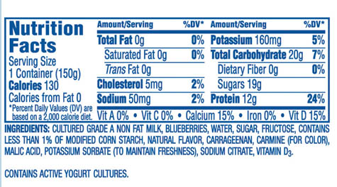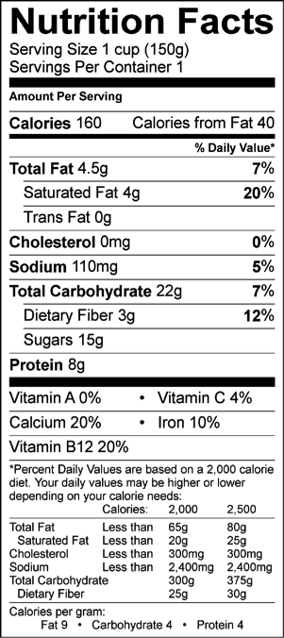
Left: Oikos yogurt Right: Daiya yogurt
Observations:
When comparing the two products above we notice differences in the nutritional facts tables; starting with an increase in sodium used in the Daiya product which could implicate that the product went through more processing during its production.
We also notice that the Daiya product is a fattier product than the regular Oikos yogurt; also, different vitamins and minerals were used in the two yogurts, Daiya used Vitamin B12 and Oikos used Vitamin D. We also notice the Daiya product packs more fiber than the Oikos yogurt product. The calories from fat in the Daiya product takes up 40 points compared to the Oikos yogurt where fat takes up 0 points.

Food Additives:
Pectin (Ge) – Gelling agent – used to thicken and stabilize various foods. These agents provide food with texture through formation of gel. Some stabilizers and thickening agents are gelling agents.
Lactic Acid (pH) – pH-Adjusting agents – Reduce, increase, or maintain the acidity of food which can affect microbiological quality, cooking, results, flavour, and texture. Some are also components of leavening agents which can make baked products light and fluffy.
Titanium Dioxide (C) – Colouring Agents – Gives foods an appetizing appearance. Factors such as processing, storage, and seasonal variation can result in unattractive or unfamiliar colour. Usually, the word “colour” appears on a label, not the specific chemical or common name.
Tricalcium Phosphate (Ac) –Anticaking Agents – keep powders free-running: salt, for example, would turn into a solid chunk during damp weather without an anticaking agent.
Locust Bean Gum (Ge) – Gelling agent – used to thicken and stabilize various foods. These agents provide food with texture through formation of gel. Some stabilizers and thickening agents are gelling agents.
Guar Gum (Ge) – Gelling agent – used to thicken and stabilize various foods. These agents provide food with texture through formation of gel. Some stabilizers and thickening agents are gelling agents.

5)
Bilingual Labelling – YES
Common Name - YES
Date Markings and storage instruction - YES
Nutrition Labelling – YES
List of Ingredients and Allergens – YES/NO
Identity and Principal Place of Business - NO
Net Quantity - YES
Legibility and Location -
Irradiated Foods - NO
Country of Origin - YES
Sweeteners – YES

6)
Canada, Health (2007,October 12). Food Additive Dictionary. Retrived February 11, 2016, from: http://www.hc-sc.gc.ca/fn-an/securit/addit/diction/index-eng.php

Daiya Foods. (n.d.). Retrieved February 11, 2016, from: http://us.daiyafoods.com/products/greek-yogurt-alternative/black-cherry-greek-yogurt-alternative

