Lecture 9 – Social Inclusion
Social Inclusion
- Ambiguous concept
- Inclusion, inclusive
  - When is it SOCIAL INCLUSION? a concept that is more sociological, has more research. The meaning Is more sociological, has more research, the meaning is more deep than simply “inclusive programs”
- Inclusion implies exclusion by definition, there is idea that there is a group that is facing:
  - Exclusion, marginalization, discrimination, segregation, “ghettoization”, “underclass”, disadvantaged, groups at risk, vulnerable populations, the poor
- When we want to work around this it means that there is a group of people that is trying to INCLUDE AND INTEGRATE
- How to understand the phenomenon of poverty beyond income and quantitative values it is about understanding beyond economic values
- It’s a process – how can a group become “excluded”?

Two Definitions:
- “Social inclusion describes how a society values all of its citizens, respects their differences, ensures everyone’s basic needs are met, and welcomes and enables full participation in that society.”
  - Here what is important is CITIZENSHIP, A fundament of democracy,
  - Ex. All the citizens of Canada are equal and the role of the state is that all the citizens have equal access to services, differences welcome, everyone can participate fully in the society
- “A socially inclusive society is one which cultivates the skills and abilities of its citizens and communities, and works towards a goal of equal opportunity and freedom from discrimination”
  - Leads to the next slide… Want to treat everyone the same and reduce the gab b/w rich and poor

DEMOCRACY | WELFAR STATE
European Trend – 1970s  -Europe, France, Britain, Canada  -We value all of our citizens equally  - Role of the State is to receive the wealth from the active citizen tax payers  -The role of the state is to use this budget to redistribute it to the population, reducing the gap between the rich and poor  -So our social class is more stable at middle class, middle class should run our society  -REDUCE THE CAP AND HAVE A MORE EQUAL SOCIETY WITH EQUALITY OF CITIZENSHIP  States more “developed”  Measuring poverty through qualitative indicators  Confront national inequalitites  Role of democratic states towards equality – Citizenship | Insurance System (Security)  Social Assistance (Welfare)  Service Access to All
Measures of Social Inclusion
- The democratic and legal system:
- Integration and participation in civil society, equality among individuals, identity recognition, a certain political power;
- Am I integrated, do I participate in civil society, do I feel equal, Is my identity recognized, can I make things change and happen, can I participate in Student associations? Am I a women where my equity is not reached?
- If you do not feel any of these, then potential for vulnerability
- The job market:
- Economic integration opportunities, creation of jobs, have a job, be part of the economic system, access to credit;
- Am I in a position to integrate in the national economy, can I find a job, can I participate in the system at all, do I have access to credit, can I be an owner of my own house?
- Social assistance:
- Access to basic services like education (primary, secondary, university), health services, insurance, social services, recreation;
- electricity, housing
- Social capital:
- Family, friends, the community, solidarity networks, opportunities to create transcendent contacts
- How is your social support system around you?

- Overall, these are different dimensions in your society you want to see filled
- In order to achieve social inclusion these 4 need to be included
- These 4 Dimensions can guide us towards understanding exclusion, marginalization etc.
- This is what this body of research tries to understand and how it forms policies that contribute to social inclusion
- This is all positive however there are also issues…

Politics of Social Inclusion: The Residential schools of the “Aggressive Assimilation Policy”
From the end of the 19th Century up to 1996, about 150,000 aboriginals, Inuit and Métis children were removed from their communities and forced to attend the Residential schools.
- The truth here is that they were not just getting more education, and more opportunities. What really happened?
- It is something that is happening right now. There are missing and murdered Aboriginal Women. These issues are not unknown and untold, it is something that we have as a duty to know and understand.

What went wrong?
Residential schools were established with the assumption that aboriginal culture was unable to adapt to a rapidly modernizing society. It was believed that native children could be successful if they assimilated into mainstream Canadian society by adopting Christianity and speaking English or French. Students were discouraged from speaking their first language or practising native traditions. If they were caught, they would experience severe punishment.

Throughout the years, students lived in substandard conditions and endured physical and emotional abuse. There are also many allegations of sexual abuse. Students at residential schools rarely had opportunities to see examples of normal family life. They were in school 10 months a year, away from their parents. All correspondence from the children was written in English, which many parents couldn't read. Brothers and sisters at the same school rarely saw each other, as all activities were segregated by gender.

When students returned to the reserve, they often found they didn't belong. They didn't have the skills to help their parents, and became ashamed of their native heritage. The skills taught at the schools were generally substandard; many found it hard to function in an urban setting. The aims of assimilation meant devastation for those who were subjected to years of mistreatment.

Problematic – Residential Schools
- The residential school system is a Canadian policy there we force the indigenous peoples to residential schools to study
- Lasted 100 years, last school closed in 1996

The Legacy of Residential Schools for Aboriginals
- Parents would try to go to the residential schools, they would sometimes never see their kids again. Kids taken away from them for 10 months
- There are so many deaths, more than what was reported
- Only physical and mental and sexual abuse is the reality of these schools.

Careful…
- The very idea of inclusion, “inclusion” of what?
- Assimilation? We have to be careful…

Health Disparities between Canadian Mainstream and Indigenous Peoples
- Canada is ranked among the top five countries in the Human Development Index (HDI). Looking exclusively at Canadian Indigenous children, this same rank drops to the 78th.
  - HDI = look at access to health, education, and economic variables
- Life expectancy of Indigenous men in 67.1 years as opposed to 76 for mainstream Canadian men, aboriginal women 73 and 81 for mainstream women.
  - Lower life expectance…and this is why indigenous community is so young
- Rates of infant mortality, diabetes rates, chronic conditions, infectious disease and obesity significantly higher than mainstream Canada

Table 1. Aboriginal Identity Population, Canada 2011

Aboriginal identity | Number | Percent
Total Aboriginal Identity Population | 1, 400, 685 | 100.0
First Nations Single Identity | 861, 560 | 60.8
Metis Single Identity | 451, 795 | 32.3
Inuit Single Identity | 59, 445 | 4.2
Multiple Aboriginal Identities | 37 895 | 28.0

Canadian Aboriginal Demographics (National Household Survey, 2011)
- The Aboriginal population is growing rapidly. Between 1996 and 2006, the Aboriginal population increased six times more than the non-Aboriginal population (47% compared with 8%).
  - Population is very young there as in Canada in general there are higher death rates, however birth rates are higher in aboriginal population
- The Aboriginal population is younger than the non-Aboriginal population. This is due to higher fertility rates and shorter life expectancy. First Nations people and Inuit tend to have higher fertility rates than the non-Aboriginal population.
- The 2011 NHS showed that there were 392,105 Aboriginal children aged 14 and under in Canada. They represented over one-quarter (28.0%) of the total Aboriginal population, and 7.0% of all children in Canada. In comparison, there were 5.2 million non-Aboriginal children aged 14 and under in Canada, representing 16.5% of the non-Aboriginal population.
- There were more than 254,515 Aboriginal youth aged 15 to 24, representing 18.2% of the total Aboriginal population, and 5.9% of all youth in Canada. Non-Aboriginal youth numbered just under 4.1 million, and accounted for 12.9% of the non-Aboriginal population.
- In comparison, seniors made up a lower proportion of the total Aboriginal population. In 2011, there were about 82,690 Aboriginal people who were seniors aged 65 and over, accounting for 5.9% of the total Aboriginal population. This was less than half of the proportion of 14.2% for seniors in the non-Aboriginal population.
- In 2011, the median age of the Aboriginal population was 28 years; 13 years younger than the median of 41 years for the non-Aboriginal population. (The median age is the age where exactly one-half of the population is older and the other half is younger).
- Inuit were the youngest of the three Aboriginal groups, with a median age of 23. The median age of First Nations people was 26, and that of Métis 31

Table 2. Median Age by Aboriginal Population, Canada 2006
Aboriginal (total) | 27 years
First Nation | 26 years
Metis | 31 years
Inuit | 23 Years
Non-Aboriginals | 41 years

Canadian Aboriginal Demographics
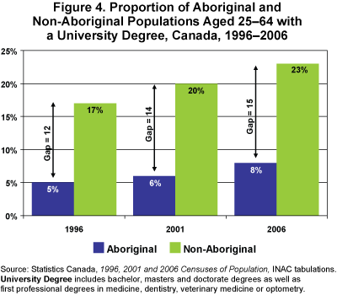
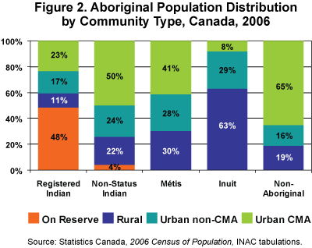

- High concentration in urban centers and reserves
- There is very low access to higher education
- There is a lot of indigenous people putting their voice in research

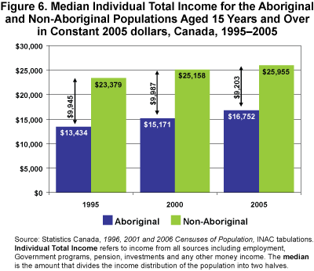
Moose Cree First Nation (2000 inhabitants)
Sandy Lake First Nation (2000 inhabitants)
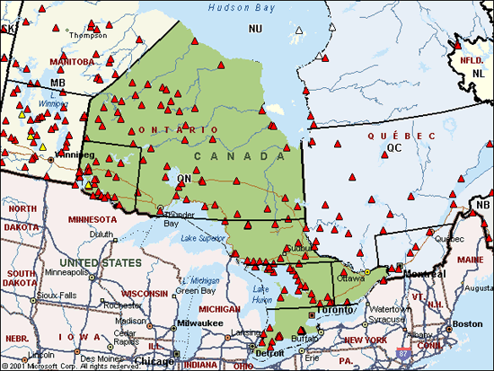

Challenging Facing Children and Youth

- We need to acknowledge what the consequences are now based on this cultural genocide
- All these children that are taken out of their families were punished if they spoke their native language, they could not be with their family, they became ashamed of who they were as a person, a huge cultural shock for all the children on the reserves
- This is repeated from generation to generation
- One of the main social issues identified in these communities is LACK OF PARENTAL SKILLS as they never had models of how to be a parent
- Now, what is replacing the residential schools is the foster care system. Today, more children in foster care vs. residential schools. However, this still breaks the family system as kids are not with their parents! Instead, forced to live with other parents.
- PLAY Program – main issue in their communities involved is the problems on how to raise their children, parents also faced a lot of drug and alcohol addictions. All of these is holistically linked to post colonialism and all the policies of colonialism and the effect it had on the families and children.
- Main issue among the children is SUICIDE and this is one of the main reasons as to why Right to Play ended piloting programs in these communities since there were high levels of crisis of suicide among the youth.

The chart shown previously is what came out of a needs assessment to the first two communities that participated in the Right to Play Program. Right to Play sent them (Professor) to go an do a needs assessment to design the PLAY program. Did interviews:
Asked about what the issues were, and what they needed help with:
- Both communities came up with exactly the same issues (Suicide, Family Dysfunction, Addiction, Education, Gender)
- Jonathon – engaged, role model! Committed suicide. Suicide was glamorized in these communities because it was the cool kid in the community that did it. This shows the lack of hope, future, projection in life. (Suicide happened 2-3 every week) These same kids that looked up to this “hero” also came from very dysfunctional families full of drama. People around these kids are coping with grief all the time… physical and emotional abuse…
  - Parents do not know how to be parents – one of the biggest issues from residential schools
  - Many parents/adults faced addictions to drugs and alcohol
  - Many people do not reach higher levels of education since often times secondary school is somewhere else, in an outside community. You need to fly to another city when you’ve never been outside of your community! It is hard for children to finish secondary school. They are also often marginalized when they reach these schools in the city and the level of education is different in reserves vs. in a city. Ultimately these children are made to fail.
  - Then when the kids come back to reserves you can’t do any school because there is only up to grade 12. Then you have to to find jobs, there is no jobs and then what do they do? The transition to adult hood is stuck What do they do? They get pregnant. This is why there is high teen pregnancies! And the cycle is reproduced.
- ****This all comes together. and it is not just because of residential schools but it is the overall residential system where indigenous people are completely dependent on the Canadian system, they only get a territory and reserves, but it is not their land or their houses. They get a cheque and that’s how they live. There is no entrepreneurship, or creativity, it’s a morph situation.

QUESTION: Apply the case of Indigenous population to the measure of social inclusion what can you say?
- The democratic and legal system:
  - Integration and participation in civil society in general not really
  - equality among individuals within Canada if you look at the developmental index of the indigenous population they are living in conditions like third world countries
  - identity recognition some, they have status cards and three (homogenizing) distinct populations
  - a certain political power not much political power but there have been attempts to change this in the past. In the present with Trudeau’s new government you can say that there is a start as there are 2 indigenous individuals who are in parliament now.

- The job market:
  - Economic integration opportunities, creation of jobs, have a job, be part of the economic system, access to credit;
  - In general, not so much. On reserves, not so much either as there are very little jobs and you just get a cheque. very little creation of job opportunities. You do not feel like you are a part of the economic system. There is no bank or credit!

- Social assistance:
  - Access to basic services like education (primary, secondary, university) and access to heating, electricity, heating (obvious to us however missing in many indigenous communities), health services, insurance, social services, recreation;
  - heating is very expensive, many communities do not have drinkable water still!
  - Education is very poor, there is money to go get school but very few programs and social and emotional support to help students finish secondary school
  - Health services, if there is an emergency then you need to fly out of the community, so overall few access to health and no insurance (no receipts, informal)
- Social capital:
  - Family, friends, the community, solidarity networks, opportunities to create transcendent contacts, How is your social support system around you
  - a broken social capital with addiction and dysfunctional families. However, when looking at the games you can see a strong and tight community. Traditionally, when talking about social capital, it is strong.

Truth and Reconciliation Commission of Canada
- The Truth and Reconciliation Commission of Canada has a mandate to learn the truth about what happened in the residential schools and to inform all Canadians about what happened in the schools. The Commission will document the truth of what happened by relying on records held by those who operated and funded the schools, testimony from officials of the institutions that operated the schools, and experiences reported by survivors, their families, communities and anyone personally affected by the residential school experience and its subsequent impacts.
- The Commission hopes to guide and inspire First Nations, Inuit, and Métis peoples and Canadians in a process of truth and healing leading toward reconciliation and renewed relationships based on mutual understanding and respect.
- The Commission views reconciliation as an ongoing individual and collective process that will require participation from all those affected by the residential school experience. This includes First Nations, Inuit, and Métis former students, their families, communities, religious groups, former Indian Residential School employees, government, and the people of Canada.

