Lecture 8: Towards ABCD (Assest-Based Community Development “Mapping Community Assets”

“Asset-based community development” (ABCD)
- Main Objective: Identify and Mobilize Assets of a Community
- Particular Attention to social capital, human assets, and associations
- “In the needs-based approach, well intentioned efforts of universities, donor agencies, and governments have generated needs surveys, analysed problems, and identified solutions to meet those needs. In the process, however, they have inadvertently presented a one-sided negative view, which has often compromised, rather than contributed to, community capacity building.”
- “Deficit-Based approaches”

Notes
- ABCD an asset based trend, a lot like how Positive Youth Development is another trend
- These are made to go against the deficit based approaches. Unfortunately, however these deficits based programs are overwhelmingly present in our system still!
- PYD = psychological on the individual, but in the developmental world this is made for groups

Kretzmann and McKnight (1993) point out that if the needs-based approach is the only guide to poor communities, the consequences can be ‘devastating’ (p. 4). One of the main effects is of fostering leadership that denigrates the community. Leaders find that the best way to attract institutional resources is to play up the severity of problems. Local leadership is judged on how many resources are attracted to the community, not on how self-reliant the community has become. Another consequence Kretzmann and McKnight identify is that people in the communities start to believe what their leaders are saying. They begin to see themselves as deficient and incapable of taking charge of their lives and of the community. Not surprisingly, community members no longer act like citizens instead they begin to act like ‘clients’ or consumers of services with no incentive to be producers.

“Play up severity of Problems” = instead of celebrating strengths, end up highlighting what is wrong. When you keep doing this over time, you start seeing yourself as a negative construction as a community.

Yet another consequence of this approach is that local groups begin to deal more with external institutions than with groups in their own community. This reinforces the notion that ‘only outside experts can provide real help’ (p. 4) and further weakens neighbour-to-neighbour links.

- EXAMPLE: Think back to the Documentary: Hockey for Development
  - The person that is behind the program is professional hockey player that wanted to give back to a community (Joe Jenue). He is White from the South who visited Koujuat and saw that the children did not have opportunity to play hockey and wanted to provide for them.
  - Two tutors/mentors that were retired school teachers worked every year with joe to make this program happen. They too are White and from the South.
  - School teachers of the kid’s were also involved and they talked about how schools partnered with programs and the positive effect there was on the kids. Teachers were also White and from the South.
  - Overall, the Inuit community seems to be a place that depends on white people from the South.
  - They are trapped into this dynamic of needing help from the outside, and only that way they can develop and move forward. They kind of just passively receive.

Appreciative Approach/Inquiry
- “What the appreciative approach seeks to achieve is the transformation of a culture from one that sees itself in largely negative terms – and therefore is inclined to become locked in its own negative construction of itself – to one that sees itself as having within it the capacity to enrich and enhance the quality of life of all its stakeholders – and therefore move towards this appreciative construction of itself.”
- Communities loose creativity, entrepreneurship, and risk of being trapped into a relationship of dependency.

Note
- Why is that? Why are we not more actively engaged and hands on in those communities?
- We see that the parents are not interested, and community is hard to shake. Is it because they are lazy/drunk/because they do not love their children? Are they just trapped in their social issues?
- Well, did you notice that they were eating on the floor? Even after having a dining table and chairs. What you need to understand and realize, is to go beyond these stereotypes.
- 2/3 generations ago these communities were nomadic, which would depend on sled dogs, and they would always be moving. Never lived in villages like they did now.
- So what happened is that their lifestyle has changed! They are currently in the adapting stage.
- NOW… we come in and tell them to get their kids educated, when there aren’t even jobs, we want them to get them to these sport programs
- We have forced them into settling into 14 different settlements. We have killed their sled dogs! This is a very good way to force a settlement.
- It is important to go beyond own convictions of what we think is right, and understand situation of these populations when we go about making a development program for these people. We need to find out why they have social issues
- They are trapped into a cycle of thinking they need help. They start internalizing that they are wrong and everything about them is wrong.
- We need to change this and start making them think that there are positives (need to shift this dynamic in theory, need to go beyond the relationship of dependency)

Wider Understanding of our Societies in Mutation and Community Assets worth Acknowledging
- Identify and discuss societal changes undergone, using the following dimensions:
- Demographic
- Social
- Economic
- Political
- Identify examples of resources/assets of the community that can be taken into account in order to plan and informed renewed and improved recreation services
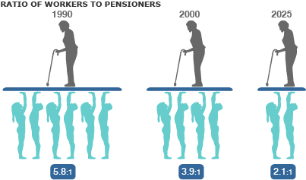
- Natural
- Human Public/Institutions
- Material
- Financial
- Cultural

1.a) Demographic Change
- Persons aged 65 years and older outnumber children 0 to 14 years (2015) – First time in history!
- Aging Population in 10 years there will be 2 adults working for 1 elderly
- Less working force/youth less tax payers to support the system of our aging population

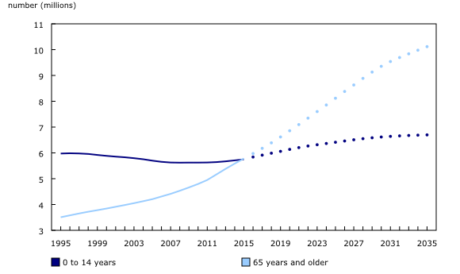

- Data for 1995 to 2015 are population estimates. Data for 2016 to 2035 are population projections (shown in the chart as dotted lines). For more information on population projections, consult the publication Population Projections for Canada (2013 to 2063), Provinces and Territories, (2013 to 2038)
- In 20 years there will be 10 million older to 6 million younger

- More and more people are aging healthy. What are we going to put all of them?
- The trend is to look after your elders and take care of them. We are trying to encourage people to look after their parents for as long as they can.
- There are more services and programs that can help the elderly! Ex. Daycare services for elders instead of children The government might take care of them 3 weeks for free!)

Cultural Diversity (Demography)
- Multiculturalism – accommodations
- We live in an increasingly more diverse society and this diversity will increase
- This is also seen as a solution for the graph showed early. So if the adult active population does not grow what do we do?? We open the door of immigration.
- Ex. Develop the policy for international students to come and stay in Canada! They can get a degree, come from middle class family, they have experience in Canada, so we want them to stay! And become active citizen here! (this is another solution)

- The youngest population of Canada is indigenous!!
- Baby Boom occurred among this population. Pushing for programs like PLAY, pushing for education a lot of things being done to make this a more active population

1.b) Social and Cultural Change – Lifestyles
- Family composition (increase in diversity and complexity) new categories that never existed
  - In Tact = 2 parents and biological kids
  - Step Families (simple and complex)
  - Same Sex Parents families
  - Same Sex Common Law families
  - Loan Parents families
- Need to keep in mind the diversity of families when planning a sport for development program because some kids may have multiple homes. Many new realities that we need to think about when making a program.
- Women and men both have full time jobs now, and kids have a lot of school work so there is less leisure and free time. Need to think about all these factors as well when planning a program.

Lifestyles, technologies, built environment
- Leisure and PA is a luxury, it is something separate from the rest of our lives and not integrated into our daily activites anymore
- The trend is to be more sedentary
- Technology has really changed our life and has had an impact on our sedentary behaviour
  - Ex. UBER and Taxi Driver employment rate dropping
Suburbs
- Built Environment you do not know your neighbours and need cars to get to services which are located somewhere else
- In England, in pubs is where you exchange and talk to people and get to know each other.

Urban Vs. Rural
- Urban most of the services are concentrated here.
- Rural less services, in community development we often work in these areas where there are wide distances to travel and transportation is always an issue.
- Very different dynamics in these two types of communities
- Up North Transportation is always an issue

1.c) Economic Trends
- Economic growth?
- Employment situation
  - Less and less stable and secure jobs. Has an impact our spending power. Do the people who we are targeting through our community development programs have the money to spend on sport and leisure. Do we as community developers have the money to create a program?
  - There are a lot of dept. as well because we are a society that over consumes.
- Financial crisis public services
- Trends in buying power from consumers

Note
- We spend only 10 years of conservative government which is an extreme or neoliberalism. We tried to limit the presence of the state in our societies, and decreased the size of the state. We cut the services and programs and to compensate it is the private sector that grows, we had economic crisis in 2008, 2011. The first thing that drops for people when this happens is leisure and sport

1.d) Political Context
- Rationalisation of public spending
  - Liberal they want to spend (where conservative wanted to cut). Liberal sayin that they want to spend and diversify the economy where we can stimulate the economy more. We can spend money on Canadian wide infrastructure. Wants to build more programs!
- Redistribution of responsibilities
  - CIDA Canadian International Development Agency, one of the first things that Harper Cut. If Liberal comes back, then they will bring back CIDA
- Services within neoliberalism / conservative government
  - With rationalization there is privatization, less provided by the state
- May encourage bottom up development!
  - New partnerships are created by society Ex. more NGO created
2.a) Natural Assets
- Biodiversity
- Parks and Protected Areas
- Access and legislation
- In Ottawa Gatineau park is a park made for the users vs. being the conservation of natute. Instead made for leisure, for people in the area.

2.b) Human Assets – Citizens
- Skills and talent of people
- Leaders
-Key people
- Youth role models
-Associations
- Role of families

Associations
- Not paid, they care enough to act: they appear in lot of stories about successful communities
- Cultural Groups
  - Drama Club
  - Dance Organisation
- Civic Event Groups
  - Local Parade planning committee
  - Art and Craft Fair
  - Gay Pride parade planning committee
- Anti Crime Groups
  - Neighbourhood watch
  - Senior safety group
- Business Organiations/ Support Groups
  - Local restaurant association
- Addiction Prevention and Recovery Groups
  - Group testimonial group for addicts
  - Campaign for a drug free neighbourhood
  - High school substance abuse committee
- Animal Care Groups
- Environmental groups Neighbourhood recycling club
  - Save the park committee
  - Clean air committee
- Family Support Group
- Health Advocacy and Fitness Groups
  - Weight watchers
  - Yoga Club
  - YMCA
  - Senior fitness club

2.c) Public/Institutions
- Not for Profit
- Government – local, national
- Local governance
- Existing programs
- social services

2.d) Material – Infrastructure
- Buildings
- Utilities
- Equipent
- Transport Systems – mobilities
- this consists of the stuff available in communities, schools, sport, arenas, culture centers, museums

2.e) Financial
- Consumer spending power
- Local Businesses
- Tax credits for sport and leisure
- Local financial skills of people
- Grants and loan – financing possibilities
- There are tax credit for sport and leisure, so it is good for parents to take their kids to sport programs as they will be given tax credits later

2.f) Cultural
- Cultural Diversity
- Chinatown
- Little Italy
- Bilingualism
-Cultural Associations
- Arts and culture
- Events and Festivals
- we have a diverse population in Ottawa and these are the different places and factors we have to represent this.

“True Winners” Hockey for Development Documentary
Nunavik Youth Hockey Development Program (NYHDP)

Location
- 14 villages in Nunavik, where all the communities are present (above Quebec)
- All these communities are fly in communities, no roads to connect them, they need planes to travel from village to village

Nunavik Youth Hockey Development Program (NYHDP) Objectives
- In 2006, Makivik and the Kativik Regional Government initiated the NYHDP, to uniformly develop a regional minor hockey structure in the context of crime prevention campaign, and as a way to promote education, physical activities, and healthy lifestyles for the youth of Nunavik.
- Administrated and developed in collaboration with former NHL player and Olympian Joé Juneau, the program is offered to all 14 communities in Nunavik.
- The NYHDP is a regional minor hockey structure and a community based program meant to offer to hundreds of children of Nunavik, an opportunity to practice and play their sport of choice while uniformly developing youth hockey throughout the entire region, according to the Quebec ice hockey federation, in an effort to promote the importance of education, physical activity, healthy living and good nutrition, in the context of a crime prevention campaign

Note
- A mixture of both top down and bottom up development
- Program is funded by the regional program Joe convinced villages to self fund! FUNDING IS NOT EXTERNAL. THIS IS A PLUS IN TERMS OF SUSTAINABILITY
- It is HUMAN ASSESTS that they are struggling with. A lot of skilled people from the external world are sent
- Through out the years they have been able to train local people and get coaches from the community however

- Goal of program: to use hockey as a motivating vehicle to encourage youth to remain in school and make positive life choices that will enable them to succeed in the future
  - All in a context of crime prevention as well. ** overall still.
  - Seems like positive youth development This is an example of positive youth development you can talk about. Midterm *
- Offered to youth in all 14 communities within Nunavik

NYHDP and School Partnership
- 2012-2013 – First year with NYHDP not tied to school
- Before…
  - Teacher were filling in weekly forms about students and how they were doing in class, their attendance etc. on top of all their other work.
- It was hard to sustain this partnership with schools as so partnership broke in 2012
- Now…
  - It is up to the communities if they want to keep this program going. And they did!
  - Pushed community engagement, they they continued to fill out the forms themselves
- As a result, …
  - You do not need to go to school anymore if you want to play hockey in this program this changed how the program worked!

Program Components
- 2 Levels
- Community Level
- Every Village has an arena
- Regional Tournaments
- Select Level
- Tryouts
- Training Camp
- Tournament in the South (Montreal, Quebec City, Ottawa)

** All the kids want to make it into Select, and Select is not tied to school. The Select Teams are stronger than before and even if they are not linked to school, there are still a lot of positive outcomes

What does this mean for NYHDP?
- Everything is on the weekends now, so no school is missed for anyone anymore
- Programs still run by two retired teachers where they talk about life skills, and nutrition, and team building skills

Community Participation
- In the communities in which the program is working well, there are on average 30-60 youth that attend hockey program after school
- More males than females participate in the program at the local and select level
- There are a lot of new certified coaches that are added to the program. We are okay with coaches in this program, however more issues with facilities (scheduling and having arena available in consistent manner)

Coaches
- - Most Inuit coaches at the community and select level since the program started
  - More Inuit individuals are becoming interested in the program and wanting to become a certified coach
  - Helps to recruit committed and reliable individuals

Perceived Successes
- Increasing participation rates
- Increasing local appropriation more local people participating
- Girls team won select tournament in Ottawa 2 years ago

Participation Rates
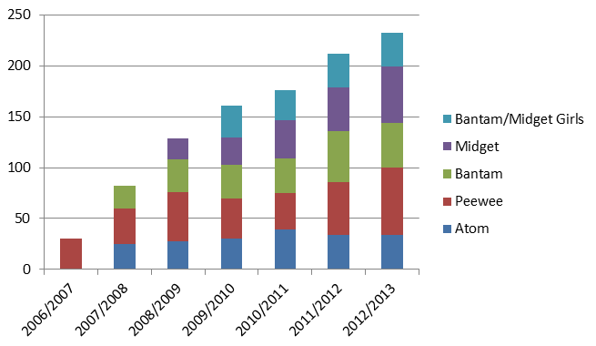

- Select Program Attendance Rates 2006-2013
- ** note that more youth were often invited that what actually attended for various reasons (primarily weather or illness)
- You can see how they are growing; in terms of program sustainability you can see that it is going well!
- This program has potential to last.

- “Girls won gold and the hearts of all Nunavik Inuit. When girls arrived home… each was a superhero in the eyes of adults and children… held a local parade to celebrate heroes and role models. They spoke to students about working hard, believing in themselves. A proud moment for an educator and a father. The NYHDP is about so much more than hockey—I never needed to be “sold” on the value of what was trying to be accomplished.” (Parent)

NYHDP’s Impact of Region of Nunavik
- Structurally, money leveraged from the Province of Québec to improve the conditions of 14 arenas in Nunavik
  - There has been more resources for infrastructure
- Media attention garnered from the program has also helped to bring visibility to the region and the reality of Nunavik’s youth
- NYHDP has received hockey equipment donations for youth
- Clear level of pride within Nunavimiuts’ related to their youth and participation in the NYHDP
- Hockey has always been very popular and of great importance within Nunavik and having youth be part of only structured hockey program elicits a great sense of pride in the region
- ** More resources, more donations. More popularity than ever before on hockey.

Perceived Challenges
- Reliable human resources
  - Local Hockey Trainers
  - Arena Manager & Zamboni Driver
    - Regular operating hours
    - Conditions of arena
- ** Arena Managers, Zambone Driver, condition of arena always really bad
- We had hard time getting right conditions, and getting things organized consistently

NYHDP – Community Level
- “Arena needs renovations”
- “Hockey room needs organization”
- “Improve communication between all people involved”

- Expensive ** MAIN CHALLENGE
  - Very costly program (esp. select component)
  - Cost of Equipment
  - Flights!
    - To be able to play a game this is only way you can get to another community
    - Still managed however, especially with a lot of partners and private sponsors

Questions form Document
- Program Sustainability…Will it last?
  - Regional Component
    - May last since the dependency is on the community and villages and its members
  - Select Component
    - Without Joe (National Hockey Player) this component would drop because him being a star attracts a lot of money, free food, free hotels, celebrity, and media to the program.
    - Without him it would just be a local trainer that would be leading the teams and they would not get all the resources, and thus it would be hard to sustain
    - If Joe leaves then unsure of how long this program will last because Joe is stubborn, and he pushes in terms of long term
    - Because of Joe the Quebec Provincial Government has accepted this program as a pilot program to run in small town Quebec! So can possibly become provincial to be funded by educational ministry! Yay! Not sure what will happen in north. But this project still getting big!

