Lecture 5: Theory of Community Development: Case Studies

Case Study 1: Start2Finish ‘Running and Reading’ (RnR)
- Running and Reading is a program created in 2004 by Kidfest (2000), now called Start2Finish
- Literacy and Fitness Program
- Ridged model implemented in 25 schools in Canada
- Not-for-Profit organizations financed by private sector and donations -> works in partnership with external agencies sponsoring
- VISION AND MISSION
  - Vision: To eradicate child poverty across Canada through education (1 million kids living in Poverty in Canada)
  - Mission: Start2Finish’s mission is to break the cycle of child poverty by providing ongoing educational support to Canada’s as risk children throughout their school years, nurturing mind, body, and social health so they are empowered to succeed and become role models for change.
    - Trying to empower the youth for personal and individual development
    - Not exactly for the community
- Youtube Vid: Explain the Program
  - Start2Finish believes all children are equal, however many live in poverty
  - Stress is one of the main reasons why children do not do well in school (stress = cortisol levels go up in the brain = reduces growth and damages hippocampus needed for memory, reading etc)
  - Physical activity reduces stress = better cognitive and emotional development

Poverty in Canada?!: Facts about how Organizations Speak about Poverty
- Almost 1 million children live in poverty in Canada today.
- In 2001, teachers spent $143 million of their own money to buy books/reading materials for students.
- By the time they start school, children living in poverty are 4.5 times behind their peers in vocabulary development.
- The higher a nation’s literacy skills, the more likely its population is to have healthier habits and lifestyles.
- 75% of children from low-income homes do not participate in organized sports, compared to only one quarter of other children.
- Children from low-income homes are twice as likely as children from middle-class homes to be living in neighborhoods with violence, drug trafficking and vandalism as everyday occurrences.

** RnR (Running and Reading)– FITNESS AND LITERACY PROGRAM: Kids with poor financial and material resources, poor nutrition, leads to low academic performance and stress

Running and Reading “Kids helping Kids” – VOLUNTEER RUN
- Erica (Professor’s old student) went to Robert E. Wilson School (Vanier, Ottawa) to implement the Program
  - Needed to find 1 day a week for 2 hours where program is run
  - Erica recruit’s volunteers to go and participate
- Physical Activity and Reading Themes
  - First hour: everyone working towards a goal and discipline end of the year there is 5K run
  - Second hour: literacy part of program word of the week every week (Ex. Respect) and reading
- End of the year run in York award ceremony at the end of the year to celebrate and motivate kids
- Some Stories…
  - Overweight girl with a hurt knee could hardly run for 1 minute and managed to by the end of the year lose 40 lbs and run whole 5K
  - Kids stealing food to take it back home to hungry siblings
  - Kids would take books home because they wanted to teach parents to read
- Overall, a lot of rich experiences for both volunteers and kids participating in the program

Case Study 2: Promoting Life-Skills in Aboriginal Youth (PLAY) Program
- Started 2010 - Ontario Ministry of Aboriginal Affairs, Olympic legacy
  - Olympic Games in Vancouver and this year the Olympic Legacy Fund was given to Ontario Ministry of Aboriginal Affairs
  - They developed a program for Aboriginal Peoples However Right to Play was unsure of how to go about this as they have never worked within a developed country like Canada (Typically Africa, Asia etc.)
  - What they did In 2010 they Pilot a Program in 2 communities
- From 2-4 communities to 57 First Nations and urban Aboriginal organizations across Ontario and Manitoba.
  - In the beginning the aim of the program was to work with 2-4 programs in total and to commit with those communities for 3-6 years and have gradual slow progression, wanted programs to last.
  - In 2011 after 1 year of piloting this program expanded to 34 communities so it was a big change
  - Right to Play managed to find multiple funding partners (beside the Olympic Legacy Fund) that allowed this program to expand so far
- PLAY: Vehicle for positive health promotion in First Nations communities and urban settings across the country.
  - From 2010 the purposes and objectives of these programs have been changing constantly and the pilot program has changed in many ways to fit into the needs of communities
    - Ex. One main issue is suicide, one main objective is sustaining cultural identify and to promote positive youth/health development
- By engaging Aboriginal children and youth—the future leaders of their communities—the PLAY program seeks to promote meaningful, lasting change.

Promoting Life-Skills in Aboriginal Youth (PLAY)
- Important Factor: PLAY works together with communities when developing programs
  - Ex. If Right to Play works with 57 communities then they hire 57 community mentors
  - Community mentor is the one in charge of leading the development and designing the program vs. having someone from outside community come, evaluate, and then develop a program.
- Hired and train someone from within the community as a paid mentor
  - Who Hires part of funding comes from community and part from Right to Play
  - Community commits by providing a venue, supporting community mentors and receiving program officers from external outside communities and come to help run the programs.
- Work with the community mentor to assess the needs of the community
- Tailor the Right to Play program to fit the needs of the community
- Empower the community mentor to deliver the program with the support from Right to Play
  - All 57 community mentors will have lots of training weeks outside of communities (annual gatherings usually funded by Tim Horton’s)
  - They develop a lot of skills and better equip community mentors to to run the programs in their local communities
  - Gatherings are very diverse as you have 1 community mentor and 2 Kids from each of 57 communities. Forms connections between communities bringing them together, great opportunity for communication and to bridge SOCIAL CAPITAL. Create great networks and within the communities themselves they will create events separately away from Right to Play initiatives.
- Encourage the community mentor to train others to ensure the learning continues

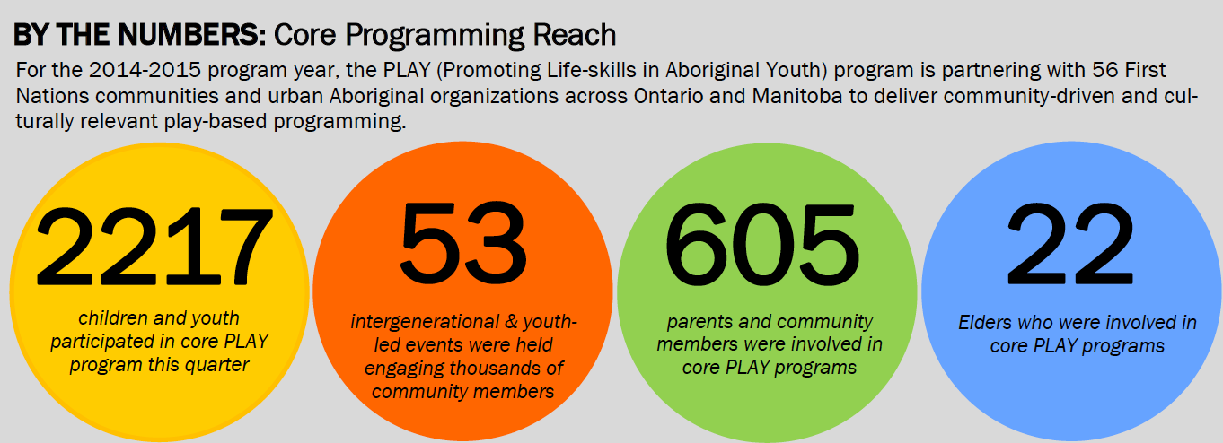

- Very wide variety of community events with wide variety of participants!
- Empowers the youth AND also engages the community to participate! Everyone involved NOT just youth development.
  - Ex. Parents and and elderly are involved. This is important as they hold traditional Knowledge and sustaining culture and tradition is one of the many initiatives of the programs

Reflect – Connect – Apply Methodology

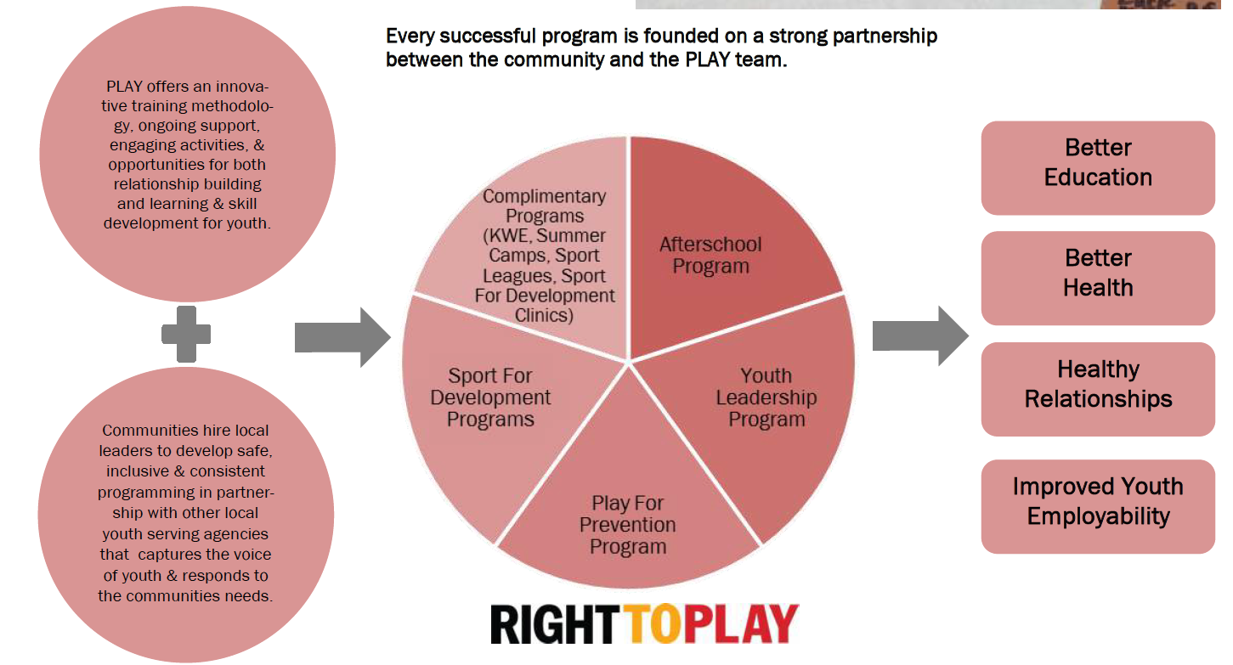

What it Looks Like:
- When it is said that a program is tailored to a community what that means is that here’s a menu, and you can pick whatever you want out of the menu. (Picture)
- It’s not that the communities develop programs from scratch, instead they pick form structures of programs that have been developed over the years, and change frequently
- There are four are Core Programs and each programs pick one of these and 1 Complementary program
  - Most of the time Youth Leadership Program is picked
    - Year long program (not just during school) where kids come 1-2 times a week including youth led events and intergenerational sport tournaments
  - Sport For Development
    - Offer soccer, baseball, hockey, lacrosse
    - Bring in clinics to develop skills, have certification programs for coaches and referees and help local members to create year long programs within the communities
  - Complementary Programs
    - KWE = program for young girls
    - Summer Programs = workshops in summer
    - Sport for Development Clinics = certification programs
- Another important aspect is the partnerships within the communities. Not only are there partnerships with external agents, but there are many local partnerships within the communities formed with these programs with local schools, other programs, associations etc.

PLAY Overview Video
- A program designed to develop young leaders within a First Nations community and empower them to make social change
- Helped youth become powerful active leaders with positive voice to share
- Helped elders become reengaged in the communities
- Helped communities recognize that youth are essential to positive social change

Actual Successes of the PLAY
Strengthened Capacity: Youth participating regularly in the PLAY program are developing significant life skills. Youth have demonstrated enhanced leadership skills and an increased level of confidence in their abilities. In 2013, 82% of youth in the PLAY program reported they felt like stronger leaders as a result of their participation. (Community Mentors as well)

Parental Involvement and Community Engagement: PLAY programs include opportunities for children and youth to learn about their ancestral history from their community Elders, creating invaluable cultural preservation for the First Nations. Parents and guardians are invited to participate in inter-generational tournaments and youth-led events designed to enhance leadership and strengthen bonds. In 2013, 91 inter-generational and 115 youth-led events were hosted as part of the PLAY program.
- Good to incorporate knowledge holders as it is key in many programs to centralize culture and tradition in development of PLAY programs

Improved School Effectiveness: With a demonstrated ability to increase student motivation, attendance and retention, the PLAY program leaders report: school attendance is higher on days when the program is offered.
(Reduce School drop out)

Key Figures from 2012-2013 PLAY Program Cycle: ** All these numbers are what funders look for **
- 3300 Children and youth were engaged (54% female) through the Youth Leadership Program and After School Programs in 47 First Nations communities
- 45 Local community mentors (57% female) were hired by local communities and Aboriginal organizations with the support of the PLAY staff team
- 115 Youth-led events were held allowing youth to take leadership roles in identifying and addressing issues that they felt were important within their communities
- 82% of youth participants felt like they were stronger leaders as a result of the PLAY program
- 91% of community mentors felt that the PLAY program has had a positive impact upon their community

Two Types of Development
TOP DOWN (typical, traditional) | BOTTOM UP
-Takes Place Externally  - Thought about at the top and then reached down the pyramid to target population  -Development from the Top  -AIM: PREVENTION | -Takes Place Internally  - Program Initially thought about within the community by community members.  - Partner with external with external agencies (but not until final steps of execution)  - Goes up to gain resources  -Development from the Bottom  -EMPOWERMENT

These are 2 EXTEME Categories:
- They each highlight different trends
- The PLAY PROGRAM Has a TOP DOWN development trend (Right To Play is a big organization with a lot of partners that reaches down to help target populations) however we also see BOTTOM UP trend in this program (With Community Mentor to find out problems in community and tailor program accordingly)
  - Try to build community control by them developing partnership within community
  - We look at community assets and opportunities and build on them (Ex. Take an existing organization in the community and develop and build on it further)
  - We invest and build capacity to develop experiences
  - At the end the aim is that if the funding from Right to Play ends, and they leave the community the community will be able to foster and continue work of the program.
    - A lot of people are trained and experienced
      - Youth trained in the program and Community Mentor continue training

- Overall the GOAL is to use TOP DOWN development incorporated with EMPOWERMENT strategies within program (From BOTTOM DOWN development)
  - Trying to conrease community control of resources with these partnership model as the communities commit to provide a lot of resources and to work together not as clients but as citizens and equals (horizontal relationships)
- This is how the Social Service Model is Changing Call it “Decentralization”
  - Right to Play would usually never hire locally, never work with people from the communities. Instead usually people would come in from the Right to Play Organization to the communities.
  - A whole trend towards decentralizing these programs and incorporating community partnerships

Bottom up | Top down
COMMUNITY DEVELOPMENT MODEL | SOCIAL SERVICE MODEL
Definition of problem by community | Definition of problem by outside agent such as government body  Ex. Start2Finish defined the problem of Poverty
Building community control, resources and capacities toward economic, social and political change | Education, improved services, lifestyle
Focus on assets  Ex. Focus on what community has to offer, focus on resources that the community has already | Focus on needs  Ex. What are the needs of these children with high stress and low nutrition.
Build from opportunities | Responds to problems
Investment Orientation  Ex. around assets of communities to provide opportunities | Charity Orientation  Ex. Not for profit organization
Emphasis on Associations  Ex. community partner with local agencies | Emphasis on Agencies  Ex. Start2Finishwill partner with external agencies, private sector
Focus on Community | Focus on individuals
Goal is empowerment | Goal is service  Ex. to allocate resources
Community control of resources and ownership is high | Community control of resources and ownership is low  Ex. Start2Finish – Vanier has no control over the program, comes from the organization, the ownership of the program is low
People are the answer  Ex. not the program. See how the people are the owner of their own change. | Programs are the answers
People are Citizens  Ex. actors of the community development. | People are clients

