Lecture 4: Defining Key Concepts of Community Development

Negative Aspects of Competitive/Organized Sport?
- Factors that can impact/disturb how you plan sport for development program/organization
  - 1) RISK OF INJURIES access to health care facilities in communities are poor and often injuries are not looked at unless emergencies
  - 2) ACCESS TO WATER important to make sure drinking facilities available
  - 3) INCLUSION becomes EXCLUSION very easily. Those you want to attract to the programs are those that are excluded and marginalized. However, you always end up with the most confident coming to the program events. As soon as you have a competitive dimension to program (which is fun to have in the games) you will exclude those that are the most marginalized. To attract those kids and keep them in the program is important. One mistake and they wont come back.
- Note: Many pilot programs are learning-by-doing and “experts” with compartmentalized knowledge about community development, sport and physical activity, sport management in theory are sent to these communities without knowing the situation.
- Programs need to be well thought through, work with people from community, and there is a lot of excitement and expectations so good to make sure planning is done well.

Old Canadian Sport Policy (2002-2012) – First Sport Policy to Exist in Canada
- The Main Goals:
  - Enhanced Participation providing access to sport to population
  - Enhanced Capacity getting more trained coaches, referees, educators, and more sport infrastructure in general
  - Enhanced Interaction developing more partnerships within sport systems (how to enhance interaction/connection between sport stakeholders Ex. Sport community, government, private sector, general population)
  - Enhanced Excellence high achievements in international competition
- This is what was in place during the time Sport for Development was being officialised
- Before 2012 the whole community was participating in renewing sport policy and this is what was formed (includes Sport for Development) can see impact of national organization (which we are a port if) in policy development:

Renewed Canadian Sport Policy (2012-2022) 5 Main Goals
- INTRODUCTION TO SPORT
  - Canadians have the fundamental skills, knowledge and attitudes to participate in organized and unorganized sport. has to do with participation but also has to do with providing more access and programs to those that have less accessibility to sport (Elders, youth, disable)
- RECREATIONAL SPORT
  - Canadians have the opportunity to participate in sport for fun, health, social interaction and relaxation. same as above
- COMPETITIVE SPORT
  - Canadians have the opportunity to systematically improve and measure their performance against others in competition in a safe and ethical manner. linked more to competitions local and international
- HIGH PERFORMANCE SPORT
  - Canadians are systematically achieving world-class results at the highest levels of international competition through fair and ethical means. same as above
- SPORT FOR DEVELOPMENT ** new
  - Sport is used as a tool for social and economic development, and the promotion of positive values at home and abroad. emphasize on economic even in Sport for Development

4th Policy Goal: Sport for Development
- Sport is used as a tool for social and economic development, and the promotion of positive values at home and abroad.
- Policy Objectives:
- The development of athletes as leaders and role models in sport and society is supported.
  - Encourage athletes to become ambassadors of these causes and take advantage of this communication platform
- Sport, community and international development organizations collaborate to leverage sport programming intentionally for domestic and international social development.
  - Within sport for development policy there is international development aspect! Sport Canada never in charge of international development and for the first time this non governmental sector which is a part of heritage Canada plays a role in authority in international development
- Sport-related sectors incorporate sport intentionally to achieve social development objectives.
- Sport events are intentionally designed and delivered to benefit host communities and local economies

Definitions of Community
- Specific group of people, living often in a given geographic zone, sharing a common culture, norms, values and who are organized in a social structure in connection with relationships developed over time. (World Tourism Organization, 1998)
- The members of a community developing their social and personal identity in sharing their common beliefs, values and norms that are rooted in the past but can change over time. The members demonstrate a conscience of their group identity and share the common needs and undertake to satisfy them.
- There are a wide variety of communities that exist and knowing your community is exist

Definitions of Community Development
- Community development is the planned improvement of all aspects of well-being (**community development is not something that happens on its own. It is something planned where you and your team all work together towards achieving positive social change) of the community (economic, social, environmental and cultural). This is a process by which members of a community come together to act and provide solutions to common problems. This applies to small initiatives destined for small groups as well as big initiatives assuming the participation of the whole community. (Frank and Smith, 1999)
- Community development consists of going to the community (** send someone to the community to understand the community first), to identify the key groups and their leaders, to work with them at resolving the common problems, helping the community to take control by giving more power to its internal organization and its support system, and to take initiatives in response to its own needs. (Toronto Health Services, 1991)
- Creation or expansion of the capacity to do, to act or to cause the action / social change.
(Health Canada, 1997)
- Increase the capacity to act according to one’s own needs. (Health Canada 1997)
- Process that is designed to promote collaboration in decision-making so that individuals can, in meaningful ways, influence decisions that affect their lives. (Community-based learning 2004)

“Capacity Building”
- “understanding the obstacles that inhibit people, communities, governments or organizations from realizing their developmental goals while enhancing the abilities that will allow them to achieve measurable and sustainable results”.
- Providing training and skills to manage and implement these programs.
  - Individual level Hire local community mentors in charge of programs. Train them in learning and facilitating games, how to deal with kids and tantrums/specific issues etc., planning programs and program design
  - Institutional level program management, learn how make your program sustainable by learning how to find your own funding, resources. Learn how to write applications and word things in a way that will get you more funding.
  - Community level how to make the community participate, how to represent the community, how will we involve the community voice within all the change happening

“Empowerment”
- an interactive process through which people experience personal and social change, enabling them to take action to achieve influence over the organizations and institutions which affect their lives and the communities in which they live”. *** how to help people to control their own lives **
  - to enhance the possibilities for people to control their own lives. People understand their own needs far better than anyone else and as a result should have the power both to define and act upon them.
  - people cannot achieve their fullest health potential unless they are able take control of those things which determine their health (World Health Organization, 1986)

Critical Youth Empowerment
** Important tool developed to measure youth empowerment in Sport for Development Programs
Really pushes a program to make youth think critically, not just be active. Engages youth to act more into their communities.

- Welcoming and safe environment having a safe and stable/consistent venue to hold program. Same place, safe hours. Good trained leaders that can provide the space and trust.
- Meaningful participation and engagement the activates you are doing are meaningful, the participation is not forced and kids are actually engaged.
- Equitable power-sharing between youth and adults the youth lead and help design program. They make decisions.
- Engagement in critical reflection on interpersonal and sociopolitical processes This is tricky. Does the program provide an opportunity to discuss interpersonal relations? A lot of the time they do and they reflect. However, in our case we will see that it is very tricky to push kids with traumas to talk about these relations as it is like opening wounds. This is where you need to get professional health! Need people who know about mental health. (Suicide is a big issue)
- Participation in sociopolitical processes to effect change if working with kids in a conflict zone, in a refugee camp, do the kids understand why they are there, and do they underhand what is going on politically. If they understand their situation, then they can act on and find solutions themselves.
- Integrated individual and community-led empowerment will be able to act and have an impact within their community. Youth can also stage events in the community about issues in the community (Ex. Drug Addiction), can reflect on why they have the problem. Do they understand the history of colonization, why are there reserves, and what has happened for there to be all these conflicts?

SOCIAL CAPITAL: Robert Putman (1995) Bowling Alone: America’s Declining Social Capital
- Groundbreaking research based on vast data
- Declines in Social Capital: Voluntary associations, family or friend dinners, card playing, generalized trust in one another, spontaneous interactions
- We sign fewer petitions, belong to fewer organizations, know our neighbors less, meet with friends socialize with families less.
- Changes in work, family structure, age, suburban life, television, computers, women’s roles favored this decline
- Suburbanization, built environment one of the key reasons for this decline
  - We do not have a core service place for communities where you would meet the members of your community
  - Now there are huge malls and chances of seeing someone you know are less

Social Capital
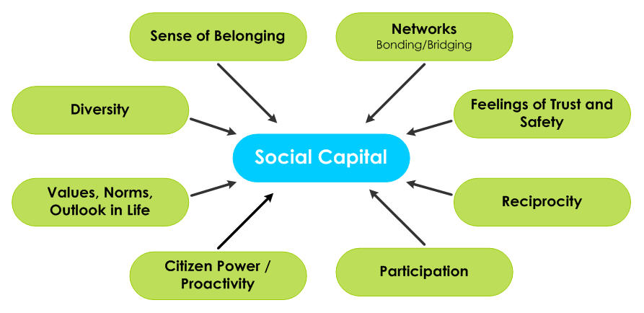
- Social networks have value
- Social capital refers to the collective value of all "social networks" [who people know] and the inclinations that arise from these networks to do things for each other ["norms of reciprocity"].
- Trust, reciprocity, information and cooperation associated with these social networks
- Glue that holds the fabric of society together

- “Features of social organization, such as trust, norms, and networks, that can improve the efficiency of society by facilitating coordinated action”. (Putnam, 1993, p. 167).”
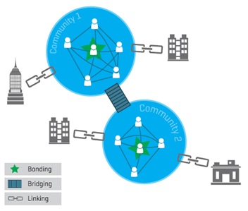
Putnam distinguishes THREE FORMS of social capital:
- bonding social: capital, referring to relations within homogeneous groups, such as those among members of sport teams or clubs, or youth developing ties with other youth from their community; (Ex. Bonding with own team)
- bridging social capital: referring to relations across horizontal social divisions, such as those across teams within a league, or youth developing relationships with adults (Bond external to homogeneous groups)
- linking social capital: referring to ties between different social groups of society; for example, citizens from all social groups who are fans of their local professional football club; youth developing ties with people representing institutions. (Connections with people who can give you something different. People who represent institutions and organizations, influential people on your situation)

Social Capital and Gender
- “social capital is unevenly distributed in society according to class, age, gender, ethnicity, and race” (Harvey et all. 2007)
- EXAMPLES:
  - women have more limited access than men to prestige positions and to diversified networks in terms of professional occupations men usually have more managerial positions
  - EXAM/MIDERM: What kind of social capital to men usually have over women?
    - If they have more diversified networks and more contacts within professional occupations, they have more LINKING social capital than women.
  - women tend to become more involved in different voluntary organizations than do men voluntary organizations can be BRIDGING or BONDING and not necessarily LINKING
  - women spend less time than do men with colleagues from the workplace Can argue that women have more responsibility at home and more interest in sharing with their family and their friends. Women would have more BONDING social capital as they have more interest in nourishing relationships with family and friends.
    - When you look at research on how women deal with rupture, divorce and strong emotions, we can see that bonding social capital is stronger for them vs. men
Social Capital
- [Sport programs] “may produce and reinforce social networks involving participants, their family systems, other residents, and other helping professions. Vibrant social networks produce rich stocks of social trust, norms of reciprocity, and conditions conductive to cooperation, coordination, and collaboration. These social networks animate democracy and sustain its civil society. All of these ‘products’ are vital to sustainable development” (Lawson, 2005: 138).
  - You can see how things can really build through social capital in a community!
  - Ex. Parents bring in baked goods for free and sell them to raise money for community

Example: Mobilizing Social Capital
- Occurred in Quebec in 2012, student movement against increasing university fees
- The student movement was very quick to mobilize in a movement. In a short period of time the change on the policy of university fees was so drastic that the response from the students was very powerful.
- All the student associations from the whole province goes to Montreal to protest
- Student leaders become famous and are all over the media. The movement managed to provoke elections and by doing this they changed the government to one that committed not increase university fees. Managed to block the making of a policy!
- New government just before getting elected approached A student, who became MP and then was elected to become a part of government! (University Student Highest authority representative in government of the cause) Became the youngest elective member of government!

TEDTalk: Video of Nicholas Christakis Intro to Social Capital
- How do social networks have an impact on our lives…?
- How networks create norms and what is perceived to be “normal”
- The spreading of ideas and the norm in social networks – the case of obesity, drug abuse, depression, divorce?
- Therefore, yet, developing the social capital, but a healthy/positive social capital encourages community well being

