Lecture 3 – Towards Achieving the Millennium Development Goals through SDP

Video from Lecture 2 (Rethinking the Field Gender and Sport in South Africa)
- There were a series of activities with sport for development
- Helped to understand how programs are structured and not just about getting kids to play sport. Also about how sports are adapted in different ways and meant to be structured into a sport for development program to educate kids about HIV/AIDS.

Millennium Development Goals
- Eradicate extreme poverty and hunger
- Achieve universal primary education
- Promote gender equality and empower women
- Reduce child mortality
- Improve maternal health
- Combat HIV and Aids, malaria and other diseases
- Ensure environmental sustainability
- Develop a global partnership for development

- A Task force made up of international organizations put together a report on this promise of sport. What is this doing to the field to Development Aid, and how does this contribute to the 8 goals.
- How can sport address these issues? …

Eradicate Extreme Poverty and Hunger
- Build a sense of community, help isolated communities, bring people together and help them work together towards development
- Extreme Poverty = defined by the UN as those that live with less that $1 a day (ECONOMIC Term, Monetary Value) So the real question being asked with this goal is how does sport increase money? How does it increase access to the capital?
- EMPLOYABILITY is crucial when you are participating in these programs because you are transferring skills, developing experiences
- Ex. Volunteer, trainer, program manager, if your kid is a participant - you are developing and learning all kinds of skills, increasing your employability!
- These programs will also get a lot of funding. Sometimes when an organization helps a community, they help find resources for the community and sometimes it can be financial resources! These communities can then have funding to hire people and all these people from the communities that help in the programs (Volunteers, managers etc.) will get paid and have a salary (more job opportunities built!)

Promote Gender Equality
- Empowerment is KEY. Normally in all these organizations for Sport for Development, this is the aim. To help people to be more autonomous with new life skills to act upon their own lives and their communities.
- *** Very important that when you work with communities with a different culture and background is to KNOW who you are working with. You really have to understand WHO you are working with.
- There is a wide variety of cultures out there and the people you reach out to can be very different from you, can have different mentalities, ways of thinking, and perceptions. You can't just arrive with your own perceptions and transfer them. You must be extremely careful.
- EX. If you are working towards breaking gender stereotypes you have to be very careful as it can be very tricky and dangerous.
  - Girls being pushed into playing sports = maybe parents or community will disagree, maybe it will lead to further stigmatization in community vs. empowerment. You really need to understand how the local community sees that first. Important to also know the historical context from which these places evolved to understand how to address the issue and how to develop and structure your own program.

Combat HIV and Aids, Malaria and other Diseases
- Such topics are often kept quite in the community and not encouraged to be talked about when in truth it is very important to discuss.
- HIV is a very tricky subject to deal with as many have it since birth while other discover later on in life that they are HIV positive, and a lot of people do not know they have it.
- These programs encourage people to get the tests done. There is a lot of stigma behind being positive in the community, a lot of exclusions, and no one knows what it is, how to catch it, or what to do when you have it so the point of these programs is to inform people and de-mystify and educate people on what to do and how you can still be friends with someone who is HIV positive.
- To us these things are obvious as we have resources and services available to us but when you are confronted with regions that have these issues that is not the case so people need to be educated! (increased rapes on young girls due to false belief that if you have sex with younger girl changes of contracting HIV is impossible - not true as she can have It from birth)
- *Diffusion of knowledge between members in the community occurs

CHARTS:
Poverty
- Increase accesses to services in the community
Education
- Sport is often used as a Hook Ex. Soccer used to help transfer messages to kids.
- Inform, educating, forming awareness
- Sport can be used directly for schools where schools develop after school programs to attract kids, or to help kids stay in school.
  - Reduce school drop out
Gender Equality
- In a lot of places when it comes to sports girls are shy and introverted as sports generally for boys
- This reflected in how the girls were also introverted to speak
- These programs really help participants to come out and speak up
- Positive shifts = important to do this. Also very important on HOW we provoke these gender shifts because we have to really understand the community you are working with.
Maternal Health
- Need to be careful talking about contraception's. You can have reactions of exclusions as talking about such things is taboo in many places. Can lead to stigmatization.

HIV
- You can involve celebrity athletes and use their capacity as a community source and use them to share information
- Kids will be more likely to listen to favorite athlete
Environment
- Also important as well that for low cost, low resources, and for low impact on the environment these programs can be cost effective
- Sport for development has a small impact on the environment. Least you really need is a field, handful of volunteers and a ball so low impact on environment.
Global partnership for development
- Really have international networks working together on these activates
- Takes us into how sport for development functions in international aid

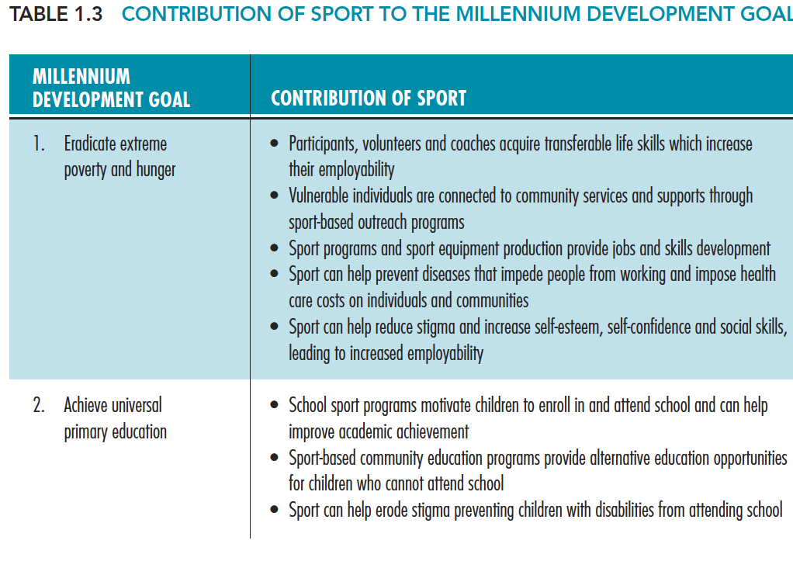

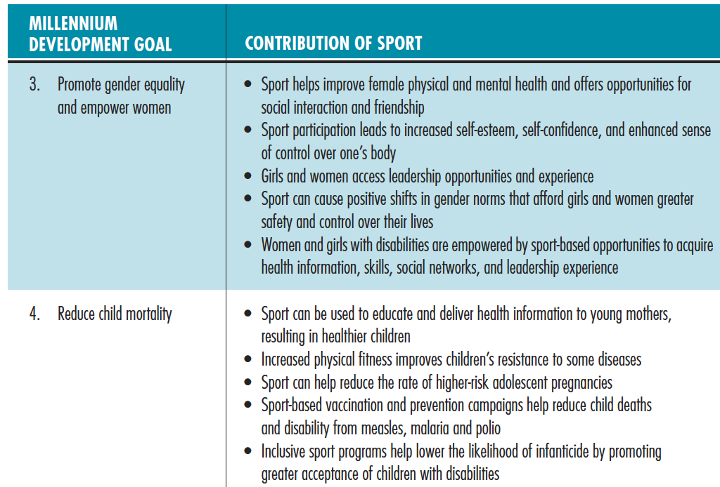

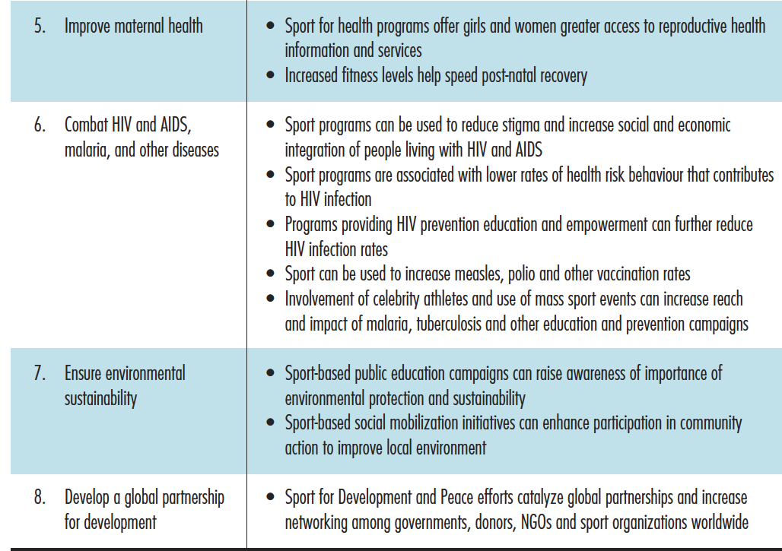

"Sport as a Significant Element of the Fourth Pillar in Development Aid" (Darnell & Black, 2011)
The First Second and Third Pillars are the Authority of International Aid. This is where typically international Aid works.

- First Pillar - Nation, Bilateral
  - Nation to Nation, Bilateral relationship.
  - CIDA (Canada) would work directly with another Country (Ex. South America) and would work towards developing programs
  - Traditional way of operating

- Second Pillar - Multilateral
  - Organizations such as the United Nations World Bank target and use resources from different donor countries (Ex. Canada through CIDA) and channel the resources (From Canada), towards wide projects concentrating and centralizing the programs for the macroeconomic sector for very wide projects (EX.directed towards industries).

- Third Pillar - (I)NGOs (International Non Governmental Organizations)
  - This starts to be related to Sport Development and Peace
  - These are organizations are often funded by government but independent from the government
  - They are developed for a specific cause, working for different regions with different communities working towards ADVOCACY
    - where not only will NGOs work for specific projects but they will also raise awareness within the donner countries about issues
  - Ex. Right to Play =There are a lot of different groups that will work locally (Ex. In Universities)

- Fourth Pillar - "Decentralized Development Cooperation initiatives"
  - Developed 10-15 years ago and Sport Development for Peace developed (2003) at the same time as the development of the fourth Pillar.
  - Globalization, multiplication, fragmentation, of international Aid
  - So Traditionally we have the first, second and third pillar that leads as the Authority of international Aid. But since last 15 years we have seen a lot of new initiatives that are born in completely different situations.
  - More horizontal (not top down), different civil society organizations, a lot of different partnerships that are developing initiatives
  - We call it the "rise of the non specialists"
    - We have different ministries that are going to be participating (Ex. Minitry of Education) who will be financing projects
    - Schools, any social movements, hospitals, sport clubs, private sectors can sponer too
    - Even a group of friends can start an initiative and start getting sponsors as well
  - This is a new phenomenon with very little research. An Emerging Sector for international aid!

****Exam question - IS CIDA AN NGO?
Answer:
- CIDA can be developed in all 4 Pillars however in different ways.
- It is NOT an NGO but it is a Government Agency that can participate in all 4 Pillars
- It is typically more a part of the first pillar

Sport’s Unique Contribution to Development
- Sport’s universal popularity
  - Sport is a universal language, don’t need to speak the local language to cross cultures
  - It’s for people from any SES, political, religion background where it is gathering people together to do enjoyable and fun things

- Sport’s ability to connect people and communities
  - How to bring together players together in a community and how you connect them
  - Both horizontal (within community) and vertically (go up through schools, government, international levels)

- Sport as a communications platform
  - FIFA has high potential for information platform and programs can use this to transfer messages
  - If you know athletes and ambassadors, then you can use them as a good and strong role model to send on messages

- Sport’s cross-cutting nature
  - Sport is linked to and can be used for so many different things
  - Ex. Promote health, prevent disease, strengthen youth education , prevent conflict, promote peace etc.

- Sport’s potential to empower, motivate and inspire
  - These programs work with positive attitudes!
  - There is often a deficit based approach where we often impose that other communities are vulnerable, and less than us. We want to avoid this in sport for development. We look at their strengths and assets and see what they can do Vs. what they can’t.

Sports, A Universal Right According to the Universal Declaration of Human Rights
- The International Charter of Physical Education and Sport adopted in 1978 by UNESCO:
  - “The practice of physical education and sport is a fundamental human right for all” Every person is entitled to participate in sport, including especially women, young people, older people and the disabled.”
  - When UNESCO declared this charter, other countries have to adopt as well too to favour this participation

- The convention on the rights of the child recognizes:
  - “The right of the child to rest and leisure, to engage in play and recreational activities appropriate to the age of the child. The state parties shall encourage the creation of opportunities for cultural, artistic recreational and leisure activity, equal for all. ”
  - Sounds obvious to us but if you are in other regions or countries you will see that this is not the case for all. Especially children that look after other children, work, child soldiers, children that are sick.

Sport as a Human Right
- Right to the highest attainable standard of physical and mental health;
- Right to education directed at the fullest development of human personality;
- Right to take part in cultural life;
- Right to rest and leisure;
- Right for children to engage in play and recreational activities;
- Women’s right to participate in recreational activities and sports;
- Right of persons with disabilities to participate in sport on an equal basis with others.

Sport for What Purpose?
- Create Champions?
- Reinforce Developmental Capacities?
- Really emphasises on the fact that you can’t use any sport in this program. And there is no way to just automatically make ANY program. Needs to be well thought through. Ex. Is water available?

Maximize the positive effects of sport and the compatible values with principles of development and peace (level of personal development)
- When you say a program is values based, what values do you associate with sport that you want to transfer through your program?
- “All of these principles contribute in increasing available opportunities for all members of a society”
  - Fair play -> learn to deal with strong emotion, how to lose/win, keep emotional balance
  - Cooperation (Group work)
  - Sharing
  - Respect
  - Empowerment -> become more autonomous and believe in yourself more
  - Resiliency -> a KEY word used in a lot of programs. The ability to get back on your feet after going through a hard time and falling down. The emotional ability to cope with trauma. (Ex. Dysfunctional family, physical/emotional abuse etc.)
  - Self-esteem -> helps individuals to reach out to opportunities as members of society
  - Social capital

Sport and how it provides Health
- Emergence of physical inactivity
  - Our societies are more and more sedentary based on how cities are built, and how they are made for cars, and mobility. Also in the way we use technology. We can’t easily be active.
- Health Benefits
  - Prevention. Also helps mental health, depression, aging populations, we all know we are working in a time where we have more aging population. These programs help elders be more active and be more autonomus and independant.
- Economic Benefits
  - How can sport improve health and how does that improve the economy?
    - with a healthy population people are less sick -> less cost on our health system
    - If more healthy population -> more productive population

Sport and Education
- Sport works as a school for life -> being involved in sport helps you learn all the values associated with it in life
- Sport in Schools
- Sport Programs – Education -> Specific
- Inclusion
- Skills and Values learned through Sport
  - Cooperation, communication, respecting rules, problem solving, understanding, connection with others, leadership, respect of others, value of effort, learn how to lose and to win, how to deal with competition, fair play, trust, confidence, self-esteem, self-respect, sharing, honesty, tolerance, resiliency, discipline, group work/group spirit, etc...

Sport and Sustainable Development

Social Development | Economic Development | Environment
- Reinforcement of community capacities  - Social cohesion / community mobilisation  - Social inclusion  - Reduce inequalities  - Reintegration / rehabilitation  - Reduce crime  - Gender equality  - Incapacity / disability  ** Most of the operations are located in social dimensions | - Manufacturing sector  - Services  - Infrastructures  - Events  - Other? Media, marketing, sponsorship etc.  ** Involved with sport industries | - The way it is presented is low impact. A program that has small impact on environment. It is green and participates in sustainable development.

Sport and Volunteering
- Events, Community sport, Social commitment / involvement, Social capital
- ** Most of the enthusiasm and creation of these sectors come from volunteers.
The Perverse Effects of Sport
- Do you agree with all the things mentioned today within this sector?
  - It is all very Theoretical and when you actually go into the field you need to be careful.
  - Sport for Development has helped national experts with personal and professional growth as it provides them with life changing experiences, boosts resume, they feel good about themselves… BUT what IS the actual impact on the Community.
  - We have all these programs but who benefits in the community itself?
- The documentary from previous lecture was very idealistic showing everything as positive!
- If Sport for Development can impact a little region how do we make it mainstream and reach out at a macro level?!
- What are some of the negative things associated with sport and any of the areas mentioned in terms of inclusion, informing, gender equality? What are the bad things attributed with sport?
  - Ex. Its not always inclusive, a lot of competition that actually end up pulling people apart Can lead to exclusion…

Negatives Aspects of Competitive/Organized Sport?
Socio – Political: Promotion of Inequality | Behavioral Promotion of Disvalues | Professional Imbalance
International:  -Racism, Stereotyping  -Conflicting national/regional values  -Glorification of wealthy nations with more financial resources channeled towards professional sports  -Animosity  -Increasing environmental hazards following mega events  Gender Inequalities:  -Privileges white, heterosexual, able-bodied men with social capital and formal network gain occupations within and outside of the sport industry  -Promoting Binary gender division: Exclusion - can encourage prejudice, excludes those who do not fit the athletic mold, sexual minorities and those with disabilities  -Men (particularly) learn the attitudinal positioning of homophobia, sexism and anti-femininity  Financial  -Promotion of Social Class division based on financial privilege  -Uneven governmental budgets/Discrimination against recreational sports  -Insufficient resources for youth engagement/ Unequal outreach | Demoralization  -Hazing, initiation rituals  -Competitiveness, Agression, Winning or signing at any cost  -Promoting Violence (Hate, Hooliganism, etc.)  -Internalizing violence; it’s “part of the game”  -Leadership / unequal opportunities/over-empowering the authority/disempowering athletes  Psychological  -Emotional abuse, dependence on the team or an individual  -Parental stereotypes pressuring for success in sports  -Self – shaming upon failure  -Unjustifiable Relationships  - Fans/ Athletes  - Athletes / coaches  - Team members  -Unrealistic portraying of athletes by Media Forming Sport Fantasies/ Star Athletes  -False illusions (body looks, achievement, glory)  -Eating disorders  -Over training, bodily abuse | Individual  -Injuries, disease and early death  -Cheating  -Drug abuse  -Negative impact on individual’s priorities and values (Sacrificing academic or family life for sport achievement)  -Involuntary withdrawal / advanced career ending  -Loss of financial sponsorship / income  -Inability to establish following long term injury /Retirement  Institutional  -Hypocrisy, Bribes etc.  -Unfair salaries, under – or over compensation  -Drop Outs at amateur level  -Olympics and bankrupting host cities (Montreal, Athens)  -Unsustainable Labor / unpaid positions  -Corruption / Gambling issues

