Signal Transduction Pt. 1
- The mechanisms by which cells communicate are very conserved
  - Physiology
  - Cell growth, survival, cancer,
  - hormonal regulation and homeostasis
  - Development
  - Immunity
Cell communication
- Nature of the message? Who sends the message? How? Where is the message sent?
  - The nature influences how it is relayed to the target cells.
  - Need a good message to get a good effect
- How is the message received?
- Interpret the message, relay the message, set-up a response
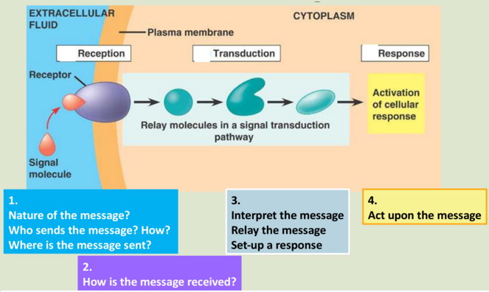
- Act upon the message
Chemical messengers
- Their structure will determine;
  - Their chemical properties (hydrophobic vs hydrophilic)
  - The communication path taken to reach target cell
  - Their mode of action / interaction with the cell and receptors
- 6 classes
  - Steroids
  - Lipids
  - Peptides / proteins
  - Purines
  - Amines
  - Gases
- Paracrine pathway: a signal that is sent to cells that are nearby
- Autocrine: a signal sent to the same cell that it was sent from
  - Used in a large cell that wants to act on a different region of that cell that is further away
- Steroids
  - Derived from cholesterol
  - Lipophilic – cannot be stored in vesicles (endocrine path)
    - Will diffuse or be bound to transport protein (eg albumin)
  - Membrane permeable – can reach intracellular receptors
  - Act as gene transcription factors
    - First step in getting a gene to be expressed (turn on or off) and that determines if a protein will be produced
  - 3 classes of steroids
    - Mineralocorticoids (aldosterone)
    - Glucocorticoids (cortisol)
    - Sex hormones (testosterone/estrogen)
  - Actually enter the cell
- Fatty acids (Eicosanoids): the local hormones
  - Most are derived deom Arachidonic acid
  - Lipophilic
  - Paracrine pathway
  - 2 main pathways lead 2 main classes:
    - Pain: prostaglandins
    - Inflammation: Leukotrienes
- Peptides/protein
  - Hydrophilic
  - Packaged in secretory vesicles
  - Secreted by exocytosis (regulated secretion)
  - Most indirect paths
  - Enzymes are packages with inactive proteins in vesicles
  - They release the messengers through calcium from the endoplasmic reticulum , the concentration of the intracellular calcium can cause the vesicle ot be carried on the cytoskeletal tracks
- Amines
  - Have an amine NH2 group
  - Usually biosynthesised from an amino acid
  - Most are hydrophilic (Reserve pool in vesicles)
  - Many neurotransmitters are amines
  - Examples: Epinephrine, histamine, GABA, and
  - Thyroid hormones (Not packaged because they are hydrophobic, use intracellular receptors like steroids)
- Purines
  - Derived from nitrogenous bases adenine and guanine
  - Need a transporter or can use exocytosis
  - Mainly use paracrine and neuronal paths
  - A lot deal with immune response
- Gases
  - Small molecules, short half-life
  - Passively diffuse
  - Direct and indirect paths
  - Ex: NO, O2, CO, etc
  - Doesn’t rely on transporters and such
  - Vascular homeostasis: NO diffuses from RBCs
    - Triggers relocation of smooth muscle cells lining blood vessels (vasodilation)
  - Gap junctions are direct pathways
- Cell communication paths
- Gap junctions: Direct paths to nearby cells
- Autocrine regulation:
- Paracrine regulation
- Neuroendocrine regulation:
- Classical endocrine regulation: through blood stream
- Exocrine regulation: through a canal
- Receiving the message
- The interaction with the receptor is the first level of discrimination (sets the path to the cell’s response)
- Receptors are proteins; they can be on cell surface or inside the cell
- Ligand (messenger) binding will induce a change in conformation od the receptor protein
- This cats as the trigger for the next phase: signal transduction
- 4 types of receptors
  - Ligand-gated ion channel: when it binds to the receptor it makes a change in conformation that allows the passage of small molecules and ions
  - Receptor-enzyme:The molecule will turn on the enzyme and will act as an enzyme
  - G protein coupled receptors: the g protein is in the cell and when the ligand binds to it the g protein will be activated and do shit inside the cell
  - Intracellular receptor: Used for molecules that can pass through the membrane
    - Can be found in the cytoplasm or in the nucleus
    - Lipophilic or very small ligands will diffuse and reach these receptors
    - The ligand-receptor complex acts as a transcription factor
      - In the nycleus, bind to specific areas of DNA (the gene promoter sequence)
      - Activate or inhibit gene transcriptiojn
      - Transmembrane proteins
        - Integral proteins that span the membtane
        - Ligand binding domain outside the cell
        - Ligansa are mostly hydrophilic
        - Ligand binding induces a change in conformation that relays the message inside the cell – second messengers
        - The ligand itself NEVER enters the cell
        - 3 classes:
- Ligand gated ion channels (many types)
- Enzyme receptors (3 main classes)
- G-protein coupled receptors (GPCTs; many types)
- Lipid rafts
  - Sphingolipids and cholesterol form highly-ordered microdomains or rafts
  - SL hydrocarbon tails are longer and saturated (i.e. not kinked)
  - Rafts are produced in the ER and sent to the plasma membrane
  - Rafts can accommodate proteins with long transmembrane domains
  - Organize and cluster proteins to functions together (eg. For receptor-mediated signaling)

