Lesson 3: The Market Environment
The market environment is one of four environments that need to be analyzed in order to assess the investment climate and market conditions. Information about the market environment can be costly to obtain.

Companies and Real Estate
Companies own real estate for the following reasons:

Stocks and Bonds
- There are a limited number of stocks and bonds
- Studies show that real estate outperforms stocks and bonds
- Studies show that real estate offers higher returns with no increase in risk compared with other investments
- Real estate provides higher overall returns with lower variance if one does not require a high level of liquidity

The Morguard Index of the Toronto Stock Exchange
- The Morguard Index of the Toronto Stock Exchange (TSX) indicates high returns and low risk
- The Morguard Index uses proxy data (appraisal values) which can cause inaccuracies because it fluctuates with market conditions
- The Morguard Index uses quarterly appraisal values to determine returns
- Studies on the Morguard Index show annual data, making it difficult to analyze the data

Appraisal Values and Actual Values
- Studies do not determine the relationship between appraisal values and actual values
- If appraisal values are understated or overstated, they will cause errors in returns

Appraisers
- If, for example, an appraiser deliberately understates the value of a house, he or she indirectly increases the rate of return for the client. If he or she overstates the value of the house, it decreases the rate of return. The following example illustrates this.
- Example:
Cash Flow = $10,000
True Market Value = $100,000
If you hire an honest appraiser, he or she will inform you that your rate of return is 10.00% (simply divide the cash flow by the market value: $10,000/$100,000).
A dishonest appraiser will downplay the market value (undervalue) and inform you that your property is only worth$90,000, and by doing so he or she has increased your rate of return to 11.11% ($10,000/$90,000).
A bad appraiser who overvalues the property decreases your rate of return. If he or she states that the value is$105,000, your rate of return is only 9.52% ($10,000/$105,000).

Information Costs
- The real estate market is segmented (residential, commercial (retail and office), industrial, special purpose and others) which increases information costs
- The real estate market is also segmented based on local market conditions
- Information costs increase the cost of operating real estate portfolios
- Information is difficult to find (commercial, industrial, special purpose) because of low turnover or low number of transactions given in a special period, compared to residential
- Information on real estate (if low turnover) is available through proxy (the use of appraisal values) which increases information costs

Capital Gains
- Capital gains make up a large portion of estimated returns (capital gains equal selling price minus original costs)
- Miles and McCue's study for a regional real estate portfolio indicates that only 14% is market related (not diversifiable), whereas 86% is diversifiable

Advantages and Disadvantages of Owning Real Estate

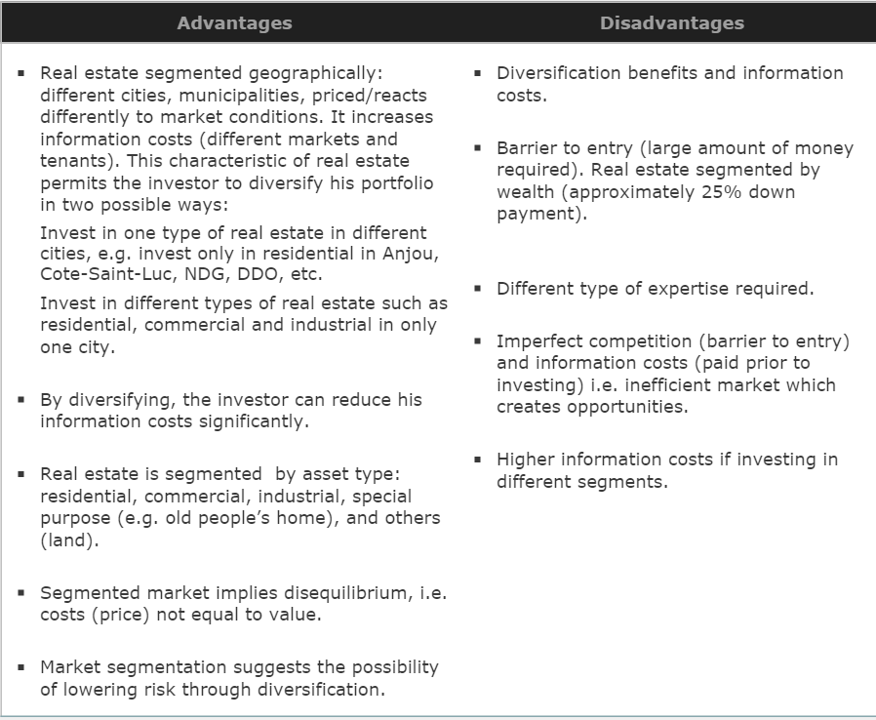

The Real Estate Pricing Puzzle

Why Is Real Estate a Puzzle?
- The present model (Capital Asset Pricing Model – CAPM) being used to value real estate is doing a poor job because it does not consider cash payments.

Performance Justifies the Development of New Models
The market should develop new models because:
- The performance of real estate compared to the other investments in the market justifies this
- Studies show that companies are including large amounts of money in real estate in their portfolios
- The performance of real estate investments outperforms other investments in the market as many studies have indicated
- There is enough order in the financial market to justify this
- Companies hire specialists in real estate for consulting services and to write reports on how good the market is for real estate investments. The companies know that the report will favour investing in real estate prior to acquiring the professional services; they simply need a professional’s name on the report. This is what “studies are done only in good times” implies; it is very rare to find any study conducted when markets are down. Furthermore, inefficiency also exists due to appraisers manipulating the numbers to their advantage and thus increasing rates of return as the above-mentioned example illustrates. Finally, current models do not capture the qualitative aspects that are taken into consideration during a real estate transaction. As mentioned earlier, they only consider risk and return, which is not sufficient.

Problems with Data
- Appraisal values estimated by the appraiser are not the same as the actual values (actual selling price). True market value can only be found when the property is sold; we hire an appraiser to determine a property’s value prior to selling. The value they return is known as a proxy. Appraisers have the habit of downplaying numbers so that when a buyer offers a bid near the true market value one will be pleased with this work.
- Short-run evaluation when real estate investments are long-term investments.
- Sample size will cause sampling errors; i.e., 1/100 compared to 1/99 does not contain much estimation error; however, in real estate the sample size is smaller and therefore the difference between ¼ and ½ is quite significant.
- Un-levered basis (assumed no leverage or debt, 100% down payment). Un-leveled property is that which is purchased with cash only (no loan used).
- Data problems, in addition to the conclusion that real estate gives higher returns and has lower risk compared with other investments, are questionable.

Reasons for Lower Variance
Three possible reasons for lower risk (or variance):
- Rent income is less risky than other income because of contractual agreements or leases
- Stocks and bonds are affected by other factors such as human resources, lumpy investments, immobility and market segmentation
- Management costs are not accounted for in the analysis
So, less risk or variance would be expected. However, less risk or variance does not mean excess return.

Portfolio Implications
- Real estate is negatively correlated compared to the stock market.
- Data problems versus high percentage of portfolio: problems with appraisal values should not stop you from investing in real estate.
- Diversification benefits possible within same market (to reduce information costs), i.e. do not have to evaluate different classes of real estate such as residential, commercial and office.
- Price should reflect mean evaluation of investors.
- Prices should reflect highest and best use, but not true in real estate because a) there is no short selling; b) price adjustment is slower; and c) optimistic opinion (pessimistic will not buy).
- Prices are biased upwards because of the sequential bidding process.
- Real estate prices vary between the average value of potential buyers and the best use of the property.
- Some price inefficiency exists: markets are segmented and not everyone has the capital required to conduct a feasibility study; therefore, inefficiency arises.

Conclusion
- Historical models used in the stock market such as the Capital Asset Pricing Model (CAPM) and the Arbitrage Pricing Model (APM) have proved to be unsuccessful in real estate.
- The Summation approach still works best.
- A gap exists (market price versus mean expected).
- Optimists buy and no short selling, i.e., price estimate less than market price.
- The studies provide a balanced view of current issues.
- There is a need for redefined models.
- Future studies should show or explain how a qualitative variable (i.e., a house is on a corner, pay is in cash, etc.) affects the property value.

Lesson 4: The Legal Environment

The Law of Agency
The legal environment in real estate transactions includes two parties: principal and agent. They are governed by the law of agency.
The law of agency entails rules set forth when another individual is doing something on one’s behalf. In real estate, a principle hires an agent to sell his house, or a principal can hire an agent to purchase a house on his behalf.
Agency is created when one person is given the right to act on behalf of, or under the control of, another. The law of agency concerns the legal rights, duties, and liabilities of the principal (P), the agent (A) and a third party (TP), based on contracts and/or the relationship between them.
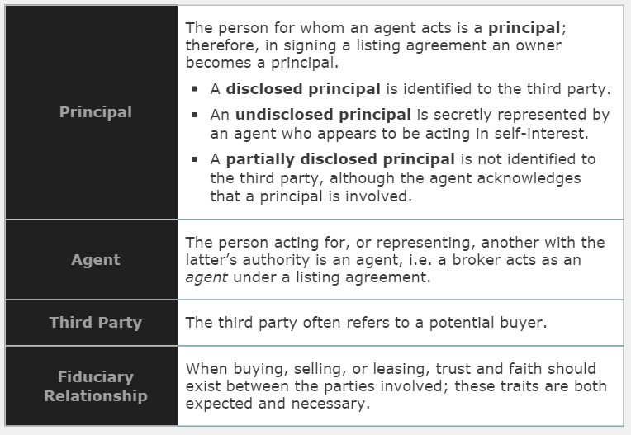

Diagram of the Law of Agency
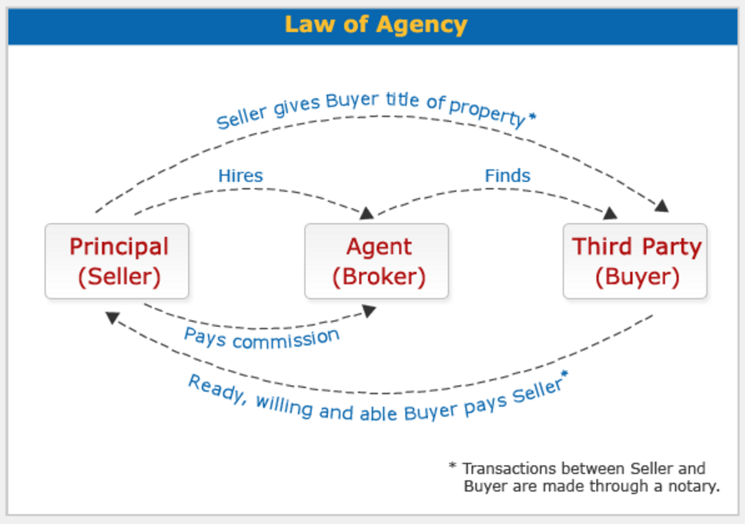

Duties, Liabilities and Rights of Principals and Agents
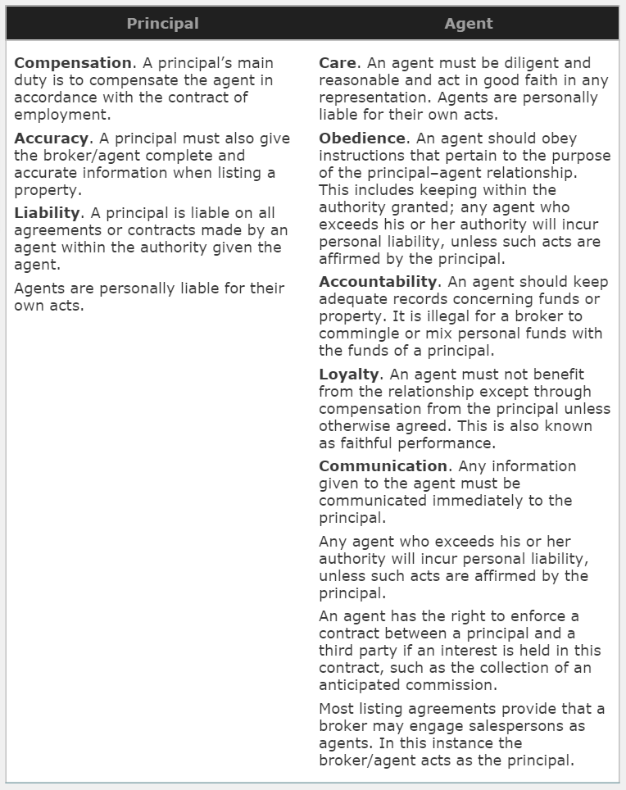

Listing Agreements
A listing agreement is an oral or written contract of employment between a principal and a broker/agent to buy, sell, or lease real estate. The broker/agent needs this agreement in order to enforce his or her right to a commission. This agreement also creates the traditional principal-agent relationship discussed earlier.
- This is the foundation of a broker’s business as it provides the basis of a broker’s trust and confidence in the principal and addresses the right to compensation.
- A typical “listing” is not a contract. Rather, it is a unilateral contract that becomes bilateral upon performance by the broker and is therefore revocable by either party at any time prior to performance.
- Listing agreements may be reached orally, but written agreements are needed in order to collect a commission. Therefore, most brokers refuse to handle a property without a written agreement.
- Most listing agreements provide that a broker may engage salespersons as agents. In this instance the broker/agent acts as the principal.

Types of Listings
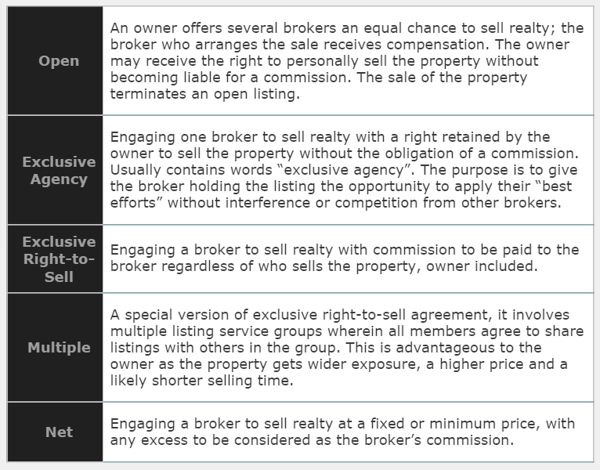

Critical Issues in the Listing Arrangement

Asking Price
- In his or her own self-interest, an owner wants the highest possible price and therefore prefers a high asking price.
- A broker prefers a low listing price for a quicker sale.
- A fiduciary relationship requires that the broker provide the owner with the market value of the property and document that any suggested listing price is not too low.

Reservation of Right-to-Sell
- An owner may retain a right-to-sell without a commission being required, even in an exclusive right-to-sell agreement, by reserving in the contract as exceptions the names of parties with whom negotiations have previously or are currently being conducted.

Broker Compensation
- Commission rates are largely set by local area customs.
- Brokers are prohibited from collusion in setting commission rates.
- The amount of commission or method of determining commission should be included in a listing agreement. Many commission methods are possible.

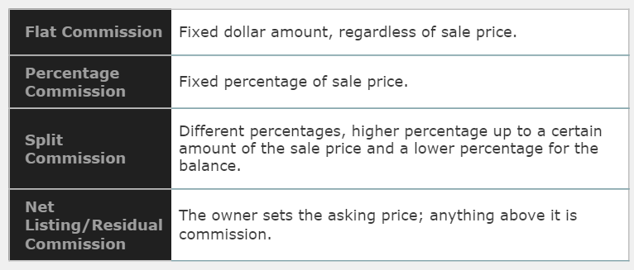

The Termination and Duration of an Agreement
Termination by actions of the parties:
- Mutual consent of the parties
- Completion of the contract by sale
- Time expiration or running-out
- Revocation by the principal
- Revocation or abandonment by the agent

Termination by law:
- Destruction of the property, as by fire
- Death of the principal or agent
- Insanity of principal or agent
- Bankruptcy of the principal or agent

Broker Proof of Performance
- A broker’s obligation is to find a buyer who is “ready, willing, and able” (RWA).
- Failure to complete a sale through fault of the owner (due to title defects, refusal of spouse to sign deed, fraud, the owner changing their mind or requiring terms not included in the listing agreement) does not cancel commission. If a qualified RWA buyer is found, the broker is entitled to commission.
- The owner may include a “no-closing, no commission” clause, which means unless the transaction results in a conveyance of title, no commission need be paid.

Commissions

General Rules on Earning Commissions
To get commission, the broker must:
- Show an agreement or contract of employment
- Be the procuring cause in the sale
- Bring about the deal on the terms of the employer
- Act in good faith
- Produce a purchaser who is “ready, willing and able”
- Arrive at a completed transaction
The employer is liable and must pay commission in every case where performance has occurred.

Commission on Installment Sales
- Owners use installment sales to spread property payments over time in order to keep tax payments low.
- A broker may agree to accept commission in proportion to principal cash payments received by the seller.

Commission on Exchanges, Loans, and Leases
- All parties in an exchange pay a commission based on the value or price of their respective properties. In some instances the broker may receive double commission.
- A broker is entitled to a commission for producing a mortgage loan only if the loan is approved.
- A lease broker is not entitled to compensation unless a lease or a complete agreement on their terms is obtained.

Selecting a Broker
Important considerations in selecting a broker are:
- Office and agent specialization
- Office location and procedures
- The firm’s attitude and reputation
- A positive track record evidenced by satisfied clients

Lesson 5: The Financing Environment
The financing environment exists when a buyer does not have sufficient cash to purchase the property in question; he/she resorts to his/her bank to obtain a mortgage to cover the portion that is missing.

Mortgage
Mortgage is the term used for a loan on a real estate transaction.

It may also go under the name Loan-To-Value ratio.

The following are important terms used to perform financing calculations:

Mortgage Payments
Usually refer to monthly instalments made to your bank in order to reduce your outstanding loan and eventually pay it off entirely.

Mortgage Payment = Interest portion + Principle portion

Principle portion = Mortgage Payment – Interest portion

Mortgage Loan Balance/ Outstanding Loan Balance
The portion of the loan that is still outstanding at any point in time.
Mortgage Loan Balance = Mortgage Loan – Principle portion

Loan-To-Value (LVR) Ratio
The loan expressed as a percentage. In other words, it is the mortgage value that the bank is willing to give you.

EXERCISES

Exercise 1: Mortgage
Given the following information:
 | Property A | Property B
Asking of Property (AP) | $500,000 | $800,000
Property sold for Selling Price (SP) | 90% of AP | 88% of AP
Loan-to-Value Ratio (LVR) | 80% | 70%

Answer the following questions. Some questions have been answered for you to help you complete this exercise:
1. What is the expected seller’s price for Property A?
Answer: $500,000

2. What is the expected seller’s price for Property B?
Answer: $800,000

3. What is the selling price of property A? SP=AP*%given
Answer: $450,000 (500,000*.90)

4. What is the selling price of property B?
Answer: $704,000

5. If the buyer needs a loan (mortgage) for Property A, and LVR is the maximum the bank will lend you, how much is the mortgage loan? Mortgage loan=SP*LVR
Answer: $360,000 (450000*.80)

6. If the buyer needs a loan (mortgage) for Property B, and LVR is the maximum the bank will lend you, how much is the mortgage loan?
Answer: $492,800 (704,000*.70)

Exercise 2: Mortgage Loan Amortization
Given the following information:
 | Property A | Property B
Asking of Property (AP) | $500,000 | $800,000
Property sold for Selling Price (SP) | 90% of AP | 88% of AP
Loan-to-Value Ratio (LVR) | 80% | 70%
Interest rate (Nominal rate) per annum | 8% | 10%
Nominal rate compounded | Annually | Annually
Mortgage payment mode | Annually | Annually
Term | 15 | 25

Answer the following questions. Some questions have been answered for you to help you solve this exercise:
1. Using the Effective Annual rate formula, what is the EAR for property A?
Answer: 8%

2. Using the Effective Annual rate formula, what is the EAR for property B?
10%
3. How many mortgage payments (term) do you have for Property A?
Answer: 15 pmt

4. How many mortgage payments do you have for Property B?
25
5. How much is the mortgage payment per annum for A?
Answer: $42,059 (rounded)

6. How much is the interest portion for property A of the first year?
Answer: $28,800

7. How much is the principle portion for property A of the first year?
Answer: $13,259

8. How much is the mortgage payment per annum for B?
54291
9. How much is the interest portion for property B of the first year?
49280
10. How much is the principle portion for property B of the first year?
5011
11. How much do you owe the bank after the first mortgage payment for property A?
Answer: $346,741 (PRN loan – PRN pd = outstanding mortgage)

12. How much do you owe the bank after the first mortgage payment for property B?

13. How much is the interest portion for property A of the second payment?
Answer: $27,739

14. How much is the principle portion for property A of the second payment?
$14,319
15. How much is the interest portion for property B of the second payment?
$48,779
16. How much is the principle portion for property B of the second payment?

17. How much is the loan balance after the second mortgage payment for loan A?
$332,422
18. How much is the loan balance after the second mortgage payment for loan B?

Exercise 3: Loan Amortization

Answer
Period | Mortgage Pmt. | Interest | Principle | Loan Balance
Year 0 |  |  |  | $360,000
1 | $42,059 | $28,800 * | $13,259 * | $346,741
2 | $42,059 | $27,739 | $14,319 | $332,422
3 | $42,059 | $26,594 | $15,465 | $316,957
4 | $42,059 | $25,357 | $16,702 | $300,255
5 | $42,059 | $24,020 | $18,038 | $282,217
6 | $42,059 | $22,577 | $19,481 | $262,736
7 | $42,059 | $21,019 | $21,040 | $241,696
8 | $42,059 | $19,336 | $22,723 | $218,973
9 | $42,059 | $17,518 | $24,541 | $194,432
10 | $42,059 | $15,555 | $26,504 | $167,928
11 | $42,059 | $13,434 | $28,624 | $139,304
12 | $42,059 | $11,144 | $30,914 | $108,389
13 | $42,059 | $8,671 | $33,388 | $75,002
14 | $42,059 | $6,000 | $36,059 | $38,943
15 | $42,059 | $3,115 | $38,943 | 0

Exercise 5: Mortgage Loan Amortization
Given the following information:
- Value of Property = $500,000
- Loan–Value–Ratio = 80%, therefore Loan = 80% × 500,000 = $400,000
- Term 10 Years
- Interest rates (variable) are as
Year 1 = 8% per annum | Year 2 = 10%
Year 3 = 9% | Year 4 = 7%
Year 5 = 12% | Year 6 to 10 = 11% per annum
Prepare a Loan Amortization Schedule.

Answer
Period | Mortgage Pmt. | Interest | Principle | Loan Balance
Year 0 |  |  |  | $400,000
1 | $59,612 | $32,000 | $27,612 | $372,388
2 | $64,662 | $37,239 | $27,423 | $344,965
3 | $62,326 | $31,047 | $31,280 | $313,686
4 | $58,205 | $21,958 | $36,247 | $277,438
5 | $67,480 | $33,293 | $34,188 | $243,251
6 | $65,816 | $26,758 | $39,059 | $204,192
7 | $65,816 | $22,461 | $43,355 | $160,837
8 | $65,816 | $17,692 | $48,124 | $112,712
9 | $65,816 | $12,398 | $53,418 | $59,294
10 | $65,816 | $6,522 | $59,294 | $0

Solution
Using mathematical formula, solve for pmt Year 1:
Pmt 1 (PVA 8%, 10) = 400000
Using PVA formula, PVA = 6.710081
Therefore, Pmt × 6.710081 = 400000
Pmt Year 1 = 59612
Using financial calculator:
In Calculator
400000
10
8
0
59612
Note:
- Mortgage Payment Year 1 = 59612
- Interest for Year 1 = 8% × Outstanding Loan balance = 32000
- And Principle = Mortgage Payment minus Interest = 59612 – 32000 = 27612
- And New Loan Balance = Outstanding loan balance minus Principle = 372388
Using mathematical formula, solve for pmt Year 2:
Pmt 2 (PVA 10%, 9) = 372388
Using PVA formula, PVA = 5.759024
Therefore, Pmt × 5.995247 = 372388
Pmt Year 2 = 64661
Using financial calculator:
In Calculator
372388
9
10
0
64661
Note:
- Mortgage Payment Year 2 = $64,662
- Interest for Year 2 = ? % × Loan balance = $37,239
- And Principle = Mortgage Payment minus Interest = $27,423
- And New Loan Balance = Old Loan balance minus Principle = $344,965
- Repeat and complete the above table for Year 3 through Year 10

Exercise 6: Compounding Intervals and Payment Intervals

The BANK offers loans at 10% per annum, compounded semi-annually
Therefore the bank's Effective Annual Rate = 10.25% (EFF)

We have 2 customers:

Example: Customer A

Customer A negotiated a $10,000 loan to be repaid monthly over 5 years.
How much is the monthly installment (payment)?

Answer:
Customer A must pay the bank 10.25% per annum, the EFF
If EFF = 10.25%, the Nominal Rate (NOM) = 9.797815% per annum, if paid monthly
The monthly NOM = 0.816485% per month; 60 months; Loan = $10,000
Pmt ( PVA 0.816485%, 60) = 10,000
Pmt = $211.48 per month (rounded)

Example: Customer B

Customer B negotiated a $10,000 loan to be repaid quarterly (every three months) over 5 year.
How much is the quarterly installment (payment)?

Answer:
Customer B must pay the bank 10.25% per annum, the EFF
If EFF = 10.25%, the Nominal Rate (NOM) = 9.878031% per annum, if paid quarterly
The quarterly NOM = 2.469508% per quarter; 20 quarters; Loan = $10,000
Pmt ( PVA 2.469508%, 20) = 10,000
Pmt = $639.63 per quarter (rounded)

Effective Cost of Borrowing (ECB)
Effective Cost of Borrowing (ECB) is a rate expressed in percentage form which takes into consideration the effects of processing fees, cancellation penalties, and so on. Processing costs are fees many banks charge in order to process your mortgage, due to the extensive paperwork and efforts on their behalf.

Exercise 7: No processing fees
Given the following information:
- You have CASH ON HAND to complete the transaction
- You stay for the entire term
- Value of Property = $300,000
- LVR = 70%
- Term = 10 years
- Payable = Annually
- Interest rate = 5% per annum (compounded annually)
- Processing fees = 0
- Cancellation penalty = 0
Answer the following questions.
1. What amount is the maximum loan?
Answer: $210,000

2. How much are the processing costs?
Answer: $0

3. What is the net amount you receive?
Answer: $210,000

4. What is the term?
Answer: 10 years

5. What is the Effective Annual Rate (EAR)?
Answer: 5.00%

6. What is the Mortgage payment per annum?
Answer: $27,196

7. What is the Effective Cost of Borrowing (ECB)?
Note: Solve this exercise using your financial calculator (Recommended Versions: Sharp 733A/735 or TI BA II Plus)
Answer: 5%, because there are no processing fees (see calculations below)
MPmt(PVA_{10,EAR}) = Loan
MPmt(PVA_{10, ECB}) = Loan
Therefore,
ECB = $27,196(PVA_{10, ECB}) = $210,000
NB: The eConcordia online calculator is not designed to calculate ECB. The procedure that you would follow with most hand-held financial calculators to calculate ECB can be found below.

In Calculator
210000
10
-27196
0
5

Exercise 8: With processing fees
Given the following information:
- You have CASH ON HAND to complete the transaction
- You stay for the entire term
- Value of Property = $300,000
- LVR = 70%
- Term = 10 years
- Payable = Annually
- Interest rate = 5% per annum (compounded annually)
- Processing fees = 2% of Loan
- Cancellation penalty = 0
Answer the following questions.
1. What amount is the maximum loan?
Answer: $210,000

2. How much are the processing costs?
Answer: $4,200

3. What is the net amount you receive?
Answer: $205,800

4. What is the term?
Answer: 10 years

5. What is the Effective Annual Rate?
Answer: 5.00%

6. What is the Mortgage payment per annum?
Answer: $27,196

7. What is the Effective Cost of Borrowing (ECB)?
Answer: More than 5%, because of processing fees (see calculations below)
MPmt(PVA_{10,EAR}) = Loan
MPmt(PVA_{10, ECB}) = Loan – processing fees
Therefore,
ECB = $27,196(PVA_{10, ECB}) = $210,000 - $4,200
ECB = $27,196(PVA_{10, ECB}) = $205,800
NB: The eConcordia online calculator is not designed to calculate ECB. The procedure that you would follow with most hand-held financial calculators to calculate ECB can be found below.

In Calculator
205800
10
-27196
0
5.418198%

Exercise 9: No processing fees, no cancellation fees
Given the following information:
- You have CASH ON HAND to complete the transaction
- You stay for 3 years
- Value of Property = $300,000
- LVR = 70%
- Term = 10 years
- Payable = Annually
- Interest rate = 5% per annum (compounded annually)
- Processing fees = 0
- Cancellation penalty = 0
Answer the following questions.
1. What amount is the maximum loan?
Answer: $210,000

2. How much are the processing costs?
Answer: $0

3. What is the net amount you receive?
Answer: $210,000

4. What is the term?
Answer: 10 years

5. What is the Effective Annual Rate?
Answer: 5.00%

6. What is the Mortgage payment per annum?
Answer: $27,196

7. What is the Mortgage Balance after 3 payments?
Answer: $157,366
MPmt(PVA_{10, EAR}) = Loan
$27,196 (PVA_{7, 5.00%}) = $157,366
Note: 7 = 10 – 3 [Loan Period – Years stayed]
Using financial calculator to find mortgage balance after 3 years
In Calculator
0
7
-27196
5
157366

8. What amount is the cancellation penalty?
Answer: $0

9. What is the Effective Cost of Borrowing (ECB)?
Answer: 5%, because there are no processing fees and no penalty fees (see calculations below)
MPmt(PVA_{3, ECB}) + [Mortgage Balance + penalty] (PV_{3, ECB}) = Loan – processing fees
Therefore,
ECB = $27,196(PVA_{3, ECB}) + $157,366(PVA_{3, ECB}) = $210,000
NB: The eConcordia online calculator is not designed to calculate ECB. The procedure that you would follow with most hand-held financial calculators to calculate ECB can be found below.

In Calculator
-157366
3
-27196
210000
5

Exercise 10: With processing fees, no cancellation fees
Given the following information:
- You have CASH ON HAND to complete the transaction
- You stay for 3 years
- Value of Property = $300,000
- LVR = 70%
- Term = 10 years
- Payable = Annually
- Interest rate = 5% per annum (compounded annually)
- Processing fees = 2% of Loan
- Cancellation penalty = 0
Answer the following questions.
1. What amount is the maximum loan?
Answer: $210,000

2. How much are the processing costs?
Answer: $4,200

3. What is the net amount you receive?
Answer: $205,800

4. What is the term?
Answer: 10 years

5. What is the Effective Annual Rate?
Answer: 5.00%

6. What is the Mortgage payment per annum?
Answer: $27,196

7. What is the Mortgage Balance after 3 payments?
Answer: $157,366
MPmt(PVA_{10, EAR}) = Loan
$27,196 (PVA_{7, 5.00%}) = $157,366
Note: 7 = 10 – 3
Using financial calculator to find mortgage balance after 3 years
In Calculator
0
7
-27196
5
157366

8. What amount is the cancellation penalty?
Answer: $0

9. What is the Effective Cost of Borrowing (ECB)?
Answer: More than 5%, because there are processing fees and no penalty fees (see calculations below)
MPmt(PVA_{3, ECB}) + [Mortgage Balance + penalty] (PV_{3, ECB}) = Loan – processing fees
Therefore,
ECB = $27,196(PVA_{3, ECB}) + $157,366(PVA_{3, ECB}) = $210,000 - $4,200
ECB = $27,196(PVA_{3, ECB}) + $157,366(PVA_{3, ECB}) = $205,800
NB: The eConcordia online calculator is not designed to calculate ECB. The procedure that you would follow with most hand-held financial calculators to calculate ECB can be found below.

In Calculator
-157366
3
-27196
205800
5.808460

Exercise 11: No processing fees; with cancellation fees
Given the following information:
- You have CASH ON HAND to complete the transaction
- You stay for 3 years
- Value of Property = $300,000
- LVR = 70%
- Term = 10 years
- Payable = Annually
- Interest rate = 5% per annum (compounded annually)
- Processing fees = 0
- Cancellation penalty = 2.5% of outstanding mortgage balance
Answer the following questions.
1. What amount is the maximum loan?
Answer: $210,000

2. How much are the processing costs?
Answer: $0

3. What is the net amount you receive?
Answer: $210,000

4. What is the term?
Answer: 10 years

5. What is the Effective Annual Rate?
Answer: 5.00%

6. What is the Mortgage payment per annum?
Answer: $27,196

7. What is the Mortgage Balance after 3 payments?
Answer: $157,366
MPmt(PVA_{10, EAR}) = Loan
$27,196 (PVA_{7, 5.00%}) = $157,366
Note: 7 = 10 – 3
Using financial calculator to find mortgage balance after 3 years
In Calculator
0
7
-27196
5
157366

8. What amount is the cancellation penalty?
Answer: 2.50% × $157,366 = $3,934

9. What is the Effective Cost of Borrowing (ECB)?
Answer: More than 5%, because there are penalty fees (see calculations below)
MPmt(PVA_{3, ECB}) + [Mortgage Balance + penalty] (PV_{3, ECB}) = Loan – processing fees
Therefore,
ECB = $27,196(PVA_{3, ECB}) + $157,366 + $3,934(PVA_{3, ECB}) = $210,000
ECB = $27,196(PVA_{3, ECB}) + $161,300(PVA_{3, ECB}) = $210,000
NB: The eConcordia online calculator is not designed to calculate ECB. The procedure that you would follow with most hand-held financial calculators to calculate ECB can be found below.

In Calculator
-161300
3
-27196
210000
5.640387

Exercise 12: With processing fees; with cancellation fees
Given the following information:
- You have CASH ON HAND to complete the transaction
- You stay for 3 years
- Value of Property = $300,000
- LVR = 70%
- Term = 10 years
- Payable = Annually
- Interest rate = 5% per annum (compounded annually)
- Processing fees = 2% of Loan
- Cancellation penalty = 2.50% of Loan
Answer the following questions.
1. What amount is the maximum loan?
Answer: $210,000

2. How much are the processing costs?
Answer: $4,200

3. What is the net amount you receive?
Answer: $205,800

4. What is the term?
Answer: 10 years

5. What is the Effective Annual Rate?
Answer: 5.00%

6. What is the Mortgage payment per annum?
Answer: $27,196

7. What is the Mortgage Balance after 3 payments?
Answer: $157,366
MPmt(PVA_{10, EAR}) = Loan
$27,196 (PVA_{7, 5.00%}) = $157,366
Note: 7 = 10 – 3
Using financial calculator to find mortgage balance after 3 years
In Calculator
0
7
-27196
5
157366

8. What amount is the cancellation penalty?
Answer: 2.50% × $157,366 = $3,934

9. What is the Effective Cost of Borrowing (ECB)?
Answer: More than 5%, because of processing and penalty fees (see calculations below)
MPmt(PVA_{3, ECB}) + [Mortgage Balance + penalty] (PV_{3, ECB}) = Loan – processing fees
Therefore,
ECB = $27,196(PVA_{3, ECB}) + $157,366 + $3,934(PVA_{3, ECB}) = $210,000 - $4,200
ECB = $27,196(PVA_{3, ECB}) + $161,300(PVA_{3, ECB}) = $205,800
NB: The eConcordia online calculator is not designed to calculate ECB. The procedure that you would follow with most hand-held financial calculators to calculate ECB can be found below.

In Calculator
-161300
3
-27196
205800
6.452849

Exercise 13: Choose a Bank
Given the following information:
- Mortgage is payable annually
- You stay for the entire term
Bank A |  | Bank B
Value of Property | $200,000 | Value of Property | $200,000
Loan-to-Value Ratio | 60% | Loan-to-Value Ratio | 60%
Loan | $120,000 | Loan #1 | $100,000
Interest Rate | 11% | Interest Rate | 9%
Term | 20 years | Term | 20 years
Processing fees | 0 | Loan #2 | $20,000
 |  | Interest | 14%
 |  | Term | 20 years
 |  | Processing fees | 0
Which bank should you choose for the $120,000 mortgage loan?

Find the following information to answer the question.

Alternative 1
1. What is the Mortgage Payment per annum for Loan A?
Answer: $15,069
MPmtA(PVA_{20,11%} ) = Loan
MPmtA(PVA_{20,11%}) = $120,000
Mortgage Payment for Bank A = MPmtA = $15,069
In Calculator
0
20
11
120000
15,069

2. What is the Mortgage Payment per annum for Loan B?
Answer: $13,975

Loan #1
MPmtB(PVA_{20,9%}) = Loan #1
MPmtB(PVA_{20,9%}) = $100,000
MPmtB # 1 = $10,955
In Calculator
0
20
9
100000
10955

Loan #2
MPmtB(PVA_{20,14%}) = Loan #2
MPmtB(PVA_{20,14%}) = $20,000
MPmtB # 2 = $3,020
In Calculator
0
20
14
20000
3020

Loan #1 + Loan #2
Total Mortgage Payment = MPMT B1 + MPMT B2
Total Mortgage Payment = $10,955 + $3,020
Total Mortgage Payment = $13,975
Total Mortgage Payment for the two loans of Bank B = MPmtB = $13,975

3. Choose the lower Mortgage Payment.
Answer: Loan B

Alternative 2
1. What is the Effective Cost of Borrowing (ECB) for Loan A?
Answer: 11.00%
MPmtA(PVA_{20, ECB}) = Loan – processing fees
ECB_{A} = $15,069(PVA_{20, ECB}) = $120,000
NB: The eConcordia online calculator is not designed to calculate ECB. The procedure that you would follow with most hand-held financial calculators to calculate ECB can be found below.

In Calculator
0
20
-15069
120000
11

2. What is the Effective Cost of Borrowing (ECB) for Loan B?
Answer: 9.874909%
MPmtB(PVA_{20, ECB}) = Loan – processing fees
ECB_{B} = $13,975(PVA_{20, ECB}) = $120,000
NB: The eConcordia online calculator is not designed to calculate ECB. The procedure that you would follow with most hand-held financial calculators to calculate ECB can be found below.

In Calculator
0
20
-13,975
120000
9.874909

3. Choose the lower ECB.
Answer: Loan B
Note: Your choice is the same whether you use Alternative 1 or 2.

