FINA 200 Final Exam Study Guide
Overview of Key Statements
- Personal Balance Sheet (Page 52)
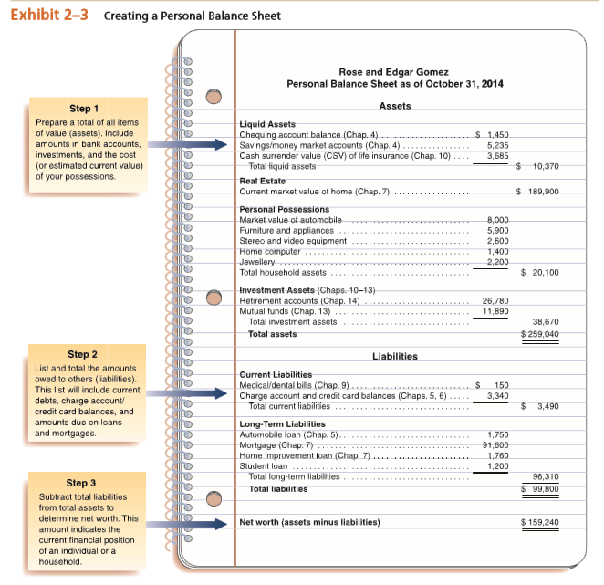
- Assets – Liabilities = Net worth
- What are assets?
  - What are liquid assets?
    - Checking accounts
    - Saving Accounts/Money Market Accounts
- What is liability?
  - Long-term (more than 1 year) vs. current (less than 1 year)
- How to increase Net Worth
  - Increase savings, reduce spending, increase investment value, reduce debts
1. Setting financial goals.
2. Estimating income.
3. Budgeting emergency fund and savings.
4. Budgeting fixed expenses.
5. Budgeting variable expenses.
6. Recording spending amounts.
7. Reviewing spending and saving patterns.
- Cash Flow Statements (Page 54)
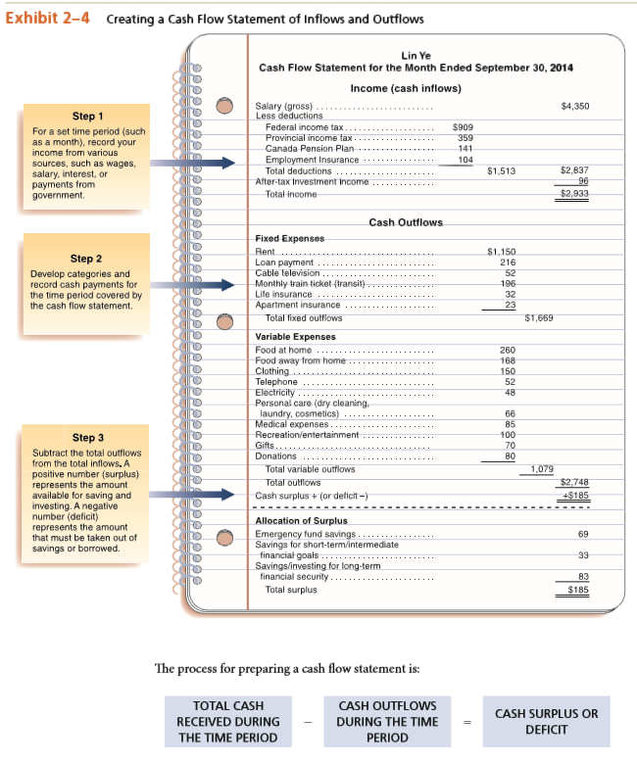
- What is income?
  - Wages, salaries, commissions, investment income, gifts, grants, government payments, pensions, alimony, etc.
- Deductions at source?
  - Federal Income Tax
  - Provincial Income Tax
  - CPP and QPP
  - EI (Employment Insurance)
- What is a Fixed Expense?
  - Rent, cable, loan, monthly train ticket
- What is a Variable Expense?
  - Food, clothing, phone, electricity
- Net Cash Outflow
  - Surplus
- How is it allocated?
  - Deficit
  - How is it financed?
    - Made up with withdrawals from savings.

- Personal Income Taxes (page 74):
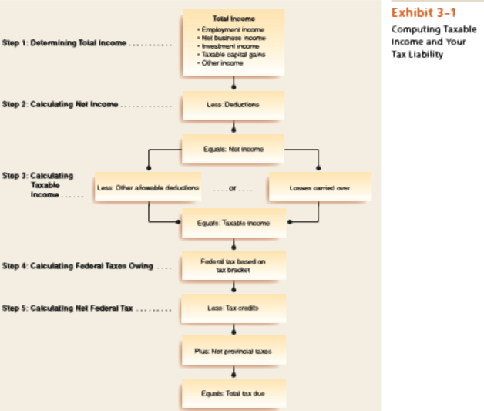
Step 1: Calculate Total Income
Step 2: Calculate Net Income
Step 3: Calculate Taxable Income
Step 4: Apply personal tax rates to calculate tax bill
Step 5: Calculate net federal tax
Step 6: Calculate refund or balance owing
Step 1: Calculate Total Income:
- Employment income, net business income, investment income (dividends), taxable capital gains (38% for eligible, 18% non-eligible), retirement income (CPP, EI, OAS, spousal)

Step 2: Less deductions
- RRSP/ RPP contributions, union dues, child care expenses, disability support, moving expenses (if you move 40km closer to work/school), employment expenses.
Step 3: Calculate Taxable Income
- Apply tax deductions
- Capital gains deduction (50%), losses from prior years.
Step 4: Calculate federal taxes owing
- Apply tax rate.
Step 5: Calculating Net Federal Tax
- Apply tax credits.
- Apply tax rate to the tax credits.
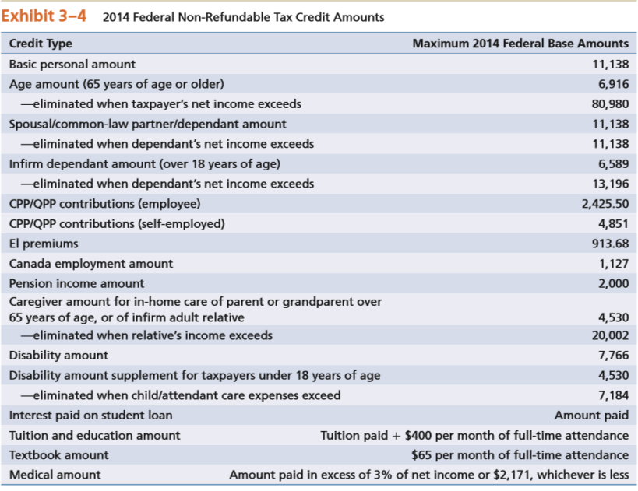
Contributions to:
- TFSA
  - 2009-2012: $5000, 2013-2015: $5500
  - At any point in the month if you are in excess, you will be taxed at 1% of excess in that month.
  - This earned income will not trigger clawbacks from GIS, OAS.
- RRSP
  - Contribution limit of $24,270 in 2014.
  - Contribute up to 18% of prior years income + any contribution room carried forward from prior years.
  - Amount allowed to contribute is diminished by amount your employer set aside for your retirement pension.
- RPP
  - Set up by employer for employee.
  - You must become vested in order to keep the benefits provided by your employer.
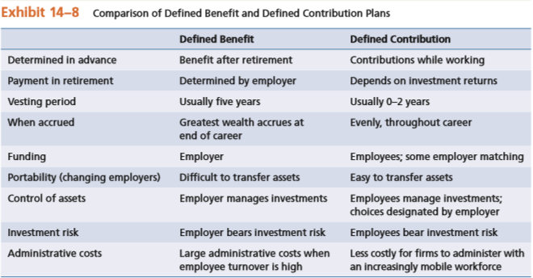
  - DCPP
    - Amount in this pension depends on contributions made and growth in those funds (like RRSP).
  - DBPP
    - Amount received in this pension is known in advance and is based on percentage of actual salary over a specified number of years.

Withdrawals and impacts from:
- RRSP
  - Must deregister by end of year of 71st birthday
  - 1) Full Withdrawal and pay income tax
    - Withholding tax: amount < 5000 = 10%, amount between 5001 to 15,000 = 20%, amount > 15,001 = 30%.
    - Full withdrawal added to your taxable income and withholding tax is entered as tax already paid.
  - 2) Sing-payment life annuity.
    - Life insurance company converts funds into lifetime income, marginal tax rate is based on annual income.
  - 3) Fixed- term annuity
  - 4) RRIF
    - Similar to RRSP except with minimum withdrawals required.
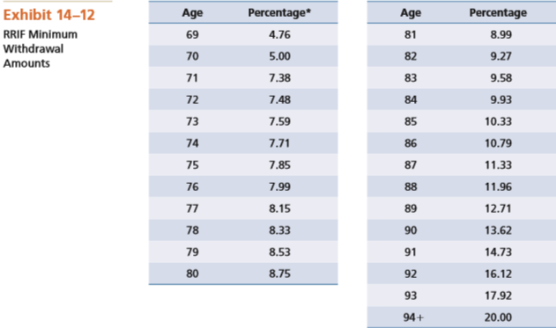
  - 5) LIF
    - Must withdraw a minimum amount every year
    - Purchase an annuity at age 80 with remaining funds.
  - 6) Segregated Fund
    - Guaranteed return of capital of certain percentage.
- HBP
  - Withdraw up to $25,000 as first time home buyer. (double amount for couples)
  - Repay over 15 years
- LLP
  - Up to $10,000 a year for total of 2 years = $20,000.
  - Must repay over 10 years, starting in the last year of study.
  - Any amount unpaid will be included as income for that year.
You can roll over RRSP to your spouse without tax.
- Time Value of Money
- Loans: Payments and Balances
  - Mortgages
    - Measured using GDS (30-32%) / TDS (40%) ratios
  - Lines of credit
    - Home equity line of credit you can borrow up to 65% of appraised value of home, minus mortgage loan balance.
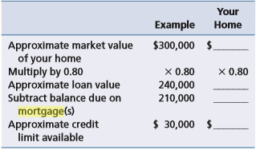
  - Credit cards. (Draw a Timeline)
    - Adjusted balance method
      - balance you end the month with
    - Previous balance method
      - Balance you start the month with.
    - Average daily balance method
      - With payments
      - Without payments
  - For each type of loan, know how to calculate the first, and second month’s payments.
  - How much is interest and how much is principle.
- Investments
  - Investment returns
    - Interest, dividends and capital gains (all part of total income)
      - How are these taxed
      - Dividends:
        - Eligible dividends are grossed up 38%
        - Non-eligible grossed up 18%
        - Then apply federal/ provincial tax.
  - Characteristics of:
    - Bonds, preferred shares, common shares.
  - Mutual Funds
    - Definition, advantages (diversification), disadvantages (FEES).
- Sources of Retirement Income (Case Questions)
- CPP/ QPP
  - Mandatory contribution amount
  - What is the maximum benefit that can be given
  - Reduced amounts for taking early (earliest 60)
  - Increased amounts for taking later (latest 70)
  - Benefits for life, indexed for inflation.
  - Survivor benefits.
- OAS
  - Non contributory
  - Based on length of Canadian residency
  - Maximum benefit will be given?
  - Starts at age 65
  - Benefits for line, indexed to inflation
  - No survivor benefits
  - Clawback calculation (if you make over the limit)
    - OAS must be repaid at a rate of 15% for every dollar of net income in excess of $71,562.
- RPPs
  - Defined Benefit Plan (DBPP)
    - Not mandatory, may be contributory
    - Retirement income is defined by a formula:
      - (%) X (# of years of service) X (average salary)
    - Risk lies with employer
    - May or may not be indexed to inflation
    - Locked in until a minimum age (usually 55 years old)
  - DCPP
    - Not mandatory, may be contributory
    - Retirement income unknown, based on contributions, investment performance and withdrawal choice.
    - Risk with employee.
    - Locked in until min (usually 55 years)
  - TFSA
    - Know how to calculate
  - RRSP
    - Contribution room = 18% of prior years’ income – pension adjustment + carry forward room.
    - Contributions are tax deductible
    - Withdrawals are taxable
    - Can contribute to spousal RRSP
    - Must be deregistered by Dec 31st of age 71.
  - Annuities
  - RRIF
    - Minimum withdrawal based on age
    - Potential growth subject to investment choices.
  - Withdrawal Stage
    - Delay CPP/ QPP if longevity is possible
    - Split income with spouse to avoid to avoid OAS clawback
    - Choose mix of annuity/ RRIF for DCPP, RRSP, and TFSA funds depending on need for income.
- Estate Planning
- Wills: holograph, legal, notarial
- Choice of executor (liquidator in Quebec) and their role.
- Consider use of testamentary trust for minors or vulnerable beneficiaries.
  - Inter vivos
    - Trust starts while you’re alive
  - Testamentary Trust.
    - Assets are protected from the beneficiary’s creditors.
    - Effective upon death
- Insurance Needs
- Types of insurance
  - Home/ Property
    - Home insurance
      - Named perils
      - All risk
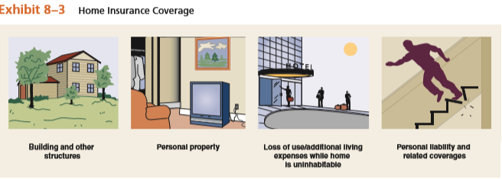
    - Tenant’s Insurance
  - Liability insurance

- Insurance needs calculation
  - Co-insurance clause
    - Requires you pay a portion of the property if it was not insured for specified percentage of the replacement value.
  - Actual Cash Value (ACV)
    - A claim in which the insured receives payment based on the current replacement cost of a damaged or lost item, less depreciation.
  - Replacement Value
    - Method in which the insured receives the full cost of repairing or replacing a damaged or lost item.
- Risk strategies – avoid, reduce, assume, shift
- Personal risk – disability, health, and death.
- Property – home, car, personal possessions
  - Automobile insurance coverages
    - No-fault insurance
      - Drivers involved in accidents collect medical expenses, lost wages, and related injury costs from their own insurance companies.

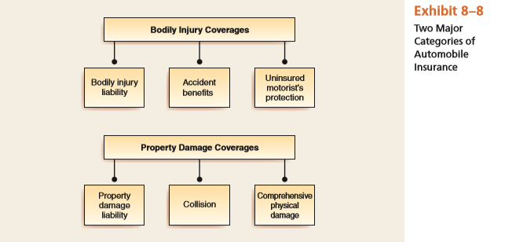
- Life and Disability Insurance (one question)
- Life insurance
  - Estimating your life insurance requirements
Income Replacement Method
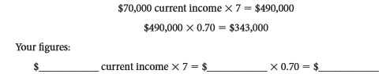
    - Beneficiary
      - A person designated to receive something, such as life insurance proceeds, from the insured.
    - Non-forfeiture Clause
      - Provision that allows insured not to forfeit all accrued benefits.
    - Incontestability Clause
      - A provision stating that insurer cannot dispute the validity of a policy after a specified period.
- Disability
- Long-term care
  - Provides day-in, day-out care for long-term illness or disability.
- Critical illness

Financial Planning Process
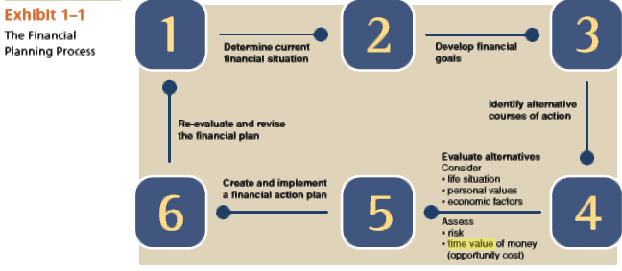
Effective Annual Rate (EAR)
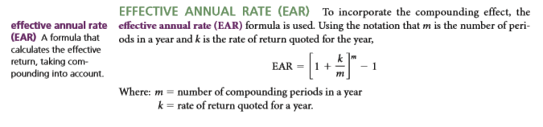
Dividends Tax
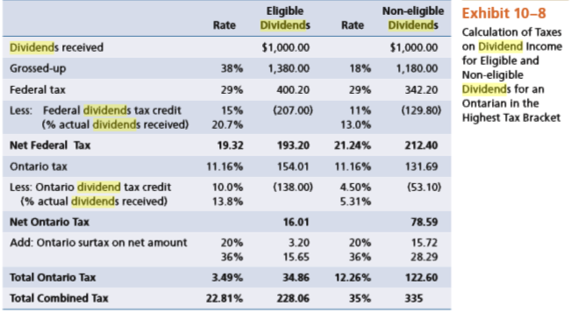

Mutual Fund Fees
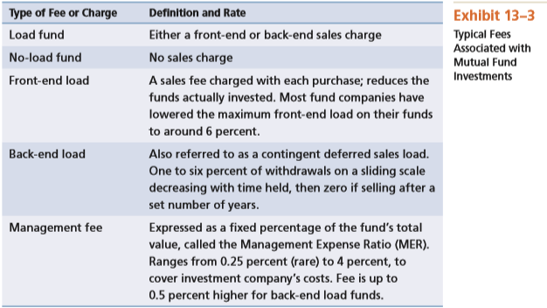
Chapter 10 Risk Factors
Business Risk
- Associated with investments in common, preferred stocks, corporate bonds.
Inflation Risk
- Risk that return on investment will not keep up with rate of inflation
Interest Rate Risk
- Associated with fixed-return investments in preferred stocks or government/ corporate bond. The value decreases when overall interest rates increase.
Market Risk
- Prices of stocks, bonds and mutual funds that invest in both types of securities may fluctuate because of changes in the economic environment.
Global Investment Risk
- Risks from stocks and bonds from international investments.

Types of Life Insurance
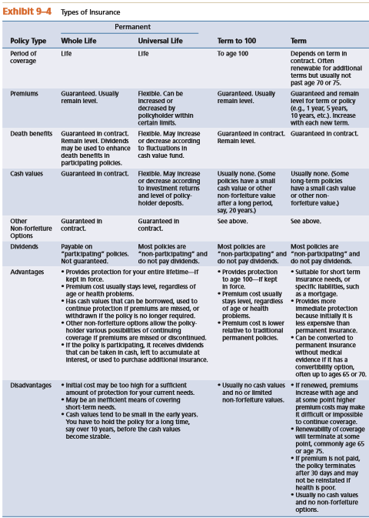
Examples of Consumer Loans vs Revolving Credit
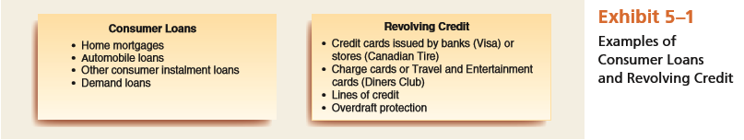
Where To Keep Financial Records
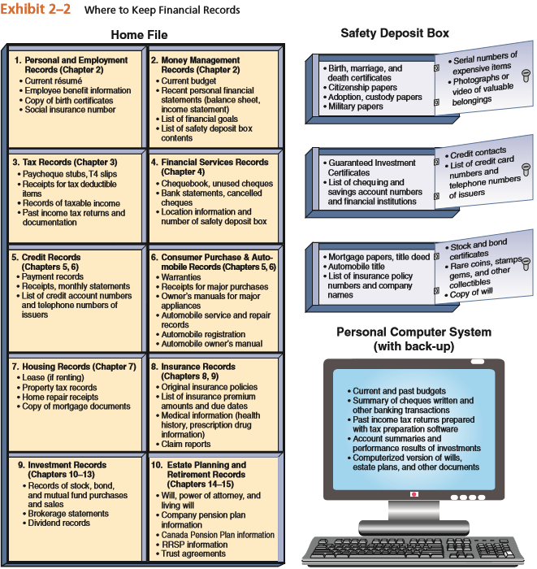

Calculation of Federal Personal Tax
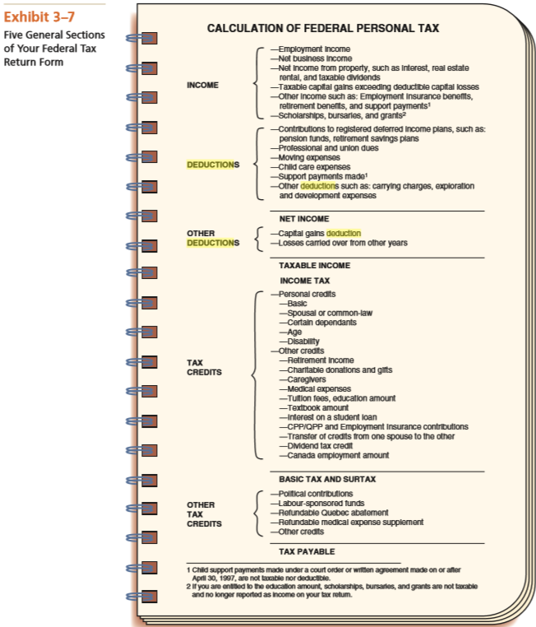

Cost of Buying Vs Leasing a Car
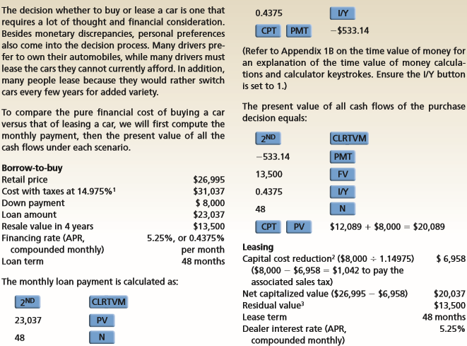
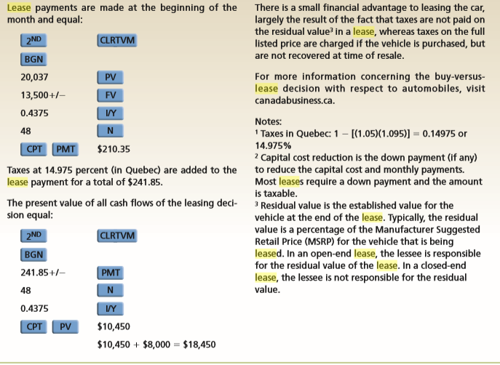

Non Refundable Tax Credits
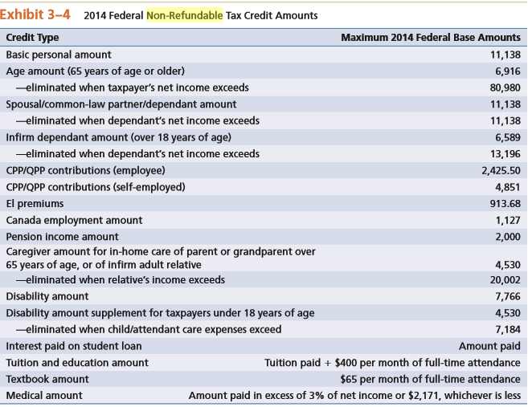
GDS / TDS Ratios
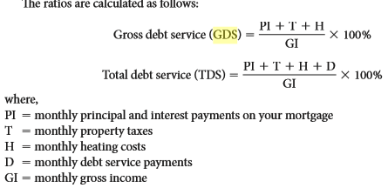
Net Asset Value of Open-End fund
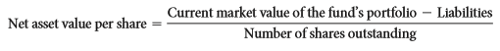
Front End Load = NAV/ (1-%)
Back End Load = NAV x (1-%)

MER
MER = Management fees and other expenses
Daily Average net asset value

