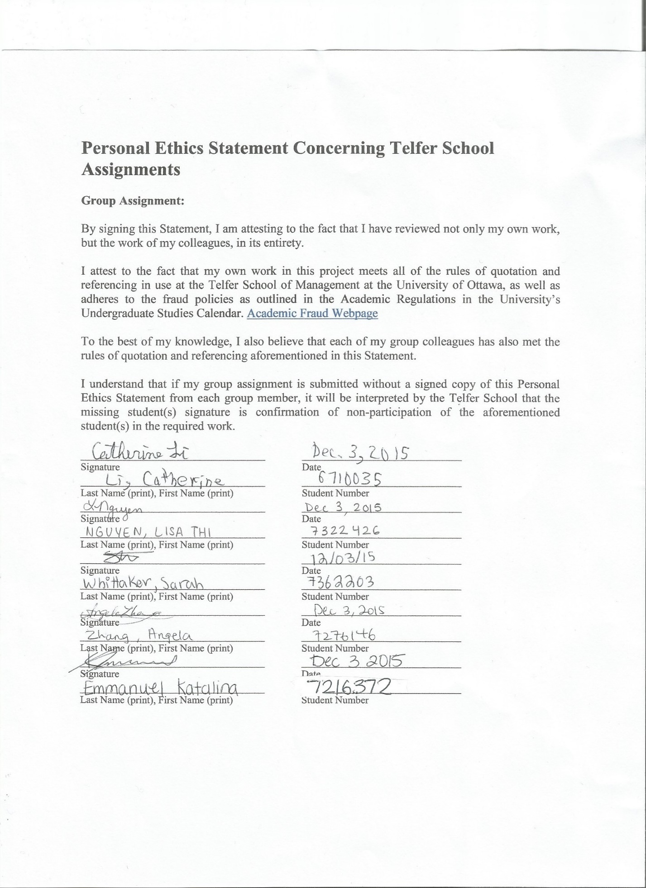
Introduction
Nowadays, companies have come to understand that technology significantly influences all facets of their business activities. The formation of Web 2.0 technologies has provided opportunities for organizations to become innovative and progressive. However, not all organizations are able to stay competitive – many have fallen behind because they did not know to what extent business can be affected.
The BT Group plc (BT), the world’s oldest communications company, realized that they could leverage social media, a Web 2.0 technology, and couple it with customer relationship management (CRM) capabilities. They described CRM as a critical activity for BT Retail, and launched a number of initiatives that leveraged web tools to reach customers (Orlikowski & Thompson, 2010)
BT created a customer service infrastructure called Debatescape, that allows support agents to interact with and assist customers who are posting on third party forums, blogs, and twitter (Orlikowski & Thompson, 2010). Graeme Stoker, General Manager of Digital Care at BT Consumer, stated that, “BT has been very much of the opinion that if customers wanted to talk to us, they’d come to us…we should be taking ourselves to where our customers are and engage with them on their terms…” (Orlikowski & Thompson, 2010). The goals for Debatescape include (1) to identify what customers were saying, and where they were saying things (2) to find a way to interact with them in those domains, and (3) keep all interactions manageable from within a customer service environment (Orlikowski & Thompson, 2010).
In developing Debatescape, two problems came up: (1) find all customers who were expressing their “pain” and focus attention on them, and (2) develop a process that operationalized the problem resolution and made it traceable and scalable (Orlikowski & Thompson, 2010). Through their development process, BT was able to significantly decrease these problems. They also created a matrix defined in two dimensions, (1) realizing short-term results while also creating conditions for future growth, and (2) cultivating core internal capabilities while also remaining open to fresh perspectives and emerging technologies from the outside (Orlikowski & Thompson, 2010).
The purpose of this document is to assess the effectiveness of Debatescape through a SWOT analysis. Afterwards, recommendations will be provided based on a SWOT matrix.
SWOT Analysis
Strengths
Debatescape offers several significant strengths to BT. In terms of the cost, Debatescape adds business value by offering a cheaper, easier, and quicker way to interact with customers. Efficiency leads to significant decreases in cost, in different ways: (1) reduces the chance of complaints escalating to high levels (very expensive), (2) reduces the chances of customers going to the competition, and (3) leverages responses in social media to reduce overall interactions with BT service agents (Orlikowski & Thompson, 2010). BT has also seen a ROI of 181%, an increase in positive customer reputation, and reduction in customer dissatisfaction. These practices have enhanced BT’s reputation, legitimacy, identity, and brand (Orlikowski & Thompson, 2010), which has generated positive word of mouth between customers. BT’s innovative practices mean that a large number of issues can be remedied when customers’ time is free (asynchronous and synchronous), and interactions are recorded and textual, which produces visible, searchable, growing, and persistent repositories of questions and resolutions. This also increases the transparency and accountability of all parties involved in the conversation (Orlikowski & Thompson, 2010).
Weaknesses
It is very difficult to precisely quantify the benefits of social media involvement. The complete set of benefits and consequences from using Debatescape have yet to fully appear, hence the net results may be negative. While the program has up to now functioned properly, it is still in the trial phase of production. There are significant costs associated with the program’s maintenance, which is said to increase as discovery of customers’ complaints increases. BT may even encourage temporary solutions instead of permanent ones by focusing on complaint resolution instead of product improvement. Customers could develop unrealistic expectations of the company instantly solving every problem that is mentioned. Since the nature of interaction between BT and customers is asynchronous, delayed responses can harm the company’s reputation. “Making sure that the advisors are really trained to be able to counter anything that comes their way,” is a quote referring to the consequences of having to further thoroughly train typical service agents in terms of how to use Debatescape properly (Orlikowski & Thompson, 2010). Debatescape “operates on a cloud infrastructure that BT doesn’t control or own”. BT managers thus do not have influence over the cloud, which leaves BT at risk of data breaches and data loss.
Opportunities
Debatescape offers the potential for growth into new markets, to build new products and opportunities, develop new relations, and learn more about customers (Orlikowski & Thompson, 2010). New practices and norms of interaction can be created to suit the new medium that has been developed. Customer service will become more efficient if it takes social media into account. Debatescape could significantly improve contact centres by giving real time information to update a web-based self-service system as well as call scripting systems. This could produce predictions about future complaints and help BT understand patterns of problems in the development of their project. Assuming Debatescape is successful in the long run, BT could sell its concept to other corporations in the form of product trials. This is an opportunity to generate more revenue and working capital that can be used to further refine the product. There is also the potential to further increase a positive social media presence, and learn more about customers to increase customer loyalty and sales. Online customer service agents in this domain can gain more expertise than specialists to solve a larger variety of customer problems.
Threats
Debatescape could encounter privacy issues in the future. Other organizations or individuals may pirate and counterfeit the software, assuming that competitors have not already adopted the social media approach. If BT’s customer service is not as good or better than their rivals, they may lose customers to competitors who are already targeting BT’s online interactions. There is also the potential for libel lawsuits if interactions between BT and customers take a wrong turn. BT has yet to mention any contingency or disaster recovery plans. For example, some social media platforms that Debatescape interacts on do not have 24/7 support; therefore, this leaves inquiries to be left unanswered for long periods of time or not at all. Without improved service or a contingency plan, problems can escalate out of control when BT is offline or unaware of a complaint. BT also cannot solve problems associated with third party sites, such as the erroneous suspension of BT’s account on a social media site.

SWOT Matrix
 | Strengths | Weaknesses
Opportunities | CRM has become more direct and efficient through social media involvement | Customers have control over online presence, customer service CRM and contact centres have improved
Threats | Debatescape is rapidly expanding, a change management system should be implemented | Third party sites can shut down Debatescape interactions, project is experiencing scalability issues

S-O strategies: pursue opportunities that are a good fit to the company’s strength
W-O strategies: overcome weaknesses to pursue opportunities
S-T strategies: identify ways that the firm can use its strengths to reduce its vulnerability to external threats
W-T strategies: Establish a defensive plan to prevent the firm’s weaknesses from making it highly susceptible to external threats

Recommendation

Debatescape is a software that searches through dozens of sites, which makes it possible to create a data warehouse specifically about customer complaints. Techniques such as data mining and statistical research could reveal insights often unseen with information, such as trends concerning customer problems. Association detection for example, can be used to determine relationships between different types of customers to the frequency of different types of problems. The management of Debatescape itself could follow an iterative approach to deal effectively with scope creep, and be the basis of a change management system. The extreme programming methodology is recommended, due to the need for rapid improvement and implementation to meet reliability demands from customers. The project is divided into tiny phases that must be completed sequentially. By completing stages step by step, this prevents errors from escalating online, and reduces the risk of the company’s reputation being harmed from carelessness. To prevent online interactions from being delayed, a hot site could be established where BT would move their operations to if a disasters occurs, and a backup should be maintained for the information itself. Encryption should be used to prevent Debatescape from being compromised, as hackers can manipulate the software for their own purposes. The most difficult matter involves the liabilities of relying on third party social media sites. BT should encourage ongoing relationships with these sites, to work towards developing an information policy that reduces the risk of violation in terms of content and privacy.

Conclusion
BT has taken an effective first mover approach to using social media for closer and improved customer relationship management. Customer satisfaction and retention have significantly improved, and in return, BT’s reputation has been positively affected. The company’s concerns with moving beyond the pilot phase, can be countered with relevant usage of iterative development, specifically an agile methodology such as extreme programming. This approach will address issues such as scalability and reliability, by reducing the risk of software programming errors. Opportunities are abundant, especially with the creation of a data warehouse and applying data mining techniques to help BT understand customer demands. The online world is a forever evolving and unforgiving medium, but BT has the chance to continue with its competitive advantage, if they are willing to take the initiative of further developing Debatescape through careful change management.

References
Orlikowski, W., & Thompson, S. (2010). Leveraging the Web for Customer Engagement: A Case Study of BT's Debatescape. MIT Sloan Management.

