Podcasts

Entrepreneurs are “hero’s”. But it used to be considered bad. Entrepreneurship clubs seems to be most popular among high schools. 1 in 5 biz school graduates will be working for a start up or a high tech firm right after graduation.

Entrepreneur is someone who arbitraged resources from a low yield to a high yield opportunity even if he/she did not own such resources. Innovators, who create high-growth organizations around new products, processes, business models, etc. Replicative are those who set up small businesses. Innovative entrepreneurs disrupt and transform existing businesses as well as established ways of doing things (small businesses vs high-growth).

Walmart became a retailing giant by replacing thousands of “mom’n’pop” shops. Amazon became a book-selling giant by driving thousands of booksellers out of business.

Bill Gates and Steve Jobs are “fairy-tale hero’s”. Entrepreneurship degree will help you: first, anticipate the learning curve you will have with your business and second, preparation and training before “combat”.

Lectures
The number of common markets that the company serves. If on firm serves market X and
Overlpap of markets between the two firms.
The more markets you and I overlap, the less likely you and I are to go to war.
The fewer markets you and I overlap, the more likely you and I to go to war.

Strategy in Disruptive Technology Contexts
(9/23)

Technology - Body of scientific knowledge used in production of goods/services;
Disruptive technology (i.e. “high tech”) industries:
- One where ‘technology’ evolves rapidly, influencing the dynamics of buyer tastes and demand, as well as characteristics of complementary products/services.
- ‘Revolutionary’ x ‘Evolutionary’ technological innovation - whats the difference?
  - Not just speed…
  - Breaks down established industrial patterns (buyers/suppliers/complementors); e.g., Transport: Uber, Mars, US-Euro 3 hr train.
  - Who invented the “print press”? Airplanes?

High-tech industries are characterized by having technical standards
What are technical standards? Are they sources of competitive advantage?
-Technical specifications that producers, users, complementors adhere to.
- Digital x Analog, 3-hole power outlet,
- Various forms of social etiquette
- Apple’s patented “half height” 3.5mm headphone jack (for thinner iPhone 7)
-Sources of advantage exists only when…
-Firm owns either the format or the key resources that easily and quickly unlocks coordination between producers/users/complementors (e.g., Uber “app”)
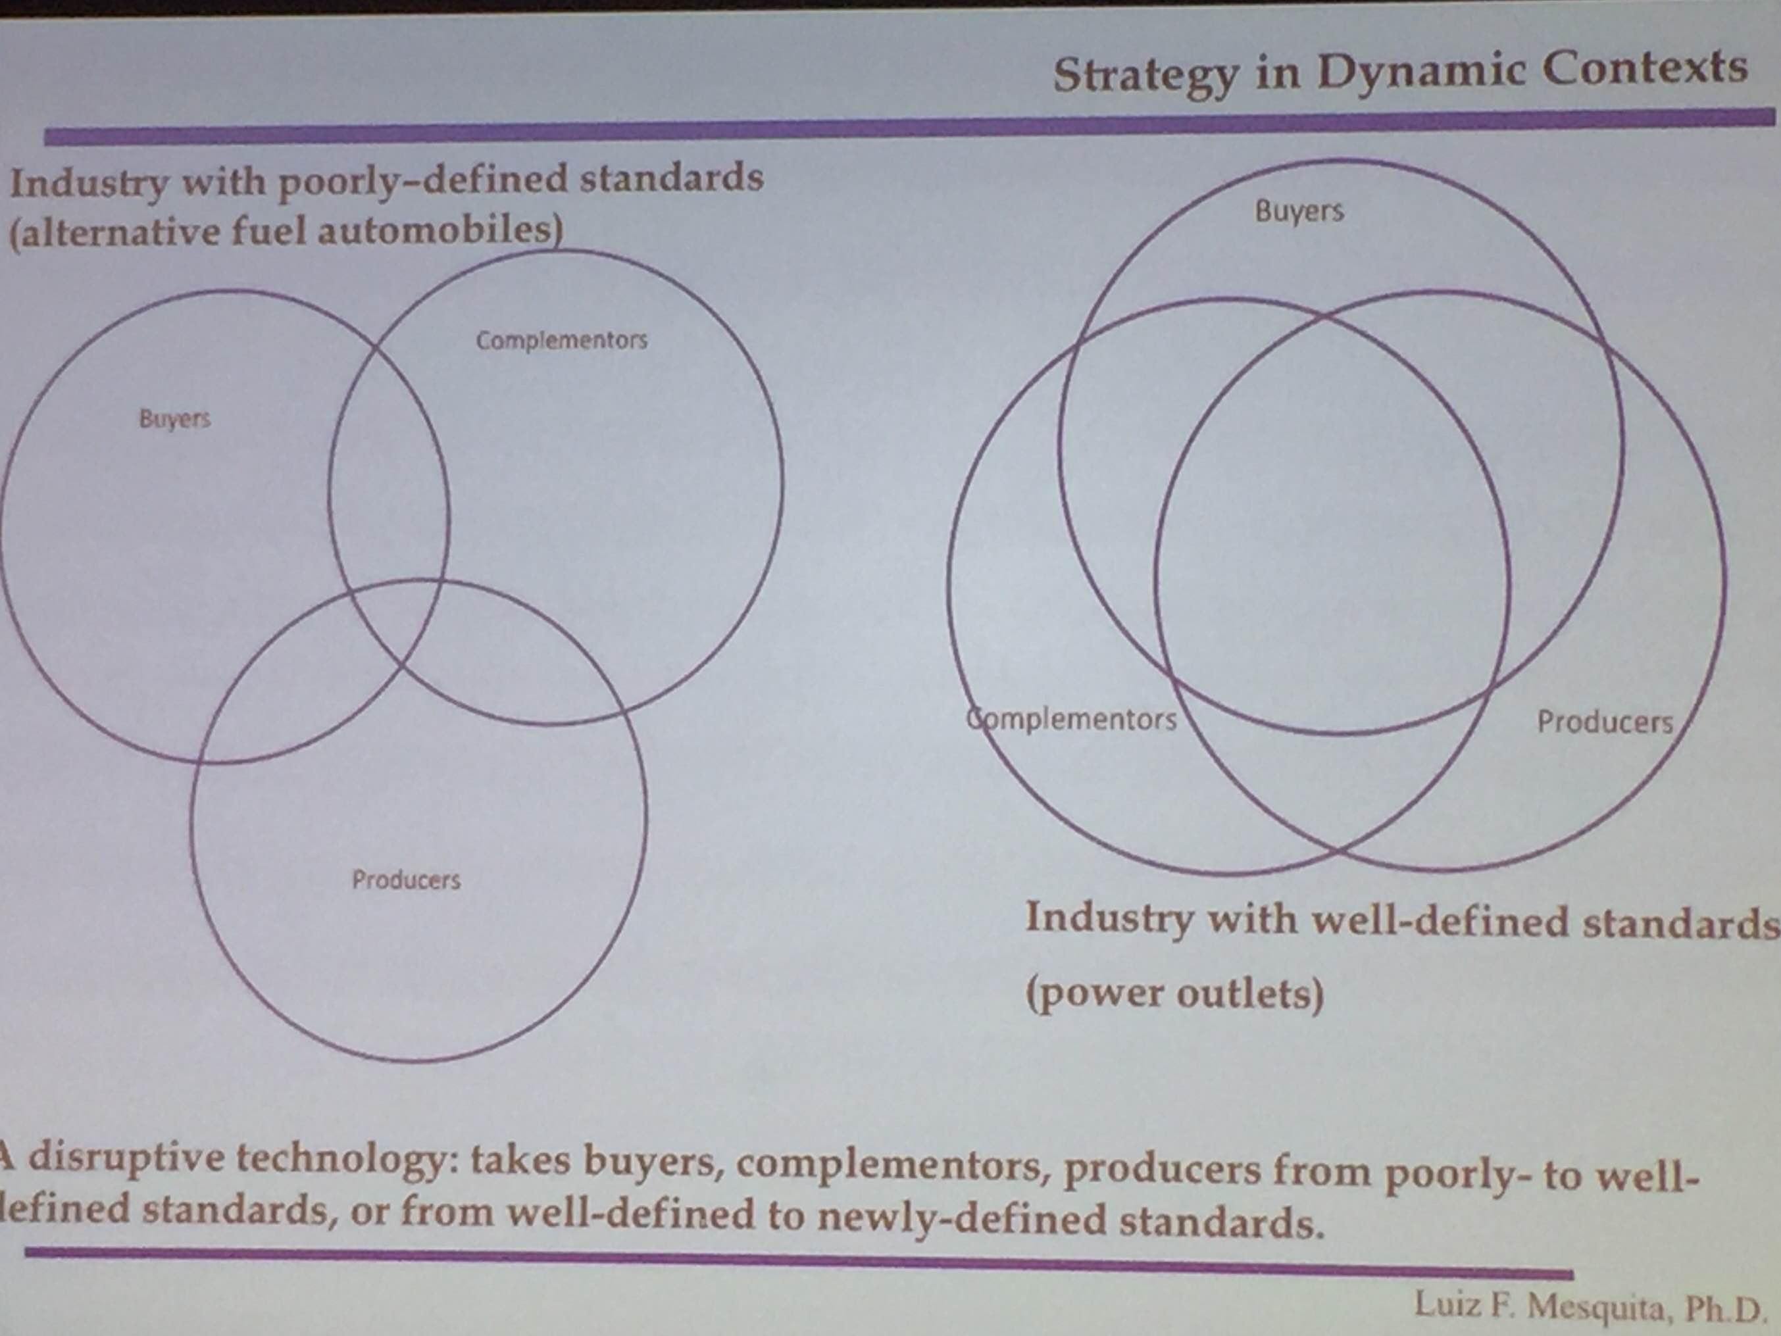
Standards reduce uncertainty!

Benefits of Standards:
- Reduces confusion in minds of consumers (what if there were 5 or 7 PC ‘OS’ standards);
- Enhances the following, for complementors
- Compatibility (Will my DVD play in this gadget?)
- Sale economies (Windows x Apple software $$ costs)
- Risk (more firms will join network)

Examples of standards:
- QWERTY keyboard
- “Wintel”
- Containers for overseas shipment, (or as basic as) USB computer ports;

Examples of Complementors:
- Uber app and drivers, Ryan Air and Hertz, Mondavi winery & local restaurants in CA north-central valley, Apple’s iPhone & app makers.

-Given economic importance of standards, firms often battle to establish new ones
-What are standard - format wars? What advantages does winner attain (examples)?
- Competitive battles to set and control technical standards in market;
- Because standards enable enormous network externalities, the firm who controls possible resources of differentiation enjoys strong 1st mover advantages…
- … such as market power, if barriers to entry exist.
- Usually involve “winner-takes-all” situations

-How do standards emerge?
- Government mandate (empty core industries);
- Firm agreements (collusion?);
- Consumer demand patterns;
- Positive “feedback loop” (i.e., “network externalities”, or “network effects”)

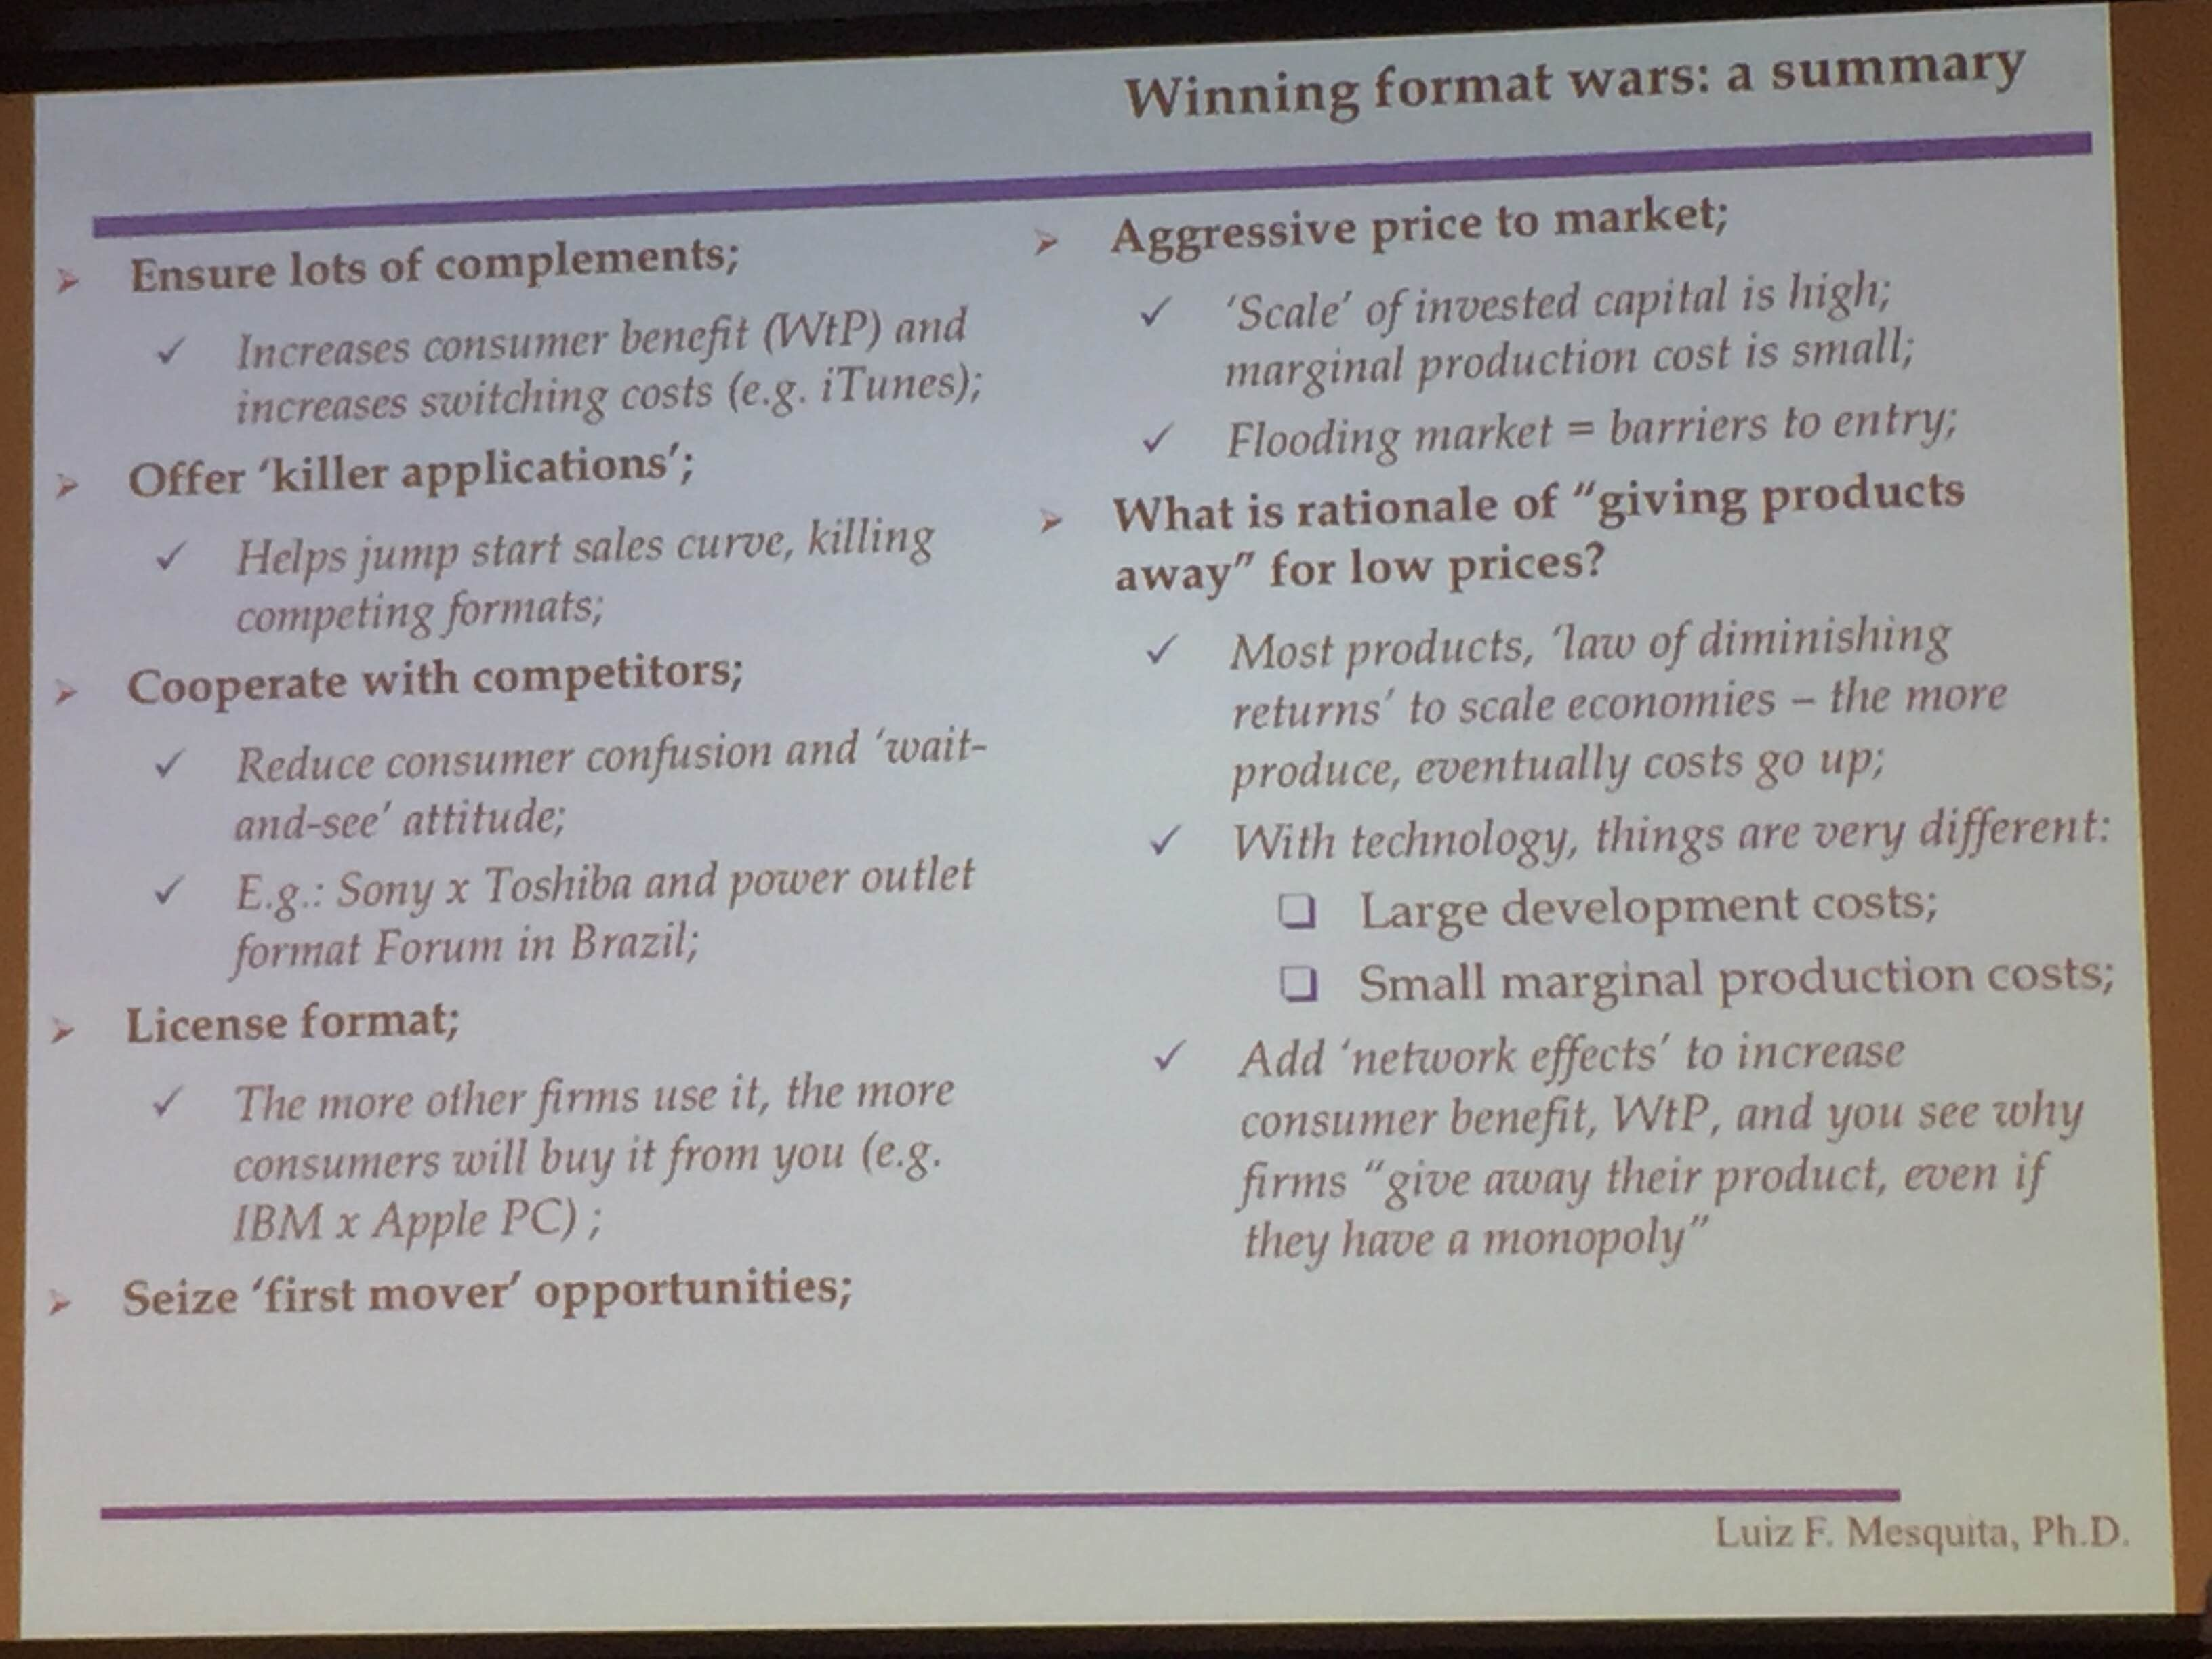
Certain products have a significant amount of network externalities (FB/FB users)
Killer “app” (examples: Mario Brothers, Internet Explorer (for free))

9/28 HD/DVD VS. BluRay

1) Format Wars: (The market doesn’t pick up)

- Consumers don’t buy
- “Complementors" don’t trust
- Producers don’t trust

2) Technology wise:

Pro’s: BluRay - Storage capacity/Resolution, Property rights
Con’s(?): HD/DVD - Cheaper to make, OK capacity

3) Resolving the conflict is desirable, but difficult:
- Property right disputes
- Hard-to-solve commitments (Path dependent) = Hard to let go/High Exit Barriers

4) Winner takes all!

- KILLER “APP”:

- Video game bundling - Sony’s move to make PS3 support BluRay and DVD
- X-Box = HD/DVD
- Microsoft bundled (free) Internet Explorer with Netscape

b) Razor and Blade strategy:

Example: Sell console very cheap to take out the rivals (winner takes all) (= $ from games, Network externalities)

c) Let us win the hearts of “complementors” (as quickly as possible):
- Movies
- Games
- Retailers

What ended the war:

9/30 Uber
- What is Uber?

Branded ride-share scheme

Virtual Firm

- Uber’s Value Proposition

Key partners: Professional/Non-Professional Drivers,

Benefits for drivers:

- Using spare capacity (scale economies)
- Ability to decline passengers
- Complement revenues
- Pay

Buyers: Anybody who need transportation
Value: Reduced uncertainty:
- Pay, Tip
- Connection/

Key Activities:
- growing drivers=riders

Consumer Relations:
- Promotion
- “Buzz”

Communication Channels:
- Social Media (FB, Twitter, Instagram)
- “Word of mouth”
- 6 degrees of separation

Key Resources: FLEXIBLE
- Lawyers
- Customer Service
- A Building
- Marketing

Costs x Revenues:
- Revenues = 20%
- Legal/Marketing/Public Relations

3. What are main Positive Feedback Loops (Positive Externalities):
- more drivers = more passengers (and vice-versa)
- drivers = fewer rivals
- celebrities = riders
- cross-segment externalities (helicopters, alcohol delivery, kids to school)

4. Why did social media fail in Seattle?
- foreign firm
- culture

5. How would you continue to grow?

6. What did you learn?

10/05 - Guest Speaker (Dr. Audrey Iffert-Saleem): Women + Entrepreneurship

According to social feminism, differences during early and continuous socialization lead women and men to inherently differ.

Altering communication about a career’s compatibility with femininity can alter women’s attitudes and behavior.

Social Capital: Resources attained via relationships
(Social exchange facilitated by trust, levels of communication and structure)

Mentoring as Social Capital:

A Good Mentor:
Has expert-level experience
Has had success as an entrepreneur
Is patient and Action-Oriented (e.g. provide sponsorship)
Is Direct yet Supportive

Useful Mentoring Strategies include:
Having a network of mentors
Having a variety of mentors, especially gender diverse
Crossing boundaries
Leveraging your mentor’s strength
Exploring formal and informal mentoring options

Mentors can't stand proteges not taking their advice.

Resources available to ASU students:

EDSON

10/14 - A Gentle Introduction to VC: bootstrapping, angels, crowdfunding

George Sorros Rules of Investment:
- Don’t lose money
- Don’t let your emotions get in the way

Odds are not good for ‘average entrepreneur’:

- 50% will be out of market in 2 years
- 80% will be out of market in 5 years
- 95% will be out of market in 10 years

You need:

- Right goals (“make money” x “create value”)
- Good opportunity
- Good business strategy (5 forces/VRIO)
- Good investment strategy (see game pattern - go for upside, but protect downside)
- Good approach to scavenging for funds
- Good coaching (outside of ASU)
“Being an Entrepreneur” x “Scavenging for Funds”
Ventures tap distinct $$ markets along their life-cycle

- FFFs - early stage
- Bootstrapping - organic growth/low risk
- Debt - high growth/low risk
- Angels - growth/high risk
- Crowdfunding - high risk/less involvement
- Venture Capitalists - high growth/high risk

Venture capitalists will ask:
- What industry are you in?
- Assets
- Organic growth
FINANCING SOURCES

Bootstrapping:

Not all need external $$
- (+) Keep the equity and operational control
- (-) Slower growth (retained earnings => organic growth)
Examples:
- Professor’s consulting practice and real estate firm (both self-financing, limited growth in the 2nd case)
Cautions:
- Bootstrapping is not for “network” businesses (e.g. Uber, AirBnB)
- Not for the faint-of-heart

Debt x Equity Financing:

Beyond bootstrapping… you need external financing: Debt x Equity
Debt Investors (e.g. banks):
- Lend fixed $$ quantity, for fixed time, for given % (typically 10 to 15% /year).
- Banks
- Does

Debt x Equity Financing:

10/28 Venture Growth - Franchising

What is franchising?
- Licensing agreement between franchisor (owner) and franchisee (authorized dealer)
- Franchisee pays fee to use franchisor’s business model and sell its products
- Typically involves up-front fee (e.g. 10K-500K), plus royalties (e.g., ~ 7%);
- Typically involve termination clauses (e.g., time, performance, etc.)
- May include opening for new post-contract clauses (watch out!)
- It is an alternative to ‘organic growth’
- Low variation in output = success

How important is franchising in today’s economy?
1/3 of all U.S. retail
~ 10% yearly growth since the 1960s

Master franchising => Sub Franchising => Area Development

- The riskiest, the closer to AD
- The most expensive, the closer to AD
- The least developed, the closer to AD
- The least knowledgeable a franchise is, the closer to Master Franchise
- The more ‘hands on approach’ by franchisor, the closer to Master Franchise

Master Franchising:
- Original franchisor x Master franchisee (e.g., Jason’s Burger King in Arkansas)

Sub Franchising:
- Accelerating knowledge transfer (e.g. Arby’s & Pizza Hut in Brazil)

Area Development:
- Flooding the market - Open competition (e.g., McDonald’s in the United States, Jason’s +10 in AK)

Why franchise?

Lucia’s career! (www.boticario.com.br/)
Armando’s daughter. Did not want to be a mechanic. Liked fashion.

Franchisees
(+) Can quickly set up business, based on proven formula (less risk)
(+) Little need for know how
(+) Access to established “club” resources (scale economies)
x Brand name
x Goodwill
x National scale advertising
(-) Control by franchisor
(-) Requires $$ (but usually less risky than own business, so may be advantageous)
(-) Unavoidable royalty fees (regardless of profit)
“Club resource" benefits everybody in the network (brand names)

Franchisors

11/09 Family Firms

Family Firm is a firm under significant ownership/influence of family members.

- Over 80% of all businesses internationally (from 60% to 98%), 60% (average) in the US, are family owned.
- Over half of Fortune 1000 are family owned
- Family businesses surpass non family ones in many respects (e.g., innovation)

- Champions across many industries: Ford, Harley Davidson, Marriot, Hilton, Hyundai, Johnson Co., Adidas, BMW, WalMart, Deere & Co, etc.
Ownership Dilution

- As the firms grow, ownership concentration falls
- But many firms retain majority family ownership (50% or more)
- Most firms with 50% ownership or less retain family influence (i.e. control)
- (Ownership does not equal control !)

Why do families wish to retain control?

- Family name pride
- Family ‘values-legacy’
- Employment of offspring
- Power, Status, family-wealth

Agency theory says that the interests are different

Firms with agency behavior are bad for the shareholders. Control agency behavior by making up Board of independent members.

Stewardship - Family firm leaders are emotionally attached to the firm and family peers, so are interested in building a good business environment/developing a great business. The number of generations decreases stewardship.
Embeddedness -

Dispersion -

!!! How did Sulzberger family control NY Times (having 20% ownership)?

1 Dual-Class stock (A x B shares, with the latter holding a 10 to 1 voting power)
- A shares: 99% of total, publicly traded, has ‘smaller’ relative voting power
- B shares: 1% of total, non publicly traded, has ‘big’ relative voting power
2.

- Stewardship
- Tacit Agreement
- DualB shares vs. A shares (10 to 1 votes)

11/23 Nordstrom

11/30 What it all boils down to…

What business are you in
X
What business are you really in?

Success X Failure

- Why are some way ahead?
- Why imitation won’t work?
- Why are customers crazy about some
- tgtg
- tgtg

Bringing it all together…
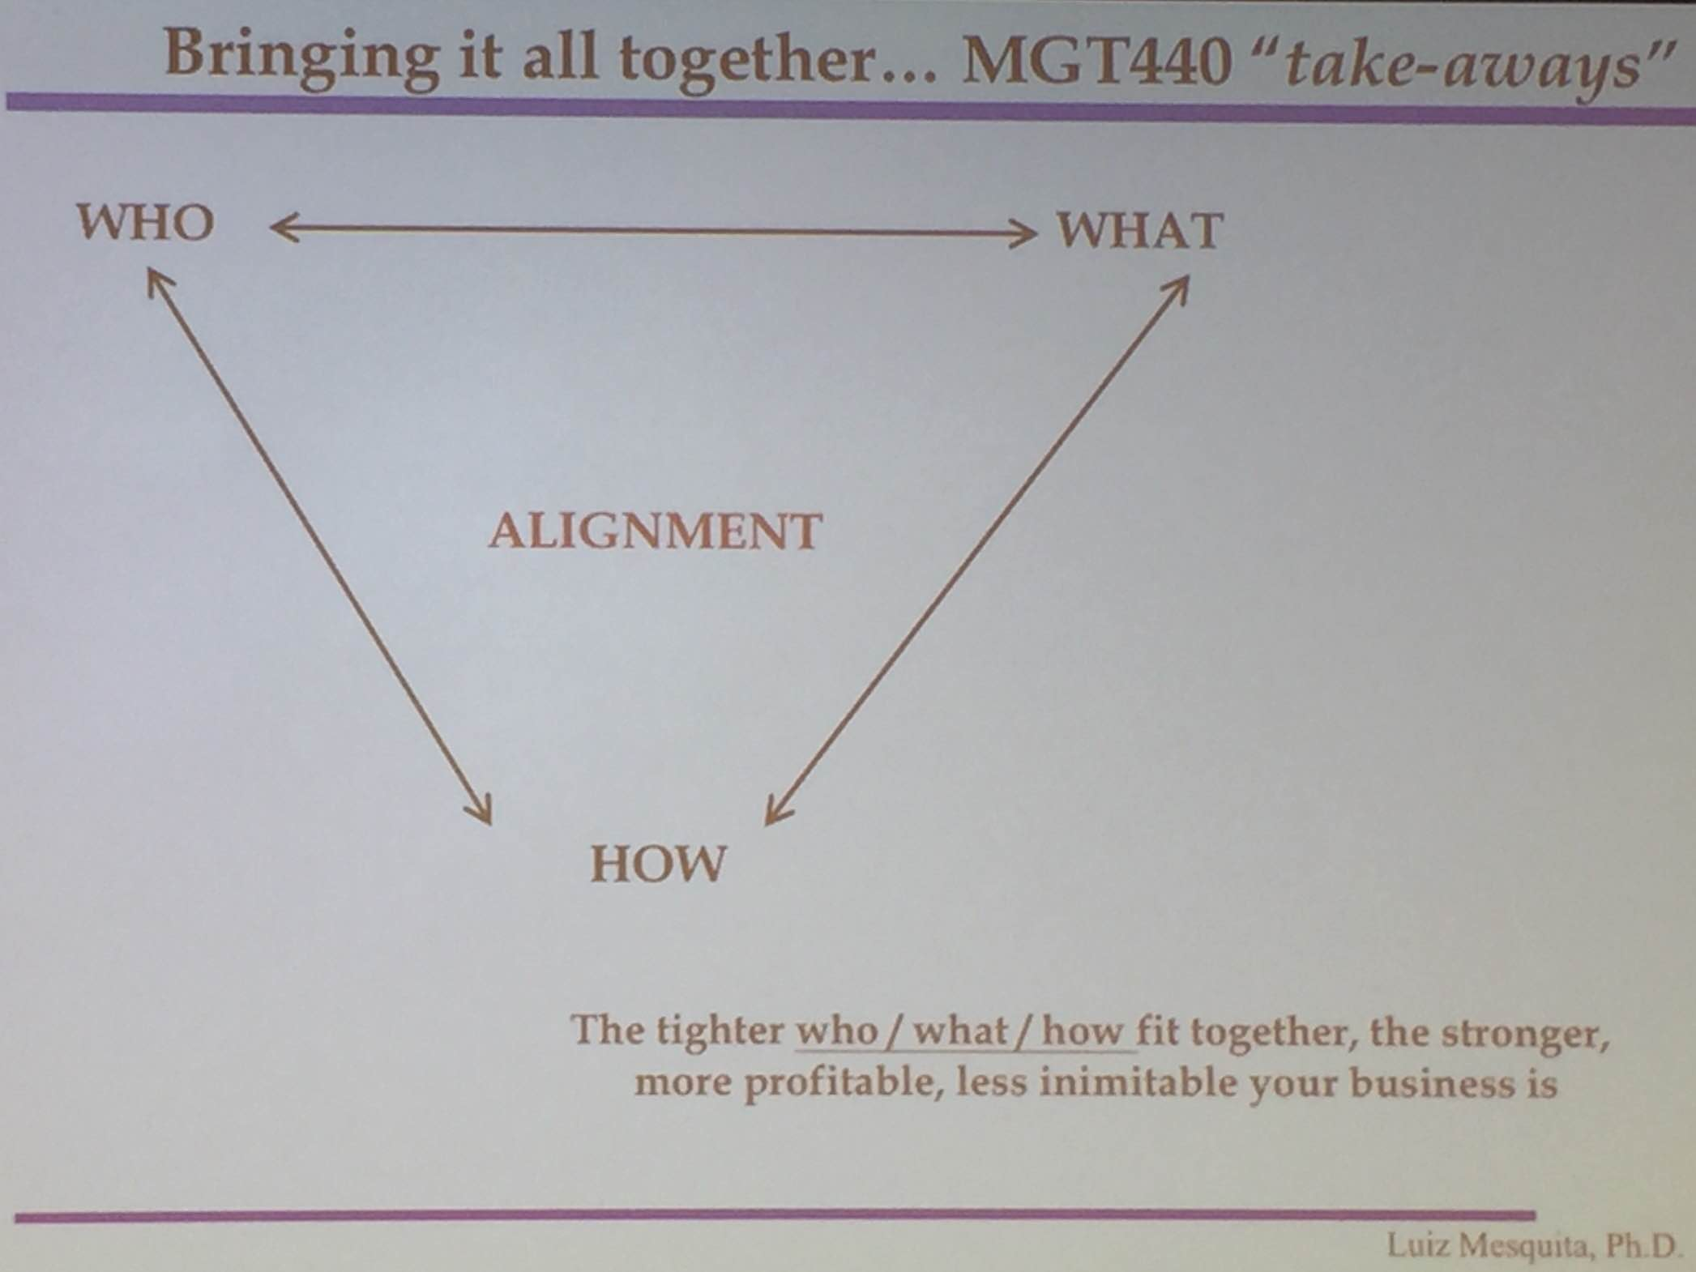

Who?
Your customer…
- … But importantly… YOUR CUSTOMER DEFINED BY HER “SPECIFIC NEEDS”
- Who your customer “is NOT”

1) Intrinsic x unarticulated
- Intrinsic = “the obvious”
- “ego massage”, Time, space, access, convenience, transaction costs, simplicity (unarticulated needs)
- E.g., ego booster, freed up time, saving in other resources, make more money, save the planet

2) Large enough to $$ profitably
- ”Gather the similar-minded crowd”
- Your buyer accepts ‘substitutes’? Has multiple servers (your rivals)?

3)

What?

Your product…

- … But more importantly… HOW YOUR PRODUCT SOLVES CUSTOMERS’ “SPECIFIC NEEDS”
- What your product “is NOT”

- Tangible x Intangible

1) Tangible is what everybody sells (rivalry)
2) Intangible is what makes your firm unique:
1) Ego booster (makes her ‘significant’); e.g., luxury car, or ‘save the planet’
2) Freed up resources (e.g., time; reduces ‘uncertainty’); e.g., brand name, guarantee, peace of mind.

How?

MGT320 12/01/2016
original idea for “super leadership’’’
MGT440 12/02/2016

Life (Sh#t) happens
- I have no control over life events, it may imply that sh#tty events have an affect on life
- sh#t controls life
(How you handle that is what matters, expand the boundaries of your comfort zone)

3 Principles to expand your comfort zone boundaries:
1) Stories you tell yourself and the interpretation that you give them (whether they are limitations or whether they make you strong). Let go of the stories!

2) Your challenges are your gift. (no mud - no lotus) - every specific quality that you have that help you step out of the area of uncertainty are only manifested in a situation of danger/difficulty. Courage only manifests if there’s danger to go together. We live in the world of duality. Whenever you see an X, you tend to think how to get it. That’s the wrong approach. You need to learn to produce X at your will, rather than obtain it. The goal is to learn the process of creating X. (e.g., Fire for neanderthals)

3) Easy does it. The secret to working 15-hour days is not thinking that you’re “working” (the tetherball principle) - take it easy until the danger comes.
2 Extra factors:

- The power questions.

- How do you make an elephant move? Ask questions. Focus your mind on the things you want done without having doubts/fears. If you ask a question, your subconscious will produce an answer.

b) Faith - Your capacity to hold an image of a desired outcome without anything fainting it.

Effortless achievement - who do you think you are cheating.

