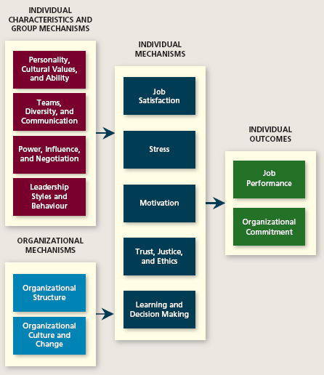
CHAPTER 1 NOTES

OB – a field of study devoted to understanding, explaining, and ultimately improving the attitudes and behaviours of individuals and groups in organizations.

HRM – theories and principles studied in OB and explore the “nuts and bolts” applications of those principles in organizations.

Strategic Management – focuses on the product ch oices and industry characteristics that affect an organization’s profitability

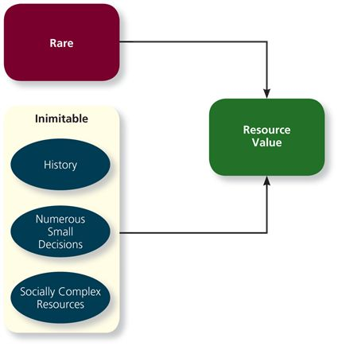
Resource-Based view suggested that the resources value is based on the two main values illustrated within the figure to the right. The model argues that rare and inimitable resources help firms maintain a competitive advantage.

Example a resource is more valuable if it is rare – ie. Diamonds. It is also more valuable if it is inimitable, meaning that it cannot be easily copied.
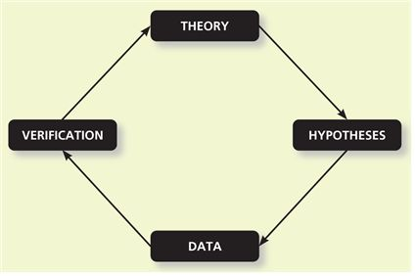
The scientific method starts by formulating a theory – a collection of verbal and symbolic assertions that specify how and why variables are related, as well as the conditions in which they should (and should not) be related. To test these theories, the process requires that theories be used to inspire hypotheses, which are written predictions that specific relationships between variables.

Meta-analysis is a method that combines the results of multiple scientific studies by essentially calculating a weighted-average correlation across studies (with larger studies receiving more weight)

Correlation between statistical data is represented with an abbreviation of “r” with values ranging from 0 to +-1 where a .50 correlation is considered “strong” and a .30 is “moderate” and a .10 is considered “weak” .

Chapter 2 Notes

Job Performance - Employee behaviours that contribute either positively or negatively to the accomplishment of organizational goals

Total Performance = Task Performance + Citizenship Behaviour + Counter-productive Behaviors

Task Performance (In-Role) – Employee behaviors that are directly involved in the transformation of organizational resources into the goods or service that the organization produces
Routine Task Performance
Well-known or habitual responses by employee’s t predictable task demands
I.e. factory-line workers, Data Entry
Adaptive Task Performance
Thoughtful responses by an employee to unique or unusual task demands
I.e. Medicine, Customer Service Based
Creative Task Performance
Ideals or physical outcomes those are both novel and useful
I.e. Music, Arts, Chef

Citizenship Behaviors (Extra-Role) – voluntary behaviors that contribute to achieving organizational goals
Organizational
Voice – speaking up to offer constructive suggestions for change, often in reaction to negative events
Civic Virtue – participation in company operations at a deeper-than-normal level through voluntary meetings, readings, and keeping up with news that affects the company
Boosterism – positively representing the organization when in public
Interpersonal
Helping
Courtesy
Sportsmanship

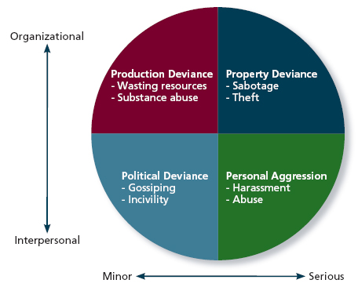
Counterproductive Behaviors (Extra-Roles) – intentional behaviors that hinder the achievement of organizational goals

Incivility – communication that is rude, impolite, discourteous and lacking in good manners.

Job Analysis
- Form a list of activities involved in a job
- Rate the “importance” or “centrality” of each activity (use of subject-matter-experts)
- Most important activities are retained and used to define performance

Performance Appraisal
BARS (Behaviorally Anchored Rating Scales)
  - Pros: Captures broader array of performance indicators than MBO; Can provide broader feedback as a result
  - Cons: Does not capture objective (outcome) performance; Critical incidents might not capture full range of important behaviours
  - Caveats: More subjective than MBO; Should be combined with some measure of objective performance
360-Degree Feedback
  - Pros: Can triangulate info from multiple sources; gives employee a voice in their own performance management
  - Cons: Can be manipulated; can generate competition/negative relationships; unclear what to do if starkly different ratings
  - Caveats: What decisions this tool is used for can affect the extent to which employees answer honestly

MBO (Management by objective)
  - Pros: Gives employees voice; clear and specific
  - Cons: Don’t focus on the ‘how’; Can promote corner-cutting/unethical behaviour; Doesn’t always give a lot of employee leeway
  - Caveats: Goals need to be challenging but manageable (S.M.A.R.T); need quantifiable output; need to be thorough

Forced Ranking:
  - Pros: Can be a robust motivator; focus on employee development; removes employees who are contributing the least; Can keep “star” employees happy
  - Cons: Can promote negative attitudes towards coworkers and organization; can motivate unethical behaviours & competition
  - Caveats: If this tool works effectively, after a few rounds, employees in the bottom 20% are potentially more valuable than ones that would subsequently replace them

Chapter 3 Notes: Organizational Commitment

Organizational commitment – an employee’s desire to remain a member of an organization
Affective commitment - Commitment to the organization due to a feeling emotional attachment
Erosion model suggests that employees with fewer bonds with co-workers are more likely to quit the organization
Social influence model - suggests that employees with direct linkages to co-workers who leave the organization will themselves become more likely to leave
Continuance Commitment - Commitment to the organization due to awareness of the costs of leaving
Embeddedness – an employee’s connection to and sense of fit in the organization and community
Normative Commitment- Commitment to the organization due to a feeling of obligation

Withdrawal Behavior
- Physical Withdrawal (EXIT):
  - Being late; missing meetings; taking long breaks; being absent; quitting
  - Quitting is considered a physical withdrawal
- Psychological Withdrawal (NEGLECT):
  - Daydreaming; looking busy; socializing; moonlighting; cyberloafing; taking longer than what is really needed to complete a task
  - Psychological Contracts: employees’ beliefs about what they owe the organization and vice versa
    - Transactional Contracts – focus on a narrow set of specific monetary obligations
    - Relational Contracts- focus on a broad set of open ended and subjective obligations

Independent Forms model – predicts that the various withdrawal behaviors are uncorrelated, so that engaging in one type of withdrawal has little bearing on engaging in other types

Compensatory forms model - indicates that the various withdrawal behaviours are negatively correlated, so that engaging in one type of withdrawal makes you unlikely to engage in the others

Progression model indicates that the various withdrawal behaviours are positively correlated, so that engaging in one type f withdrawal makes one more likely to engage in other types.

Chapter 4 Notes: Job Satisfaction
Job Satisfaction - A pleasurable emotional state resulting from the appraisal of one’s job or job experiences; represents how a person feels and thinks about his or her job

Value-Percept Theory:
Dissatisfaction = (V_want – V_have) X (V_imporatance)
These variables reflect how much of a value an employee wants, how much of that value the organization/job supplies and how important the value is towards the employee.
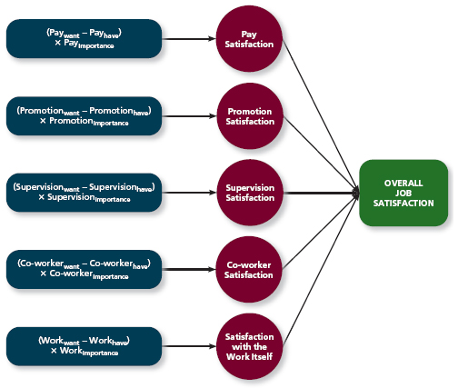

Pay satisfaction – employees’ feelings about the compensation for their jobs
Promotion satisfaction – employees’ feelings about how the company handles promotions
Supervision satisfaction – employees feeling about their boss, including his or her competency communication and personality
Co-worker satisfaction – employees’ feelings about their co-workers including their abilities and personalities
Satisfaction with the work itself

Job characteristics theory – a theory that argues that five core characteristics (variety, identity, significance, autonomy and feedback) combine to result in high levels of satisfaction with the work itself
Variety – the degree to which a job requires different activities and skills
Identity – the degree to which a job offers completion of a whole identifiable piece of work
Significance – the degree to which a job really matters and impacts society as a whole
Autonomy – the degree to which a job allows individual freedom and discretion regarding how the work is to be done
Feedback (specific) – the degree to which the job itself provides information on how well the job holder is doing

Meaningfulness of Work – a psychological state indicating the degree to which work tasks are viewed as something that counts in the employees system of philosophies and beliefs
Responsibility for outcomes – a psychological state indicating the degree to which employees feel they are key drivers of quality of work output
Knowledge of results – a psychological state indicating the extent to which employees are aware of how well or how poorly they are doing

Knowledge and Skill – the degree to which employees have the aptitude and competence needed to succeed on their job

Growth need Strength – The degree to which employees desire to develop themselves further

Moods & Emotions

Affective Events Theory – a theory that describes how workplace events can generate emotional reactions that impact work behaviors (ex. Crappy email from boss triggers emotion towards BOSS)

Emotional Labor – the management of their emotions that employees must do to complete their job duties successfully

Emotional Contagion – the idea that emotions can be transferred from one person to another

Things that affect FLUCTUATION in job satisfaction
- Mood: States of feeling that are mild in intensity, last for an extended period of time, and are not directed at anything
- Emotions: Intense feelings, often lasting for a short duration at someone or some circumstance
  - Negative
  - Positive

Chapter 5: Stress
Stressor Stress Strain

Stressor: demands that cause a stress response
- Hindrance Stressors: stressful demands that are perceived as hindering progress toward personal accomplishments or goal attainment.
- Challenge Stressors: stressful demands that are perceived as opportunities for learning, growth, and achievement.

Stress: “Stress is a psychological response to demands when there is something at stake for the individual, and when coping with these demands would tax or exceeds individual capacity or resources.”

Strain: Negative consequences of the stress response
- Physiological Strain: Reactions from stressors that harm the human body.
  - Stressors can reduce the effectiveness of the body’s immune system, which makes it more difficult for the body to ward off illness and infection.
  - Stressors can hard the body’s cardiovascular system, cause the heart to race, increase blood pressure, and create coronary artery disease.
  - Stressors can cause headaches, tight shoulders and back pain.
  - Stomach aches, indigestion, diarrhea, and constipation.
- Psychological Strains: Negative psychological reactions from stressors such as depression, anxiety, and anger.
  - Ex: Hostility, reduced self-confidence, irritability, inability to think clearly, forgetfulness, lack of creativity, memory loss and a loss of sense of humor.
  - Burnout: The emotional, mental and physical exhaustion from coping with stressful demands on a continuing basis.
- Behavioral Strains: Patterns of negative behaviors that are associated with other strains.
  - Ex: grinding one’s teeth at night, being overly critical and bossy, excessive smoking, compulsive gum chewing, overuse of alcohol, and compulsive eating.

Transactional theory of stress: explains how stressful demands are perceived and appraised, as well as how people respond to the perceptions of appraisals
(Work and Non-Work)
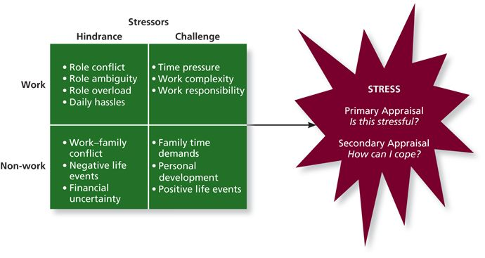
Primary appraisal - Does this demand cause me to feel stressed? – Evaluation of whether a demand is stressful and, if it is, the implications of the stressor in terms of personal goals and well-being
Secondary appraisal - How do I cope with this stressor? – when people determine how to cope with the various stressors they face

**Benign job demands are demands that are not appraised (thought) as being stressful. (I.e. being a cashier is not appraised to be stressful)

Types of Stressors
Hindrance Stressors – stressors that tend to be apprised as thwarting progress toward growth and achievement
Work Hindrance Stressors
- Role conflict – others having differing expectations of what an individual needs to do in a role
- Role ambiguity – a lack of direction and information about what needs to be done in a role
- Role overload – an excess of demands on an employee preventing him or her from working effectively
- Daily hassles – minor day-to-day demands that interfere with work accomplishment
Non-Work Hindrance Stressors
- Work-family conflict – a form of role conflict in which the demands of a work role hinder the fulfillment of the demands in a family role (or vice versa)
- Negative life events – events such as divorce, personal loss, etc. that tend to be appraised as a hindrance
- Financial uncertainty – uncertainties with regard to the potential for loss of livelihood, savings, or the ability to pay expenses

Challenge Stressors – stressors that tend to be apprised as opportunities for growth and achievement
Work Challenge Stressors
- Time pressure – the sense that the amount of time allotted to do job is not quite enough
- Work complexity – the degree to which job requirements, in terms of knowledge, skills , and abilities, tax or just exceed employee capabilities
- Work Responsibility – the number and importance of the obligations that an employee has to others
Non-Work Challenge Stressors
- Family time demands – the amount of time committed to fulfilling family responsibilities
- Personal development – participation in activities outside of work that foster growth and learning
- Positive life events – events such as marriage, child birth, etc. that tend to be appraised as a challenge

Coping – behaviours and thoughts used to manage stressful demands and the emotions associated with the stressful demands

TABLE 5-3 | Problem-Focused | Emotion-Focused
Behavioural Methods | - Working harder  - Seeking assistance  - Acquiring additional resources | - Engaging in alternative activities  - Seeking support  - Venting anger
Cognitive Methods | - Strategizing  - Self-motivation  - Changing priorities | - Avoiding, distancing, ignoring  - Looking for positive in negative  - Reappraising

- Behavioral coping methods – physical activities used to deal with a stressful situation
- Cognitive coping methods – thoughts used to deal with a stressful situation
- Problem-Focused Coping: Behaviors and cognitions of an individual intended to manage the stressful situation itself
- Emotional-Focused Coping: Behaviors and cognitions of an individual intended to help manage emotional reactions to the stressful demands

Types of Strain
- Physiological Strain – reactions from stressors that harm the human body
- Psychological strains – negative psychological reactions from stressors such as depression, anxiety, and anger
- Behavioural strains – patterns of negative behaviours that are associated with other strains

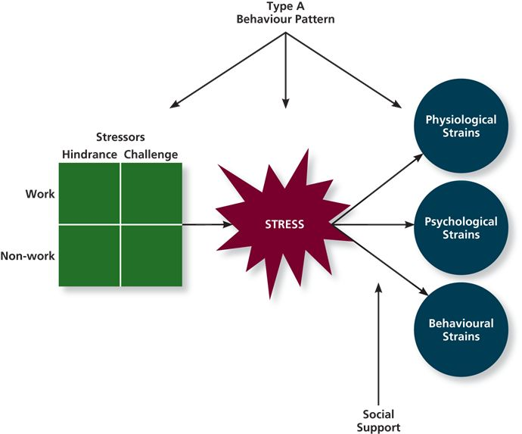
Chapter 6: Motivation

Motivation – a set of energetic forces that determine the direction intensity, and persistence of employee work effort.

Expectancy Theory – the cognitive process employees go through to make choices among different voluntary responses
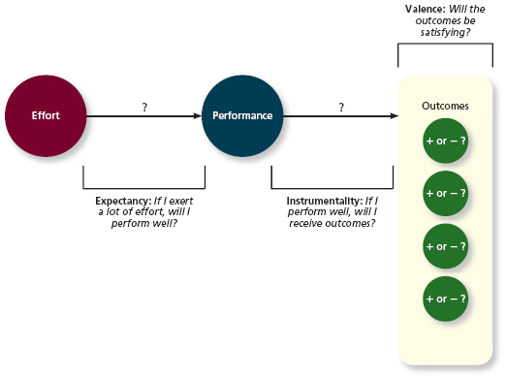

Expectancy - People are motivated to act if they believe their actions will result in their desired goals
  - Expectancy – IF I exert a lot of effort will I perform well?
  - Instrumentality – If I perform well, will I receive certain outcomes?
  - Valence - Will the outcomes be satisfying?
    - Linked to needs
    - The more an outcome satisfies a need, the more positively valence that outcome is
  - Motivational Force Equation: [EP] X [Σ((PO) X V)]
    - Effort E Performance P Outcome V

Goal Setting Theory – views goals as the primary drivers of the intensity and persistence of effort
- Specific and Difficult Goals – goals that stretch an employee to perform at his or her maximum level while still staying within the boundaries of his or her ability
- Self-Set Goals – the internalized goals that people use to monitor their own progress
- Affect moderators on task performance
  - Feedback – In goal setting theory it refers to progress updates on work goals
  - Task Complexity – the degree to which information and actions needed to complete a task are complicated
  - Goal Commitment – the degree to which a person is determined to reach the goal
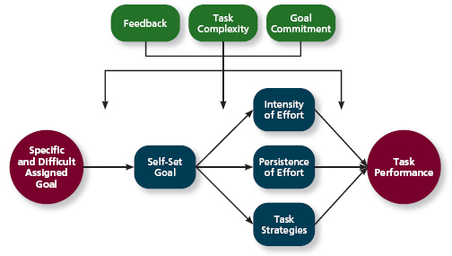

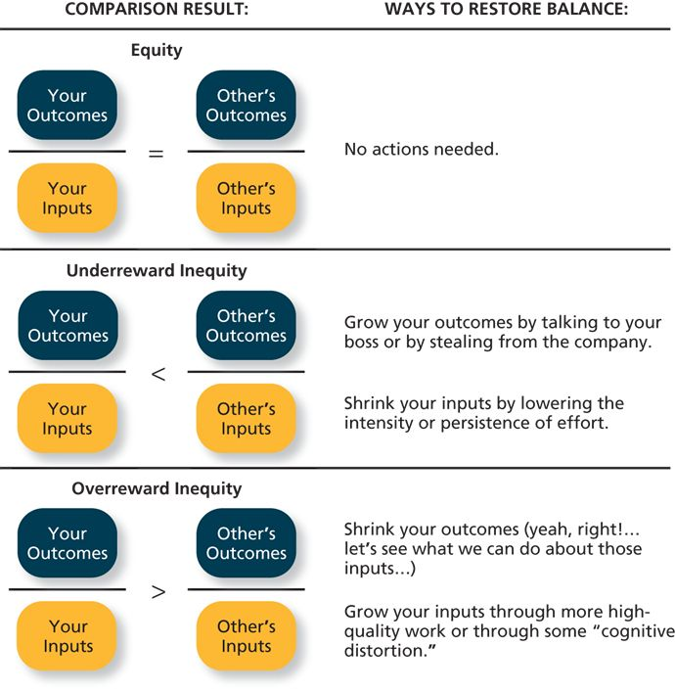
Equity Theory – suggests that employees create a mental ledger of the outcomes they receive for their job inputs, relative to some comparison other
- Comparison Other –another person who provides a frame of reference for judging equity
- Equity Distress – an internal tension that results from being over rewarded or underprepared relative to some comparison other
  - Over rewarded inequity
  - Under rewarded inequity
- Cognitive Distortion – a revaluation of the inputs an employee brings to a job, often occurring in response to equity distress
- Internal Comparisons – comparing oneself to someone in your same company
- External Comparisons – comparing oneself to someone in a different company

Psychological empowerment- energy rooted in the belief that tasks are contributing to some larger purpose
- Represents a form of intrinsic motivation, in that merely performing the work tasks serves as its own reward.
- Meaningfulness: A psychological state reflecting one’s feelings about work tasks, goals, and purposes, and the degree to which they contribute to society and fulfill one’s ideals and passions.
  - Managers can instill a sense of self-meaningfulness by articulating an exciting vision and fostering a climate in which employees are free to express passion and idealism without criticism.
  - Employees can identify and clarify their own passions.
- Self-determination: A sense of choice in the initiation and continuation of work tasks.
  - Managers can instill a sense of self-determination by delegating work tasks, rather than micromanaging them, and by trusting employees to come up with their own approach to certain tasks.
  - Employees can gain more self-determination by earning the trust of their bosses and negotiating for the latitude that comes with that increased trust.
- Competence: The capability to perform work tasks successfully.
  - Managers can instill a sense of competence by providing opportunities for training and knowledge gain, expressing positive feedback, and providing challenges that are an appropriate match for an employee.
  - Employees can engage in self directed learning, seeking out feedback from managers, and managing their own workloads.
- Impact: The sense that a person’s actions “make a difference” – that progress is being made toward fulfilling some important purpose.
  - Managers can instill a sense of impact by celebrating milestones along the journey to task accomplishment, particularly for tasks that span a long time frame.
  - Employees can attain a deeper sense of impact by building the collaborative relationships needed to speed task progress.

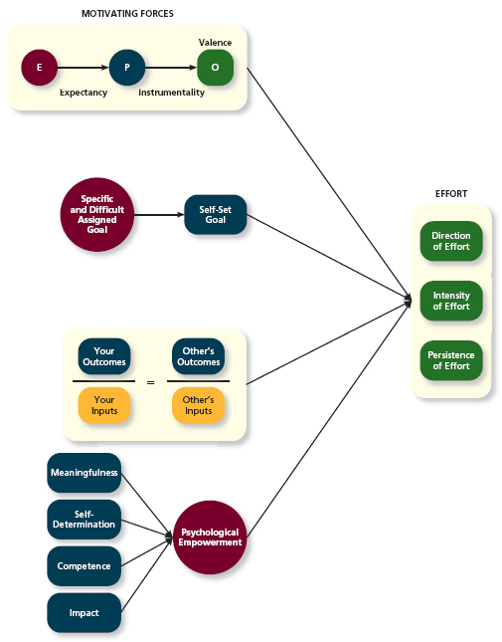

Chapter 7 Truth, Justice, and Ethics

Trust – the willingness to be vulnerable to an authority based on positive expectations about the authority’s actions and intentions
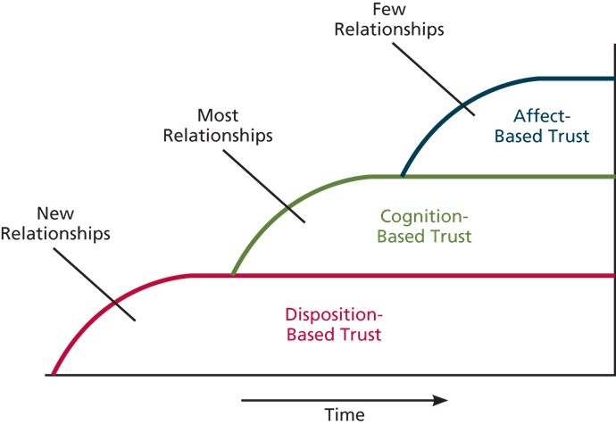

Disposition-Based Trust – trust that is rooted in one’s own personality as opposed to a careful assessment of the trustee’s trustworthiness
- Trust propensity – a general expectation that the words, promises, and statements of individuals can be relied upon

Cognition-Based Trust- trust that is rooted in a rational assessment of the authority’s trust worthiness
- Ability – the skills, competencies, and areas of expertise that enable an authority to be successful in some specific are
- Benevolence – the belief that an authority wants to do good for a trustor, apart from any selfish or profit centered motives
- Integrity – the perception that an authority adheres to a set of values and principles that the trustor finds acceptable

Affect-Based Trust – trust that depends on feelings toward the authority that go beyond any rational assessment of trustworthiness
- Feelings towards trustee –

Justice- the perceived fairness to an authority‘s decision making
- Distributive-Justice- the perceived fairness of decision making outcomes
  - Equity vs. equality vs. need
- Procedural Justice reflects the perceived fairness of decision-making process.
  - Voice
  - Correctability
  - Consistency
  - Bias suppression
  - Representativeness
  - accuracy
- Interpersonal Justice reflects the perceived fairness of the treatment received by employees from authorities.
  - Respect
  - propriety
- Informational justice reflects the perceived fairness of the communications provided to employees from authorities.
  - Justification
  - Truthfulness
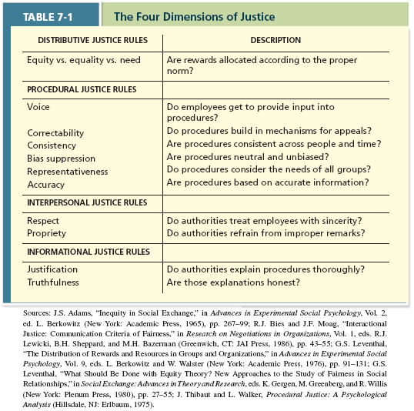

Ethics – the degree to which the behaviours of an authority are in accordance with generally accepted moral norms
- The study of business has two primary models:
  - Perspective: scholars debating how people ought to act using various codes and principles.
  - Descriptive: scholars relying on scientific studies to observe how people tend to act based on certain individual and situational characteristics.
- Unethical Behavior: Behavior that clearly violates accepted norms of morality. Directed at:
  - Employees: Discrimination, harassment, health and safety violations, etc.
  - Customers: Invading privacy, violating contract terms, using false advertisement, etc.
  - Financiers: falsifying financial info, misusing confidential info, etc.
  - Society: violating environmental info, exposing the public to safety risks, etc.
- “Merely” Ethical Behavior: behavior that adheres to some minimally accepted standard of morality.
  - Obeying labor laws, and complying with formal rules and contracts.
- “Especially” Ethical Behaviors: behaviors that exceed some minimally accepted standards of morality.
  - Charitable giving
  - Whistle-blowing: employees exposing immoral or illegal actions by their employer.

Four-Component Model:
1) Moral Awareness: Recognition that a moral issue exists in a situation
- Moral Attentiveness (individual factor) – what determines whether a person understands the right versus wrong thing to do?
- Moral Intensity – the degree to which an issue has ethical urgency
2) Moral Judgement: when an authority can accurately identify the “right” course of action
  - Cognitive Moral Development – as people age and mature, they move through several states of moral development, each more mature and sophisticated than the prior one
  - Moral principles – (prescriptive guides, define what is right
  - Moral development – (individual factor)
3) Moral Intent (situational factor) – an authority’s degree of commitment to the moral course of action
- Moral identity – the degree to which a person views their self as a moral person
4) Ethical Behaviour

Chapter 8: Learning and Decision Making

Leaning: a relatively permanent change in an employee’s knowledge or skill that results from experience.

Decision-making: The process of generating and choosing from a set of alternatives to solve a problem.
- Expertise: The knowledge and skill that distinguish experts from novices.

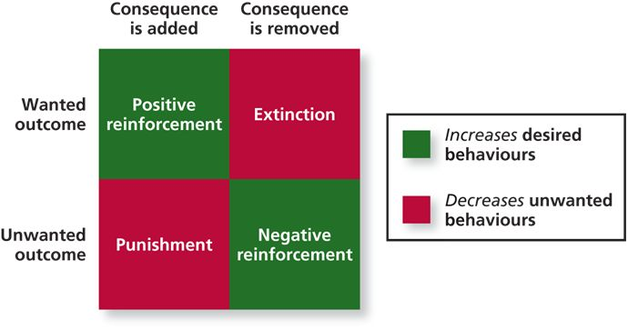
Contingencies of reinforcement – four specific consequences used by organizations to modify employee behaviour
- Positive reinforcement – a reinforcement contingency in which a positive outcome follows a desired behaviour
- Negative reinforcement occurs when an unwanted outcome is removed following a desired behaviour
- Punishment – an unwanted outcome that follows an unwanted behaviour
- Extinction – the removal of a positive outcome following an unwanted behaviour

Schedules of Reinforcement – the timing of when contingencies are applied or removed
- Continuous Reinforcement – a schedule of reinforcement in which a specific consequence follows each and every occurrence of a certain behaviour
- Fixed-interval schedule – a schedule whereby reinforcement occurs at fixed time periods
- Variable-interval schedule – a schedule whereby reinforcement occurs at random periods of time
- Fixed-Ratio schedule – reinforcement occurs following a fixed number of desired behaviours
- Variable ratio schedule – behaviours are reinforced after a varying number of them have been exhibited

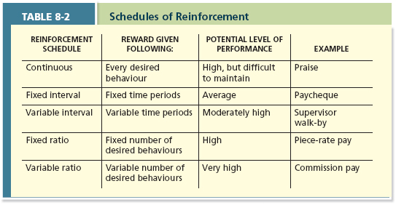

Observation
- Social learning theory: theory that argues that people in organizations learn by observing others.
- Behavioral Modeling: When employees observe the actions of others, learn from what they observe and then repeat the observed behavior.
  - Attentional Processes: Learner focuses attention on the critical behaviors exhibited by the model.
  - Retention Processes: Learner must remember the behaviors of the model once the model is no longer there.
  - Production Processes: Learner must have the appropriate skill set & must be able to reproduce the behavior.
  - Reinforcement: The learned must view the model receiving reinforcement for the behavior and then receive it themselves.
Goal Orientation
- Learning orientation: a predisposition or attitude according to which building competence is deemed more important by an employee than demonstrating competence.
  - Enjoys working on new kinds of tasks, even if they fail during their early experiences.
  - Improves self-confidence, feedback-seeking behavior, learning strategy development, and learning performance.
- Performance-prove orientation: a predisposition or attitude by which employees focus on demonstrating their competence so that others think favorably of them.
  - Work on tasks at which they’re already good, preventing them from failing in front of others.
- Performance-avoid orientation: a predisposition or attitude by which employees focus on demonstrating their competence so that others will not think poorly of them.
  - Work on tasks at which they’re already good, preventing them from failing in front of others.
Methods of Decision Making
- Programmed Decisions: decisions that are somewhat automatic because the decision maker’s knowledge allows him to recognize the situation and the course of action to be taken.
  - Intuition: an emotional judgment based on quick, unconscious feelings.
    - Effective intuition results when people have a large amount of tactic knowledge.
  - Crisis Situation: a change – sudden or evolving – that results in an urgent problem that must be addressed immediately.
- Non-Programmed Decision: decisions made by employees when a problem is new, complex or not recognized.
  - Rational Decision Making Model: A step-by-step approach to making decisions that is designed to maximize outcomes by examining all available alternatives. Assumes that people are perfectly rational.
Programmed and Non-Programmed Decisions:

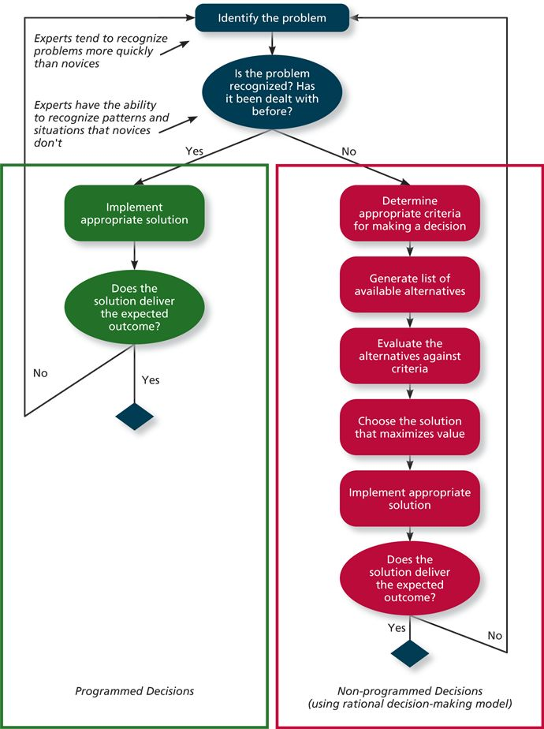

Decision Making Problems
Limited Information
- Bounded Rationality: the notion that people do not have the ability or resources to process all available information and alternatives when making a decision.
  - People have to filter and simplify information to make sense of their complex environment and potential choices they face. This leads to them to miss info when perceiving problems, generating and evaluating alternatives, or judging the result.
  - People cannot possibly consider every single alternative when making a decision.
  - Satisficing: A decision maker who chooses the first acceptable alternative considered.
Faulty Perceptions
- Selective perception: the tendency for people to see their environment only as it affects them and as it is consistent with their expectations.
  - Affects our ability to identify problems, generate and evaluate alternatives, and judge outcomes.
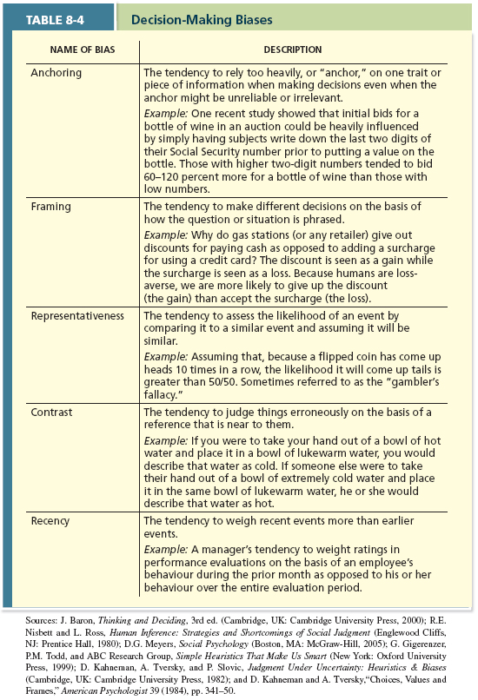
- Projection Bias: The fault perception by decision makers that other think, feel, and act as they do.
  - It limits our ability to develop appropriate criteria for decisions and evaluate decisions carefully.
- Social Identity Theory: A theory that people identify themselves according to the various groups to which they belong and judge others according to the groups they associate with.
- Stereotype: Assumptions made about other based on their social group membership.
- Heuristics: Simple and efficient rules of thumb that allow one to make decisions more easily.
- Availability Bias: The tendency for people to base their judgments on info that is easier to recall.

Faulty Attributions
- Fundamental attribution error: The tendency for people to judge others’ behaviors as being due to internal factors such as ability, motivation, or attitudes.
- Self-serving bias: When one attributes one’s own failures to external factors and success to internal factors.
- Consensus: Used by decision makers to attribute cause, whether other individuals behave the same way under similar circumstances.
- Distinctiveness: Used by decision makers to attribute cause, whether the person being judged acts in a similar fashion under different circumstances.
- Consistency: Used by decision makers to attribute cause, whether this individual has behaved this way before under similar circumstance.
Consensus
Distinctiveness
Consistency
Low
Low
Low
High
High
High
Internal attribution
Individual factors such as ability, motivation, or attitudes are to blame.
External attribution
Environmental factors are to blame.
Behavior is observed

D

Escalation of Commitment
- A common decision making error, in which the decision maker continues to follow a failing course of action.

CHAPTER 9 – PERSONALITY, CULTURAL VALUES, AND ABILITY
Personality: the structures and propensities inside a person that explain his or her characteristic patterns of thought, emotion, and behavior; personality reflects what people are like and creates their social reputation.
- Creates people’s social reputations – the way they are perceived by others.
- It captures what people are like. And is a collection of multiple traits.
Traits: Recurring trends in people’s responses to their environment. Ex: responsible, easy going, polite
Cultural Values: Shared beliefs about desirable end states or modes of conduct in a given culture that influence the expression of traits. Ex: traditional, informal, risk-averse Cultural values can influence the development of a person’s personality traits.
Ability: Relatively stable capabilities of people for performing a particular range of related activities. Captures what people can do and is relatively stable.
How Can We Describe What People Are Like?
The Big Five Taxonomy
Big Five: The five major dimension of personality: conscientiousness, agreeableness, neuroticism, openness to experience, and extraversion.
- Conscientiousness: Dimensions of personality-reflecting traits like being dependable, organized, reliable, ambitious, hard-working, and persevering.
  - Has the biggest influence on job performance.
  - Conscientious employees prioritize accomplishment striving, which reflects a strong desire to accomplish task-related goals as a means of expressing personality.
    - These people have a built in desire to finish work tasks, channel a high proportion of their efforts towards those tasks, and work harder and longer on task assignments.
- Agreeableness: dimensions of personality-reflecting traits like being kind, cooperative, sympathetic, helpful, courteous, and warm.
  - Prioritize communion striving, which reflects a strong desire to obtain acceptance in personal relationships as a means of expressing personality.
  - They focus on getting along, not getting ahead. Agreeableness is not related to performance across all jobs.
  - They have stronger customer service skills.
- Extraversion: dimensions of personality-reflecting traits like being talkative, sociable, passionate, assertive, bold, and dominant.
  - Easiest to judge in zero acquaintance situations – situations in which two people have just met.
  - Extraversion is not necessarily related to performance across all jobs.
  - Extraverted people prioritize status striving, which reflects a strong desire to obtain power and influence within a social structure as a means of expressing one’s personality.
  - Extraverts care a lot about being successful, influential & direct about their work efforts towards “moving up” and developing a strong reputation. They are more likely to emerge as leaders in social & task-related groups.
  - They tend to be high in positive affectivity, which is a dispositional tendency to experience pleasant, engaging moods such as enthusiasm, excitement and elation.
- Neuroticism: dimensions of personality-reflecting traits like being nervous, moody, emotional, insecure, and jealous.
  - Second most important when it comes to job performance.
  - There are few jobs for which the traits associated with neuroticism are beneficial to on-the-job behaviors.
  - Neuroticism is synonymous with negative affectivity, which a dispositional tendency to experience unpleasant moods such as hostility, nervousness, and annoyance.
  - Neurotic people are more likely to appraise day-to-day situations as stressful and feel like they are exposed to stressors more frequently.
  - Neurotic people are more likely to be “Type A’s”.
  - Neuroticism is strongly related to locus of control, which reflects whether people attribute the causes of events to themselves or the external environment.
  - They often believe that the events that occur around them are driven by luck, chance, or fate. (External Locus)
External and Internal Locus of Control
People with an external locus of control tend to believe: | People with an internal locus of control tend to believe:
Many of the unhappy things in people’s lives are partly due to bad luck. | People’s misfortunes result from the mistakes they make.
Getting a good job depends on being in the right place at the right time. | Becoming a success is a matter of hard work; luck has nothing to do with it.
Many times exam questions tend to be unrelated to course work that studying is useless. | In the case of the well-prepared student, there is rarely if ever such a thing as an unfair test.
The few people that are in power run this world, and there is not much the little guy can do about it. | The average citizen can have an influence in government decisions.
There’s no use in trying too hard to please people. | People are lonely because they don’t try to be friendly.

- Openness to Experience: dimensions of personality-reflecting traits like being curious, imaginative, creative, complex, refined, and sophisticated.
  - The traits associated with openness are not related to job performance across all tasks.
  - Jobs that are very fluid and dynamic, with rapid changed in job demands benefit from high levels of openness.
Cultural Values
Culture: The shared values, beliefs, motives, identities, and interpretations that result from common experience of members of a society and are transmitted across generations.
- Culture provides society with their own distinct personalities. And certain cultures tend to place a higher value on certain traits.
- The values that are salient in a given culture influence how people select and justify courses of action and how they evaluate themselves and other people.
- Cultural values come to reflect the way things should be done in a given society.
Ethnocentrism: One who views his cultural values as “right” and values of other cultures as “wrong.”
Hofstede’s Dimensions of Cultural Values
Individualism and Collectivism:
- The degree to which a culture has a loose social framework (individualism) or a tight social framework (collectivism).
Individualistic | Collectivistic
The culture is a loosely knit social framework in which people take care of themselves and their immediate family.  (Ex: Canada, the Netherlands, France) | The culture is a tight social framework in which people take care of the members of a broader in-group & act loyally to it.  (Ex: Indonesia, China, West Africa)
Power Distance:
- The degree to which a culture prefers equal power distribution (low power distance) or an unequal power distribution (high power distance).
Low | High
The culture prefers that power be distributed uniformly where possible, in a more egalitarian fashion.  (Ex: Canada, Germany, the Netherlands) | The culture accepts the fact that power is usually distributed unequally within organizations.  (Ex: Russia, China, Indonesia)
Uncertainty Avoidance:
- The degree to which a culture tolerates ambiguous situations (low uncertainty avoidance) or feels threatened by them (high uncertainty avoidance)
Low | High
The culture tolerated uncertain and ambiguous situations and values unusual ideas and behaviors.  (Ex: Canada, Indonesia, Netherlands) | The culture feels threatened by uncertain and ambiguous situations and relies on formal rules to create stability.  (Ex: Japan, Russia, France)
Masculinity-Femininity:
- The degree to which culture value stereotypically male traits (masculinity) or stereotypically female traits (femininity).
Masculine | Feminine
The culture value stereotypically male traits such as assertiveness and the acquisition of money and things.  (Ex: Canada, Japan, Germany) | The culture value stereotypically female traits such as caring for others and caring for quality of life.  (Ex: Netherlands, Russia, France)
Short-term VS. Long-term Orientation:
- The degree to which a culture stresses values that are past and present oriented (short-term orientation) or future oriented (long-term orientation).
Short-term Orientated | Long-term Orientated
The culture stresses values that are past and present oriented, such as respect for tradition and fulfilling obligations.  (Ex: Canada, Russia, West Africa) | The culture stresses values that are future oriented, such as persistence, prudence and thrift.  (Ex: China, Japan, the Netherlands)

Project Globe
Globe: Global leadership and organizational behavior effectiveness.
- Collection of 170 researchers from 62 cultures who have studied 17 300 managers in 951 organizations since 1991.
- The main purpose is to examine the impact of culture on the effectiveness of various leader attributes, behaviors, and practices.
The Ten “Societal Clusters”
Anglo (7): | Latin Europe (6):
United States, Canada, Australia, England | France, Spain, Italy, Israel
Nordic Europe (3): | Germanic Europe (5);
Denmark, Finland, Sweden | Germany, Austria, the Netherlands, Switzerland
Eastern Europe (8): | Latin America (10):
Poland, Hungary, Russia, Greece | Mexico, Brazil, Columbia, Venezuela
Sub-Saharan Africa (5): | Middle East (5);
Zimbabwe, Namibia, Nigeria | Turkey, Egypt, Kuwait, Morocco
Southern Asia (6): | Confucian Asian (6):
India, Thailand, Indonesia, Malaysia | China, South Korea, Japan, Singapore
Nine Units of Measurement or “Cultural Dimensions”
Performance Orientation | Uncertainty Avoidance | Humane Orientation
Institutional Collectivism | In-Group Collectivism | Assertiveness
Gender Egalitarianism | Future Orientation | Power Distance

- Gender Egalitarianism: The culture promotes gender equality and minimizes role difference between men and women.
  - High: Nordic Europe, Easter Europe. Low: Middle East
- Assertiveness: The culture values assertiveness, confrontation, and aggressiveness in social relationships.
  - High: Germanic Europe, Easter Europe. Low: Nordic Europe.
- Future Orientation: The culture engages in planning and investment in the future while delaying individual or collective gratification.
  - High: Germanic Europe, Nordic Europe. Low: Middle East, Latin America, and Eastern Europe.
- Performance Orientation: The culture encourages and rewards members for excellence & performance improvement.
  - High: Anglo, Confucian Asia, Germanic Europe. Low: Latin America, Eastern Europe.
- Humane Orientation: The culture encourages and rewards members for being generous, caring, kind, fair, & altruistic.
  - High: Southern Asia, Sub-Saharan Africa. Low: Latin Europe, Germanic Europe
The Big Five
- Conscientiousness
- Agreeableness
- Neuroticism
- Openness to Experience
- Extraversion
Cultural Taxonomies
- Hoftede Dimensions
- Project Globe Dimensions
Cultural Values

Personality

What employees are like.

What Does It Mean For An Employee To Be “Able”?
Cognitive Ability: Capabilities related to the use of knowledge to make decisions and solve problems.
- Verbal Ability: Various capabilities associated with understanding and expressing oral and written communication.
  - Oral comprehension: the ability to understand spoken words and sentences.
  - Written comprehension: the ability to understand written words and sentences.
  - Oral expression: refers to the ability to communicate ideas by speaking.
  - Written expression: refers to the ability to communicate ideas by writing.
  - Verbal abilities are most important in jobs in which effectiveness depends on understanding and communicating ideas and information to others.
- Quantitative Ability: Capabilities associated with doing basic mathematical operations and selecting and applying formulas to solve mathematical problems.
  - Number Facility: capability to do simple math operations.
  - Mathematical Reasoning: the ability to choose and apply formulas to solve problems that involve numbers.
- Reasoning Ability: A diverse set of abilities associated with sensing and solving problems using insight, rules, and logic.
  - Problem Sensitivity: the ability to sense that there is a problem right now or likely to be one in the near future.
  - Deductive Reasoning: The ability that refers to the use of general rules to solve problems. It is important in any job in which people are presented with a set of facts that need to be applied to make effective decisions.
  - Inductive reasoning: refers to the ability to consider several specific pieces of information and then reach a more general conclusion regarding how those pieces are related.
  - Originality: The ability to develop clever and novel ways to solve problems.
- Spatial Ability: Capabilities associated with visual and mental representation and manipulation of objects in space.
  - Spatial Orientation: refers to having a good understanding of where one is relative to other things in the environment.
  - Visualization: imagining how something will look like after it has been rearranged.
- Perceptual Ability: The capacity to perceive, understand, and recall patterns of information.
  - Speed and Flexibility of closure: refers to being able to pick out a pattern of info quickly in the presence of distracting information, even without all the information present.
  - Perceptual Speed: refers to being able to examine and compare numbers, letters, and objects, quickly.
- General Cognitive Ability: The general level of cognitive ability that plays an important role in determining the more narrow cognitive abilities.
Type | More specific facet | Jobs where relevant
Verbal | - Oral and written comprehension.  - Oral and written expression. | Business executives; police, fire, and ambulance dispatchers; psychologists.
Quantitative | - Number facility  - Mathematical reasoning | Treasurers; financial managers; mathematical technicians; statisticians.
Reasoning | - Problem sensitivity  - Deductive reasoning and Inductive reasoning  - Originality | Surgeons; business executives; fire inspectors; judges; police detectives; forensic scientists; cartoonists; designers.
Spatial | - Spatial Orientation  - Visualization | Pilots; drivers; boat captains; photographers; set designers.
Perceptual | - Speed and flexibility of closure  - Perceptual Speed | Musicians; firefighters; police officers; pilots; mail clerks; inspectors.

Emotional Ability
Emotional Intelligence: A set of abilities related to the understanding and use of emotions that affect social functioning.
- Self-Awareness: The ability to recognize and understand the emotions in oneself.
- Other-Awareness: The ability to recognize and understand the emotions that other people are feeling.
  - People who are high in this aspect are not only sensitive to the feelings of others but also can anticipate the emotions that people will experience in different situations.
  - People who are low in this aspect don’t effectively sense the emotions that others are experiencing, and if the emotions are negative they could possibly worsen the situation.
- Emotion Regulation: The ability to recover quickly from emotional experiences. Applies to positive & negative emotions.
- Use of Emotions: The degree to which people can harness emotion and employ them to improve their chances of being successful in whatever they are seeking to do.
Physical Ability
- Strength: The degree to which the body is capable of exerting force.
  - Static Strength: the ability to lift, push, or pull very heavy objects using the hands, arms, legs, and back.
  - Explosive Strength: the person exerts short bursts of energy to move himself on an object.
  - Dynamic Strength: ability to exert force for a long period of time without becoming overly tired & giving out.
- Stamina: The ability of a person’s lungs and circulatory system to work efficiently while he is engaging in prolonged physical activity.
- Flexibility and coordination:
  - Flexibility: The ability to bend, stretch, twist, or reach.
    - Extent Flexibility: degree of flexibility.
    - Dynamic Flexibility: speed of flexibility.
  - Coordination: The quality of physical movement in terms of synchronization of movements and balance.
    - Gross body Coordination: coordinating movement of body, arms, & legs in activities that involve all 3.
    - Gross body Equilibrium: Ability to regain balance in contexts where balance is upset.
- Psychomotor ability: capabilities associated with manipulating and controlling objects.
  - Fine manipulative abilities: keeping hand and arm steady while grasping manipulating, and assembling small objects.
  - Control movement abilities: making quick, precise adjustments to a machine while operating it.
  - Response orientation: quickly choosing among appropriate alternative movements.
  - Response time: quickly responding to signals with body movements.
- Sensory ability: Capabilities associated with vision and hearing.
  - Near and far vision: seeing details of an object up close or at a distance.
  - Night vision: seeing well in low light.
  - Visual color discrimination: detecting differences in colors and shades.
  - Depth perception: Judging relative distances.
  - Hearing sensitivity: Hearing differences in sounds that vary in terms of pitch and loudness.
  - Auditory attention: Focusing on a source of sound in the presence of other sources.
  - Speech recognition: Identifying and understanding the speech of others.
Type | More specific facet | Jobs where relevant
Strength | - Static, explosive, and dynamic. | Structural iron and steel workers; tractor-trailer and heavy truck drivers; farm workers; firefighters.
Stamina | - Exerting oneself over a period of time without circulatory system giving out. | Athletes, dancers, commercial divers, firefighters.
Flexibility and Coordination | - Extent and dynamic flexibility.  - Gross body coordination and gross body equilibrium | Athletes, dancers, riggers, industrial machinery mechanics, choreographers, structural iron and steel workers.
Psychomotor | - Fine manipulative abilities and control movement abilities  - Response orientation and response time | Fabric menders; potters; jewelers; construction drillers; photographers, highway patrol pilots, athletes.
Sensory | - Near and far vision, night vision, visual color discrimination, depth perception, hearing sensitivity, auditory attention, speech recognition. | Electronic testers and inspectors; highway patrol pilots; bus drivers; airline pilots; photographers; musicians; composers.

What Does It Mean For An Employee To Be “Able”?
Overall Ability
Physical Ability
Emotional Ability
Cognitive Ability
- Strength
- Stamina
- Flexibility and Coordination
- Psychomotor
- Sensory

- Self-Awareness
- Other-Awareness
- Emotion Regulation
- Use of Emotions
- Verbal
- Quantitative
- Reasoning
- Spatial
- Perceptual

How Important Are These Individual Differences?
Effects of Personality on Performance and Commitment
Conscientiousness | Moderate Positive | Job Performance
Conscientious employees have higher levels of task performance. They are also more likely to engage in Citizenship Behaviors and less likely to engage in Counterproductive Behaviors.
Conscientiousness | Moderate Positive | Organizational Commitment
Conscientious employees have higher levels of affective commitment and higher levels of normative commitment.

Effects of General Cognitive Ability on Performance and Commitment
Cognitive Ability | Strong Positive | Job Performance
General cognitive ability has a strong positive effect on task performance, but no effect on citizenship & counter productive behaviors.
Conscientiousness | No Effect | Organizational Commitment
General cognitive ability has no effect on affective commitment, normative commitment, or continuance commitment.

CHAPTER 10 – TEAMS, DIVERSITY AND COMMUNICATION
Team Characteristics and Diversity
Team: Two or more people who work interdependently over some time period to accomplish common goals related to some task-oriented purpose.
- Interactions among members within teams revolve around a deeper dependence on one another than in groups.
- Interactions within teams occur with a specific task-related purpose in mind.
What Characteristics Can Be Used To Describe Teams?
Types of Teams
- Work Teams: a relatively permanent team in which members work together to produce goods and provide services.
  - One way that work teams vary is in the degree to which members have autonomy in defining their roles in decision making.
  - Work teams focus on the accomplishment of core operational level production and service tasks.
- Management Teams: A relatively permanent team that participates in managerial-level tasks that affect the entire organization.
  - Management teams participate in managerial-level tasks that affect the entire organization.
  - They help the organization achieve their long-term goals. Top management teams consist of senior-level executives who meet to make decision about the strategic direction of the organization.
- Parallel Teams: A team composed of members from various jobs within the organization that meets to provide recommendations about important issues.
  - Require only part-time commitment from members, and they can be permanent or temporary.
- Project Teams: A team formed to take on one-time tasks, most of which tend to be complex and require input from members from different functional areas.
- Action Teams: A team of limited duration that performs complex tasks in contexts that tend to be highly visible and challenging.
Type of team | Purpose and activities | Life span | Member involvement | Examples
Work team | Produce goods or provide services. | Long | High | Self-managed work team  Production team  Sales team
Management team | Integrate activities of subunits across business functions. | Long | Moderate | Top management team
Parallel team | Provide recommendations and resolve issues. | Varies | Low | Quality Circle  Advisory Council  Committee
Project team | Produce a one-time output | Varies | Varies | Product design team  Research group  Planning team
Action team | Perform complex tasks that vary in duration & take place in highly visible or challenging circumstances. | Varies | Varies | Surgical teams  Musical group  Expedition team
Variations Within Team Types
Virtual Teams: A team in which the members are geographically dispersed, and interdependent activity occurs through e-mail, Web conferencing, and instant messaging.
Two Models of Team Development:
Predictable Sequence
- Stage 1 – Forming: members orient themselves by trying to understand their boundaries in a team.
  - They try to get a feel of what’s expected of them, what types of behaviors are out of bounds, & who’s in charge.
- Stage 2 – Storming: members remain committed to ideas they bring with them to the team.
- Stage 3 – Norming: members realize that they need to work together to accomplish team goals and they begin to cooperate with one another.
  - Over time norms and expectations develop regarding what different members are responsible for doing.
- Stage 4 – Performing: members are comfortable working within their roles, & the team makes progress toward goals.
- Stage 5 – Adjourning: members experience anxiety and other emotions as they disengage and ultimately separate from the team.
Punctuated team equilibrium:
- At the initial team meeting, members make assumptions and establish a pattern of behavior that lasts for the first half of its life. That pattern continues to dominate the team’s behavior as it settles into a sort of inertia.
- At the midway point of the project something happens: member realize that they have to change their task paradigm fundamentally to complete it on time. Teams that take this opportunity to plan a new approach during this transition tend to do well, and the new framework dominates their behavior until task completion. However, teams that don’t take the opportunity to change their approach tend to persist with their original patters and may “go down the ship.”
Team Interdependence
- Task Interdependence: The degree to which team members interact with and rely on other team members for information, materials, and resources needed to accomplish work for the team.
  - Pooled Interdependence: group members complete their work assignments independently, and then this work is simply “piled up” to represent the group’s output.
    - Has the lowest degree of required coordination.
  - Sequential Interdependence: different tasks are done in a prescribed order, and the group is structured such that the members specialize in these tasks.
    - Interaction only occurs between members who perform tasks that are next to each other in the sequence.
    - The member performing the task in the latter part of the sequence depends on the member in the earlier part of the sequence, but not the other way around.
  - Reciprocal Interdependence: members are specialized to perform specific tasks. However, instead of a strict sequence of activities, members interact with a subset of other members to complete the team’s work.
  - Comprehensive Interdependence: Each member has a great deal of discretion in terms of what they do and with whom they interact in the course of the collaboration involved in accomplishing the team’s work.
    - Required the highest level of interaction and coordination among members as they try to accomplish work.
- Goal Interdependence: The degree to which team members have a shared goal and align their individual goals with that vision.
  - In order to create a high level of goal interdependence, you need to ensure that the team has a formalized mission statement that members buy into. Good mission statements describe what the team is trying to accomplish in a way that creates a sense of commitment and urgency among team members.
    - Creating their own mission statements allow the team to feel a sense of ownership over the goals.
- Outcome Interdependence: The degree to which team members share equally in the feedback and rewards that result from the team achieving its goals. Ex: pay, bonuses, recognition, and etc.
  - High outcome interdependence also implies that team members depend on the performance of other team members for the rewards that they receive.
  - Low outcome interdependence exists in team in which individual members receive rewards and punishments on the basis of their own performance, without regard to the performance of the team.
Team Composition
Team Composition: The mix of the various characteristics that describe the individuals who work in the team.
- Member Roles: The behavior a person is generally expected to display in a given context.
  - One way to distinguish roles is to consider the role of the leader and the role of members.
    - Leader-Staff teams: the leader makes decisions for the team and provides direction and control over members who perform assigned tasks, so this distinction makes sense in that the responsibilities of the leader and the rest of team are distinct.
  - Team task roles: refers to behaviors that directly facilitate the accomplishment of team tasks.
    - The orienter: establishes the direction for the team
    - The devil’s advocate: offers constructive challenges to the team’s status quo.
    - Energizer: motivates team members to work harder toward team goals.
  - Team building roles: behaviors that influence the quality of the team’s social climate.
    - Harmonizer: steps in to resolve differences among teammates.
    - Encourager: Praises the work of teammates.
    - Compromiser: Helps the team see alternative solutions that teammates can accept.
  - Individualistic roles: reflect behaviors that benefit the individual at the expense of the team. Foster negative feelings among team members, which serves to hinder a team’s ability to function and perform effectively.
    - Aggressor: puts down or deflates other teammates.
    - Recognition seeker: takes credit for team’s success.
    - Dominator: manipulates teams to acquire control and power.
- Member Ability: Team members possess a wide variety of abilities. Teams involved in physical work, physical activity abilities will be important to take into account. Cognitive abilities are important because smarter teams perform better since teamwork tends to be quite complex.
  - Disjunctive tasks: members who possess the highest level of the ability relevant to the task will have the most influence on the effectiveness of the team.
  - Conjunctive tasks: the team’s performance depends on the abilities of the weakest link.
  - Additive tasks: the contributions resulting from the abilities of every member add up to determine team performance.
- Member Personality: team members possess a wide variety of personality traits which affect the roles that team members take on, as well as how teams function and perform as units.
  - Agreeableness: agreeable people tend to be more cooperative and trusting, and they are more concerned with their team’s interest than their own so they work hard on behalf of the team.
  - Conscientiousness: conscientious people tend to be dependable and work hard to achieve team goals.
  - Extraversion: people who are extraverted tend to perform more effectively in interpersonal contexts and are more positive and optimistic in general.
- Team Diversity: the degree to which team members are different from one another.
  - Value in diversity problem-solving approach: a theory that supports team diversity because it provides a larger pool of knowledge and perspectives.
    - Stimulates the exchange of info, which in turn fosters learning among team members. The knowledge that results from this learning is then shared and integrated with the knowledge of other members.
  - Similarity-Attraction Approach: A theory explaining that team diversity can be counterproductive because people tend to avoid interacting with others who are unlike them.
  - Surface level diversity: Diversity of observable attributes such as race, gender, ethnicity, and age.
    - These attributes have a negative impact at first but they tend to disappear over time as members get to know each other more.
  - Deep level diversity: Diversity of attributes that are inferred through observation or experience, such as one’s values or personality. Ex: Differences in attitudes, values, personality, and communication style.
    - Time increases the negative impacts of these attributes.
- Team Size: Having a greater number of members is beneficial for management and project teams but not for teams engaged in production tasks.
  - Management and project teams engage in activities that are complex so they benefit from the additional resources and expertise of the extra members.
  - Production teams engage in routine tasks that are less complex so having too many members results in communication and coordination problems.
What Characteristics Can Be Used to Describe Teams?
Team
Characteristics
Team
Composition
Team
Types
Team
Interdependence
Team Size
Team Diversity
Member Personality
Member Ability
Member Roles
Outcome Interdependence
Goal Interdependence
Task Interdependence
- Work Teams
- Management Teams
- Parallel Teams
- Project Teams
- Action Teams

Team Processes and Communication
Team Process: The different types of activities and interactions that occur within a team as the team works towards its goals.
- Team processes include interactions among members that occur behaviorally, as well as the hard-to-see feelings and thoughts that coalesce as a consequence of member interactions.

Why Are Some Teams More Than The Sum of Their Parts?
- Process Gain: When team outcomes are greater than expected based on the capabilities of individual members.
  - Most critical in situations in which the complexity of the work is high or tasks require members to combine their knowledge, skill, or effort to solve problems.
  - It’s important because it results in resources & capabilities that didn’t exist before the team created them.
- Process Loss: Loss considered to have occurred when team outcomes are less than expected in view of the capabilities of the individual members.
  - Coordination loss: When members have to work not only to accomplish their own tasks but the tasks of the team as well. This consumes time and energy that might otherwise be devoted to task activity. And it happens when members have to wait on one another before they can do their job.
  - Motivational loss: loss in team productivity that occurs when team members don’t work as hard as they could.
    - It is difficult to gauge exactly how much each team member contributes to the team.
Task work Processes
Task work processes: The activities of team members that relate directly to the accomplishment of team tasks.
- Creative Behavior: when teams engage in creative behavior their activities are focused on generating novel and useful ideas and solutions.
  - Brainstorming: involves a face-to-face meeting of team members in which each offers as many ideas as possible about some problem or issue.
- Express all ideas that come to mind (no matter how strange).
- Go for quantity of ideas rather than quality.
- Don’t criticize or evaluate the ideas of others.
- Build on the ideas of others.
  - Why doesn’t brainstorming work as well as individual idea creation?
    - There may be a tendency for people to social-loaf.
    - Members may be hesitant to express ideas that seem silly or not well thought out.
    - Brainstorming results in production blocking because members have to wait to share their ideas.
  - Nominal Group Technique: the process starts off by bringing the group together and outlining the purpose of the meeting. Next, members are given a period of time to write down their ideas. Then members share the ideas that they came up with, with the rest of the team. After the ideas are recorded, the team discusses and builds on the ideas. Then the members individually rank the ideas and give the card to a facilitator. Finally the winning idea is chose.
- Decision Making: Decision-making involves multiple members gathering and considering info relevant to their area of specialization, and then making recommendation to a team leader who is responsible for the final decision.
  - Decision Informity: reflects whether members possess adequate info about their own task responsibilities.
  - Staff Validity: reflects to the degree to which members make good recommendation to the leader.
  - Hierarchical Sensitivity: reflects the degree to which the leader effectively weighs the recommendations of the members.
- Boundary Spanning: Involves 3 types of activities with individuals & groups other than those who are part of the team.
  - Ambassador activities: refer to the communications that are intended to protect the team, persuade others to support the team, or obtain important resources for the team.
  - Task coordinator activities: involve communications that are intended to coordinate task related issues with people or groups in other functional areas.
  - Scout activities: things team members do to obtain information about technology, competitors, or the broader marketplace.
Teamwork Processes
Teamwork processes: the interpersonal activities that promote the accomplishment of team tasks but do not involve task accomplishment itself.
- Transition Processes: teamwork processes, such as mission analysis and planning, that focuses on preparation for future work in the team.
  - Mission analysis: involves an analysis of the team’s task, the challenges that face the team, and the resources available for completing the team’s work.
  - Strategy Formulation: refers to the development of courses of action and contingency plans, and then adapting those plans in light of changes that occur in the team’s environment.
  - Goal Specification: involves the development and prioritization of goals related to the team’s mission and strategy.
- Action Processes: Teamwork processes such as helping and coordination that aid in the accomplishment of teamwork as the work is actually taking place.
  - Monitoring progress towards goals: teams that pay attention to goal related information are typically in a good position to realize when they are off track and need to make changes.
  - Systems monitoring: involves keeping track of things that the team needs to accomplish its work.
    - A team that doesn’t engage in systems monitoring may fail because it runs out of inventory, time or other necessary resources.
  - Helping behavior: involves member going out of their way to help or back up other team members.
  - Coordination: refers to synchronizing team members’ activities in a way that makes them mesh effectively and seamlessly.
- Interpersonal Processes: Teamwork processes such as motivating and confidence building, which focuses on the management of relationships among team members.
  - Motivating and confidence building: which refers to things team members do or say that affect the degree to which members are motivated to work hard on the team’s task.
  - Conflict Management: Involves the activities that the team uses to manage conflicts that arise in the course of its work.
  - Relationship conflict: refers to disagreements among team members in terms of interpersonal relationships or incompatibilities in respect to personal values or preferences.
  - Task Conflict: refers to disagreements among members about the team’s task.
  - Effective Conflict Management:
    - First, it’s important for members to stay focused on the team’s mission.
    - Second, any benefits of task conflict disappear if the level of the conflict gets too heated, if parties act in self-interest as oppose to the best interest of the team, or if there is high relationship conflict.
    - Third, members need to discuss their positions openly & be willing to exchange information in a way that fosters collaborative problem solving.
Communication
Communication: The process by which info and meaning is transferred from a sender to a receiver.
- Interpersonal Communication: involves one-on-one info exchanges between two individuals.
Information
Sender
Encoding
Message
Decoding
Receiver
Understanding
Noise

  - Sender might be a team member who wants to share info with another team member.
  - Senders may use verbal or written language, as well as non-verbal language, to encode info into a message.
  - This encoded message is transmitted to a receiver, who needs to decode the message to form an understanding of the info it contains.
- Communicator Competence: Refers to the skills involved in encoding, transmitting, and receiving messages.
  - Encoding and interpreting messages can be a major source of communication problems.
  - A receiver who isn’t skilled in listening carefully to a sender’s message may misinterpret a message or miss it altogether.
- Gender Difference: Men tend to use a style of communication that helps them achieve and maintain status, power, and independence, whereas women tend to send messages and use a style that builds and strengthens their relationships.
  - Gender difference in communication styles can be serious because they can lead to misunderstanding between male and female team members, and often lead to faulty inferences about each other’s confidence and competence.
- Noise: Depending on how a message is being transmitted noise can take several different forms.
  - The sender can try to talk louder or more clearly or by using other forms of communication such as hand gestures and body language to help clarify messages. In addition, the receiver has to listen more carefully and think harder to fill in the spaces left by spoken words that are impossible to hear.
- Information Richness: the amount and depth of info that gets transmitted in a message. Messages transmitted face-to-face have the highest info richness. At the opposite end of the spectrum are computer-generated reports with lots of numbers. A personal written note has moderate info richness.
- Network Structure: The pattern of communication that occurs regularly among each member of the team.

  - Centralization: The degree to which the communication in a network flows through some members rather than others. The more communication flows through fewer members of the team, the higher the degree or centralization.
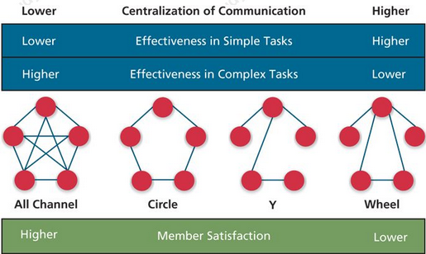
Team States
Team States: Specific types of feelings and thoughts that coalesce in the minds of team members as a consequence of their experience working together.
- Cohesion: A team state that occurs when members of the team develop strong emotional bonds to other members of the team and to the team itself.
  - Groupthink: Behaviors that support conformity and team harmony at the expense of other team priorities.
  - A way to avoid cohesion is to assign someone to be a devil’s advocate.
- Potency: A team state reflecting the degree of confidence among team members that the team can be effective across situations and tasks.
  - When a team has high potency, members are confident that their team can perform well, and focus more of their energy on achieving team goals.
  - When a team has low potency, members are not as confident about their team, so they begin to question the team’s goals and one another.
- Mental Models: The degree to which team members have a shared understanding of important aspects of the team and its task.
  - A team may have shared mental models with respect to the capabilities that members bring to the team as well as the processes the team needs to use to be effective.
  - When team members know each other’s capabilities, they’re more likely to know where to go for the help they might need to complete their work. In addition, they should be able to anticipate when another member needs help to do their work
- Transactive Memory: The degree to which team members’ specialized knowledge is integrated into an effective system of memory for the team.
  - Not everyone on a team has to possess the same knowledge. Instead team members should try to combine their knowledge with others’ knowledge for best results.

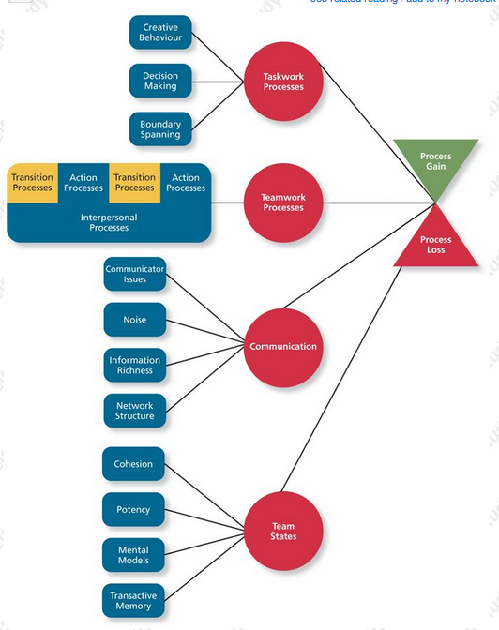

Effects of Task Interdependence on Performance and Commitment
Task Interdependence | Moderate Positive | Team Performance
The correlation is higher in teams involved in more complex knowledge work rather than less complex work.
Task Interdependence | Weak Positive | Team Commitment
The correlation is stronger for teams involved in more complex knowledge work than in teams involved in less complex work.

Transition Processes
Teamwork Process | Moderate Positive | Team Performance
That aspect of team process has a stronger effect on performance for teams involved in more complex knowledge work rather than less complex work.
Teamwork Process | Strong Positive | Team Commitment
That aspect of team process has a stronger effect on commitment for teams involved in more complex knowledge work rather than less complex work.

CHAPTER 11 – POWER, INFLUENCE, AND NEGOTIATIONS
Why Are Some People More Powerful Than Others?
Power: The ability to influence the behavior of others and resist unwanted influence in return.
- Just because a person has the ability to influence others doesn’t mean that they will choose to do so.
- In addition to influencing others, power can be seen as the ability to resist the influence attempts of others.
Acquiring Power
- Organizational Power: The three types of power derive primarily from a person’s position within an organization. They are considered to be formal in nature.
  - Legitimate Power: A form or organizational power based on authority or position.
    - They usually have some title, & they have the right to ask others to do things that are considered within the scope of their authority. The higher up you are the more legitimate power you have.
    - Limits: It doesn’t generally give a person the right to ask employees to do something outside the scope of their jobs or roles within the organization.
  - Reward Power: A form or organizational power based on the control of resources or benefits.
    - For example: giving out raises, bonuses, benefits, awards, and etc.
  - Coercive Power: A form or organizational power based on the ability to hand out punishments.
    - Operates on the principle of fear. For example: being able to fire someone.
    - Not used often because it tends to result in negative feelings toward those that use it.
- Personal Power:
  - Expert Power: A form or personal power based on expertise or knowledge.
    - When people demonstrate high performance, the ability to solve problems, or specific knowledge that is necessary to accomplish tasks, they are more likely to be able to influence other people who need that expertise.
  - Referent Power: A form or personal power based on attractiveness and charisma of the leader.
    - Exists when others have a desire to identify and be associated with the person.
Guidelines for Using Power
Type of Power | Guidelines for use
Legitimate | Make polite, clear requests, and explain the reason for the request.  Don’t exceed your scope or authority.  Follow up to verify compliance, and insist on compliance if appropriate.
Reward | Offer the types of rewards people desire, and that are fair and ethical.  Don’t promise more than you can deliver.  Explain the criteria for giving rewards and keep it simple.  Provide rewards as promised if requirements are met.
Coercive | Explain rules and requirements and ensure people understand the serious consequences of violations.  Respond to infractions promptly and without favoritism.  Use punishments that are legitimate, fair, and commensurate with the seriousness of non-compliance.
Expert | Explain the reason for a request and why it’s important.  Provide evidence that a proposal will be successful.  Don’t make rash, careless, or inconsistent statements.  Listen seriously to the person’s concerns and suggestions.
Referent | Show acceptance and positive regard.  Act supportive and helpful and use sincere form of ingratiation.  Defend and back up people when appropriate.  Do unsolicited favors and keep promises.

- Contingency Factors
  - Substitutability: The degree to which people have alternatives in accessing the resources that a leader controls. Individuals that are able to control resources to which no one else has access can use their power to gain greater influence.
  - Discretion: The degree to which managers have the right to make decision on their own.
  - Centrality: How important a person’s job is & how many people depend on that person to accomplish their tasks.
  - Visibility: How aware others are of a leader and the resources that leader can provide.
Contingency | An individual’s ability to influence others increases when:
Substitutability | There are no substitutes for the rewards or resources the individual controls.
Discretion | The individual’s role is important and interdependent with others in the organization.
Centrality | The individual has the freedom to make his or her own decisions without being restrained by organizational rules.
Visibility | Others know about this individual and the resources he can provide.
Using Influence
Influence: The use of behaviors that cause behavioral or attitudinal changes in others.
- Influence Tactics:
  - Rational Persuasion: The use of logical arguments & hard facts to show someone that a request is worthwhile.
  - Consultation: An influence tactic whereby the target is allowed to participate in deciding how to carry out or implement a request.
  - Inspirational Appeal: An influence tactic designed to appeal to one’s values and ideals, there by creating an emotional or attitudinal reaction.
  - Collaboration: An Influence tactic that whereby the leader makes it easier for the target to complete a request by offering to work with and help the target.
  - Ingratiation: The use of favors, compliments, or friendly behavior to make the target feel better about the influencer.
  - Personal Appeals: An influence tactic in which the requestor asks for something based on personal friendship or loyalty.
  - Exchange tactic: An influence tactic in which the requestor offers a reward in return for performing a request.
  - Apprising: An influence tactic in which the requestor clearly explains why performing the request will benefit the target personally.
  - Pressure: An influence tactic in which the requestor uses coercive power through threats & demands.
  - Coalition: An influence tactic in which the influencer enlists other people to help influence the target.
- Responses to Influence Tactics:
  - Internalization: A response where the target agrees with and becomes committed to the request.
  - Compliance: When targets of influence are willing to do what the leader asks but do it with a degree of uncertainty.
  - Resistance: When a target refuses to perform a request and puts forth an effort to avoid having to do it.

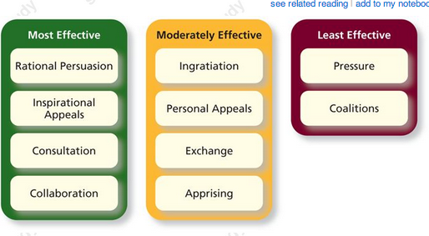
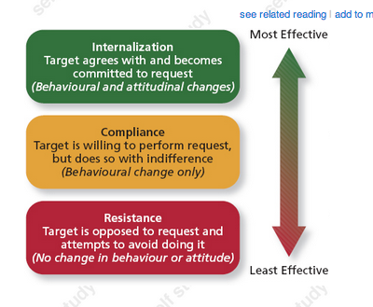

Power and Influence in Action
Organizational Politics
- Organizational Politics: Individual actions directed toward the goal of furthering a person’s self-interest.
- Political Skill: the ability to understand others and the use of that knowledge to influence them to further personal or organizational objectives.
  - Networking Ability: adeptness at identifying and developing diverse contacts.
  - Social astuteness: the tendency to observe others and accurately interpret their behavior.
  - Interpersonal Influence: having an unassuming and convincing personal style that’s flexible enough to adapt to different situations.
  - Apparent sincerity: involves appearing to others to have high levels of honesty and genuineness.
- Environments that are perceived as extremely political have been shown to cause lower job satisfaction, increased strain, lower job performance, and lower organizational commitment among employees.
- Personal Characteristics that foster organizational politics:
  - Strong need for power, high in self-monitoring, and “Machiavellian” tendencies, meaning they are willing to manipulate and deceive others to acquire power.
- Organizational factors most likely to increase politics are those that raise the level of uncertainty in the environment.
  - Events the trigger uncertainty: include limited or changing resources, ambiguity in role requirements, high performance pressures, or unclear performance evaluation measures.
Conflict Resolution
- Conflict arises when two or more people perceive that their goals are in opposition.
- Conflict and politics are intertwined, because the pursuit of one’s self-interest often breeds conflict in others.
- Competing: A conflict resolution style by which one party attempts to get his or her own goals met without concern for the other party’s result. (High assertiveness, low cooperation)
- Avoiding: A conflict resolution style by which one party wants to remain neutral, stay away from conflict, or postpone the conflict to gather information or let things cool down. (Low assertiveness, low cooperation)
- Accommodating: A conflict resolution style by which one party gives in to the other and acts in a completely unselfish way. (Low assertiveness, high cooperation)
- Collaboration: A conflict resolution style whereby both parties work together to maximize outcomes. (High assertiveness, high cooperation)
- Compromise: A conflict resolution style by which conflict is resolved by give and take concessions. (Moderate assertiveness, moderate cooperation)
Negotiations
Negotiation: A process in which two or more interdependent individuals discuss and attempt to reach agreement about their differences.
Negotiation Strategies
- Distributive bargaining: A negotiation strategy in which one person gains and the other person loses.
  - Similar to competing approach to conflict resolution approach.
- Integrative Bargaining: A negotiation strategy that achieves an outcome that is satisfying for both parties.
  - Involves the use of problem solving & mutual respect to achieve an outcome that’s satisfying for both parties.’
  - Similar to the collaborating conflict resolution approach.
  - It is most appropriate when multiple outcomes are possible, there is an adequate level of trust, and parties are willing to be flexible.
Negotiation Stages
- Preparation: Each party determines what its goals are for the negotiation & whether the other party has anything to offer. Each party also should determine its best alternative to a negotiated agreement, or BATNA.
  - BATNA: A negotiator’s best alternative to a negotiated agreement.
- Exchanging Information: Each party makes a case for its position & attempts to put all favorable info on the table. Each party also informs the other party how it has arrived at their conclusion & which issues it believes are important.
- Bargaining: The previous two stages need to be successful for this stage to work. During this stage, both parties likely must make concessions and give up something to get something in return. To the degree that each party keeps the other parties motives in mind.
- Closing and commitment: This stage entails the process of formalizing and agreement reached during the previous stage.

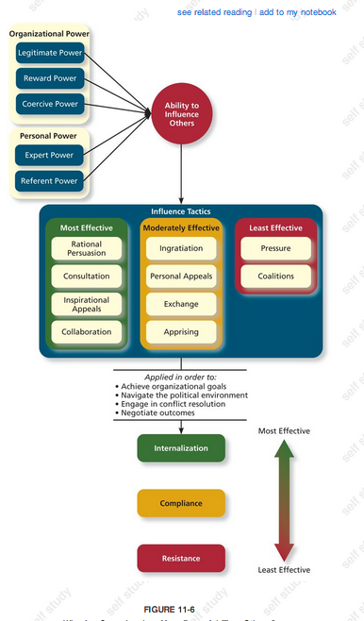

Effects of Power and Influence on Performance and Commitment
Power and Influence | Moderate Positive | Team Performance
When used effectively this can increase internalization and compliance, which facilitates task performance.
Power and Influence | Moderate Positive | Team Commitment
The use of personal forms of power, such as expert and referent increases affective commitment.

Application: Alternative Dispute Resolution
Alternative dispute resolution: a process by which two parties resolve conflict through the use of specially trained, neutral third party.
Mediation: A process by which a third party facilitates a dispute resolution process, but with not formal authority to dictate a solution.
Arbitration: A process by which a third party determines a binding settlement to a dispute between two parties.
CHAPTER 12 – LEADERSHIP STYLES AND BEHAVIOR
Leadership Styles And Behavior
Leadership: The use of power and influence to direct the activities of followers towards goal achievement.
- That direction can affect followers’ interpretation of events, the organization of their work activities, their commitment to key goals, their relationship with other followers, and their access to cooperation and support from other work units.
- Leaders might be judged by objective evaluations of unit performance, such as profit margins, market share, sales, return on investment, productivity, quality, cost, and so on.
- They can also be judged based on employee absenteeism, retention of talented employees, grievances filed, requests for transfer, and so forth.
Leader-member exchange theory: a theory describing how leader-member relationships develop over time on a dyadic basis.
- Role taking: The phase in a leader-follower relationship when a leader provides an employee with job expectations and the follower tries to meet those expectations.
  - The leader tries to get a feel for the talent and motivation levels of the employee.
- Role making: The phase in a leader-follower relationship when a follower voices his own expectations for the relationship, resulting in a free-following exchange of opportunities and resources for activities and effort.
- High quality exchange: a type of member-leader dyad that is marked by frequent one on one exchanged of info between the leader and the member, mutual influence, support and attention.
  - Form the leaders “in group and are characterized by higher levels of communication, mutual trust, respect, and obligation.
- Low quality exchange: a type of member-leader dyad that is marked by a more limited exchange of info, influence, latitude, support, and attention.
  - Form the leaders “out group” and are characterized by lower levels of communication, mutual trust, respect, and obligation.
WHY ARE SOME LEADERS MORE EFFECTIVE THAN OTHERS?
Leader effectiveness: The degree to which the leader’s actions result in the achievement of the unit’s goals, the continued commitment of the unit’s employees, and the development of mutual trust, respect, and obligation in leader-member dyads.
Leader emergence: the process of becoming a leader in the first place.
Leader Decision Making Styles
- A leader’s decision-making style reflects the process the leader uses to generate and choose from a set of alternatives to solve a problem. Decision-making styles capture how a leader decides as oppose to what a leader decides.
Defining the styles
- Autocratic style: A leadership style where the leader makes the decision alone without asking for opinions or suggestion of the employees in the work unit.
- Consultative style: A leadership style where the leader presents the problem to employees asking for their opinions and suggestions before ultimately making the decision himself.
- Facilitative style: A leadership style where the leader presents the problem to a group of employees and seeks consensus on a solution, making sure his opinion receives no more weight than anyone else’s.
- Delegative style: A leadership style where the leader gives the employee the responsibility for making decisions within some specified boundary conditions.
When Are The Styles Most Effective?
- There are many factors to consider before choosing a decision-making style:
  - The quality of the resulting decision.
  - Whether employees will accept and commit to the decision.
- How can leaders effectively manage their choice of decision-making styles?
  - The time-driven model of leadership: a model that suggests that seven factors combine to make some decision-making styles more effective than others in a given situation.
    - Decision significance: is the decision significant to the success of the project or the organization.
    - Importance of commitment: is it important that the employees buy in to the decision?
    - Leader expertise: Does the leader have significant knowledge or expertise regarding the problem?
    - Likelihood of commitment: How likely is that the employees will trust and commit to the decision?
    - Shared objectives: Do employees share and share and support that same objectives, or do they have an agenda of their own?
    - Employee expertise: Do the employees have significant knowledge or expertise regarding the problem?
    - Teamwork skills: Do the employees have the ability to work together to solve the problem, or will they struggle with conflicts?
  - Autocratic styles are reserved for decisions that are insignificant or decision for which employee commitment is unimportant.
  - Delegative styles are reserved for circumstances in which employees have strong teamwork skills and aren’t likely to just commit to whatever decision the leader provides.
Day-to-Day Leadership Behaviors
- Initiating structure: A pattern of behavior where the leader defines and structures the roles of employees in pursuit of goal attainment.
  - Had a strong positive relationship with employee motivation and moderate positive relationship with perceived leader effectiveness, job satisfaction, and overall unit performance.
- Consideration: A pattern of behavior where the leader creates job relationships characterized by mutual trust, respect for employee ideas, and consideration of employees feelings.
  - Had a strong positive relationship with perceived leader effectiveness, employee motivation, and employee job satisfaction. It had a moderate positive relationship with overall unit performance.
Behavior | Description
Initiating Structure
Initiation | Originating, facilitating, and sometimes resisting new ideas and practices.
Organizing | Defining and structuring work, clarifying leader versus member roles, coordinating employee tasks.
Production | Setting goals and providing incentives for the effort and productivity of employees.
Consideration
Membership | Mixing with employees, stressing informal interactions, and exchanging personal services.
Integration | Encouraging a pleasant atmosphere, reducing conflict, promoting individual adjustment to the group.
Communication | Providing info to employees, seeking info from them, showing an awareness of matters that affect them.
Recognition | Expressing approval or disapproval of the behaviors of employees
Representation | Acting on behalf of the group, defending the group, and advancing the interest of the group.

- Lifecycle theory of leadership: A theory stating that the optimal combination of initiating structure and consideration depends on the readiness of the employee in the work unit.
  - Readiness: the degree to which employees have the ability and willingness to accomplish their specific tasks.
    - R1: refers to a group of employees who are working together for the first time and are eager to begin but they are inexperienced.
      - Telling: High initiating and low consideration – the leader provides specific instruction and closely supervises performance.
    - R2: the members have begun working together and are finding that their work is more difficult than anticipated. Eagerness turns to dissatisfaction.
      - Selling: High initiating structure and high consideration – the leader supplements his directing with support & encouragement to protect the confidence levels of the employees.
    - R3: Employees have learned to work together well, though they still need support and collaboration from the leader to help them adjust to their more self-managed state of affairs.
      - Participating: Low initiating structure and high consideration – leaders share ideas and try to help the group its affairs.
    - R4: Readiness level. Final stage.
      - Delegating: Low initiating and low consideration – leader turns responsibility for key behaviors to employees.
Transformational Leadership Behaviors
Transformational Leadership: A pattern of behavior in which the leader inspires followers to commit to a shared vision that provides meaning to their work while also serving as a role model who helps followers develop their own potential and view problems from new perspectives.
- Laissez-faire Leadership: When the leader avoids leadership duties altogether.
  - Important actions are delayed, responsibilities are ignored, and power and influence go unutilized.
- Transactional Leadership: A pattern of behavior in which the leader rewards or disciplines the followers on the basis of performance.
  - Passive management-by-exception: A type of transactional leadership in which the leader waits around for mistakes and errors, then takes corrective actions as necessary.
  - Active management-by-exception: A type of transactional leadership in which the leader arranges to monitor mistakes actively, and takes correction action when required.
  - Contingent reward: A more active and effective transactional leadership, in which the leader attains follower agreement on what needs to be done using rewards in exchange for adequate performance.
- Transformational Leadership: the most active and effective approach. It is also the leadership approach that is the most universally endorsed across cultures.
  - Idealized influence: The power held by a leader who behaves in ways that earn the admiration, trust, and respect of followers, causing followers to want to identify with and emulate the leader. Charismatic.
  - Inspirational Motivation: A type of influence in which the leader behaves in ways that foster and enthusiasm for and commitment to a shared vision of the future.
  - Intellectual Stimulation: A type of influence in which the leader behaves in ways that challenge followers to be innovative and creative by questioning assumptions and reframing old situations in new ways.
  - Individualized consideration: A type of influence in which the leader behaves in ways that help followers achieve their potential through coaching, development, and mentoring.

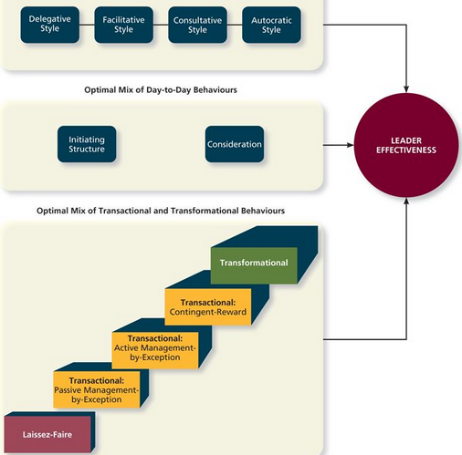
Effects of transformational Leadership on Commitment and Performance
Transformational Leadership | Moderate Positive | Job Performance
Employees with transformational leadership have higher levels of task performance and are more likely to engage in citizenship behaviors.
Transformational Leadership | Strong Positive | Organizational Commitment
Employees with transformational leadership have higher levels of affective commitment and higher levels of normative commitment. It has no effect on continuance commitment.

CHAPTER 13 – ORGANIZATIONAL STRUCTURE
Organizational Structure: Formally dictates how jobs & tasks are divided & coordinated between individuals & groups in the company.
- Downward: from the top to the bottom of the organization through different levels of managers. Ex: directives
- Upward: from the bottom to the top of the organizations. Ex: employee suggestions for improvement.
- Horizontal: horizontal flows of info between cross-functional teams or between departments at the same level.
WHY DO SOME ORGANIZATIONS HAVE DIFFERENT STRUCTURES THAN OTHERS?
Organizational chart: a drawing that represents every drawing in the organization and the formal reporting relationships between those jobs.

Elements of Organizational Structure
- Work Specialization: the degree to which tasks in an organization are divided into separate jobs. (Division of labor)
  - Never-ending trade off between productivity, flexibility, and worker motivation.
- Chain of Command: Answer to the question of who reports to whom, and signifies formal authority relationships.
  - Organizations depend on this flow of authority to attain order, control, and predictable performance.
- Span of Control: Represents how many employees each manager in the organization has responsibility for.
  - Narrow span of control: allow managers to be much more hands-on with employees, giving them the opportunity to use directive leadership styles while developing close mentoring relationships with employees.
    - Especially more important if the manager has substantially more skill and expertise that the others.
    - Requires organizations to hire many managers, which increase labor costs.
    - If the span of control becomes too narrow, employees can become resentful of their close supervision and long for more latitude in their day-to-day decision-making.
  - Frist, more layers of management means having to pay more management salaries.
  - Second, communication in the organization becomes more complex as each new layer becomes one more point through which info must when travelling upward or downward.
  - Third, the ability for organization to make decisions becomes slower because approval for decision has to be authorized at every step of the hierarchy.
- Centralization: Aspects of structure that dictates where decisions are formally made in organizations.
  - Highly centralized structure: only the top managers within a company have the authority to make final decisions.
  - Decentralized structure: when decision making authority is pushed down to lower-level employees and these employees feel empowered to make decisions on their own.
- Formalization: The degree to which & procedures are used to standardize behaviors and decision in an organization.
  - Rules and procedures are a necessary mechanism for control in every organization.
  - Formalization is a necessary coordination mechanism that organizations rely on to get standardized products or to deliver standardized services.
- Elements in Combinations:
  - Wide spans of control tend to be associated with decentralization in decision-making.
  - High level of work specialization tends to bring about a high level of formalization.
  - Mechanistic Organizations: Efficient, rigid, predictable, and standardized organizations that thrive in stable environments.
    - Typified by structures that rely on high levels of formalization, a rigid & hierarchical chain of command, high degrees of work specialization, centralization of decision-making, & narrow spans of control.
  - Organic Organizations: Flexible, adaptive, outward focused organizations that thrive in dynamic environments.
    - Typified by structures that rely on low levels of formalization, weak or multiple chains of command, low levels of work specialization, and wide spans of control.
Characteristics of Mechanists vs. Organic Structures
Mechanists Organizations | Organic Organizations
High degree of work specialization; employees are given a narrow view of the tasks they are to perform. | Low degree of work specialization; employees are encourages to take a broad view of the tasks they are to perform.
Very clear lines of authority; employees know exactly whom they report to. | Although there might be a specified chain of command, employees think more broadly in terms of where their responsibilities lie.
High levels of hierarchical control; employees are not encouraged to make decisions without their manager’s consent. | Knowledge and expertise are decentralized; employees are encouraged to make their own decisions when appropriate.
Info is passed through vertical communication between an employee and his supervisor. | Lateral communication is encouraged, focusing on info and advice as opposed to orders.
Employees are encouraged to develop firm-specific knowledge and expertise within their area of specialization. | Employees are encouraged to develop firm-specific knowledge and expertise outside their area of specialization.

Organizational Design
Organizational Design: The process of creating, selecting, or changing the structure of an organization.
- Business Environment: The outside environment, including customers, competitors, suppliers, and distributors, which all have an impact on organizational design.
  - One of the biggest factors in an environment’s effect on structure is whether the outside environment is stable or dynamic.
    - Stable environments don’t change frequently, and any changes that do occur happen very slowly. They allow organizations to focus on efficiency and require little change over time.
    - Dynamic environments change on a frequent basis and require organizations to have structures that are more adaptive.
- Company Strategy: An organization’s objectives and goals and how it tries to capitalize on its assets to make money.
  - Low-cost producer strategy: relying on selling products at the lowest possible cost.
    - They have to focus on being as efficient as they can be.
    - More likely to take a mechanistic approach to organizational design.
  - Differentiation Strategy: try to make their products unique in some way.
    - Hinges on adjusting to changing environments quickly, which often makes an organic structure more appropriate.
- Technology: The method by which an organization transforms inputs to outputs.
  - Research suggests that the more routine the technology is, the more mechanistic the structure should be.
  - If technologies need to be changed or altered to suit the needs of consumers, it follows that decisions would be more decentralized and the rules and procedures the organization relies on would need to be more flexible.
- Company Size: The number of employees in a company.
  - As organizations become larger, they need to rely on some combination of specialization, formalization, and centralization to control their activities, thereby becoming more mechanistic.
Common Organizational Forms
- Simple Structures: An organizational form that features one person as the central decision-making figure.
  - They are generally used by extremely small organizations in which the manager, president, and owner are all the same person.
  - It is a flat organization with one person as the central decision-making figure; it is not large enough to have a high degree of formalization and will only have very basic differences in work specialization.
- Bureaucratic Structures: An organization form that exhibits many of the facets of a mechanistic organization. They are designed for efficiency and rely on high levels of work specialization, formalization, centralization of authority, rigid and well-defined chains of command, and relatively narrow spans of control.
  - Functional Structure: An organizational form in which employees are grouped by the functions they perform for the organization.
    - The success of the functional structure is based on the efficiency advantages that come with having a high degree of work specialization that’s centrally coordinated.
    - Functional structures are extremely efficient when the organization as a whole has a relatively narrow focus, fewer product lines or services, and a stable environment.
    - Weakness: Individuals in each function get so wrapped up in their own goals and viewpoints that they loose sight of the bigger organizational picture. They don’t communicate well across functions as they do within functions.
  - Multidivisional Structure: An organizational form in which employees are grouped according to product, geography, or client.
    - Product Structure: An organizational form in which employees are grouped around different products that the company produces.
      - Each of these divisions becomes responsible for manufacturing, marketing and doing R&D for the products in its own division.
      - Product structure makes sense when the firms diversify to the point that the products they sell are so different that managing them becomes overwhelming.
      - Weakness: when products are not really different.
    - Geographic Structure: An organizational form in which employees are grouped around different locations where the company does business.
      - Reasons for this are that customers have different tastes in different regions, the size of the locations that need to be covered by different salespeople, or the fact that the manufacturing or distribution of a product are better served by a geographic breakdown.
    - Client-Based Structure: An organizational form in which employees are organized around serving customers.
  - Matrix Structure: A complex form of organizational structure that combines a functional and multidivisional grouping.
    - The matrix allows an organization to put together very flexible teams based on the experience and skills of their employees. This flexibility allows the organization to adjust much more quickly to the environment than a tradition bureaucratic structure would.
    - The matrix gives each employee two chains of command, two groups with which to interact, and two sources of information to consider. This doubling of traditional structuring elements can create high stress levels for employees if the demands of their functional grouping are at odds with the demands of their products or client-based grouping.

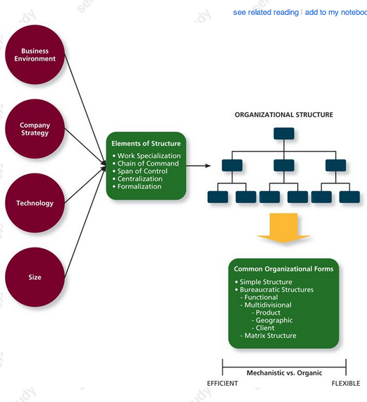

Effects of Organizational Structure on Performance and Commitment
Restructuring | Weak Negative | Job Performance
Task performance tends to be lower in organizations that restructure.
Restructuring | Moderate Negative | Organizational Commitment
Affective commitment tends to be lower in organizations that restructure.

CHAPTER 14 – ORGANIZATIONAL CULTURE AND CHANGE
Organizational Culture
Organizational Culture: The shared social knowledge within an organization regarding the rules, norms, and values that shape the attitude and behaviors of its employees.
- Culture is social knowledge among members of the organization. Employees can learn about most important aspects of culture through other employees. This transfer of knowledge might be through explicit communication, simple conversation, or other less obvious methods.
- Culture is shared knowledge, which means that members of the organization understand and have a degree of consensus regarding what culture is.
- Second, culture tells employees what the rules, norms and values are within the organization.
- Third, organizational culture shapes and reinforces certain employee attitudes and behaviors by creating a system of control over employees.
Why Do Some Organizations Have Different Cultures Than Others?
Culture Components
- Observable Artifacts: aspects of an organization’s culture that employees and outsiders can easily see or talk about. Artifacts supply the primary means of transmitting the organization’s culture to its workforce.
  - Symbols: The images an organization uses, which generally convey messages.
    - Corporate logo, images on a website, uniforms employees wear.
  - Physical Structures: The organization’s buildings and internal office design.
  - Language: The jargon, slangs, and slogans used within an organization.
  - Stories: Anecdotes, accounts, legends, and myths passed down from cohort to cohort within an organization.
  - Rituals: The daily or weekly planned routines that occur in an organization.
  - Ceremonies: Formal events generally performed in front of an audience of organizational members.
- Espoused Values: The beliefs, philosophies, and norms that a company explicitly states.
  - Can range from public documents, such as company’s vision or mission statement, to verbal statements made to employees by executives and managers.
- Basic Underlying Assumptions: The ingrained beliefs and philosophies of employees.
  - Represent the deepest and least observable part of the culture and may not be consciously apparent, even to organizational veterans.
  - They are also the aspects of an organizational culture that are the most long-lasting and difficult to change.
General Culture Types
Solidarity: The degree to which group members think and act alike.
Sociability: Represents how friendly employees are to one another.
- Fragmented Culture: An organizational culture type in which employees are distant & disconnected from one another.
  - Low in solidarity and low in sociability.
- Mercenary Culture: An organizational culture type in which employees think alike but are not friendly to one another.
  - High in solidarity but low in sociability.
- Networked Culture: An organizational culture type in which employees are friendly to one another, but everyone thinks differently and does his or her own thing.
  - Low in solidarity but high in sociability.
- Communal Culture: An organizational culture type in which employees are friendly to one another and think alike.
  - High in solidarity and high in sociability.
Specific Culture Types
- Customer Service Culture: A specific culture type focused on service quality.
  - A culture that fosters a common set of values among its members, such as being friendly, passionate, and showing appreciation for their “guests.”
  - Service-oriented leadership behavior > Service Culture > Service-oriented employee behavior > Customer satisfaction > Unit sales
- Safety Culture: A specific culture type focused on he safety of employees.
  - The payoff for these organizations is often an increased level of safety awareness and behaviors, and lower accidents.
  - How to instill this into your employees: strong management commitment to protecting and promoting safety, careful selection and training of its new employees, extensive and mandatory safety rules and procedures, and required safety knowledge training and testing.
- Diversity Culture: A specific culture type focused on fostering or taking advantage of a diverse group of employees.
  - Differences in people are seen as valuable and potential assets.
- Creativity Culture: A specific culture type focused on fostering a creative atmosphere.
Culture Strength
- Culture Strength: The degree to which employees agree about how things should happen within the organization and behave accordingly.
- Subcultures: A culture created within a small subset of the organization’s employees.
  - May be created because there is a strong leader in one area of the company that engenders different norms and values, or because different divisions in a company act independently and create their own cultures.
  - Subcultures exist when the overall organizational culture is supplemented by another culture governing a more specific set of employees.
- Counterculture: A subculture whose values do not match those of the organization.
  - Can sometimes serve a useful purpose by challenging the values of the overall organization or signifying the need for change.
  - However, in extreme cases countercultures can split the organization’s culture right down the middle.
Pros and Cons of a Strong Culture
Advantages of a Strong Culture | Disadvantages of a Strong Culture
Differentiates the organization from others | Makes merging with another organization more difficult
Allows employees to identify themselves with the organization | Attracts and retains similar kinds of employees, thereby limiting diversity of thought.
Facilitates desired behaviors among employees | Can be “too much of a good thing” if it creates extreme behavior among employees
Creates stability within the organization | Makes adapting to the environment more difficult

Maintaining an Organizational Culture
- Attraction-Selection-Attrition (ASA): A theory that states that employees will be drawn to organizations with cultures that match their personality, organizations will select employees that match, and employees will leave or be forced out when they are not a good fit.
- Socialization: The primary process by which employees learn the social knowledge that enables them to understand and adapt to the organization’s culture. It is a process that begins when the employee starts work and doesn’t stop until the employee leaves.
  - Anticipatory Stage: A stage of socialization that begins as soon as an employee develops an image of what it would be like to work for a company.
    - The bulk of the info acquired during this stage occurs during the recruitment and selection process.
  - Encounter Stage: A stage of socialization beginning the day an employee starts work, during which the employee compares the info as an outsider to the info learned as an insider.
  - Reality Shock: A mismatch of info that occurs when an employee finds that aspects of working at a company are not what the employee expected it to be.
  - Understanding and adaption: the final stage of socialization, during which newcomers come to learn the content areas of socialization and internalize the norms and expected behaviors of the organization.
Changing an Organizational Culture
- The change process: one of the most widely held perspectives on organizational change suggests a basic process that involves three sequential steps: unfreezing, change initiative, and freezing.
  - Unfreezing: occurs when the organization comes to some realization that the status quo is unacceptable.
  - Change initiative: Once a need for change has been recognized, you need to plan and implement that change. In the case of culture change it may involve bringing a new leader, introducing a new reward system, or implementing a new training program.
  - Refreeze: the newly developed attitudes and behaviors need to “harden up,” becoming entrenched as new norms, values, and shared understandings.
  - Issues to overcome: Proper Diagnosis and resistance
- Changes in leadership: Sometimes leaders have to be the driving force for change as the environment around the organization shifts.
- Mergers and Acquisitions: The best way to change a culture is to merge two companies. It is just hard to know what the culture will look like after the merge takes place.
  - Ideally, a new culture would be created out of a compromise in which the best of each company is represented by the culture. Mergers rarely result in a strong culture. Most merged companies operate under a differentiated culture.
  - Merging two different cultures has major effects on the attitudes and behaviors of organizational employees.

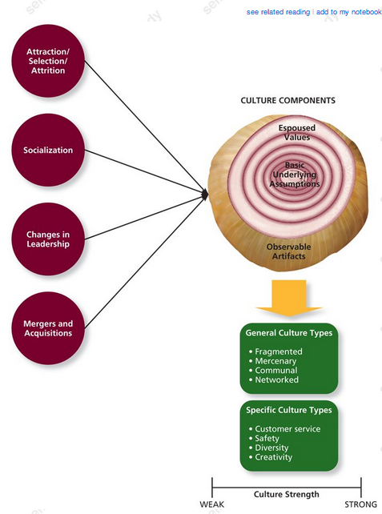

Effects of Person-Organization Fit on Performance and Commitment
Person-organization fit | Weak Positive | Job Performance
Employees who fit with their organizations tend to have slightly higher levels of Task performance, with effects on citizenship behavior slightly stronger.
Person-organization fit | Strong Positive | Organizational Commitment
Employees who fit with their organizations tend to have higher levels of affective commitment.

