Bio 2244B- Textbook Notes Chapter 7: 7-1, 7-2, 7-3, 7-5 March 13th, 2012

7-1: Overview
Definitions
- Hypothesis: a claim or statement about a property of a population
- Hypothesis test (test of significance): a standard procedure for testing a claim about a property of a population
- Recall the rare event rule: if, under a given assumption, the probability of a particular observed event is exceptionally small, we conclude that the assumption is probably not correct

7-2: Basics of Hypothesis Testing
- Components of a formal hypothesis test:
  - Null hypothesis (H₀): A statement that the value of a population parameter (such as proportion, mean, or standard deviation) is equal to some claimed value. We test the null hypothesis directly in the sense that we assume it is true and reach a conclusion to either reject H₀ or fail to reject H₀
  - Alternative hypothesis (H₁ or H_{a}): the statement that the parameter has a value that somehow differs from the null hypothesis. For this chapter, the symbolic form of the alternative hypothesis must use one of these symbols: < or > or ≠
  - Test statistic: a value computed from the sample data and it is used in making the decision about the rejection of the null hypothesis
    - it is found by converting the sample statistic to a score with the assumption that the null hypothesis is true
    - Test statistic for proportion: $z= \frac{\hat{p}-p}{\sqrt{\frac{pq}{n}}}$
    - Test statistic for mean: $z= \frac{x ̅-μ}{\frac{σ}{\sqrt{n}}}$ OR $t= \frac{x ̅-μ}{\frac{s}{\sqrt{n}}}$
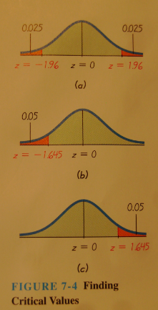
    - Test statistic for standard deviation: $X^{2}= \frac{(n-1)s^{2}}{σ^{2}}$
- Critical region (rejection region): the set of all values of the test statistic that cause us to reject the null hypothesis
- Significance level (α): the probability that the test statistic will fall in the critical region when the null hypothesis is actually true
  - If the test statistic falls within the critical region, we reject the null hypothesis, so α is the probability of making the mistake of rejecting the null hypothesis when it is actually true
- Critical value: any value that separates the critical region (where we reject the null hypothesis) from values of the test statistic that do not lead to rejection of the null hypothesis
  - Critical values depend on the nature of the null hypothesis, the sampling distribution that applies and α
  - See the figure at right to help determine what critical value to use
- Tails: the extreme regions in a distribution that are bounded by critical values
  - Two-tailed test: the critical region is in the two extremes of the regions (tails) under the curve
    - In two-tailed tests, the significance level α is divided equally between the two tails that constitute the critical region
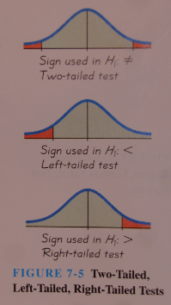
  - Left-tailed test: the critical region is in the extreme left region (tail) under the curve
  - Right-tailed test: the critical region is in the extreme right region (tail) under the curve
  - The alternative hypothesis is often helpful in determining what type of test is being conducted. See the figure at right to show how to use the alternative hypothesis to determine what kind of tailed-test the hypothesis test is
- P-value (p-value or probability value): the probability of getting a value of the test statistic that is at least as extreme as the one representing the sample data, assuming that the null hypothesis is true
  - The null hypothesis is rejected if the P-value is very small (ie. 0.05 or less)
  - To determine a p-value, remember:
    - Left-tailed test: the p-value is the area to the LEFT of the test statistic
    - Right-tailed test: the p-value is the area to the RIGHT of the test statistic
    - Two-tailed test: the p-value is TWICE the area in the tail bounded by the test statistic
  - P-values can also be found using the following flow chart:
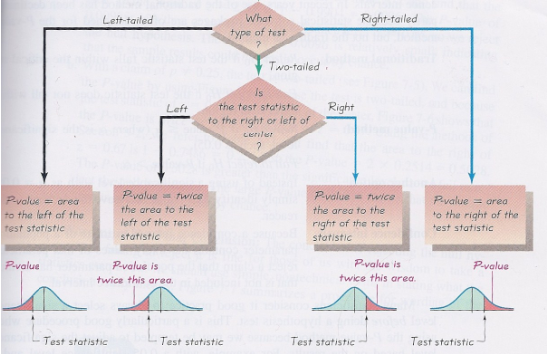

- Decision criterion: the decision to reject or fail to reject the null hypothesis is usually made using either the traditional method of testing hypotheses, the p-value method, or the decision is sometimes based on confidence intervals
  - Traditional method: reject H₀ if the test statistic falls within the critical region; fail to reject H₀ if the test statistic does not fall within the critical region
  - P-value method: reject H₀ if P-value ≤ α; fail to reject H₀ if P-value > α
  - Confidence intervals: because a confidence interval estimate of a population parameter contains the likely values of that parameter, reject a claim that the population parameter has a value that is not included in the confidence interval
- When wording the final conclusion, note that whether we say we “fail to reject the null hypothesis” or we “accept the null hypothesis” we are not proving the null hypothesis
- Type I error: the mistake of rejecting the null hypothesis when it is actually true; α is used to represent the probability of a type I error
- Type II error: the mistake of failing to reject the null hypothesis when it is actually false; β is used to represent the probability of making a type II error
- Use a mnemonic to remember the difference between type I and II errors: RouTiNe FoR FuN
  - RTN= reject true null (type I error)
  - FRFN= failure to reject a false null (type II error)
- Power: the power of a hypothesis test is the probability (1-β) of rejecting a false null hypothesis, which is computed by using a particular significance level, α, a particular sample size, n, a particular assumed value of the population parameter (used in the null hypothesis) and a particular value of the population parameter that is an alternative to the value assumed in the null hypothesis

7-3: Testing a Claim about a Proportion
- Requirements:
- The sample observations are a SRS
- The conditions for a binomial distribution are satisfied
- The conditions np ≥ 5 and nq ≥ 5 are both satisfied, so the binomial distribution of sample proportions can be approximated by a normal distribution with μ = np and σ = $\sqrt{npq}$
- Notation:
n = sample size or number of trials
p̂ = x/n (sample proportion)
p = population proportion (used in null hypothesis)
q = 1-p
- Test statistic for testing a claim about a proportion: $z= \frac{\hat{p}-p}{\sqrt{\frac{pq}{n}}}$
- P-values: use standard normal distribution
- Critical values: use the standard normal distribution
- Traditional method:
  - Step 1: Identify the specific claim or hypothesis to be tested and put it in symbolic form
  - Step 2: Give the symbolic form that must be true when the original claim is false
  - Step 3: Of the two symbolic expressions obtained so far, let the alternative hypothesis H1 be the one not containing equality, so that H₁ uses the symbol > or < or ≠. Let the null hypothesis H₀ be the symbolic expression that the parameter equals the fixed value being considered
  - Step 4: Select the significance level α based on the seriousness of a type 1 error. Make α small if the consequences of rejecting a true H₀ are severe.
  - Step 5: Identify the statistic that is relevant to this test and determine its sampling distribution (such as normal, t, chi-square )
  - Step 6: Find the test statistic, the critical values, and the critical region. Draw a graph and include the test statistic, critical value(s), and critical region
  - Step 7: Reject H₀ if the test statistic is in the critical region. Fail to reject H₀ if the tests statistic is not in the critical region
  - Step 8: Restate this previous decision in simple, nontechnical terms, and address the original claim.
- P-value method:
  - Step 1: Identify the specific claim or hypothesis to be tested and put it in symbolic form
  - Step 2: Give the symbolic form that must be true when the original claim is false
  - Step 3: Of the two symbolic expressions obtained so far, let the alternative hypothesis H1 be the one not containing equality, so that H₁ uses the symbol > or < or ≠. Let the null hypothesis H₀ be the symbolic expression that the parameter equals the fixed value being considered
  - Step 4: Select the significance level α based on the seriousness of a type 1 error. Make α small if the consequences of rejecting a true H₀ are severe.
  - Step 5: Identify the statistic that is relevant to this test and determine its sampling distribution (such as normal, t, chi-square )
  - Step 6: Find the test statistic and find the P-value. Draw a graph and show the test statistic and P-value
  - Step 7: Reject H0 if the P-value is less than or equal to the significance level α. Fail to reject H0 if the p-value is greater than α
  - Step 8: Restate this previous decision in simple, nontechnical terms, and address the original claim
- Confidence interval method:
  - For two-tailed hypothesis tests, construct a confidence interval with a confidence level of 1-α; but for a one-tailed hypothesis test with significance level α, construct a confidence interval with a confidence level of 1-2α
  - If the claimed value does fall within the confidence interval, it could easily be true that the value of the population proportion is what the claim says it is, (ie. if our claim is that p = 0.25 and our confidence interval is 0.226 < p < 0.298) and so we wouldn’t have enough evidence to reject the claim

7-4: Testing a claim about a mean: σ known
- Requirements:
- The sample is an SRS
- The value of the population standard deviation σ is known
- Either or both of these conditions is satisfied: the population is normally distributed or n > 50
- Test statistic for testing a claim about a mean (with σ known): $z= \frac{\overline{x}- μ_{\overline{x}}}{\frac{σ}{\sqrt{n}}}$
- P-values: use the standard normal distribution
- Critical values: use the standard normal distribution

7-5: Testing a Claim About a mean: σ not known
- Requirements:
- The sample is an SRS
- The value of the population standard deviation σ is not known
- Either or both of these conditions is satisfied: the population is normally distributed or n > 50
- Test statistic for testing a claim about a mean (with σ not known): $t= \frac{\overline{x}- μ_{\overline{x}}}{\frac{s}{\sqrt{n}}}$
- P-values and critical values: Use df = n-1 for the number of degrees of freedom and use the t-distribution

- Finding p-values from the t-distribution
  - For a positive test statistic greater than 3.106:
    - Right-tailed test has a p-value less than 0.005
    - Two-tailed test has a p-value less than 0.01
  - For a positive test statistic between 2.201 and 1.796:
    - Right-tailed test has a p-value between 0.025 and 0.05
    - Two-tailed test has a p-value between 0.05 and 0.1
  - For a positive test statistic less than 1.363:
    - Right-tailed test has a p-value greater than 0.1
    - Two-tailed test has a p-value greater than 0.2
  - Note that if the test statistic is negative, drop the negative sign, then…
    - Left-tailed test has the same p-value as described above for a right-tailed test
    - Two-tailed test has the same p-value as described above for a two-tailed test
    - Right-tailed test has a p-value greater than 0.5

